1)firstname = input("Enter first name :")

lastname = input("Enter last name :")

fn = firstname[::-1]

ln = lastname[::-1]

print (fn,"",ln)

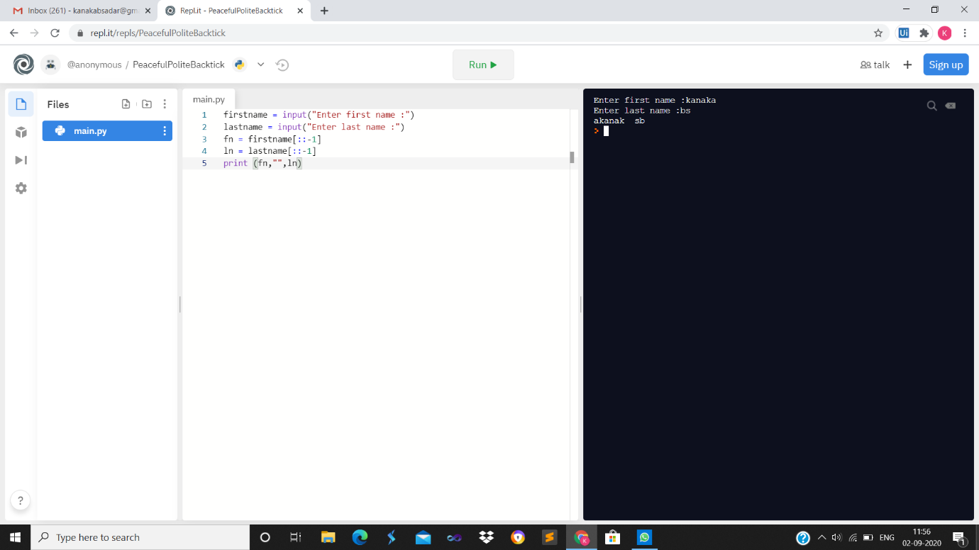

2)from datetime import date

d0 = date(2020, 7, 19)

d1 = date(2020, 8, 27)

delta = d1 - d0

print("Total difference in days is",delta.days)

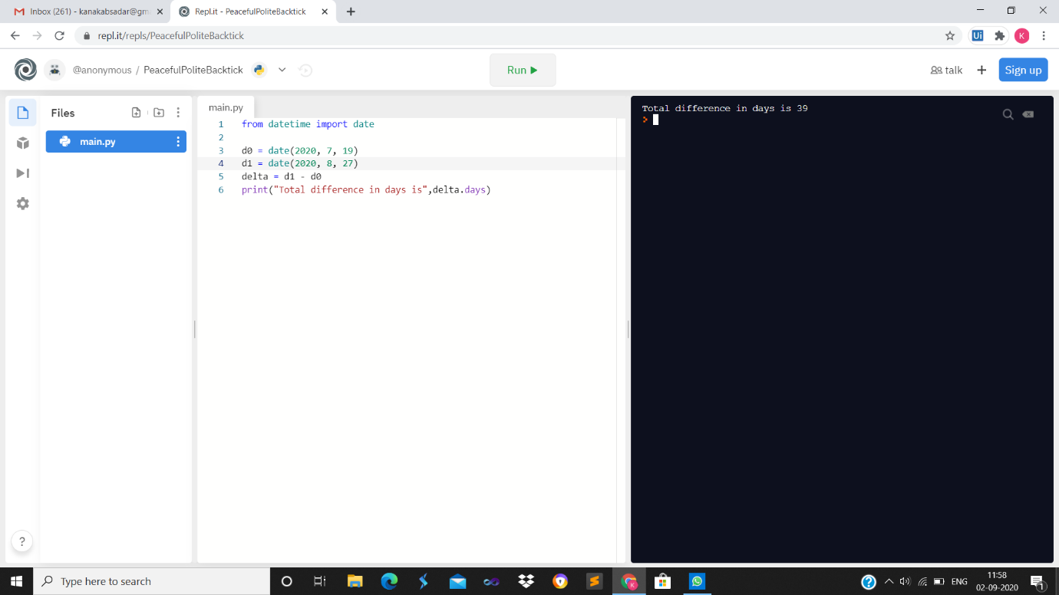

3)ch = input(" Enter a Character : ")

if(ch == 'a' or ch == 'e' or ch == 'i' or ch == 'o' or ch == 'u' or ch == 'A'

or ch == 'E' or ch == 'I' or ch == 'O' or ch == 'U'):

print(ch, "is a Vowel")

else:

print(ch, "is a not a vowel")

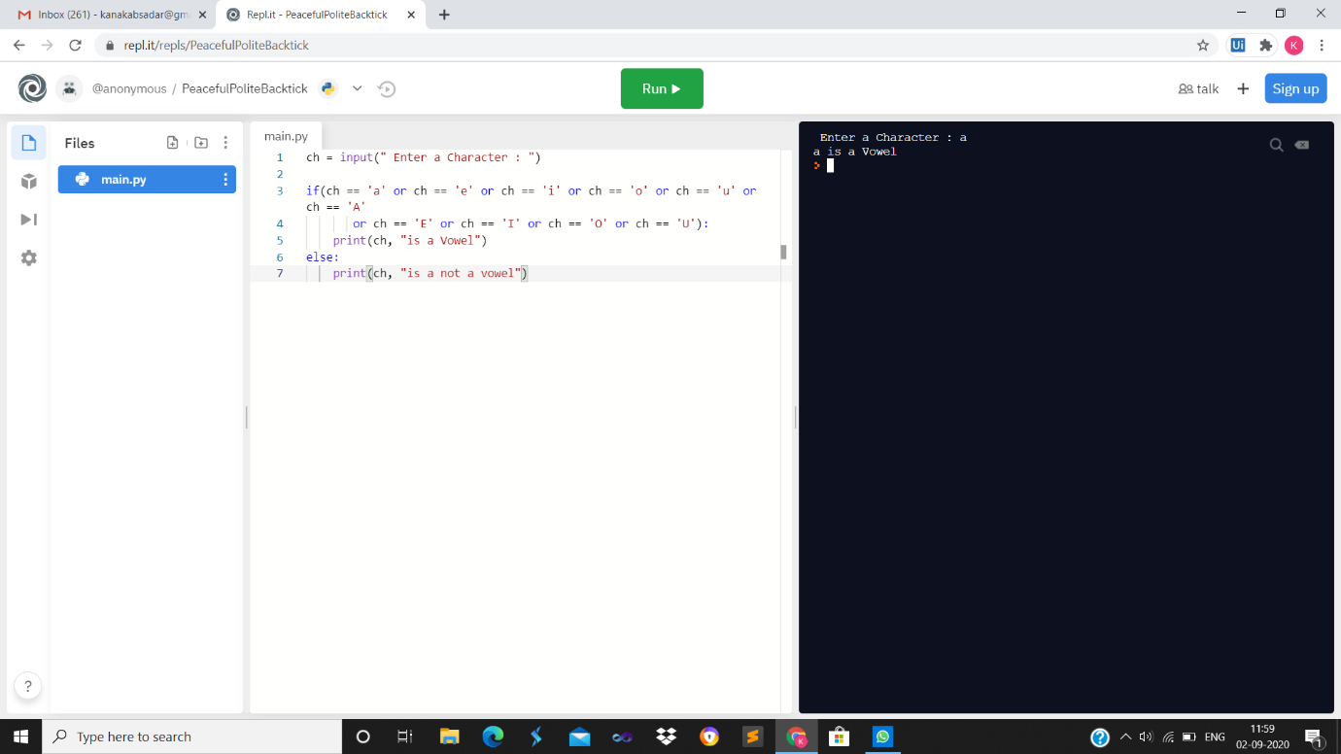

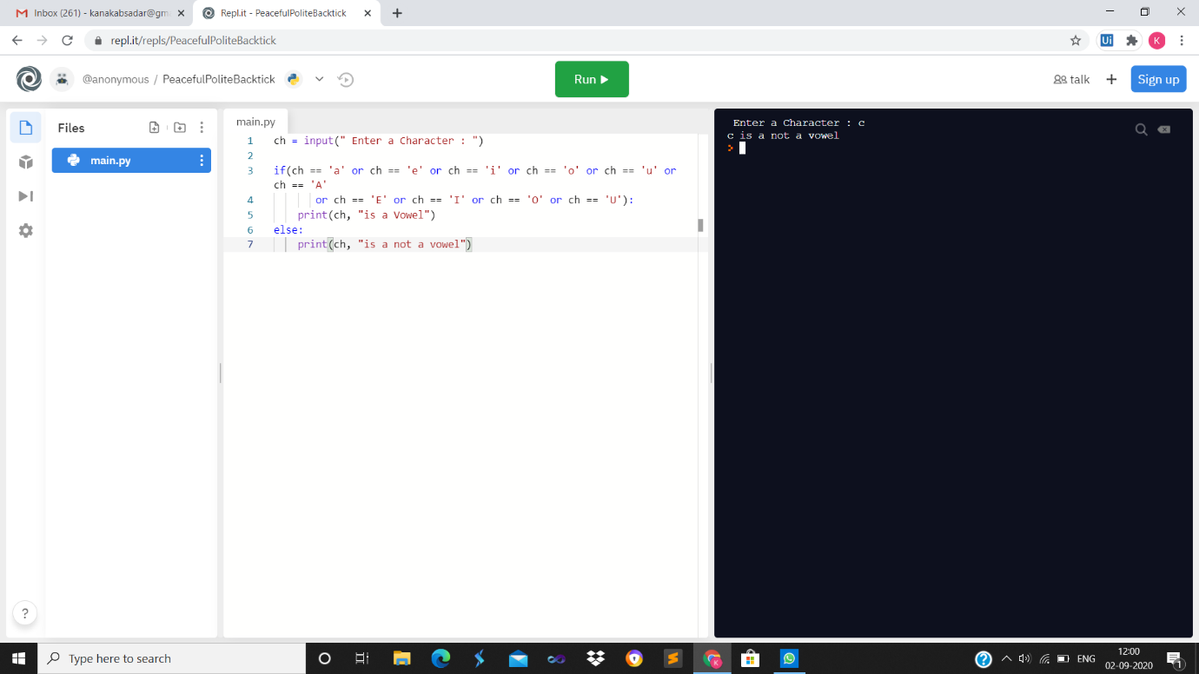

4)def sum(x, y, z):

if x == y or y == z or x==z:

sum = 0

else:

sum = x + y + z

return sum

x=int(input("enter first number :"))

y=int(input("enter second number :"))

z=int(input("enter third number :"))

print("sum is",sum(x, y, z))

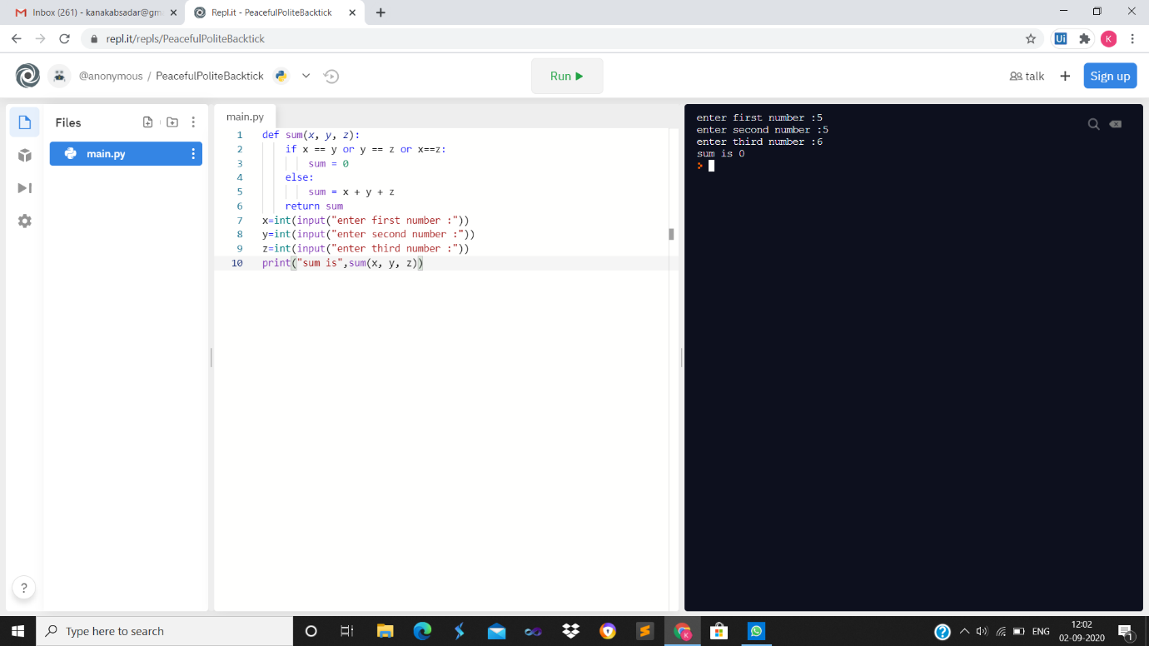

5)test_str = input("Enter the string :")

all_freq = {}

for i in test_str:

if i in all_freq:

all_freq[i] += 1

else:

all_freq[i] = 1

print ("Count of all characters is :\n " + str(all_freq))

