SalaryShield
AI-Driven, Inflation-Adaptive Compensation Intelligence
Design & Solution Document
Hackathon submission — mapped to the 10 scoring parameters
Quantify real-wage erosion. Justify fair corrections. Retain talent. SalaryShield is a two-sided platform that turns invisible city-level inflation into a fair, data-backed compensation decision for both employees and employers — powered by a City-Level Inflation Index (CLII) and a GenAI Copilot grounded in the user's own numbers.
Technology Stack
Layer | Technology
Frontend | React 19, Vite 8, JavaScript (JSX)
UI / Design | CSS variables + glassmorphism design system, lucide-react icons
State & Persistence | React Hooks (useState / useEffect), browser localStorage
Domain / Model | src/lib/inflation.js — CLII model, analyzeBudget(), savingsSeries(), break-even engine
AI (implemented) | Grounded GenAI Copilot — user budget + CLII injected as context
AI (roadmap) | LLM gateway → Claude / Azure OpenAI GPT-4o via server proxy, RAG
Data (roadmap) | MOSPI CPI, RBI, MagicBricks / 99acres, Zomato / Swiggy ingestion pipeline
Tooling | oxlint, Vite build (1,779 modules, ~80 KB gzip)

Solution Architecture
SalaryShield is a layered, model-driven single-page application. The presentation layer hosts five modules; all of them read a single domain model (src/lib/inflation.js), so every metric and every AI answer is computed from one source of truth. Client state is held in React hooks and persisted to localStorage, which is how the user's budget flows from the Budget Planner into the Negotiation Coach and the Copilot. The AI layer and live data-ingestion pipeline are staged on the roadmap behind the same model boundary.
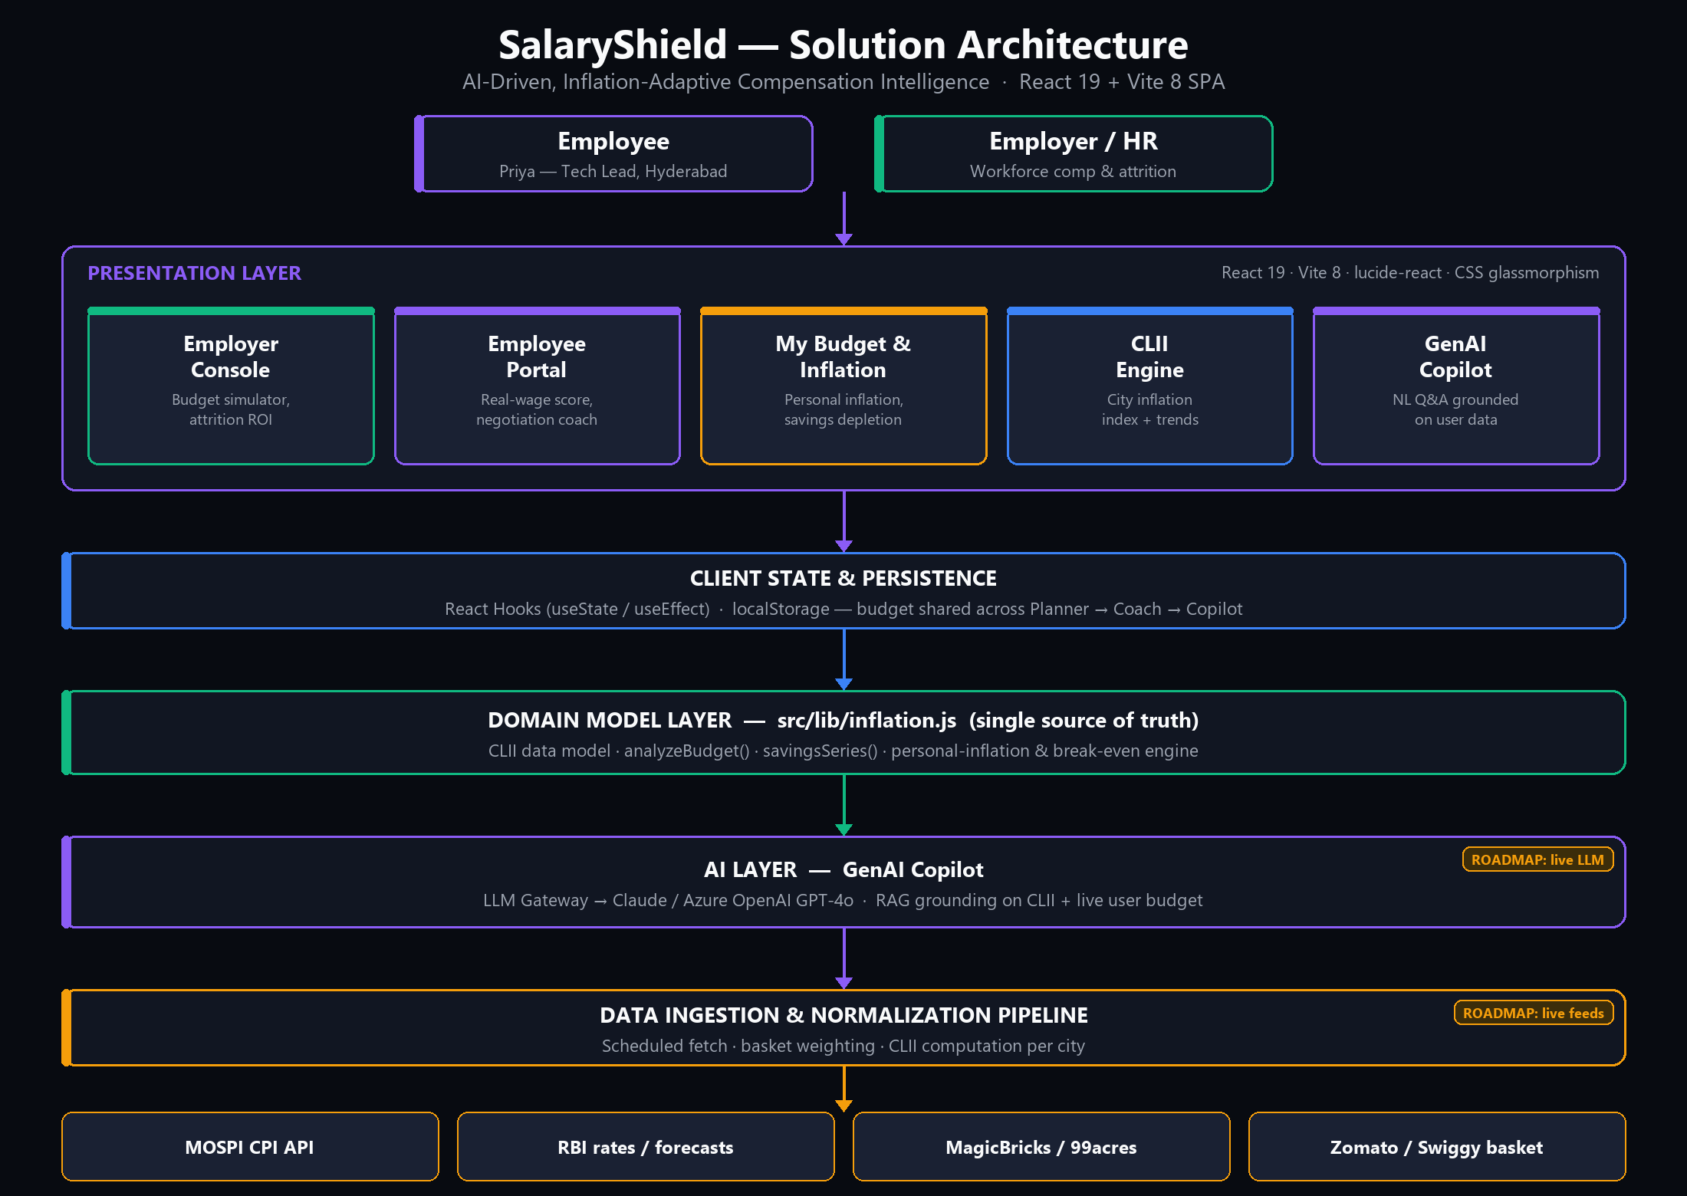
Figure 1 — SalaryShield layered architecture (roadmap items tagged).

Evaluation Against the 10 Scoring Parameters
1. Problem Definition
Nominal salary is not real income. Inflation across India's tech hubs silently erodes purchasing power, yet the national CPI under-represents how urban tech workers actually spend.
- Tech-hub inflation is high and uneven — Hyderabad 8.4%, Mumbai 9.1%, Bengaluru 7.9%, Pune 6.8%.
- National MOSPI CPI under-weights the urban tech-worker basket: IT-corridor rent, education, food delivery, commute.
- Employees cannot quantify their real-wage loss or defend a corrective hike with evidence.
- Employers lose talent to inflation lag without city-level visibility — each exit costs roughly Rs.37.5L to replace.
- Outcome: mis-priced pay, avoidable attrition, and unfair compensation across geographies.
2. Solution Architecture
A layered SPA with a single domain model shared by every module (see Figure 1).
- Presentation: five React modules — Employer Console, Employee Portal, My Budget & Inflation, CLII Engine, GenAI Copilot.
- Domain model: src/lib/inflation.js is the single source of truth — CLII data, analyzeBudget(), savingsSeries(), break-even and personal-inflation engine.
- State: React hooks + localStorage; the user's budget is shared Planner -> Coach -> Copilot.
- Roadmap boundary: the live LLM gateway and data-ingestion pipeline slot in behind the same model interface.
3. Engineering / Build Quality
The app is clean, verifiable, and production-shaped.
- React 19 + Vite 8 SPA; one component per module; CSS-variable design system (glassmorphism).
- DRY: domain logic extracted into src/lib/inflation.js and reused by three modules.
- Testable: pure, deterministic functions (analyzeBudget, savingsSeries) — unit-test-ready.
- Verified: production build passes (1,779 modules, ~80 KB gzip); oxlint clean; localStorage persistence; live in-browser checks with zero console errors.
4. AI Appropriateness
AI is applied only where it adds unique value.
- Hard numbers — inflation, break-even, ROI — stay in deterministic code for accuracy and auditability.
- The LLM handles what it is uniquely good at: reasoning over those numbers and expressing them in plain language.
- Principle: the engine computes, the AI explains — no AI-for-AI's-sake and no hallucinated math.
- The output is genuinely language-shaped: personalized advice and ready-to-send negotiation scripts.
5. AI Implementation
A grounded, consistent, demo-safe Copilot.
- Natural-language Q&A: 'Am I underpaid?', 'What is my attrition risk?'.
- RAG-style grounding: the user's live budget + CLII data are injected as context, so answers cite the user's real rupee figures rather than model priors.
- Consistency: Budget Planner, Negotiation Coach and Copilot all read the same model — one data story.
- Roadmap: LLM gateway (Claude / Azure OpenAI GPT-4o) behind a server proxy, with a deterministic fallback so the demo survives offline.
6. AI Impact
Invisible loss becomes a clear, immediate action.
- Employee: surfaces a hidden ~Rs.1.03L/yr loss and generates a copy-paste, data-backed pitch — improving raise success.
- Employer: converts attrition risk into ROI — retain a key hire and avoid ~Rs.37.5L in replacement cost.
- Insight: personalized inflation (e.g. 7.7% vs a 8.4% city average) that no generic calculator provides.
- Data becomes a decision in seconds, for both the individual and the organization.
7. Business Relevance
A large, recurring, two-sided need.
- Addressable users: 5M+ Indian IT professionals and every enterprise running India delivery centers.
- The pain is universal and recurring — it resurfaces at every appraisal cycle.
- Maps directly to top HR priorities: retention, pay equity, and compensation-budget optimization.
- Two-sided design gives both employee and employer a reason to adopt.
8. Benefits & Viability
A clear model with low cost and a real data moat.
- Revenue: freemium employee tier for acquisition; B2B SaaS (per-seat / per-audit) from employers.
- Moat: the proprietary CLII index compounds in value as coverage and history grow.
- Economics: a static SPA plus serverless LLM calls keeps infrastructure lean.
- Path: MVP is built; remaining pieces (live feeds, HRMS integration, auth) are known and incremental.
9. Working Demo
A running, interactive MVP — not slideware.
- Step 1 — Budget Planner: enter salary & expenses; see live personal inflation, a 12-month savings-depletion chart, and the break-even raise; push rent up to trigger the deficit alert.
- Step 2 — Negotiation Coach: the pitch auto-cites those exact numbers; one-click copy.
- Step 3 — GenAI Copilot: 'Am I underpaid?' answers with the same live figures.
- Resilience: a deterministic fallback means the demo never breaks, even without a network.
10. Differentiation
Not another salary calculator.
- Personal, city-level, expense-weighted inflation — not a one-size national average.
- Two-sided: employee guidance and employer workforce economics in a single product.
- AI output is an actionable artifact — a negotiation script — not just a number.
- A single, consistent data story flows across every module; the CLII index is defensible IP.

Roadmap
- Now: MVP live — CLII model, five modules, budget engine, grounded Copilot.
- Next: live data ingestion (MOSPI / RBI / rent / consumer basket) and the CLII computation pipeline.
- Next: production LLM gateway (Claude / Azure OpenAI GPT-4o) with streaming responses.
- Then: HRMS integration, authentication, multi-user, and a historical CLII data moat.

The one-line pitch: SalaryShield turns invisible inflation into a fair, data-backed pay decision — for the employee and the employer.

