Project Hancock Software Manager
Design and Planning Document
04/27/09, Version 2.0

Document Contents
Project Hancock Software Manager 1
Document Contents 2
Document Revision History 3
System Architecture 3
Design Details 8
Testing plan 10
Plan 13

Document Revision History
Rev. 1.0 2009-04-23 - initial version, template created
Rev. 1.1 2009-04-24 – added main UI UML
Rev. 1.2 2009-04-23 – data management UML
Rev. 1.3 2009-04-24 – action management UML
Rev. 1.4 2009-04-25 – logging UML
Rev. 1.5 2009-04-25 – scheduling UML
Rev. 1.6 2009-04-25 – preliminary plan
Rev. 1.7 2009-04-26 – Added subsection User Interface Requirements, File Explorer, and Error Detection to the Design Details section. Fixed footer.
Rev. 1.8 2009-04-26 – Added Starting Processes, Queuing Commands and Logs to the Design Details section.
Rev 1.9 2009-04-26 – Added Unit Testing, System Testing, and added some text to tie together System Architecture
Rev 2.0 2009-04-27 – Added Integration and Regression Testing

System Architecture
The main structure of this application is modeled after an event-based architecture with object-oriented elements. This is a natural choice because any application with a graphical user interface must handle events such as clicking, typing, and otherwise selecting elements. The object-oriented aspect arises from the general structure of the MFC framework which we are using to build the application. The MFC organizes key elements and their handlers as objects. In addition, we have various complex data types which merit their own objects, such as a file and its corresponding data.

Primary UI Elements

The main visible portions of the application work mainly through a MainFrame class which manages most MFC objects, such as the ribbon. It will be in charge of reporting to the rest of the program. The entire program is enclosed in a Core class, which will initialize the MainFrame. A UML class diagram representing the general layout is below.

To prevent the diagram from becoming cluttered, connections to other parts of the application are omitted. These connections are enumerated in the next section of this document.

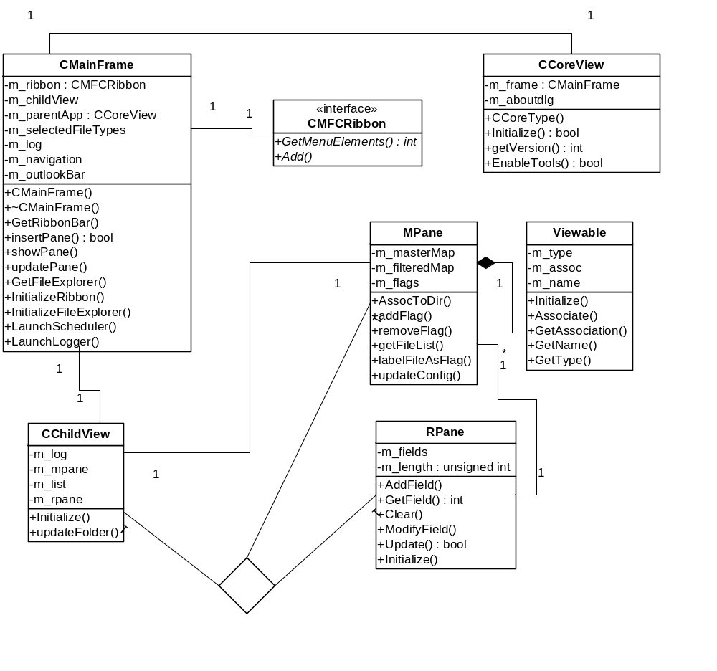

Containers of File/Directory Data

The below diagram describes how data about specific input and output data is represented within the program so that it can easily be handled by the various Action tasks.

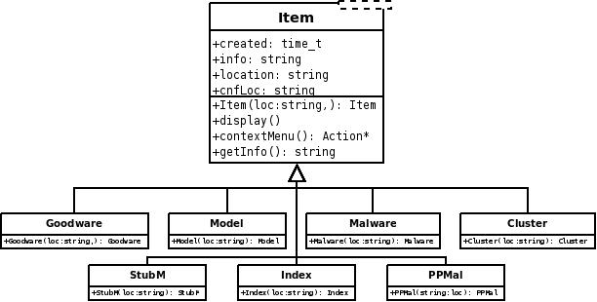

Handling of Actions on Input
The following classes describe the possible families of actions on each type of file that Symantec requests that the program handle. It will communicate with the logger to record actions and the scheduler to queue them.
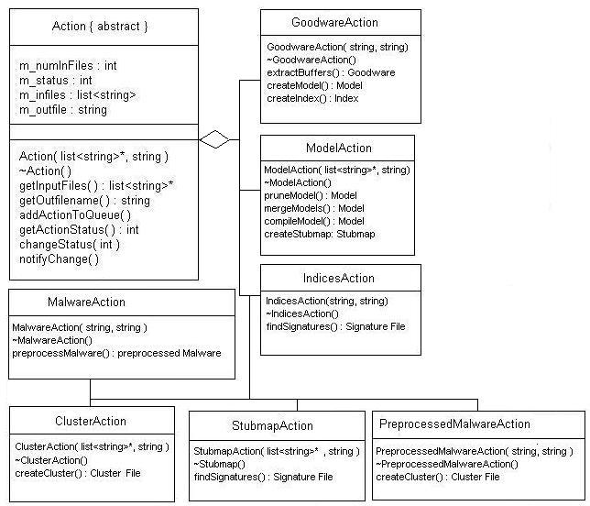

Scheduling
The scheduling classes will work with the starting of actions as well as a third-party scheduler. The Action will be provided as input as well as any configuration data. At that point, the scheduler will be asked to queue the corresponding Symantec executable.

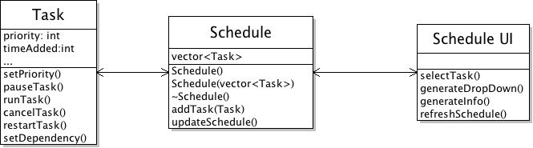

Maintaining and Viewing Logs
The Log class is primarily to record and report the logging information for the current session. It provides a straightforward interface to all of the other components of this utility. The Log UI allows for selection of certain logs, as well as a way to show or hide details.

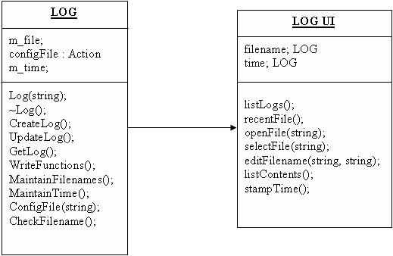

Design Details
The entire program is enclosed in the CCoreView class.
User Interface Requirements
The main window of the user interface, which consists of the ribbon at the top with tabs for different operations on file types such as Goodware, Model, Malware, Cluster, StubMap, Index, PreProcessed Malware is created in the constructor CMainFrame() of the CMainFrame class.
The ribbon, which holds the tabs and interactive buttons, is interfaced using the CMFCRibbon class. It is initialized from the InitializeRibbon() function of CMainFrame. The CMFCRibbon class uses the protocol defined by Microsoft’s MFC libraries for interaction with those classes. CMFCRibbon also interacts with CMainFrame to report events such as clicks. It is updated by UpdateRibbon().

File Explorer
The class FileExplorer is responsible for displaying the file explorer. It is initialized from CMainFrame through the function InitalizeFileExplorer().
The file explorer holds information such as the location of the current directory being explored, in m_curDirectory. It has the file browser type pane, similar to the left pane of Microsoft Outlook, in m_outlookBar. It communicates with the classes MPane and RPane which help browse through files and directories, as well as display information regarding the currently selected file.
RPane is used to store information regarding an individual file through AddField(), and ModifyField(), and retrieve stored information through GetField(). The algorithm for retrieval and storage of this information is linear: when an action is executed elsewhere in the program, it will call AddField() or ModifyField() functions of RPane directly or through another class, providing some string data, which will be stored in association with a file. RPane itself will call GetField() directly and display appropriate information regarding the currently selected file in the right panel.
MPane is used primarily to select a current working file object, for example, when a user wants to select a file through a mouse click action. It uses GetSelected() and SetSelected() to retrieve and store information on the current working file object. This information will be returned to FileExplorer or CMainFrame which can use the value as a parameter for one of the executables provided to us, through the configuration (.cfg) file. Additionally, this class uses another class, Viewable to obtain attributes such as associations though GetAssociations(), name through GetName(), and type through GetType(). The Viewable class provides the backend for the filter functionality in the file explorer, in which a user selects to view only, for example, PreProcessed Malware type files, in which the file explorer must only show that type of file. The algorithm for that functionality is as follows: CMainFrame obtains information from the CMFCRibbon object that the ‘PreProcessed Malware’ checkbox is selected, and sends this as a parameter to the ShowType() function of MPane, which will use Viewable’s GetType() functionality to display only the correct file types.
Error Detection
A click action registers an event with the CMFCRibbon object, which returns the value to CMainFrame. Through the LaunchScheduler() function, the Schedule class calls the Tasks class which will call one of the Action classes: MalwareAction, GoodwareAction, ModelAction, IndicesAction, ClusterAction, StubmapAction, or PreprocessedMalwareAction, which on completion of a certain task will perform some preliminary checks on the size of the intermediate file. If not within a certain pre-specified size, then an error is logged via the Log class, and returned to the caller, which will proceed to the next available task while the error is returned to the main user interface CMainFrame which displays it. The same is done before the action is run, as any necessary dependant files are checked for. If unavailable, the same algorithm is applied and the error is reported and logged.
Starting Processes:
The handling of actions are constructed so that they are contained in the abstract class Action, with the specific actions mentioned above. Depending on which operation is chosen, the associated action class will be called. The selected input files are given by the call to getInputFiles() an stored in m_infiles, and similarly, the name of the output file designated by the user will be retrieve through getOutfileName(). If error detection had run without incident, the process is then started through addActionToQueue() by communicating with the Task and Schedule classes. The task that was created for the process sets the priority depending on whether the user had checked “Prioritize” when prompted, and any dependencies on other processes must be computed and stored through setDependency() of the Task class. When the process has been successfully started, UpdateLog() is called from Log to record the time and action.
Queuing Commands:
The Schedule class maintains the different tasks, generated from the Task class, that are currently in the queue by listing them out in order of each tasks’ priority. From the display of the queue, the user may select a task which would call selectTask() from ScheduleUI and right-click in order to generateDropDown() to see the menu for possible operations. From the menu given, the user may request for information regarding the chosen task, which would call generateInfo() to display the additional information, or to refresh the queue display by calling refreshSchedule(). To pause the task, the user may choose “Pause” from the drop-down menu, which would call pauseTask() in the selected task and, in the same manner, cancelling the task calls cancelTask(). If the user chooses to restart the task from the menu, a call to restartTask() would make some checks to see if any intermediate files must be flushed before resetting the task and calling runTask() and UpdateLog(). The user also has the option to reorder the tasks in the queue by dragging the task before or after others. The selectTask() would then check the given task’s dependencies and, if possible, change the priority of the task through setPriority(). After the queue has been reordered, the schedule must call updateSchedule() to determine the new ordering of the tasks by priority.
The task at the head of the queue is started by the scheduler with an automated call to runTask(). This would change the status of the task through changeStatus() of the Action abstract class and any requests to see the status of the current task would return getActionStatus(). Once the process has completed, changeStatus() would set the status to complete and notifyChange() will let the scheduler now that the task has finished. This would trigger a call to UpdateLog() to record the completion of the task and any associated outputs, such as the generation of output files, as well as allow the schedule to updateSchedule() to show the new order in the queue.

Logs:
The Log class maintains the log file that is associated with the current session. Once the program has started, a new log file is created through CreateLog() using the current time as the name. When any call to UpdateLog() is made throughout the session, the class checks for the current time as well as the action taken and adds the information to the log file with WriteFunction().
When the user enters the log viewer, the LogUI class displays all available logs by calling listLogs(). If the user wishes to view a particular log file, selectFile() is called in conjunction with openFile() to display the contents of the log. The user also may want to rename a log file, where editFilename() would be called with the new filename passed as a parameter after the user is prompted.

Testing plan
Unit Testing
For each class, along with the individual class, there will be a class designed to send sample input and receive sample output. This will likely be built around a framework that could be considered a C++ version of JUnit. That way, we can set up a simple program to read in and pass a variety of data and be sure that the output is correct. We can even link it to a GUI and visually analyze the test results. Each unit test will complete after each class implementation is complete. Thus, this will encompass much of our initial work.
For the UI components, we will build a command line interface along with the GUI so that we can write scripts and check outputs with limited need for human testing. Initially, we will not test portions designed to communicate with other components. This will be handled in depth in the integration and system phases. To test the GUI, we will build nonworking versions that spawn simple MessageBox dialogs reporting back that individual clicks will start the intended functions. This will also make integration testing easier since we can ensure that our user interfaces are correct before connecting them to actual components.
Integration Testing
We want to test heavily the interfaces between the different classes, due to the need in our program of many different partitions (i.e., the explorer, scheduler, ribbon interface) interacting with each other and providing each other with key parameters and information. It will be feasible to provide input to one class, and retrieve the perceived input from other classes that are directly and indirectly communicating to the class being tested. In the command line interface (CLI) we will add a verbose option which will write to an output file each of the member functions called, or relevant member functions called. For example, the dependencies between the FileExplorer class, MPane, RPane and Viewables is strong, so we will test when an action is performed in FileExplorer, whether the other classes see the input correctly. This can be accomplished as follows: there will be a text input file which will call all the functions in FileExplorer when used as an input to a CLI option. We will have another file which will hold information on which member functions of MPane, RPane, etc should be called. The functions that are actually called will be logged by the CLI into a secondary output file. Simply comparing the human written output file to the one generated by the CLI will reveal whether the classes are performing correctly in relation to other classes. We will perform analogous actions in the Ribbon Interface, the Log and the Schedule classes.
System Testing
The primary form of system testing that can occur is having a small set of goodware and malware input files and have the program, initially though the command line interface, queue and call the appropriate executables to finally generate some candidate signatures. At that point, we can compare the output data with that from a run of Symantec executables that did not use our tool. Because these initial tests will be though the CLI, we can write scripts in any scripting-capable language (e.g. Python) and simply run diff commands to compare output.
Unfortunately, because this program uses a GUI, there must be some human testing involved, as well. However, once the CLI is confirmed to work as expected, we simply must check that clicking and otherwise selecting the UI elements spawns the same dialogs and passes the same data onto other components as the CLI. Thus, these tests will ideally be limited and not take up a large amount of available human time.

Regression Testing
In this aspect of testing, we need to check whether a previously working functionality of the program has stopped working or is malfunctioning due to a new addition in the code. In order to accomplish this we use Google Code’s defect tracking functionality. When a major functionality is added or a milestone is reached, we will perform many of the tests described above, especially automated unit testing through the usage of a CLI. Simple batch files or scripts in python or AutoHotKey scripting languages can perform fully automated tests which will be run at these intervals. When a bug is caught in this manner, it will be assigned to a programmer who will fix it. The fix will be verified by repeating the previously failed test, at which time, the code repository will be updated or regressed.

Plan
ID | Name | Duration | Start | Finish | Predecessors | Assigned To
1 | Finish Design | 4 days | 4/22/09 | 4/27/09 |  | All
2 | Research Schedulers | 10 days | 4/28/09 | 5/9/09 |  | Prabhu, Michael, Kanak
3 | Create Non-Working Ribbon | 5 days | 4/30/09 | 5/6/09 |  | Kanak
4 | Create Log Internals | 5 days | 4/30/09 | 5/6/09 |  | Humera, Mary
5 | Log CLI | 2 days | 5/7/09 | 5/8/09 | 4 | Humera, Mary
6 | Implement MPane Internals | 6 days | 5/4/09 | 5/9/09 |  | Danial, Michael
7 | Ribbon CLI | 2 days | 5/11/09 | 5/12/09 | 6 | Sargis, Prabhu
8 | MPane UI (working) | 4 days | 5/18/09 | 5/21/09 | 7 | Sargis, Kanak
9 | CFG File Interpreter | 5 days | 5/7/09 | 5/12/09 |  | Danial, Mary
10 | File Interpreter | 4 days | 5/7/09 | 5/11/09 |  | Prabhu, Humera
11 | File CLI | 2 days | 5/18/09 | 5/19/09 | 10 | Prabhu
12 | Nonworking Action UI (Dialog) | 5 days | 5/9/09 | 5/14/09 |  | Kanak, Michael
13 | Nonworking Log UI (Dialog) | 5 days | 5/11/09 | 5/15/09 | 2 | Sargis, Danial
14 | File Type Classes | 4 days | 5/13/09 | 5/18/09 |  | Mary
15 | Create Actions | 3 days | 5/19/09 | 5/21/09 | 14 | Prabhu, Sargis
16 | Merge Actions with UI | 2 days | 5/22/09 | 5/25/09 | 12,15 | Prabhu, Michael
17 | Scheduling Classes | 4 days | 5/12/09 | 5/15/09 |  | Humera
18 | Scheduling CLI | 2 days | 5/18/09 | 5/19/09 | 17 | Danial
19 | Nonworking Schedule UI | 3 days | 5/13/09 | 5/17/09 |  | Kanak, Prabhu
20 | Merge Schedule with UI | 2 days | 5/18/09 | 5/19/09 | 17,19 | Mary
21 | Implement RPane | 3 days | 5/21/09 | 5/25/09 | 6 | Michael, Danial
22 | Ribbon Communication | 4 days | 5/26/09 | 5/29/09 | 3,6,21,20,16,12,13 | Kanak, Prabhu

