Project Hancock Software Manager
Requirements and Specification Document
05/27/09, Version 2.4
This is Windows software designed to be used as a Symantec internal tool. It is used to help developers manage various tasks on large sets of input, intermediate, and output files. These include, but are not limited to: exploring directories and identifying files, queuing commands to run, scheduling sessions, error detection analysis, and running processes.

This is a project run by UCLA's CS 130 Spring 09 Group 6.

Contributors to this project are Kanak Biscuitwala, Prabhu Eswaran, Humera Moulvi, Sargis Panosyan, Mary Qi, Danial Sajed, Michael Wilson

Document Contents
Project Hancock Software Manager 1
Document Contents 2
Document Revision History 3
Introduction 3
Customer 4
Competitive Landscape 4
User Requirements 4
Use Cases 6
User Interface Requirements 15
Security Requirements 18
System Requirements 18
Specification 18

Document Revision History
Rev. 1.0 2009-04-14 – initial version, template created
Rev. 1.1 2009-04-16 – added Customer, User Requirements, Security Requirements, System Requirements, and Competitive Landscape
Rev. 1.2 2009-04-18 – added specification of File Manager and Logging
Rev. 1.3 2009-04-19 – added specification of queuing management and starting of processes
Rev. 1.4 2009-04-19 – added User Interface Requirements
Rev. 1.5 2009-04-19 – added Use Cases without UML
Rev. 1.6 2009-04-19 – added UML use case diagrams
Rev. 1.7 2009-04-19 – updated Competitive Landscape, added error detection under Specification, updated faulty table of contents format
Rev. 2.0 2009-04-19 – submission candidate
Rev. 2.1 2009-04-23 – Editing Requirements section based on feedback
Rev. 2.2 2009-05-09 – Modifying Queuing and Adding Tasks specification
Rev 2.3 2009-05-10 – Modifying Use Cases

Rev 2.4 2009-05-27 – Updating the document to reflect recent decisions

Introduction
The Project Hancock Software Manager is designed to be an internal tool for Symantec Corporation to manage the various operations that are involved in generating anti-virus signatures. Many of the executables involved are highly-system intensive and have relatively complicated interfaces and require many human-initiated steps to start. This program will attempt to eliminate as many as possible.
In addition, there are several files types involved in this project and another goal of this program is to display details about those files and folders in an easily accessible and useful manner.

Customer
This software is designed for internal use at Symantec Corporation. Scott Schneider is acting as a liaison from Symantec to the project team, and will inform it of all requirements, deadlines etc.

Competitive Landscape
This software is specifically tailored for internal usage at Symantec Corporation. It has a very specific set of requirements based on the needs of the customer, and thus, there are virtually no competitors from external companies. That said, there exists mainly two different approaches to solve the problem which our program addresses. One is to request from an external company to create custom tailored software, such as is being done in this project. The other is to use macro creating software such as AutoHotKey, AutoIt, or JitBit Macro Recorder to accomplish a certain set of tasks sequentially. The second approach is far inferior to the first, in that it will not be nearly visually equivalent to the first without a large amount of work, and will lack key functionality our program provides, such as the scheduler, explorer, etc. Thus, there is little or no competition. There may be other tools developed within Symantec for similar tasks which could qualify as competitive software, but these software will be used along side each other rather than compete with one another.

User Requirements
Project Hancock at Symantec is responsible for generating candidate signatures for their security software. There are large numbers of input, intermediate, and output files involved in testing these signatures, as well as several executables that can operate on them. This can get quite cumbersome, so that is why the Project Hancock Software Manager was suggested. The project is responsible for several key tasks that make managing operations easier for a Symantec engineer. Below are the key requirements:

- The program should keep an internal data store that it can save and load. It should keep some type of log of every action that the program takes from execution to close. The significant information should also be reported through the UI.
- The program should have some type of file manager that can browse directories and allow goodware and malware files and whole directories to be selected. Once selected, any critical data about the file/directory should be reported. This includes files that a model has been trained on, any executables run on the file/directory, and any pending or running tasks on the file/directory.
- There should be some notion of queuing tasks on the files/directories. This involves determining which tasks can be run in parallel and which depend on others. Often, executables take the output of one executable as its input. Also, it should take into account the CPU and memory limitations of the system. Scott suggests we look for an open source scheduler to help handle this.
- After an executable finishes its processing, some error detection must be done. This involves checking log files for any flags suggesting errors.
- Finally, this program should be able to run and stop Symantec’s executables. We should be able to generate configuration files for each executable allowing for specification of major properties through the UI and user specification of non-default flags within the file. Then, the program should recognize these parameters and start the specified task.
- Viewing files and directories of a certain type should be handled by some form of filter that will display only checked types.
- We should be able to specify certain files or directories as representative of a certain file type.
Though we do not have a concrete list of executables from Symantec to date, there are some confirmed tasks.
- Good software
  - Extract buffers
  - Create index
  - Create a Markov model
- Markov Models
  - Prune a model
  - Merge two models
  - Compile a model
  - Create a Stub Map (needs a model and a clustering)
- Indeces
  - Find signatures (needs a stub map, clustering and index)
- Malware
  - Preprocess it – Unpack and disassemble the malware file
- Preprocessed Malware
  - “Cluster run” – determine the family that the malware belongs to
- Clustering
  - Create a stub map based on the results preprocessing and clustering
    - A stub map is a list of candidate signatures; also requires a model
- Stub Map
  - Find individual signatures in a stub map and output them (needs a stub map, clustering, and index)
    - Text, Excel, and Binaries are acceptable output mediums
- Find Signatures Output
  - Know they exist and be able to open them

Use Cases
UML Diagrams
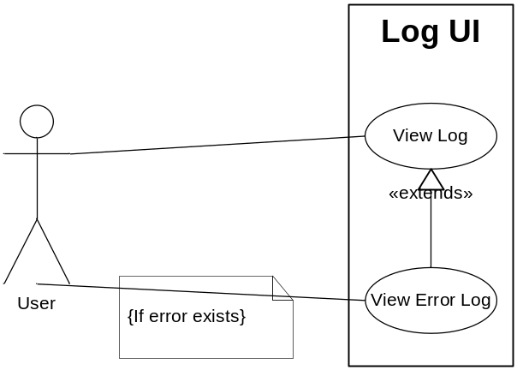

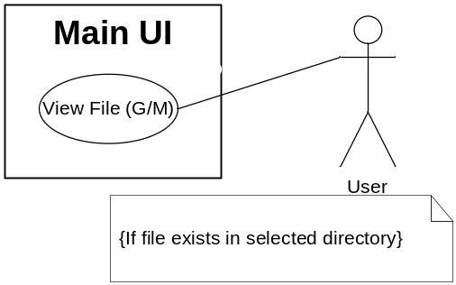
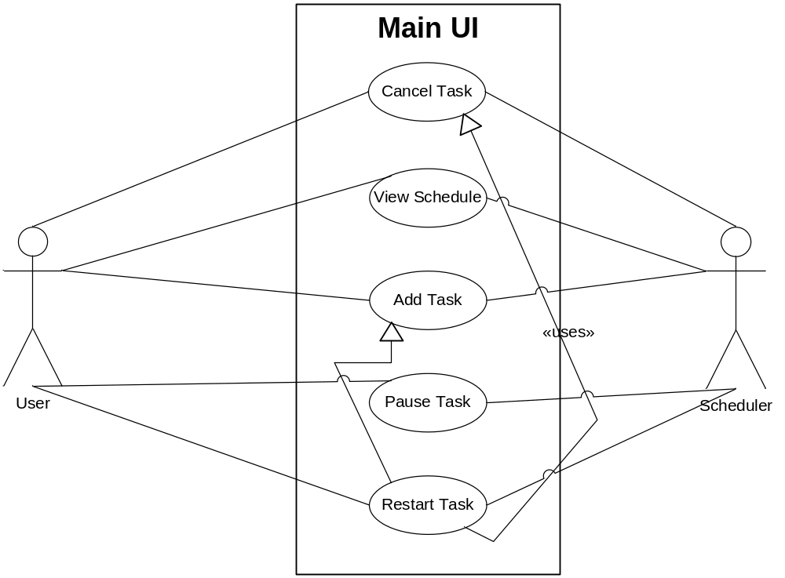

Description of Use Cases

Use Case: View Log (Must-have)

Version: 1.1 (05/10/09)

Goal: To allow the user to view the log file of any session of the program.

Summary:

The internal data store of the program will be automatically started once the session has begun and will continue to keep a log file of all actions taken in the session until the program is closed. This aspect isn't controlled by the user. However the user may choose to view the log file at any time by choosing to show the current session's log, or a previous log file, through the tools menu, which will result in a new window displaying all available logs and the contents of a chosen log file.

Actors: The user.

Preconditions: The user must be in the tools menu.

Triggers: Clicking on the show logs option in the menu.

Basic course of events:

1. The user clicks on show log.

2. The program opens a new window with a file browser and a blank panel.

3. The user clicks on the log file in the file browser of the new window.

4. The program displays the contents of the log file in the right panel.

Use Case: View Error Log (Stretch)

Version: 1.1 (05/10/09)

Goal: To allow the user to view errors in the log file of any session of the program.

Summary:

Inside the view log window, there is a tab that allows the user to only view errors that occurred in the selected log file. The content that is displayed is a filtered version of the log file only containing errors.

Actors: The user.

Preconditions: The program must have the view log window open.

Triggers: Clicking on the show logs option in the menu.

Basic course of events:

1. The user clicks on the view errors tab within the view log window.

2. The program displays the filtered results of the selected log file in the right panel.

Use Case: View File (Must-have)

Version: 1.1 (05/10/09)

Goal: To allow the user to view specific information regarding modules in different directories.

Summary:

The file browser is visible at all times in the program and displays the directories and the different modules that are contained in them. Which types of files are displayed is selected through a row of checkboxes on the ribbon. The user may choose directories to display their contents, which is selective in the types of files that are shown. The user may click on the different files to show details regarding the file on a panel to the right of the file browser. This panel will contain specific information, such as the date of creation, modification, the executables that were run on the model and the associated dates, as well as which family the model may belong to.

Actors: The user.

Preconditions: The user must check the correct type of file to be displayed and there must be an available file.

Triggers: Clicking on a file in the file browser.

Basic course of events:

1. The user clicks on a directory in the file browser (if not the current directory).

2. The user clicks on a file in the directory that he wishes to see details for.

3. The program displays file information in the panel to the right of the file browser.

Use Case: View Schedule (Must-have)

Version: 1.1 (05/10/09)

Goal: To allow the user to view all the tasks currently in the queue that are scheduled to run.

Summary:

The program's scheduler will keep track of all the tasks that the user chooses to run in a queue. This queue is displayed to the user in a separate window; where right-clicking each task gives the options of deleting the task from the queue, pausing the task, or prioritizing through rearrangement of the queue order. All other components of the scheduler are hidden from the user.

Actors: The user, the scheduler (internal).

Preconditions: The user must be in the tools menu.

Triggers: Clicking on the show schedule option in the menu.

Basic Course of Events:

1. The user clicks on show schedule.

2. The program opens a new window that contains the queued tasks in list form.

Use Case: Add Task to Queue (Goodware - Create Model) (Must-have)

Version: 1.1 (05/10/09)

Goal: To allow the user to add the task of creating a goodware model into the queue.

Summary:

In order to add the task of creating a model to the queue, the user would indicate the desired file and then click on the create a model executable button. The task will then be sent to the queue, where the scheduler attempts to optimize the ordering of the queue. The user may choose to manually run an executable at the moment, disregarding the queue, by choosing to prioritize the task over the waiting tasks.

Actors: The user, the scheduler (internal).

Preconditions: An allowable name for the output model must be given and there are sufficient resources.

Triggers: Clicking on the create a model button in the ribbon.

Basic Course of Events:

1. The user clicks on the create a model button in the tab.

2. The program prompts for options regarding the execution on the file and output model name.

3. The user chooses the desired options.

4. The program accepts the options and creates a config file for the model.

5. If the user chose to prioritize, the program runs creates a model with the given config file, if possible.

6. Else, the program adds the task to the queue.

7. The program logs the activity.

8. The program allows the scheduler to try to optimize the order.

Use Case: Add Task to Queue (Models - Prune Model) (Must-have)

Version: 1.1 (05/10/09)

Goal: To allow the user to add the task of pruning a model into the queue.

Summary:

Similar to the use case of creating a model, the user would indicate the desired file and then click on the prune model executable button on the ribbon. The task will then be sent to the queue, where the scheduler attempts to optimize the ordering of the queue. The user may choose to manually run an executable at the moment, disregarding the queue, by choosing to prioritize the task over the waiting tasks.

Actors: The user, the scheduler (internal).

Preconditions: A valid model must be selected.

Triggers: Clicking on the prune model button in the ribbon.

Basic Course of Events:

1. The user selects a model from the file browser.

2. The user clicks on the prune model button in the tab.

3. The program prompts for options regarding the execution on the file.

4. The user chooses the desired options.

5. The program accepts the options and creates a config file for the model.

6. If the user chose to prioritize, the program runs prune model with the given config file, if possible.

7. Else, the program adds the task to the queue.

8. The program logs the activity.

9. The program allows the scheduler to try to optimize the order.

Use Case: Add Task to Queue (Models - Merge Models) (Must-have)

Version: 1.1 (05/10/09)

Goal: To allow the user to add the task of merging two models into the queue.

Summary:

The user would indicate the two desired files to be merged and then click on the merge models executable button. The task will then be sent to the queue, where the scheduler attempts to optimize the ordering of the queue. The user may choose to manually run an executable at the moment, disregarding the queue, by choosing to prioritize the task over the waiting tasks.

Actors: The user, the scheduler (internal).

Preconditions: Two valid models must be selected.

Triggers: Clicking on the merge models button in the ribbon.

Basic Course of Events:

1. The user selects two models from the file browser.

2. The user clicks on the merge model button.

3. The program prompts for options regarding the execution on the file, including the new name.

4. The user chooses the desired options.

5. The program accepts the options and creates a config file for the model.

6. If the user chose to prioritize, the program runs merge models with the given config file, if possible.

7. Else, the program adds the task to the queue.

8. The program logs the activity.

9. The program allows the scheduler to try to optimize the order.

Use Case: Add Task to Queue (Models - Compile Model) (Must-have)

Version: 1.0 (05/10/09)

Goal: To allow the user to add the task of compiling models into the queue.

Summary:

The user would indicate the desired model to be compiled and then click on the compile model executable button. The task will then be sent to the queue, where the scheduler attempts to optimize the ordering of the queue. The user may choose to manually run an executable at the moment, disregarding the queue, by choosing to prioritize the task over the waiting tasks.

Actors: The user, the scheduler (internal).

Preconditions: A valid model must be selected.

Triggers: Clicking on the compile model button in the ribbon.

Basic Course of Events:

1. The user selects a model from the file browser.

2. The user clicks on the compile model button.

3. The program prompts for options regarding the execution on the file, including the output model name.

4. The user chooses the desired options.

5. The program accepts the options and creates a config file for the model.

6. If the user chose to prioritize, the program runs merge models with the given config file, if possible.

7. Else, the program adds the task to the queue.

8. The program logs the activity.

9. The program allows the scheduler to try to optimize the order.

Use Case: Add Task to Queue (Goodware - Create String Lookup Table) (Must-have)

Version: 1.1 (05/10/09)

Goal: To allow the user to add the task of creating a string lookup table to the queue.

Summary:

The user would indicate the desired file to and then click on the create string lookup table executable button. The task will then be sent to the queue, where the scheduler attempts to optimize the ordering of the queue. The user may choose to manually run an executable at the moment, disregarding the queue, by choosing to prioritize the task over the waiting tasks.

Actors: The user, the scheduler (internal).

Preconditions: A valid goodware file must be selected.

Triggers: Clicking on the create string lookup table button in the ribbon.

Basic Course of Events:

1. The user selects a goodware model from the file browser.

2. The user clicks on the create string lookup table button in the tab.

3. The program prompts for options regarding the execution on the file, including new file name for the output index.

4. The user chooses the desired options.

5. The program accepts the options and creates a config file for the model.

6. If the user chose to prioritize, the program runs create string lookup table with the given config file, if possible.

7. Else, the program adds the task to the queue.

8. The program logs the activity.

9. The program allows the scheduler to try to optimize the order.

Use Case: Add Task to Queue (Goodware - Extract Buffers) (Must-have)

Version: 1.1 (05/10/09)

Goal: To allow the user to add the task of extracting file parts of a goodware model into the queue.

Summary:

The user would indicate the desired file to be the source of extraction and then click on the extract file parts executable button. The task will then be sent to the queue, where the scheduler attempts to optimize the ordering of the queue. The user may choose to manually run an executable at the moment, disregarding the queue, by choosing to prioritize the task over the waiting tasks.

Actors: The user, the scheduler (internal).

Preconditions: A valid goodware file must be selected.

Triggers: Clicking on the extract file parts button in the ribbon.

Basic Course of Events:

1. The user selects a goodware model from the file browser.

2. The user clicks on the extract file parts button in the tab.

3. The program prompts for options regarding the execution on the file, including the output name.

4. The user chooses the desired options.

5. The program accepts the options and creates a config file for the model.

6. If the user chose to prioritize, the program runs extract file parts with the given config file, if possible.

7. Else, the program adds the task to the queue.

8. The program logs the activity.

9. The program allows the scheduler to try to optimize the order.

Use Case: Add Task to Queue (Malware - Preprocess) (Must-have)

Version:

1.1 (05/10/09)

Goal: To allow the user to add the task of preprocessing a malware model into the queue.

Summary:

The user would indicate the desired file to be preprocessed and then click on the preprocess executable button. The task will then be sent to the queue, where the scheduler attempts to optimize the ordering of the queue. The user may choose to manually run an executable at the moment, disregarding the queue, by choosing to prioritize the task over the waiting tasks.

Actors: The user, the scheduler (internal).

Preconditions: A valid malware file must be selected.

Triggers: Clicking on the preprocess button in the ribbon.

Basic Course of Events:

1. The user selects a malware model from the file browser.

2. The user clicks on the preprocess button.

3. The program prompts for options regarding the execution on the file, including the name of the processed output.

4. The user chooses the desired options.

5. The program accepts the options and creates a config file for the model.

6. If the user chose to prioritize, the program runs preprocess with the given config file, if possible.

7. Else, the program adds the task to the queue.

8. The program logs the activity.

9. The program allows the scheduler to try to optimize the order.

Use Case: Add Task to Queue (Preprocessed Malware – Cluster Files) (Must-have)

Version: 1.1 (05/10/09)

Goal: To allow the user to add the task of clustering preprocessed malware models into the queue.

Summary:

The user would indicate the desired files to cluster and then click on the cluster files button. The task will then be sent to the queue, where the scheduler attempts to optimize the ordering of the queue. The user may choose to manually run an executable at the moment, disregarding the queue, by choosing to prioritize the task over the waiting tasks.

Actors: The user, the scheduler (internal).

Preconditions: Valid malware files must be selected.

Triggers: Clicking on the cluster files button in the ribbon.

Basic Course of Events:

1. The user selects preprocessed malware models from the file browser.

2. The user clicks on the cluster files button in the tab.

3. The program prompts for options regarding the execution on the file, including the output cluster.

4. The user chooses the desired options.

5. The program accepts the options and creates a config file for the model.

6. If the user chose to prioritize, the program runs determine family with the given config file, if possible.

7. Else, the program adds the task to the queue.

8. The program logs the activity.

9. The program allows the scheduler to try to optimize the order.

Use Case: Add Task to Queue (Models/Clusters - Create Stub Map) (Must-have)

Version: 1.1 (05/10/09)

Goal: To allow the user to add the task of creating a stub map into the queue.

Summary:

The user would indicate the desired file to create a stub map for and then click on the create stub map executable button. The task will then be sent to the queue, where the scheduler attempts to optimize the ordering of the queue. The user may choose to manually run an executable at the moment, disregarding the queue, by choosing to prioritize the task over the waiting tasks.

Actors: The user, the scheduler (internal).

Preconditions: A valid model and cluster file must be selected.

Triggers: Clicking on the create stub map button in the ribbon.

Basic Course of Events:

1. The user selects a cluster and model from the file browser.

2. The user clicks on the create stub map button in the tab.

3. The program prompts for options regarding the execution on the file, including the destination of the results.

4. The user chooses the desired options.

5. The program accepts the options and creates a config file for the model.

6. If the user chose to prioritize, the program runs create stub map with the given config file, if possible.

7. Else, the program adds the task to the queue.

8. The program logs the activity.

9. The program allows the scheduler to try to optimize the order.

Use Case: Add Task to Queue (Indices/Stub Maps - Find Signatures) (Must-have)

Version: 1.1 (05/10/09)

Goal: To allow the user to add the task of finding signatures and specifying the type of output file to save them in and adds this task to the queue.

Examples of allowed output types are: Text, Excel, or Binary file formats. The user can also specify the name of the output file.

Summary:

The user would indicate the desired stub map, cluster and index to search for a signature which will be specified by the user. The user will also be able to select the output type and name of the file which the output will be saved to. The task will then be sent to the queue, where the scheduler attempts to optimize the ordering of the queue. The user may choose to manually run an executable at the moment, disregarding the queue, by choosing to prioritize the task over the waiting tasks.

Actors: The user, the scheduler (internal).

Preconditions: A valid stub map, cluster and index file must be selected.

Triggers: Clicking on the create stub map button in the ribbon.

Basic Course of Events:

1. The user selects a stub map, cluster and index from the file browser.

2. The user clicks on the find signatures button.

3. The program prompts for options regarding the execution on the file, including the destination of the results; name and type of the output file.

4. The user chooses the desired options.

5. The program accepts the options and creates a config file for the task.

6. If the user chose to prioritize, the program runs find signatures with the given config file, if possible.

7. Else, the program adds the task to the queue.

8. The program logs the activity.

9. The program allows the scheduler to try to optimize the order.

Use Case: Pause Task in Queue (Stretch)

Version: 1.0 (04/16/09)

Goal: To allow the user to pause a task currently in the queue.

Summary:

The user right-clicks on a task in the show schedule window, there the option to pause the task is given. By clicking on pause, it would either pause the task if it is currently running or temporarily hold the task so that it does not begin if the task isn't currently running but is scheduled to do so.

Actors: The user.

Preconditions: The user must have the show schedule window open and a valid task must be selected.

Triggers: Clicking on pause after right-clicking a task in the show schedule window.

Basic Course of Events:

1. The user right-clicks a task in the show schedule window.

2. The user clicks on pause.

3. If the task is currently running, the program places the task on pause.

4. Else, the program places the task on hold in the queue.

5. The program logs the activity.

Use Case: Cancel Task in Queue (Must-have)

Version: 1.0 (04/16/09)

Goal: To allow the user to cancel a task currently in the queue.

Summary:

The user right-clicks on a task in the show schedule window, there the option to cancel the task is given. By clicking on cancel, it immediately end the task if it is currently running or remove it from the queue if it is scheduled to run.

Actors: The user.

Preconditions: The user must have the show schedule window open and a valid task must be selected.

Triggers: Clicking on pause after right-clicking a task in the show schedule window.

Basic Course of Events:

1. The user right-clicks a task in the show schedule window.

2. The user clicks on cancel.

3. If the task is currently running, the program ends the task.

4. Else, the program places takes the task out of the queue.

5. The program logs the activity.

Use Case: Restart Task in Queue (Stretch)

Version: 1.0 (04/16/09)

Goal: To allow the user to restart a task currently in the queue.

Summary:

The user right-clicks on a task in the show schedule window, there the option to restart the task is given. By clicking on restart, it immediately ends the task if it is currently running and restarts it. If the task selected is not currently running, nothing happens.

Actors: The user.

Preconditions: The user must have the show schedule window open and a valid task must be selected.

Triggers: Clicking on pause after right-clicking a task in the show schedule window.

Basic Course of Events:

1. The user right-clicks a task in the show schedule window.

2. The user clicks on restart.

3. If the task is currently running, the program ends the task and restarts it.

4. If successful, the program logs the activity.

User Interface Requirements
The main window of the User Interface consists of a Ribbon toolbar at the top, and a file browser in the lower portion. The goal of this interface is to be able to easily select files on the computer and view information related to the file.

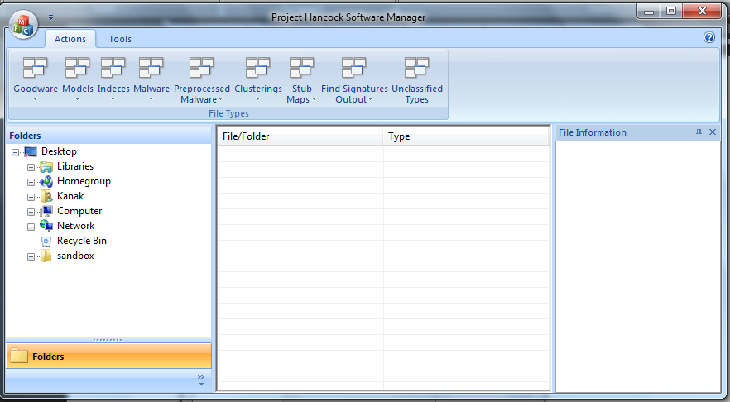
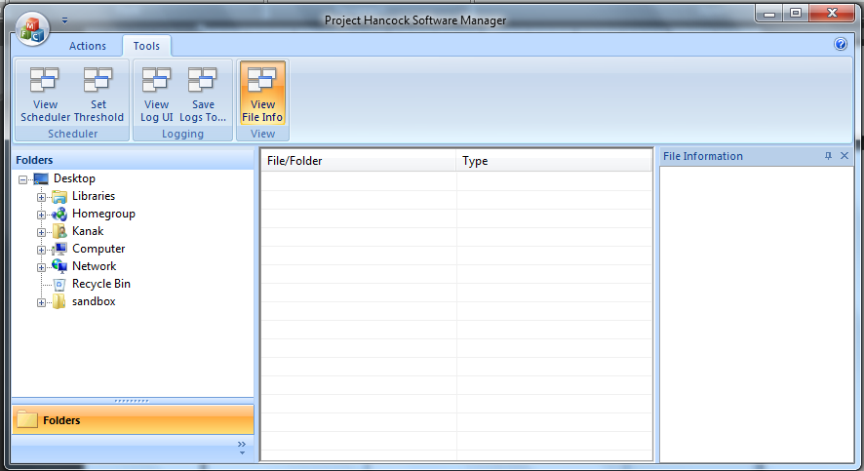
The ribbon has two main tabs: File Types and Tools. In the File Types tab, there are buttons that are capable of causing operations to be performed on the files and directories through submenus for each file type. It is also possible to label a selected file or folder in the file browser as a certain type from the ribbon. Clicking on a button causes a new window to pop up, and the user can input options related to the operation. Each operation is added to a queue, and so the user can specify priority, dependencies on other operations, and whether the task should run immediately. The goal of the button/popup window interface is to easily add tasks to the queue.
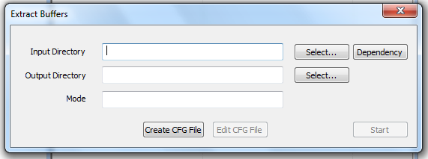
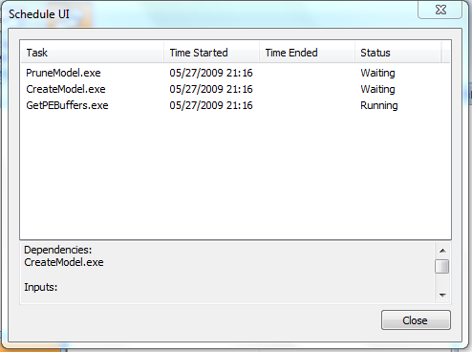
The schedule can be accessed from the Tools tab in the ribbon, and it pops up in a new window. From the schedule window, the user may access the information related to each task, change the priority of the task and/or edit the configurations of the task.
Finally, there is a log viewer, which should allow the user to view the log files for this application. The Tools menu will also allow for specifying a new directory to save files and this user interface will display logs from the currently associated directory.
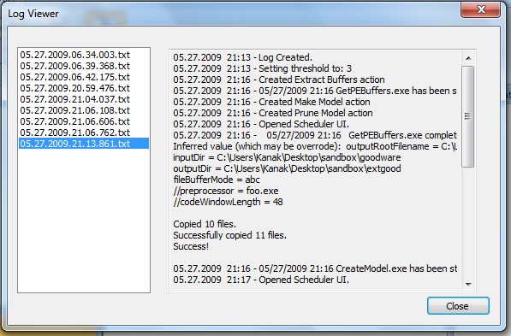

Security Requirements
In terms of the security of the actual application, requirements are limited. The program should run robustly, but since it is an internal tool with no planned features involving internet access, there are not a large amount of security concerns present. Probably the only point of concern is that this program will work closely with samples of malware, but the tool we are creating will not touch the actual malware files themselves. Also, it is to our benefit that there is not any malware targeted at our application and there likely never will be because it is not designed to leave Symantec facilities.

This does not mean we should not use good programming practices and common sense, however. Anything that could easily be classified as a potential vulnerability, like a buffer susceptible to overflow attacks, should not be ignored. Certainly, if this program is expanded upon in the future, this foundational application should not contain weak links.

A somewhat unrelated aspect to security is how we would manage internal Symantec materials. We cannot put confidential documents or executables on a publicly accessible server due to the nature of non-disclosure agreements. This means keeping this information offline or behind a password-protected server.

System Requirements
This application, based on the user requirements, is intended to be run on Windows. This likely means that Symantec’s machines will need Visual Studio redistributable packages in order to execute our code correctly while running Windows XP or newer. In addition, because this program will need to interface with a scheduler, it is possible that this scheduler could be one of the pre-installed applications on the client machine.

Because this product’s main function is that of a software and file manager, it is useless without Symantec’s executables and test files. For each of the tests that this program is designed to start and queue, there needs to be the corresponding Symantec executable along with the appropriate goodware or malware files to be used as its input.

As for the hardware requirements for this tool, they vary based on the executables that Symantec would like to attach to it. The tool itself is not CPU or memory-intensive and likely will not use a large amount of hard disk space, so any modern machine that is capable of running Windows will not have any issues using this application. However, a supercomputer is required to run Symantec’s executables on their typical input file sizes. This computer would have multiple cores, multiple processors, and as much as 128 gigabytes of RAM.

Specification
File Explorer
The file explorer will have a windows explorer style folder view in a pane on the left side where the user can expand and collapse folders. When the user opens a folder, its relevant contents will be displayed in the middle pane in list form. The middle pane will display only the file types that are depressed in the ribbon at the top of the window. Multiple types may be selected. In addition, if the 'unclassified types’ button is depressed, files that have not been assigned to a file type will be displayed.
When a file is clicked on, it will be highlighted, and a separate pane on the far right will display certain properties of the file. These will include but are not limited to: date of creation, types of files/malware it pertains to, a list of actions performed on the file or to create the file (if it is the result of a merger). If no file is selected the pane will remain empty.
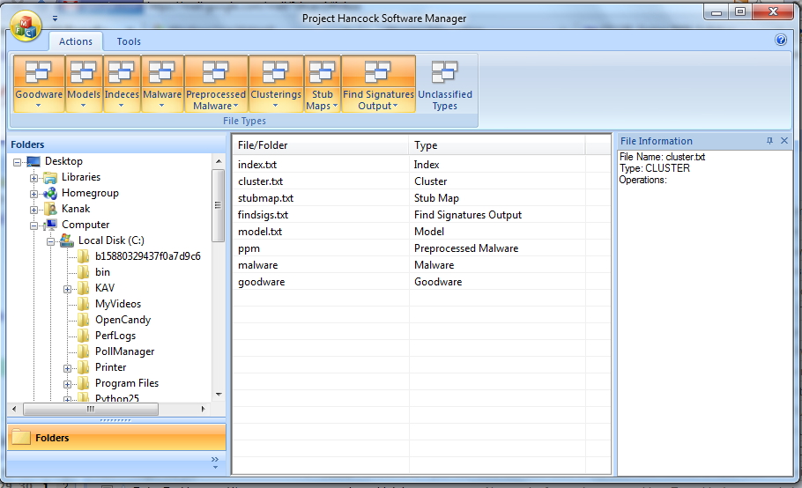
Logs
Upon click, the log window will appear. On a pane on the left there will be a complete list of logs from each session labeled. The most recent one will be open by default in the right pane. Each plain text log file will consist of every action performed during each execution session. The right pane by default will only show actions performed, errors and the files with which they are associated, but none of the other attributes. There will be a button that will allow the user to view the complete contents of the log file which will contain any details regarding operations and errors.
The log files are plaintext and contain timestamps for each task. Unless the option is enabled to view all data, the UI will only contain a subset of this file. For more details about the UI, see the mockup in “User Interface Requirements”.

Queuing Commands

This section describes how user input would affect how this program schedules tasks to be run. Most of the work will likely be done by an open-source scheduler, but the general workflow is required in order to build a working interface between this program and our own.

- This part of the project handles the scheduling. The tasks run on the manager have optimal ordering.
- The manager is given a task and we prompt if the input for the current task requires output from an incomplete task.
- The various action UIs will query the scheduler to determine if an action can be run immediately
  - This means that the action does not have active dependencies and the simultaneous number of actions must be below a specified threshold
  - The scheduling UI is updated accordingly (see notes on this UI below)
  - Configuration data contains number of processors and memory limits
    - Parse this data and pass it on to the scheduler
  - Scheduler reports running, started, and completed tasks, which we note and update the UI
- Scheduler ( diagram below)
  - Click on Schedule Tab➔ right click on selected file ➔ choose operation

Scheduling
Select file
Run
Cancel
Pause
Restart
Set Priority
Set Dependency

Right-click

- Queuing (diagram below)
Selected File Types
Selected Operation
Save File
Add to Queue
  - Selected File Types
    - Goodware
    - Malware
    - Pre-processed Malware
    - Indices
    - Models
    - Cluster Files
    - Stub Maps
  - Selected Operations
    - Extract buffers
    - Create models
    - Label
    - Prune
    - Merge
    - Compile
    - Find signatures

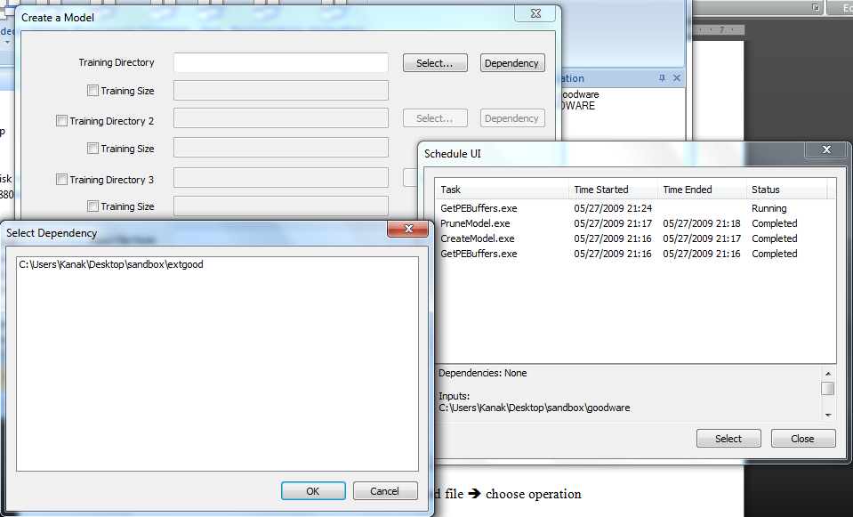

- Queuing User Interface
  - User brings up this interface by selecting Tools ➔ Show Scheduler
  - A window appears that shows the progress of running and queued tasks
    - List on left, details on right
    - The list is ordered by priority, with currently running tasks on top with immediate successors following
  - Coloring of tasks differentiates running, queued, or completed
  - As noted above, right clicking a task spawns a menu of operations on that task
  - See “User Interface Requirements” for the mockup of this screen

Starting Processes

This is the general operation of starting one of the executables provided by Symantec. Some key factors include providing for external configuration as well as allowing the user to start a task even if the input is not yet ready. This portion of the program works closely with queuing, so there may be some overlap with that section.

- For each operation, a UI is spawned that allows for additional configuration and specification of input of the task
- This part of the project takes parameters (execution files) and creates configuration files.
- You could start tasks individually or multiple task together. The tasks are also given an option to be prioritized.
- The user can modify additional parameters in the generated configuration files before starting the task
  - These are parsed automatically when the user starts the operation
- The user wants to do the tasks and then pass into scheduler.
  - If a file is selected
    - click on button corresponding to desired task ➔ creates a schedule of queued task (should be able to cancel it)
  - If prioritized, this will be put at the safest position closest to the top of the operations queue
- The task could be a main task, or sub-task. The default values of the task could be changed by the user.
- Many options are given upon starting a task
  - After the selection of the file, the user is given an option to queue the process. The user is informed that the process will be queued behind previous task.
  - The user is also asked if the input of the new task is the file that is currently under process or if the input file is already in the directory. If it requires incomplete input, it will automatically be queued after its dependencies.
  - The user is also given the option to prioritize the task, such that it will run parallel, if possible.
- See “Use Cases” for specific details on using individuals executables

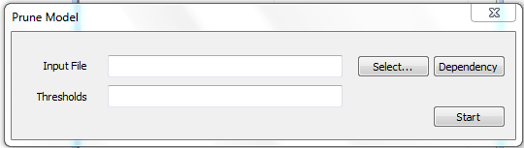
File Types
(Goodware/Malware,etc.)
Check Error Detection
Set Dependency
Get Input Files
(executables)
Get Output file Name
Choose Action
Add to Queue
Set Priority
Update Log

Error Detection

The below diagram indicates when errors are detected and reported to the user. For now, the system will be designed to continue with its next set of schedule tasks after an error has been reported. Here, “dependencies” means the necessary input for an executable to run successfully.

Scheduled task/ user requested task starting
Dependencies are not found/ do not exist
Dependencies are found, or are scheduled to be created
Error logged, and reported to user
Task run, and intermediate output produced
Intermediate file size not within range
Text, excel, binary output contains string “ERROR”
Task completed successfully
Error logged, and reported to user
Error logged, and reported to user

