Project Hancock Software Manager
Design and Planning Document
04/25/09, Version 1.4

Document Contents

Project Hancock Software Manager 1
Document Contents 2
Document Revision History 3
System Architecture 3
Design Details 5
Testing plan 5
Plan 5

Document Revision History
Rev. 1.0 2009-04-23 - initial version, template created
Rev. 1.1 2009-04-24 – added main UI UML
Rev. 1.2 2009-04-23 – data management UML
Rev. 1.3 2009-04-24 – action management UML
Rev. 1.4 2009-04-25 – logging UML

System Architecture
Here you should describe the high-level architecture of your system: the major pieces and how they fit together. Use graphical notations as much as possible in preference to English sentences. For example, you could describe the architecture using UML, or a finite automaton, if your system lends itself to these descriptions. Try to use standard architectural elements (e.g., pipe-and-filter, client-server, event-based). Make sure to describe the major interfaces between components.

The main structure of this application is modeled after an event-based architecture with object-oriented elements. This is a natural choice because any application with a graphical user interface must handle events such as clicking, typing, and otherwise selecting elements. The object-oriented aspect arises from the general structure of the MFC framework which we are using to build the application. The MFC organizes key elements and their handlers as objects. In addition, we have various complex data types which merit their own objects, such as a file and its corresponding data.

Primary UI Elements

The main visible portions of the application work mainly through a MainFrame class which manages most MFC objects, such as the ribbon. It will be in charge of reporting to the rest of the program. The entire program is enclosed in a Core class, which will initialize the MainFrame. A UML class diagram representing the general layout is below.

To prevent the diagram from becoming cluttered, connections to other parts of the application are omitted. These connections are enumerated at the end of this section of the document.

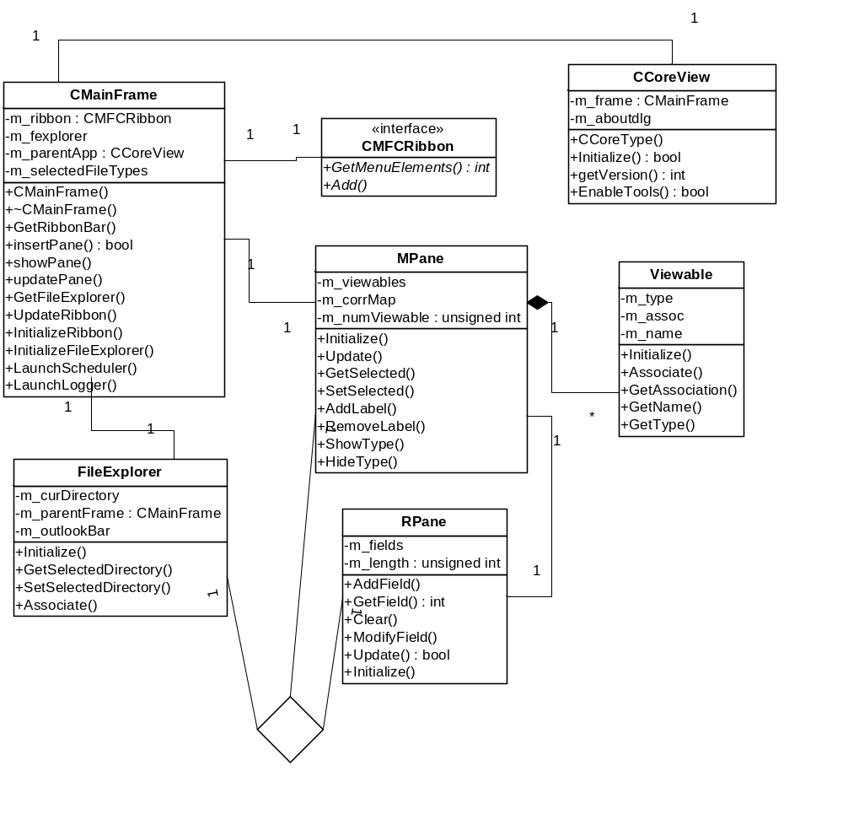

Containers of File/Directory Data
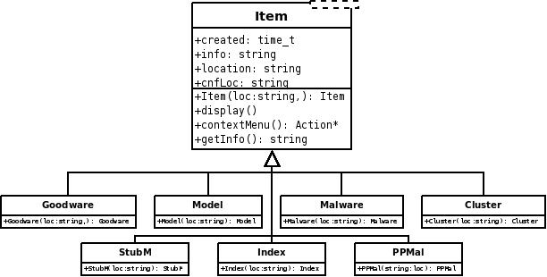

Handling of Actions on Input
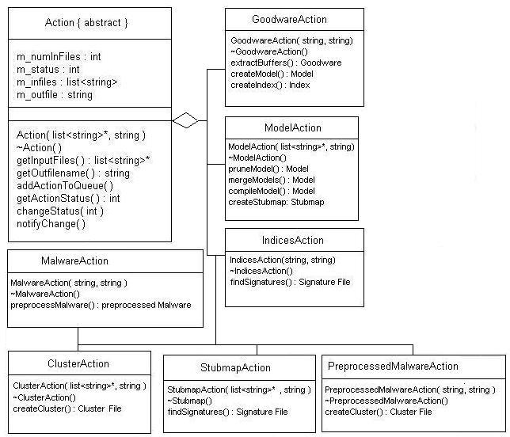

Scheduling
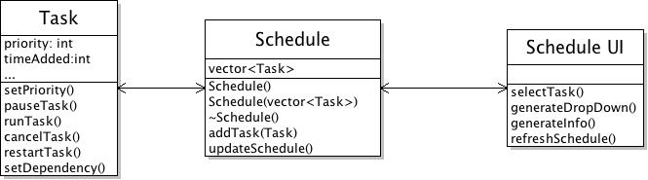

Maintaining and Viewing Logs
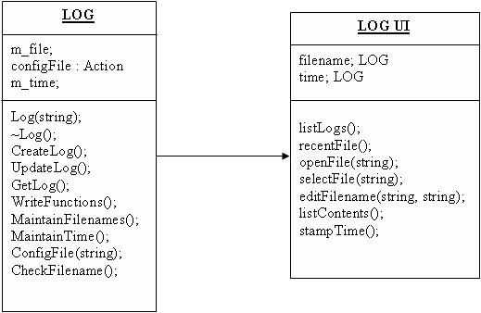

Design Details
In this section go those important facets that are not at the level of architecture, such as descriptions of critical algorithms, protocols, and key invariants. Also, wherever possible items should be linked back to your specification. Ideally, you can match up everything in the specification with where it is implemented in the design.

Testing plan
In this section goes a brief description of how you plan to test the system. Thought should be given to how mostly automatic testing can be carried out, so as to maximize the limited number of human hours you will have for testing your system. The purpose of this section is a reality check that your design will in fact be testable with a reasonable effort. You should specifically discuss design decisions that affect testing, and describe any test interfaces built into the system in this section. You must discuss here your plans for unit testing (approach, when are they created, when are they run), integration testing (what order), system testing (what kind), regression testing (how are you going to organize and run them).

Plan
From your design you should prepare a plan. In particular, you should list all of the tasks to be done, a preliminary assignment of tasks to people in the group, estimates of the time for each task, dependencies between tasks, and a preliminary division into builds (e.g., which features are implemented in the first build, second build, and so on). The plan should be designed to get some prototype system running as quickly as possible and then growing towards to the full project over a sequence of builds. Please pay extra attention to the dependency relationships between tasks; you will almost certainly run into the situation where one bit isn't done but everything else is waiting for it. In that case, you want to know exactly where resources need to go, and how urgent each bit is (hint: NOT proportional to its size or importance in the whole system).

