Project Hancock Software Manager
Instructions for Use
05/27/09, Version 1.0

Document Contents
Project Hancock Software Manager 1
Document Contents 2
Document Revision History 3
Unzipping and Starting 3
File Browser 4
Starting Actions 5
Scheduling 5
Logging 6
Questions 6
Known Issues 6

Document Revision History
Rev. 1.0 2009-05-27 - initial version
Obtaining the Source
If you would like to compile and run the source code on your machines, it can be obtained with the following command:
svn checkout http://cs130-hancock.googlecode.com/svn/trunk/ cs130-hancock-read-only
Note that you will need Microsoft Visual C++ 2008, along with the Visual C++ 2008 Feature Pack. The former can be obtained from SEASNet and the latter is a free download from Microsoft.

Unzipping and Starting
Before running the program, you will likely need the Microsoft Visual C++ 2008 SP1 Redistributable Package. This is a free download from Microsoft.

To begin, change the file extension of phmgr.zi_ to .zip. Then, extract the contents to any convenient location. When prompted for a password, enter “hancock.” The password is simply to facilitate sending executables over e-mail. The zip file should contain the following:

- hancock.bat – Use this to execute the program.
- hancock.exe – The Project Hancock Software Manager. Do not start this program directly.
- logdir.txt – Contains a string that notifies the program where to save program logs.
- threshold.txt – Specifies the number of Symantec programs allowed be started at any one time.
- Logs/ - An empty directory where program logs will be saved by default.
- executables/ - A directory containing all of Symantec’s executables. The default versions take approximately one minute to complete. The fast versions should complete within seconds.

To start the program, simply double-click or otherwise run hancock.bat.

We have also included source code for each of Symantec’s executable stubs, along with sample configuration files. Unzipping this archive (ToolStubs.zi_) is done in the same way as phmgr.zi_.

File Browser
The file browser functionality is described in detail in the Specification Document, but below is a brief overview on basic usage.

For testing purposes, we recommend that you create a sandbox directory containing various files and folders of any type. Now, in the program, press all file type buttons so that each is highlighted. Browse to the directory using the File Browser on the left of the program and label these files as various types by using the “Label as” commands in the submenus of each file type.

Now, labeled files will be tagged with their label and when selected, the right pane will display relevant information about them. See screenshot:

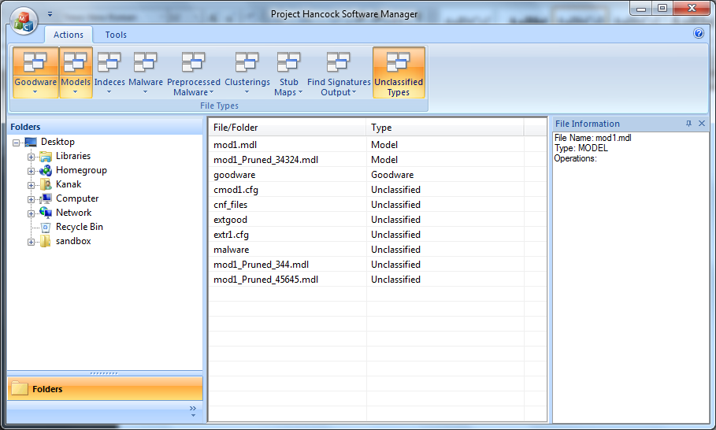

Starting Actions
We recommend that you try any and every possible input that could break this program for each action UI. However, here are some approaches that will yield worthwhile results:

First, choose an action to start from the submenu of the appropriate file type. Then, select appropriate input and output files/directories for the task. For example, if pruning a model, give a model as input. Any input fields that are not file types that this program manages (Goodware, Models, Indices, Malware, Preprocessed Malware, Clusterings, Stub Maps, Find Signature Output) can be given random values. For example, the mode for Extract Buffers could be “abcd.”

After all inputs and outputs are specified, most Actions require that you create a CFG file. So, click the corresponding button, edit the CFG file if you would like, then click Start.

To test the functionality of dependencies, simply start one action, then open the UI for starting another action that requires the output of the first. Now, select “Dependency” on the appropriate input field, and a version of the Schedule UI will appear. Select the dependent task, and click OK. Another dialog will appear that will list the outputs of the dependency. Select the output that you would like to use as input and click OK.

A common chain of tasks that can be run to test dependencies is Extract Buffers →Create Model →Prune Model. There are several other chains as well. You can choose any sequence of actions that could take as input the output of another action.

Refer to the specification document for more details on starting actions.

Scheduling
The threshold of the maximum number of simultaneous processes can be specified from the Tools menu. The dialog should only accept numbers.

To view the status of tasks executed by this program, open the Schedule UI from the Tools menu. This will list all queued, running, and completed tasks since the application was started. Selecting one action will list dependencies, inputs, and outputs.

Logging
To view the full log history generated by the program, open the Log UI from the Tools menu. The logs are sorted from oldest to most recent and the current log should be highlighted and displayed at the beginning. The log contains information such as outputs of Symantec processes and details about any actions taken by the user with the software.

To change the directory that contains the logs, specify a new directory from Save Logs To… in the Tools menu.

Questions
If any of the members of the test team has any questions about using the Project Hancock Software Manager, contact kanakb@gmail.com

Known Issues
Below is a list of known issues with the alpha version of the program:

- If the executable associated with an action is not present in the “executables” directory, then the Scheduler reports the action as “Running” instead of failed.
- If the executable associated with an action fails for any reason, the failure output is logged correctly, but the Scheduler reports the action as “Completed” instead of failed.
- The output of an action is not automatically labeled within the file browsing feature after the action is completed.
- The output files associated with the Find Signatures and Cluster Files actions are not currently generated.
- hancock.exe cannot be run directly because actions will not report as completed. A temporary workaround is to run hancock.bat instead.

