JWT

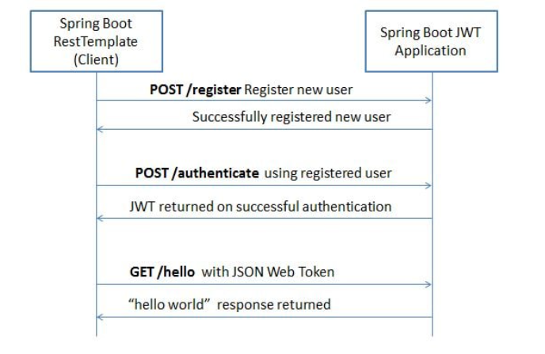

Right side one is Authentication server, which generated token for requesting client service.

Client MSs needs to register themselves with Authentication server (with client id and secret). This is one time activity. Once client MS registered with Authentication server, client MS sends client id() and secret(vault), authentication server validates client, once validated successfully authentication server generates token and sends back to client and client passes this to provider application to access provider application.