
Server Room
Sensor Node
Sensor Field
Node Location?
Internet

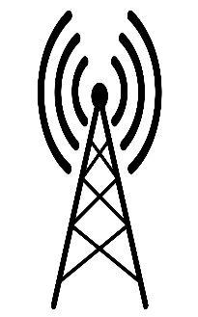
Event Occurs

