1. **Go to https://wbsfdc.devserv.in/**

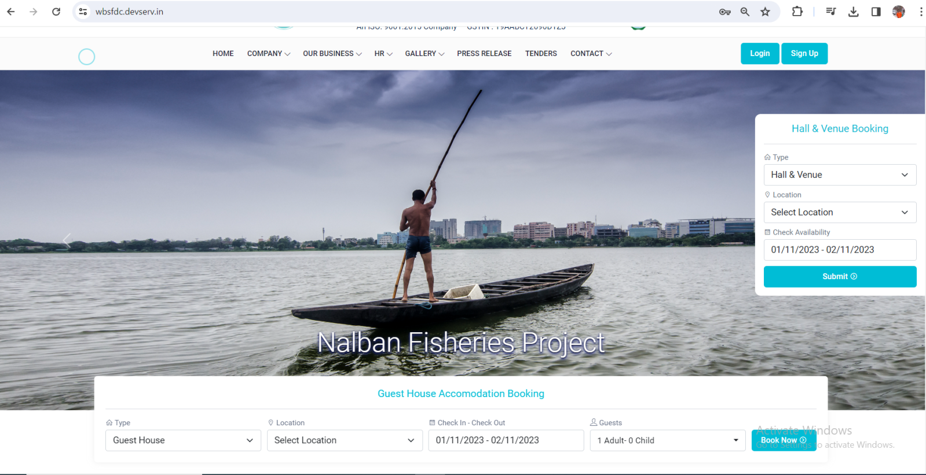

1. On the bottom, you will find a BOOK NOW Button, please click into that
2. You will get a List of Properties screen.

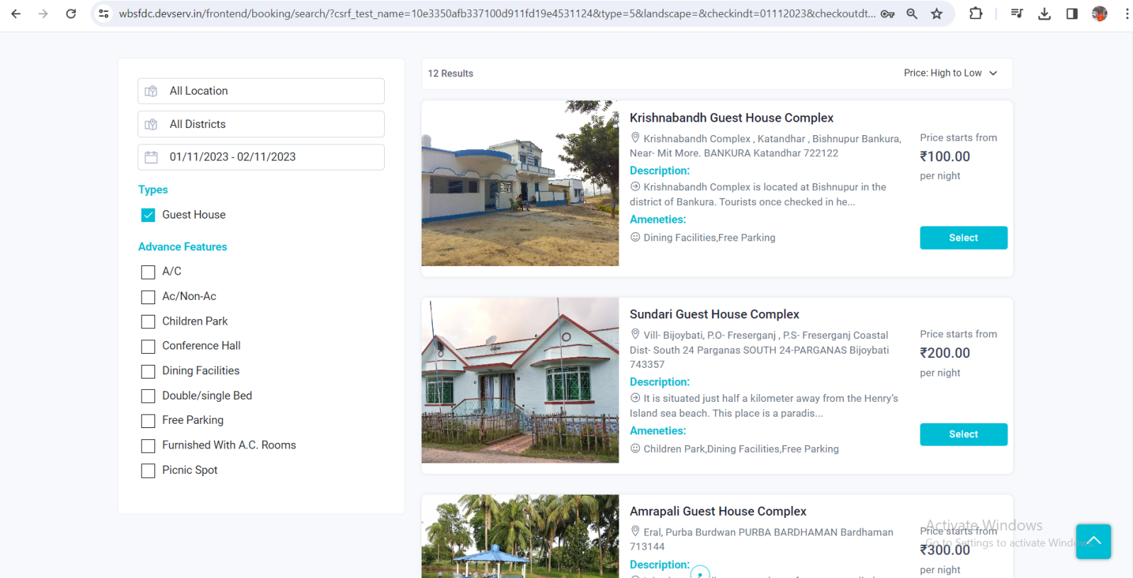

1. Select any Property from the list. Once you select any property you will land details page of that property.

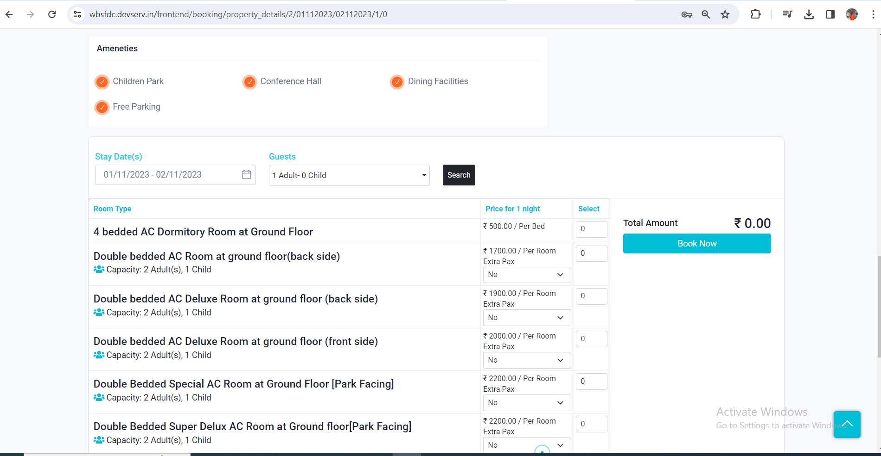

1. Now you can select any room and click on BOOK NOW.

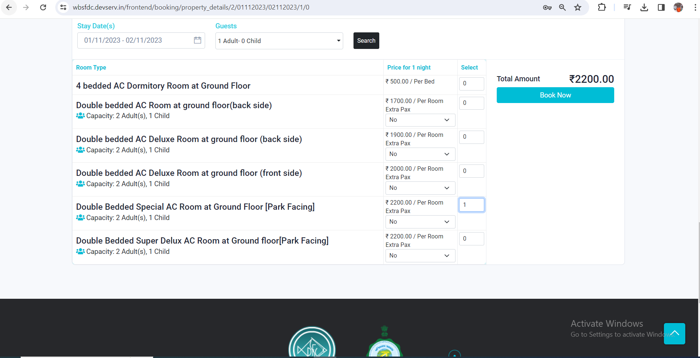

1. If you are not logged in then it will redirect to login screen.

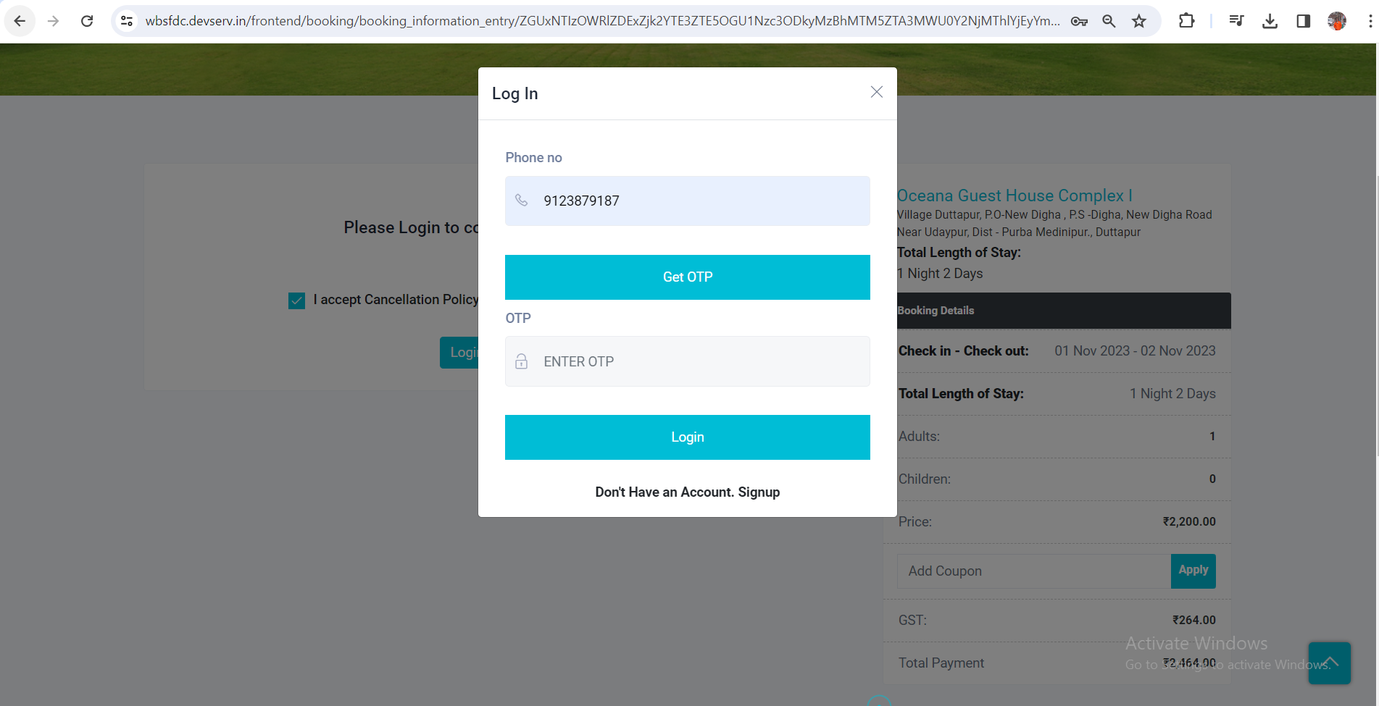

1. After login to the application you will redirect to below page to fill up the details:

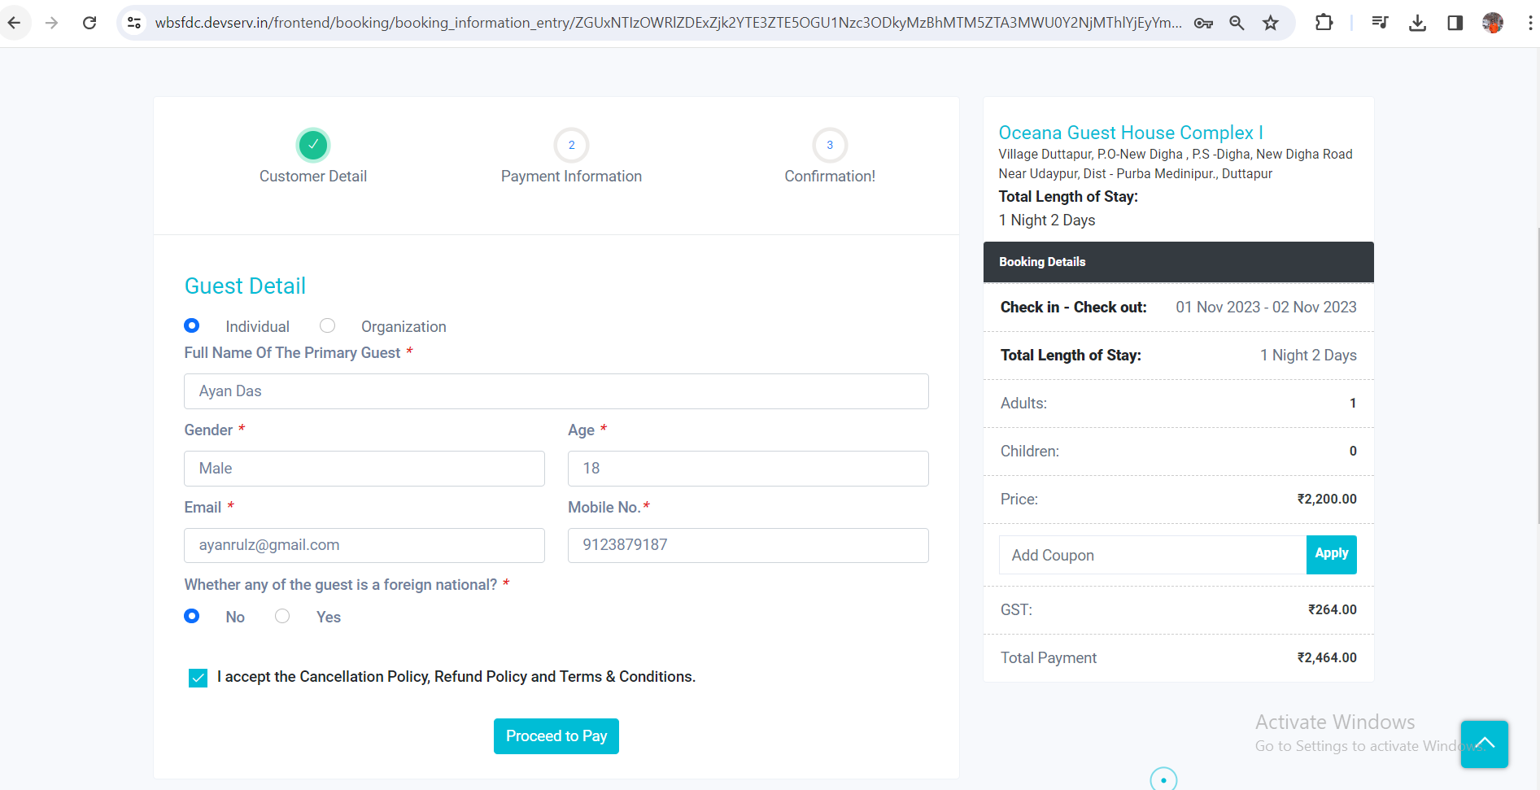

Now once you click on the Proceed to Pay button it will redirect to the payment gateway screen.

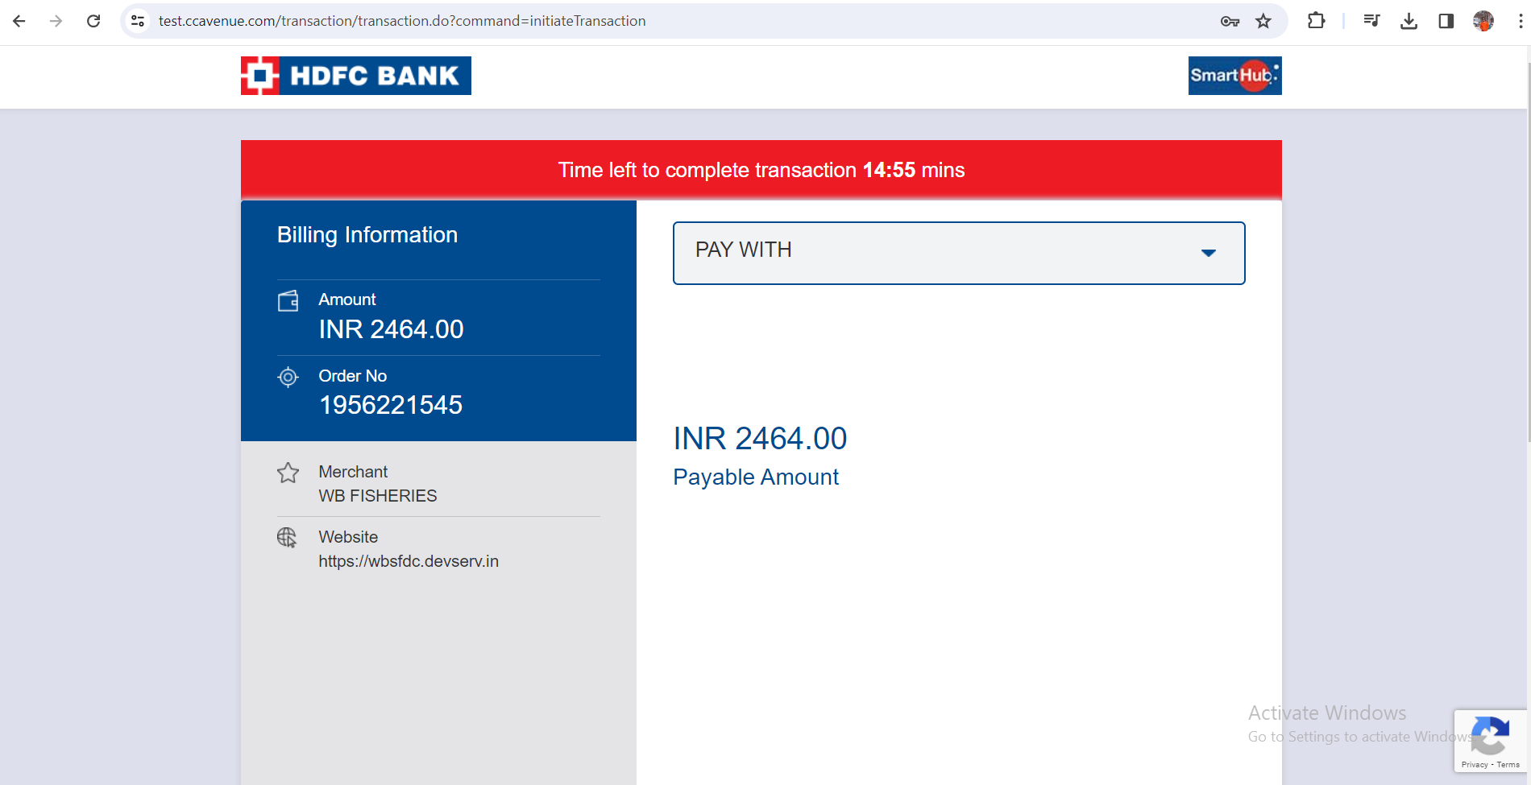

1. Next is card details/information page:

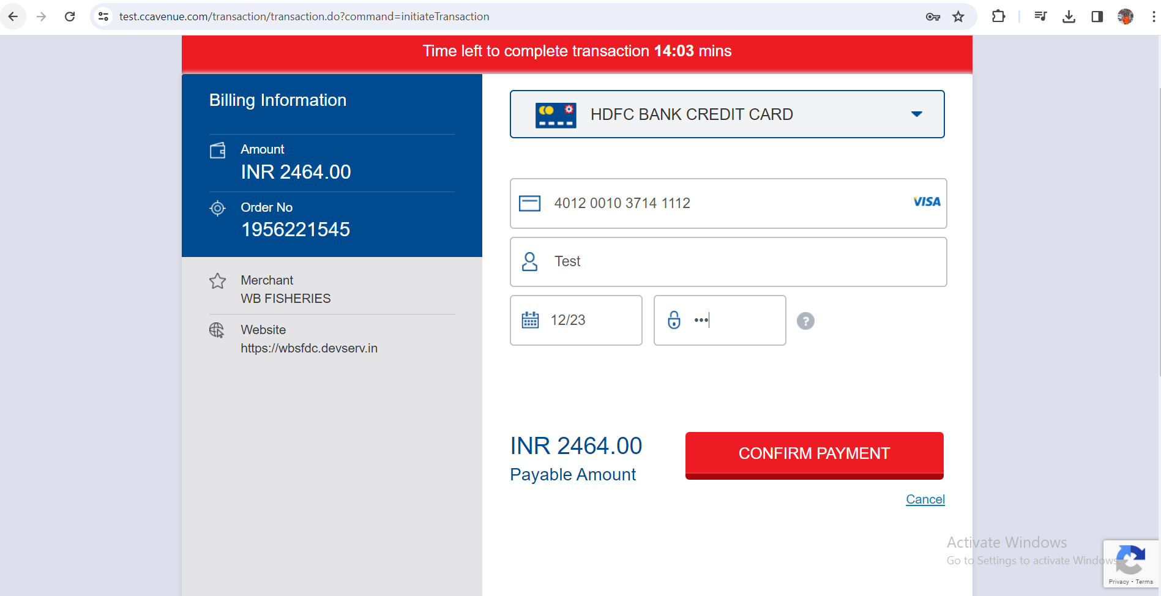

1. Once I click on the CONFIRM PAYMENT , it will redirect to next page:

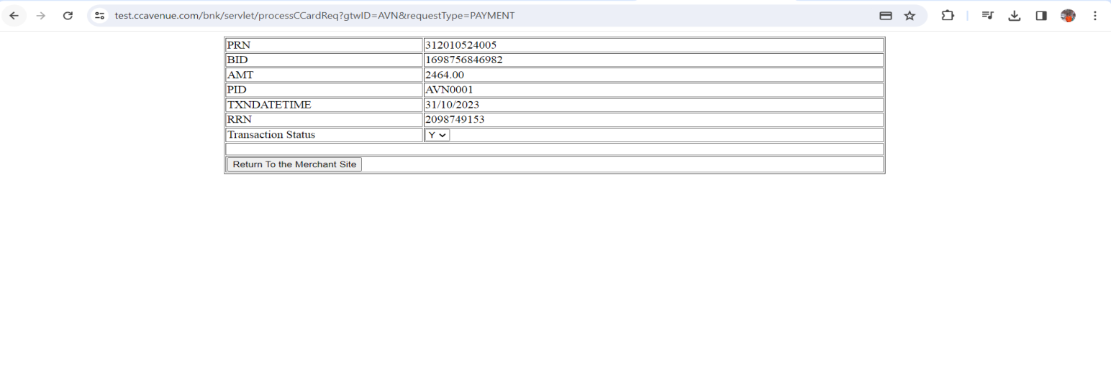

I have selected Transaction Status “Y” and click on “Return To the Merchant Site”.

1. Once I click “Return To the Merchant Site” it gives us success response and redirect to <https://wbsfdc.devserv.in/my-booking>

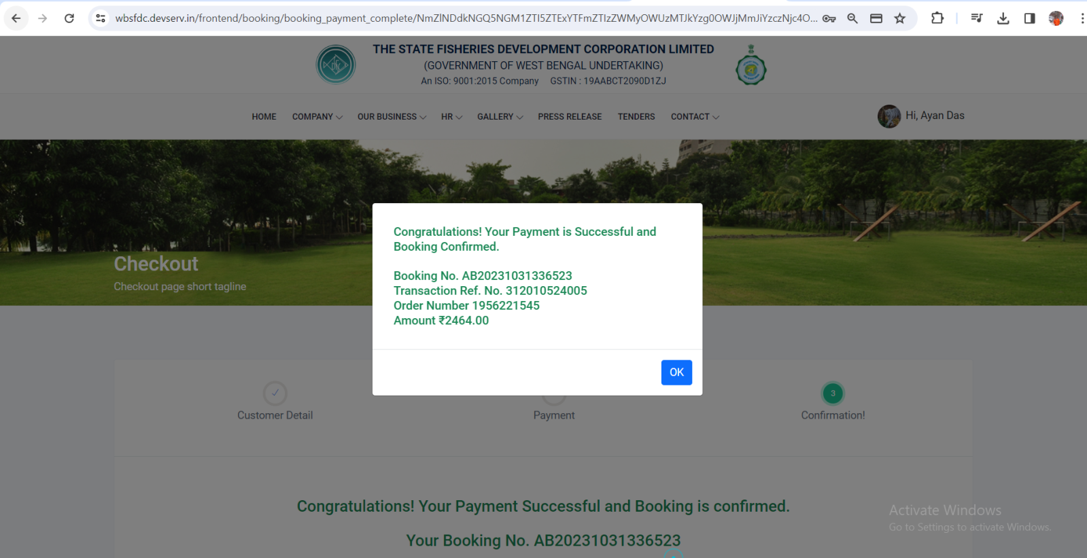

**My Booking List page**

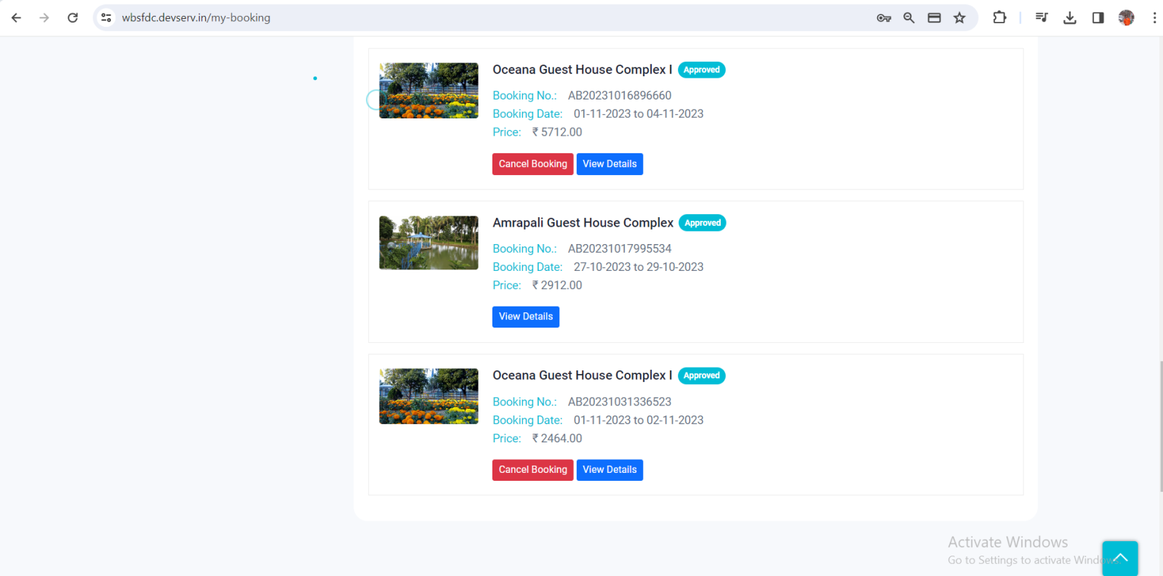

**Kindly refer attachment for verify payment, once done share us request and response string of a successful "Status" API to check at our end.**

**Request**

**Query String :**

**enc_request=900f89aad9054b6d3c6d2d614b5238c271a578d2d1067f8699b0a6e550598566&access_code=AVAT09KI22AB88TABA&command=orderStatusTracker&request_type=JSON&response_type=JSON**

**Curl Request Array**

**Array**

**(**

**[url] => https://apitest.ccavenue.com/apis/servlet/DoWebTrans**

**[content_type] =>**

**[http_code] => 200**

**[header_size] => 223**

**[request_size] => 324**

**[filetime] => -1**

**[ssl_verify_result] => 20**

**[redirect_count] => 0**

**[total_time] => 0.935202**

**[namelookup_time] => 0.001059**

**[connect_time] => 0.228451**

**[pretransfer_time] => 0.686821**

**[size_upload] => 171**

**[size_download] => 1944**

**[speed_download] => 2078**

**[speed_upload] => 182**

**[download_content_length] => -1**

**[upload_content_length] => 171**

**[starttransfer_time] => 0.935021**

**[redirect_time] => 0**

**[redirect_url] =>**

**[primary_ip] => 180.179.175.17**

**[certinfo] => Array**

**(**

**)**

**[primary_port] => 443**

**[local_ip] => 45.13.254.1**

**[local_port] => 47178**

**[http_version] => 2**

**[protocol] => 2**

**[ssl_verifyresult] => 0**

**[scheme] => HTTPS**

**[appconnect_time_us] => 686753**

**[connect_time_us] => 228451**

**[namelookup_time_us] => 1059**

**[pretransfer_time_us] => 686821**

**[redirect_time_us] => 0**

**[starttransfer_time_us] => 935021**

**[total_time_us] => 935202**

**)**

**Response**

**Array**

**(**

**[Order_Status_Result] => Array**

**(**

**[order_gtw_id] => AVN**

**[order_no] => 1956221545**

**[order_ship_zip] =>**

**[order_ship_address] =>**

**[order_bill_email] => ayanrulz@gmail.com**

**[order_capt_amt] => 2464**

**[order_ship_tel] =>**

**[order_ship_name] =>**

**[order_bill_country] =>**

**[order_card_name] => Visa**

**[order_status] => Shipped**

**[order_bill_state] =>**

**[order_tax] => 0**

**[order_bill_city] =>**

**[order_ship_state] =>**

**[order_discount] => 0**

**[order_TDS] => 0**

**[order_date_time] => 2023-10-31 18:21:42.757**

**[order_ship_country] =>**

**[order_bill_address] =>**

**[order_fee_perc_value] => 0**

**[order_ip] => 202.8.114.87**

**[order_option_type] => OPTCRDC**

**[order_bank_ref_no] => 1698756846982**

**[order_currncy] => INR**

**[order_fee_flat] => 0**

**[order_ship_city] =>**

**[order_bill_tel] => 9123879187**

**[order_device_type] => PC**

**[order_gross_amt] => 2464**

**[order_amt] => 2464**

**[order_fraud_status] => NA**

**[order_bill_zip] =>**

**[order_bill_name] => Ayan Das**

**[reference_no] => 312010524005**

**[order_bank_response] => Y**

**[order_status_date_time] => 2023-10-31 18:24:05.713**

**[status] => 0**

**)**

**)**