**Venue > 1.Edit Button Should be named as Update.**

1. **Option needed for add more Photos.**

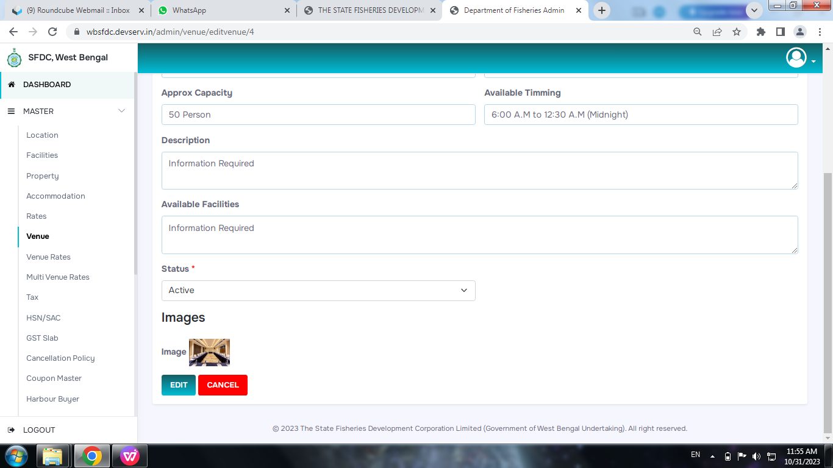

**Property > City should be optional**

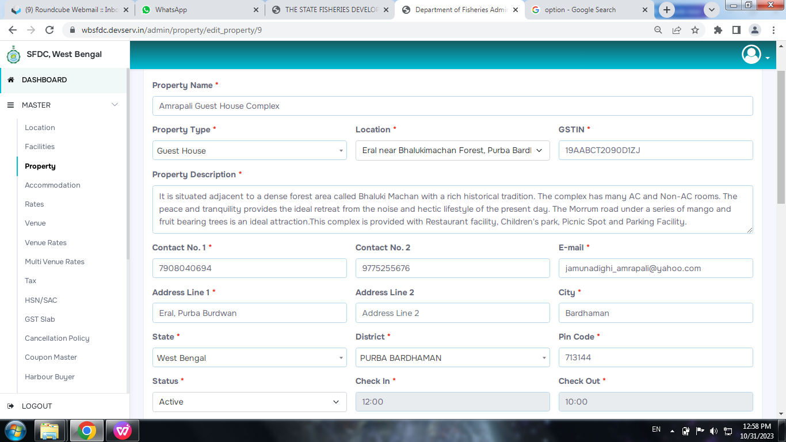

**Accommodation > Need option for no child.**

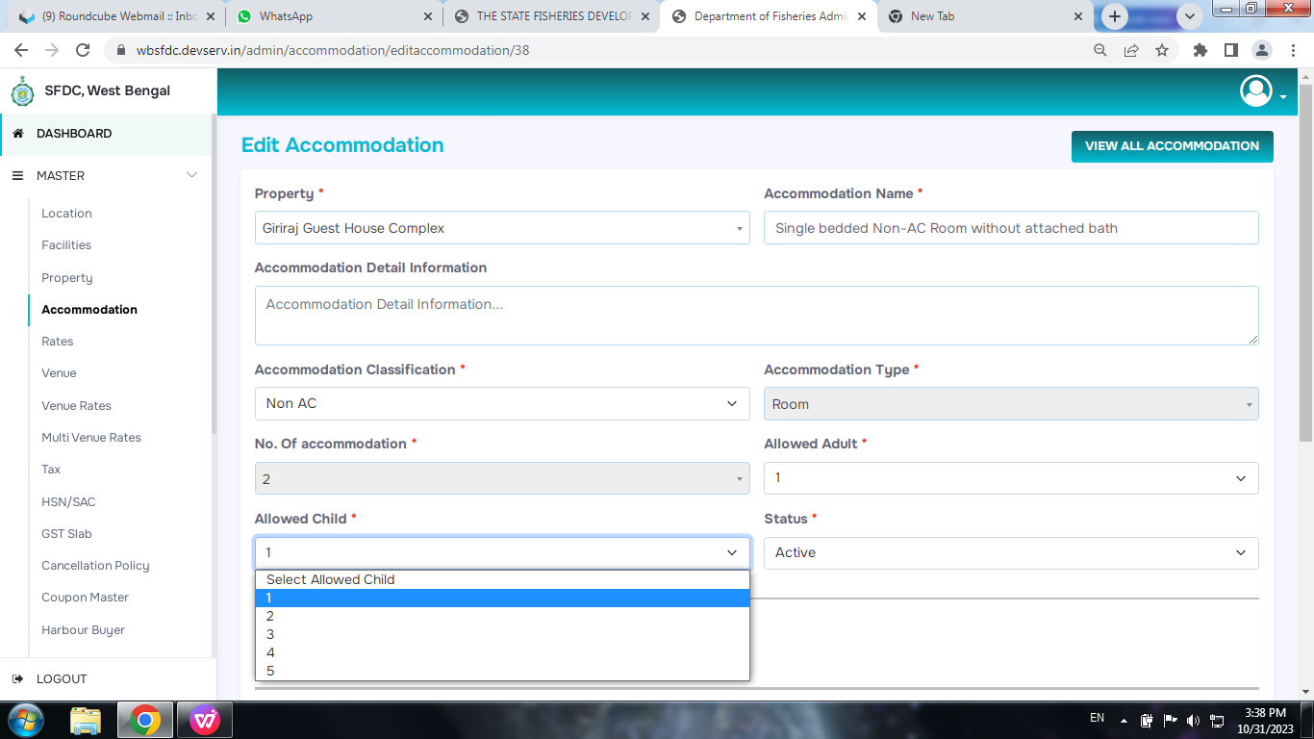

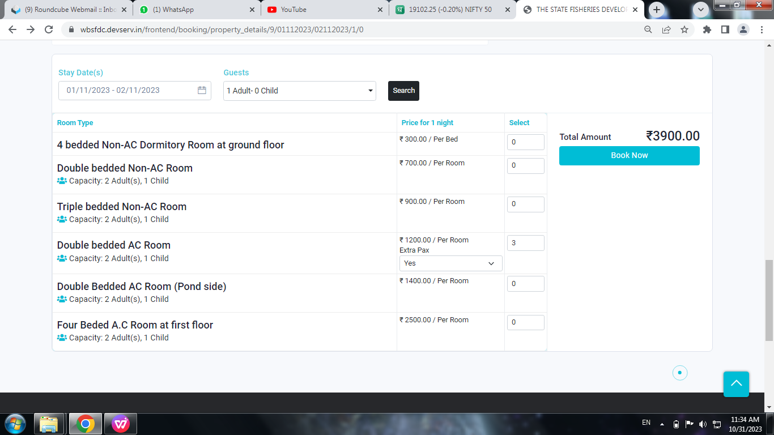**Amount Should be calculated for one room**

* Document archived for post checking approval
* Multiple file upload
* Uploaded file view Required

**uld be added for one occupancy on a room.**