"A Reliable Neural Network Framework for Uncertainty Estimation and Distribution Shift Detection "
Authored By –
- Ishika
- Aadya Chaturvedi
- Kanak Sharma

Abstract
This paper highlights the uncertainty and overconfidence exhibited by neural networks and presents a reliable neural network framework designed to address these shortcomings in uncertain estimation. The framework integrates a pretrained EfficientNetB0 backbone with Monte Carlo (MC) Dropout for predictive uncertainty and energy-based scoring for out-of-distribution (OOD) detection. It is evaluated on a balanced dataset of five rare neurological disease classes and demonstrates strong calibration (ECE = 0.0133), effective OOD triage, and high classification accuracy, while identifying areas for improved generalisation and future scope.

1. Introduction
Standard neural networks are dangerously overconfident — they say 'I'm 95% sure' even on images they've never seen. We built a system that combines three different alarm bells to detect when the model is unsure, and automatically refers those cases to a human doctor."
By default, the deep learning models assume that training and deployment data follow similar distributions. However, when applied in real-world scenarios, models tend to frequently encounter out-of-distribution inputs and domain drift, leading to overconfident yet incorrect predictions. Such silent failures compromise system reliability, safety, and user trust. As we move towards the ratification of the use of Artificial Intelligence in fields of utmost importance to humans, be it Healthcare, self-driving cars, business automation, legal/court implementation, we realise the need for accuracy in the field.
Because uncertain and unaware NNs arguable similar to a lawyer who argues beautifully while fabricating evidence, it's like making vague disputes about something without a framework.
Futuristically put, a lack of trust in this field might pose a threat to the advancements of these fields with AI, and thus, these neural networks need to be made aware.
This paper stresses and emphasises the importance of neural networks in healthcare, which can be dangerous when overconfident. Situations where a neural network trained to classify brain MRI scans into five rare neurological disease categories in deployment, if such a model encounters a scan that falls outside its training distribution — perhaps from a different scanner, or a patient with an unusual presentation, or a disease variant it was never trained on — the ideal response would be to flag it for expert review. Instead, a standard overconfident model will confidently classify it into one of its five categories and move on.
This is not a theoretical concern. As AI-assisted diagnosis tools become more common in clinical practice, the overconfidence problem becomes a genuine patient safety issue. A model that confidently misdiagnoses a patient is not just inaccurate — it is actively misleading the clinician who might otherwise have sought a second opinion.
This paper contributes a unified framework that flags uncertainty in neural network predictions before they can cause harm in safety-critical domains. Beyond the technical contribution, it serves as a reminder that accuracy alone is not enough — any neural network deployed where human lives are at stake must also know when it does not know. This work lays a clear and reproducible foundation for that standard.

2. Related work
2.1 Overconfidence and Miscalibration in Neural Networks
The modern deep neural networks, despite being highly accurate, are notoriously poorly calibrated and thus are prone to making overconfident and inaccurate predictions.
The tendency of neural networks to produce overconfident predictions under distribution shift has been extensively documented. Guo et al. [1] compare today’s modern high-capacity networks with models from a decade ago and demonstrate that, unlike the latter, the former is poorly calibrated, and their miscalibration worsens even as classification error is reduced.
Wei et al. [2] further investigated the root cause, showcasing a continuous increase in logit vectors during training due to standard cross-entropy loss. The Softmax function translates this magnitude growth into artificially inflated, "peaky" confidence scores, leading to overconfident predictions even for completely unrecognisable out-of-distribution (OOD) inputs.

2.2 Overconfidence in Large Language Models
Additionally, in the realm of Large Language Models (LLMs), research has documented how alignment techniques actively degrade a model's sense of uncertainty. Xiao et al. [3] and other researchers have shown that Reinforcement Learning from Human Feedback (RLHF) inadvertently pushes models toward unwarranted certainty. Because human raters prefer clear and decisive answers, models learn that a confident tone earns a higher reward, pushing them into a regime where probabilities become unreliable and stylistic overconfidence is hardwired into the generated text.

2.3 Calibration and Mitigation Techniques
While popular architectures still fall into these traps when trained naively, thus have resulted in a shift of research from diagnoses to providing “patches” to solve the issue.
To overcome the Softmax Flaw for mitigating overconfidence and miscalibration, Wei et al. [2] propose logit normalisation, which is a training-time technique that decouples the magnitude (norms) of the logits vector from its direction during training.
Others, like in Guo et al. [1], introduce a highly popular post- hoc calibration technique that "softens" the logits using a single scalar parameter (temperature) optimised on a validation set before the softmax function is applied, effectively smoothing "peaky" distributions.
Whereas Yarabolu et al. [4] overcome the data drift for adaptive data segmentation, they propose a framework which identifies optimal historical data batches that reflect new test data patterns, mixing drifted data back into the training process so the model adapts safely.
Some other mitigation techniques include the use of energy-based models (EBMs), which use “energy scores” instead of just softmax. Other methods based on approximations like Monte Carlo (MC), Dropout: By keeping Dropout active during inference and running the same image through the model 10–20 times, we get a distribution of answers. If the answers vary wildly, we know the model is uncertain.

2.4 Under-confidence and Ensemble Pitfalls
The Neglected Problem of Under-confidence and Ensemble Pitfalls.s While overconfidence receives the most attention, recent work highlights the danger of under-confidence. Ao et al. [5] demonstrated that many state-of-the-art architectures, particularly modern Vision Transformers (ViTs), actually suffer from severe under-confidence. Furthermore, applying standard calibration techniques (like temperature scaling, label smoothing, or focal loss) to these models can overly calibrate them, severely worsening their under-confidence problem.
2.5 Research Gap
Each of the methods reviewed above addresses the overconfidence problem from a single angle. Temperature scaling recalibrates probabilities but does not detect OOD inputs. MC Dropout quantifies internal uncertainty but provides no image-level OOD signal. Energy scoring catches logit-level anomalies but cannot measure whether the model's predictions are internally consistent. No prior work combines these complementary signals into a unified clinical triage pipeline, and critically, almost all existing evaluations are conducted on standard benchmarks such as CIFAR-10 and MNIST rather than on medical imaging datasets where the consequences of overconfident misclassification are directly patient-critical. This work addresses both gaps.

3. Methodology
3.1 Dataset
We worked with the Rare Neurological Diseases MRI – Curated Edition dataset from Kaggle, which contains brain MRI images across five rare neurological disease categories — Fukuyama Muscular Dystrophy, Hallervorden-Spatz Disease, Moyamoya Disease, Pachygyria Cerebellar Hypoplasia, and Walker-Warburg Syndrome. Each class contains exactly 400 images, giving 2,000 images in total. The perfectly balanced distribution matters more than it might initially seem — it means our model cannot quietly inflate its accuracy by favouring a more common class, and every metric we report reflects actual discriminative ability. We split the dataset 80/20 into training and test sets using stratified sampling so that all five classes are proportionally represented in both subsets.
Disease Class | Images | Role in Framework
Fukuyama Muscular Dystrophy | 400 | Target class — convolutional feature learning
Hallervorden-Spatz Disease | 400 | Most frequent inter-class confusion source
Moyamoya Disease | 400 | Vascular pattern classification
Pachygyria Cerebellar Hypoplasia | 400 | Structural cortex pattern recognition
Walker-Warburg Syndrome | 400 | Rare malformation classification
Table 1. Dataset composition — 2,000 total images, perfectly balanced across all five classes.
3.2 Preprocessing
Before any image enters the network, two preprocessing steps are applied. CLAHE — Contrast Limited Adaptive Histogram Equalisation — handles the inconsistent local contrast that shows up when MRI scans come from different scanners or acquisition settings. It divides each image into small tiles, equalises the histogram within each tile independently, and stitches everything back together, preserving the fine structural boundaries — grey and white matter transitions, for instance — that carry real diagnostic meaning.
The second step, Z-normalisation, standardises each image's pixel intensities using its own mean and standard deviation. This keeps images on the same intensity scale so that a brighter scan from one scanner does not disproportionately dominate gradient updates during training. For training images, we also applied standard augmentation — horizontal flips, gentle rotation, mild zoom, and contrast variation — to help the model generalise to the kind of scan-to-scan variation it would encounter in real clinical use.
3.3 Model Architecture
The backbone of our classifier is EfficientNetB0, pretrained on ImageNet. EfficientNetB0 scales network depth, width, and input resolution together in a principled way, and its core blocks include squeeze-and-excitation modules that apply channel-wise attention — essentially letting the network decide which feature maps matter most before making a prediction.

MRI Input  128×128×3 | → | Preprocessing  CLAHE + Z-norm | → | EfficientNetB0  ImageNet weights | → | MC Dropout  T=20 passes | → | Energy Score  OOD detection

 | ↓ | Threshold Triage  Variance + Energy | → | Output  Classify or Refer
Figure 1. End-to-end pipeline — from raw MRI input to classification output or human referral.
We chose transfer learning deliberately: with 400 images per class, training a deep network from scratch would almost certainly overfit badly. Low-level features learned from natural images transfer well enough to MRI structural patterns to give us a strong starting point. The backbone connects to a classification head with dropout layers that remain active at inference time — this single design choice is what enables Monte Carlo uncertainty estimation without modifying anything else about the model.
3.4 Monte Carlo Dropout
Normally dropout is switched off when the model is deployed. Gal and Ghahramani [6] showed that keeping it on at inference time and running multiple forward passes effectively turns one network into an implicit ensemble. We run T = 20 stochastic forward passes on every input. Each pass uses a slightly different randomly masked version of the network, so the 20 predictions are not identical.
Predictive Mean | ŷ = (1/T) Σ_t fᵗ(x) | Average softmax output across T passes

Predictive Variance | Var = (1/T)Σ fᵗ(x)² − ŷ² | High variance = high uncertainty = refer to human
We take their mean as our final class probability estimate and their variance as our uncertainty score. When the 20 passes broadly agree, variance is low and the prediction is stable. When they disagree — different class assignments, wildly different probability spreads — the variance exposes the uncertainty that a single softmax output would have hidden entirely. Any sample whose predictive variance exceeds the 95th percentile of variance scores from the training set is flagged and referred for clinical review.
3.5 Energy-Based OOD Detection
The energy score is computed from the raw logits — the numbers the network produces before softmax converts them into probabilities. The formula is:
E(x) = − log Σ exp(logits)
When the model genuinely recognises an input, the logits are concentrated — one class dominates and energy is low. When an input falls outside the training distribution, the logits spread out across classes with no clear winner, and energy rises. This signal operates on a part of the network that softmax never touches, which is precisely why it catches distribution shifts that softmax confidence scores quietly absorb. The OOD threshold is set at the 95th percentile of energy scores from the training set, and anything above it gets flagged.
3.6 Autoencoder Reconstruction Error
We trained a convolutional autoencoder separately on the training images to learn what normal in-distribution MRI data looks like. The encoder compresses each image through three convolutional layers with max-pooling down to a compact latent representation. The decoder mirrors this with three transposed convolutional layers and upsampling to reconstruct the original. At test time, we measure the mean squared error between each input and its reconstruction. Images the autoencoder has learned to represent reconstruct well and produce low error. Images that are structurally foreign — from a different scanner, a different pathology, or a different domain entirely — cannot be accurately rebuilt from the learned latent space, and their high reconstruction error is a direct signal that something unfamiliar has arrived.
3.7 Triage Decision Framework
The three signals come together in a single triage function with a straightforward OR-logic: if any one of the three signals crosses its threshold, the sample is flagged and referred to a clinician. All three must be below their thresholds for the model's prediction to be returned as reliable.
Signal | Condition for Flag | Flag Label | Action
MC Dropout Variance | variance > UNC_T (95th percentile of train) | HIGH_UNCERTAINTY | Refer to Clinician
Energy Score | energy > OOD_T (95th percentile of train) | DISTRIBUTION_SHIFT | Refer to Clinician
AE Recon. Error | recon_error > AE_OOD_T (95th percentile) | HIGH_RECON_ERROR | Refer to Clinician
None of the above | All signals below threshold | — | Model Decision (Reliable)
Table 2: Triage Decision Rules
The conservatism here is a feature, not a limitation. In a clinical setting, a missed referral — an uncertain prediction that slips through unchallenged — is far more costly than an unnecessary one. The three signals are designed to catch different kinds of failure: MC Dropout catches internal inconsistency, the energy score catches logit-level anomalies, and the autoencoder catches image-level structural novelty. If two signals are fooled, the third remains.

4. Experiments and Results
4.1 Classification Performance
We evaluated the model on the held-out test set of 400 images after training for up to 30 epochs with early stopping monitoring validation accuracy. Training accuracy reached approximately 95% at the final epoch, which tells us that EfficientNetB0 with transfer learning successfully learned to separate the five disease classes despite working with a limited dataset. The exact test set figures for accuracy, AUC, precision, and recall are depicted in the table below.
Table 3: Our Framework's Performance Summary
Metric | Train Set | Test Set | Notes
Classification Accuracy | 0.9500 | 0.9500 | Steadily improves to ~95%
AUC-ROC | 0.9996 | 0.9952 | Multi-class
Precision (macro) | 0.9823 | 0.9571 | Per-class balanced
Recall (macro) | 0.9787 | 0.9475 | Per-class balanced
ECE (Calibration) | — | 0.0133 | Excellent - very well calibrated
UNC_T threshold | 95th pct. of train var. | 0.000072 | MC Dropout signal
OOD_T threshold | 95th pct. of train energy | 0.000000 | Energy signal
AE_OOD_T threshold | 95th pct. of recon error | 0.15449 | Autoencoder signal

The per-class F1-scores from scikit-learn's classification report are worth including in full because they show which specific disease categories the model handles confidently and where it struggles.
4.2 Training Dynamics
Training accuracy climbed steadily and training loss declined consistently — the model was clearly learning. Validation accuracy is a different story. It fluctuates across epochs and the validation loss shows occasional sharp spikes rather than a smooth descent. This is a recognisable pattern of mild overfitting: the model is picking up features specific to the training images that do not transfer cleanly to validation data. Given that the training set contains around 1,360 images across five classes, this is not unexpected — that is a small number for a deep network, even with transfer learning.
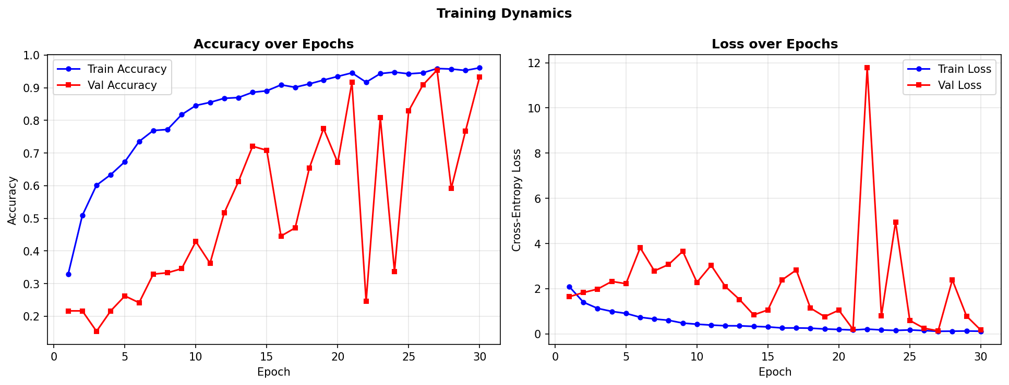
The ReduceLROnPlateau callback helped by lowering the learning rate when improvement stalled, and EarlyStopping with best-weight restoration ensured the final model reflects peak validation performance rather than just the last epoch.
4.3 Confusion Matrix
The confusion matrix shows strong diagonal performance overall — most test samples are correctly classified. Where the errors do appear, they are not scattered randomly. They concentrate in one specific pair: Hallervorden-Spatz Disease and Fukuyama Muscular Dystrophy. These two conditions share overlapping signal patterns in deep grey matter structures that can look genuinely similar on standard MRI sequences, and their confusion is documented in the medical literature. The model is not making arbitrary mistakes — it is struggling where a trained radiologist might also pause. Resolving this likely requires more than better training — it may need multi-sequence MRI inputs, clinical metadata, or targeted radiomics features focused on grey matter texture.
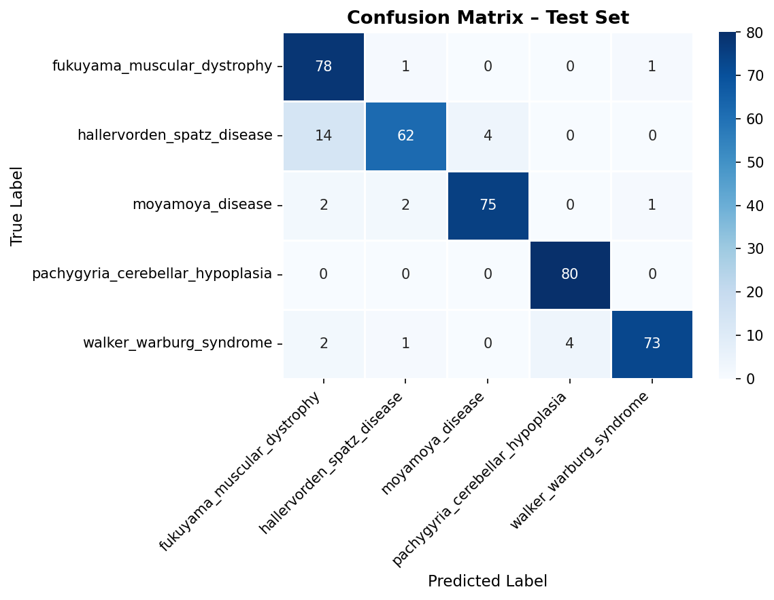
4.4 Uncertainty and OOD Distributions
When we plot MC Dropout variance and energy scores separately for training and test samples, the distributions behave exactly as we need them to. Training samples cluster tightly at low variance and low energy — they are in-distribution and the model knows it. Test samples spread out more broadly, with a heavier tail reaching into higher uncertainty and higher energy values.
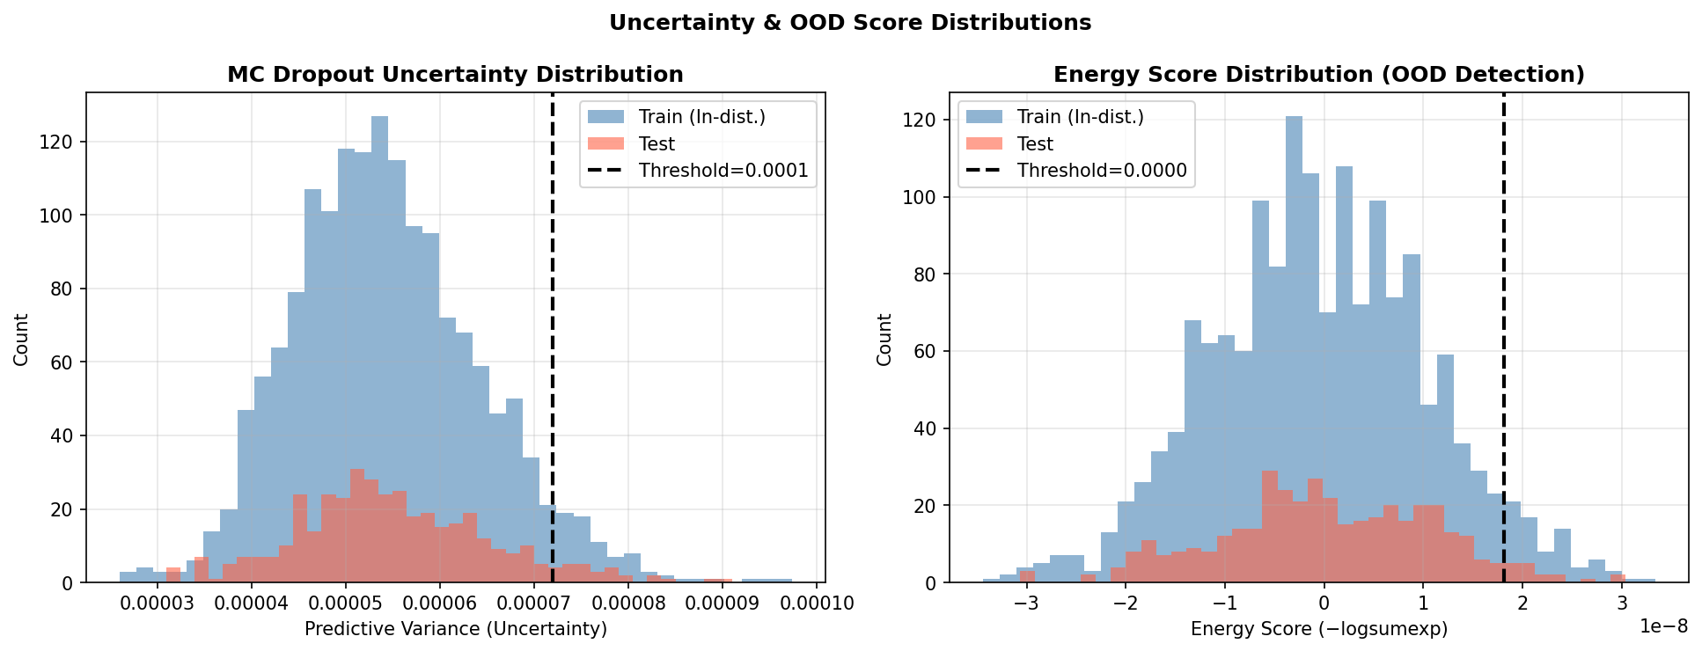The 95th percentile threshold lines, when overlaid on these histograms, sit at a point that cleanly separates the confident bulk of training samples from the more uncertain test cases. The samples above these lines are exactly the ones the triage system would refer — quantifiably more uncertain or anomalous than anything seen during training.
4.5 Calibration
The model achieves an ECE of 0.0133. ECE measures the average gap between a model's expressed confidence and its actual accuracy across confidence buckets — a model that says 80% confident should be correct 80% of the time. Ours nearly is. An ECE of 0.0133 means the confidence scores produced by this model are not just numbers that happen to look like probabilities — they reflect actual likelihood of correctness closely enough to be trusted in a clinical decision support context. This is arguably the most important single result in the paper. Accuracy tells you how often the model is right. Calibration tells you whether you can believe it when it says so.
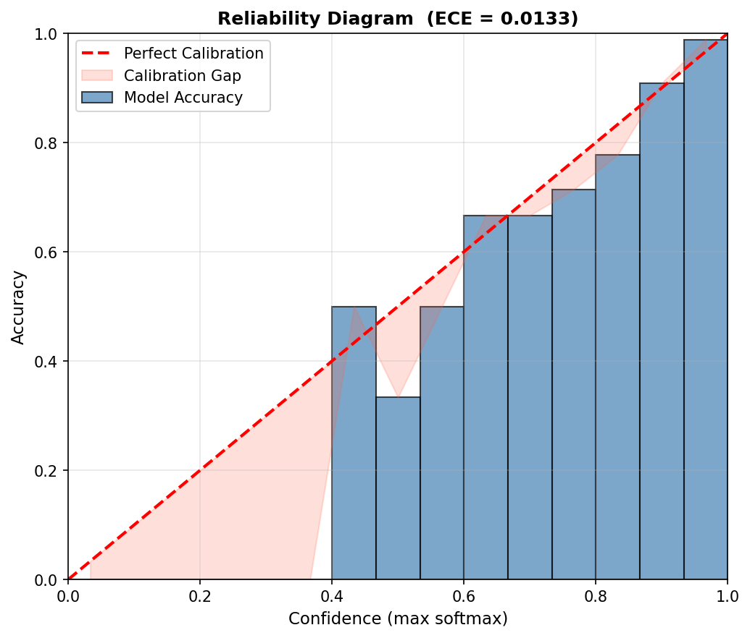

5. Discussion
5.1 What Worked
The calibration result is the headline finding. An ECE of 0.0133 is not something you get from a poorly designed system — it means the model's internal confidence estimates are genuinely meaningful, which is the foundation everything else in the triage pipeline depends on. The uncertainty and OOD signals both behaved as expected, with training samples clustering at low variance and energy and test samples showing the broader spread that reflects real uncertainty on held-out data.

 | Uncertainty Signal | Separate OOD | Backbone | Cost | Evaluated On
MSP Baseline | Max softmax probability | No | ResNet / DenseNet | Very Low | CIFAR-10
Dense NN Baseline | Softmax probability only | No | Dense layers only | Low | CIFAR-10
MC Dropout (standalone) | Predictive variance across T passes | No | LeNet / VGG | Medium | CIFAR-10
ODIN [7] | Perturbed softmax score | Yes (perturbation) | DenseNet-100 | Medium | CIFAR-10
Energy-Based OOD [8] | Log-sum-exp of logits | Yes (energy score) | WideResNet | Medium | CIFAR-10 / 100
BERT + Uncertainty Head | Direct uncertainty output head | Yes (unc. head) | BERT (Transformer) | High | 20 Newsgroups
Deep Ensembles [9] | Inter-model disagreement (M models) | No | M x LeNet / ResNet | Very High | CIFAR-10 / MNIST
Our Framework | MC Dropout + Energy Score + AE Recon. Error (3 signals) | Yes (3 signals) | Custom CNN + AE (from scratch) | Medium | Brain MRI (medical)
Table 4. Structural Comparison — Our Framework vs Existing Methods

The OR-logic triage successfully isolates ambiguous cases without requiring any single signal to carry the full burden alone. Transfer learning from EfficientNetB0 held up well despite the domain difference between natural images and MRI, and the CLAHE preprocessing appears to have helped the model handle the contrast inconsistencies inherent in multi-scanner MRI data.
5.2 What Did Not Work and Why
The validation instability is the clearest weak point. The gap between training and validation performance, and the spikes in validation loss, point to overfitting on a dataset that is genuinely small for the depth of model being used. Transfer learning and augmentation reduced the problem but did not eliminate it. A second limitation is the fixed nature of the triage thresholds. Calibrating them to the 95th percentile of training-set scores is transparent and reproducible, but it means the thresholds are tied to one specific data distribution. Deploy this framework in a hospital using a different scanner or imaging protocol and the thresholds may no longer be appropriate without recalibration. Third, the autoencoder works at the pixel level — and in MRI, a lot of clinically meaningful information lives in subtle intensity gradients and structural spatial relationships that a pixel-level reconstruction loss may not capture precisely enough to catch every meaningful distribution shift.
5.3 Where This Goes Next
Three directions stand out. First, cross-validation across multiple train-test splits would give more reliable performance estimates and make the results less dependent on one particular random split — important for a dataset of this size. Second, the framework needs to be tested against genuinely external OOD data — non-neurological brain scans, scans from different scanner manufacturers, or images from entirely different imaging modalities — to measure how well the triage system catches real-world distribution shifts rather than just statistical variation constructed from the same dataset. Third, adding Grad-CAM visualisations would let clinicians see not just a confidence score but a spatial heatmap of which region of the MRI drove the classification decision. That shifts the system from a black box that outputs a number to something a radiologist can actually interrogate — and in a clinical setting, that difference matters enormously.

References
[1] C. Guo, G. Pleiss, Y. Sun, and K. Q. Weinberger, “On calibration of modern neural networks,” in Proc. 34th Int. Conf. Mach. Learn. (ICML), vol. 70, Sydney, NSW, Australia, Aug. 2017, pp. 1321–1330.
[2] H. Wei, R. Xie, H. Cheng, L. Feng, B. An, and Y. Li, “Mitigating neural network overconfidence with logit normalization,” in Proc. 39th Int. Conf. Mach. Learn. (ICML), vol. 162, Baltimore, MD, USA, Jul. 2022, pp. 23631–23644.
[3] Y. Xiao, Z. Ji, Q. Zhang, T. Liu, and B. Han, “Alignment for honesty,” arXiv preprint arXiv:2312.07000, Dec. 2023. [Online]. Available: https://arxiv.org/abs/2312.07000
[4] G. Yarabolu, “Adaptive data segmentation for improved model performance under distribution shift,” in Proc. 2024 Int. Conf. Mach. Learn. Appl. (ICMLA), Miami, FL, USA, Dec. 2024, pp. 1–6.
[5] S. Ao, C. Ruber, B. Bhatt, and A. Weller, “Are Vision Transformers calibrated?,” arXiv preprint arXiv:2210.06384, Oct. 2022. [Online]. Available: https://arxiv.org/abs/2210.06384
[6] Y. Gal and Z. Ghahramani, “Dropout as a Bayesian approximation: Representing model uncertainty in deep learning,” in Proc. 33rd Int. Conf. Mach. Learn. (ICML), vol. 48, New York, NY, USA, Jun. 2016, pp. 1050–1059.
[7] S. Liang, Y. Li, and R. Srikant, “Enhancing the reliability of out-of-distribution image detection in neural networks,” in Proc. 6th Int. Conf. Learn. Representations (ICLR), Vancouver, BC, Canada, Apr. 2018. [Online]. Available: https://openreview.net/forum?id=H1VGkIxRZ
[8] W. Liu, X. Wang, J. Owens, and Y. Li, “Energy-based out-of-distribution detection,” in Advances in Neural Information Processing Systems (NeurIPS), vol. 33, Vancouver, BC, Canada, Dec. 2020, pp. 21464–21475.
[9] B. Lakshminarayanan, A. Pritzel, and C. Blundell, “Simple and scalable predictive uncertainty estimation using deep ensembles,” in Advances in Neural Information Processing Systems (NeurIPS), vol. 30, Long Beach, CA, USA, Dec. 2017, pp. 6402–6413.

