# Hints : Lab2

1. Include the GPIO framework to the project by this procedure:

Select the project and click Framework menu then click Select Drivers/Components/Services

Click Next and the select GPIO.

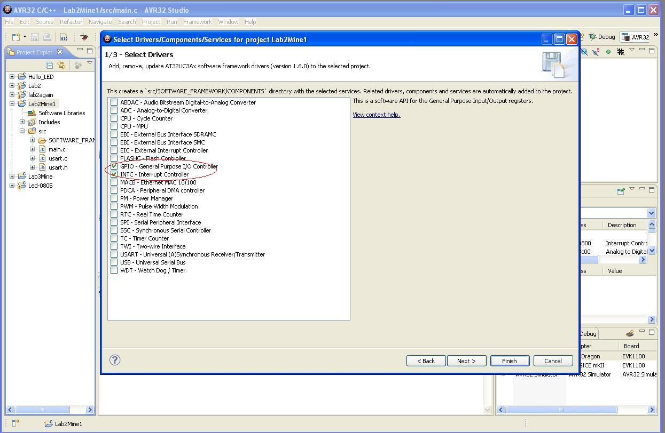

1. Sometimes the GPIO stops working and there come a lot of compilation errors, most of them relate to the gpio.h file. In that case create a new project and copy your main file and other files to it. I think it is a bug in the developer environment.

## Serial Communication for Linux:

When connecting terminal thru a serial connection do the following setting: it is example of cutecom in linux:

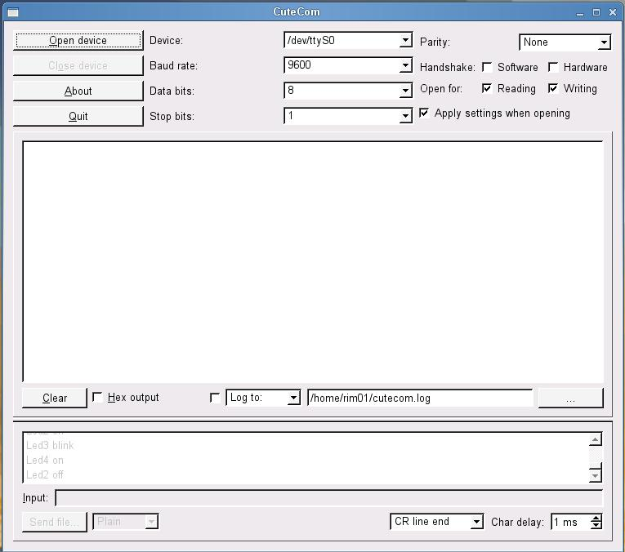

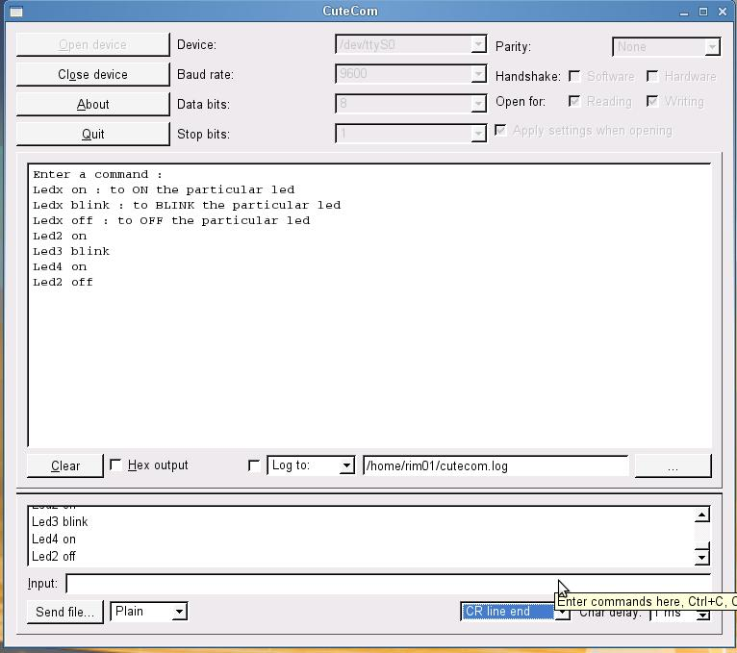

Send ‘\r’ when u want the cursor to come at the start of the next line (\n is used in C) in the hyper terminal.

## Serial communication in Windows

You can use teratem terminal and do the following setting:

Check the COM port on which your serial cable is connected. Give that COM port as shown in the following figure:

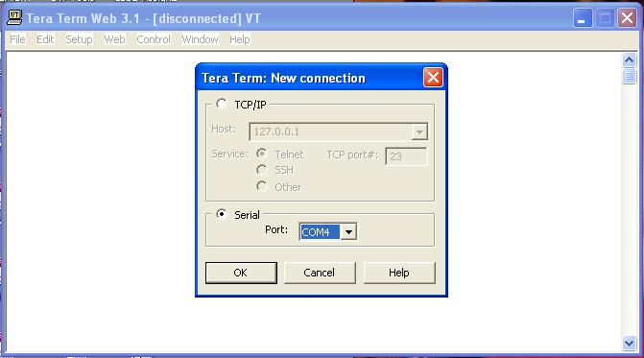

Click on the Setup/SerialPort… and do the following settings:

