### Techstack included in the project:

* Protractor using Jasmine
* JavaScript
* POM design pattern
* Data driven using Json
* Allure Report

-----------------------------------------------------------------------------------------------------------

### **Project Design**

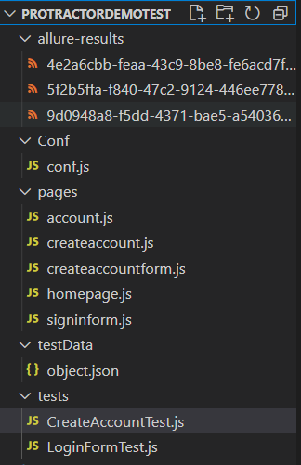

Conf/Conf.js:

Execution begins with this file, here we specify the name of browser, spec file to execute, framework to use…etc

Using Jasmine Framework, and doing the parallel execution with two spec file here and also headless browser execution it supports.

Pages/account.js, Createaccount.js, createaccountForm.js, homepage.js, signinform.js:

As we are following the POM design pattern, so that we have page respective class contains the locations and methods

testData/object.json:

Test data maintaining in object.json file, we are avoiding the hardcode test data for an test cases

Tests/createaccounttest.js, LoginFormTest.js:

Written JavaScript based test script inside these .js file using Jasmine framework

Allure result:

Allure html report created using protractor

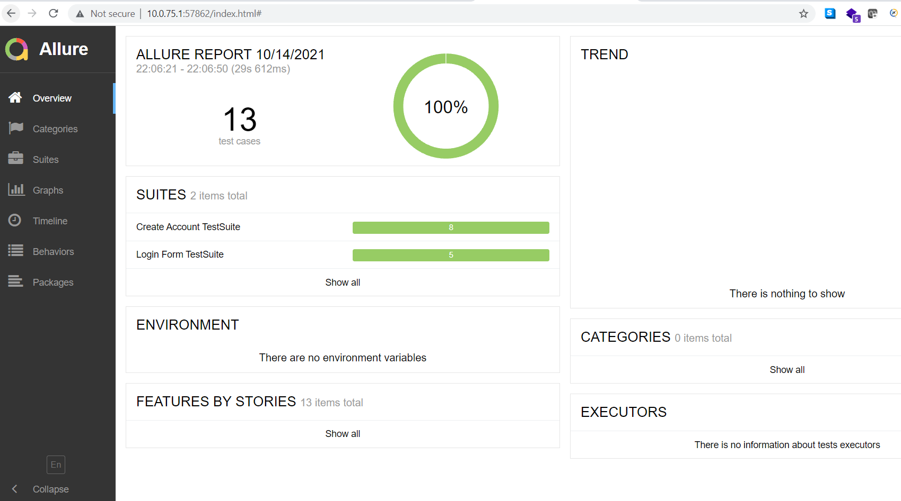

* Headless mode works which need lower version of chrome browser
* Parallel execution done by using multicapabilities in Conf.js
* Framework support of execution on chrome and Firefox browser
* By hitting below command begins the executions of CreateAccountTest.js and LoginFormTest.js parallely

protractor .\Conf\conf.js

