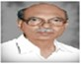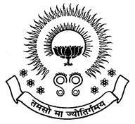PBRVITS Alumni Association

**ALUMNI ASSOCIATION CELL**



**AAC HANDBOOK**

**ALUMNI ASSOCIATION CELL**

**Objectives :**

* Expanding & updating the database of ALUMNI.
* Providing the alumni the information about the programs & events conducted in college.
* To promote fellow feeling amongst ALUMNI.
* To bring together the ALUMNI of the college by arranging frequent meetings.
* To assist in campus recruitments, suitable placements & training for the students.
* Setup guidance cell to aid present & past students.

#### Alumni Meet

Every year an ALUMNI MEET is conducted to bring together the ALUMNI of the college.

#### Alumni Database

An alumni database has been maintained at present in which almost all the alumni have registered as life time members.

#### Alumni E-Group

Alumni e-Group has been created

#### Alumni Website

**LIST OF MEMBERS**

|  |  |  |  |  |  |
| --- | --- | --- | --- | --- | --- |
| Name in block letter & s/o,W/o | Age | Designation | Occupation | Residential  Address | Signature |
| Vemula.V.Sunil Kumar  S/O Mala Kondrayudu | 33 | PRESIDENT | Associate Professor,PBRVITS,kavali | 9-27-31A  Om santhi street  Kavali-524201 |  |
| Javangula.Vamsinath  S/O J.Venkata Narasimha Rao | 30 | VICE PRESIDENT | Associate Professor,PBRVITS,kavali | 3-8-22,  vishnalayam Street,  Kavali-524201 |  |
| Chittimuri. Srinivasulu Reddy  S/O Ch.Venkata Rami Reddy | 34 | SECRETARY | Associate Professor,PBRVITS,kavali | 5-1-34A,old town,  Kavali-524201 |  |
| K. Manoj Siva Kumar | 30 | JOINT  SECRETARY | AssistantProfessor  PBRVITS,kavali | 3-14-9  Boddukuri vari street,  Kavali-524201 |  |
| Nosina. Krishna Chaithanya  S/O N.Seshaiah | 33 | TREASURER | Associate Professor  PBRVITS,kavali | 25-7-558,C-block, vengalarao nagar, dycus road,  Nellore-524004 |  |
| Ch.V.S.Parameswara Rao  S/o Ch.Subba Rao | 48 | EXECUTIVE  MEMBER | PRINCIPAL  PBRVITS,kavali | Plot no-401,  Sai meadows,  Kavali |  |
| Vemuri.Phani Bhushan  S/O V.Subramanyam | 43 | EXECUTIVE  MEMBER | HOD,ECE Dept.  PBRVITS,kavali | 11-33-990/c  Balaji Street,  Vengala rao nagar  Kavali-524201 |  |
| Bade.Konda Reddy  S/O B.Mala konda reddy | 38 | EXECUTIVE  MEMBER | HOD,Mechanical Dept  PBRVITS,kavali | 11-40  Near water tank,  Bapuji nagar,  Kavali-524201 |  |
| Dodla.Srujan Chnadra Reddy  S/O D.Manohar Reddy | 38 | EXECUTIVE  MEMBER | HOD,CSE Dept.  PBRVITS,kavali | 4-14-38  Old town,  kavali |  |

Signature of the President

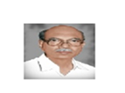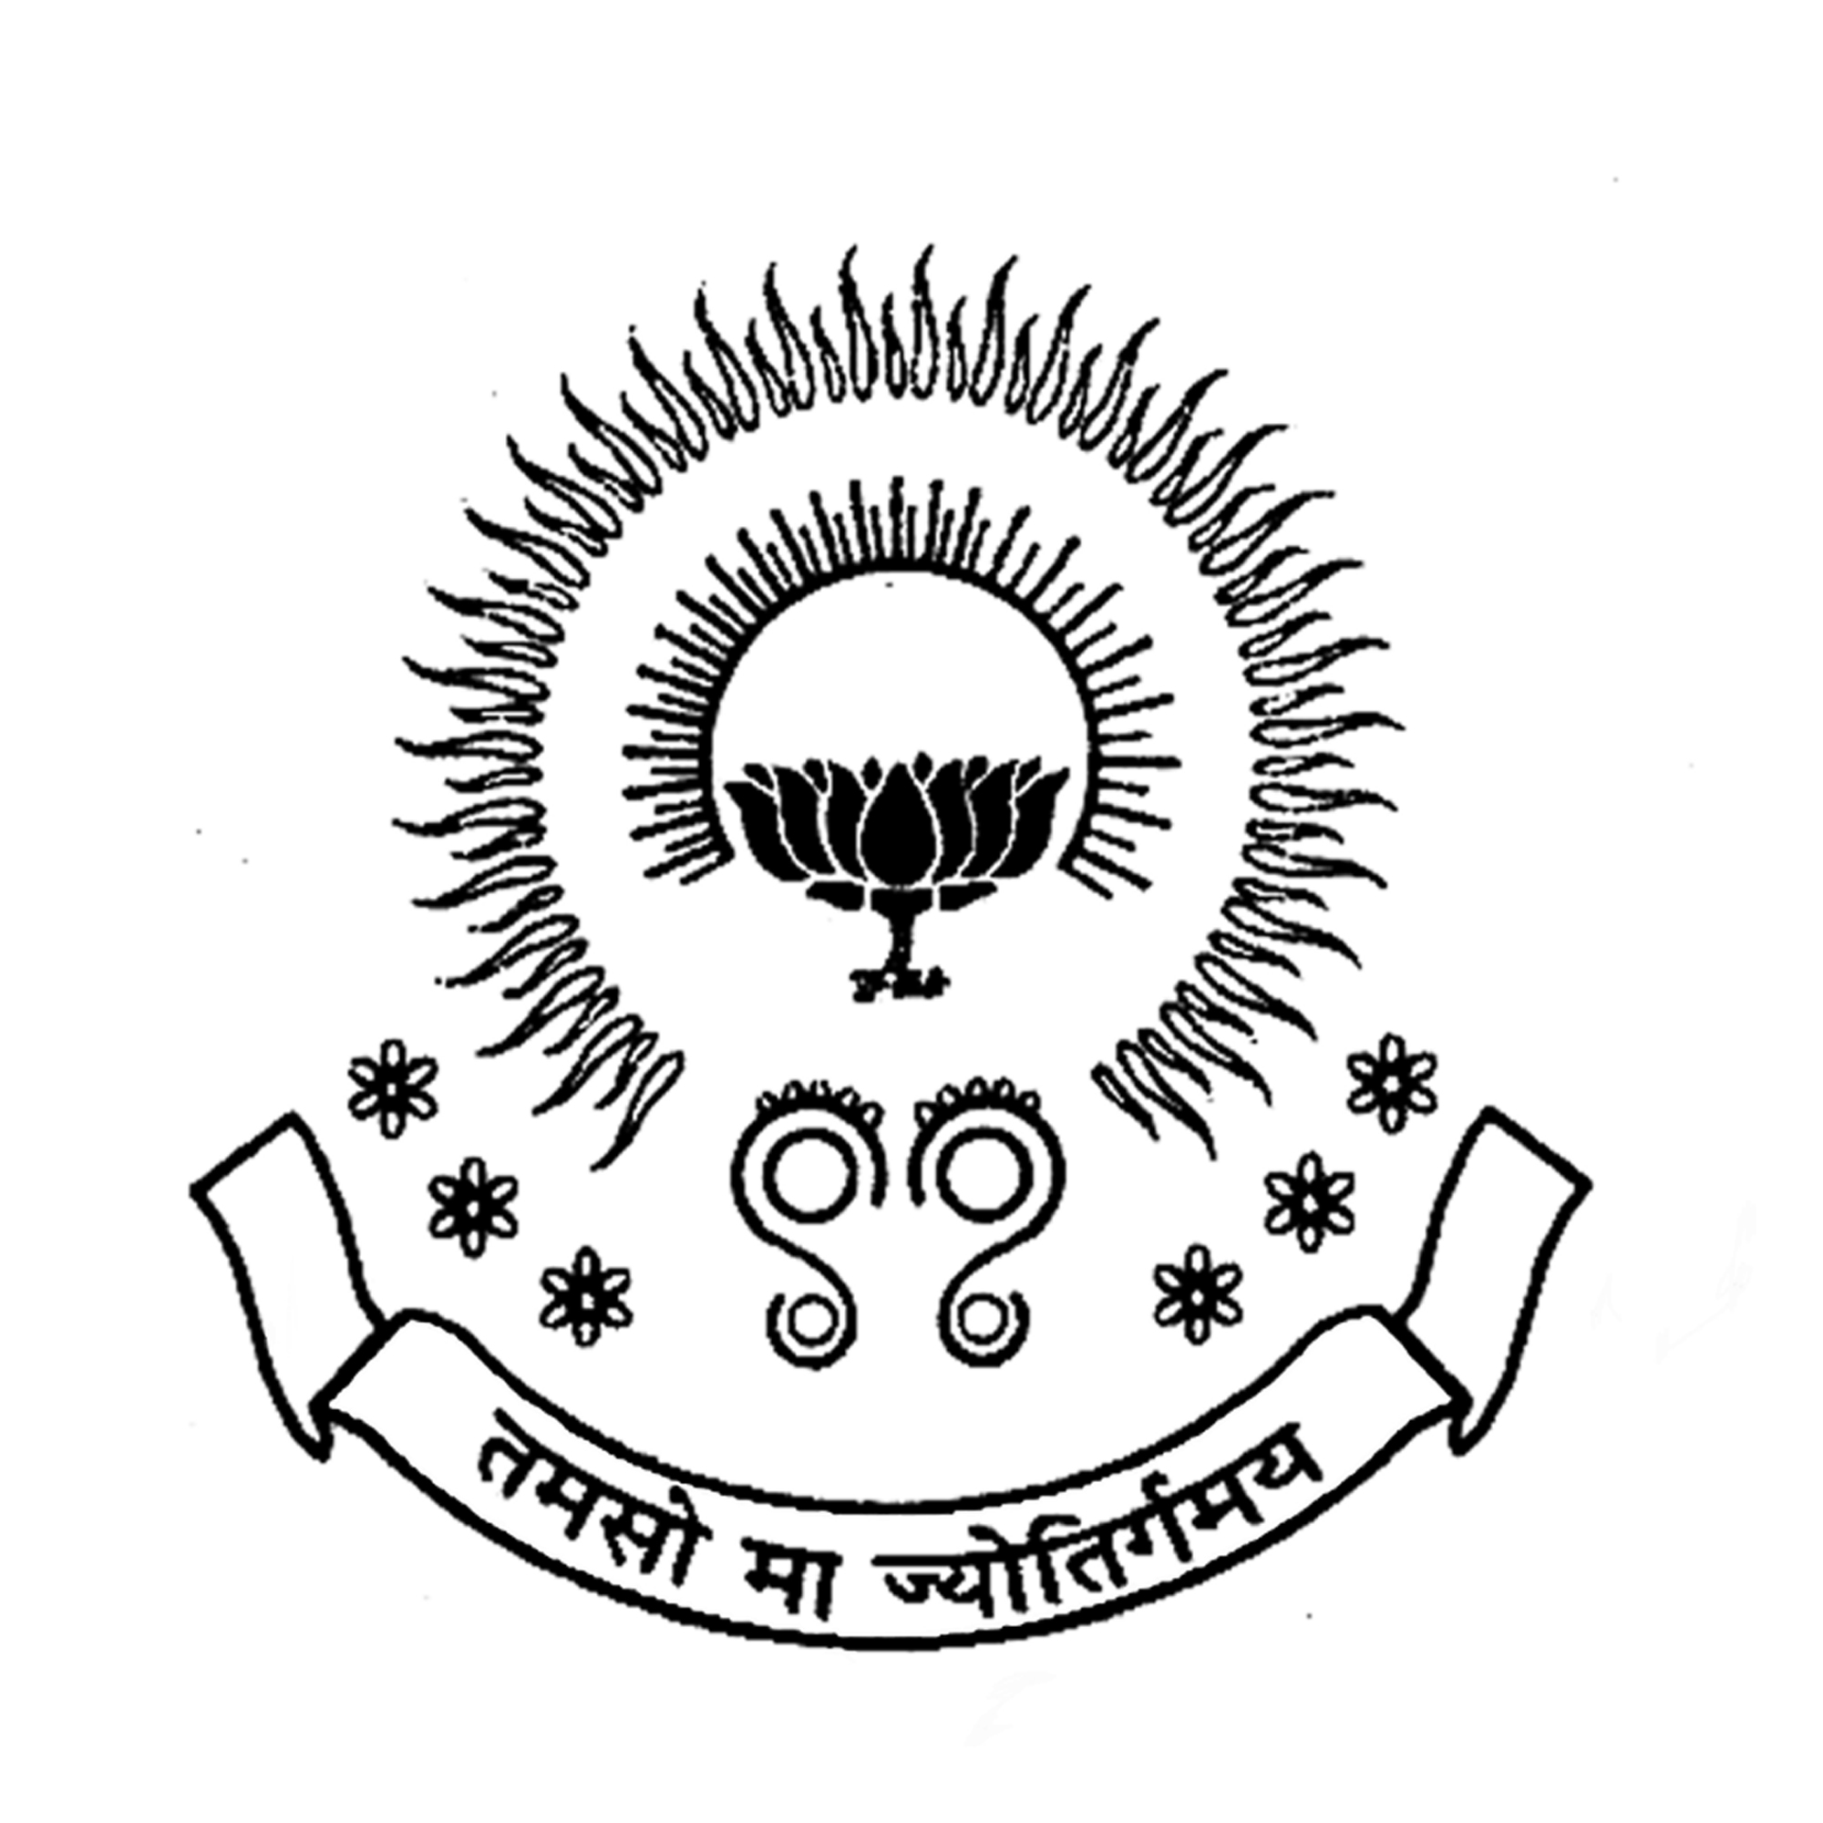 **PBR VISVODAYA INSTITUTE OF TECHNOLOGY & SCIENCE**

**KAVALI**

*(Affiliated to J.N.T.U.A., Anantapuram and Approved by AICTE, New Delhi)*

**ALUMNI ASSOCIATION CELL**

**Minutes of Meeting**

**Date: 06-11-2017**

**Opening:**

The regular meeting was called by the co-ordinator of AAC to order at 11.00 AM on 06-11-2017.

**Present:**

1. V.V.Suneel Kumar ( President, AAC PBRVITS )
2. J. Vamsinath( Vice President, AAC PBRVITS )
3. Ch.Srinivasulu Reddy( Secretary, AAC PBRVITS )
4. K.Manoj Siva Kumar( Joint Secretary, AAC PBRVITS )
5. N.Krishna Chaithanya(Treasurer)
6. Ch.V.S.Parameswaro Rao(Executive Member,AAC PBRVITS)

**Agenda:**

* The members of the AAC have finalized the date of Alumni meet on second Saturday of January 2018. i.e 13/01/2018 at 10.00 AM.
* Decided on Win Commander I.P.C Reddy to be the invitee.
* Committees were also formed for the smooth conduction of the Alumni meet .

|  |  |  |
| --- | --- | --- |
| **Committee** | **Incharge** | **Duties** |
| Stage | Sk.Shaheena Begum  A. Madhavarao  S.Penchal Naidu | Stage decoration, Anchoring |
| Reception | I.J Abhishita  Volunteer students | Guest receiving, Arrangements |

Meeting was adjourned at 11.45 AM by V.V Suneel kumar.

**AAC Co-ordinator**

**PROGRAM SCHEDULE OF ALUMNI MEET**

Date: 13th January, 2018

Venue: Conference hall, PBR VITS.

|  |  |
| --- | --- |
| Time | Program |
| 10:00 A.M- 10.30 A.M | Welcome by prayer |
| 10:30A.M-1:00 P.M | Lighting of the Inaugural program |
| Welcome Address by President, Chief guest, Principal, Treasure, Placement officer |
|  | Alumni Interaction |
| 1:00 P.M -2:00 P.M | Lunch |
| 2:00 P.M -3:00 P.M | Alumni Feedback |
| 3:00 P.M -4:00 P.M | Awards distributions |
| 4:00 P.M – 4:30 P.M | Vote of Thanks |

STAGE MEMBERS

1. Mr. V.V Suneel kumar, President
2. Mr. Win Commander I.P.C Reddy, Chief Guest
3. Ch.V.S.Parameswara Rao, Principal
4. N.Krishna Chaithanya, Treasurer
5. Mr. B. Vamsee Mohan ,Placement officer

* The program conducted successfully by 10:30 A.M with the grace presence of all dignitaries and Alumni students.
* Total 110 students attended the meet from various outstations, companies and with different profiles. In response, few of the alumni shared their experience as well as intresting moments of campus life to the audience.
* A delicious lunch was served for all the alumni members at the end of alumni reunion.
* Thank you one and all for being a part of the alumni Reconnect program. The occasion was successfully ended.

|  |  |  |  |  |  |  |
| --- | --- | --- | --- | --- | --- | --- |
| **YEAR** | **Date of conduction** | **No. of Alumni’s Attended** | | | | **TOTAL** |
| **CSE** | **ECE** | **EEE** | **ME** |
| **2015** | **09/01/2016** | **30** | **35** | **20** | **10** | **95** |
| **2016** | **14/01/2017** | **36** | **35** | **18** | **13** | **102** |
| **2017** | **13/01/2018** | **38** | **34** | **23** | **15** | **110** |

**Summary Table**

**AAC Co-ordinator**

**Suggestions**

* Suggestions for upgradation of new technologies.
* Providing helping hands for the needs.