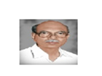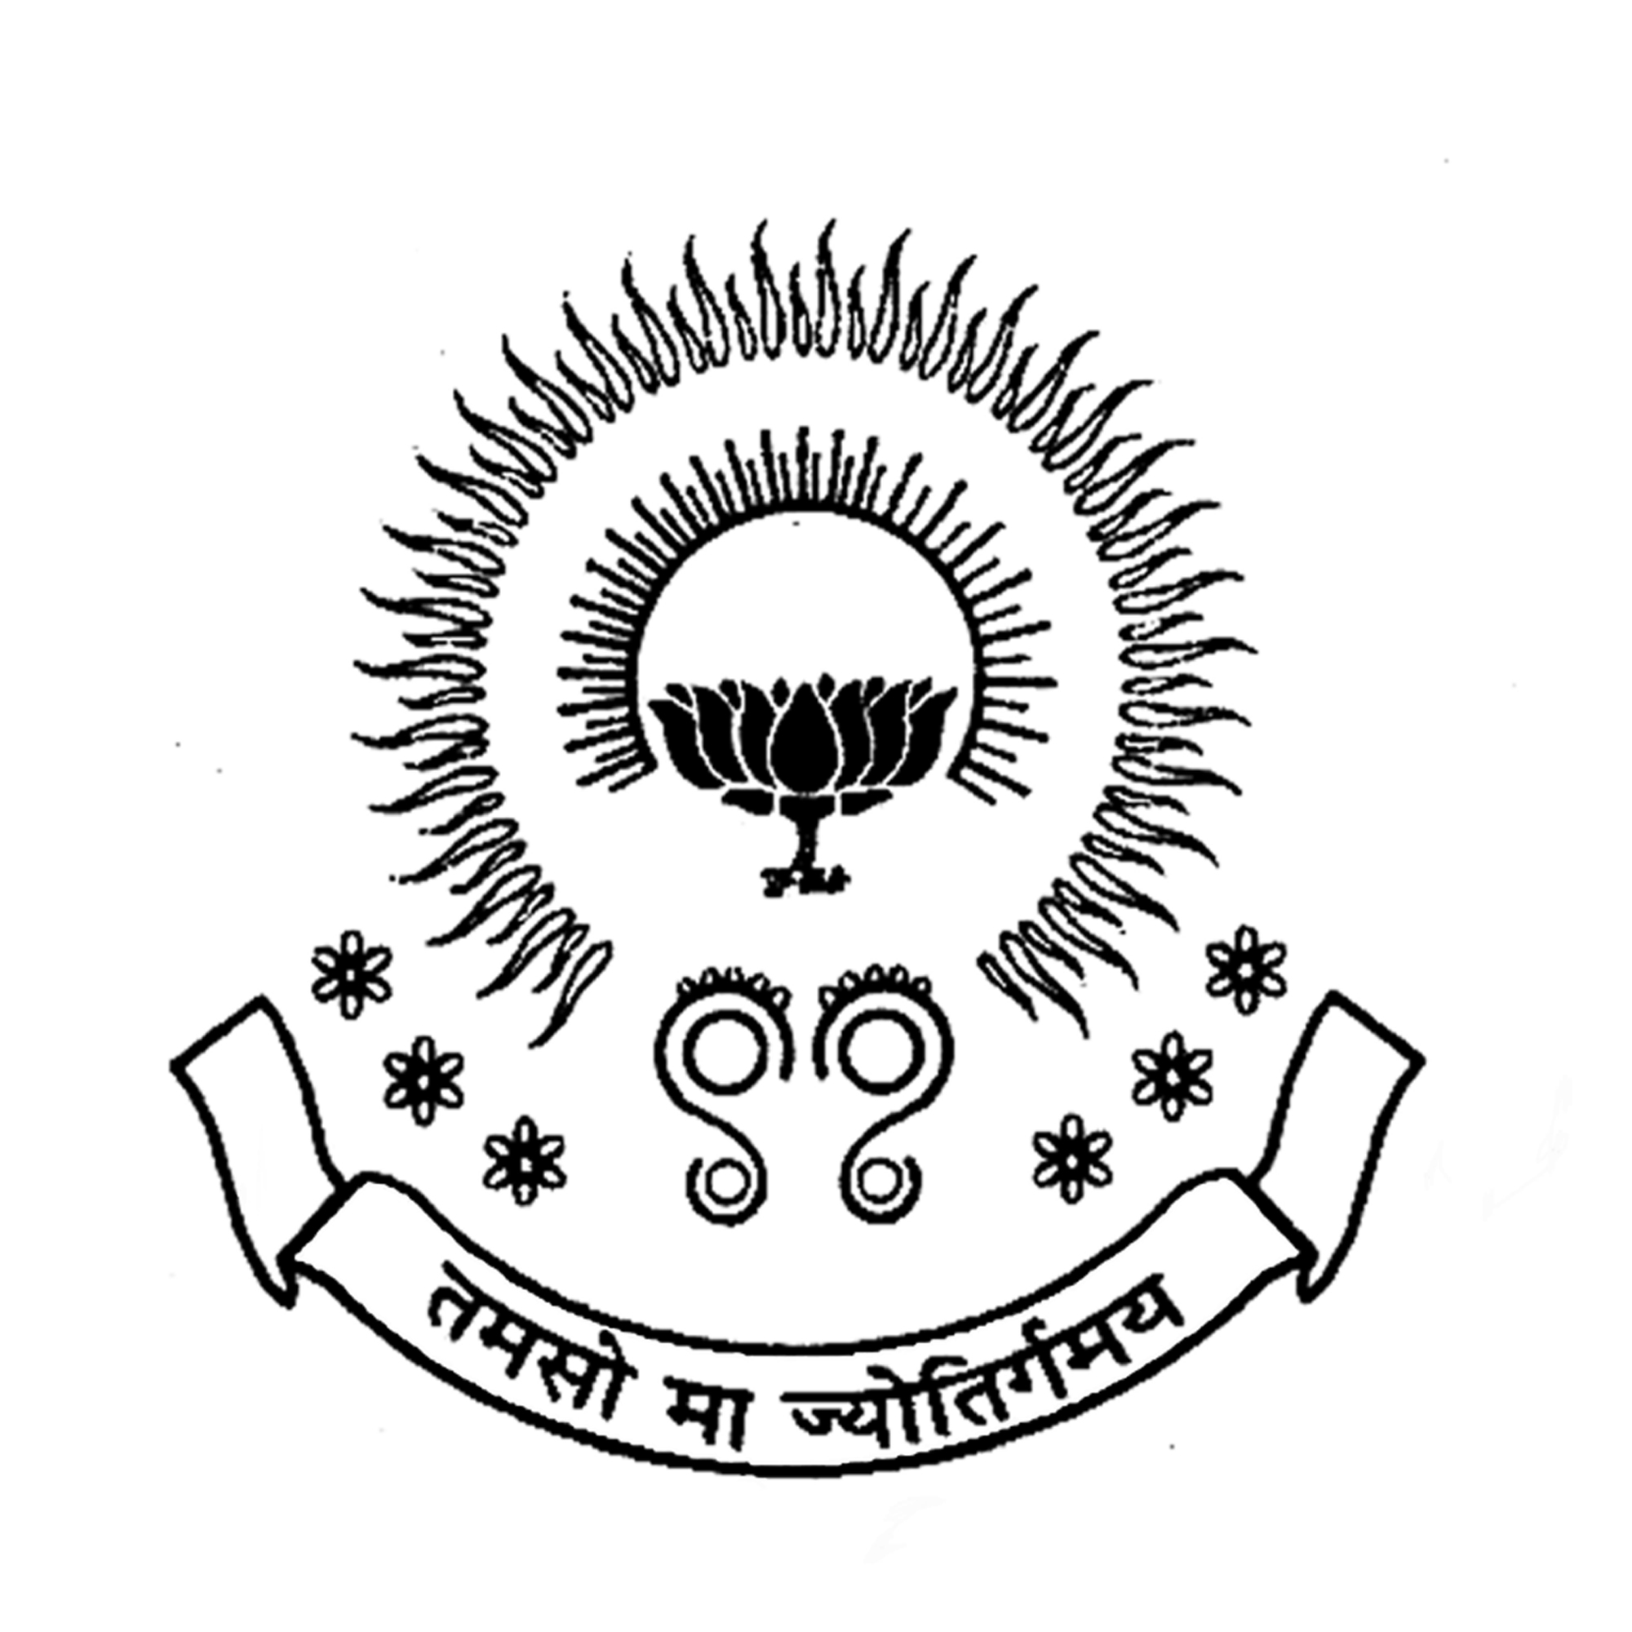 **PBR VISVODAYA INSTITUTE OF TECHNOLOGY & SCIENCE**

**KAVALI**

*(Affiliated to J.N.T.U.A., Anantapuram and Approved by AICTE, New Delhi)*

**ALUMNI ASSOCIATION CELL**

**Minutes of Meeting**

**Date: 30-12-2021**

**Opening:**

The regular meeting was conducted by the coordinator of Alumni Association Cell at 4.00 PM on [28-12-2021](mailto:28-12-2021@4.00pm) through online via <https://meet.google.com/cvz-seky-daf>

**Details:**

PBRVITS ALUMNI MEET-2021  
Tuesday, December 28 · 4:00 – 6:00pm  
Google Meet joining info  
Video call link:

<https://meet.google.com/cvz-seky-daf>

Total 235 alumni attended the meet from various outstations, companies and with different profiles. In response, few of the alumni shared their experience as well as interesting moments of campus life to the audience.

**Discussions**

* Applied for Alumni society registration.
* Discussed about Higher educations.
* Training sessions for Fresher graduates to introduce them to Industrial sector.

**Coordinator**

**Alumni Association Cell**