How to run the Staff Leave Management System Django Python

1. Download the zip file

2. Extract the file , copy staffleave folder and paste on the desktop

3. Open PyCharm and click on the terminal

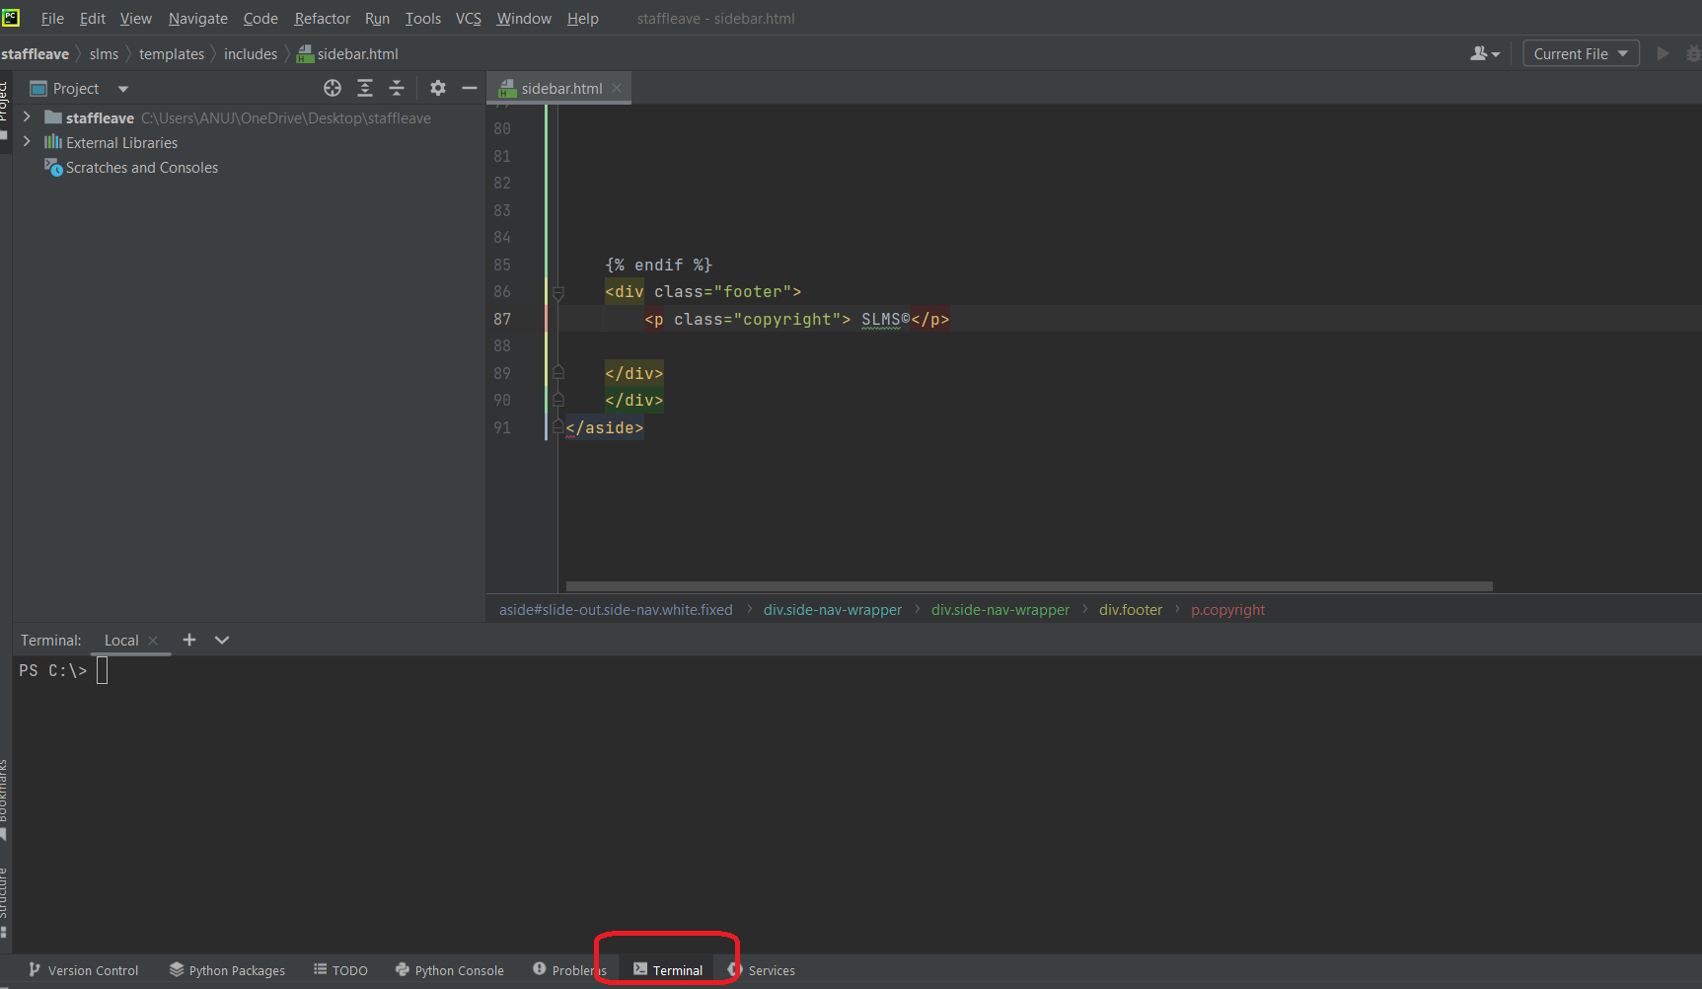

4. Go to the desktop->staffleave->slms directory using cd command as below

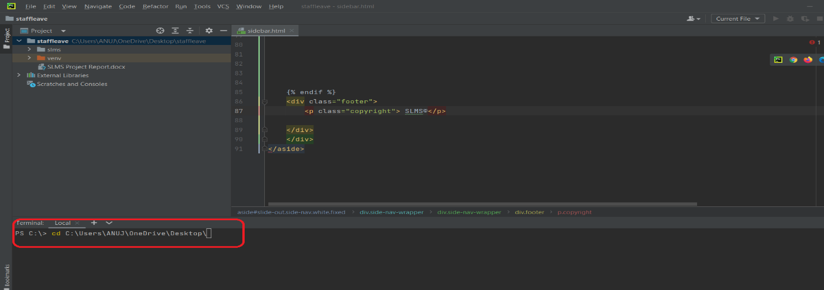

5. Go to the desktop->staffleave->slms directory using cd command and run the server using command

Python manage.py runserver

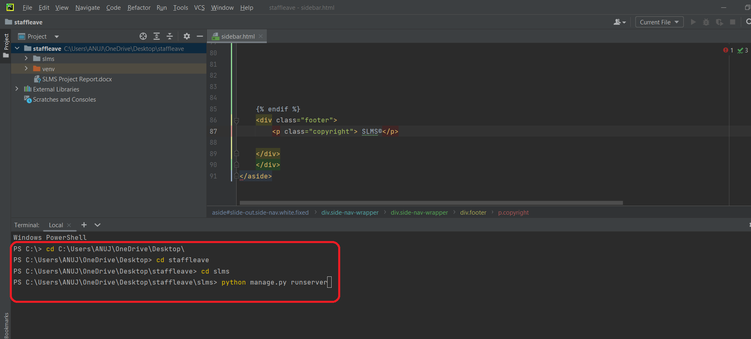

After running the above command you will get the below screen

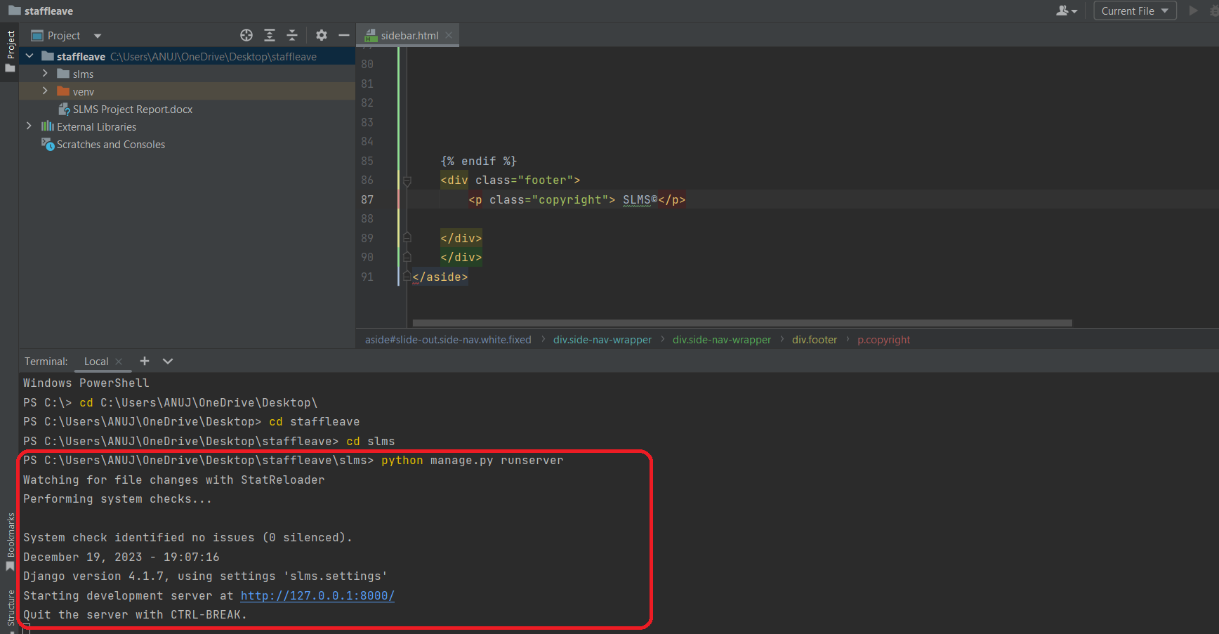

Now click the url <http://127.0.0.1:8000> and Project will Run

