**A PROJECT REPORT ON**

# SEISMIC ANALYSIS AND DESIGN OF A BUILDING USING STAAD PRO

***Submitted in partial fulfillment of the requirement for the award of the Degree in***

**BACHELOR OF TECHNOLOGY**

**IN**

**CIVIL ENGINEERING**

**Submitted by**

|  |  |
| --- | --- |
| **Potluri Anudeep (18501A0145)**  **Naveen Shiju Joseph(18501A0133)** |  |

## K. Jaya Rama Chandra Prasad ( 18501A0120)

## P. Sai Likhith (18501A0135)

## K. Nitin Chowdary (18501A0121)

**Under the Esteemed Guidance of Mr. K. V. SUBASH , M. Tech, (Ph.D)**

**Assistant Professor**



**DEPARTMENT OF CIVIL ENGINEERING PRASAD V. POTLURI SIDDHARTHA INSTITUTE OF**

**TECHNOLOGY(AUTONOMOUS)**

**Affiliated to JNTU Kakinada, Approved by AICTE, New Delhi Accredited by NBA & NAAC A+, ISO 9001:2015 Certified Institution KANURU, VIJAYAWADA-520007**

**2021-2022**

**PRASAD V. POTLURI SIDDHARTHA INSTITUTE OF TECHNOLOGY**

**(Autonomous) DEPARTMENT OF CIVIL ENGINEERING**

**KANURU, VIJAYAWADA-520 007**



CERTIFICATE

## This is to certify that the Project work entitled “SEISMIC ANALYSIS AND DESIGN OF A BUILDING USING STAAD PRO” is a record of bonafide work carried out by

## P. Anudeep (18505A0145),Naveen Shiju Jeseph (18501A0133), K.Jaya Rama Chandra Prasad (18501A0120),P. Sai Likhith(18501A0135), K. Nitin Chowdary (18501A0121)

## for the award of BACHELOR OF TECHNOLOGY degree in CIVIL ENGINEERING at Prasad V. Potluri Siddhartha Institute of Technology is a record of student’s work carried out under our supervision and guidance during academic year 2021-2022.

**Mr. K.V. SUBASH (Dr. K. Ramesh)**

**Project Guide Head of the Department**

**External Examiner**

**DECLARATION**

**This is to certify that the Major project report entitled “SEISMIC ANALYSIS AND DESIGN OF BUILDING USING STAAD PRO” written and submitted by us is an original work done under the guidance of Mr. K.V. SUBASH is submitted in partial fulfillment of the requirements for the award of the Degree of Bachelor of Technology in Civil Engineering. This is a record of bonafide work carried out by us and the results embodied in this Project Report have not been reproduced and copied from any source.**

**PROJECT ASSOCIATES:**

**P. Anudeep (18505A0145)**

**Naveen Shiju Joseph (17501A0133)**

**K. Jaya Rama Chandra Prasad (18501A0120)**

**P. Sai Likhith (18501A0135)**

## K. Nitin Chowdary (18501A0121)

**ACKNOWLEDGEMENT**

**The satisfaction and euphoria on the successful completion of any task would be incomplete without the mention of the people who made it possible, whose constant guidance and encouragement crowned our effort with success.**

**We would like to express our profound appreciation to our Principal Dr. K. Sivaji Babu, Principal, PVP Siddhartha Institute of Technology for extending his official support for the completion of our Major Project.**

**We express our thanks to Dr. K. Ramesh, Head of Civil Engineering Department, for all the facilities provided to successfully complete our Major project work.**

**We are deeply indebted to our Project Guide, Mr. K. V. Subash, Assistant Professor, for the motivation, guidance, tutelage and patience throughout this Major project work. We appreciate his broad range of expertise and attention to detail, as well as the constant encouragement he has given to us over the years.**

**We have immense pleasure to express my gratitude to Dr. V. Jagadish, Associate Professor, Project Coordinator of Civil Engineering, PVPSIT for his encouragement and help at many stages in the course of our B. Tech Project.**

**We are thankful to Sai Karthikeya Consultant Services, AT Agraharam, Guntur**

**- 522004, Andhra Pradesh, India for providing the guidance for our project.**

**In our association with all the above persons, we experienced not only their depth of knowledge but also affection towards us. Finally, we take this opportunity to thank one and all of our Civil Engineering Teaching & Non-Teaching Staff For their able cooperation both academic and non-academic all throughout our four years. We shall remember all our staff as long as our memory lives.**

**PROJECT ASSOCIATES:**

**P. Anudeep (18501A0145)**

**Naveen Shiju Joseph (18501A0133)**

**K. Jaya Rama Chandra Prasad (18501A0120)**

**P. Sai Likhith ( 18501A0135)**

**K. Nitin Chowdary (18501A0121)**

# ABSTRACT

Urbanization and construction of residential buildings has increased due to immense population migrating towards developing towns & cities. This project describes about the significance of setbacks as per NBC and providing the plan of the building by eliminating or counteracting the plan and elevation irregularities as per IS code 1893(1)-2016, project also describes the computerized methodology to design a safe, economical and elegant. The relevant Indian standard codes are used for design and analysis of slabs, beams, columns, footing & staircase.

The building consists of stilt+3 stories of about 15m×8m as plinth area. Site chosen consist of Hard/Rock type of soil with seismic zone 2. Preliminary dimensions were designed using IS 456. Planning considerations and analysis were done using IS 1893(1) and ductile detailing using IS 13920. The analysis, design & drawings were prepared using STAAD Pro version 22 and detailing, Bill of Quantities, Bar Bending Schedule were prepared using STAAD Advanced Concrete Design.

The region selected for our study comes under seismic zone 2 and comprises of hard/rock soil provided with the ductile detailing in order to resist against seismic forces.

CONTENTS

ABSTRACT

CHAPTER 1: INTRODUCTION Page No.

* 1. Background 1
  2. Statements of project 4

CHAPTER 2: LITERATURE 7

CHAPTER 3: CALCULATION OF PRELIMINARY DIMENSIONS

* 1. Slab 9
  2. Beam 11
  3. Column 12

CHAPETR 4: CALCULATION OF BASE SHEAR 16

CHAPTER 5: STUDY ON IRREGULARITIES & PROVIDING SETBACKS

* 1. Study on Irregularities 20
  2. Setbacks 23

CHAPTER 6: ANALYSIS USING STAAD PRO

* 1. Methodology 24
  2. Analysis Results 26

CHAPTER 7: DESIGN OF MEMBERS

* 1. Beam Design 38
  2. Column Design 42
  3. Slab Design 44

CHAPTER 8: DETAILING AND ESTIMATION USING STAAD ADVANCED CONCRETE DESIGN SOFTWARE

* 1. Beam Detailing and estimation 47
  2. Column Detailing and estimation 51
  3. Slab Detailing and estimation 59
  4. Staircase Detailing and estimation 62
  5. Footing Detailing and estimation 64

CHAPTER 9: CONCLUSIONS 68

CHAPTER 10: SUGGESTIONS 69

CHAPTER 11: REFFERENCES 70

# LIST OF FIGURES

|  |  |
| --- | --- |
| **Sl .No. Title Name** | **Page No** |
| 1) Types of seismic waves | 1 |
| 2) Plan of a Building | 9 |
| 3) 3-D Rendered view | 28 |
| 4) Loading Diagram | 29 |
| 5) Shear Force & Bending Moment Summary | 30 |
| 6) Displacement Summary | 30 |
| 7) Shear force in “Y” direction | 31 |
| 8) Shear force in “Z” direction | 32 |
| 9) Bending Moment in “Z” direction | 33 |
| 10) Bending Moment in “Y” direction | 34 |
| 11) Displacement Diagram | 35 |
| 12) Plate Results | 36 |
| 13) Base Shear values from Staad output file | 37 |
| 14) Model highlighting beams and columns | 38 |
| 15) Model highlighting slab panel | 44 |
| 16) Detailing of Beam | 47 |
| 17) Detailed Drawing of a Beam | 48 |
| 18) Bar Bending Schedule | 49 |
| 19) BOQ of Beams | 50 |
| 20) Typical detailing of columns 1, 2 &3 | 51 |
| 21) Typical detailing of columns 4, 5, 6 & 7 | 52 |
| 22) Typical detailing of columns 8 to 11 | 53 |
| 23) Typical detailing of columns12 to 15 | 54 |
| 24) Typical detailing drawings of column | 55 |
| 25) BBS of Column 5 | 57 |
| 26) BOQ of Columns | 58 |
| 27) Top view of slab | 59 |
| 28) Detailing of slab panels | 60 |
| 29) BBS of Slab | 60 |
| 30) BOQ of Slab in one floor | 61 |

|  |
| --- |
| 31) Loading and Design of staircase slab 62 |
| 32) Detailed Drawings of staircase slab 63 |
| 33) Footing Marking 64 |
| 34) Bar Bending Schedule of Footing 12 64 |
| 1. Detailing of Footings 65 2. Cross – Section of Footing 12 66 |
| **LIST OF TABLES**  **Sl .No. Title Name Page No**   1. Moment Magnitude Scale 2 2. Classification of types of soils as per table 4 of 1893(1)-2016 6   **LIST OF MAPS**  **Sl .No. Title Name Page No**  1 Seismic Zoning Map 3 |

**CHAPTER 1: INTRODUCTION**

## Background:-

The shaking of the earth surface is called as an earthquake resulting from the sudden release of energy from earth’s lithosphere. Earthquakes may occur due to colliding of tectonic plates, some manmade causes like mine blasting. There are two types of earthquakes like inter plate earthquakes and intraplate earthquakes, out of these intraplate i.e., occurrence of earthquakes within the plate are more frequent than compared with inter plate earthquakes. There are some secondary effects of the earthquakes like ‘Tsunamis’, landslides and volcanic activities.

Earthquakes may occur naturally or by the human activities of like mine blast, nuclear tests. Mostly the earthquakes are due to rupture of geological faults which belong to the category of intraplate earthquakes.

Initial point of rupture of earthquake is called as “Focus” which is also called as Hypocenter and the point above the focus on the ground surface is called as “Epicentre”. Generally there are two kinds of earthquakes depending on the movement of the released energy. They are surface waves and body wave. P-waves and S- waves are the examples of body waves and Rayleigh’s waves and Love waves which are surface waves which are shown in figure 1. Out of these, surface waves will cause more damage to the structures.

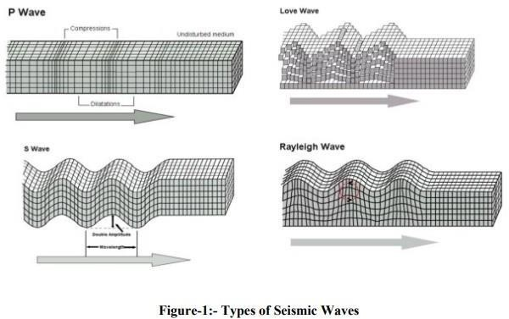

The moment magnitude scale is a measure of an [earthquake'](https://en.wikipedia.org/wiki/Earthquake)s magnitude based on its [seismic](https://en.wikipedia.org/wiki/Seismic_moment) [moment](https://en.wikipedia.org/wiki/Seismic_moment). It was defined in a 1979 paper by [Thomas C. Hanks](https://en.wikipedia.org/wiki/Thomas_C._Hanks) and [Hiroo Kanamori.](https://en.wikipedia.org/wiki/Hiroo_Kanamori) Moment magnitude is considered the authoritative magnitude scale for ranking earthquakes by size as mentioned in table 1. It is more directly related to the energy of an earthquake than other scales, and does not saturate i.e., it does not underestimate magnitudes as other scales do in certain conditions.

## Table: 1- Moment Magnitude Scale

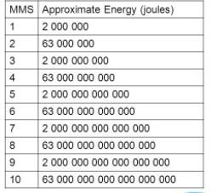

Structures can be constructed either earthquake resistant or earthquake proof structures. Usually earthquake resistant design is given to residential buildings and earthquake proof design is given to the important structure which has of high significance and their performance is required even after the impact major seismic forces. Comparatively resistant structures are cost effective that earthquake proof design. Some common examples of proof structures are hospitals, water tanks, nuclear power plants etc.

The common procedure of designing is first calculating the preliminary dimensions of slabs, beams, columns by using IS 456 and thumb rules, secondly the calculated preliminary dimensions are analyzed in software and checked whether the members are passing are not during the analysis stage, if so then their dimensions can be increased by trial and error method followed by design and detailing.

Analysis can be performed by two methods i.e., static analysis or dynamic analysis based upon the soil classification, building height, seismic zoning, regularity and irregularity of the building. And the results form the analysis is used for designing.

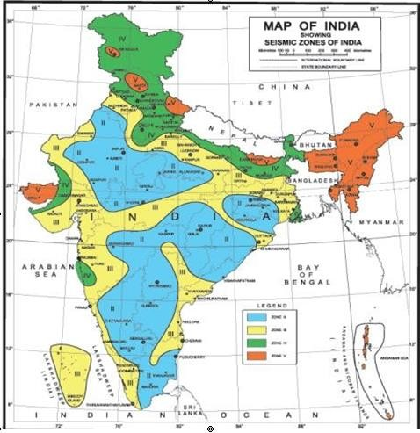

**MAP 1**

## Statement of project:-

Utility of building : Residential Building No. of stories : Stilt + 3

Plot area : 14 m × 25.5 m

Plinth area : 8m × 15m Setbacks are provided as per NBC- 2016 Building is adjacent to 4m wide road No. of Stair cases 1

Type of Construction : Special Moment RC Resisting Frame Type of Walls : Brick Wall

230 mm thickness for outer walls

130 mm thick wall for internal partition walls

Geometric Details:

Floor to Floor Height: 3 m Materials:

Concrete : M 25

Main Steel : Fe 415 Unit weight & Loading:-

Unit weight of RCC : 25 KN/m2 Unit weight of Brick Wall : 19 KN/m2 Live Load : 2 KN/m2

Floor Finish : 1 KN/m2

Foundation & Soil classification:-

Soil Type: Hard / Rock soil as mentioned in Table 2. Assuming Bearing Capacity of Soil: 170 KN/m2 Seismic Zone: 2 as shown in Map1

Isolated Footing

Cost assumed for various elements:- Shuttering : 600 / m2

Excavation : 350 / m3 Backfill : 250 /m3

PCC : 4500 / m3

RCC : 6500 / m3

Auto Load combination was used

Assuming that continuous water supply system is provided by the local authorities

Assuming that sewerage system is also being present and hence not performed design for septic tank or dispersion trench.

**Table 2 – Classification of types of soil as per 1893(1)-2016**

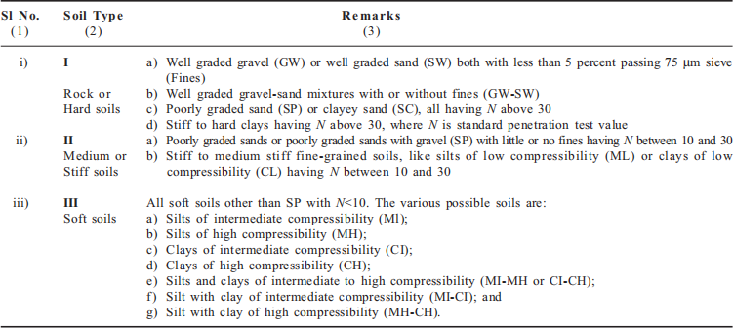

# CHAPTER 2: LITERATURE

**IS1893-2016(1):-**

This standard deals with assessment of seismic loads on various structures and earthquake resistant design of buildings. Its basic provisions are applicable to buildings. Temporary elements such as scaffolding, temporary excavations need not be designed for earthquake forces.

## Study on Static & Dynamic Analysis of Multi-Storied Building in Seismic Zones (MV Naresh and KJ Brahmachari- 2009):-

For high rise buildings Static analysis is not enough it’s necessary to provide dynamic analysis. Base Shear reverence is more in the zone 5 and that in the delicate soil in unpredictable setup.

**NICEE, IITK:-**

National Information Center of Earthquake engineering it was hosted at IIT Kanpur. It handles all the data regarding earthquakes and conducts experimental works and provides workshops and collects information and maintains to mitigate earthquake disaster in India.

**IS 4326 - 2013:-**

This code provides guidelines for earthquake resistant buildings constructed using masonry, timber and also buildings with prefabricated flooring and buildings with prefabricated roofing elements.

## Study of Suitable Foundation in Seismic Zone3 Considering SSI (M. Manjari , Hanumantarao Chappidi 2017):-

The soil structure interaction must be considered in seismic analysis. By using stripped foundation shear force is about 85% less than that of isolated foundation and bending moment is less that 95% of isolated foundation. Therefore out of strip and isolated foundation strip foundation is found to be more effective.

## Proposed codal provisions for design & detailing – beam column joint in seismic region (Sudhir K. Jain, R.K Ingle & Goutam Mondal):-

In this article we have identified the importance of beam column joint design and its detailing in moment resisting frame. Also identified the importance of shear of beam column joint and anchorage design.

## IS 456-2000 (Reaffirmed 2021):-

This standard deals with the general structural use of plain and reinforced concrete. Based on these codal provisions we calculated the preliminary dimensions of members. Followed by analysis and design by taking appropriate IS codes.

## A Comparative Study on Static & Dynamic Analysis of High Rise Building with & without Open Ground Storey (Surjeet Kumar, Shubbam Srivastava & Zain -2017) :-

The results of equivalent static analysis are approximately uneconomical because values of displacements are higher than dynamic analysis. In both the analysis it’s found that the column forces at ground storey increases for the presence of infill’s in upper storey’s. Also identified that bare frame structures lead to under estimation of base shear which is to be avoided.

**IS 13920 - 2016:-**

This code covers specifications for designing and detailing of members of R.C. structures in order to resist lateral effects of ground shaking. The provisions of this code are can be taken as a guide for R.C.Bridge piers and wells of large cross-sections.

## A Review on Shear wall in High Rise Buildings (DR. Krishna Murari, Sonali Pandey December 2017):-

The shear wall at adequate locations will reduce the displacement due to lateral forces such as wind and seismic forces. Also from the comparison study between steel and RCC shear wall it has been observed that steel plate shear wall occupies less space. Also identified that the performance of shear wall in high rise buildings is more effective than that of shear wall in low rise buildings.

# CHAPTER 3: CALCULATION OF PRELIMINARY DIMENSIONS OF BUILDING MEMBERS

The preliminary dimensions can either be calculated with reference of IS codal provisions

## Slab:

The slabs of building considered were shown in plan figure 2.

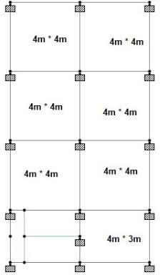

**FIGURE 2: PLAN OF BUILDING**

Shortest span of slab

Effective depth (d) =

35 to 42

= 4000 to 4000

35 42

= 115mm to 95mm

Diameter of bar

Overall depth [D] = d + clear cover +

2

= 151 + 25 + (12/2)

= 146 mm

≅ 150 mm

∴Provide 150 mm depth of slab with 25 mm clear cover in slab

## Beam

Effective depth (d) = Span of Beam

12 to 15

= 4000

12

4000

to

15

= 334 mm to 267 mm

Diameter of bar

+

Overall depth (D) = d + clear cover

2

16

+

= 334 + 25

2

= 367 mm

≅ 400 mm

Width of beam =

D 2D

to

2 3

= 400to 2 × 400

2 3

= 200 mm to 267 mm

≅ 270 mm

∴ B × D = 270 mm × 400 mm

By providing the obtained dimensions of the beam form the thumb rule are failing at the analysis stag, by trial and error method they were improved to 400 mm × 470 mm.

## Column

As per IS 456 codal provisions

Considering the interior column i.e. critical column

Dead Load = [ Partition Load ] + [ Floor Finish ] + [ Dead Load of Slab ] + [ Dead Load of Beam]

+ [ Dead Load of Column ]

Area of Slab panel under consideration = L× B

= 4 × 4

2 2

= 4 𝑚2

Dead Load calculation applied on critical column :- Floor Finish = Area × 1 𝐾𝑁

𝑚2

= 4 KN

Partition Load = 1 × 4

= 4 KN

Dead Load of Slab = Unit weight of RCC × Area × Thickness

= 25 × 4× 0.15

= 15 KN

Total length of beams under consideration from all the directions

4 4 4 4

= +

+ +

2 2 2 2

= 8 m

Beam self weight = unit weight of RCC × cross section × length

= 25 × 0.4 × 0.47 × 8

= 37.6 KN

Initially consider B × D of column as = 0.3 × 0.3m

Self weight of column = height of column × 0.3 × 0.3× unit weight of RCC

= 3 × 0.3 × 0.3× 25

= 7 KN

Wall load = unit weight of brick wall × thickness of brick wall × breadth × height

= 19 ×0.23 × 8 × 3

= 105 KN

∴ Total Dead Load acting on column = 4 + 4 + 15 + 37.6 + 7 + 105

= 172.6 KN

≅ 173 KN

Live Load acting on critical column:-

𝐾𝑁

Live Load intensity = 2

𝑚2

No live load on ground floor is taken into consideration for design of column dimensions as there is no impact on column from the G.F live load.

|  |  |  |
| --- | --- | --- |
| 1st Floor | = 2 × 0.9 × 4 | = 7.2 KN |
| 2nd Floor | = 2 × 0.8 × 4 | = 6.4 KN |
| 3rd Floor | = 2 × 0.7 × 4 | = 5.6 KN |
| Terrace | = 1.5 × 4 | = 6 KN |



Total Live Load = 25.2 KN

Calculation of total load acting on critical column :-

Floor Dead Load Live Load Total

|  |  |  |  |
| --- | --- | --- | --- |
|  | (KN) | ( KN) | (KN) |
| Ground Floor | − | − | − |
| 1st Floor | 173 | 7.2 | 181 |
| 2nd Floor | 173 | 6.4 | 180 |
| 3rd Floor | 173 | 5.6 | 179 |
| Terrace | 173 | 6 | 179 |



Total Load acting on critical column = 719 KN

Total Factored Load acting on critical column = 1.5 × Load acting

= 1.5 × 719

PU = 1079 KN

Consider the effect of earthquake add another 30 % of PU = 1.3× 1079

= 1403 KN

Total Factored Load = {0.45× 25×(Ag – 0.04 Ag)} + {0.67 × 415 × 0.04Ag} 1403 KN = 10.8Ag + 11.12 Ag

1403 KN = 21.922 Ag

Ag = 63999 mm2

Provide 300mm × 300 mm column dimension is sufficient. But during the analysis sate the columns are failing and hence by trial and error method the column dimension are altered to 450mm × 450 mm.

# CHAPETR 4: CALCULATION OF BASE SHEAR

Seismic weight = Dead load + live load Seismic weight of roof

= (mass of infill) + (mass of column) + (mass of beams in both the directions)

+ (mass of slab) + (live load)

In clause 7.3.2 of 1893(1), mentioned that live load on roof need not to be considered. Length of beams:-

In x - direction = (4m – 0.45 – 0.45)*5

= 15.5m

In z - direction = (4 – 0.45 – 0.45 – 0.45)*3

= 7.95m

Total length of beams in each storey = 7.95 + 15.5

= 23.45m

Length of 230mm thick wall = 3.55 * 10 = 35.5m

Length of 130mm thick wall = (3.55 * 2) + (3.55 * 2) = 14.2m

According to table 10, pg.no:20 of 1893(1):-

It’s mentioned to consider only 25% of live load when love load less than 3KN/m^2 in calculation of seismic weight of floors.

Seismic weight of roof

= (mass of column) + (mass of slab) + (mass of beam) + (mass of walls)

= 15[(0.45 × 0.45) × (3/2) ×25] + {[(8×12) + (3×4)] ×0.15×25} + {[(8×12) + (3×4)] ×2}

+ {0.4×0.47×23.45×25} + {[0.23× (3/2) ×35.5] + [0.13× (3/2) ×14.2]} ×19

= 114 + 405 + 216 + 110.2 + 285

= 1130 kN

Seismic weight of first floor

= (mass of column) + (mass of slab) + (mass of beam) + (mass of walls) + live loads

= 15(0.45× 0.45×3×25) + [(8×12) + (3×4)0.15×25] + {0.4×0.47×23.45×25}

{[0.23×(3/2) ×35.5] + [0.13×(3/2) ×14.2]} ×19 + [0.25×3×{(8×12)+(3×4)}]

= 228 + 405 + 110.2 + 285.4 + 81

= 1127.9kN

≅ 1128kN

Seismic weight of 2nd & 3rd floors

= (mass of infill) + (mass of column) + (mass of slab) + (mass of beams) + (live load)

= 228 + 405 + 110.2 + 81 + [(0.23×3×35.5) + (0.13×3×14.2)] ×19

= 1395kN

Calculation of seismic weight of staircase:-

Dimensions of mid-landing slab = 1.4m × 3m Dimensions of flight slab = 1.4m × 2.878m

C/s of each step = 245mm thread, 150mm rise No. of steps = 2878/√245²150² = 10.01 = 10 No`s

Vol. of each step = (1/2 × 0.245 ×0.15) ×1.5 = 0.0275675

Vol. of all steps = (0.0275625×10×2) = 0.56m³ Thickness of waist slab = 230mm

Area of each step = (0.245×105) + (1.5×0.15) = 0.5925m²

Area of all steps of mid landing = (0.5925 ×10×2) + (3×1.4) = 16.05m² Seismic weight of staircase

= (mass of slab) + (mass of BM steps) + (mass due to FF) + (mass due to LL)

= [(3×1.4) + 2(1.5 × .878)] 25 × 0.23 + [(3×1.4) + 2(1.5×2.878)] ×1 + [0.525×19] +

[0.25×0.75× (2.878 + 1.4 + 3 + 2.875)]

= 98.5kN

Seismic weight of each floor staircase = 98.5kN

Note:-

In calculation of live load it was multiplied with running meter i.e. length of staircase as the Live Load units are in kN/m

Seismic weight of considered building considering all the elements

= 1128 + 2(1395) + 1130 + 4(98.5)

= 5442 kN

Seismic weight of roof = 1130 + (98.5/2) = 1180 kN Seismic weight of first floor = 1130 + 98.5 = 1228.5kN

Seismic weight of 2nd & 3rd floors = 1(1395) + 98.5 = 1494 kN Length of building in X direction (dx) = 15m

Length of building in Y direction (dy) = 8m

Calculation of fundamental time period:-

Tx = (0.09h) / (√dx) = (0.09 × 12) / √8 = 0.38 seconds Sa/g = 2.5 [from fig 2A, 1893(1)-2016]

Ty = (0.09h) / (√dy) = (0.09 × 12) / √15 = 0.278 seconds Sa/g = 2.5 [from fig 2A, 1893(1)-2016]

**Calculation of base shear: -** [7.2.1; 1893(1)-2016 ]

**VB**= Ah.w where,

= [Z / 2 ] ×[ Sa / y] × [I/R] w Z→ 0.1

= [0.1/2] × [ 2.5 ] × [1/5] ×5442 Sa/g= 2.5

= 136 kN I = 1 & R=5

# CHAPTER 5: STUDY ON IRREGULARITIES & PROVIDING SETBACKS

## Study on Irregularities:

Irregularities are of two types i.e. plan and vertical geometric irregularities and can be checked as per table 5 and 6 of IS 1893(1) - 2016

* + 1. **Plan Irregularity:-** ( table 5, IS 1893(1)-2016)

1. Torsional Irregularity :

Plan aspect ratio = 15/8 = 1.8 < 3

Being columns heights in each storey throughout the building are constant the condition of stiffness irregularity i.e. soft storey effect need not to be considered.

I

Stiffness (K) =

L

= [(0.45)³/12/3] = 0.00253

Mass irregularity check as per table 6:- Mass of 1st floor = 1128 kN

Mass of 2nd floor = 1395 kN Mass of 3rd floor = 1395 kN Mass of roof = 1136 kN

Percentage increase in mass from 1st to 2nd floor = 1395−1128 ×100 = 23.5% within limits

1128

Percentage decrease in mass from 3rd floor to roof = 1395−1136100 = 18.5% within limits

1395

W2> 1.5W1 1395 > 1.5(1136)

1398 <1704

Condition not satisfied

W r > 1.5W3 1136 > 1.5 (1395)

1136 <2093

Condition not satisfied

∴Mass irregularity doesn’t exist

As mass and stiffness irregularities are absent & plan aspect ratio is less than 3 i.e. within limits, it can be said that plan irregularity doesn’t exist for the considered plan.

1. Re-entrant corner:-

The condition as per 1893(1) “A building is said to have a re-entrant corner in any plan dimension, when its structural configuration in plan has a projection of size greater than 15% of its overall plan dimension in that direction” doesn’t exist in our plan and hence it can said that the considered plan is free from re-entrant corner condition.

1. Floors having excessive opening:-

No opening are present in the plan, therefore this irregularity also doesn’t exist.

1. Out of plane offsets in vertical elements:-

Not required for the considered plan as no such case exist.

1. Non-parallel lateral force system:-

Since our building is symmetric in nature, no such case will arise.

* + 1. **Vertical Geometrical Irregularity:-** (Table 6 of IS 1893(1)-2016)

1. Soft storey (stiffness irregularity) :-

As the entire storey heights are equal in elevation. The building is said to be free from stiffness irregularity

1. Mass irregularity:-

As explained in 4.1.1 (i) there is no such case exist.

1. Vertical geometry irregularity:-

Selected plan for project is simple in elevation of hence free from vertical geometry irregularity.

1. In - plane discontinuity in vertical elements resisting lateral forces:- No discontinuities are present in elevation.
2. Floating columns:-

Floating columns are not provided & hence no problem identified.

1. Strength irregularity (weak storey):-

A weak storey is a storey whose lateral strength is less than that of the storey above. Being floating column absent in the building this condition doesn’t exist.

## 5.2. Setbacks

Considered that building is adjacent to 4m road

The height of the building is 12m and from clause 8.2.3.1 and table 4 of National Building Code

- 2016 its advised to provide side and rear open spaces of width 3m.

As per clause 9.4.1(a) the front open space

= 1.5(road width) + front open space as per 8.2.1.1(a)

= {1.5 ×4} + 1.5

= 7.5m

Therefore, it can be concluded that the front open space = 7.5m

Rear & side open space = 3m

# CHAPTER 6: ANALYSIS USING STAAD PRO

## Methodology

There are two methods for seismic analysis such as static and dynamic analysis, among the two appropriate methods is selected based on the building configuration, seismic zone, soil classification. Since the building configuration as said in the previous chapter is free from both geometric and ventricular irregularities and soil condition is also hard/rock type and seismic zone 2, it’s clear that static analysis can be performed as per IS 1893(1)-2016

## Steps to be carried for static analysis:

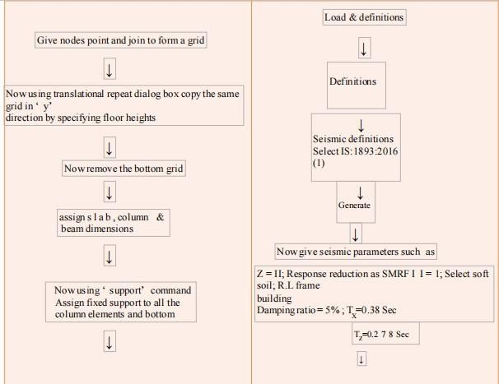

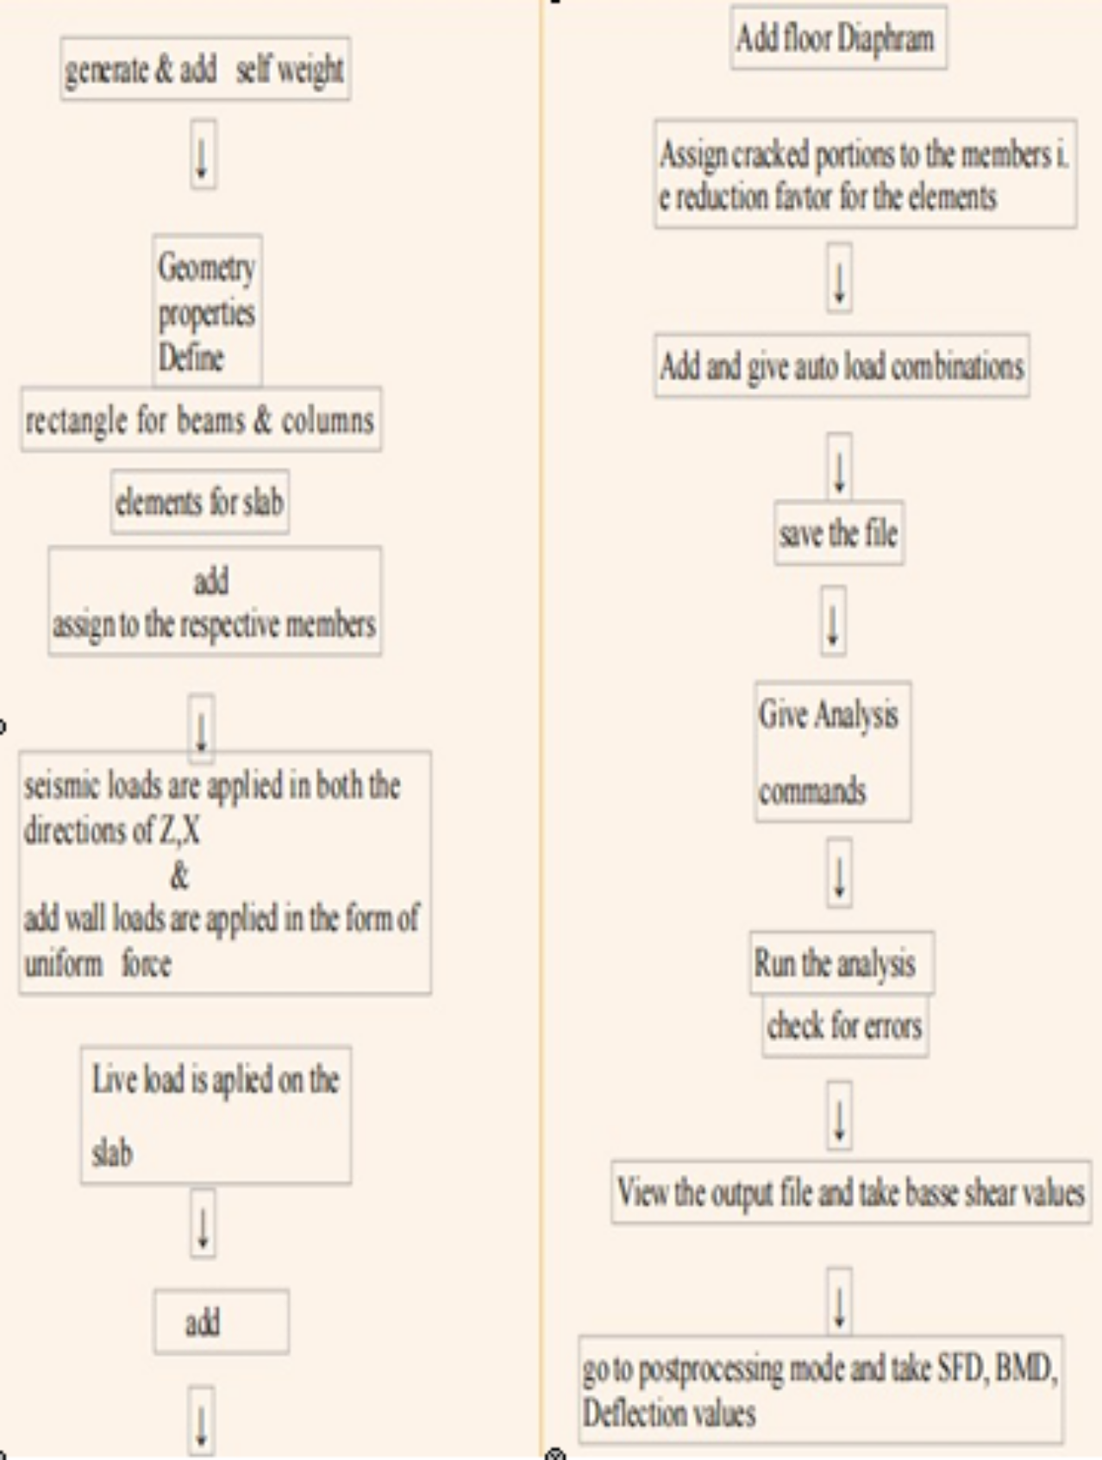

## Analysis Results

Initial Pages of STAAD output file:-

****************************************************

* *

* STAAD.Pro CONNECT Edition/Academic *

* Version 22.06.00.138 *

* Proprietary Program of *
* Bentley Systems, Inc. *

* Date= JUN 24, 2021 *

* Time= 13:21:30 *

* *

* Licensed to: PVP Siddhartha Engieering Colleg *

****************************************************

* + 1. STAAD SPACE

INPUT FILE: C:\Users\DELL\Desktop\Dil Design\booring.STD

* + 1. START JOB INFORMATION
    2. ENGINEER DATE 24-JUN-21
    3. END JOB INFORMATION
    4. INPUT WIDTH 79
    5. UNIT METER KN

## Load Combinations:

Auto load combination method is followed, they are as below:

. LOAD COMB 5 ULC, 1.5 DEAD + 1.5 LIVE LOAD COMB 6 ULC, 1.2 DEAD + 1.2 LIVE

LOAD COMB 7 ULC, 1.2 DEAD + 1.2 LIVE + 1.2 SEISMIC (1)

LOAD COMB 8 ULC, 1.2 DEAD + 1.2 LIVE + 1.2 SEISMIC (2)

LOAD COMB 9 ULC, 1.2 DEAD + 1.2 LIVE + -1.2 SEISMIC (1)

LOAD COMB 10 ULC, 1.2 DEAD + 1.2 LIVE + -1.2 SEISMIC (2)

LOAD COMB 11 ULC, 1.5 DEAD

LOAD COMB 12 ULC, 1.5 DEAD + 1.5 SEISMIC (1)

LOAD COMB 13 ULC, 1.5 DEAD + 1.5 SEISMIC (2)

LOAD COMB 14 ULC, 1.5 DEAD + -1.5 SEISMIC (1)

LOAD COMB 15 ULC, 1.5 DEAD + -1.5 SEISMIC (2)

LOAD COMB 16 ULC, 0.9 DEAD

LOAD COMB 17 ULC, 0.9 DEAD + 1.5 SEISMIC (1)

LOAD COMB 18 ULC, 0.9 DEAD + 1.5 SEISMIC (2)

. LOAD COMB 19 ULC, 0.9 DEAD + -1.5 SEISMIC (1)

LOAD COMB 20 ULC, 0.9 DEAD + -1.5 SEISMIC (2)

The analysis results for one load case Earthquake forces in X –direction were shown in figure 3 to figure 13.

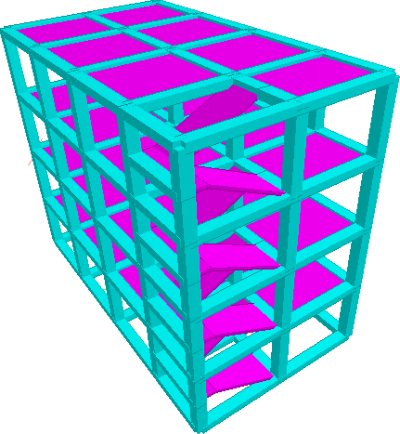

**Figure 3:- 3-D Rendered view**

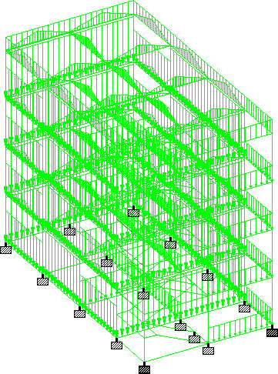

**Figure 4:- Loading Diagram**

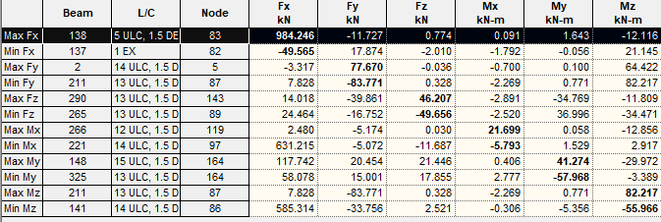

**Figure 5:- Shear Force & Bending Moment Summary**

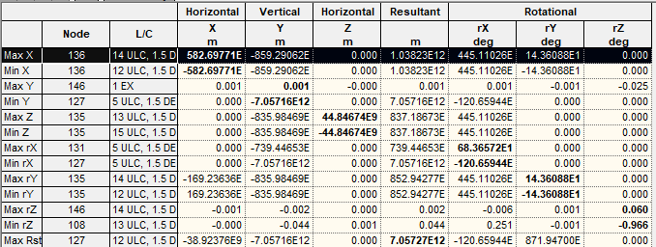

**Figure 6:- Displacement Summary**

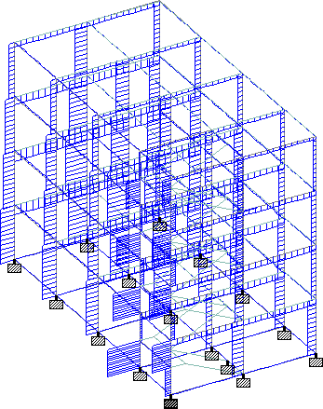

**Figure 7:- Shear force in “Y” direction**

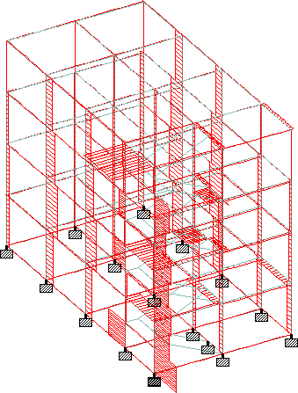

**Figure 8:- Shear force in “Z” direction**

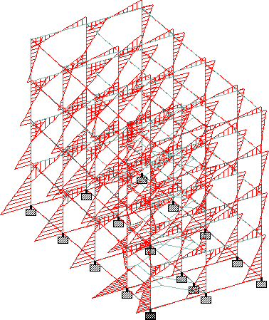

**Figure 9:- Bending Moment in “Z” direction**

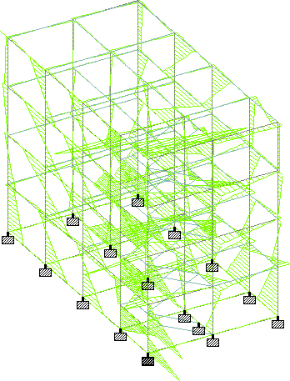

**Figure 10:- Bending Moment in “Y” direction**

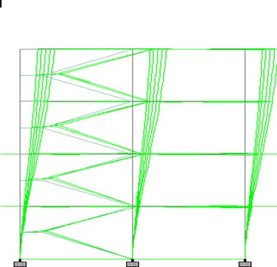

**Figure 11:- Displacement Diagram**

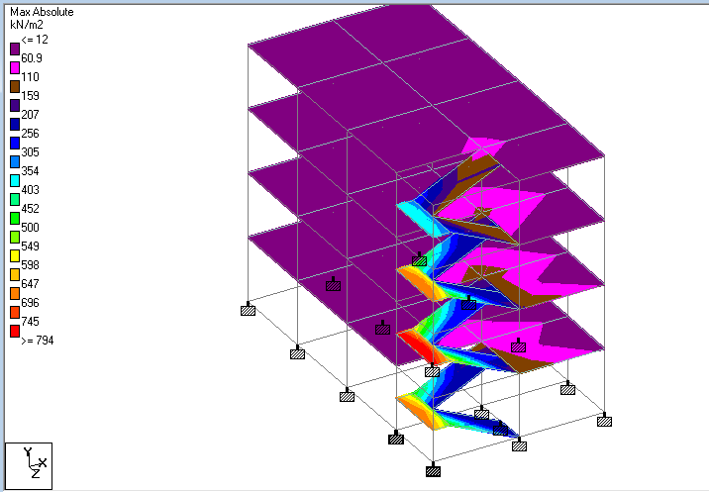

**Figure 12:- Slab Stresses**

The shown figures are the results for earthquake force in X- direction only, the same procedure can be followed and finally by selecting required load combination the results of the remaining can also be viewed similarly.

## Base Shear:-

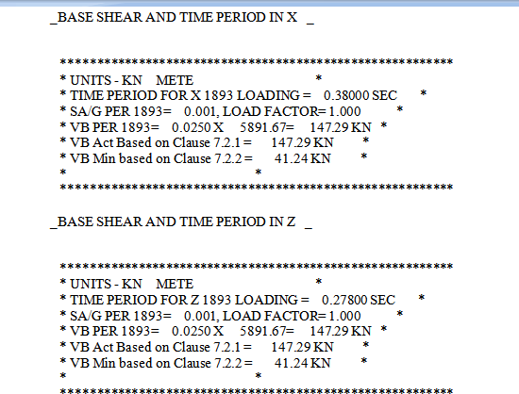

**Figure 13:- Base Shear values from Staad output file**

The value of base shear from staad output file is 147 kN and by manual calculation is 138 kN and it’s been observed that the accuracy work increases with STAAD Pro.

# CHAPTER 7: DESIGN OF MEMBERS

## Procedure:-

After analyzing the structure → Design → select concrete → go to code →select appropriate IS code → give design constants → analyse → run analysis and take the results

## Beam Design:-

A typical beam which was highlighted in the figure 14 and results were shown below:

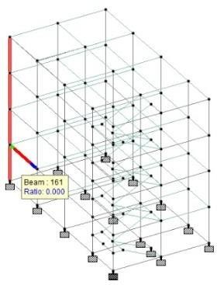

## Figure 14:- Model Highlighting Beams and Columns

IS-13920 L I M I T S T A T E D E S I G N

B E A M N O. 161 D E S I G N R E S U L T S

M25 Fe415 (Main) Fe250 (Sec.)

LENGTH: 3992.9 mm SIZE: 470.0 mm X 400.0 mm COVER: 35.0 mm

SUMMARY OF REINF. AREA (Sq.mm)

SECTION 0.0 mm 998.2 mm 1996.4 mm 2994.7 mm 3992.9 mm

TOP 487.89 487.89 487.89 487.89 487.89

REINF. (Sq. mm) (Sq. mm) (Sq. mm) (Sq. mm) (Sq. mm)

BOTTOM 487.89 487.89 487.89 487.89 487.89

REINF. (Sq. mm) (Sq. mm) (Sq. mm) (Sq. mm) (Sq. mm)

SUMMARY OF PROVIDED REINF. AREA

SECTION 0.0 mm 998.2 mm 1996.4 mm 2994.7 mm 3992.9 mm

TOP 5-12d 5-12d 5-12d 5-12d 5-12d

REINF. 1 layer(s) 1 layer(s) 1 layer(s) 1 layer(s) 1 layer(s)

BOTTOM 5-12d 5-12d 5-12d 5-12d 5-12d

REINF. 1 layer(s) 1 layer(s) 1 layer(s) 1 layer(s) 1 layer(s)

SHEAR 2 legged 10d 2 legged 10d 2 legged 10d 2 legged 10d 2 legged 10d REINF. @ 70 mm c/c @ 170 mm c/c @ 170 mm c/c @ 170 mm c/c @ 70 mm c/c

SHEAR DESIGN RESULTS AT DISTANCE 2d (TWICE EFFECTIVE DEPTH) FROM FACE OF THE SUPPORT

SHEAR DESIGN RESULTS AT 943.0 mm AWAY FROM START SUPPORT VY = 33.64 MX = -1.56 LD= 15

Provide 2 Legged 10d @ 70 mm c/c

SHEAR DESIGN RESULTS AT 943.0 mm AWAY FROM END SUPPORT VY = -39.72 MX = -1.58 LD= 13

Provide 2 Legged 10d @ 70 mm c/c

CONFINING REINFORCEMENT : Provide reinforcement as per CL 9.2.1 b) of IS-13920:2016 at member start.

CONFINING REINFORCEMENT : Provide reinforcement as per CL 9.2.1 b) of IS-13920:2016 at member end.

## Column

The column design of the highlighted member as shown in figure 14 and results given below:

=====================================================================

=======

IS-13920 L I M I T S T A T E D E S I G N

C O L U M N N O. 27 D E S I G N R E S U L T S

M25 Fe415 (Main) Fe250 (Sec.)

LENGTH: 2997.1 mm CROSS SECTION: 450.0 mm X 450.0 mm COVER: 40.0 mm

** GUIDING LOAD CASE: 1 END JOINT: 11 TENSION COLUMN

REQD. STEEL AREA : 1620.00 Sq.mm. REQD. CONCRETE AREA: 200880.00 Sq.mm.

MAIN REINFORCEMENT : Provide 16 - 12 dia. (0.89%, 1809.56 Sq.mm.)

(Equally distributed)

CONFINING REINFORCEMENT : Provide 12 mm dia. rectangular ties @ 70 mm c/c over a length 500.0 mm from each joint face towards

midspan as per IS-13920.

4 number overlapping hoops or a single hoop with crossties are provided along Y direction. (As per IS-13920)

4 number overlapping hoops or a single hoop with crossties are provided along Z direction. (As per IS-13920)

TIE REINFORCEMENT : Provide 8 mm dia. rectangular ties @ 190 mm c/c

SECTION CAPACITY BASED ON REINFORCEMENT REQUIRED (KNS-MET)

Puz : 2764.13 Muz1 : 109.18 Muy1 : 109.18

INTERACTION RATIO: 0.09 (as per Cl. 39.6, IS456:2000)

SECTION CAPACITY BASED ON REINFORCEMENT PROVIDED (KNS-MET)

WORST LOAD CASE: 1

END JOINT: 155 Puz : 653.34 Muz : 0.00 Muy : 0.00 IR: 0.00

## Slab

A typical slab panel which was highlighted in the figure 15 and results were shown below:

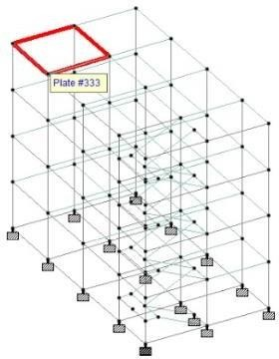

## Figure 15:- Model highlighting slab

ELEMENT DESIGN SUMMARY:

ELEMENT LONG. REINF MOM-X /LOAD TRANS. REINF MOM-Y /LOAD (SQ.MM/ME) (KN-M/M) (SQ.MM/ME) (KN-M/M)

333 TOP : 126. 0.17 / 7 126. 0.17 / 8

BOTT: 126. 0.00 / 0 126. 0.00 / 0

# CHAPTER 8: DETAILING AND ESTIMATION USING STAAD ADVANCED CONCRETE DESIGN

Any structure can be analyzed and designed using STAAD Pro, but it’s to be noted that the detailing provided by the staad pro will not be always appropriate and hence after completion of designing in staad software, the file is imported to Staad Advanced Concrete Design (ACD) Version 10 software which is used for giving effective detailing and generating bar bending schedule, bill of quantities for various elements like beams, columns, slabs, footings.

## Procedure:-

After designing in staad pro → click on the “Advanced concrete design” → it redirects to Staad ACD → Provide name for the project → click at Beams → mark the elevation which are necessary

→ create a new project → give concrete and steel grades → settings → ok →give load combinations → ok → add from analysis → ok → and the beam design can be obtained

## To obtain bar bending schedule:

Reports → Detailed drawing → select the beams → ok → detailed drawings can be obtained → Bill of Quantity (BOQ) → provides bill of quantities → go to text schedule → group the beams → bar bending schedule (BBS) is obtained

Similarly the column, slabs, footings can also be detailed and BBS & BOQ reports can be taken.

## Beams Detailing and estimation:-

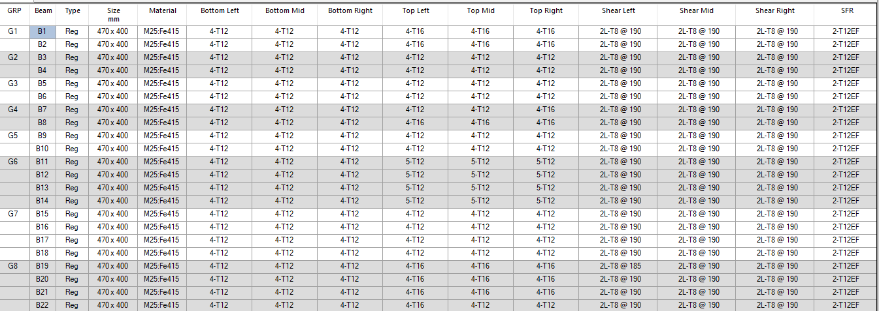

By following the mentioned procedure, the detailing of beams can be obtained as shown in figure 16 to figure 19.

**Figure 16: Detailing of Beams**

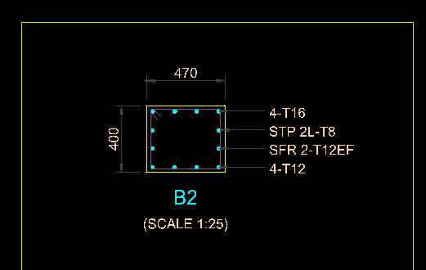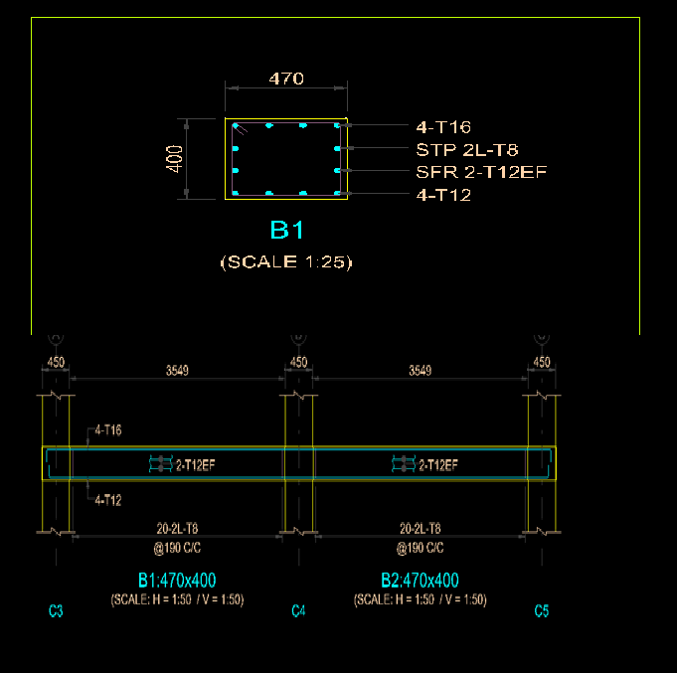

**Figure 17:- Detailed Drawing of a Beam**

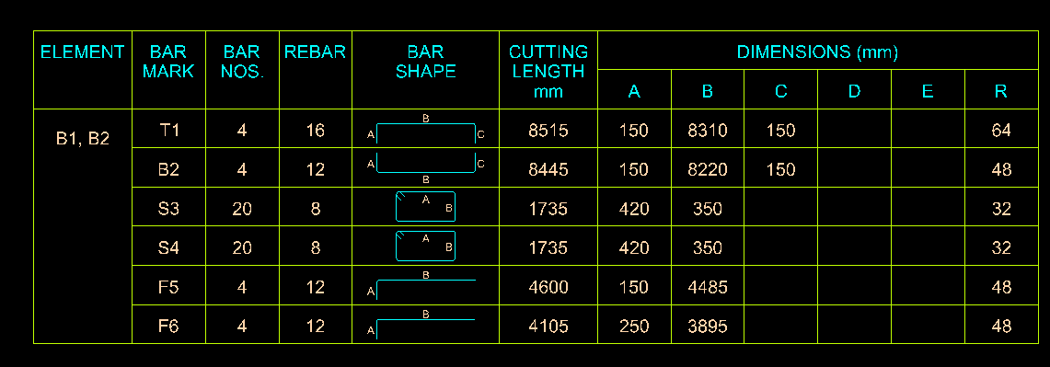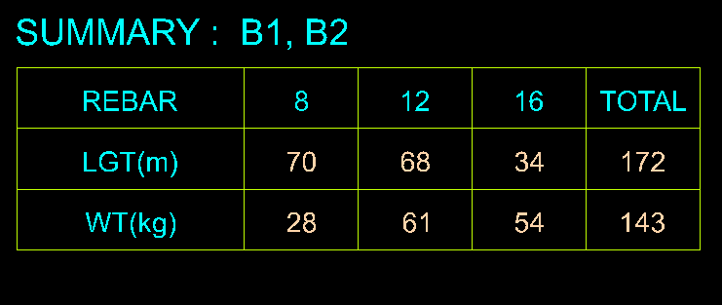

**Figure 18- Bar Bending Schedule**

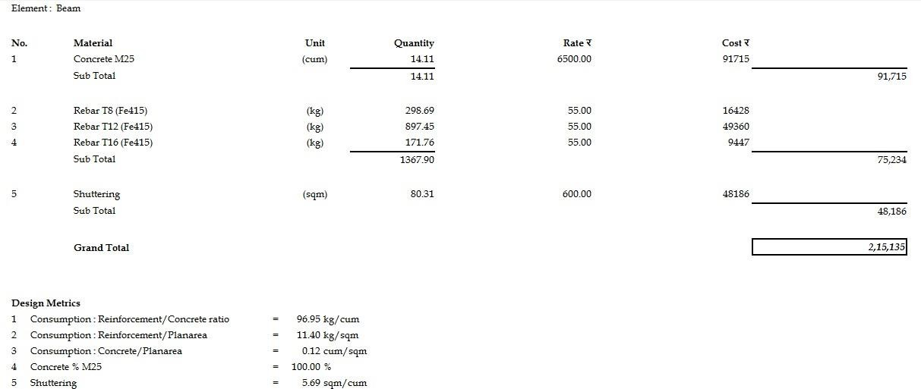

**Figure 19 – BOQ of Beams**

* 1. **Columns Detailing and estimation:-**

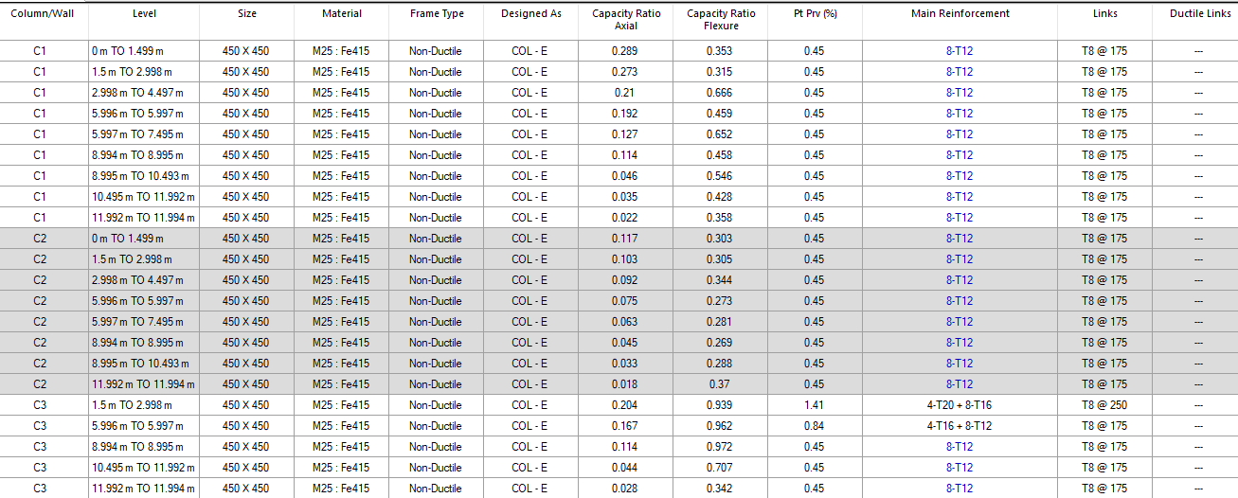

By following the similar procedure the detailing of columns can be obtained as shown in figure 20 to figure 26.

**Figure 20- Typical detailing of columns 1, 2 &3**

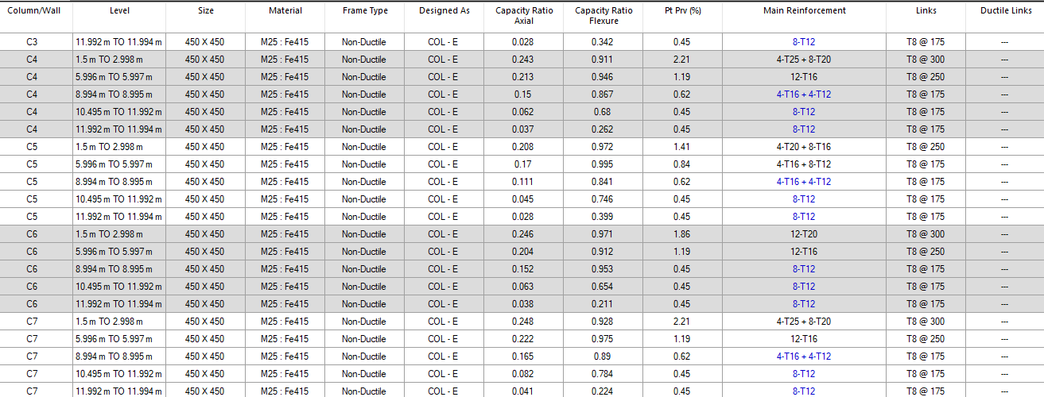

**Figure 21- Typical detailing of columns 4, 5, 6 & 7**

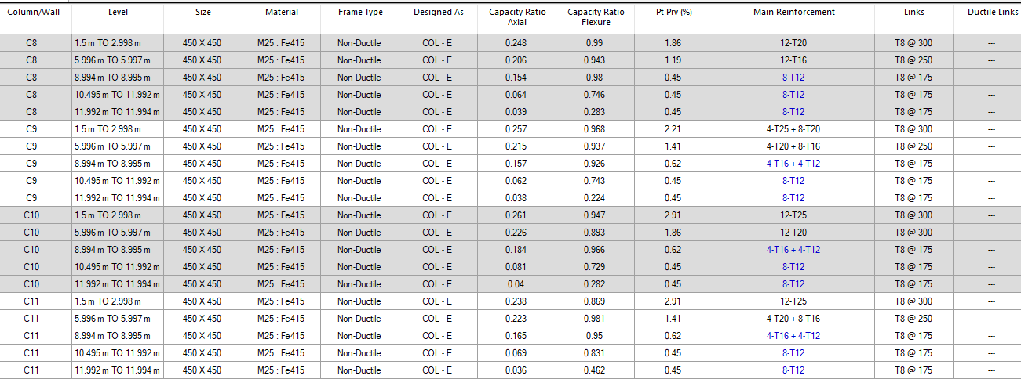

**Figure 22- Typical detailing of columns 8 to 11**

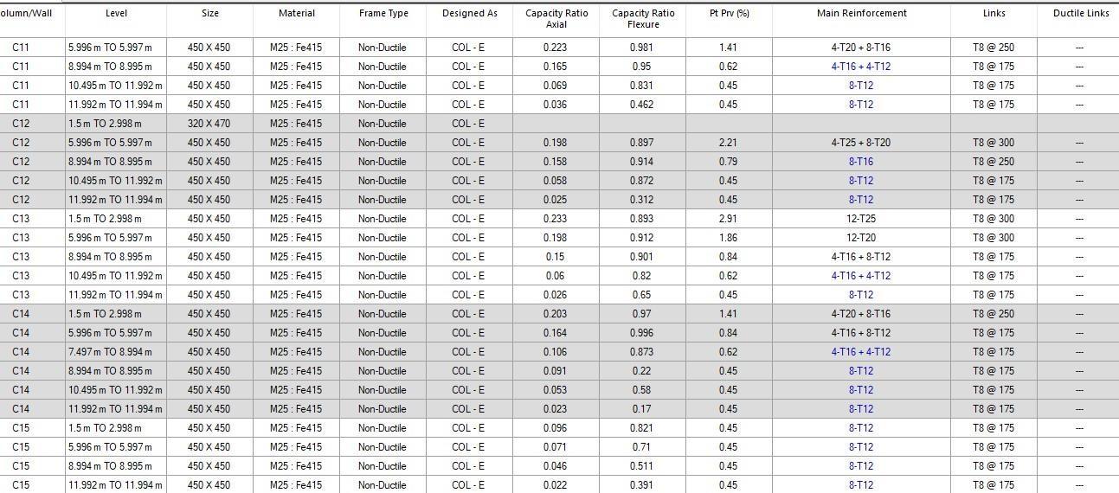

**Figure 23- Typical detailing of columns12 to 15**

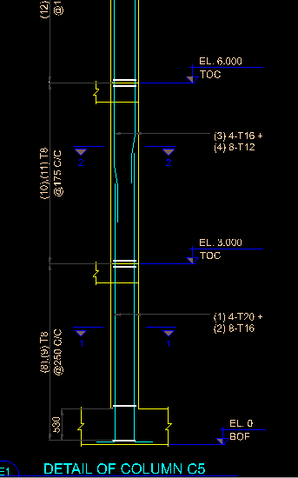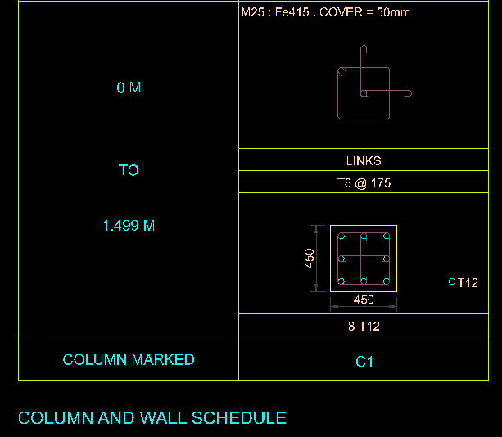

**Figure 24- Typical detailing drawings of column**

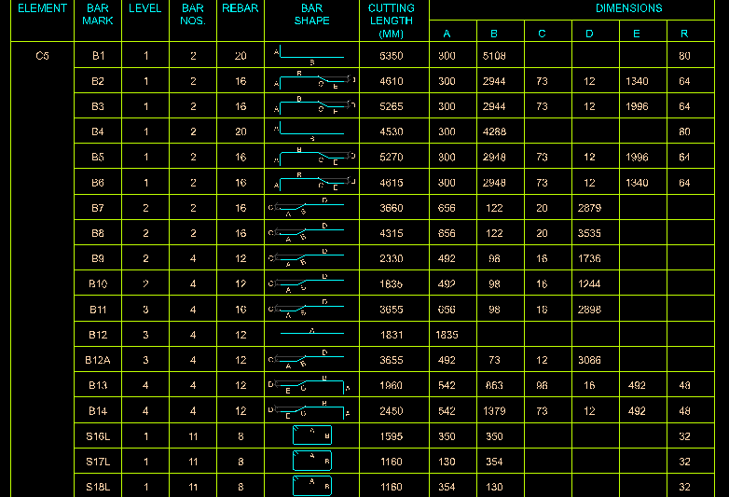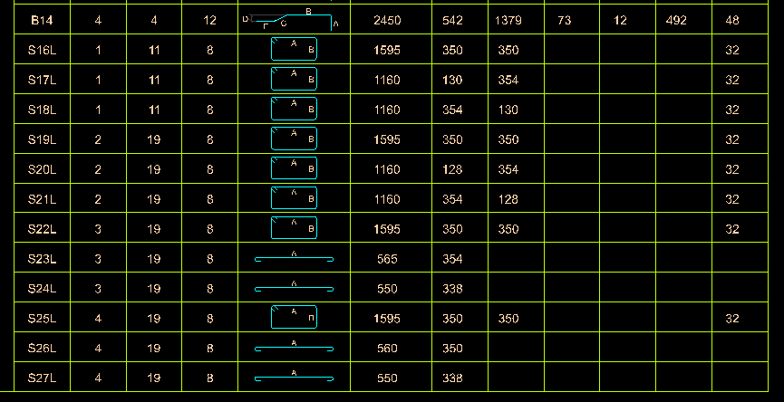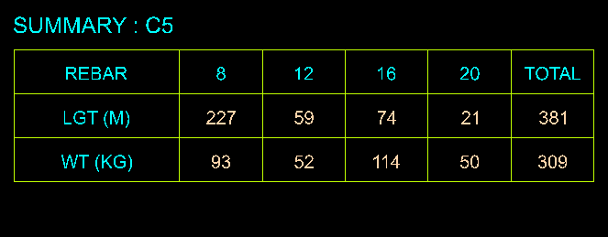

**Figure 25- BBS of Column 5**

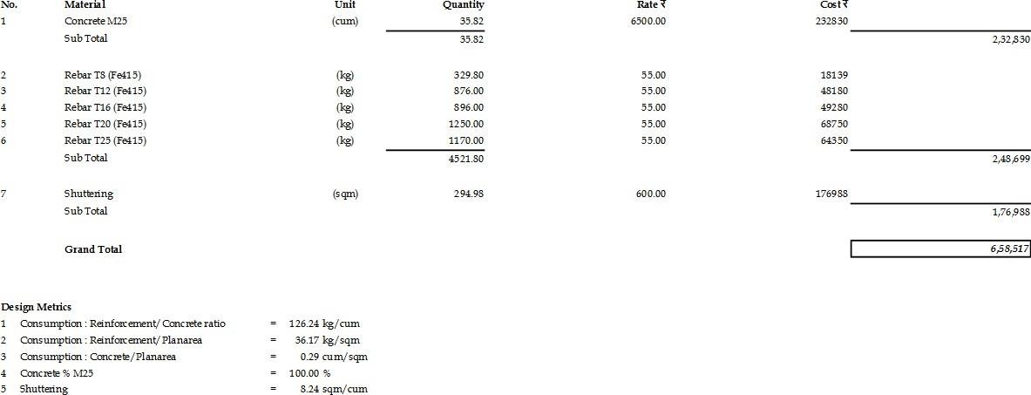

**Figure 26- BOQ of Columns**

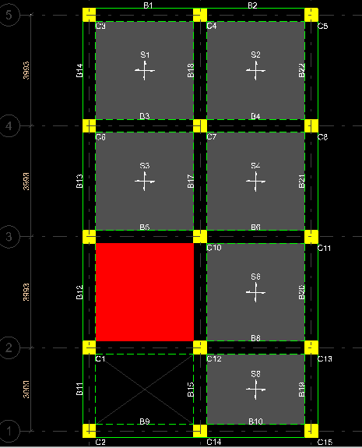

* 1. **Slabs Detailing and estimation:**

By following the similar procedure the detailing of slabs can be obtained as shown in figure 27 to figure 30.

**Figure 27- Top view of slab**

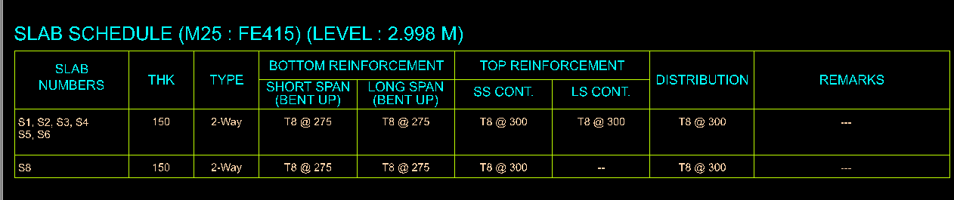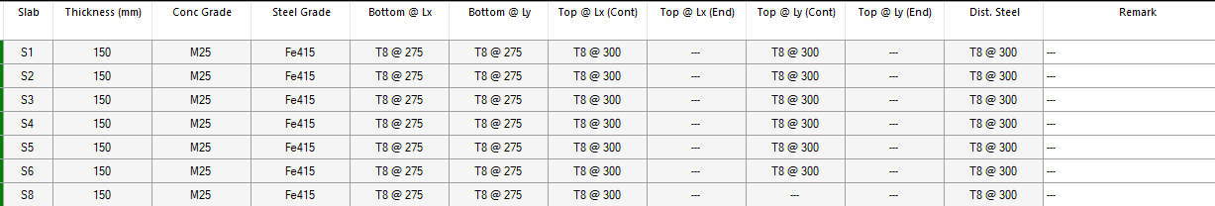

**Figure 28 – Detailing of slab panels**

**Figure 29- BBS of Slab**

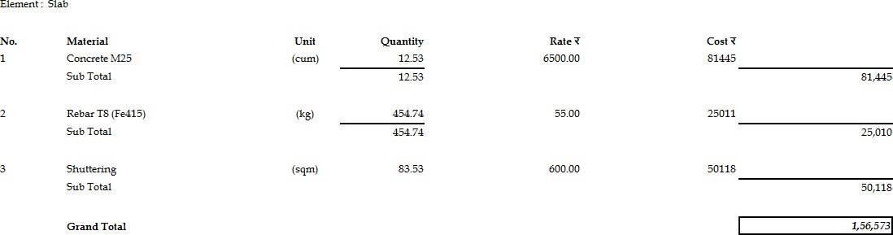

**Figure 30 – BOQ of Slab in one floor**

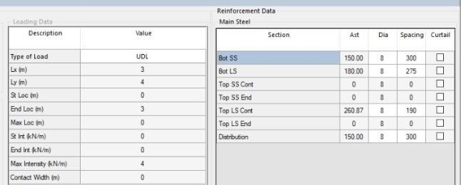

## Staircase detailing and estimation

By following the similar procedure the detailing of staircase can be obtained as shown in figure 31 to figure 32.

**Figure 31– Loading and Design of staircase slab**

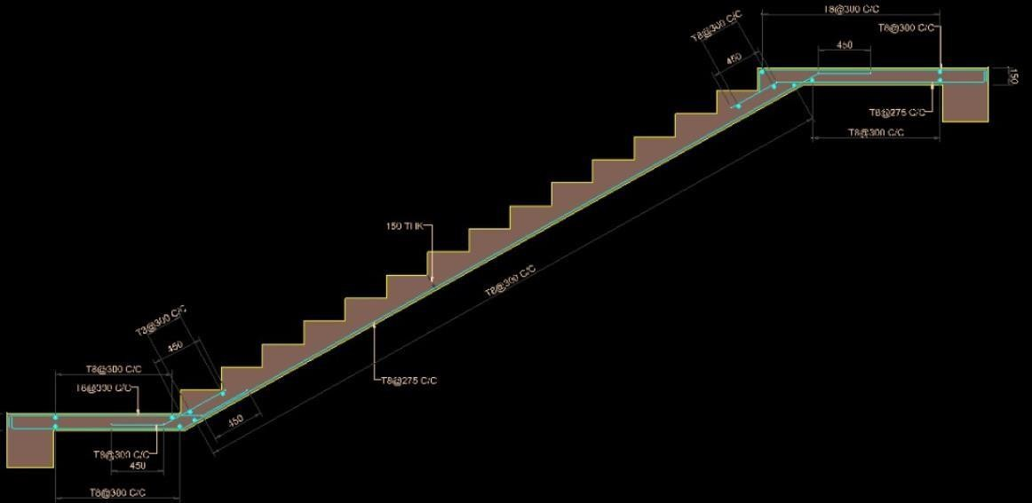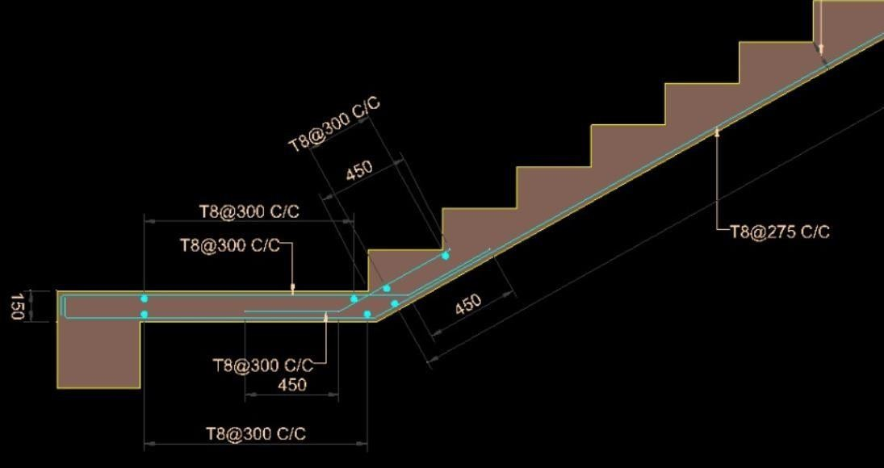

**Figure 32 – Detailed Drawings of staircase slab**

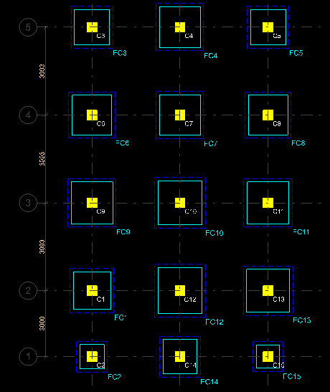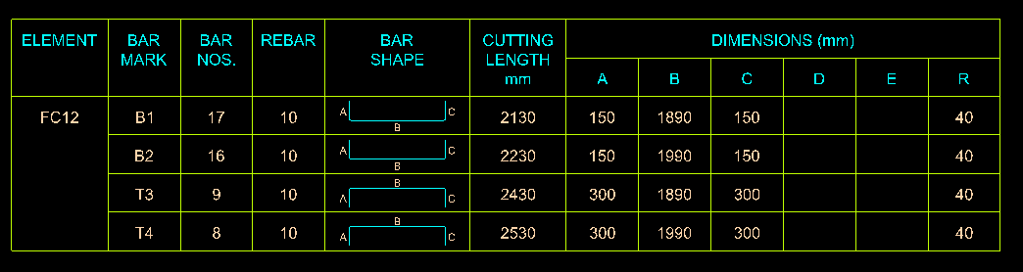

* 1. **Footings detailing and estimation**

By following the similar procedure the detailing of columns can be obtained as shown in figure 33 to figure 37.

**Figure 33- Footing Marking**

**Figure 34- Bar Bending Schedule of Footing 12**

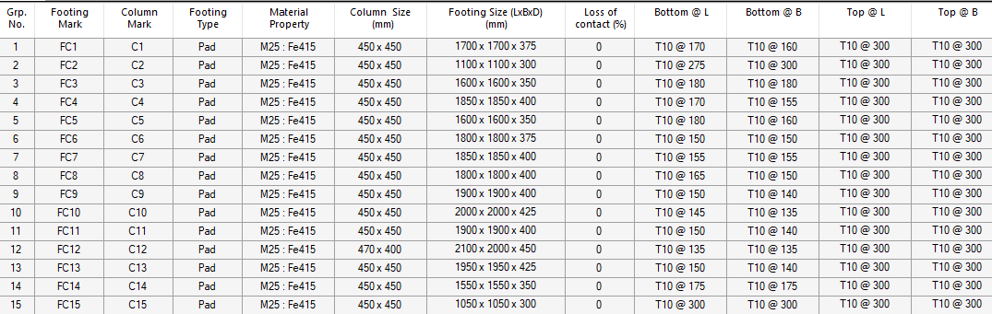

**Figure 35 – Detailing of Footings**

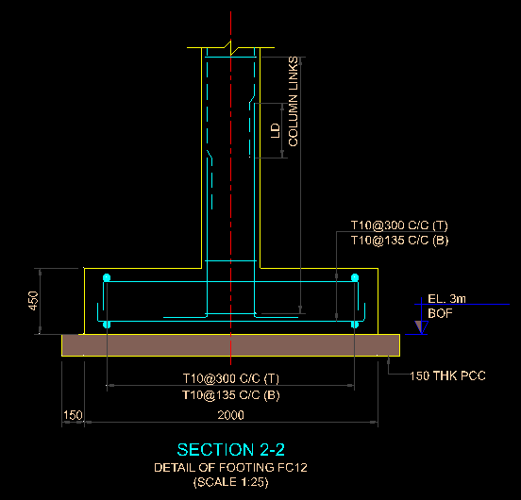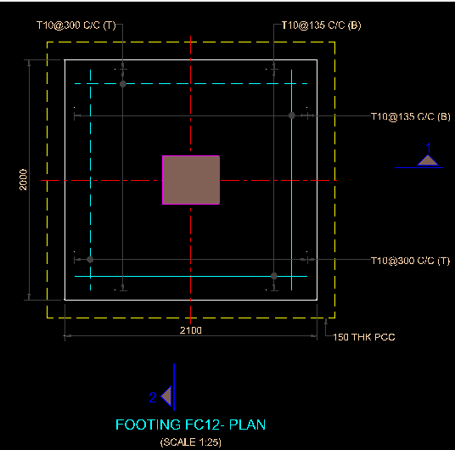

**Figure 36– Cross - sections of Footing 12**

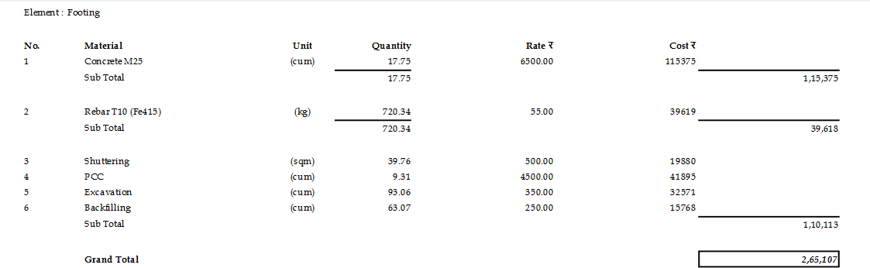

**Figure 37 – BOQ of Footings**

# CHAPTER 9: CONCLUSIONS

* The considered plan of Stilt + 3 building is checked for the plan and vertical geometric irregularities, as setbacks play an important role in rescue and relief operations they were provided as per NBC 2016.
* Preliminary dimensions of column considered as per IS 456 codal provisions and beams, slabs dimensions were proportioned as per experience.
* The analysis and design were performed using STAAD Pro Version 22.
* It is observed that base shear calculation is more accurate from the staad output file rather than manual calculation as there is 11KN difference.
* The design and area of steel can be taken from the staad output file but the detailingof elements is not appropriate in all the cases.
* After conducting analysis and design, the file had been imported to RCDC Version 10 where the various elements like beams, columns, slabs, staircase and footings were detailed.
* RCDC software is also used to calculate the Bar bending schedules (BBS) and Bill of quantities (BOQ) of the respective elements. The ductile detailing provided as per IS 13920-2016 for considered building in seismic zone 2, hard / rock type of soil by performing static analysis.

# CHAPTER 10: SUGGESTIONS

The detailing provided is for static analysis and seismic zone 2, soil of hard / rock type soil. In this study, the earthquake forces considered in both X and Z directions based on the building and soil conditions. And this can be extended to dynamic analysis by considering the seismic forces in Y direction as well, medium soil or soft soil, and seismic zone of 3, 4, 5 and building height greater than 12 m.

# CHAPTER 11: REFERENCES

1. IS1893-2016(1)

1. Study on Static & Dynamic Analysis of Multi-Storied Building in Seismic Zones (M. VNaresh and KJ Brahmachari- 2009)
2. NICEE, IITK 4. IS 4326-2013
3. Study of Suitable Foundation in Seismic Zone 3 Considering SSI (M. Manjara , Hanumantarao Chappidi 2017)
4. Proposed codal provisions for design & detailing – beam column joint in seismic region:-(Sudhir K. Jain, R.K Ingle & Goutam Mondal)

7. IS 456-2000

8. A Comparative Study on Static & Dynamic Analysis of High Rise Building with &without Open Ground Storey (Surjeet Kumar, Shubbam Srivastava & Zain - 2017)

9. IS 13920 – 2016

10. A Review on Shear wall in High Rise Buildings (DR. Krishna Murari, Sonali Pandey, December 2017)