Kanan Travel CRM
Complete Process Flow
Diagram and stage-by-stage explanation

Prepared by: Bhargav & Om
Reviewed by: Sandeep Ojha
For sign-off by: Vicky Ray (HOD — Travel)
Date: 25 May 2026
;

1. What this document covers
This document explains how a customer moves through the Kanan Travel CRM — from the first enquiry to a completed trip. It has two parts:
- The full process diagram, showing all 12 stages in one picture.
- A stage-by-stage explanation, telling you what happens, who does it, what comes in, what goes out, and which decisions are made.

Read the diagram first to get the overall shape. Then read the detailed stage notes for the inner workings.

2. The complete process flow
Read top to bottom. The dashed branches on the sides show what happens when a lead doesn't qualify or when a customer requests changes.

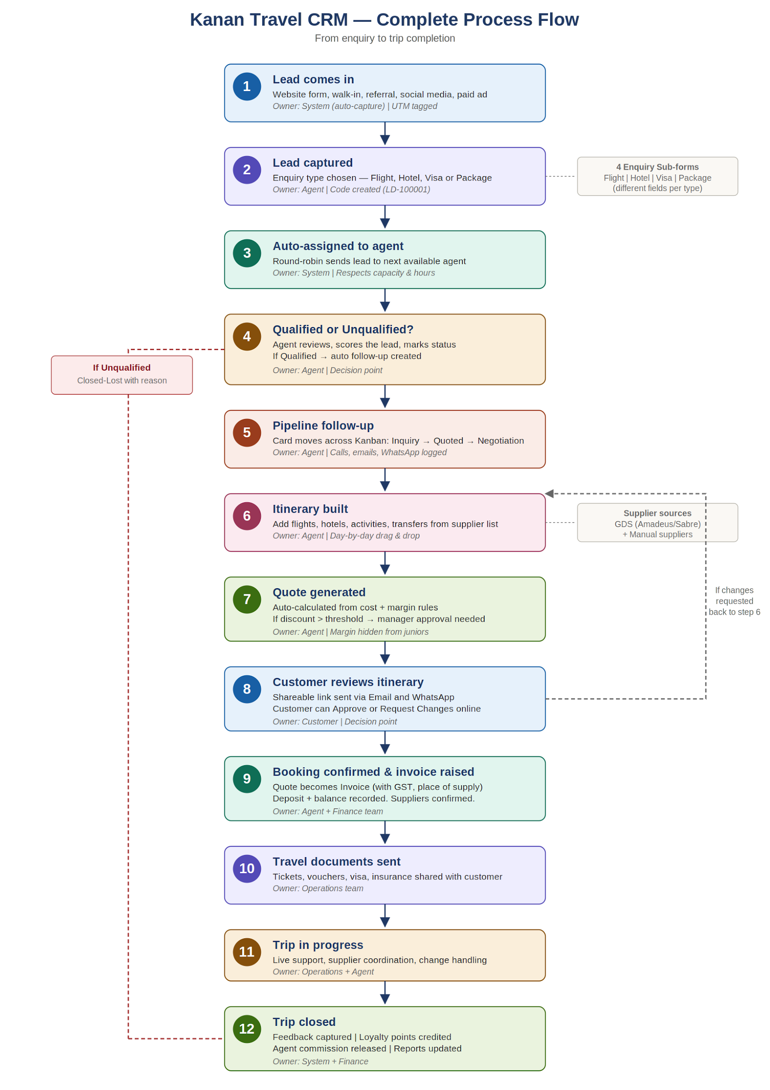

3. Stage-by-stage explanation
Each stage below has the same five lines: what happens, who owns it, what comes in, what goes out, and what decision is made. Read them as a checklist.

Stage 1 | Lead comes in
What happens | An enquiry reaches the system from one of several channels — the company website form, a walk-in at a branch, a phone call, a referral, social media (Facebook/Instagram/WhatsApp), or a paid ad campaign.
Who owns it | The system captures it automatically. No human action needed at this stage.
What comes in | Customer name, mobile, email, and the channel of arrival. If the lead came from a paid campaign, the UTM tags (utm_source, utm_medium, utm_campaign) are captured from the URL.
What goes out | A raw Lead record sitting in the system, ready to be processed.
Decision | None. Auto-capture only.

Stage 2 | Lead captured
What happens | The lead is opened in the system and the enquiry type is set — Flight, Hotel, Visa or Package. A numeric Lead Code (for example, LD-100001) is created so agents can refer to it easily on phone calls.
Who owns it | The agent who first picks up the lead, or the system if the lead arrived via a structured web form.
What comes in | Raw Lead record + the agent's selection of enquiry type.
What goes out | Structured Lead record with a code, type, and the right sub-form fields ready to fill (each type has different fields).
Decision | Which enquiry type? This sets which sub-form opens — Flight asks origin and class, Hotel asks star rating and rooms, Visa asks visa type, Package asks for multi-destination.

Stage 3 | Auto-assigned to agent
What happens | If the lead hasn't already been picked up by an agent, the round-robin engine assigns it to the next available agent. The engine respects each agent's capacity, working hours, and skill match (for example, only visa-trained agents get visa leads).
Who owns it | The system.
What comes in | Structured Lead record without an owner.
What goes out | Lead now has an owner (assigned_agent_id). The agent gets a notification — in-app and optionally on WhatsApp.
Decision | None at the lead level. The engine's matching rules sit in Settings.

Stage 4 | Qualified or Unqualified?
What happens | The agent reviews the lead — checks budget, travel readiness, intent — and marks it Qualified, Unqualified, or Pending. A lead score (0-100) is calculated from source quality, engagement, budget fit and recency. If marked Qualified, a Follow-up task is created automatically with a default SLA from Settings.
Who owns it | The assigned agent.
What comes in | Structured Lead record + the agent's research and judgement.
What goes out | Lead with a qualification status, score, and either a follow-up task or a closure reason.
Decision | First major decision point. If Unqualified → the lead branches off, marked Closed-Lost with a reason (the dashed red branch on the left of the diagram). If Qualified or Pending → continues to Stage 5.

Stage 5 | Pipeline follow-up
What happens | The lead becomes a card on the Kanban pipeline. The agent moves it across stages — Inquiry → Quoted → Negotiation. Every call, email, and WhatsApp message is logged against the card. Reminders trigger if the agent doesn't follow up on time.
Who owns it | The agent.
What comes in | Qualified lead with a follow-up task.
What goes out | Lead that is actively progressing through the pipeline, with a clear next action.
Decision | Continuous. At every touchpoint the agent decides whether to push for closure, send more options, or move it to Lost.

Stage 6 | Itinerary built
What happens | The agent opens the Itinerary Builder and assembles the trip day by day — flights, hotels, activities, transfers. Suppliers can be added two ways: pulled live from GDS systems like Amadeus or Sabre, or selected from the manual supplier list (preferred local hotels, ground operators).
Who owns it | The agent.
What comes in | Customer requirements (dates, travellers, budget, preferences) + supplier inventory.
What goes out | A complete itinerary with cost, dates, and supplier references for every segment.
Decision | Which suppliers to use — preferred suppliers are starred and appear at the top of search results.

Stage 7 | Quote generated
What happens | From the itinerary, a Quote is auto-generated. Selling price = supplier cost + margin (margin rules sit in Settings). If the agent applies a discount above the configured threshold, the quote moves to Pending Approval and a manager (or above) must release it before it can be sent.
Who owns it | The agent generates it. A manager approves it if discount exceeds the threshold.
What comes in | Completed itinerary + margin rules + any discount the agent has applied.
What goes out | A Quote document with a unique number, validity date, and terms attached. The margin column is hidden from junior agents in the UI.
Decision | Was the discount over the threshold? If yes → goes to Pending Approval (manager decision). If no → Quote is Ready to Send.

Stage 8 | Customer reviews itinerary
What happens | A secure share link is generated and sent to the customer over Email and/or WhatsApp. The customer opens it on any device and sees a branded, beautiful view of their itinerary day by day. They can click Approve or Request Changes.
Who owns it | The customer.
What comes in | Quote + itinerary + share link.
What goes out | Either an Approval (move forward) or a Change Request (loop back).
Decision | Second major decision point. If Approved → continue to Stage 9. If Changes Requested → the agent receives a notification with the customer's comments, edits the itinerary and re-shares — the dashed loop in the diagram showing return to Stage 6.

Stage 9 | Booking confirmed and invoice raised
What happens | Once the customer approves, the Quote becomes a final Invoice with GST details, the customer's GSTIN, and place of supply. The agent records the deposit; the balance due date is scheduled. In parallel, the agent confirms each supplier — GDS-linked suppliers get a confirmation via API; manual suppliers get a confirmation email.
Who owns it | The agent collects payment confirmations. The Finance team validates and posts the invoice.
What comes in | Approved Quote + customer GST and billing details + payment confirmation.
What goes out | A confirmed Booking, a posted Invoice, supplier confirmation references stored against each segment, and a Payment record for the deposit.
Decision | Payment method (Stripe, bank transfer, cheque, cash) and split (full payment vs deposit + balance).

Stage 10 | Travel documents sent
What happens | All travel documents — flight tickets, hotel vouchers, visa copies, insurance policy, pre-travel pack — are compiled and sent to the customer. Documents are stored in the customer's record for future reference.
Who owns it | The Operations team (with the agent in the loop).
What comes in | Confirmed booking + supplier confirmations + customer documents (passport copies, visa documents).
What goes out | A travel document pack delivered to the customer over email or shared via a download link.
Decision | Are all documents complete? If anything is missing (visa not yet issued, hotel voucher pending), the booking is flagged with a hold.

Stage 11 | Trip in progress
What happens | The customer is travelling. The Operations team is on standby for live support — flight changes, hotel issues, supplier escalations. Any change is logged against the booking. The original assigned agent stays informed.
Who owns it | Operations team, with the agent as escalation contact.
What comes in | Customer travel dates + supplier contact details + emergency procedures.
What goes out | Resolved customer issues, change orders, and a clean travel record.
Decision | Any mid-trip changes — these may trigger a top-up invoice (extra night, upgraded room, missed flight rebook).

Stage 12 | Trip closed
What happens | After the return date, the booking is marked Completed. The customer is asked for feedback (a short rating + comments). Loyalty points are credited based on the trip value. The agent's commission is calculated and released for payout based on the rules in Settings. Final P&L for the trip is pushed to reports.
Who owns it | The system runs the close-out automatically. Finance signs off on commission payouts.
What comes in | Completed booking + customer feedback + commission rules.
What goes out | Loyalty point credit, commission released to agent, updated lifetime value of the customer, and final reports.
Decision | None — automated. Exception: if the customer has filed a complaint, commission may be held pending resolution.

4. Key things to remember
Three points that come up again and again:
Two big decision points
Stage 4 (Qualified or Unqualified) and Stage 8 (Customer Approves or Requests Changes). Most CRM leakage happens here. Watch these two stages closely in reports.
Loops are normal, not failures
Stage 8 looping back to Stage 6 is the normal flow of customers refining their itinerary — it is not a sign of a bad agent. Track the number of revision cycles per booking; more than 3 cycles is a coaching signal.
Side-doors out of the flow
The flow looks linear in the diagram, but bookings can be cancelled, refunded, or moved to a different agent at any stage. Each side-door is captured in the Audit Log so nothing is silently lost.

5. Sign-off
By signing below, the requester confirms the flow above is correct and authorises the team to begin implementation.

Role | Name | Signature | Date
Requested by (Vicky Ray)
Prepared by (Bhargav & Om)
Reviewed by (Sandeep Ojha)

