TASK 1:BOOKMARKING TAG (animal BOOKMARKING TEXT TO IMAGE)?

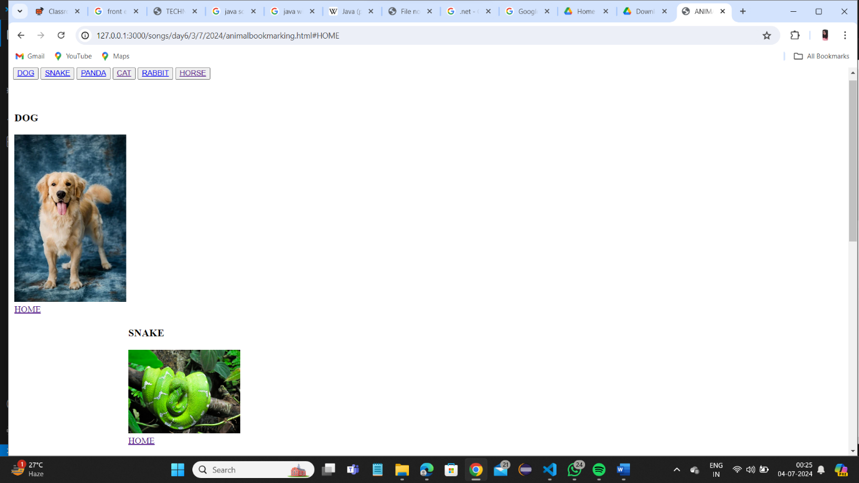

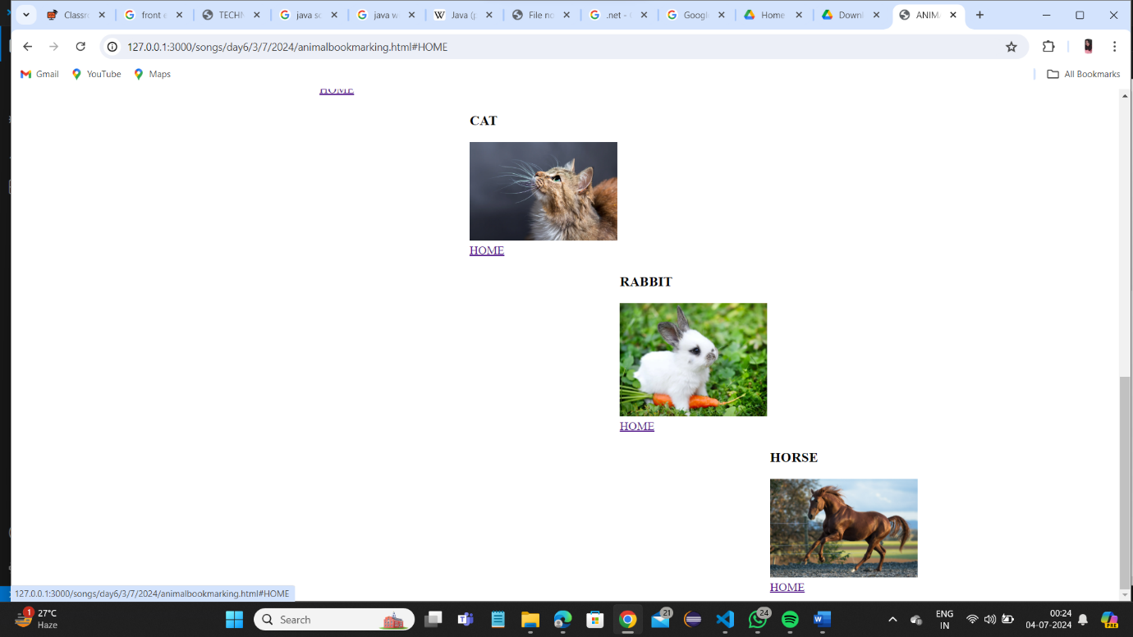





***code***

<!DOCTYPE html>

<html lang="en">

<head>

    <title>ANIMAL BOOKMARKING</title>

</head>

<body>

    <P id="HOME"></P>

    <button><a href="#dog">DOG</a></button>

    <button><a href="#snake">SNAKE</a></button>

    <button><a href="#panda">PANDA</a></button>

    <button><a href="#cat">CAT</a></button>

    <button><a href="#rabbit">RABBIT</a></button>

    <button><a href="#horse">HORSE</a></button>

    <br>

    <br>

    <br>

    <table>

        <tr>

    <td><h3 id="dog">DOG</h3>

    <img src="https://cdn.pixabay.com/photo/2023/08/18/15/02/dog-8198719_640.jpg" alt="image not available" width="200"><BR>

    <a href="#HOME"> HOME</a></td>

    </tr>

    <tr>

        <td></td>

        <td><h3 id="snake">SNAKE</h3>

    <img src="https://upload.wikimedia.org/wikipedia/commons/thumb/e/e7/Corallus_caninus.JPG/640px-Corallus_caninus.JPG" alt="image not available" width="200"><BR>

    <a href="#HOME"> HOME</a></td>

</tr>

    <tr>

        <td></td>

        <td></td>

        <td><h3 id="panda">PANDA</h3>

    <img src="https://t4.ftcdn.net/jpg/05/54/52/13/360_F_554521329_ngmDQSjSrUSRnbK2xK0bkcprsinG9Xdv.jpg" alt="image not available" width="200"><BR>

    <a href="#HOME"> HOME</a></td>

</tr>

    <tr>

        <td></td>

        <td></td>

        <td></td>

        <td><h3 id="cat">CAT</h3>

    <img src="https://cdn.britannica.com/39/226539-050-D21D7721/Portrait-of-a-cat-with-whiskers-visible.jpg" alt="image not available" width="200"><BR>

    <a href="#HOME"> HOME</a></td>

</tr>

    <tr>

        <td></td>

        <td></td>

         <td></td>

          <td></td>

          <td><h3 id="rabbit">RABBIT</h3>

    <img src="https://rd-prod.twic.pics/media/images/Anna/baby-bunny-with-carrot.jpg?twic=v1/resize=1280/quality=73/focus=auto" alt="image not available" width="200"><BR>

    <a href="#HOME"> HOME</a>

</td>

</tr>

    <tr>

        <td></td>

         <td></td>

          <td></td>

           <td></td>

            <td></td>

            <td><h3 id="horse">HORSE</h3>

    <img src="https://upload.wikimedia.org/wikipedia/commons/1/16/Lusitano_Hengst_%28132668445%29.jpeg" alt="image not available" width="200"><BR>

    <a href="#HOME"> HOME</a></td>

</table>

</body>

</html>

TASK2:LINKING WIKIPEDIA TO A IMAGE AND APPLYING BOOKMARKING TO THAT WEB pAGE?

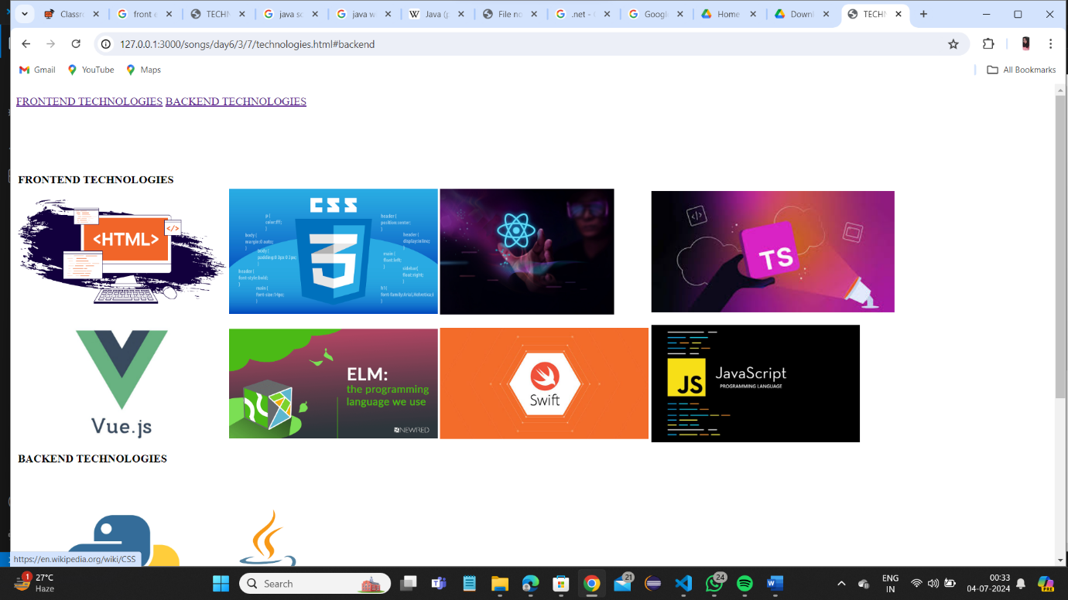

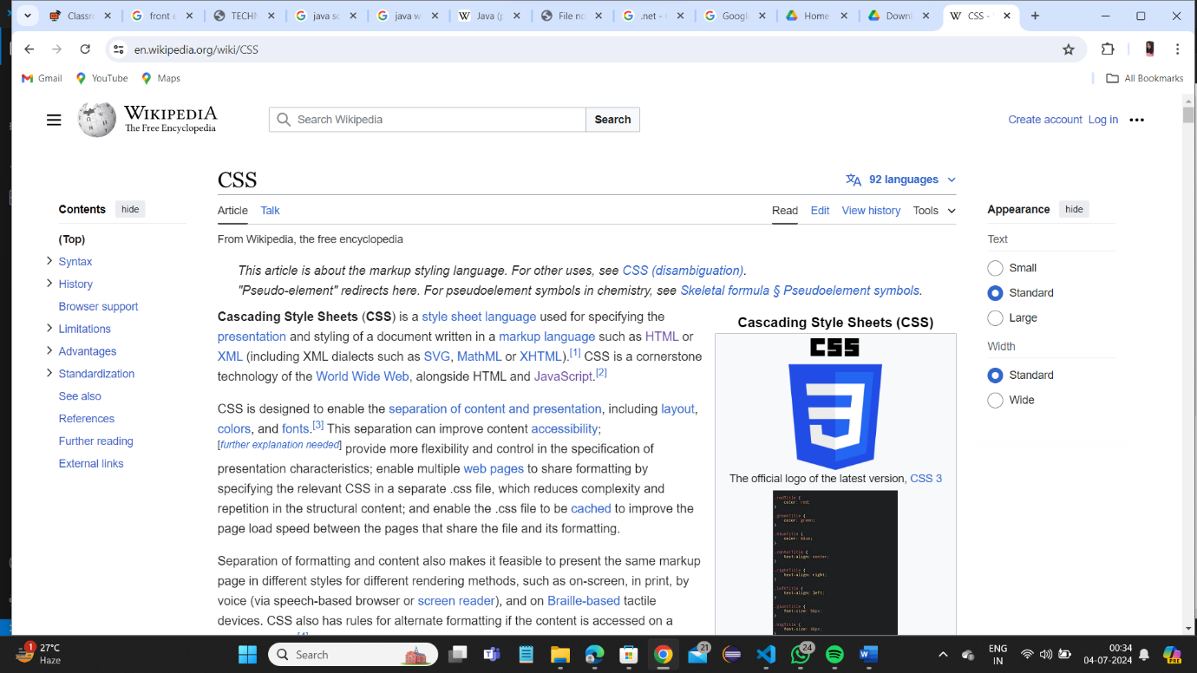



Code

<!DOCTYPE html>

<html lang="en">

<head>

    <title>TECHNOLOGIES</title>

</head>

<body>

    <p id="home"></p>

    <a href="#frontend">FRONTEND TECHNOLOGIES</a>

    <a href="#backend">BACKEND TECHNOLOGIES </a>

    <BR><BR><BR><BR><BR><BR>

    <table>

        <tr>

            <td colspan="2" id="frontend"><strong>FRONTEND TECHNOLOGIES</strong></td></tr>

            <TR>

            <td><a href="https://en.wikipedia.org/wiki/HTML"><img src="https://austingil.com/wp-content/uploads/HTML-Blog-Cover.png" alt="" width="300"></td></a>

            <td><a href="https://en.wikipedia.org/wiki/CSS"><img src="https://www.oxfordwebstudio.com/user/pages/06.da-li-znate/sta-je-css/sta-je-css.png" alt="" width="300"></td></a>

            <td><a href="https://en.wikipedia.org/wiki/React_(JavaScript_library)"><img src="https://knackforge.com/wp-content/uploads/2022/11/Benefits-of-ReactJS.jpg" alt="" width="250"></td></a>

            <td><a href="https://en.wikipedia.org/wiki/Typescript"><img src="https://encrypted-tbn0.gstatic.com/images?q=tbn:ANd9GcR7-Ny-dYUbbJ12rvUfoLKT9gGc64M1jdZbZw&s" alt="" width="350"></td></a>

        </tr>

        <tr>

            <td><a href="https://en.wikipedia.org/wiki/Vue.js"><img src="https://miro.medium.com/v2/resize:fit:900/1*OrjCKmou1jT4It5so5gvOA.jpeg" alt="" width="300"></td>

            <td><a href="https://en.wikipedia.org/wiki/ELM"><img src="https://www.newired.com/wp-content/uploads/2019/06/ELM-2.png" alt="" width="300"></td>

            <td><a href="https://en.wikipedia.org/wiki/SWIFT"><img src="https://miro.medium.com/v2/resize:fit:750/1*OgeU8HPo8TFF1cZQ-4XjJw.jpeg" alt="" width="300"></td>

            <td><a href="https://en.wikipedia.org/wiki/JavaScript"><img src="https://bairesdev.mo.cloudinary.net/blog/2023/08/What-Is-JavaScript-Used-For.jpg?tx=w_1920,q_auto" alt="" width="300"></td>

        </tr>

        <tr>

            <td colspan="2" id="backend"><strong>BACKEND TECHNOLOGIES</strong></td></tr>

            <TR>

            <td><a href="https://en.wikipedia.org/wiki/Python"><img src="https://i0.wp.com/junilearning.com/wp-content/uploads/2020/06/python-programming-language.webp?fit=1920%2C1920&ssl=1" alt="" width="300"></td></a>

            <td><a href="https://en.wikipedia.org/wiki/Java_%28programming_language%29"><img src="https://upload.wikimedia.org/wikipedia/en/thumb/3/30/Java_programming_language_logo.svg/800px-Java_programming_language_logo.svg.png" alt="" width="100"></td></a>

        </tr>

        <tr>

            <td><a href="https://en.wikipedia.org/wiki/.NET"><img src="https://www.verisign.com/en_US/resources/img/VRSN_SocialShare-net-Logo_201712.png" alt="" width="300"></td></a>

            <td><a href="https://en.wikipedia.org/wiki/C_(programming_language)"><img src="https://bs-uploads.toptal.io/blackfish-uploads/components/blog_post_page/4087150/cover_image/regular_1708x683/cover-0828_AfterAllTheseYearstheWorldisStillPoweredbyCProgramming_Razvan_Newsletter-92346cef5f5a3b5b3fe99c736dd48ae6.png" alt="" width="300"></td></a>

        </tr>

        <tr>

            <td><a href="#home">home</a></td>

        </tr>

    </table>

</body>

</html>