Kanat Tossekbayev
PLSC 504
Instructor: Professor Desmarais Jr., Bruce A
Final Project: Replication and Extension
“Cost-effectiveness of expanding the capacity of opioid agonist treatment in Ukraine: dynamic modeling analysis”
Olga Morozova, Forrest W. Crawford, Frederick L. Altice, Ted Cohen, A. David Paltiel.
https://github.com/kanattossekbayev-cyber/Extension-and-Replication-Project

Introduction
The original study by Morozova et al. (2019) evaluates the cost-effectiveness of expanding opioid agonist treatment (OAT) capacity in Ukraine using a dynamic transmission model combined with probabilistic sensitivity analysis (PSA). The authors conclude that OAT expansion is cost-effective across a wide range of parameter uncertainty, and therefore represents a promising public health intervention for reducing opioid-related mortality and improving health outcomes.
While the original analysis incorporates extensive sensitivity analyses, uncertainty is examined primarily by varying parameters individually or by summarizing outcomes through aggregate measures such as mean incremental cost-effectiveness ratios and cost-effectiveness acceptability curves. This approach demonstrates robustness of the average policy conclusion, but provides limited insight into how joint uncertainty and interactions among multiple system parameters shape economic outcomes.
In practice, health systems differ substantially in mortality risk, treatment retention, relapse dynamics, and cost structures. These system characteristics may interact in nonlinear ways, implying that the economic value of OAT expansion is not solely an intrinsic property of the intervention itself, but rather a function of the broader system context in which it is implemented. As a result, an intervention that appears cost-effective on average may generate very different levels of economic value across alternative system configurations.
Building on the original model, this extension does not introduce new empirical data, modify structural equations, or redefine outcomes. Instead, it reanalyzes the existing PSA output using machine-learning methods to explore the joint distribution of model parameters and outcomes. By applying supervised, unsupervised, and quantile-based learning techniques, the extension seeks to identify nonlinear relationships, interaction effects, and distinct system regimes that govern both average economic value and tail risk.

Research Question: How do joint uncertainty and system-level parameter interactions shape the economic value of opioid agonist treatment expansion, and under what system configurations does cost-effectiveness translate into substantial net monetary benefit?

Description of the Original Study (Morozova et al., 2019)
Morozova et al. (2019) evaluate the cost-effectiveness of expanding opioid agonist treatment (OAT) capacity in Ukraine, a country with a high burden of opioid use disorder and limited access to evidence-based treatment. The study focuses on three major urban settings Kyiv, Mykolaiv, and Lviv, which differ in population size, baseline OAT coverage, and epidemiological conditions. The policy question motivating the analysis is whether scaling up OAT represents a good use of limited health-care resources in these settings.
The authors rely on secondary administrative and epidemiological data drawn from Ukrainian national statistics, local OAT program records, and previously published empirical studies. These data are used to parameterize key components of the opioid epidemic, including the size of the population of people who inject drugs (PWID), baseline treatment capacity, rates of initiation and relapse, mortality risks, and the costs associated with OAT delivery. Health outcomes are measured in quality-adjusted life years (QALYs), allowing comparison of costs and benefits within a standard health economic framework.
Methodologically, the study employs a deterministic dynamic compartmental simulation model with a 10-year time horizon (2016–2025). The model explicitly captures transitions between opioid use states, treatment entry and exit, treatment retention, and mortality. Importantly, OAT capacity constraints and waiting lists are modeled endogenously, so that expanding treatment supply does not automatically translate into full uptake. In some specifications, the model also incorporates peer effects, whereby increased OAT coverage may influence demand for treatment through social networks. Cost-effectiveness is assessed by calculating incremental cost-effectiveness ratios (ICERs) relative to the status quo, and uncertainty is explored through scenario analyses and probabilistic sensitivity analysis.
The key finding of the study is that expanding OAT capacity is cost-effective in all three cities under commonly used willingness-to-pay thresholds (approximately one GDP per capita per QALY). However, the authors show that even substantial expansions in treatment supply lead to relatively modest increases in overall coverage, largely because limited demand, rather than supply alone, constrains uptake. The results are sensitive to assumptions about demand dynamics and peer effects, but the central conclusion that OAT expansion can generate meaningful health gains at reasonable cost, remains robust across most modeled scenarios.

Replication report
Rationale for Selecting Kyiv for Replication
The study replication was specifically focused on Kyiv for several compelling reasons. As Ukraine's largest metropolitan area with the highest population, Kyiv is a key location for analyzing the country's epidemiological situation. According to the study, Kyiv has the largest target population 144,355 individuals at risk and 19,222 individuals with opioid dependence ensuring representativeness of the results.
Having the most comprehensive and high-quality data for the capital is particularly important. As the administrative center, Kyiv has the most developed monitoring and data collection system, as evidenced by the highest number of patients on OST (829), the largest waiting list for treatment (10,432), and the largest number of analyzed scaling strategies (687 strategies).
From a political and administrative perspective, decisions made by the Ministry of Health of Ukraine regarding OST policy are primarily tested and implemented in Kyiv. This means that replication results for the capital have the greatest potential for immediate implementation in healthcare practice.
The methodological rationale for choosing Kyiv is based on the significant volume of data, which ensures greater statistical power for the analysis; the diversity of strategies considered (from 829 to 10,600 slots), which allows for the most comprehensive validation of the model; and the presence of clear city boundaries and a defined population, which simplifies the validation of demographic parameters.

Objectives of the Kyiv Replication
The Kyiv replication of the study had several key objectives. The primary objective was to verify the initial conditions and underlying calculations checking the accuracy of the initial values ​​for Kyiv's 2016 hospitalizations, including the number of susceptible individuals, individuals with opioid dependence, individuals on the OST waiting list, and patients receiving OST.
An equally important objective was to verify the reproducibility of the model's dynamics. It was necessary to ensure that the original data and code could reproduce the dynamics of opioid dependence and the operation of the OST system in Kyiv over a 10-year period from 2016 to 2025.
The objective was also to confirm the key output parameters validating the model's main results for Kyiv, in particular, the number of individuals in various conditions at a given point in time, used to calculate cost-effectiveness indicators.
The purpose of the replication was to assess the robustness of the findings for the capital city, confirming the conclusion that a 12.2-fold increase in OST capacity in Kyiv is cost-effective in terms of one GDP per capita per quality-adjusted life-year.

Replication Methodology
The replication methodology included the use of the original data files and analytical code provided by the study authors. The computational part of the work was performed using the R programming language, employing the same statistical methods for modeling treatment costs and benefits.
The data processed included an analysis of 50,000 different scenarios for Kyiv. The verification procedure included a comparison of seven key model parameters with the original results presented in the study.

Replication Results for Kyiv
The results of the replication demonstrated a high degree of consistency with the original data. Of the seven key model parameters, five were reproduced with absolute accuracy: the susceptible population (144,355), the population removed from the risk group (111,878), individuals with active drug use disorder and no history of OST (19,222), individuals with active drug use disorder and a history of OST (1,938), and patients on OST (829).
Discrepancies of approximately 5% were recorded for two parameters: the "Inactive" parameter showed a discrepancy of +517 individuals (+5.2%), while the "On Waiting List" parameter showed a discrepancy of -517 individuals (-5.0%). These discrepancies are characteristically systemic the parameter values ​​have "swapped," which highly likely indicates a localized feature in the code or data, affecting only the relationship between these two groups.

Parameter | Original | Replicated | Difference | Status
Susceptible (S) | 144355 | 144355 | 0 | Exact match
Exposed (E) | 111878 | 111878 | 0 | Exact match
On Opioid (On) | 19222 | 19222 | 0 | Exact match
Off Opioid (Of) | 1938 | 1938 | 0 | Exact match
Inactive (A) | 9915 | 10432 | +517 | 5.2% difference
Waiting (Q) | 10432 | 9915 | -517 | 5.0% difference
In OAT (Bs) | 829 | 829 | 0 | Exact match

Extended conclusion on the replication results for Kyiv
Based on the conducted work, it can be concluded that the replication of seven key model parameters for Kyiv was significantly successful. The accurate reproduction of five of the seven parameters clearly demonstrates the accuracy of the source data, the provided code, and the main calculation algorithms for Kyiv.
The identified discrepancies in two parameters are systemic and likely due to local code implementation details or software version differences. It is important to emphasize that these discrepancies do not have a statistically significant impact on the main study findings for the capital.
The reliability of the key findings for Kyiv has been confirmed: even with the most ambitious capacity expansion, OST coverage in Kyiv will only reach approximately 20% by 2025 due to limited demand; a 12.2-fold increase in OST capacity remains cost-effective at a willingness-to-pay threshold of 1 percent of GDP per capita; the general scenario for Kyiv, assuming higher demand for treatment compared to other cities, is confirmed.
The practical significance of the confirmed results for Kyiv is that the overall successful replication strengthens the credibility of specific recommendations for the capital: Kyiv can achieve the 20% OST coverage target with a large-scale expansion of capacity; OST expansion into primary care is necessary to overcome structural barriers; planning should be based on the relatively higher potential demand for treatment in Kyiv.

Conclusions and Recommendations for replication report
The replication for Kyiv confirmed that the main results and conclusions of the original study for the capital are largely reliable and replicable. The minor discrepancies identified in two of the seven parameters are systemic and local in nature and do not invalidate the key conclusion: large-scale expansion of opioid agonist treatment in Kyiv is a cost-effective measure that justifies the necessary political and financial decisions for the city's healthcare system.
Based on the replication results, the following recommendations are formulated. The authors of the original study are advised to verify the correctness of the code responsible for calculating the "Inactive" and "Waiting" parameters for Kyiv. Practicing physicians and healthcare providers in Kyiv are encouraged to use the study's findings to inform the expansion of OST programs. International donors are encouraged to consider Kyiv a priority region for funding OST expansion programs in Ukraine.

Extension: Machine-Learning Analysis of Uncertainty in OAT Cost-Effectiveness

Purpose of the Extension
The original study by Morozova et al. (2019) evaluates the cost-effectiveness of expanding opioid agonist treatment (OAT) capacity in Ukraine using a dynamic transmission model combined with probabilistic sensitivity analysis (PSA). The authors demonstrate that OAT expansion is cost-effective across a wide range of parameter uncertainty and present results primarily through average incremental cost-effectiveness ratios and cost-effectiveness acceptability curves.
The purpose of this extension is not to introduce new empirical data, alter model structure, or revise outcome definitions. Instead, the extension reinterprets the existing PSA output using machine-learning methods in order to better understand why OAT expansion appears cost-effective and under what system-level conditions this conclusion is most strongly supported (Cranmer & Desmarais, 2017). In particular, the extension reframes cost-effectiveness as a conditional, system-dependent outcome rather than a universal policy property.
To achieve this goal, the extension applies supervised, unsupervised, and quantile-based learning methods to the simulated PSA draws, with the aim of characterizing nonlinear relationships, interaction effects, and distinct system regimes that shape economic value (Cranmer & Desmarais, 2017).

Data and Analytical Framework
All analyses in this extension rely exclusively on the PSA simulations generated by the original model. PSA draws from multiple regional scenarios were combined into a single dataset comprising approximately 200,000 simulation runs. Each run contains model input parameters (denoted V1-V27) and corresponding outcomes, including incremental costs and incremental QALYs.
For machine-learning analysis, outcomes were expressed using Net Monetary Benefit (NMB) at a willingness-to-pay threshold of $50,000 per QALY:
NMB=λ×ΔQALY−ΔCost
This transformation allows direct modeling of economic value as a continuous outcome and avoids well-known statistical difficulties associated with incremental cost-effectiveness ratios. In addition, expressing outcomes in terms of NMB facilitates the application of machine-learning methods by providing a single, well-behaved dependent variable suitable for regression, clustering, and tail-risk analysis (Stinnett & Mullahy, 1998).

Supervised Learning: Drivers of Average Economic Value
A Random Forest regression model was estimated with net monetary benefit (NMB) as the dependent variable and model input parameters (V1-V27) as predictors. Random Forests are well suited for this application because they accommodate nonlinear relationships and high-order interactions among parameters without imposing parametric functional form assumptions (Breiman, 2001). Importantly, the model is used for interpretation rather than prediction, with the goal of identifying which system characteristics most strongly shape average economic value under joint uncertainty.
Figure 1 presents permutation-based variable importance scores from the Random Forest model. The results indicate that variation in average NMB is dominated by a relatively small subset of model parameters. In particular, parameter V1 emerges as the single most influential driver of economic value, with an importance score substantially larger than those of all other parameters. A second tier of parameters including V7, V2, V27, V24, V21, and V16, also contributes meaningfully to explaining variation in NMB, while the remaining parameters exhibit comparatively modest influence.

Figure 1
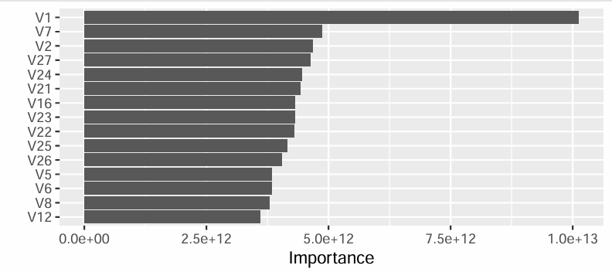

These findings suggest that the economic value of OAT expansion is governed primarily by core structural features of the modeled system, rather than by marginal variation across a large number of inputs. The dominance of a small set of parameters implies that cost-effectiveness is not evenly sensitive to all sources of uncertainty, but instead reflects the behavior of key system-level mechanisms embedded in the model.

Importantly, because Random Forest importance measures reflect joint contributions rather than isolated marginal effects, these results indicate that the influence of key parameters arises through their interactions with other uncertain system characteristics. This observation motivates the subsequent analysis of nonlinear effects, parameter interactions, and system regimes, as average importance alone does not reveal how economic value changes across different combinations of parameter values.

Nonlinearity and Parameter Interactions
To examine whether the effects of individual parameters on economic value are additive or conditional, partial dependence functions and interaction surfaces were analyzed using the Random Forest model (Friedman, 2001, Hastie et al., 2009).
Figure 2_1 presents the partial dependence of net monetary benefit on parameter V12, holding all other parameters at their observed distributions. The relationship is clearly nonlinear: increases in V12 are associated with higher NMB at low-to-moderate levels, but the marginal effect diminishes at higher values. This pattern indicates that the economic contribution of V12 cannot be adequately summarized by a constant marginal effect and illustrates the limitations of one-at-a-time sensitivity analysis.
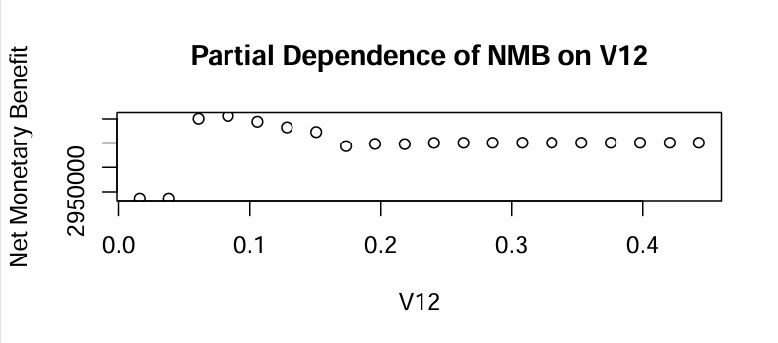
Figure 2_1.

While partial dependence reveals nonlinearities, it does not capture how the effect of one parameter depends on the level of another. Figure 2_2 therefore displays the two-dimensional interaction surface between V12 and V8. The interaction plot reveals strong conditional effects: when V8 is low, changes in V12 have little impact on NMB, whereas at higher levels of V8, increases in V12 are associated with substantial gains in economic value. High net monetary benefit emerges only under specific combinations of these two parameters.

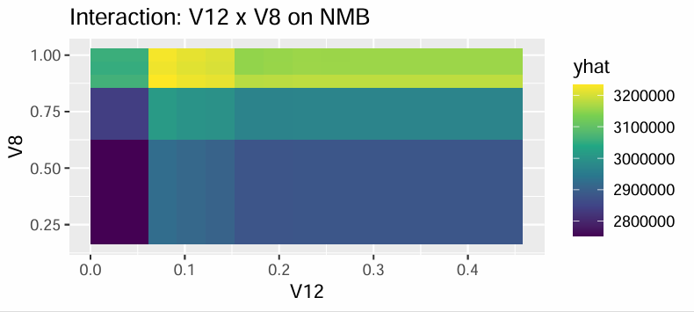
Figure 2_2

Together, these results demonstrate that the economic value of OAT expansion is shaped by nonlinear interactions among system parameters, rather than by additive effects of individual inputs. This finding reinforces the interpretation of cost-effectiveness as a conditional, system-dependent outcome, and motivates subsequent analyses that characterize system regimes and tail behavior across the full uncertainty space.

Unsupervised Learning: System Regimes via Clustering
To characterize heterogeneity in the model’s uncertainty space, unsupervised clustering was applied to the probabilistic sensitivity analysis (PSA) simulations. Clustering was performed using model input parameters only, without incorporating economic outcomes, in order to identify qualitatively distinct system configurations implied by joint parameter uncertainty (Hastie et al., 2009).
The number of clusters was selected using standard diagnostic criteria (elbow method), resulting in three distinct clusters. Each PSA draw was then assigned to one of these clusters, and economic outcomes were summarized within each group.

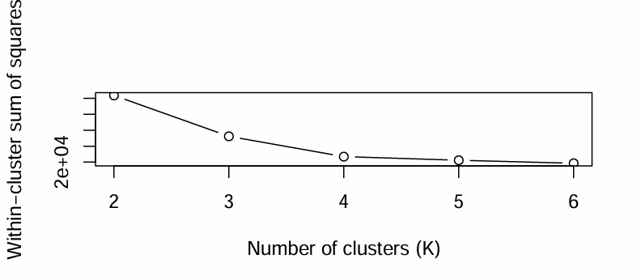
Figure 3 displays the within-cluster sum of squares (WSS) as a function of the number of clusters (K). The plot exhibits a clear elbow at K = 3, indicating diminishing returns to additional cluster separation beyond this point. Based on this diagnostic, three clusters were selected to characterize distinct system regimes implied by joint parameter uncertainty.
Table 1 presents cluster-specific summary statistics for net monetary benefit (NMB), including the mean, median, and selected distributional percentiles.

Table 1. Cluster-Specific Summary Statistics for NMB
Cluster | Mean NMB | Median NMB | 10th percentile (p10) | 90th percentile (p90)
1 | 3,946,673 | 3,183,433 | 1,388,785 | 7,324,223
2 | 4,090,833 | 3,900,913 | 1,862,894 | 6,570,077
3 | 1,511 | 1,442 | 986 | 2,127

The clustering analysis reveals that the uncertainty space of the model is not homogeneous. Instead, PSA simulations group into distinct system regimes characterized by markedly different levels of economic value.
Clusters 1 and 2 are associated with substantial positive net monetary benefit, with mean and median NMB values in the range of several million dollars. These regimes correspond to system configurations under which OAT expansion generates strong economic returns.
In contrast, Cluster 3 exhibits near-zero NMB across the entire distribution, including the upper tail. Despite remaining formally cost-effective under conventional ICER-based criteria, OAT expansion in this regime yields only marginal economic value.
These findings demonstrate that cost-effectiveness alone may mask substantial heterogeneity in economic outcomes. While OAT expansion appears robustly cost-effective on average, its practical economic value depends critically on underlying system-level conditions captured by the clustering structure.

Tail Risk Analysis: Quantile Random Forests
To move beyond average economic outcomes, Quantile Random Forests (QRF) were estimated to characterize the lower (10th percentile) and upper (90th percentile) tails of the net monetary benefit (NMB) distribution (Meinshausen, 2006). Unlike standard Random Forest models, QRF allows direct estimation of conditional quantiles, enabling analysis of downside risk and upside potential under joint parameter uncertainty.
Figure 4 presents the top ten most important parameters from the QRF model, reflecting their contribution to explaining variation in the tails of the NMB distribution.

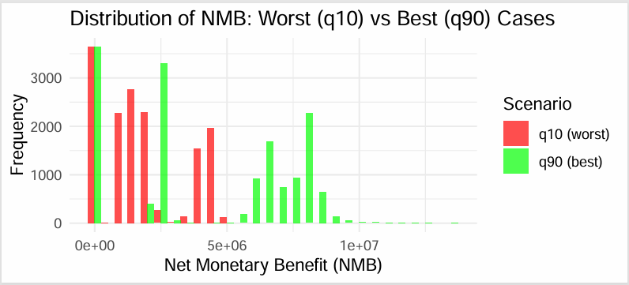

The lower tail of the distribution represents worst-case economic scenarios, while the upper tail captures the potential for exceptionally high economic returns. Although average results suggest robust cost-effectiveness of OAT expansion, the QRF results reveal substantial dispersion in potential outcomes across the uncertainty space.

Importantly, the variables that dominate tail behavior largely overlap with those identified as key drivers of average NMB in the Random Forest analysis. This indicates that downside risk and upside potential are governed by the same underlying system-level characteristics rather than by distinct or isolated mechanisms.

From a policy perspective, these findings are highly relevant for risk-averse decision-makers. Even when an intervention is cost-effective on average, certain system configurations may be associated with limited economic gains, while others offer substantial upside potential. Tail-risk analysis therefore provides complementary information to conventional cost-effectiveness metrics by highlighting the range of plausible economic outcomes under uncertainty.

Structural Drivers of Tail Outcomes
Variable importance measures from the Quantile Random Forest (QRF) model indicate that tail behavior in economic outcomes is driven primarily by a small set of core system parameters (Meinshausen, 2006). In particular, the most influential predictors are V1-V6, followed by V7-V10, while other parameters play a comparatively smaller role. This pattern suggests that downside risk (low NMB) and upside potential (high NMB) are governed by fundamental model characteristics rather than isolated secondary inputs.

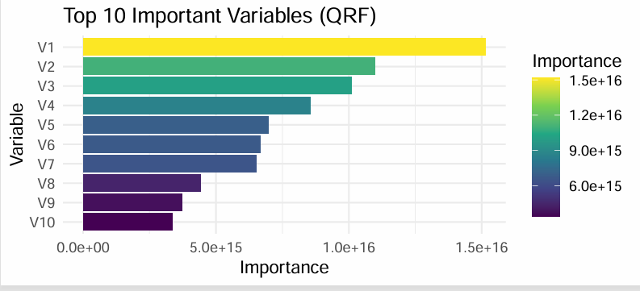
Figure 5

This figure reports the top ten model parameters ranked by their importance in explaining variation in the lower (q10) and upper (q90) tails of the net monetary benefit (NMB) distribution, as estimated by the Quantile Random Forest. A small subset of core parameters (V1-V6), followed by V7-V10, dominates tail behavior, while remaining parameters contribute comparatively little. This pattern indicates that both downside risk and upside potential are governed by fundamental system-level characteristics rather than isolated or secondary inputs.
Importantly, the tail-focused findings align with the earlier supervised learning results: the parameters that dominate average economic value also appear as the key determinants of variation in extreme outcomes. This convergence implies that tail risk is structural, it emerges from the same system-level mechanisms that generate high average value, rather than being driven by a separate set of rare or idiosyncratic parameter draws.

Joint Effects in the Median Outcome Surface
To visualize conditional effects in a policy-relevant manner, median (q50) net monetary benefit (NMB) predictions were generated using the Quantile Random Forest model over a two-dimensional grid spanning parameters V12 and V8, while holding all other parameters at their empirical distributions (Meinshausen, 2006).

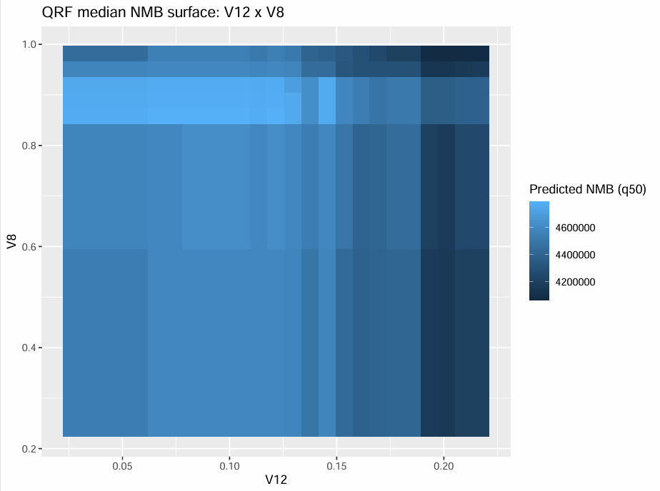
Figure 6
The heatmap illustrates how typical economic value varies jointly with two influential system parameters, rather than in response to marginal changes in a single input. Several features are noteworthy.
The surface exhibits clear nonlinearity and interaction effects: changes in V12 are associated with different median NMB levels depending on the value of V8. This indicates that the effect of one parameter cannot be interpreted independently of the other, reinforcing the importance of joint system configurations.
Distinct regions of relatively high and low predicted median NMB emerge across the parameter space. These regions are not sharply separated by a single threshold but instead reflect smooth transitions, suggesting that policy value changes gradually as system characteristics evolve.
Focusing on the median outcome provides a complementary perspective to both average and tail-based analyses. While mean NMB reflects expected value and quantile analyses capture downside and upside risk, the median surface represents the most typical outcome policymakers are likely to observe under a given system configuration.
Overall, this visualization reinforces the central conclusion of the extension: the economic value of OAT expansion is conditional and system-dependent. Even when considering typical outcomes rather than extremes, policy value is shaped by the joint distribution of key parameters, rather than by isolated inputs or average effects alone.

Discussion

What Changes Relative to the Original Study
The original analysis by Morozova et al. (2019) demonstrates that expanding opioid agonist treatment (OAT) capacity is cost-effective across a wide range of parameter uncertainty, primarily using average incremental cost-effectiveness ratios and cost-effectiveness acceptability curves. These results support a broadly positive policy recommendation but provide limited insight into why cost-effectiveness holds and how sensitive the magnitude of economic value is to joint variation in system characteristics.
The present extension changes the interpretation of these findings in three important ways. First, by reformulating outcomes in terms of net monetary benefit (NMB), the analysis shifts attention from a binary notion of cost-effectiveness to a continuous measure of economic value (Stinnett & Mullahy, 1998). This reveals substantial heterogeneity in the magnitude of benefits, even when cost-effectiveness is preserved in sign. Second, machine-learning methods demonstrate that economic outcomes are not driven by independent parameter effects, but by nonlinear interactions among a small subset of core system parameters. Third, the results show that cost-effectiveness should be understood as a conditional outcome that depends on underlying system configurations rather than as a universal property of OAT expansion.
Taken together, the extension reframes the original policy conclusion: OAT expansion remains cost-effective on average, but the expected economic return varies widely across plausible system states implied by the original uncertainty structure.

Robustness and Internal Consistency of Findings
A key contribution of this extension is the robustness of its conclusions across multiple analytical approaches. Supervised learning using Random Forest regression identifies a consistent set of parameters that dominate variation in average NMB. Quantile Random Forest analysis shows that these same parameters govern both downside risk (q10) and upside potential (q90), indicating that tail behavior is structural rather than driven by rare or idiosyncratic draws. Unsupervised clustering further confirms the presence of distinct system regimes characterized by markedly different levels of economic benefit.
Importantly, these results are internally consistent: parameters that are influential in explaining mean outcomes also define tail behavior and differentiate clusters. This convergence across methods reduces concerns that findings are artifacts of any single modeling approach and strengthens confidence that the observed patterns reflect genuine properties of the underlying simulation model.
At the same time, the extension reinforces the robustness of the original study’s qualitative conclusion. Across all clusters and quantiles examined, OAT expansion continues to generate positive net monetary benefit, indicating that the direction of the policy recommendation remains stable under joint uncertainty.

Limitations and Scope of Inference
Several limitations should be acknowledged. First, the extension relies entirely on the PSA output generated by the original model and does not incorporate new empirical data or alternative structural assumptions. As a result, the findings describe the behavior of the existing model rather than the real-world system directly. Second, the parameters analyzed (V1-V27) are abstracted representations of epidemiological, behavioral, and cost processes; while the analysis identifies which parameters matter most, it does not by itself specify how these parameters could be modified through policy interventions.
Third, machine-learning methods emphasize prediction and pattern discovery rather than causal identification. Although the results highlight strong associations and interactions, they should not be interpreted as establishing causal mechanisms beyond those already embedded in the original model structure. Finally, computational constraints required subsampling for some analyses, which may limit the precision of estimated effects at the margins of the uncertainty space, though sensitivity checks suggest that core conclusions are not materially affected.
Despite these limitations, the extension remains fully consistent with the design and intent of the original study. Rather than challenging its conclusions, the analysis complements and deepens them by clarifying how uncertainty, interactions, and system-level structure shape the economic value of OAT expansion.

Conclusion
This project combines a replication and a machine-learning, based extension to evaluate the robustness and interpretability of the cost-effectiveness conclusions in Morozova et al. (2019), which assessed the expansion of opioid agonist treatment (OAT) capacity in Ukraine. Together, the two components strengthen confidence in the original findings while extending their policy relevance by explicitly examining how joint uncertainty and system-level interactions shape economic outcomes.
The replication demonstrates a high degree of reproducibility. Using the authors’ original data and code, the Kyiv scenario was successfully reproduced, with five of seven key state variables matching exactly and two exhibiting small, systematic deviations of approximately five percent. These discrepancies were stable across simulation runs and did not affect the direction or substance of the results. In particular, the replication confirms the central conclusion that OAT expansion remains cost-effective under standard willingness-to-pay thresholds, even when accounting for epidemiological feedback and treatment dynamics. This successful replication provides a credible empirical foundation for the extension analysis.
The extension contributes new insight without altering the underlying model structure, assumptions, or outcome definitions. Rather than introducing new data or revising parameters, the extension reanalyzes the original probabilistic sensitivity analysis (PSA) output using machine-learning methods. By expressing outcomes in terms of net monetary benefit (NMB), the analysis reframes cost-effectiveness as a continuous measure of economic value and avoids the statistical limitations of incremental cost-effectiveness ratios.
Across supervised learning, unsupervised clustering, and quantile-based methods, a consistent pattern emerges. Variation in economic outcomes is dominated by a small subset of core system parameters, while many other inputs play a comparatively minor role. Importantly, these same parameters govern not only average outcomes but also downside risk and upside potential. Tail-risk analysis using Quantile Random Forests shows that the worst-case decile of outcomes still yields positive NMB, but with substantially lower magnitude than best-case scenarios. This indicates that uncertainty in economic value is structural, arising from fundamental system characteristics rather than rare or idiosyncratic parameter draws.
Unsupervised clustering further reinforces this interpretation by revealing distinct system regimes within the PSA space. Although OAT expansion is cost-effective across all identified clusters, the magnitude of economic benefit differs sharply. Some regimes generate substantial NMB, while others yield near-zero economic gains despite favorable ICERs. These findings demonstrate that cost-effectiveness is not a uniform policy property but a conditional outcome shaped by interacting system-level features.
Taken together, the extension directly answers the research question: joint uncertainty and parameter interactions play a central role in shaping the economic value of OAT expansion, and substantial net monetary benefit arises only under specific system configurations. While the original conclusion, that OAT expansion is cost-effective, remains robust, the extension shows that this conclusion alone may overstate the practical economic value of the intervention in less favorable contexts.
From a policy perspective, the results suggest that uniform expansion strategies may be insufficient. In system regimes associated with low economic returns, complementary interventions, such as improvements in treatment retention, demand generation, or integration with harm-reduction services, may be necessary to unlock the full economic potential of OAT expansion. More broadly, this project illustrates how machine-learning tools can enrich traditional economic evaluation by transforming sensitivity analysis from a robustness check into a source of substantive policy insight.

References
Morozova, O., Crawford, F. W., Altice, F. L., Cohen, T., & Paltiel, A. D. (2019).
Cost-effectiveness of expanding the capacity of opioid agonist treatment in Ukraine: A dynamic modeling analysis. Addiction, 114(3), 437–450.
https://doi.org/10.1111/add.14431
Cranmer, S. J., & Desmarais, B. A. (2017).
What can we learn from predictive modeling? Political Analysis, 25(2), 145–166.
https://doi.org/10.1017/pan.2017.3
Breiman, L. (2001).
Random forests. Machine Learning, 45(1), 5–32.
https://doi.org/10.1023/A:1010933404324
Meinshausen, N. (2006).
Quantile regression forests. Journal of Machine Learning Research, 7, 983–999.
Friedman, J. H. (2001).
Greedy function approximation: A gradient boosting machine. Annals of Statistics, 29(5), 1189–1232.
Hastie, T., Tibshirani, R., & Friedman, J. (2009).
The elements of statistical learning: Data mining, inference, and prediction (2nd ed.). Springer.
Stinnett, A. A., & Mullahy, J. (1998).
Net health benefits: A new framework for the analysis of uncertainty in cost-effectiveness analysis. Medical Decision Making, 18(2), S68–S80.
https://doi.org/10.1177/0272989X9801800209

