**Grab Dat Money**

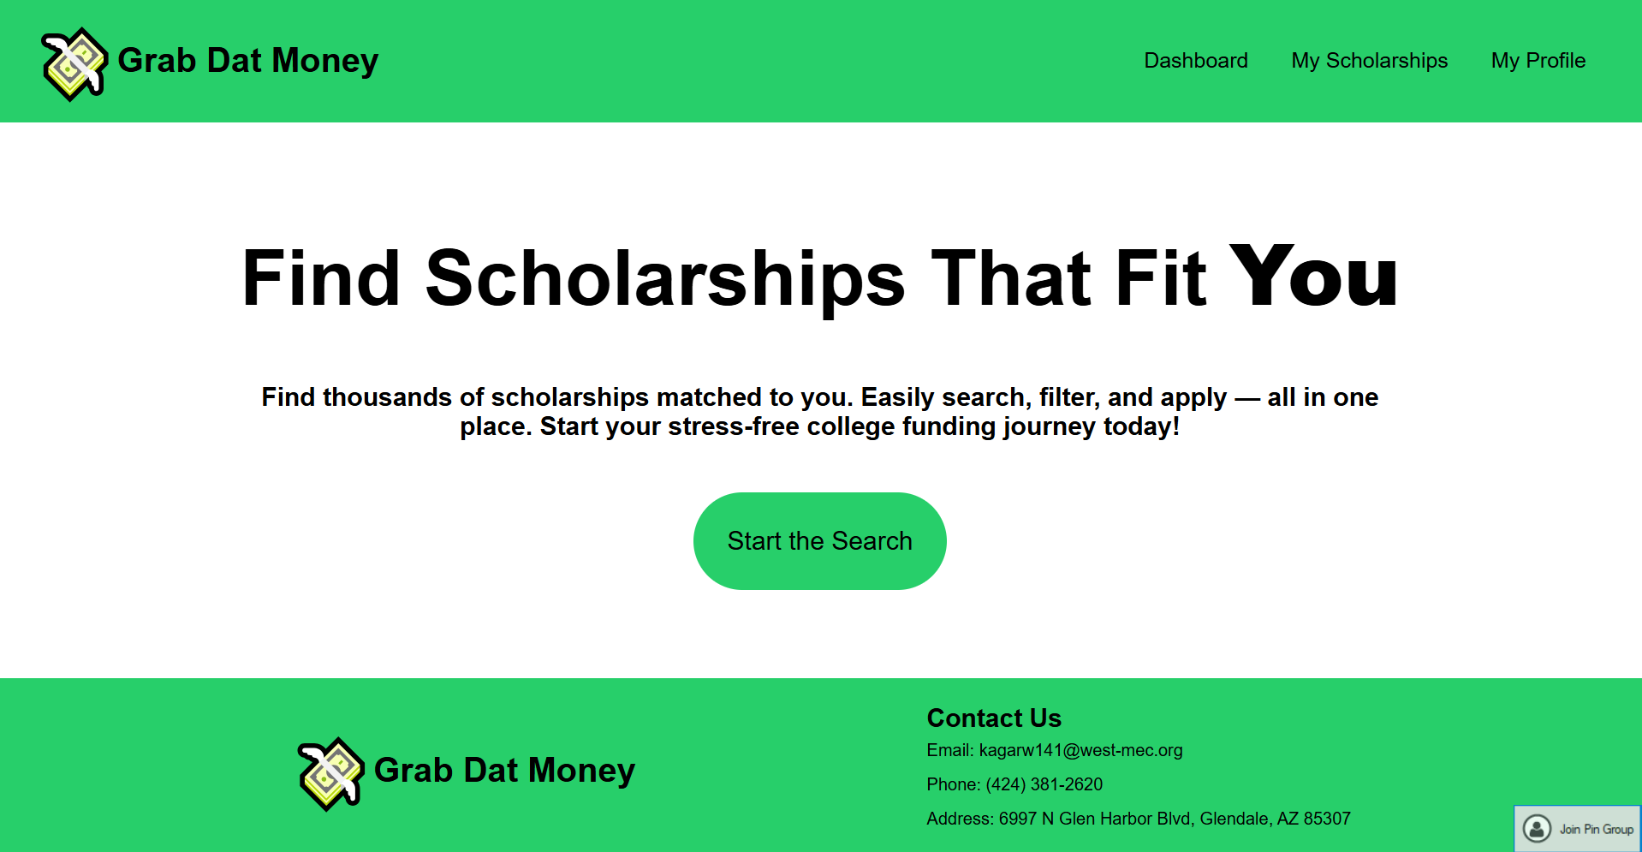

Grab Dat Money is an easy-to-use scholarship finder web application that finds scholarships for students as a capstone project.

The app allows users to build their profile and view scholarships that match with their profile, making it easier for students to apply to scholarships.

Functionalities:

1. Manage your profile
2. View all scholarship (including provider, amount, eligibility, deadline, etc.)
3. View matched scholarships
4. Filter/Rearrange scholarships based on deadline, amount, and etc.
5. Save scholarships you are interested in
6. Directly go to the scholarship to apply

Languages Used:

1. HTML - Basic Structure of website
2. CSS - Styling of the webpage
3. JavaScript - Run functionalities on the webpage
4. JSON – Store information about available scholarships