**Bug Report**

1. **Overall Rating page - Traversing through pages giving an unexpected response**

**User Story**

**As** a User

**When** I log in Buggy Cars Rating app

**And** I go to Overall Rating Page from the home page

**And** I traverse through different pages

**Then**

**Expected Response**: After the last page (5 in this case) the forward page button should be disabled

**Actual Response**: User can goto pages more than 5 with no data present in them

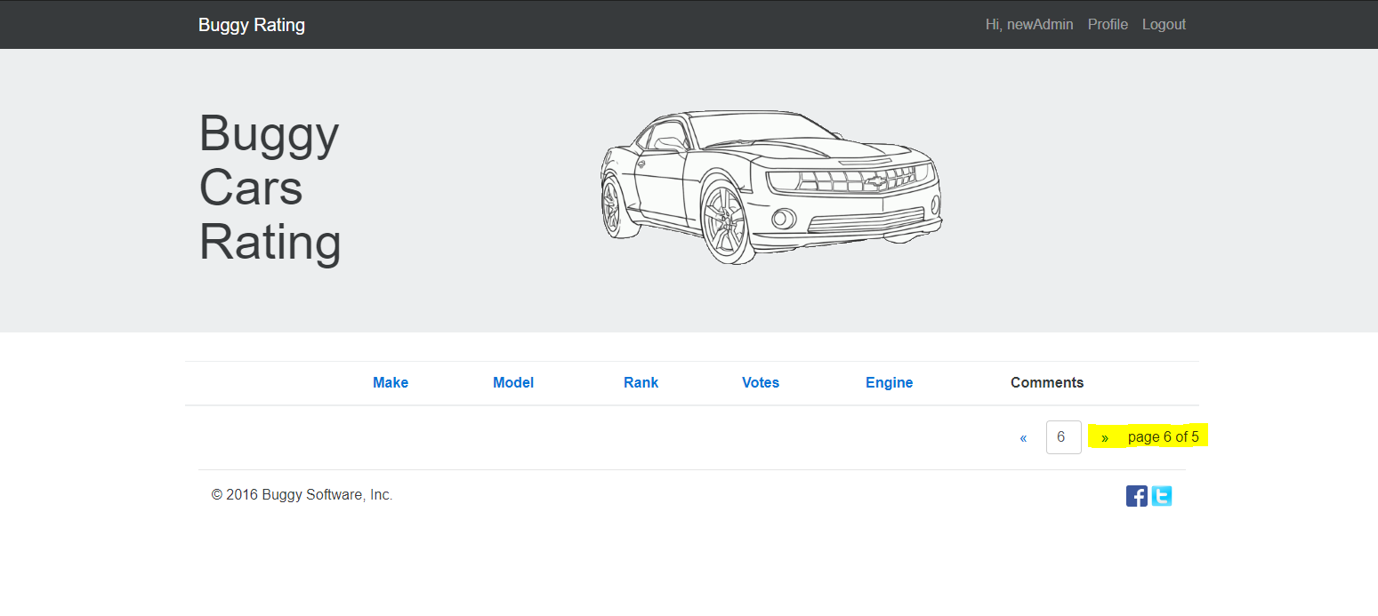

1. **Buggy Rating (Home button) unresponsive when in any car make page**

**User Story**

**As** a user

**When** I log in Buggy Cars Rating app

**And** I goto Popular Make page

**And** I click Buggy Rating (Home button)

**Then**

**Expected response**: I should be navigated back to the home page

**Actual Response**: I stay on the same page

**Note**: The same bug is happening when User goes to Overall Rating page and select any car make

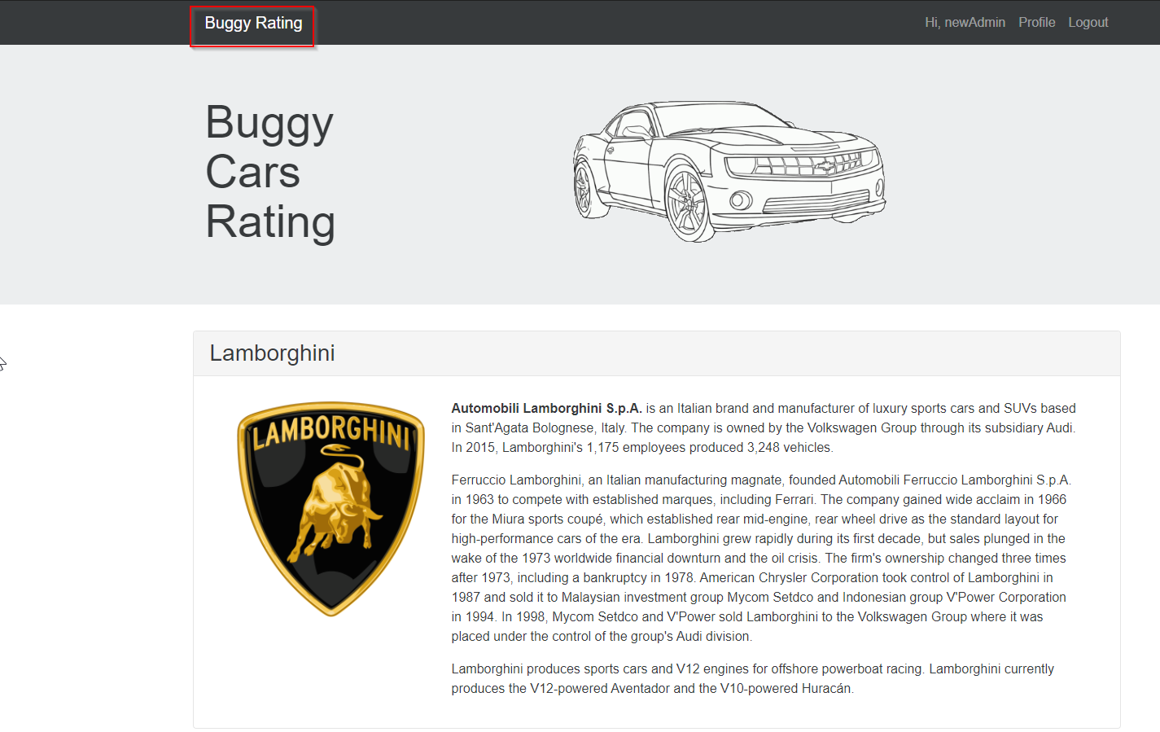

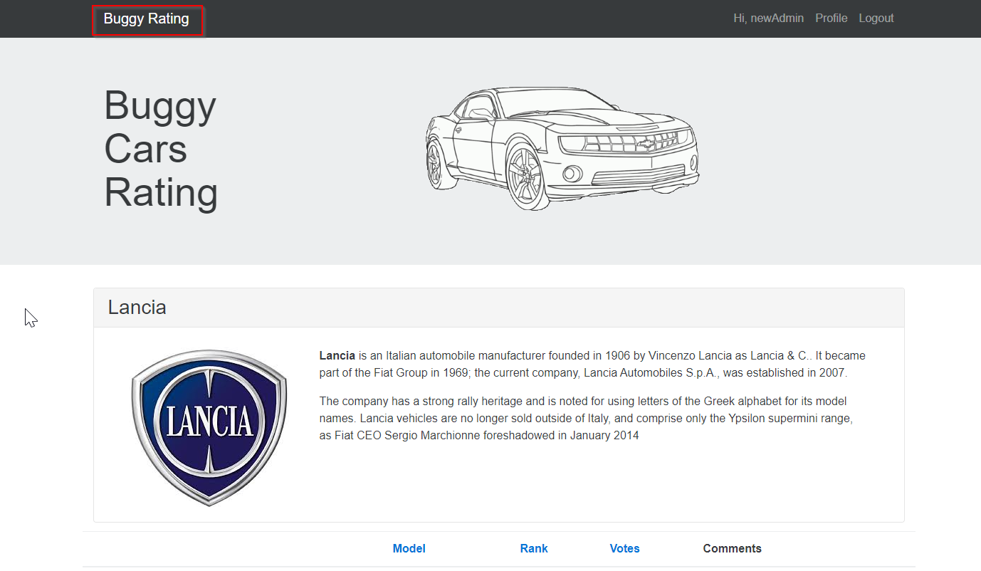

1. **Sorting on basis of votes in popular make page is incorrect**

**User Story**

**As** a User

**When** I log in Buggy Cars Rating app

**And** I goto Popular Make page

**And** I try to sort cars on basis of votes by clicking on votes link

**Then** Cars are sorted in no specific manner

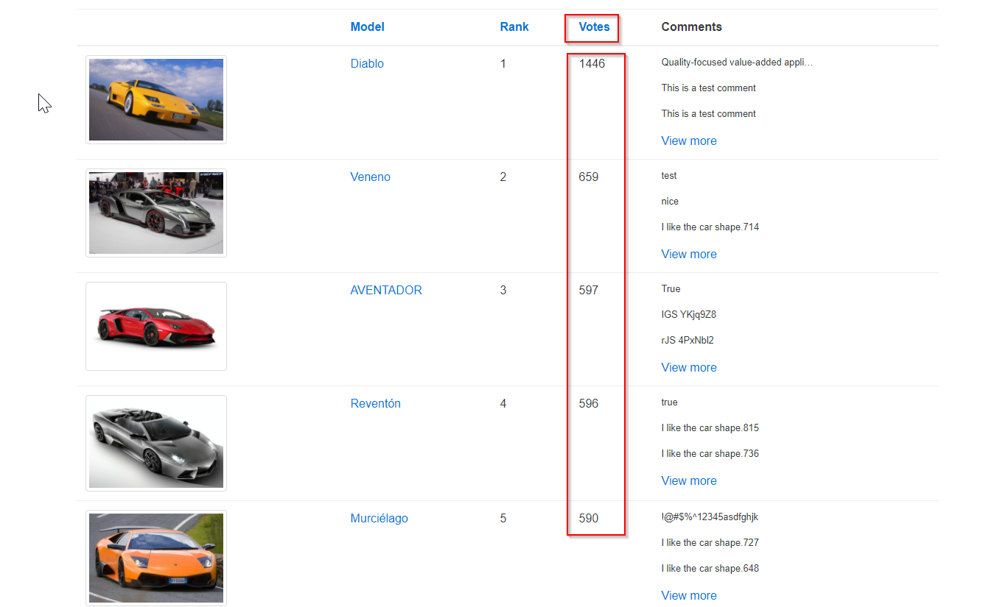

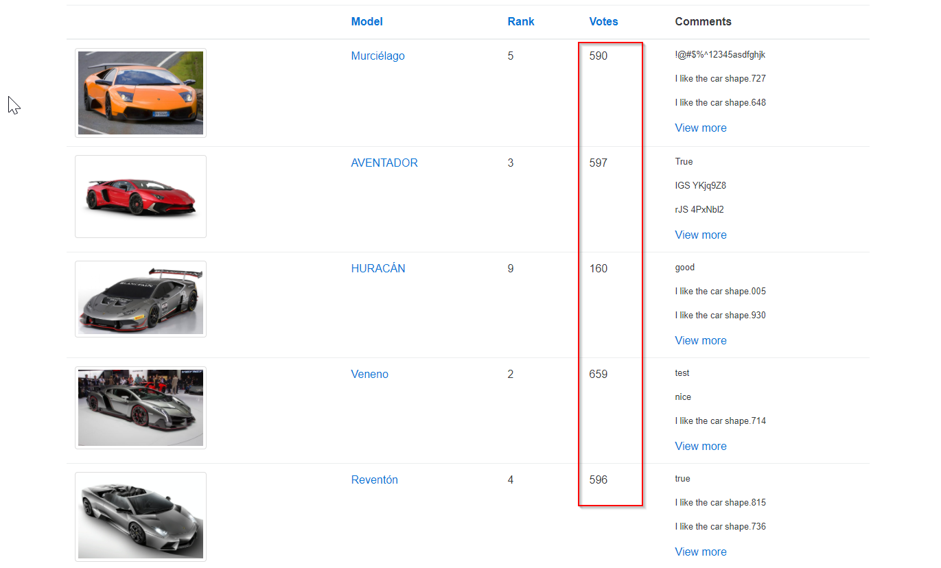

1. **Author of comments is not updated for some cars**

**User Story**

**As** a User

**When** I log in Buggy Cars Rating app

**And** I goto Overall Rating page

**And** I click on any car model

**Then**

**Expected response**: In Date, Author, Comment table author should be updated. Example

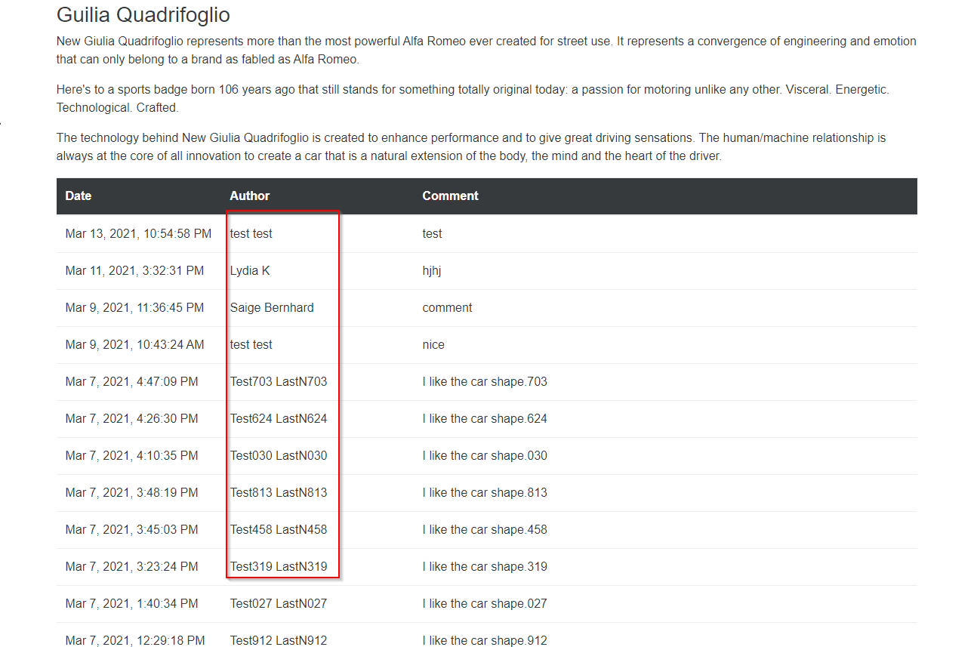

**Actual response**: Author section is not updated for all the car models. Example

