|  |  |
| --- | --- |
|  |  |

**Installation Manual**

**Authors**Robert Kettler  
Daniel Weidle

# Table of contents

Table of contents 2

List of Figures 3

List of Tables 3

Version History 5

Introduction 6

1 System requirements 7

1.1 Recommended hardware requirements 7

1.2 Software requirements 7

1.2.1 Windows / Mac prerequisites 8

2 Download and install 9

3 Reindexation Process 10

# List of Figures

Figure 1: Check virtualization support 8

# List of Tables

Table 1: Recommended system requirements 7

# Version History

|  |  |  |
| --- | --- | --- |
| **Version** | **Date** | **Description** |
| 0.1 | 13.06.2016 | Initial |
| 02. | 17.06.2016 | Added reindex Process |

# Introduction

This document includes software installation and maintenance instruction for Metis to enable system administrators installing and maintaining the software.

Software Installation and Maintenance depends on the destinations operating system. This is caused by the usage of Docker. While Linux includes native Docker support, Windows and Mac needs tools like Docker Toolbox or Boot2Docker (Deprecated).

Administrators who are responsible for Software Installation and Maintenance should be familiar with the Docker ecosystem.

# System requirements

To install and run Metis software your system must meet the following minimum requirements.

## Recommended hardware requirements

Table 1: Recommended system requirements

|  |  |
| --- | --- |
|  | **Recommended requirements** |
| **Operating system** | Windows 7, Linux or MacOS |
| **CPU** | Core 2 Duo at 2,6 GHz with VT-X |
| **Memory** | 2 GB RAM |
| **Hard drive** | At least 5 GB free hard disk space |
| **Network** | 1 Gbit/s |
| **Internet** | Metis requires internet access to download the Docker images. After the build is done, internet connection isn’t required anymore. |

## Software requirements

Metis requires at least the following software. Make sure that virtualization is enabled in BIOS. For Windows 8/8.1/10 open Task Manager, go to Performance tab - under CPU you should see virtualization enabled.

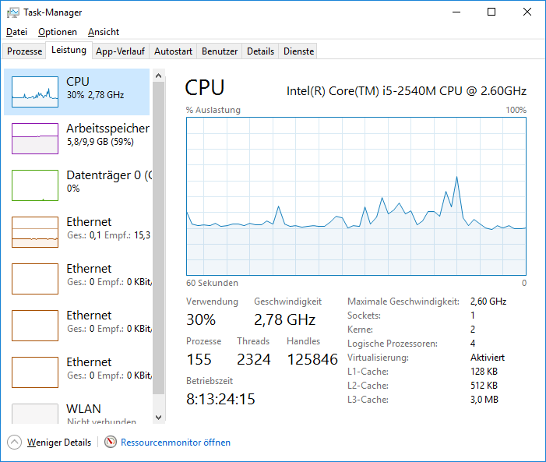

Figure 1: Check virtualization support

### Windows / Mac prerequisites

If you run Metis on Windows or Mac environment, the Docker Toolbox version 1.11.1 or later must be installed.

# Download and install

Following general instructions has to be executed:

* Ensure there is at least 5 GB of free disk space to contain downloaded installation files.
* Specify the installation directory, use only alphanumeric characters and do not type and special characters or symbols. Including special characters may let the installation fail.
* Download the latest stable release from the Kanbananas GitHub repository (https://github.com/kanbanana/knowledgebase/releases)
* Unpack the downloaded release into the earlier specified installation directory.

**Windows / MacOS**

* Start Docker Toolkit and navigate to installation directory.
* Run “./install.sh”. The script will download the needed images, provision them and start the application. By default, Metis listens on port 8080. This port can be changed by changing the port in the install.sh file.

**Linux**

* Open a Terminal session and navigate to the earlier specified installation directory.
* Run “./install.sh”. The script will download the needed images, provision them and start the application. By default, Metis listens on port 8080. This port can be changed by changing the port in the install.sh file.

# Reindexation Process

In order to reindex files uploaded to the system, the web interface provided by Open Search Server is used. The web interface can be accessed over <URL>:8080/oss/admin On the start page, chose the index you want to reindex:

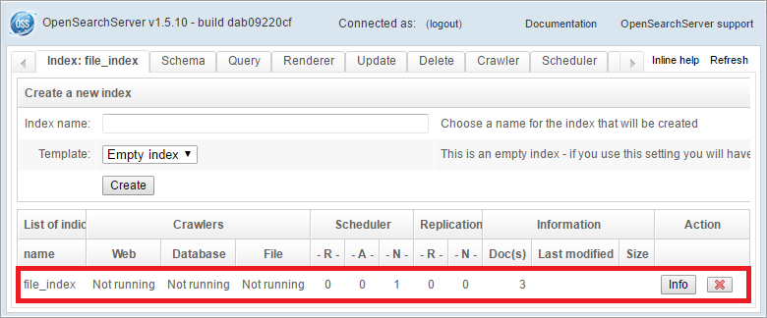

As first step of the reindexation process all files are deleted from the file crawler. In order to do that, go to Crawler -> Files -> File Browser. Here query the documents you would like to delete from the file crawler (probably all, so leave the query empty). Then chose the “Delete Selection” command and click “Go”:

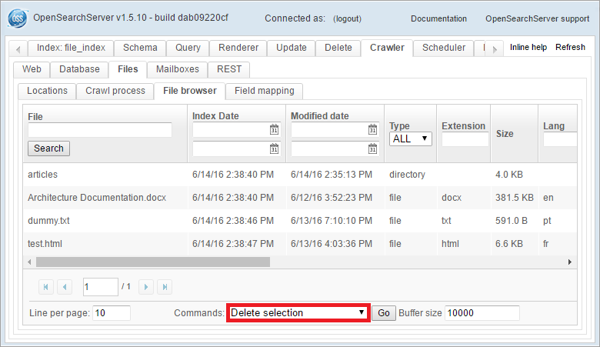

After respective files are deleted from the file crawler, the index itself can be truncated. In order to do that, go to Runtime -> Commands and click the Truncate option “Delete All”. Afterwards click “Reload” to make sure the index has successfully been truncated (status changes to “0 documents”).

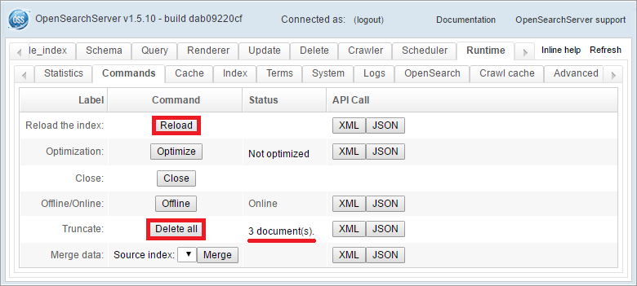

The file crawler and index are now cleaned and can be filled again. For this purpose, the file crawler needs to be executed. Go to Crawler -> Files -> Crawl Process and run the file crawler once (make sure to not run it consecutively).

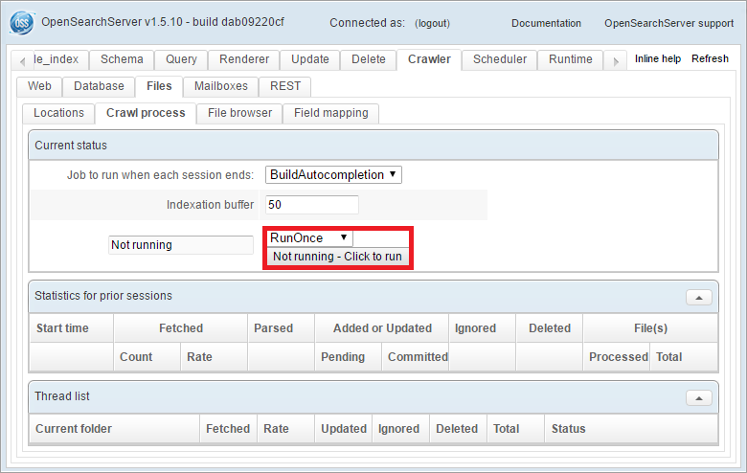

Reindexation process has been completed, as soon as the file crawler terminates. All files in target directory have been added to the index at this point.