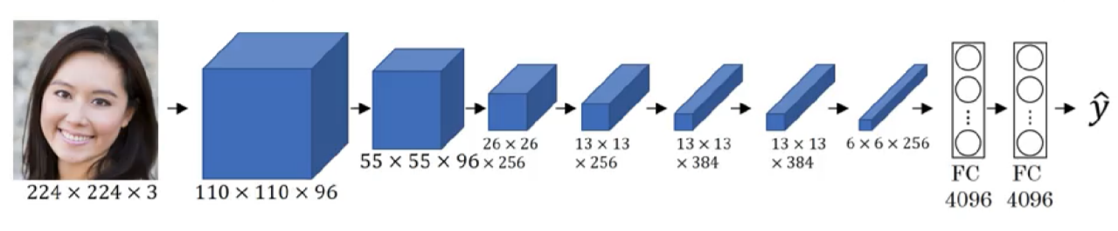

Total weight parameter : 55737376

**FC**

4096*4096

=16777216

**FC**

(6*6*256)*4096

=37748736

**CONV 2D**

Stride = 2

Filter = 256

Kernel = 3

No padding

Mask = (3*3*384)*256

=884736

**CONV 1*1**

**CONV**

Stride = 1

Filter = 384

Kernel = 1

No padding

Mask = (1*1*1)*256*384

=98304

**POOLING**

F = 2

Stride = 2

**CONV 2D**

Stride = 2

Filter = 256

Kernel = 3

No padding

Mask = (3*3*96)*256

=221184

**POOLING**

F = 2

Stride = 2

**CONV 2D**

Stride = 2

Filter = 96

Kernel = 5

No padding

Mask = (5*5*3)*96=7200