Ques 1. Git Setup
Sol. sudo apt install git
git –version

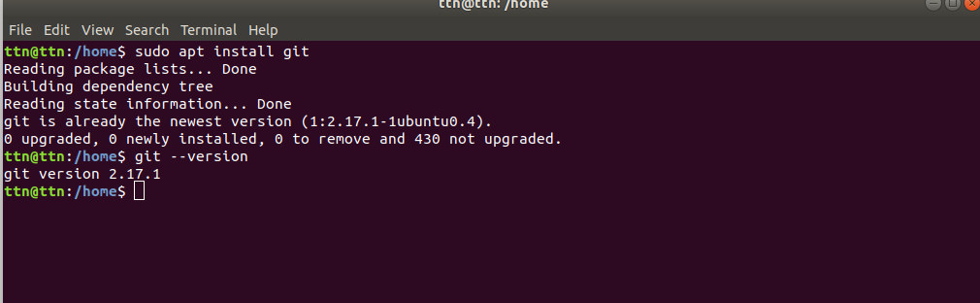

Ques 2. Initialize a Git Repository
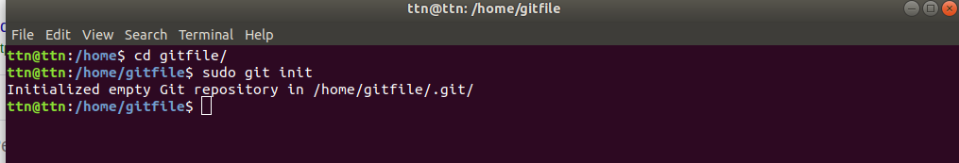

Ques 3. Add files to the repository
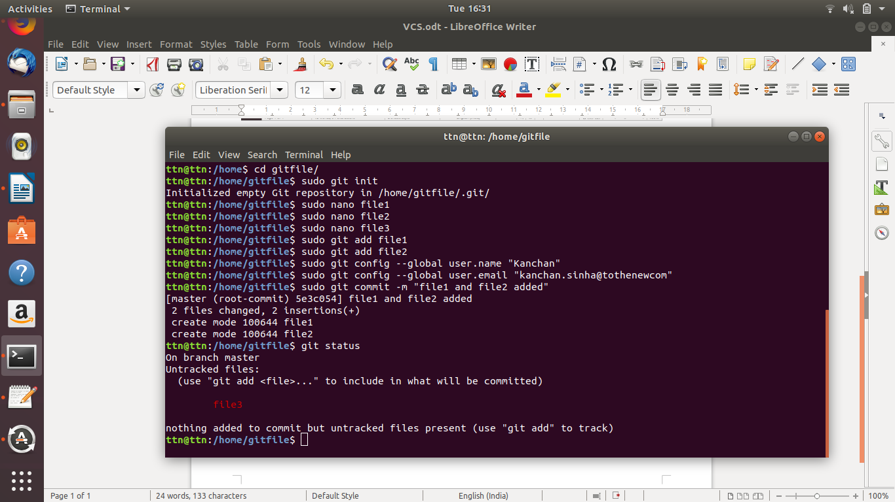

Ques 4.Unstage 1 file

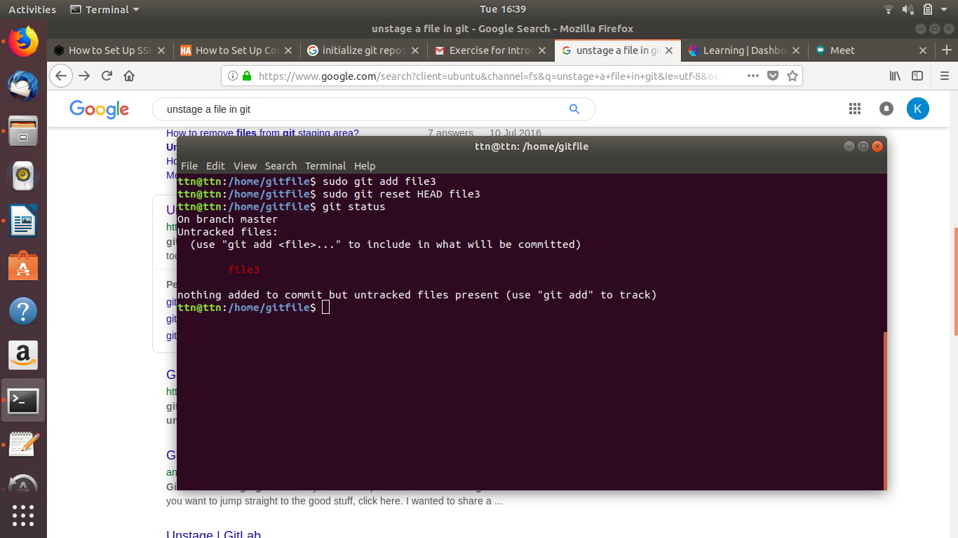

Ques 5.Commit the file

Ques 6. Add a remote.

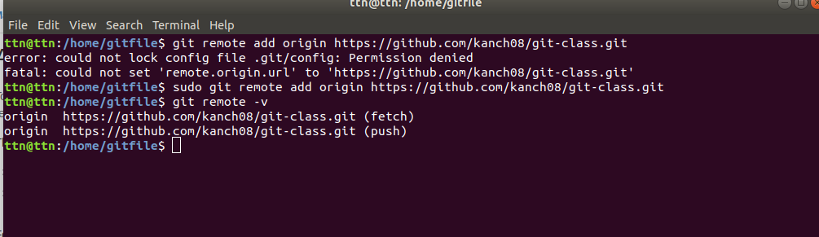

Ques 7. Undo changes to a particular file
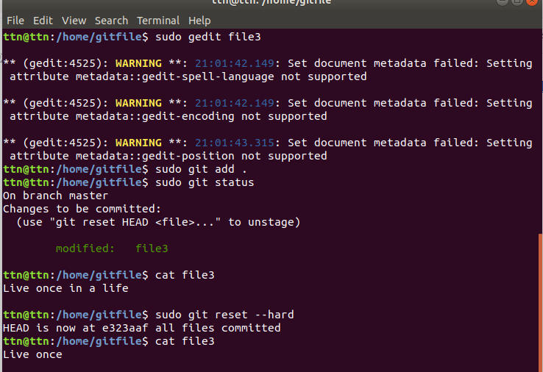

Ques 8. Push changes to Github

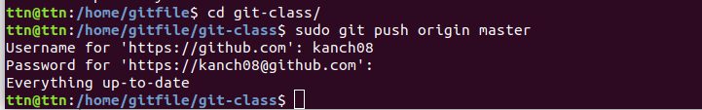

Ques 9 Clone a repository

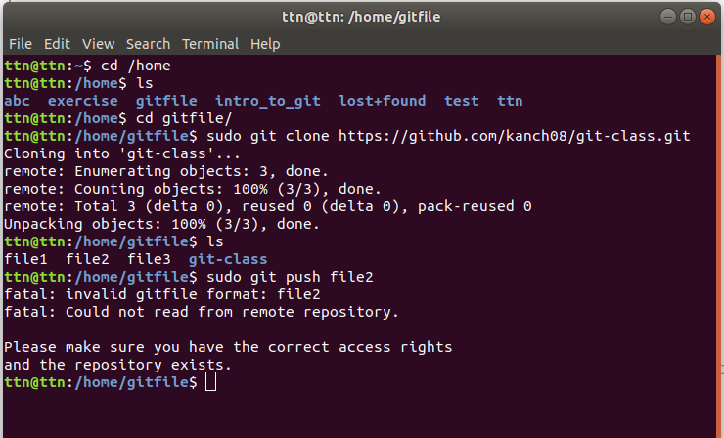

Ques 10. Add changes to one of the copies and pull the changes in the other.

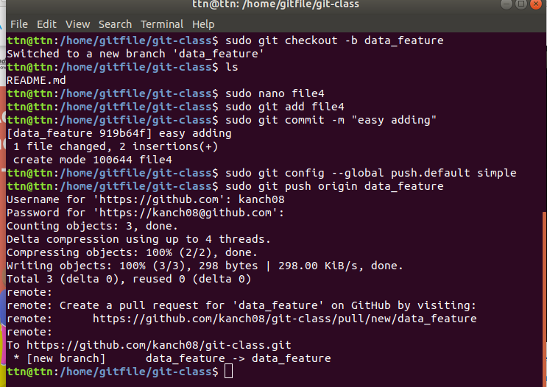

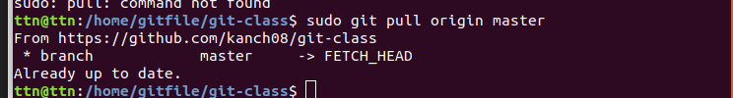

Ques 11. Check differences between a file and its staged version

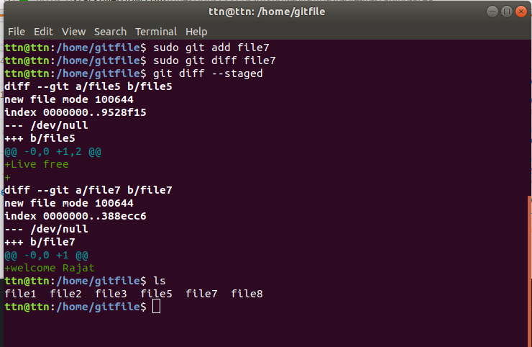

Ques 12. Ignore a few files to be checked in.
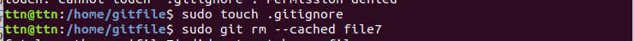
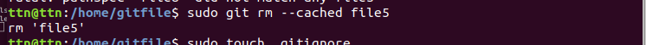

Ques 13. Create a new branch.
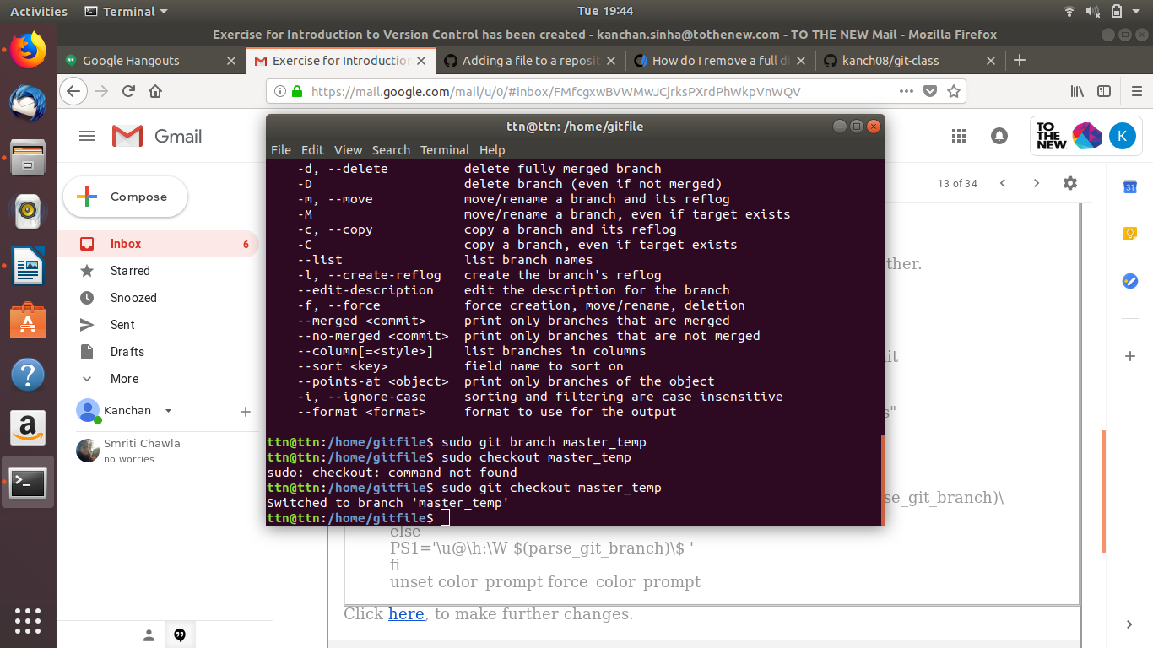

Ques 14. Diverge them with commits
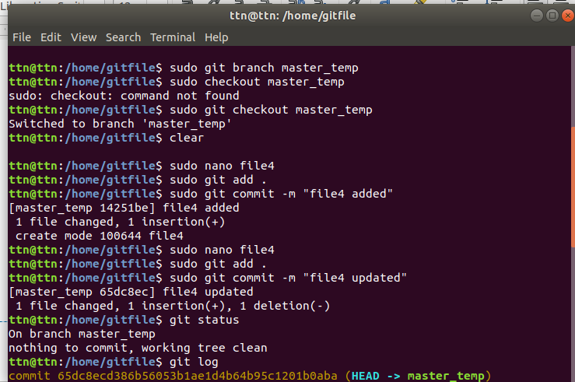

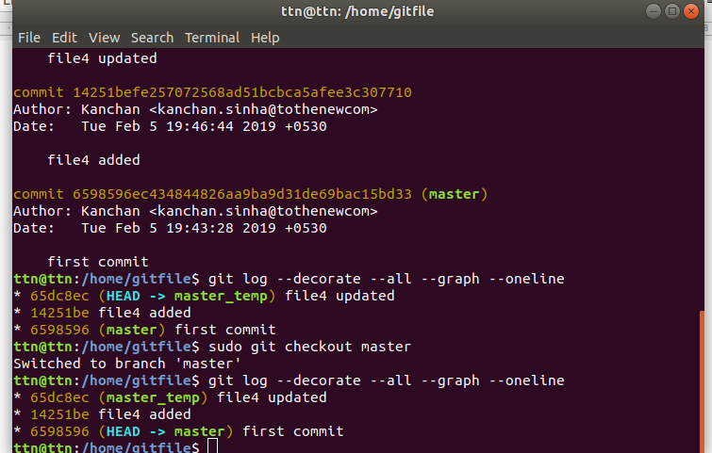

Ques 15 Edit the same file at the same line on both branches and commit
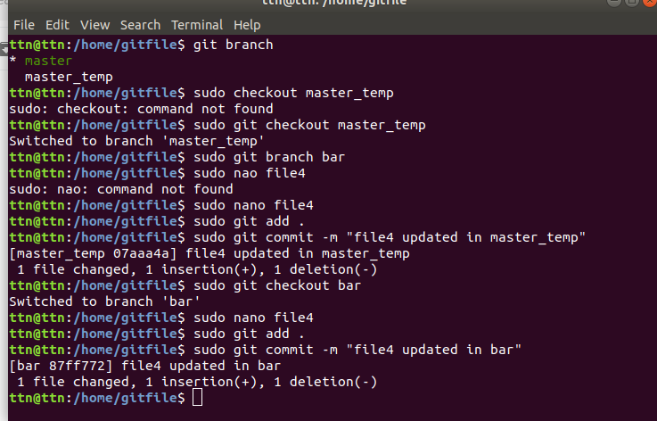

Ques 16 Try merging and resolve merge conflicts.

To see the beginning of the merge conflict in your file, search the file for the conflict marker <<<<<<<. When you open the file in your text editor, you'll see the changes from the HEAD or base branch after the line <<<<<<< HEAD. Next, you'll see =======, which divides your changes from the changes in the other branch, followed by >>>>>>> BRANCH-NAME.
Decide if you want to keep only your branch's changes, keep only the other branch's changes, or make a brand new change, which may incorporate changes from both branches. Delete the conflict markers <<<<<<<, =======, >>>>>>> and make the changes you want in the final merge. In this example, both changes are incorporated into the final merge

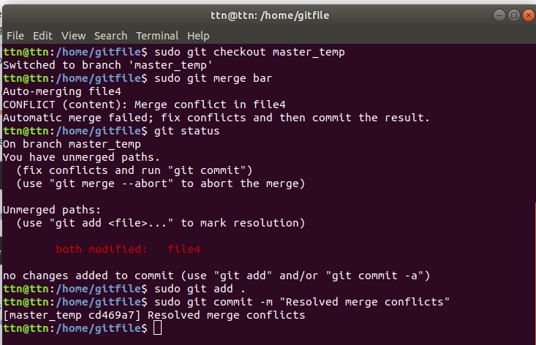

Ques 17 Stash the changes and pop them

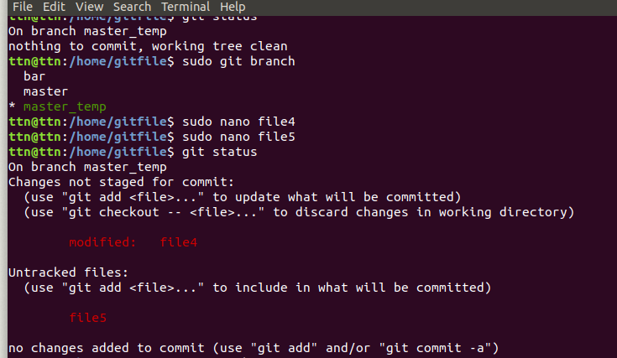

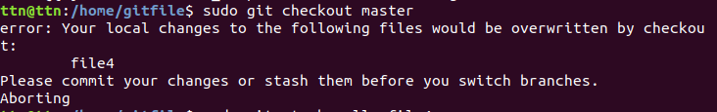

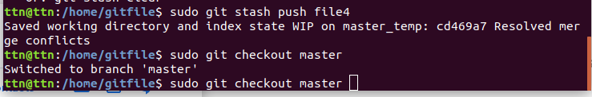

Ques 18.Add the following code to your .bashrc file : color_prompt="yes"
parse_git_branch() {
git branch 2> /dev/null | sed -e '/^[^*]/d' -e 's/* \(.*\)/(\1)/'
}
if [ "$color_prompt" = yes ]; then
PS1='\u@\h\[\033[00m\]:\[\033[
else
PS1='\u@\h:\W $(parse_git_branch)\$ '
fi
unset color_prompt force_color_prompt



