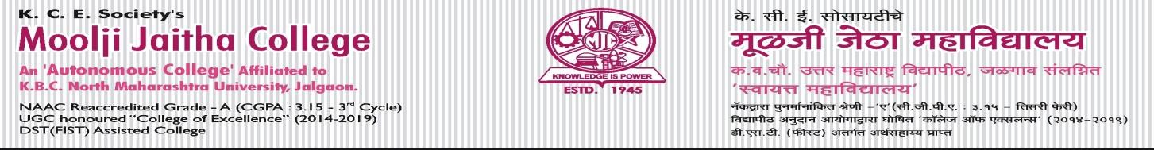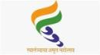

Circular No: - MJCA/Exam 04/2023 F. Y. B.A. Sem-I (Old)
Examination Time Table (As per 2019 Syllabus) – NOV. 2023
- Candidates should be present in the examination hall before fifteen minutes of the schedule time.
- Candidates are forbidden to take any study material in the examination hall.
- Candidates are requested to see the notice board regularly for changes if any, notified later in the schedule of the examination.
- Candidates are required to take note of exact date, day, time and places of every paper on every day.
- No request for any concession, such as change in time or day fixed for the Autonomous college Examination on religious or any other ground shall be granted.
- If there is difficulty about time, subject in time table contact Examination section immediately before 8 days of commencement of examination.
- Course No. of respective subject and paper should be mentioned on answer books along with name of subject and paper title.
- Autonomous college reserves right to make timely changes in Examination time table.
- Students should refer to the official time table displayed on college website only for Nov.-2023 examination.
- The schedule of the examination is as under.

Date & Day | Time | Subject | Sub. Code | Title
20-11-2023 Monday | 9.00 am to  11.00 am | Compulsory English | CENG – 111 | Compulsory English - I
22-11-2023  Wednesday | 9.00 am to  11.00 am | Compulsory English | CENG – 112 | Compulsory English - II
24-11-2023 Friday | 9.00 am to  11.00 am | English Optional | OENG – 111 | Optional English - I
 |  | Hindi | HIN – 111 | Hindi Sahitya Aur Bhasha Dakshata
 |  | Marathi | MAR – 111 | Vangmayprakar - Katha
 |  | Sanskrit | SAN – 111 | Bhashakaushalye - I
 |  | Economics | ECO – 111 | Principles of Microeconomics -I
 |  | Music | MUS – 111 | Vocal Music - I
 |  | Philosophy | PHI – 111 | Introduction to Philosophy - I
 |  | Political Science | POL – 111 | The Constitution Framework of India - I
28-11-2023 Tuesday | 9.00 am to  11.00 am | English Optional | OENG – 112 | Optional English - II
 |  | Hindi | HIN – 112 | Hindi Bhasha Parichaya
 |  | Marathi | MAR – 112 | Spardhatmak Parikshansathi Marathi - I
 |  | Sanskrit | SAN – 112 | Nitisahitya
 |  | Economics | ECO – 112 | Economy of Maharashtra
 |  | Philosophy | PHI – 112 | Introduction to Philosophy - II
 |  | Political Science | POL – 112 | Politics in India After Independence - I
30-11-2023 Thursday | 9.00 am to  11.00 am | Defense Studies | DEF – 111 | Study of War and Peace
 |  | Drama | DRA – 111 | Natyashashtrachi Olakh (Theory)
 |  | Geography | GEOG – 111 | Introduction to Lithosphere
 |  | History | HIS – 111 | History of Ancient India - I
 |  | Psychology | PSY – 111 | Introduction to Psychology
 |  | Sociology | SOC – 111 | Introduction to Sociology
 |  | Yogic Science | YOG – 111 | Introduction to Yoga-I (Yama)
02-12-2023 Saturday | 9.00 am to  11.00 am | Defence Studies | DEF – 112 | Defence Machanism In India
 |  | Geography | GEOG – 112 | Morphology of Landscape
 |  | History | HIS – 112 | History of Pre-Modern World - I
 |  | Psychology | PSY – 112 | Personality
 |  | Sociology | SOC – 112 | Indian Sociology
 |  | Yogic Science | YOG – 112 | Introduction to Yoga-II (Asana)
07-12-2023 Thursday | 12.00 pm to  2.00 pm | AECC  Communication English | AECC - 1111 | English Communication (40+10 Pattern)
Place-Jalgaon SD/-
Date-23-10-2023 Controller of Examinations

1

