Anti-Lock Braking System

Image of designed system

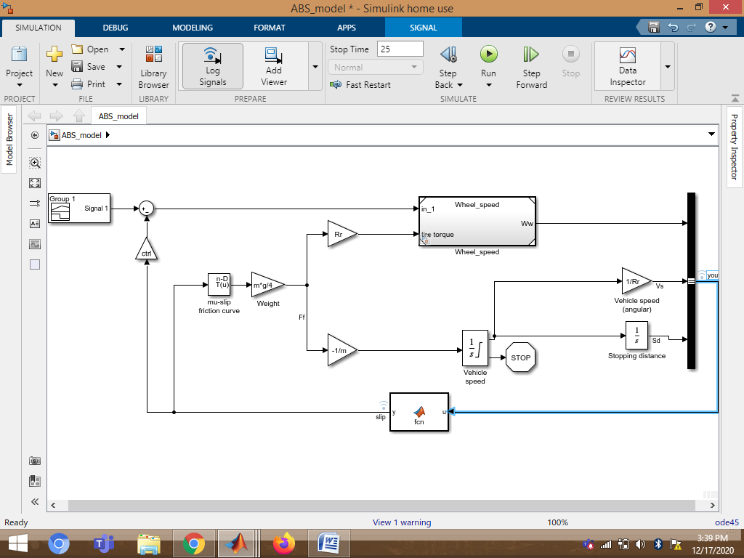

1.Callback:

In a model hierarchy, the execution of callbacks reflects the order in which the top model and the models it references execute their callbacks. In this model I have used PostLoadFcn callback that creates variable in MATLAB workspace.

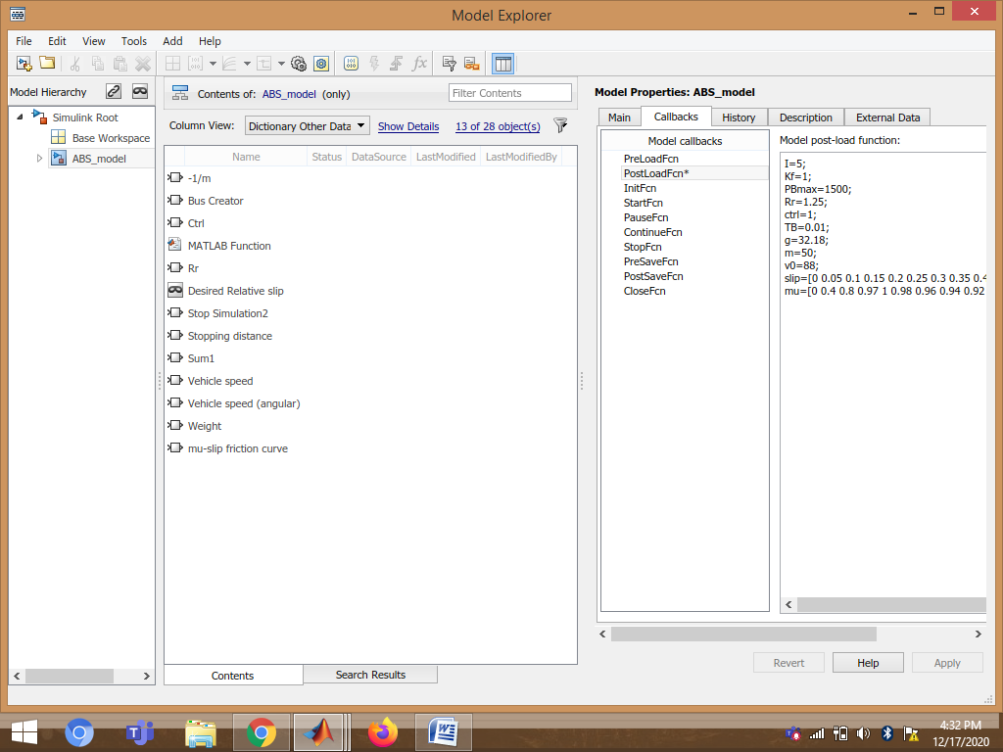

2.Data Inspector:

Data inspector is used to inspect and compare data and simulation results to validate and iterate model design.

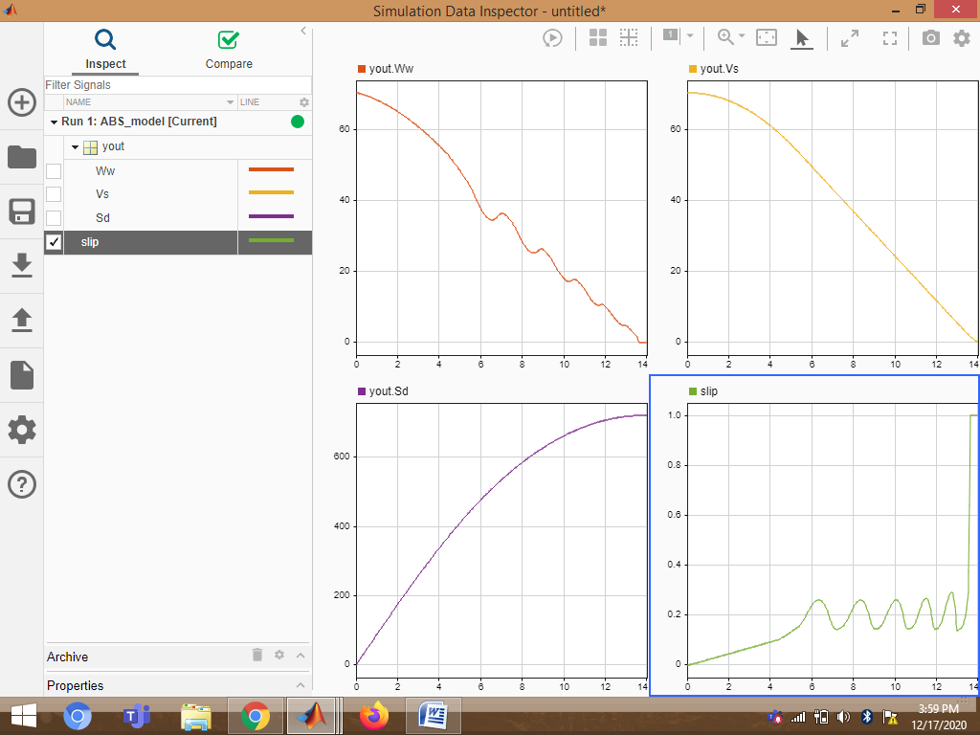

3. Solver selection strategy

In this model I have used ode45 solver. Because ode45 performs well with most ODE problems and should generally be first choice of solver. It is used for Non-Stiff problems and it provides medium level accuracy.

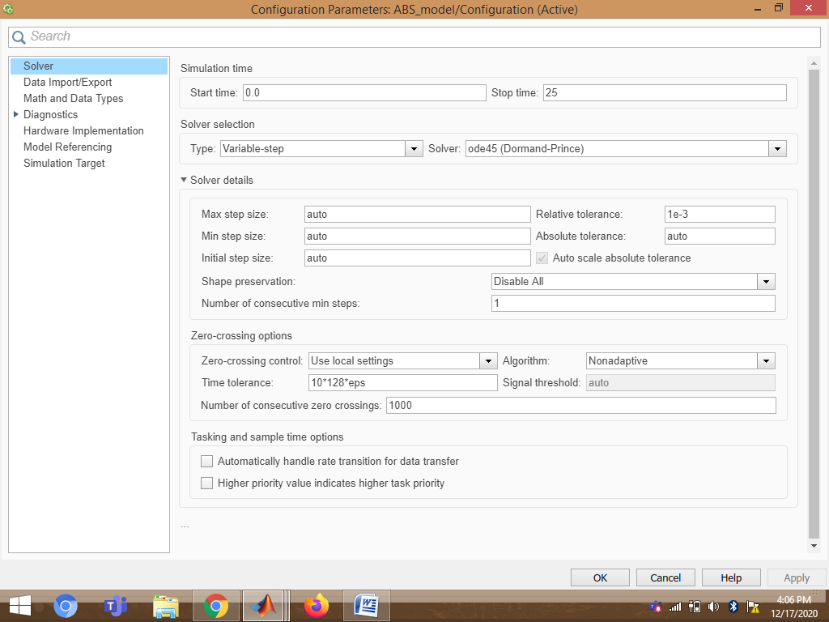

4.MATLAB function block:

MATLAB Function block is used to implement MATLAB functions to Simulink models to deploy code and embed code in processors.  MATLAB Function block is used to generate readable, efficient, and compact C/C++ code for deployment to desktop and embedded applications

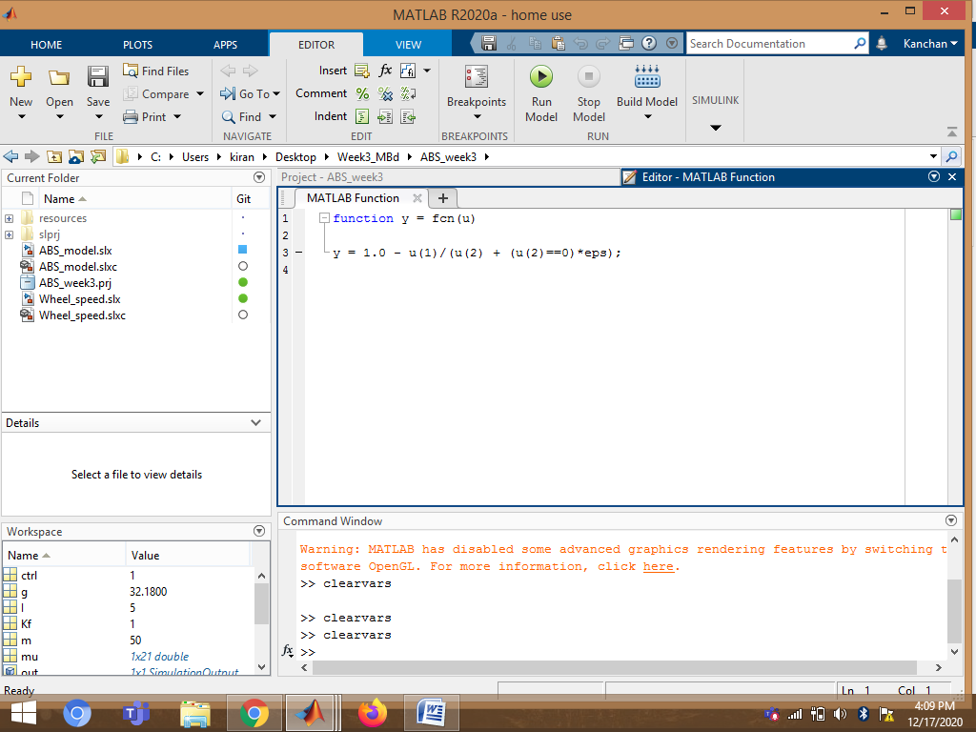.

5.Look-Up Table:

A lookup table block uses an array of data to map input values to output values, approximating a mathematical function. Given input values, Simulink performs a “lookup” operation to retrieve the corresponding output values from the table In this model I have used 1-D Lookup table for mu-slip friction curve.

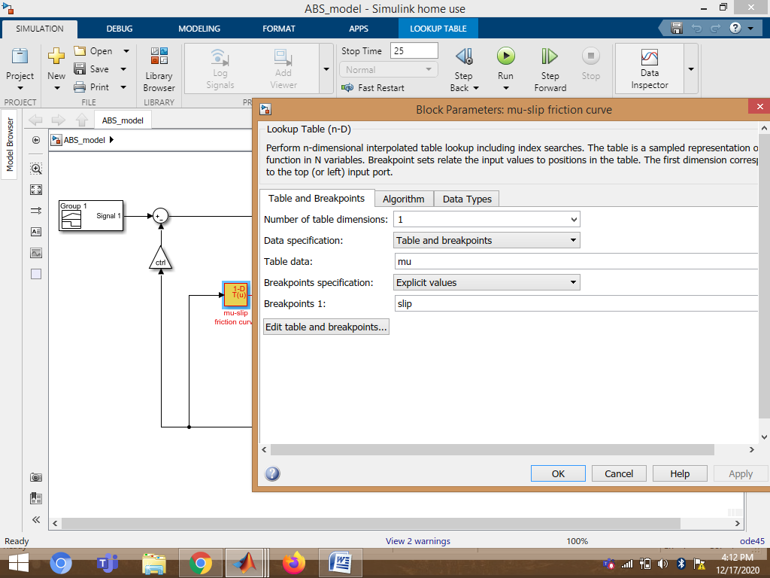

6.Signal Builder:

In this model, I have used signal builder to provide desired relative slip as input.

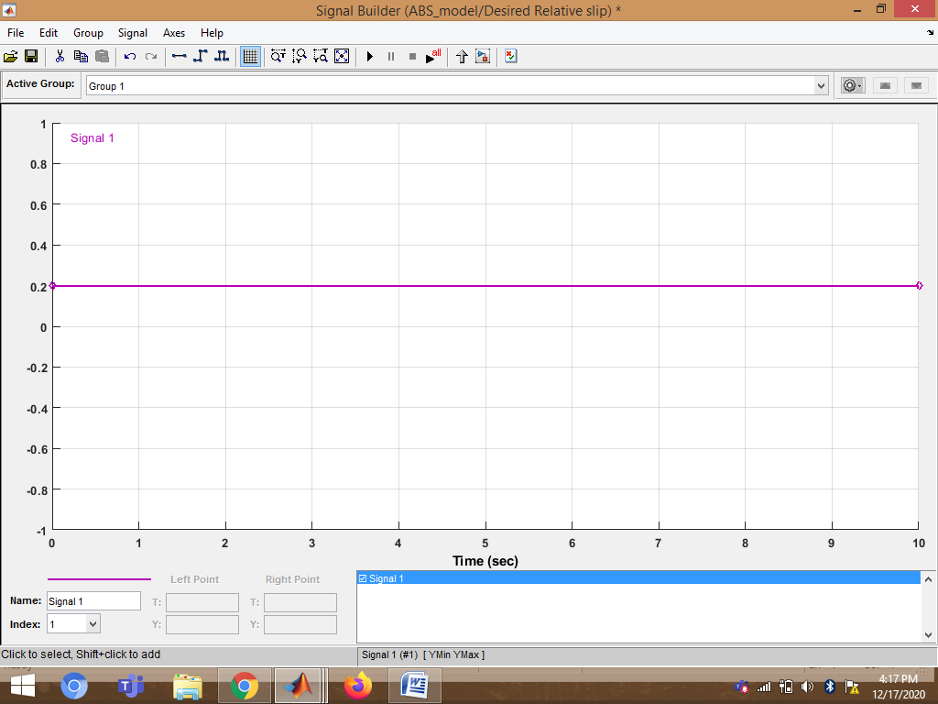

Observations:

1.Vehicle behavior without ABS:

Model variable ctrl = 0. This disconnects the slip feedback from the controller, resulting in maximum braking.

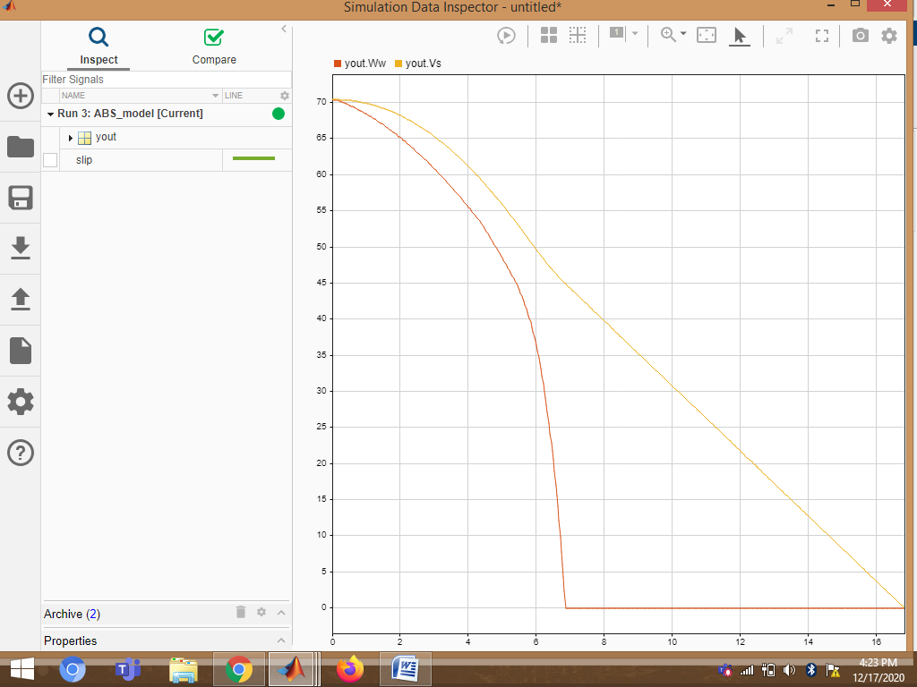

2.Vehicle behavior with ABS:

Model variable ctrl = 1. This connects the slip feedback from the controller.

