Chapter-1

**Introduction of Handwritten Text into Digital Text**

Intelligent image analysis is an appealing research area in Artificial Intelligence and also crucial for a variety of present open research difficulties. Handwritten digits recognition is a well-researched subarea within the field that is concerned with learning models to distinguish pre-segmented handwritten digits. It is one of the most important issues in data mining, machine learning, pattern recognition along with many other disciplines of artificial intelligence. The main application of machine learning methods over the last decade has determined efficacious in conforming decisive systems which are competing to human performance and which accomplish far improved than manually written classical artificial intelligence systems used in the beginnings of optical character recognition technology. However, not all features of those specific models have been previously inspected. A great attempt of research worker in machine learning and data mining has been contrived to achieve efficient approaches for approximation of recognition from data . In twenty first Century handwritten digit communication has its own standard and most of the times in daily life are being used as means of conversation and recording the information to be shared with individuals. One of the challenges in handwritten characters recognition wholly lies in the variation and distortion of handwritten character set because distinct community may use diverse style of handwriting, and control to draw the similar pattern of the characters of their recognized script. Identification of digit from where best discriminating features can be extracted is one of the major tasks in the area of digit recognition system. To locate such regions different kind of region sampling techniques are used in pattern recognition.

The challenge in handwritten character recognition is mainly caused by the large variation of individual writing styles. Hence, robust feature extraction is very important to improve the performance of a handwritten character recognition system. Nowadays handwritten digit recognition has obtained lot of concentration in the area of pattern recognition system sowing to its application in diverse fields. In next days, character recognition system might serve as a cornerstone to initiate paperless surroundings by digitizing and processing existing paper documents. Handwritten digit dataset are vague in nature because there may not always be sharp and perfectly straight lines. The main goal in digit recognition is feature extraction is to remove the redundancy from the data and gain a more effective embodiment of the word image through a set of numerical attributes. It deals with extracting most of the essential information from image raw data. In addition the curves are not necessarily smooth like the printed characters. Further more characters dataset can be drawn in different sizes and the orientation which are always supposed to be written on a guideline in an upright or downright point. Accordingly, an efficient handwritten recognition system can be developed by considering these limitations. It is quiet exhausting that sometimes to identify hand written characters as it can be seen that most of the human beings can’t even recognize their own written scripts. Hence, there exists constraint for a writer to write apparently for recognition of handwritten documents. Before revealing the method used in conducting this research, software engineering module is first presented.

Pattern recognition along with Image processing plays compelling role in the area of handwritten character recognition. The study describes numerous types of classification of feature extraction techniques like structural feature based on 2018 Global Journals

methods, statistical featured based methods and global transformation techniques. Statistical approaches are established on planning of how data are selected. It utilizes the information of the statistical distribution of pixels in the image. provided SVM based offline handwritten digit recognition system. Authors claim that SVM outperforms in the experiment. Experiment is carried out on NIST SD19 standard dataset. The study is provide the conversion of handwritten data into electronic data, nature of handwritten characters and the neural network approach to form machine competent of recognizing hand written characters. The study addresses a comprehensive criterion of handwritten digit recognition with various state of the art approaches, feature representations, and datasets. However, the relationship of training set size versus accuracy/error and the dataset-independence of the trained models are analyzed. The papers presents convolution neural networks into the handwritten digit recognition research and describes a system which can still be considered state of the art Handwritten character recognition is a difficult problem due to the great variations of writing styles, different size and orientation angle of the characters.

Handwriting conversion is a technique of a Computer to receive handwritten input from source such as text documents, scanned images etc. Intelligent Word Recognition (IWR) technologies use neural networks to find a meaningful of words to digitise text. In a neural network for handwriting recognition, a group of input neurons may be activated by the pixels of an input image representing a letter or digit. The activations of these neurons are then passed on, weighted and transformed by some function determined by the network's designer, to other neurons, etc., until finally an output neuron is activated that determines which character was read.

* 1. **Motivation and Objective :**

This thesis is conducted by using Machine learning concepts. Before going deep into the topic, we must know about some of these concepts. Machine Learning is a method which trains the machine to do the job by itself without any human interaction. At a high level, machine learning is the process of teaching a computer system on how to make accurate predictions when fed the data. Those predictions will be the output. There are many sub-branches in machine learning like Neural Networking, Deep Learning, etc. Among these, Deep Learning is considered to be the most popular sub-branch of Machine Learning. Initially, the idea of Machine Learning has come into existence during the 1950s, with the definition of perception. It is the first machine which was capable of sensing & learning. Further, there was multilayer perceptron in the 1980s, with a limited number of hidden layers. However, the concept of perceptron was not in usage because of its very limited learning capability. After many years, in the early 2000s, a new concept called Neural Networks came into existence with many hidden layers. After the emergence of neural networks, many machine learning concepts like deep learning came into force with multiple levels of representation. Because of these multiple levels of representation phenomenon, it has become easy to learn and recognize machines. The human brain is considered as a reference to build deep learning concepts, as the human brain similarly processes information in multiple layers.

A human can easily solve and recognize any problem, but this is not the same in the case of a machine. Many techniques or methods should be implemented to work as a human. Apart from all the advancements that have been made in this area, there is still a significant research gap that needs to be filled. Consider, for example, online handwriting recognition vs offline recognition. In online handwriting recognition of letters, an on-time compilation of letters is performed while writing because stroke information is captured dynamically. Whereas, in offline recognition, the letters aren’t captured dynamically. Online handwriting recognition is more accurate when compared to offline handwriting recognition because of the lack of information.

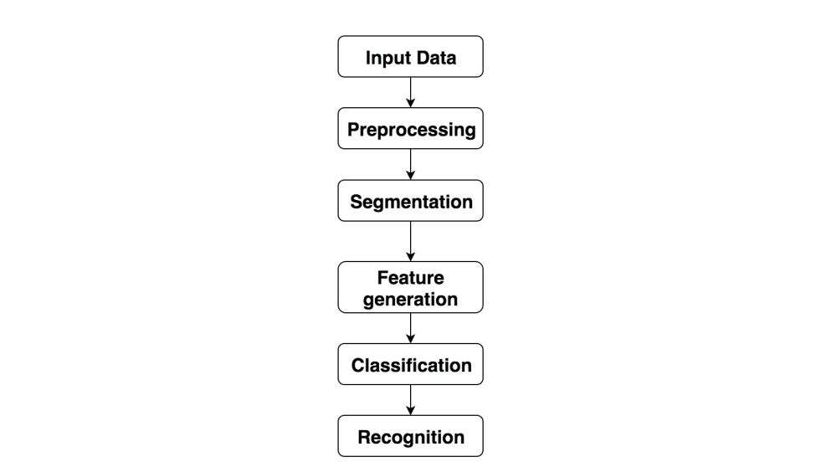 Therefore, there can be research done in this area to improve offline handwriting recognition. The main task in offline handwriting recognition is to recognize the character of words. There are different approaches for recognizing the characters of a word in offline handwriting.

**Figure 1.1. Steps of the typical character recognition system**

Initially, a dataset is given as input. This is followed by preprocessing, where an image is subjected to various operations like noise reduction, document skew correction, slant correction, normalization, smoothing, and skeletonization. The result of this preprocessing can be given as an input to feature generation. Segmentation of an image is done to isolate the characters of an image into different subimages. Each sub-image is considered as one individual character. The next phase is feature generating, in which various extraction techniques are used to represent an image as a vector feature in the feature generator To keep it clear without any noise, an algorithm is implemented to reduce the size of the image, which in turn reduces the noise in that image. The feature generation is followed by classification. There are a large number of classifiers, which reduces the performance of classification at each step. There are also classifiers for recognition including the statistical, the structural, the stochastic classifiers and finishing on a combination of classifiers. At each step, selecting the appropriate parameters could affect the final classification performance, which results in the complete recognition of an image.

* 1. **Aim of project:**

The aim of this project is to develop such a tool which takes an Image as input and extract characters (alphabets, digits, symbols) from it. The Image can be of handwritten document or Printed document. It can be used as a form of data entry from printed records. OCR is the identification of both handwritten and printed document using computer Reading of written or printed document is easy for humans, using OCR (Optical Character Recognition) technique.

**1.3Special Tools:**

This project is based on Machine learning, We can provide a lot of data set as an Input to the software tool which will be recognized by the machine and similar pattern will be taken out from them. We can use Android Studio and Xammp as a building tool for this and MySql for database java programming language.

We have used the android studio 2.0 version, TensorFlow backend, OpenCV, sklearn, Kera’s it consists of the statistics and machine learning Toolbox which is used for training and testing the data using for different classifiers.

Dataset Used The dataset is required for the training and testing. The images of data are represented in datasets and it contain colored images. The dataset contains a total of 9096 images. From the available data, we have used 70% of the images for training the classifier and rest of the 30% used for testing.

**1.4 Related Works:**

The following are some of the terms and concepts used in this research. Our work performance of machine learning methods by using a support vector machine, artificial neural network and convolutional neural network on handwritten digits recognition is inspired by a few related works. While, applying this three classifier SVM, ANN, and CNN to recognizing digits with noise. It demonstrated that SVM, ANN and CNN ,OCR system can achieve high accuracy on recognition of handwritten digits on documented images. However, these methods are used in this work to find the best algorithm for handwritten digits recognition. They were few drawbacks identified by the research area, by this, we can say that it is important to conduct a pre-study in order to understand the work that has been already done on classifying the methods and to understand the limitations of existing machine learning methods. The results from the literature review give us a lot of existing research area on preprocessing, segmentation, feature extraction with specific techniques and classification to recognize the digits In the paper , the authors have conducted research related to “Handwritten Word Recognition Using Multi-view Analysis”.

Chapter-2

**Requirement Analysis of Handwritten Text into Digital Text**

**2.1 Previous Work and Related Research:**

Researchers have worked on many different approaches for both the segmentation and recognition task of word recognition. Some researchers have used optical character recognition technique and with pattern matching algorithm. OCR technique recognise only characters but no semantics. while others have used intelligent character recognition technique using template matching algorithm. Holistic word recognition (HWR) recognises is a concept which only the particular style of writing such as cursive, purely discrete, touching discrete, or a mixture of these styles. The performance of an ICR system (Intelligent Character Recognition) based on MLP neural networks. Recently, some researchers have turned to the segmentation process. Segmentation process makes the work as easier by extracting the individual characters. Cursive word segmentation is employed more powerful in nowadays to deal a recognition problem.

**2.2 Purpose ED Recognition Techniques:**

**2.2.1** **System Architecture:**

This project deals the cursive handwriting conversion. First stage is input of scanned images retrieved from the database. Second stage is the Preprocessor. The preprocessor’s inputs are bitmap files obtained by scanning a handwritten document page. The preprocessing stage consists of two steps:

1. Line Segmentation- segment the lines from handwritten documents.

2. Word Segmentation- segment the words from lines. Third Stage is how segmentation algorithm deals with the handwritten image and extracting individual characters from handwritten word. Extraction words are converted in to digitized text through segmentation algorithm. Fourth Stage is IWR engine understands the converted words and recognizes whether it is meaningful. Fifth stage is recognized words are stored in the database. Finally words are converted into digitized text and displayed.The digitized text can be further used to identify the semantics such as.

**2.2.2** **Intelligent Word Recognition:**

The IWR technique is used in the cursive handwriting conversion. This system can convert any cursive handwriting into the digital form. Using IWR technique can convert all type of cursive handwriting. IWR recognizes only meaningful words. Proposed system can achieve both online and offline conversions through segmentation algorithm. Segmentation technique used for separating cursive and joined handwriting. For example, when an OCR system is extracting the word “god” from a document, it will recognize “g”, “o”, and “d”. IWR will match the letters to a dictionary and extract the whole word, “god” based on neural networks. Special Issue, 4th National Conference on Advanced Computing, Applications & Technologies, May 2014

**2.2.3 Segmentation Algorithm :**

Segmentation Algorithm is used to extracting the individual characters from words. It is a very difficult process because handwritten letters are joined, slanting and in different shapes. Heuristic Segmentation is one of the part of segmentation algorithm, it validates the every word before process. Anheuristic feature detection algorithm is used to locate prospective segmentation points in handwritten words. Each word is inspected in an attempt to locate characteristics representative of segmentation points. Binary Segmentation Algorithm (BSA)rectifies the risk of chain problem during validation. BSA supports unordered segmentation also.

**2.2.4 Machine Learning :**

According to Arthur Samuel, “Machine learning is a subfield of computer science which gives computers the ability to learn without being explicitly programmed”. This study helps in predicting and learning from the data imported with the help of algorithms implemented. Machine learning is used where there is difficulty in programming tasks instead machine learning algorithms are used to achieve the task. Some of these tasks include Identity Fraud Detection, computer vision, population Growth Prediction, email filtering, Weather forecasting, OCR (optical character recognition), Diagnostics, real-time decisions etc.

Machine learning concepts are classified into three categories:

1. Supervised Learning

2. Unsupervised Learning

**1.** **Reinforcement Learning Supervised Learning:**

Consider, a dataset is given as input and assumptions can be made on the output data how it looks like. In supervised learning, there’s a relationship between the input data and the output data. The output can be predicted with the input given.

**2. Unsupervised Learning:**

Unsupervised learning is an approach where the algorithm has to identify the hidden patterns in the given input. So, the algorithm works without any guidance as the input data is not labelled or classified. Reinforcement Learning: Reinforcement learning is a suitable action to maximize reward in a particular situation. It is to find the best possible behavior or path it should take in a specific situation.

**2.2.5 Deep Learning :**

According to Arthur Andrew Ng, “Deep Learning is a superpower. With it, you can make a computer see, synthesize novel art, translate languages, render a medical diagnosis, or build pieces of a car that can drive itself. If that isn’t a superpower, I don’t know what is”. Deep learning is a broader family of machine learning methods based on learning data representations, as opposed to task-specific algorithms. Learning can be supervised or unsupervised. It is a set of algorithms in machine learning to learn multiple levels of representation, corresponding to different layers of abstraction that help to make sense of data . Many layers are used to compute nonlinear functions with highly complex data. Each layer gets its input from a preceding layer, then it computes and transforms the data and sends it to the further layers. Each layer in a network consists of neurons and has various modes of connections to other neurons in the same layer as well as to those of other layers depending on the type of network. The whole idea of deep learning is using brain simulations, helping to make learning algorithms more efficient to use and revolutionary advances in machine learning and Artificial Intelligence. Nowadays deep learning gets more attention with development of modern technologies and easy execute it.

Automatic handwritten digits extracts from images is a crucial role for creating documents and processing the systems. The main purpose is to find out the rules to be used in the AHDR for document images using machine learning methods. The field studied in this work is to recognize the corrupted handwritten digits and increase the reliability of the result of the recognition process and to speed up the collecting training and test data from handwritten digit strings. The overall recognition process consists of preprocessing, segmentation, classification and finally recognition of given input data.

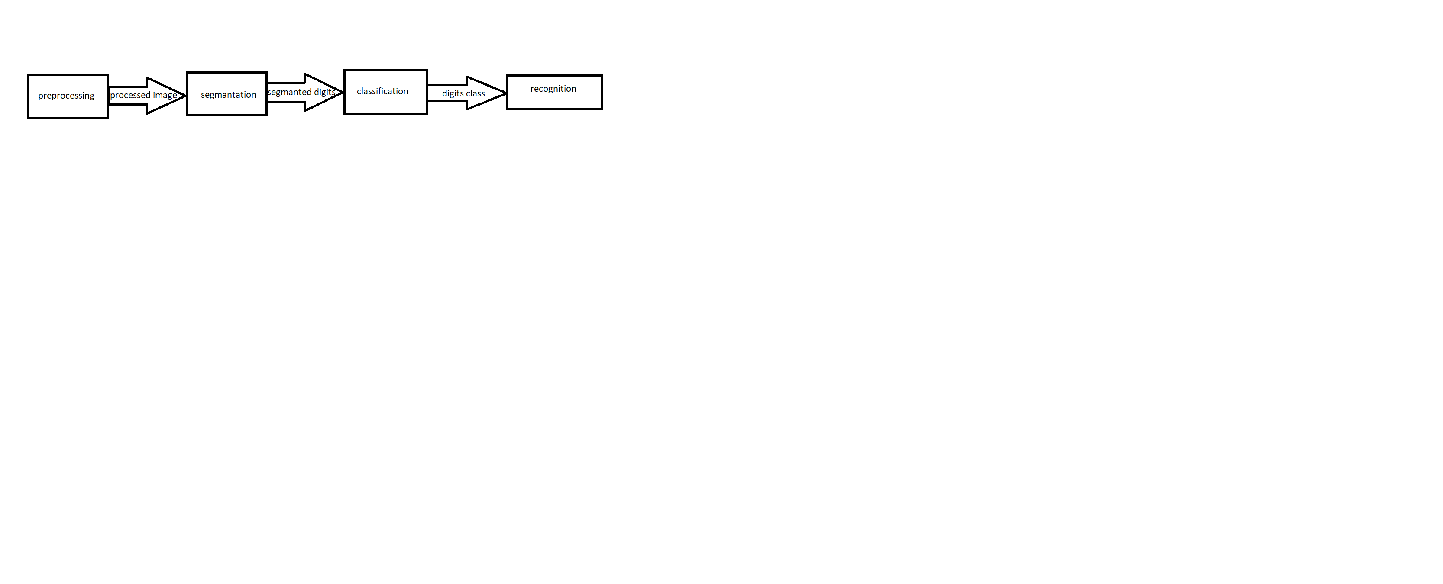 Figure 2.1Modules of Handwritten Digit Recognition

**1. Pre-Processing Method:**

Pre-processing and feature extraction are very important steps in automatic handwritten digit recognition(AHDR) for documented images. The basic step is to improve the discriminating nature of the pixels or raw features being computed from input images. It has been taken a lot of work improving the preprocessing. One of the problems in the recognition process is skew/slant detection and correction in the documented images, which introduces challenges for segmentation

However, we can generally categorize the tasks into noise reduction, normalization, smoothing and seletonization as the Fig.

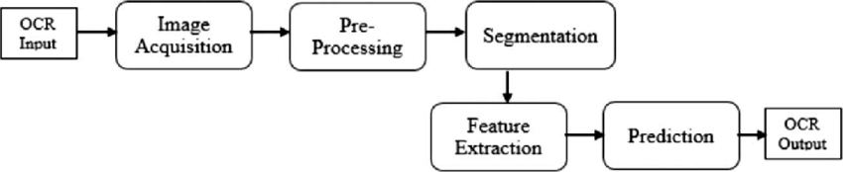

Figure 2.2 Pre-Processing Method

At first, the Input image is in RGB format and huge saturation are discarded and intensity is used to obtain a grayscale image. Then the grayscale image should be turned into a binary form. There are two main categories of binarization methods. a. Global thresholding. b. Local thresholding. Global thresholding: In this algorithm uses a single threshold value for overall images. Twenty global thresholding techniques were compared by Sahoo et al. based on uniformity and shape measures. Local thresholding: In this algorithm uses different types of threshold values for each pixel using their spatial information. According to the comparison, Otsu’s thresholding method gave the best performance. There are various local thresholding techniques as well. Trier and Jain, Sezgin and Sankur surveyed and discussed these thresholding techniques. After binarization, the skew correction could be done in order to correct the angle of the digits and the X-axis. Knerr determined the angle by computing the pixel densities between ±5 degrees with the help of horizontal guidelines. With the help of the histogram, we created the pixel densities, histogram with the longest peak is chosen as the angle of the text in the image. The problem with this method relies on the fact of horizontal guideline to realize the actual angle.

**2. Noise reduction :**

Noise reduction is the process of removing noise from an image. There are many techniques to reduce noise. Basically, the noise filtering function is used to remove the noises and diminish spurious points in the image. Even we take an example, Symmetric Gaussian filter function is used for smoothing equally in all directions[. An alternative approach is to use Morphological operations, which are basically neighborhood operations. It can perform on the input images using the structure element.

**3. Normalization :**

Normalization method is the most popular method used in character recognition. Because to reduce all types of variations and to obtain standardized data and it also gives excessive shape. The characters for normalizing methods in the following:

1. Skew normalization: It is used due to different types of writing style; the skew can hurt the effectiveness of recognition and therefore it is easy to detect and correct the baseline. Various methods have been used, which are the projection profile of the image, the Hough transform or the shape of the nearest neighbor clustering. After skew detection, the character or word is translated to the origin and rotated until the baseline is horizontal.

2. Slant normalization: The character inclination typically found in cursive script is called slant. Formally, it is defined as the angle between the longest stroke in a word and the vertical direction referred to the word slant. Slant normalization is used to normalize all characters to a standard form with no slant. Many methods have been proposed to detect and to correct the slant of cursive words. One of the used methods is based on the center of gravity, another method uses the projection profiles and some used a variant of the Hough transform

3. Size normalization: It is used to adjust the size, position, and shape (dimension) of the character image. This step is required for reducing the shape variation between images of the class to facilitate the feature generation and improve their classification.

**4. Smoothing:**

Smoothing operation is done to regularize the edges in the image, to remove small bits of noise and to reduce the high-frequency noise in the image. Furthermore, different preprocessing methods are used for the smoothing image to acquire a more accurate output image.

**5.Skeletonization:**

Skeletonization is a morphological operation used for reducing the contours in a binary image to a skeletal, the connectivity of the original region is detected while destroying most of the original foreground pixels.

These were divided into two methods and they were iterative and noniterative

1.Iterative method approaches peeling contours of process parallel or sequentially by erasing or removing the unwanted pixels in each iteration.

2. Non-iterative approaches, the skeleton is straightforwardly extracted without examining each pixel individually. Unfortunately, these techniques are difficult to implement and slow as well. Thinning can be somewhat performed for skeletonization using methods like erosion or opening. In this mode, it is commonly used by reducing all lines to single pixel thickness

**6. Segmentation:**

Segmentation is the most challenging part in the recognition of handwritten digits process[54]. The main reasons to occur this problem is because of the size of each digit, a number of digits and the gap between the digits are unknown. To overcome this problem a perfect algorithm digit segmentation should be implemented. If there are some rules like box for each digit to if there is a gap between the strings it will be much easier to segment the handwritten digit. By using a trivial algorithm, these types of strings can be segmented by applying connected component analysis after removing noises . The main goal of this research is to develop a perfect segmentation algorithm for handwritten recognition. By using touching strings, the goal can be achieved. There are five types of touching digit strings and these can be further categorized into single touching digit strings and multiple touching digit strings .

Types of touching digit strings. Segmentation algorithms are categorized into two types, one is segmentation-then based, and another Segmentation algorithms are categorized into two types, one is segmentation-then based, and another is recognition-based algorithms. Initially, segmentation-then based algorithms, segmented images are extracted where each segmented part is assumed as a single character. This segmented character is given as input to the classifier. Whereas, in the recognition-based algorithm, all segmented images are made into a segmented list and the list is given as input to the classifier. Due to the classification of all the options in the segmentation list, the computational cost of recognition-based algorithms is very high. Instead of having a high computational cost they provide good results. Besides, this algorithm must classify fragments, isolated characters and connected characters. Classification of recognition-based algorithms is made into two types as implicit segmentation and explicit segmentation. segmentation generates candidate characters for the recognizer. in the explicit recognition. Whereas, segmentation and recognition are performed simultaneously in implicit segmentation.

**2.2.5 Feature extraction:**

Feature extraction is a method of extracting features of characters from the sample image. There are basically two types of feature extraction:

1. Statistical feature extraction

2. Structural feature extraction

1. Statistical feature extraction: In statistical feature extraction the feature vector is the combination of all the features extracted from each character and these association feature vector relative to positions of features in the character image matrix.

2. Structural feature extraction: In structural feature extraction extracts the morphological features of a character from the image matrix. It considers the edges, curvature, regions, etc. The functions that are used in feature extraction for indexing and labeling the dataset and it helps in the classification and recognition of handwritten digits.

**2.2.6 Use Case Diagram:**

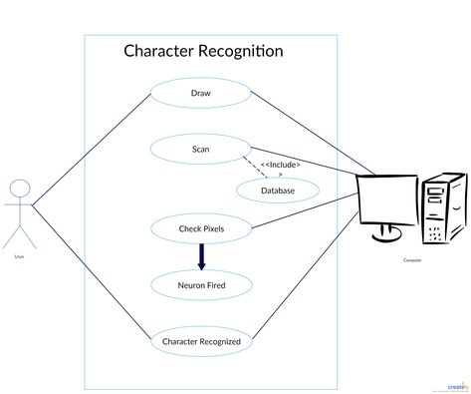

**Fig 2.3 use-case diagram**

**2.3 Feasibility Study**

Feasibility to a project determines whether it is possible to develop the project. There are three main factors, which determine the feasibility of the projects. They are discussed as follows.

**2.3.1 Operational Feasibility Study:**

The Operational Feasibility is the determination of your system’s minimum configuration used and the machine’s eligibility. This study resultant we that it requires a Web-browser, Pentium processer, a system with adequate peripherals, macromedia or adobe Photoshop, etc.

**2.3.2 Technical Feasibility Study:**

The study is related to any technical terms manner is to be mentioned in the Technical Feasibility Study. It consists of all the database storage facility, accessing facility, for the restore of data; etc. It needs a high speed processer in GHz with the advent in technology. According to the entire infrastructure, the system seems to be Technically Feasible.

**2.3.3 Economic Feasibility Study:**

The main part of among all the three areas of Feasibility Study is the Economic Feasibility Study. Whenever, anything is started one must see its benefits and loses. To check such things we have to the related to the financial status of the project. The developer has to be in the budget and has to develop the project. The additional cost incur is the manpower.

**2.4 System Analysis or Requirements :**

Analysis was done by keeping in mind the two modules of the project. The Analysis part of the project was the user module. Users of this application may or may not have much computer/mobile knowledge, so we mainly focused on our design, which had to be as user friendly as possible. The next important thing was to provide user level security. It was necessary to provide privacy to community members. Another thing was the appearance of the application; it had to be made pleasant and decent enough to attract the user.Last but not the least, was to provide the authorities to the administrators. Proper validations where to be implemented of the registration-form.

**2.4.1 Functional Requirements:**

1. Input image , progress following, email or copy data.
2. The registration is totally secured and confidential.
3. Helpful for those who want to save the entry of data in a softcopy means digital form.

**2.4.2 Non-functional Requirements:**

1. 24/7 functional.
2. It is designed to provide high performance at the time of traffic.
3. This type of designs are not only useful for the present time but also they can be extended or updated as per requirement for future.

**2.5 External Interface Requirements**

These requirements are discussed under the following categorization:

1)User interface:

1. Application will be accessed through a Browser Interface. The interface would be viewed best using 1024 x 768 and800 x 600 p ixels resolution setting. The software would be fully compatible with Microsoft Internet Explorer for version 6 and above. No user would be able to access any part of the application without logging on to the system.

2) Hardware Interface:

1. Front End/Language: HTML, Css,php,Java
2. Back End/Database: MySql
3. Additional Tools: Xampp ,Andriod Studio
4. Operating System: Windows 7, 8, 9, 10, XP

3) Server Side:

1. Operating System: Windows 9x/XP, Windows ME.
2. Processor: Pentium 3.0 GHz or higher.
3. RAM: 256 Mb or more.
4. Hard Drive: 10 GB or more.

4) Client side:

1. Operating System: Windows 9x or above, MAC or UNIX.
2. Processor: Pentium III or 2.0 GHz or higher.
3. RAM: 256 Mb or more.

5) Software Interface:

1. Client Side: HTML, Web Browser, chrome/mobile phone
2. Web Server: HTML, window

6) Communication Interface:

1. The Customer must connect to the Internet to access the application
2. Dial up Modem of 52 kbps.
3. Broadband Internet.
4. Dialup or Broadband Connection with a Internet Provider.

**2.6 Other Requirements**

1)Hardware Requirements: As this system is an online Web-based application so a client server will be the most suitable Organizational style for this system. Computer systems will be needed by each of the actor as well as that user must be connected to the internet. So, concisely following hardware will be needed.

1. Mobile phone/computer
2. Internet availability

2) Safety and Security: This Project must be safe and secure because customers will directly contact their account through the internet. Software will have to identify the valid customer according to his/her bank details and password. So it is a difficult task to prevent the system by major disasters by preventing the unauthorized access to the system.

**2.7 Sequence Diagram:**

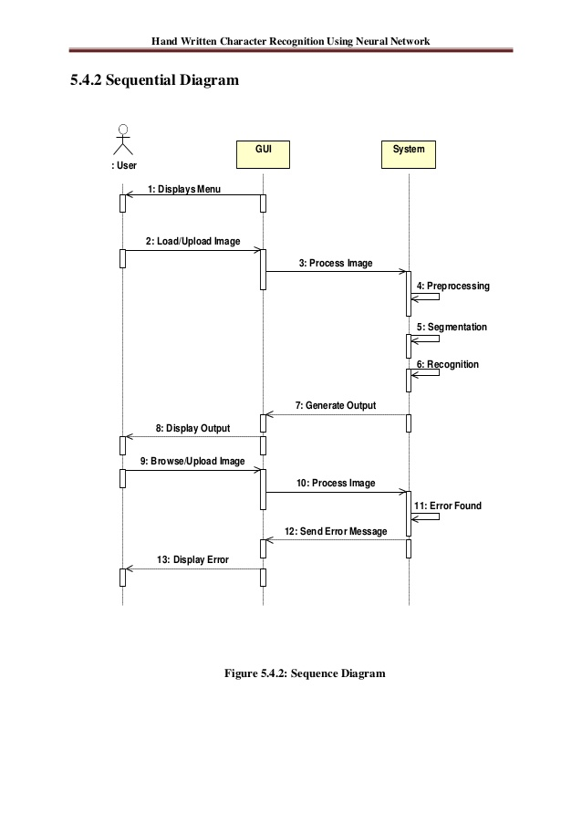

Chapter -3

**METHODOLOGY**

In this section we are describing the various steps and accepts such as methods, tools, datasets used, how the models are created and how the models were trained are tested. In this section, we are discussing how algorithms used and presented the block diagram of the proposed system.

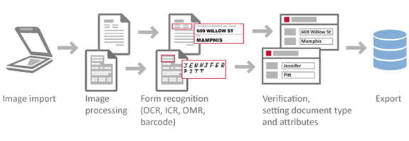

**Figure 3.0 Block diagram of a Proposed method**

**3.1 Method For this research:**

1. There is two types of research methods have been selected and they were

1. Literature review

2. Experiment Literature review

Initially, the literature review has been conducted to answer RQ1 to know which type of data is required to train and test the machine learning methods. The motivation behind adopting the literature review is to gain knowledge towards the data sets in the machine learning and find about different types of machine learning methods that can be adopted while training the data set. A simple literature review was performed to gain knowledge about different datasets that can be used for training and testing the data. The author also gained knowledge of different processes of data preprocessing, segmentation and various machine learning methods to be adopted in the study.

Independent variables: The dataset and algorithms used in this study were Segmentation algorithms, Classification algorithms, i.e. Support vector machine, Artificial neural network, and Conventional neural network are the Independent variables. Dependent variables: The performance algorithms, i.e. Segmentation algorithms, Classification accuracy, and Training classification algorithms are the dependent variables.

Tools Used This study is to identify AHDR on documented images with the use of machine learning methods. At first, we need to construct a suitable model or method for training and testing. The program able to extract characters one by one to get target output for training & testing model. The implementation and the experimentation of the algorithm had been carried out by using Python and supported with the usage of Graphical User Interface (GUI).

We have used the android studio 2.0 version, TensorFlow backend, OpenCV, sklearn, Kera’s it consists of the statistics and machine learning Toolbox which is used for training and testing the data using for different classifiers.

Dataset Used The dataset is required for the training and testing. The images of data are represented in datasets and it contain colored images. The dataset contains a total of 9096 images. From the available data, we have used 70% of the images for training the classifier and rest of the 30% used for testing.

2. Training new images on the constructed model After preprocessing of the dataset, we will train the data from the top layer of the network and step by step outputs were:

1 Training accuracy

2 Validation accuracy

3 Cross-entropy.

1. Training accuracy: While training accuracy we can find the percent of the images used in the current training batch was labeled with the correct class.
2. Validation accuracy: In validation accuracy, we will find the precision on a randomly-selected group of images from a different set.
3. Cross-entropy: The Cross entropy is a loss function which gives a glimpse into how well the

learning process is progressing. While training the dataset, we feed data to get predictions and these predictions are compared with the actual label data to update the layers weights through the backpropagation process. This process continues until accuracy increases. The trained model will perform on the classification task trained data to classify and generate a model.

3. Testing new images on the constructed model After training model is completed with the selected algorithms or classifiers then we will perform the testing model by using the selected algorithms or classifiers. While testing the dataset, initially all the steps used to train the model are followed except feeding the data to the classifier and generating a model. Here instead of feeding the data and training the model, we use the saved model to predict the class of the image i.e. After predicting the classes of the test dataset, they are compared with the actual classes to check the accuracy of the algorithms or classifiers to check how well an algorithm works.3.4 Handwritten Digit Segmentation Segmentation of digit on documented images depends upon the link between adjacent digits. In this study, we are working with three situations which are Connected digits, Disjoint digits, Overlapped digits, respectively. In this part, describing the segmentation methods used in our system for which we propose a new segmentation method performed specifically for connected digits

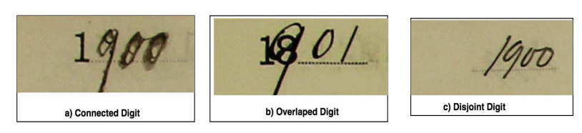

**Figure 3.4 Different types of digits**

Segmentation of Connected Digits Segmentation of Connected digits various techniques were used to detect the connected digits by using

the countermeasure skeleton technique. We used split touching digits using thinning processes and it is based on segmentation strategy for a handwritten connected digit in this process to generate all possible conditions for segmentation. finally proposed a method for finding the Base Points (BPs) and Interconnection Points (IPs) on the contour and the skeleton of the connected digits according to the connection configuration. After that, a crossing-oriented window is set around IP for finding correctly the cutting path can be performed according to the following steps:

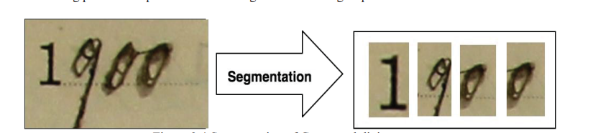

**Figure 3.4 Segmentation of Connected digits**

1. Apply a contour measure detection to detect all possible BPs from the local extrema

2. Perform the skeleton algorithm in order to detect all possible IPs.

3. If IP is detected, with a sliding window having the same height of the images and a fixed width is set on IP in the middle of the width. Then optimal orientation angle is used to match the right angle inter-digit it also allows reducing the number of segmentation cuts.

4. Segmentation hypotheses are helped to find the best cutting path. The hypothesis is performed using the digit recognition. In this case, the classifier plays an important role in detecting the overlapped or/and connected digits.

**3.2 Segmentation of overlapped digits:**

Segmentation of overlapped digits is based on the contour analysis using the contour detection, which is extracted from the binary image using the morphology. Hence, two adjacent digits are then separated using the fixed distances. In some cases, broken parts of an overlapped component are detected by examining the intersection with the median line of each component image.

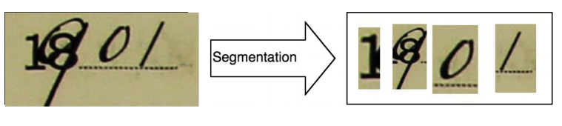

**Figure 3.4 Segmentation of Overlapped digits**

**3.3 Segmentation of Disjoint Digits:**

Segmentation of disjoint digits by using the histogram of the vertical projection (HVP). The HVP is used to perform on the binary digits with a simple count of the black pixels in each column is running in order to detect the white space between successive digits. It determines the location of each component of the image. During this method, the advantages of the ability of segmented digits with the unknown-length. In HVP we can split only digits comprising either it is a single digit or more than two digits.

**3.4 Handwritten Digit Recognition:**

The handwritten digit recognition system is based on the input image, pre-process the image, segment the image, extract the feature of the image and classify the digit that is based on feature extracted module, and the proposed handwritten digits recognition, . In the following, we briefly describe feature generation method, classifiers and the technique of recognition the digits.

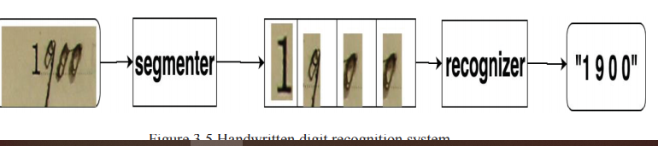

**Figure3.5 Handwritten digit recognition system**

* 1. **Feature generation:**

In feature generation, there are various feature generation methods have been proposed. In the proposed system, we use a combination of multiple features for improving the recognition rate of handwritten digits by minimizing the intra-class variability and maximizing inter-class variability. These features were used in the study to include some global statistics and projection based features and features computed from the contour and skeleton of the digit. 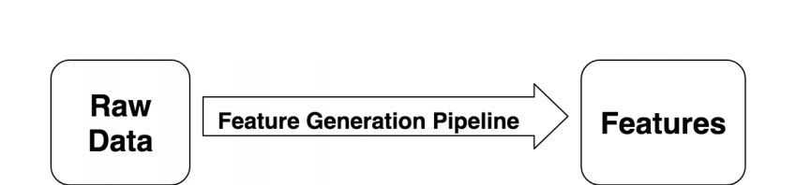 **Figure 3.5 Feature generation**

* 1. **Connected digits recognition:**

In connected digit recognition, all the images split into a sequence of the segment and each one of them is considered as a segmentation hypothesis, which is expected to contain a digit or a fragment of a digit. If GC is accepted, then it is considered as a digit otherwise it is considered as a non-digit. The grouping of segments using conjointly GCA and DRV is performed according to the following heuristic rules: XGC {Accept if GC intersects median line and fmax(XGC) >= tf XGC {Reject fmax(XGC) >= tf Overlapped digit recognition Overlapped digit recognition is performed when the segmented component is less than a threshold. In this case, segmented components are considered as non-digits.

Therefore, contour detection is performed on segmented components for separation using a fixed some specific rules. The results of sub-components are identified by segmented component analysis for deciding if each one is a digit or non-digit. When it is detected as a digit, digit recognition is used for accepting or rejecting. Disjoint digit recognition Disjoint digit recognition is performed by using successively the Histogram of the vertical projection, segmented component analysis, and Digit recognition. HVP allows producing multiple segmented components and it is analyzed by segmented component analysis to find out it is a digit or non-digit. When a segmented component is detected as a digit, then digit recognition recognize digit with the help the of classifiers.

* 1. **Statements of correct and incorrect:**

segmentation-recognition To recognize the handwritten digits whether the segmentation and recognition working correctly or incorrectly of our system Table.3.6 presents with some examples of correctly and incorrectly recognized digits.

**3.7.1 Threats to validity:**

The results of the research are helpful to the extent the various techniques for improving the performance of the segmentation and resolve issues for recognition. It is essential to consider the validity threats in this research and the validity of research is concerned with the question of how the conclusions might be wrong. In quantitative research there are four types of validity threats, which are conclusion validity, internal validity, construct validity and external validity. Internal Validity: The Internal validity threats affect the independent variables concerning causality. In this paper, the independent variables are the dataset and algorithms used in this project. To mitigate this validity threat, the data required for the dataset is selected by discussing with the supervisor currently working on the image processing. Also, data preprocessing for algorithms is done by using previous research work. Construct Validity: Construct validity threats concerns about the design of the experiment. To mitigate this validity threat, the hypothesis is defined, and the experiment is designed upfront. Here, the experiment is designed based on the amount of data obtained and by evaluating other designs. External Validity: The fact that the administration of a test may affect the performance of the participants in the study. Its results may not be generalizable to situations where pretesting will not occur. This threat is mitigated by employing an experimental design which does not have any pretests. The experimenters involved in the study alter the observations by creating expected outcomes by themselves. We have used thresholding technique to combat this bias.

**3.7.2 Computation cost of the proposed system:**

The proposed system of automatic handwritten digits on documented images by using machine learning methods allows resoling different segmentation and recognition problems. Even this system can be deployed in the real environment, to compute the cost required for treating all situations. Hence, the computation cost is measured by considering three situations: Connected digit: The total number of Segmentation Hypothesis is equal to the sum of all numbers of segmentation hypotheses and formula is NSH = NDS(NHVP + NCA). Overlapped digit: Let NGBC be the Number of Grouped Broken Component provided by CA when the broken component exists and NID the total Number of Isolated Digit provided by CA, then, the total Number of Segmentation Hypotheses from CA (NCA) is NCA = NGBC + NID Spaced digit: The total Number of Segmentation Hypotheses using HVP (NHVP) is the same as the number of the spaced digits.

Chapter-4

**Implementation of handwritten to digital application**

System analysis is the process of gathering and interpreting facts, diagnosing problems and using the information to recommend improvements on the system. System analysis is a problem solving activity that requires intensive communication between the system users and system developers.

**4.1 Study Of System Modules:**

The system after careful analysis has been identified to be presented with the following modules and roles. The modules involved are:

**4.1.1 Administator:**

The administrator is the super user of this application. Only admin have access into this admin page. The administrator has all the information about all the users and activities going on the website. admin have its own login username and password.

This module is divided into different sub-modules:

1.Log In

1.Log In:

This is a simple but most important step because this is the gate pass for this website. To log in the user submits his email id or user id and password.

5.Update Blog:

admin can update the data and also delete the data on the site or store it for future use

**4.1.2 User:**

The user is a person who is the access of this online platform for the purpose of converting handwritten text into digital text the authority like admin to modify any content on the app.

The user has authority to do following tasks:

1. Registration
2. Log In
3. Three bars
4. camera
5. copy to clipboard
6. send a gmail

1.Registration:

To access the content on this website the user must register. For registration few credentials are mandatory those are email id and password for this app. and conform password for accuracy then it's get registered.After registration the user will get registered with that email id. In order to verify, if already register user can directly Log In.

2.Log In:

This is a simple but most important step because this is the gate pass for this website. To log in the user submits his email id and password.

**4.2 Summary of flow of App**:

we have proposed an online crime reporting system which allows the user to file complaints or missing reports and keep a track of it. There are 3 categories that a user can file; Complaint, Crime Report and Missing Report and can see all the status of what action has been taken by the admin.

## **4.3 Hyper Text Markup Language (HTML)**

The Hyper Text Markup Language (HTML) is a simple markup language used to create hypertext documents that are portable from one platform to another HTML documents are SGML documents with generic semantics that that are appropriate for representing information from a wide range of applications. This specifications defines HTML version4.0 aims to capture recommended practice as of early ‘96 and as such to be used as a replacement for HTML 3.2.

### **4.3.1 Why to use HTML:**

While these page publications and a document as a formatted in any single format you should use HTML for home page and all primary pages and the site. This will enable the millions of web users it considered first formatting any new material you plan to publish on the web HTML documents are platform independent, meaning that they don‘t conform to any standard it they are created properly you can more home page to any server platform or you can access them with any complaint www browser.

**1.**<HTML>…</HTML> - All HTML files start and end with the tag pair.

**2.** <HEAD>…</HEAD> - All HTML have a pair of ―HEAD‖ tags that indicate what the tile and other attributes of the page are going to be.

**3.** <TITLE>…</TITLE>- This tag indicates what the title of the HTML file is going to be on the BROWSER window title.

**4.** <BODY>…</BODY>- This tag pair is to logically separate the HTML file into the header and the body. Usually the header contains information regarding the html where as the body contains information that the HTML file must actually contain.

**5.** The HTML template must look like.

<! DOCTYPE HTML PUBLIC ―THIS IS AN EXAMPLE‖>

<HTML>

<HEAD>

<TITLE> YOUR TITLE GOES HERE</TITLE>

</HEAD>

</HTML>

**6.** <P>…</P> - This tag pair used to indicate the paragraph. Any text that needs to be separated into a paragraph must be put in within a paragraph tag.

**7.** <B>…</B>- This tag pair is used to indicate the text within tag pair must be in bold letters.

**8.** <I>…</I> - This tag pair is used to indicate the text within the tag pair must be in italic letters.

**9. <**IMG SRC=‖../images/corp.gif‘‖ ALT=‖LOGO‖ HEIGHT=‖100‖WIDTH=‖100‖/>

- This tag is used to embed images in the HTML pages. The SRC attribute is used to locate the file name under a directory, the ALT attribute is used to indicate the TOOLTIP message that must appear, and HEIGHT and WIDTH indicate the height and the width of the images that is being shown on the HTML pages.

**10.** <H1 ALIGN=‖CENTER‖>…</H1> - This pair of tags is used to indicate that the text must be main title for the HTML page. The ALIGN attribute can be used to set the alignment to ―‖enter‖ or ―‖left‖ or ―‖right‖

**11.** <H1>Heading1</H1>

<H2>Heading2</H2>

<H3>Heading3</H3> - This set of tags will show the Headings in smaller fonts as the heading increases.

**12.** ALIGN – The align attribute can be used for headings as well. For

<P>…</P> tags also, the ALIGN attribute can be used.

**13.** <BR> - Used to insert a carriage return in the HTML file. The attribute to be used for this is the CLEAR attribute.

**14.** <CENTER>…</CENTER> - To enter the entire block of text this tags are used.

**15.** <A>…</A>- Anchor Tags. These tags are used linking namely hyperlinking.

**16.** Images Basics: Image Tag is used to embed images in the html document.

**17.** the order in which these interactions take place. We can also use the terms event diagrams or event scenarios to refer to a sequence diagram. Sequence diagrams describe how and in what order the objects in a system function. These diagrams are widely used.

### **Example:**

<A H[REF=http://www.ibm.com](http://www.ibm.com/)>Visit IBM Web Pages</A>

**4.4 Hypertext preprocessor(PHP) :**

PHP is a server-side scripting language designed specifically for the web. Within an HTML page, you can embed PHP code that will be executed each time the page is visited. Your PHP code is interpreted at the web server and generates HTML or other output that the visitor will see.

A PHP file is just a HTML file saved using .php extension instead of .html or .htm extension, which tells the server to looking the page for code.

PHP is a language that can be used to create dynamic web pages, In fact that is the whole point of PHP.

Static Vs Dynamic web pages

1. A static web page never change, unless a person specifically edit the page.

2. A dynamic web page can be different every time it is viewed by a browser because the sever edits the page prior to sending it to the browser accordingly to what instructions the programmer has coded into that specific page.

3. PHP was introduced in 1994. As of November 2007, it was installed on more than 21 million domains worldwide, and this number is growing rapidly. You can see the current number at <http://www.php.net/usage.php>

PHP is an OpenSource project. PHP originally stood for Personal Home Page and now stands for PHP Hypertext Preprocessor.

**3.4.1 Why to use php:**

PHP is mainly focused on server-side scripting, so you can do anything any other CGI program can do, such as collect form data, generate dynamic page content, or send and receive cookies. But PHP can do much more.

There are three main areas where PHP scripts are used.

Server-side scripting. This is the most traditional and main target field for PHP. You need three things to make this work: the PHP parser (CGI or server module), a web server and a web browser. You need to run the web server, with a connected PHP installation. You can access the PHP program output with a web browser, viewing the PHP page through the server. All these can run on your home machine if you are just experimenting with PHP programming. See the installation instructions section for more information.

Command line scripting. You can make a PHP script to run it without any server or browser. You only need the PHP parser to use it this way. This type of usage is ideal for scripts regularly executed using cron(on *nix or Linux) or Task Scheduler (on Windows). These scripts can also be used for simple text processing tasks. See the section about Command line usage of PHP for more information.

Writing desktop applications. PHP is probably not the very best language to create a desktop application with a graphical user interface, but if you know PHP very well, and would like to use some advanced PHP features in your client-side applications you can also use PHP-GTK to write such programs. You also have the ability to write cross-platform applications this way. PHP-GTK is an extension to PHP, not available in the main distribution. If you are interested in PHP-GTK, visit » its own website.

PHP can be used on all major operating systems, including Linux, many Unix variants (including HP-UX, Solaris and OpenBSD), Microsoft Windows, macOS, RISC,OS, and probably others. PHP also has support for most of the web servers today. This includes Apache, IIS, and many others. And this includes any web server that can utilize the Fast CGI PHP binary, like light tpd and nginx. PHP works as either a module, or as a CGI processor. So with PHP, you have the freedom of choosing an operating system and a web server. Furthermore, you also have the choice of using procedural programming or object oriented programming (OOP), or a mixture of them both.

With PHP you are not limited to output HTML. PHP's abilities includes outputting images, PDF files and even Flash movies (using libswf and Ming) generated on the fly. You can also output easily any text, such as XHTML and any other XML file. PHP can autogenerate these files, and save them in the file system, instead of printing it out, forming a server-side cache for your dynamic content.

One of the strongest and most significant features in PHP is its support for a wide range of databases. Writing a database-enabled web page is incredibly simple using one of the database specific extensions (e.g., for mysql), or using an abstraction layer like PDO, or connect to any database supporting the Open Database Connection standard via the ODBC extension. Other databases may utilize cURL or sockets, like CouchDB.

PHP also has support for talking to other services using protocols such as LDAP, IMAP, SNMP, NNTP, POP3, HTTP, COM (on Windows) and countless others. You can also open raw network sockets and interact using any other protocol. PHP has support for the WDDX complex data exchange between virtually all Web programming languages. Talking about interconnection, PHP has support for instantiation of Java objects and using them transparently as PHP objects. PHP has useful text processing features, which includes the Perl compatible regular expressions (PCRE), and many extensions and tools to parse and access XML documents. PHP standardizes all of the XML extensions on the solid base of libxml2, and extends the feature set adding Simple XML, XML Reader and XMLWriter support. And many other interesting extensions exist, which are categorized both alphabetically and by category. And there are additional PECL extensions that may or may not be documented within the PHP manual itself.

**4.4 MYSQL:**

If you are going to spend any time doing computer programming, and that is that sooner or later, you are going to have to either create or display data from a database. In this article, we look at how to program a MySQL database in KDE. For the completely uninitiated, the KDE environment is built upon the Qt C++ libraries provided by Troll tech, so in this article, classed that start with the letter Q are part of the Qt library, and classes that start with the letter K are part of the KDE library. The main classes we will use are the built-in database widgets of Q Data Table, Q Data Browser, and Q Data View, but first of all, we need to set up some information to use in our database. For this demonstration, we will be using MySQL which comes with open and probably given its popularity, every other version of Linux as well.

**4.5 XAMPP:**

Let us say you want to create a dynamic website that makes use of PHP code then you require Apache server to compile your PHP code. In case you want to perform some operations related to a database such as storing data into a database or fetching data from a database. you want to have MySQL, MariaDB database functionality.

So, you need to use XAMPP to fulfill the requirements to run your PHP, Perl, and some other programming languages.

**4.5.1 why to use Xampp:**

XAMPP offers the Run environment or executes codes and tasks for your PHP, Perl and some other language programming. It is open source and free to use. XAMPP was developed by Apache Friends. Includes Apache HTTP server, MySQL, PHP parser, Perl and other programming languages, Maria Api etc.

How to Run PHP Code Using XAMPP

Follow the below steps to run your PHP code or project using the XAMPP server.

Step 1: Install XAMPP

1. The first step is to install XAMPP onto your computer. it is very easy to install XAMPP. Just visit the official website to download XAMPP.
2. xampp download page.
3. Apache Friends: <https://www.apachefriends.org/index.html>
4. On this site you can see XAMPP for Windows, Linux and OS X. Where you can download XAMPP based on your computer OS and after downloading install it.

Step 2: Open XAMPP control panel

1. After installing XAMPP on to your PC the next step is to start the Apache server and MySQL.
2. The control panel XAMPP which is something like this.
3. xampp control panel
4. To launch Apache service and MySQL service, click on the Start button. if you want to stop any of the services at any time you can click on stop button in XAMPP control panel.

Step 3: Executing Project

1. Once the Apache and MySQL services are started and running in the background. Now extract the project zip file which you have downloaded from our site.
2. extract project mini project
3. After extracting you should see the folder which contains all the code and related files of the project that you have downloaded.
4. copy project folder
5. Copy this folder and navigate to xampp folder (which is basically located in C drive) and inside this folder (xampp) find the htdocs folder and paste the project folder into this htdocs folder
6. In my case, the path is something like this C:\xampp\htdocs
7. Paste folder to htdocs
8. After the project folder is successfully copied to the specified location on your computer. Then go to your browser (Chrome) and type in URL field: localhost/ FOLDER NAME and then hit enter.
9. Run project using xampp
10. If the project folder name is “OCR1en type in URL field: localhost/ OCR1 hit enter. That’s it your project will start running.

**Android Studio:**

Android Studio is the official integrated development environment (IDE) for Google's Android operating system, built on JetBrains' IntelliJ IDEA software and designed specifically for Android development.[8] It is available for download on Windows, macOS and Linux based operating systems or as a subscription-based service in 2020. It is a replacement for the Eclipse Android Development Tools (E-ADT) as the primary IDE for native Android application development.

A specific feature of the Android Studio is an absence of the possibility to switch autosave feature off.

The following features are provided in the current stable version:

Gradle-based build support

Android-specific refactoring and quick fixes

Lint tools to catch performance, usability, version compatibility and other problems

ProGuard integration and app-signing capabilities

Template-based wizards to create common Android designs and components

A rich layout editor that allows users to drag-and-drop UI components, option to preview layouts on multiple screen configurations

Support for building Android Wear apps

Built-in support for Google Cloud Platform, enabling integration with Firebase Cloud Messaging (Earlier 'Google Cloud Messaging') and Google App Engine

Android Virtual Device (Emulator) to run and debug apps in the Android studio.

Android Studio supports all the same programming languages of IntelliJ (and CLion) e.g. Java, C++, and more with extensions, such as Go;

and Android Studio 3.0 or later supports Kotlin and "all Java 7 language features and a subset of Java 8 language features that vary by platform version."

External projects backport some Java 9 features.

While IntelliJ states that Android Studio supports all released Java versions, and Java 12, it's not clear to what level Android Studio supports Java versions up to Java 12 (the documentation mentions partial Java 8 support). At least some new language features up to Java 12 are usable in Android.

Once an app has been compiled with Android Studio, it can be published on the Google Play Store. The application has to be in line with the Google Play Store developer content policy.

## **Why Is Android Application Development Your Best Option?**

Every entrepreneur needs to compete with creativity to capture the attention of more potential customers. It is because the ultimate goal of any business is to generate revenue. Further, the evolution of the Android development platform offers entrepreneurs with a cost-effective and scalable opportunity to develop apps.

1 Android mobile applications have influenced most of the industries as part of the digital revolution today. Even though iOS is a popular platform, listed below are some of the reasons why android development is by far the best and a leading platform for businesses.High ROI With Lower Costs:  
One of the key advantages of Android app development is the easy availability of the Android SDK. The development teams can use the material design from these SDKs to build interactive apps. However, the developers/development teams are required to pay a one-time registration fee for application distribution. After that, they can leverage any computer device to build and test the product for their smartphones, ensuring low investment and increased user engagement. In turn, the end users, are benefited by an interactive app, and the enterprise gains a higher return on investment.

1. Faster Deployment:  
   Android apps for business have a rapid development cycle lasting a few hours. It offers a competitive edge to companies who wish to have a quicker go-to-market for their new idea. Reduced Time to Market (TTM) is, thus, one of the best benefits of Android development.
2. Target Multiple Platforms:  
   The use of Java as a programming language makes it easy to port the app to multiple operating systems like Symbian and Ubuntu. Thus, businesses can target multiple platforms with Android app development. It is one of the many reasons why businesses choose Android development**.** Learn the essentials of [porting iOS apps to Android](https://www.rishabhsoft.com/blog/port-ios-application-to-android). And, how it helps companies to take advantage of the time and resources based on the interest of different target group.  
   Google also made Kotlin an official language (or a Java alternative) for Android development. Kotlin Multiplatform can be used to power applications that run on iOS, Android and Java Desktop. Leading technology companies like Pivotal, Atlassian, and giants like Pinterest, Uber, and Evernote are also [using Kotlin for their Android solutions](https://www.rishabhsoft.com/blog/kotlin-for-android-development).
3. Versatility And Scalability:  
   With the arrival of Android Studio, the OS has scaled up on flexibility and adaptability. It integrates with the entire Android ecosystem including smartphones, tablets, wearables, and Android TV. It makes Android Apps compatible with emerging technologies like IoT, AR, and VR. Therefore, it is also one of thesignificant android app benefits. Further, the versatility of the Android app platform allows development teams to build dynamic mobile applications that serve multiple purposes after being installed on the device.
4. **Enhanced Security:**  
   Android P introduced several additional and in-built security features. It will help with the protection against malware and viruses. Thus, safety and reliability are exceptional benefits of android application development. Read on about the [Android best practices for security & privacy](https://www.rishabhsoft.com/blog/android-app-security-best-practices) that helps organizations to define the right approach throughout the application lifecycle.
5. **Customization:**  
   Android is an open source platform and offers maximum customization features to development teams. It is why android applications are a popular choice. Further, the OS enables the creation of versatile Android apps that can be easily integrated into multimedia tools and data management functions of your existing business processes.  
   Thus, businesses can benefit from reaching to a broader customer base by accommodating the changing business requirements.

**Java:**

The job of these virtual machines is to interpret the bytecode.

Java is a programming language first released by Sun Microsystems back in 1995. It can be found on many different types of devices from smartphones, to mainframe computers. You can use it on your desktop PC and even on the Raspberry Pi. Java doesn’t compile to native processor code but rather it relies on a “virtual machine” which understands an intermediate format called Java bytecode. Each platform that runs Java needs a virtual machine (VM) implementation. On Android the original VM is called Dalvik. Google has also started previewing its next generation VM called ART. The job of these virtual machines is to interpret the bytecode, which is really just a set of instructions similar to the machine code found in CPUs, and execute the program on the processor. The VMs use a variety of technologies including just-in-time compilation (JIT) and ahead-of-time compilation (AOT) to speed up the processes.

Must read: Java tutorial for beginners

What this all means is that you can develop Android apps on Windows, Linux or OS X and the Java compiler converts the source code into bytecode. This in turn is executed on the VM built-in to Android. This is different to the model used by iOS which uses a native compiler to turn Objective-C into ARM machine code.

The official language for Android development is Java. Large parts of Android are written in Java and its APIs are designed to be called primarily from Java. It is possible to develop C and C++ app using the Android Native Development Kit (NDK), however it isn’t something that Google promotes. According to Google, “the NDK will not benefit most apps. As a developer, you need to balance its benefits against its drawbacks. Notably, using native code on Android generally does not result in a noticable performance improvement, but it always increases your app complexity.”

### Java Software Development: Custom applications for your business

By far our favorite, Java is one of the most popular programming languages in use, for enterprise, web and mobile applications, with the following characteristics:

1. object-oriented, simple, and platform-independent, yet robust and secure
2. architecture-neutral and portable
3. applications can run on servers or in the cloud, not only on local computers
4. functionalities can be reused, yet object composition is favored
5. object-relational mapping
6. automatic garbage collector to manage memory in the object life cycle
7. makes it easy to concentrate on solving business requirements not technical issues

### **Service Offerings**

Guided by values of quality and transparency, ROPARDO provides its customerswith **high class Java software development services**, backed up by:

1. responsive attitude
2. competitive rates
3. customer feedback consideration
4. dedicated and experienced specialists

With it, ROPARDO offers full-cycle Java development services. We build reliable, scalable and secure applications that meet the most sophisticated business requirements.

**Analysis and Consulting**

1. Project analysis and requirements management
2. Business process modeling
3. Data modeling
4. Solution architecture design
5. Security consulting and audit

**Application Development**

1. Custom application development
2. Product development
3. Third party solution and framework customization
4. Optimization, reengineering and performance tuning
5. Migration from legacy technologies to Java
6. User interface skinning

**Integration**

1. Enterprise Service Bus implementation
2. Manageable data connectors
3. Portal integration
4. Ad hoc application integration

**Support and Maintenance**

1. 2nd and 3rd level support and maintenance
2. 4th level support including application enhancements
3. Third party solution support & maintenance

**5.5 Limitations:**

The limitations were classifier robustness, no obvious segmentation point on connected digits and training time of the conventional neural networks is too high to perform statistical analysis of all possible combinations of the experiment variables.

**5.6 Discussion:**

the segmentation technique will be improved in a number of ways. Firstly, the heuristic component of the segmentation system will need to be enhanced further. Originally, one of the main aims of the heuristic algorithm was to keep the number of incorrect segmentation points to a minimum, so that errors and processing time could be reduced.

We have used the custom dataset to train and test. There are 9096-digit handwriting images. we get the separated letters by using the segment method to split connected letters as you can see the code and trained and tested the classifier models with them. For example, we can see below figures for this image shows the individual letters. So, we can train the models with these images as a result, under segmentation was noticeable in some words. Therefore, the algorithm shall be modified so that it will be possible to detect a smaller number of incorrect segmentation points, while at the same time recovering more correct segmentations. This can be achieved by looking for more features or possibly enhancing technique In the neural component, a more robust, structural feature extraction technique shall be used to better to extract information from segmentation zones in the hand written words. More handwritten patterns shall also be used in training and testing, and finally the technique shall be integrated into a complete handwriting recognition system

**5.6 Summary:**

The goal of this thesis is to present automatic handwritten digits on documented images by using machine learning methods and it is a combination of several techniques like HOG, Ostus, Segmentation and Recognition methods. While segmentation we have been used several methods like Histogram of the Vertical Projection, Component Analysis and used with Segmented Component Analysis and Digit Recognition for Recognition. The benefit of this system is the ability to get proper segment information while segmenting the handwritten digits like connected digits, overlapped and disjoint digits. The obtained performance of the proposed automatic handwritten digits on documented images depends on mainly three different factors of accuracy SVM, ANN, CNN on Digit Recognition, while using segmentation methods, the combination problem is with some heuristic rules. In some cases, the unknown-length of the digits or images makes more difficult to recognize the task for classifiers However, by combining HVP and CA, the proposed system allows the confusion of the automatic handwritten digits on documented images by using machine learning methods

**Experimental Results of**

In this chapter contains all algorithms are applied for the digitization of image to segmentation and recognition of digital images. After the digitization, a grayscale image is calculated. Then thresholding technique is applied on Otsu’s method to obtain binary images and it is resized shape of the image in certain aspect ratio is fixed so all the images have the same height and width. Finally, the morphological operator used to remove the noise in the image. After completing the preprocess segmentation part is applied. In segmentation, we have used water reservoir algorithms for comparison. That merges the concept of a drop-fall algorithm is applied as a baseline for comparison purpose. Then digit recognition module is used in preprocessing module in order to get compatible images for the classifier. In this module mainly consists of a center of mass extraction and normalization. Finally, the digit classifier module is used to recognize segmented digits. In this part, support vector machines, artificial neural networks and conventional neural networks are used and compare between them and to find the best-suited algorithm for recognition performance with high success rate. In this chapter, the modules mentioned earlier will be described step by step until the conclusion of the experiments.

**5.1 Registration page:**

Registration only happens the first time you access the system. It is a way to check your credentials. Every time after your initial registration, you will log on to the system using the username and password you created.you are a registered user. Signup means you have to register to become a registered user.

Inregistration form the attributes are:

1. name
2. mobile number
3. Email
4. Password
5. Re-confrom password

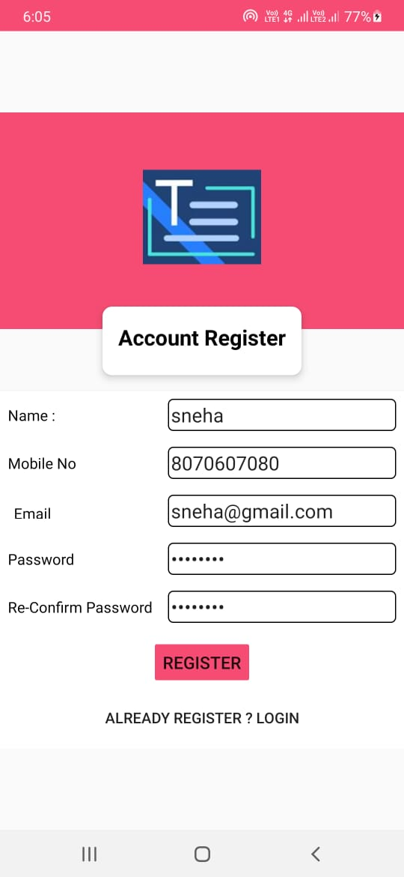

* 1. **Login page:**

A Login form is used to enter authentication credentials to access a restricted page or form. The login form contains a field for the username and another for the password. When the login form is submitted its underlying code checks that the credentials are authentic, giving the user can access the restricted page.Log in means you have already a username and password.

Login page attributes

1 mobile number

2 password

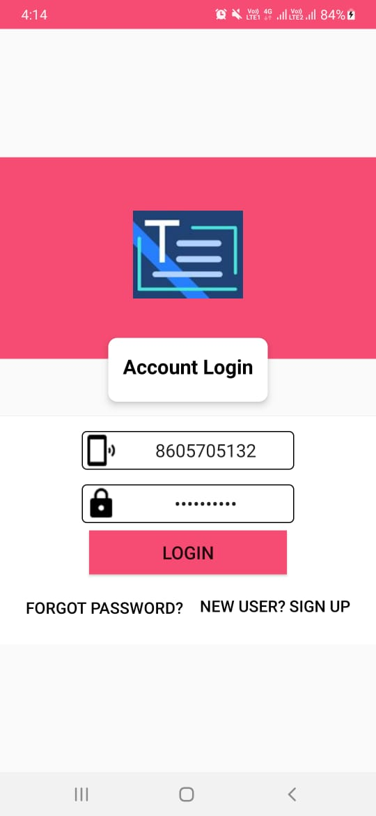

**5.3 Detect Text page:**

optical Character Recognition (OCR) is used to analyze text in images. The proposed algorithm deals with taking scanned copy of a document as an input and extract texts from the image into a text format using Otsu's algorithm for segmentation and Hough transform method for skew detection. The system was confined to recognize English alphabets (A-Z, a-z) and numerals (0-9). OCR technique has been implemented to recognize characters. Validation tests were done on screenshots of typed texts and images of scanned document from Internet sources. Experimental results indicate that the proposed algorithm is able to recognize alphabets written in Verdana font style with size 14 and also showed good results with rotated images. The average accuracy to determine rotation angle correctly was calculated to be 90% and overall system accuracy was calculated to be 93%.View less

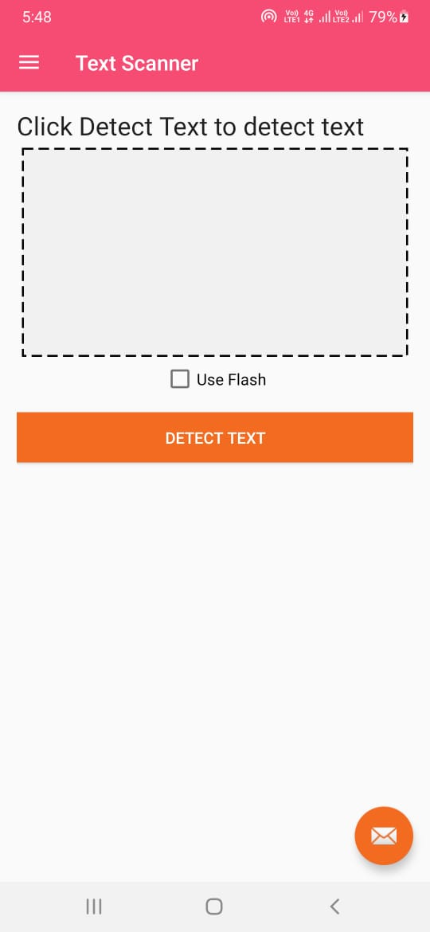

After login twe can detect the text by using tehn the camera open and scan text

**5.4 How to detect text using ocr :**

Simply defined, OCR is a set of computer vision tasks that convert scanned documents and images into machine readable text. It takes images of documents, invoices and receipts, finds text in it and converts it into a format that machines can better process. You want to read information off of ID cards or read numbers on a bank cheque, OCR is what will drive your software.

Learning how to [extract text from images](https://nanonets.com/blog/how-extract-text-from-image-pdf-files/)or how to apply deep learning for OCR is a long process and a topic for another blog post. The focus of this one is going to be understanding where the OCR technology stands, what do OCR products offer, what is lacking and what can be done better.

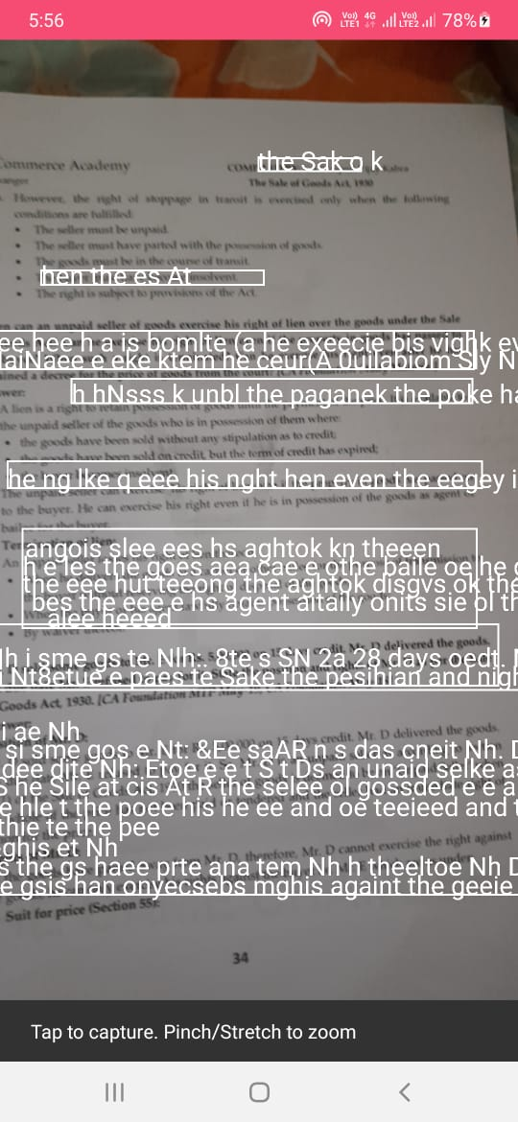

***Tilted text in images*** - While current research suggests that [object detection](https://medium.com/zylapp/review-of-deep-learning-algorithms-for-object-detection-c1f3d437b852) should be able to work with rotated images by training them on augmented data, it is surprising to find that none of the OCR tools available in the market actually adopt object detection in their pipeline. This has several drawbacks, one of which is that your OCR model won’t pick up the characters and words that are tilted. Take, for example, reading number plates. A camera attached to street light will capture a moving car on a different angle, depending on the distance and the direction of the car. In such cases, the text will appear to be tilted. Better accuracy might mean stronger traffic law enforcement and a decrease in the rate of accidents.

[***OCR in natural scenes***](https://www.deepdetect.com/applications/ocr_wild/) - OCR has historically evolved to deal with documents and though much of our documentation and paperwork happens with computers these days, there still are several use cases that require us to be able to process images taken in a variety of settings. One such example is reading shipping container numbers. Classical approaches tend to find the first character and go in a horizontal line looking for characters that follow. This approach is useless when trying to run OCR on images in the wild. These images can be blurry and noisy. The text in them can be at a variety of locations, the font might be something your OCR model hasn’t seen before, the text can be tilted, etc.

***Handwritten text, cursive fonts, font sizes*** - The OCR annotation process requires you to identify each character as a separate bounding box and models trained to work on such data get thrown off when they are faced with handwritten text or cursive fonts. This is because a gap between any two characters makes it easy to separate one from another. These gaps don’t exist for cursive fonts. Without these gaps, the OCR model thinks that all the characters that are connected are actually one single pattern that doesn’t fit into any of the character descriptions in its vocabulary. These issues can be addressed by powering your [OCR engine with deep learning](https://towardsdatascience.com/https-medium-com-rachelwiles-have-we-solved-the-problem-of-handwriting-recognition-712e279f373b).

***Text in languages other than English*** - OCR models provided by [Google](https://cloud.google.com/vision/docs/ocr) and [Microsoft](https://azure.microsoft.com/en-in/services/cognitive-services/computer-vision/) work well on English but do not perform well with other languages. This is mostly due to the lack of enough training data and varying syntactical rules for different languages.  Any platform or company that intends to use OCR for data in their native languages will have to struggle with bad models and inaccurate results. It is possible that you might want to analyze documents that contain multiple languages at once, like forms to deal with government processes. Working with such cases is not possible with the available OCR APIs.

***Noisy/blurry images*** - Noisy images can very often throw off your classifier to generate wrong results. A blurry image can [confuse your OCR model](https://blog.playment.io/compare-computer-vision-apis-for-ocr/) between ‘8’ and ‘B’ or ‘A’ and ‘4’. De-noising images is an active area of research and is being actively studied in the fields of deep learning, computer vision. Making models that are robust to noise can go a long way in creating a generalized approach to [character recognition](https://nanonets.com/blog/how-extract-text-from-image-pdf-files/) and image classification and understanding de-noising and applying it in character recognition tasks can improve accuracy to a great extent.

Sahre and copy text :

**The attributs of text scanner aftr scanning text:**

**1 use flash**

**2 detecttext**

**3 send email**

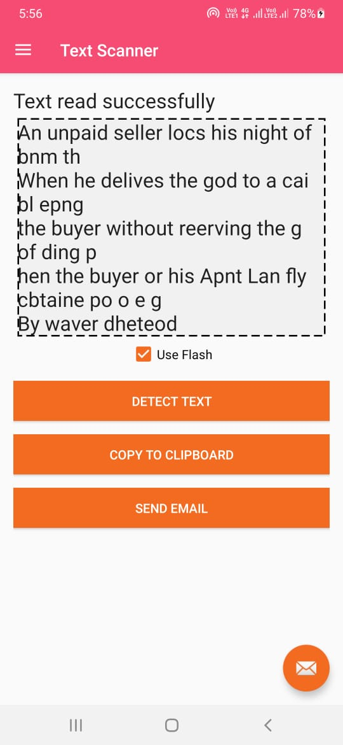

Copy to clipboard:

The Copy to Clipboard tool copies one or more elements to the clipboard. You can then use the Paste from Clipboard or Paste Aligned tools to paste copies of the elements in the drawing or in another project.The Copy to Clipboard tool is different from the Copy tool. Use the Copy tool when you want to copy a selected element and place it immediately (for example, in the same view). Use the Copy to Clipboard tool, for example, when you need to switch views before placing the copies.

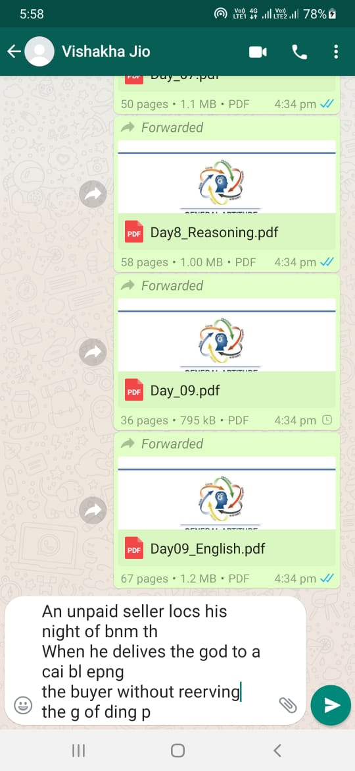

**Sahred on whatappby copy the text**

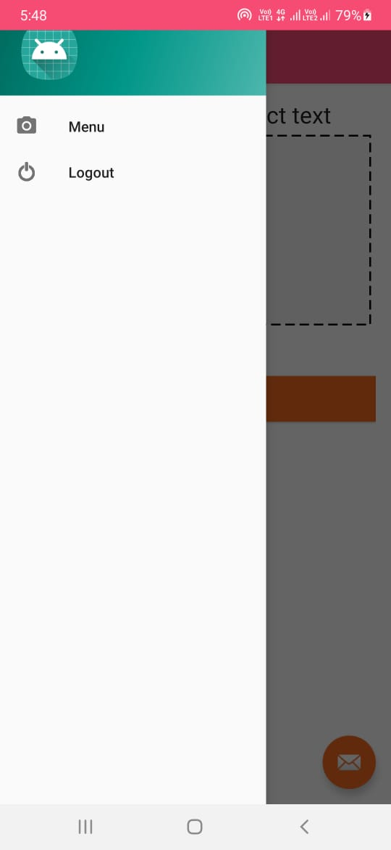

**Logout:**

**CONCLUSION**

Optical character recognition is a great way of modernizing your business and for increasing your productivity around the workers of your company.The data entry work that takes hours or even days for conversion can be done within some minutes through the OCR.This way, more time would be saved for your business while the accuracy is much.

An intelligent Word Recognition and segmentation algorithm techniques has been presented in this paper, and has produced good intermediate results. It was used to segment difficult cursive handwritten documents with some modifications, and process shall be conducted to allow the technique to be used as part of a larger system. It is therefore hoped that further research can be dedicated to analyzing and improving the results of this very important procedure.

The main objective of this investigation is to find a representation of isolated handwritten digits that allow their effective recognition. In this paper used different machine learning algorithm for recognition of handwritten numerals. In any recognition process, the important problem is to address the feature extraction and correct classification approaches. The proposed algorithm tries to address both the factors and well in terms of accuracy and time complexity. The overall highest accuracy 90.37% is achieved in the recognition process by Multilayer Perceptron. This work is carried out as an initial attempt, and the aim of the paper is to facilitate for recognition of handwritten numeral without using any standard classification techniques The recognition module is used to configure the digit strings in difficult situations. The initial results are important because all the ways of segmentations are managed by the proposed framework. By implementing few rules, the proposed framework has many advantages in providing the correct segmentation without having any prior knowledge in the research.

**REFERENCES**

* OCR, 5 June 2010. Retrieved 5 June 2010 Puigcerver, Joan. "Are Multidimensional Recurrent Layers Really Necessary for Handwritten Text Recognition?." Document Analysis and Recognition (ICDAR), 2017 14th IAPR International Conference on. Vol. 1. IEEE, 2017.
* Huang, B.; Zhang, Y. and Kechadi, M.; Preprocessing Techniques for Online Handwriting Recognition. Intelligent Text Categorization and Clustering, Springer Berlin Heidelberg, 2009, Vol. 164, "Studies in Computational Intelligence" pp. 25–45.
* Holzinger, A.; Stocker, C.; Peischl, B. and Simonic, K.-M.; On Using Entropy for Enhancing Handwriting Preprocessing, Entropy 2012, 14, pp. 2324-2350
* [30/05, 2:26 pm] Shinde: D. C. Ciresan, U. Meier, J. Schmidhuber. Multi-column Deep Neural Networks for Image Classification. IEEE Conf. on Computer Vision and Pattern Recognition CVPR 2012.