Sample Test Cases

**Test Case 1:-**

Input:- time=23:00

Output: all the three student , teacher and staff can play but not

at the same time one after another

**Test Case 2:-**

Input:- time=10:00

Output:-only staff will be able to play the game.

**Test Case 3:-**

Input:- time--17:35

Output:- teacher will be allowed to play the game and the staff will also be allowed to play

after teacher is done.

**Test case 4**

Input: time =9:23

Output: staff will be allowed to play .

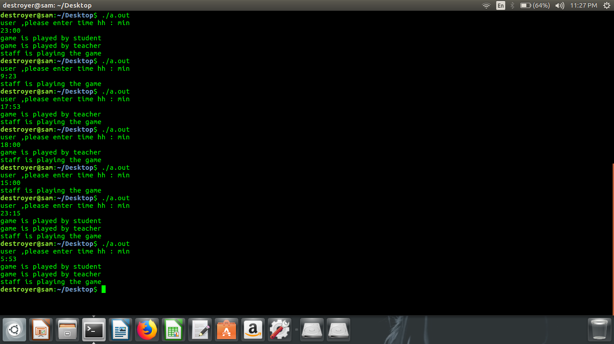

**CODE SNNIPETS**

