GIVEN SCENARIO:
consider a computer system in which computer games can be played by student only in between 10P.M. to 6 A.M. ,by faculty members between 5P.M. AND 8 A.M. and by computer staff at all the times . suggest a scheme for implement this policy efficiently.

SOLUTION:
Here, we have to make a computer system in which at a given time a particular person such as faculty member ,staff or student will be playing the game. Also, there will be time when more than one of them will have the access to play game but , on a particular system the person who will arrive first will play the after he/she is finished then other one after it will be allowed to play the game
The main concepts involved in this solution will require the knowledge of following :-
1>process synchronisation.
2>context switching.
3>multiple threading.
How these concept are related:
Process synchronisation:- since here we have 3 processes that may or may not occurs at the same time . so , the synchronisation is very essential as to avoid the race condition.That is why we will apply lock when once of the processes would be running.
multiple threading and context switching will also be used as we will be required to make different processes and then will switching between these process when needed.

Algorithm
1. Take the input as time from the user or from the system(in 24 hours format)
2. make three thread ,one for each student , faculty and staff.
3. compare the time (taken by user).{all thread will run concurrently}
a>if time is between 10P.M.-6A.M. then make the student will put lock and will play.
b>if time is between 5P.M.-8A.M.then make the faculty will put lock and play.
c>for staff as it can play all the time it will run parallel to all the thread.
{no two can play at same time as the one who playing will put lock and then play}
4. all the thread will return to the main function and will be joined.

Complexity
As , my program does not contains any loop ,or any call to non-constant time function the complexity of my program will be :- O(1).
Overall complexity:-O(1)

Boundary Conditions and constraints
1.if suppose the system time fails or is altered due to some reasons ,then in that case the effective user will no longer will be able to play game .
2. And in case of when we take input of the system time from the user then in that case ,if the user input the wrong time ,we can’t be be able to verify it as we have not used the system date to compare.
3. In case for a particular time , more than one user will be there for a particular system then we will have nothing to deal with in that case the first come first serve will be used.

Sample Test Cases

Test Case 1:-
Input:- time=23:00
Output: all the three student , teacher and staff can play but not
at the same time one after another

Test Case 2:-
Input:- time=10:00
Output:-only staff will be able to play the game.

Test Case 3:-
Input:- time--17:35
Output:- teacher will be allowed to play the game and the staff will also be allowed to play
after teacher is done

some test cases:-
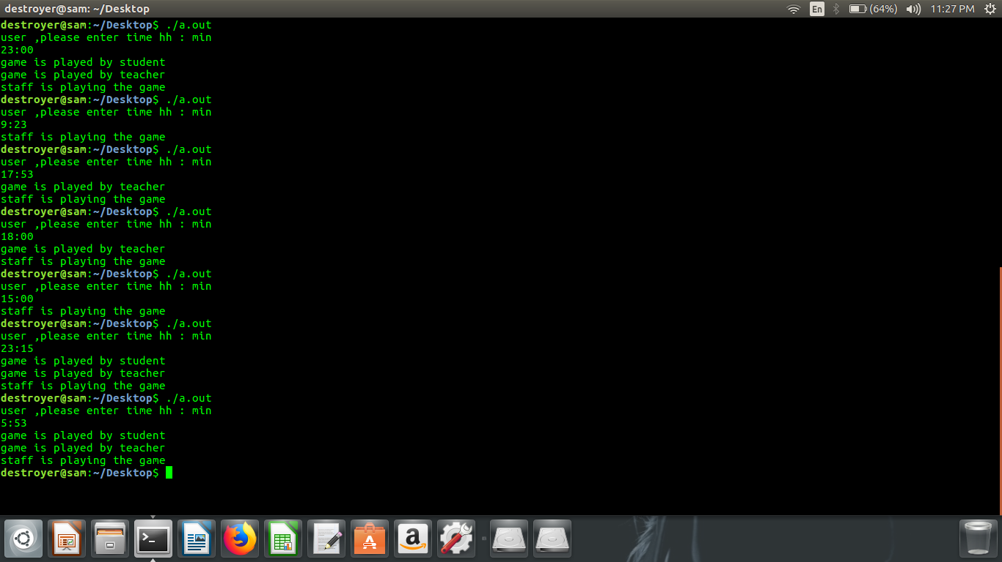

CODE SNNIPETS
