**AWS NAT gateways:**

**When the server has only private ip using Nat gateway we can connect the server**

**Step 1.** First, we must create **two subnets** 1. **public subnets** (after creating right click and we select) and 2. **private subnets** (private means simply create subnet)

**Step 2**. lunch **two instance** using two subnets

[] in server A select **public subnet**

[] in server B select **private subnet**

[] in auto assign public Ip automatically disable

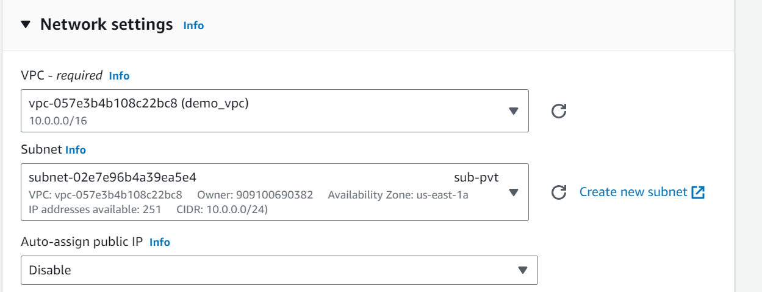

**Step 3**. go to **NAT gateway**

[] select **create** and **then select public subnet**

[] **allocate elastic Ip** and **create**

**Step 4.** go to **route table**

[] select **create** and **select VPC** which want

[] select **subnet association** and **select private subnet and save**

[] select **route** and **edit route**

[] add route in **destination 0.0.0.0/0** and in **target select NAT gateway** (select created NAT)

-----------------------------------------------------------------------------------------------------------------------------

In server terminals

[] sudo su -

[] vi test.pem (we have to paste the .pem key of when we create key pair that time we downloaded)

[] chmod 400 test.pem

[] ssh -I test.pem [ubuntu@1.2.3.4](mailto:ubuntu@1.2.3.4) (private Ip of server B) (small I)

[] yes

Server B is connected and download the things it will download server B

[] wget image link

Ex: wget --output-document=images_icons_linux-bsd.gif https://www.electrictoolbox.com/images/icons/linux-bsd.gif