**AWS IAM:**

AWS Identity and Access Management (IAM) is a web service that helps you securely control access to AWS resources. With IAM, you can centrally manage permissions that control which AWS resources users can access. You use IAM to control who is authenticated (signed in) and authorized (has permissions) to use resources.

**Access management:**

* [User groups](https://us-east-1.console.aws.amazon.com/iamv2/home?region=us-east-1#/groups)
* [Users](https://us-east-1.console.aws.amazon.com/iamv2/home?region=us-east-1#/users)
* [Roles](https://us-east-1.console.aws.amazon.com/iamv2/home?region=us-east-1#/roles)
* [Policies](https://us-east-1.console.aws.amazon.com/iamv2/home?region=us-east-1#/policies)
* [Identity providers](https://us-east-1.console.aws.amazon.com/iamv2/home?region=us-east-1#/identity_providers)
* [Account settings](https://us-east-1.console.aws.amazon.com/iamv2/home?region=us-east-1#/account_settings)

**Users:**

An IAM *users* is an identity within your AWS account that has specific permissions for a single person or application. Where possible, best practices recommend relying on temporary credentials instead of creating IAM users who have long-term credentials such as passwords and access keys.

1. On the **Console Home** page, select the IAM service.
2. select **Users** and then select **Add users**.
3. **User details**, in Username, enter the name for the new user and next.
4. On the **Set permissions** select which option we want and next.
5. if we want to provide console access to a person.

6. select Provide user access to the AWS Management Console.

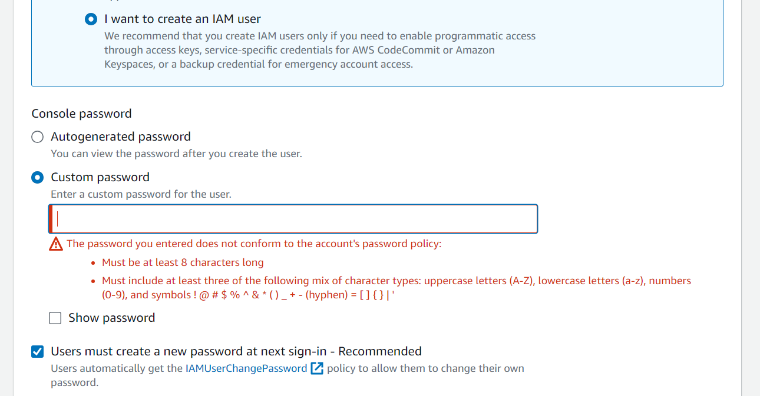

7. select I want to create an IAM user and select **Custom password.**

8. select user must create a new password at next sign-in-Recommended. (User will create new password after first login)

9. next

[**User groups:**](https://us-east-1.console.aws.amazon.com/iamv2/home?region=us-east-1#/groups)

An IAM user group is a collection of IAM users. User groups let you specify permissions for multiple users, which can make it easier to manage the permissions for those users.

1. Sign into the AWS Management Console and open the IAM console
2. In the navigation pane, choose **User groups** and then choose **Create group**.
3. For **User group name**, type the name of the group.
4. In the list of users, select the check box for each user that you want to add to the group.
5. In the list of policies, select the check box for each policy that you want to apply to all members of the group.
6. Choose **Create group**.

Example: 2 users need to access only ec2 instances of python-servers

Group name: Python

Users: user1, user2

Policy: EC2_restrict_pythonservers (created custom policy)

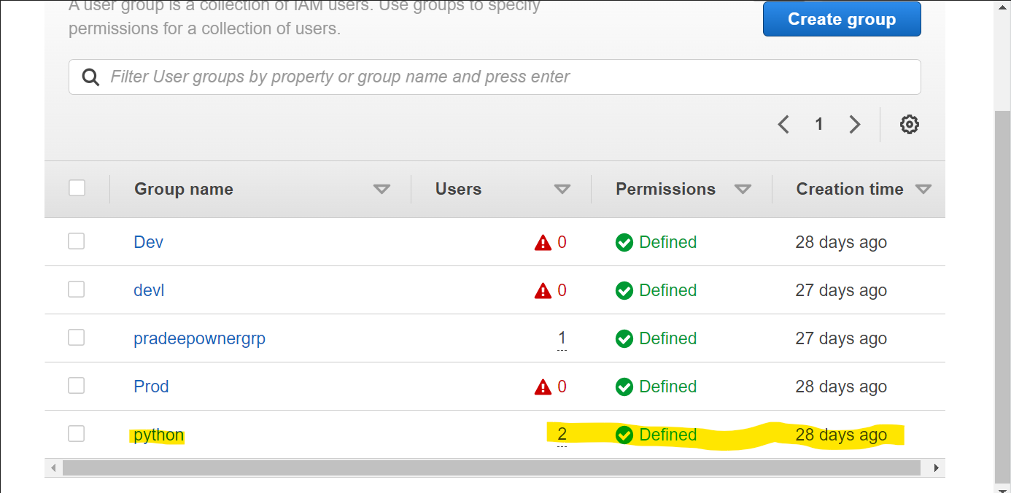

[**Roles:**](https://us-east-1.console.aws.amazon.com/iamv2/home?region=us-east-1#/roles)For one service giving access of another service we will create roles.

If we go with roles no need to create access keys and secrete key, you can use roles to delegate access to users, applications, or services that don't normally have access to your AWS resources

**Example:**

**For 1 ec2 instance giving access of S3 directly.**

1. Sign into the AWS Management Console and open the IAM console
2. In the navigation pane of the console, choose **Roles** and then choose **Create role**.
3. Choose **AWS service** role type.
4. Choose in **use case** and **common use** **case** select **EC2** and next.

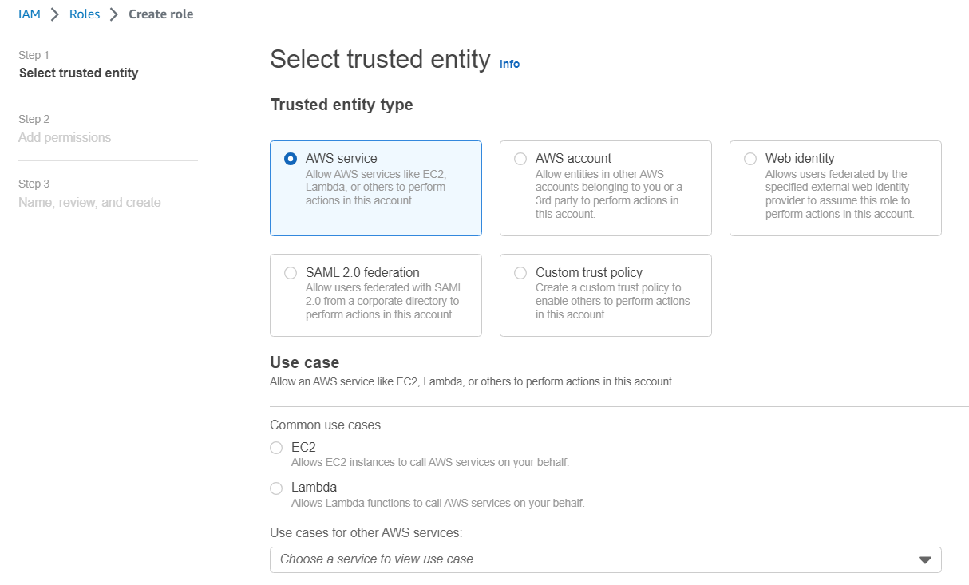

1. Select which police permission you want to give.

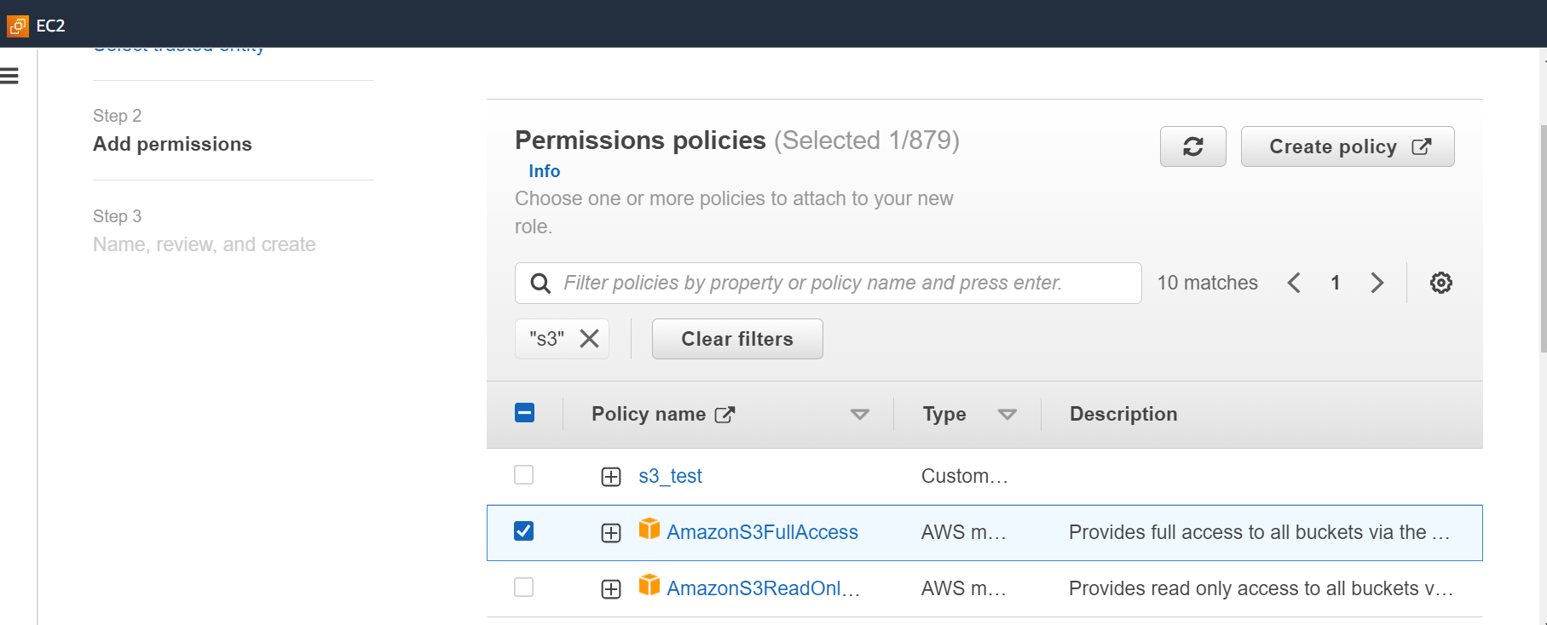

1. In role details fill **role name** and **description** (optional).

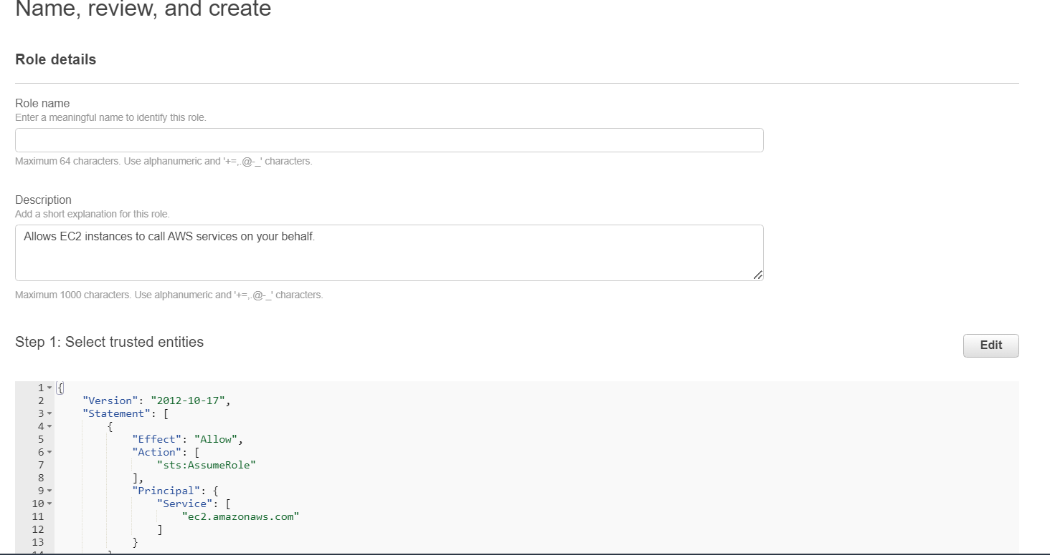

1. Create Role

8. Go to Ec2 Select instance and right click to select **Security > Modify IAM role** and there add the S3 access role.

[**Policies:**](https://us-east-1.console.aws.amazon.com/iamv2/home?region=us-east-1#/policies)

To Creating polices we can give permission for users which permission we want to give

1. Sign into the AWS Management Console and open the IAM console.
2. In the navigation pane of the console, choose policies and then choose **Create policy.**
3. Select JSON and edit the policies or we can select Visual and create policy by selecting required permissions.
4. Resolve any security warnings, errors, or general warnings generated during policy validation, and then choose **Next**.
5. On the **Review and create** page, type a **Policy Name** and a **Description** (optional) for the policy that you are creating. Review **Permissions defined in this policy** to see the permissions that are granted by your policy.
6. Choose **Create policy** to save your new policy.

**Inline policy:**

An inline policy is a policy created for a single IAM identity (a user, group, or role). Inline policies maintain a strict one-to-one relationship between a policy and an identity. They are deleted when you delete the identity.

1. On the **Console Home** page, select the IAM.
2. select **Users** and then under **Permissions policies.**
3. Select **add Permissions** and then select create inline policy.
4. Select JSON and edit the policies
5. Resolve any security warnings, errors, or general warnings generated during policy validation, and then choose **Next**.
6. On the **Review and create** page, type a **Policy Name** and a **Description** (optional) for the policy that you are creating. Review **Permissions defined in this policy** to see the permissions that are granted by your policy.
7. Choose **Create policy** to save your new policy.

**Example:** Create custom policy (we can give it to all IAM users/inline policy (user policy)

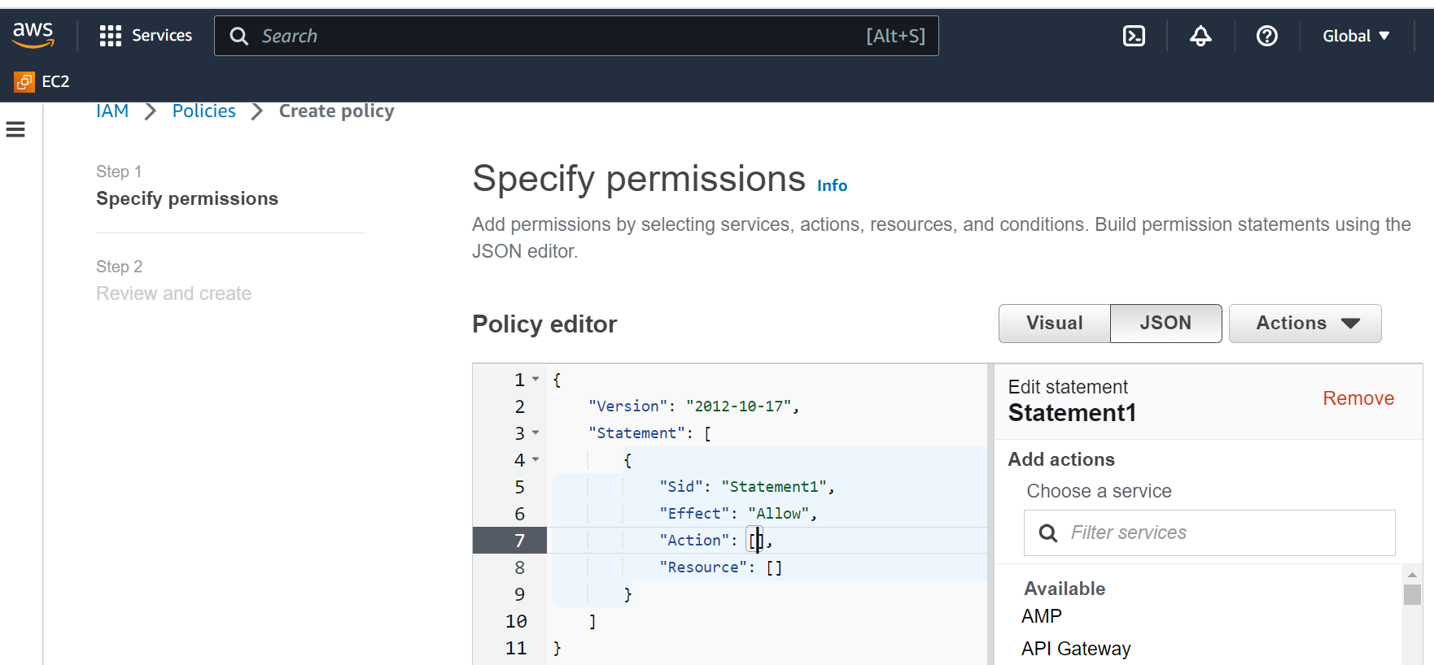

Write custom policy code in Json format based on our requirement and give permissions accordingly. And save the Policy by giving name and Descriptions.

Now we can add policy to Users or Groups, and they get access to resources-based on our Custom policy permissions.

## **Identity providers:**

Use an identity provider (IdP) to manage your user identities outside of AWS but grant the user identities permissions to use AWS resources in your account.

**Account settings:**

## **Password policy**

Info

Configure the password requirements for the IAM users.

### This AWS account uses the following default password policy:

Password minimum length

8 characters

Password strength

Include a minimum of three of the following mix of character types:

* Uppercase
* Lowercase
* Numbers
* Non-alphanumeric characters

Other requirements

* Never expire password
* Must not be identical to your AWS account name or email address

## **Security Token Service (STS)**

Info

STS is used to create and provide trusted users with temporary security credentials that can control access to your AWS resources.

### Session Tokens from the STS endpoints

AWS recommends using regional STS endpoints to reduce latency. Session tokens from regional STS endpoints are valid in all AWS Regions. If you use regional STS endpoints, no action is required. Session tokens from the global STS endpoint (<https://sts.amazonaws.com>) are valid only in AWS Regions that are enabled by default. If you intend to enable a new Region for your account, you can use session tokens from regional STS endpoints or activate the global STS endpoint to issue session tokens that are valid in all AWS Regions.

Global endpoint

Valid only in AWS Regions enabled by default

Regional endpoints

Valid in all AWS regions

|  |  |  |
| --- | --- | --- |
| **Region name** | **Endpoint** | **STS status** |
| Global Endpoint | <https://sts.amazonaws.com> | Always active |
| US East (N. Virginia) | <https://sts.us-east-1.amazonaws.com> | Always active |