**Aws Alias:**

Alias name is user Friedly name means, if we create alias name user no need to use account id to log in to aws , they can use alias name.

**Alias creation:**

[] in IAM select **dashboard**

[] In the **AWS Account** section, next to **Account Alias**, choose **Create**. If an alias already exists, then choose **Edit**.

[] In the dialog box, enter the name you want to use for your alias, then choose **Save changes**.

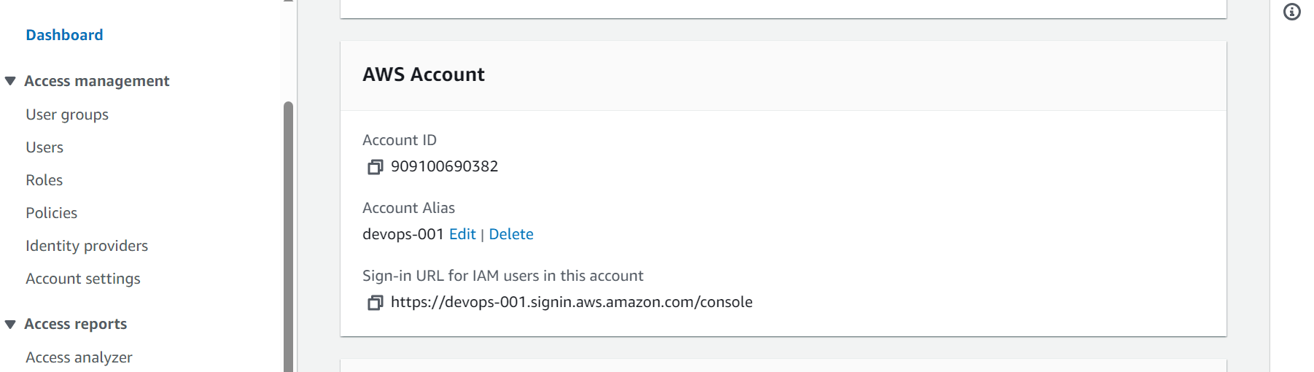

[] give sign in URL to user

**VPC peering:**

An AWS (Amazon Web Services) VPC (Virtual Private Cloud) peering connection is a networking connection between two VPCs that enables us to route traffic between them using private IPv4/IPv6 addresses. Instances in either VPC can communicate with each other as if they are within the same network. We can create a VPC peering connection between our own VPCs, or with a VPC in another AWS account.

[] Go to VPC select **Peering Connection**.

[] Select **“Create Peering Connection”.**

[] Select a local VPC (**Requester**) to peer with. (Local VPC to initiate the request), it’ll show us the CIDR Block associated with the local VPC.

[] Select another VPC to peer with. Here, we can select a VPC from the same account or another account. We can also select from the same region and from another region (inter-region VPC Peering Connection) as well.

[] Provide target VPC (**Accepter**) ID and click on Create Peering Connection.

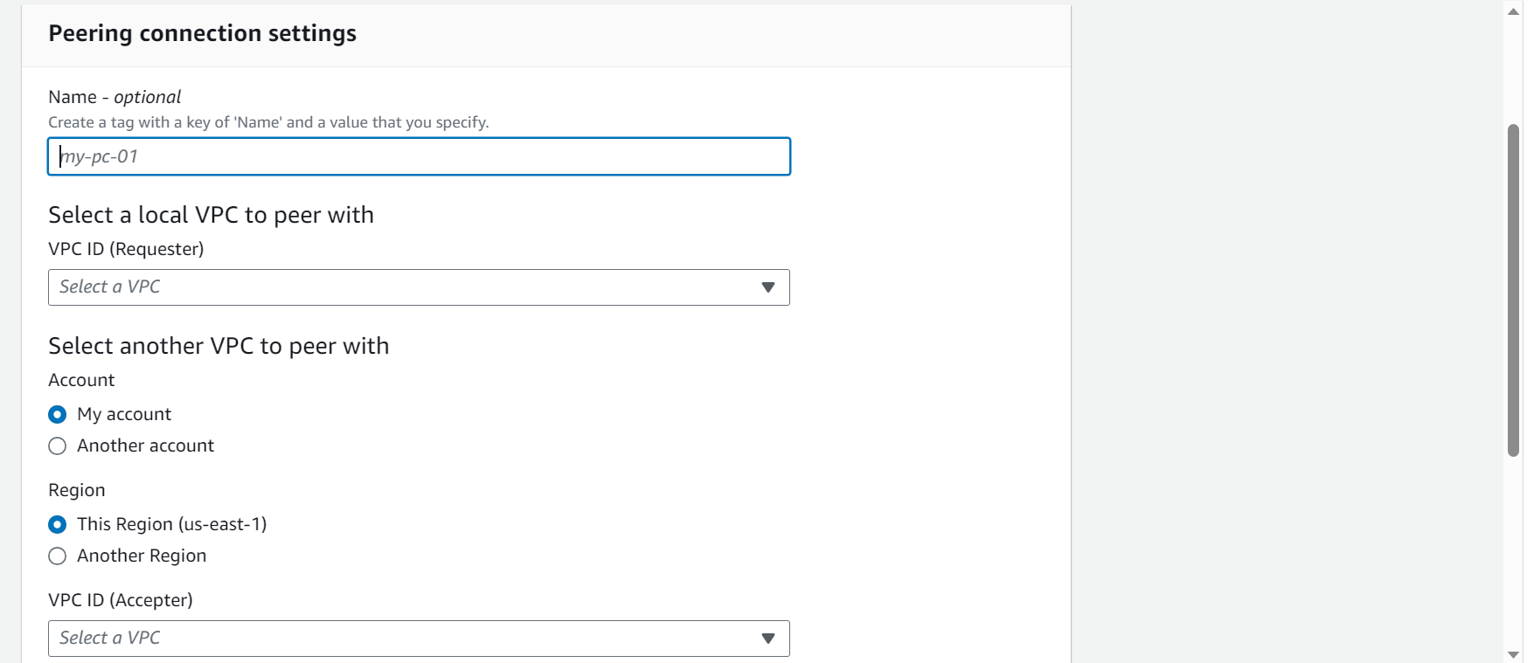

[] Select the **pending VPC** and select **action** and Select **“Accept Request”** and Accept Request confirmation comes.

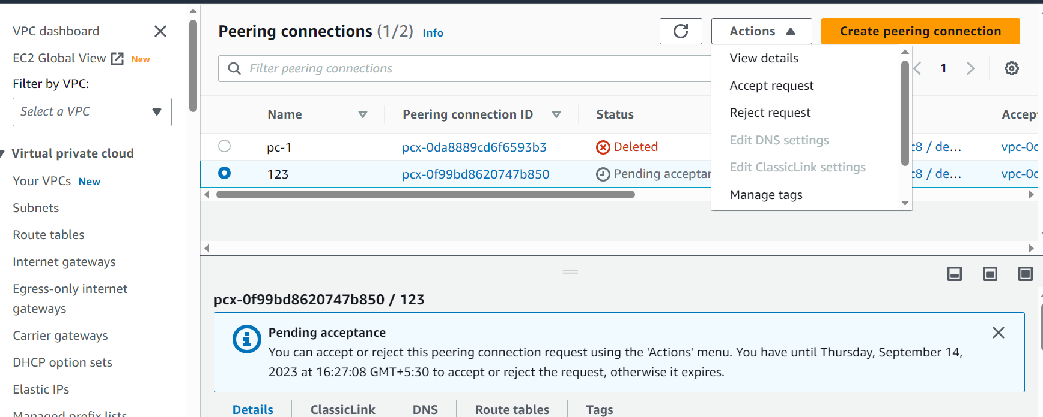

**After connecting we must set up route table**

Create Routes on both VPC

On VPC 1, we need to provide CIDR for destination VPC2 and target should be “Peering Connection”. Click on “Save routes”.

[] go to **route tables** and select route which we mention to peering and scroll down select **route** then select **edit route**

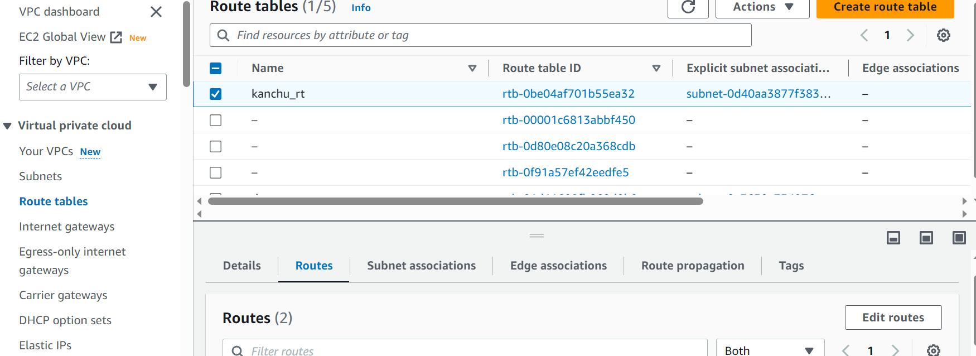

[] select **add route** and in destination give **CIDR of opposite VPC** and in target select **peering connection** and save changes

[] we must do same in **anther VPC** also

[] to check ping private IP of opposite server

[] ping private IP