**AWS cloudwatch alarm setup to instances CPU utilization :**

**Way 1 :**

[] Open the aws console and in the navigation pane open **cloudwatch**

[] choose **Alarms**, **All alarms.**

[] Choose **Create alarm**.

[] Choose **Select Metric**.

[] select **EC2** then select **pre instance Metrices**.

[] select which instance want

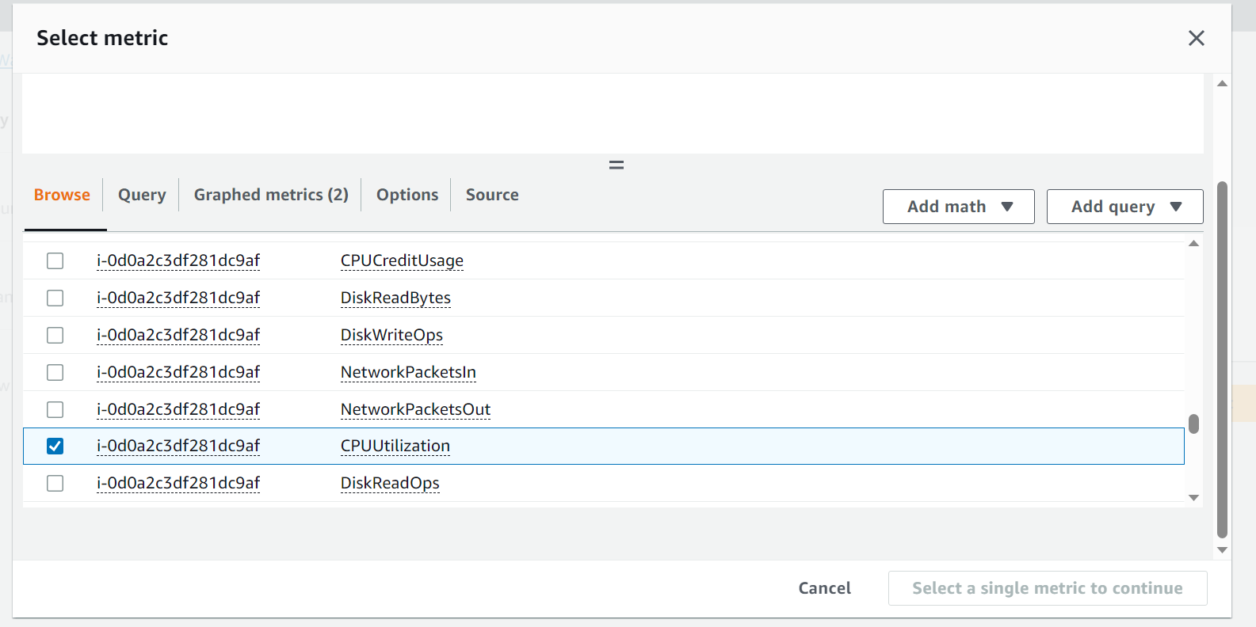

[] For **Alarm thresholds**, select the metric and criteria for the alarm. For example, you can leave the default settings for **Group samples by** (**Average**) and **Type of data to sample** (**CPU utilization**). For **Alarm when**, choose **>=** and enter **0.80**. For **Consecutive period**, enter **1**. For **Period**, select **5 minutes**.

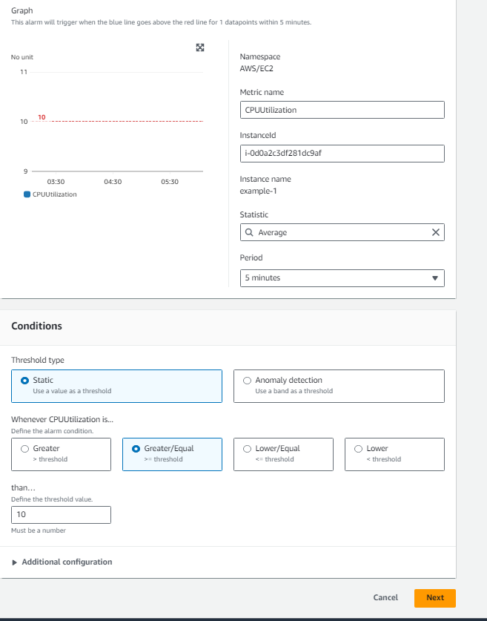

[] next

[] in configure actions

[] In **Alarm state trigger** in that select **in alarm**

[] **Select an existing SNS topic** (first we should create SNS topics) or choose to create new topics

[] in send notifications select which we **already created SNS**

[] after selecting SNS in Email (endpoints) its shows email id which we mention in SNS

[] next and give alarm name and next

[] create alarm

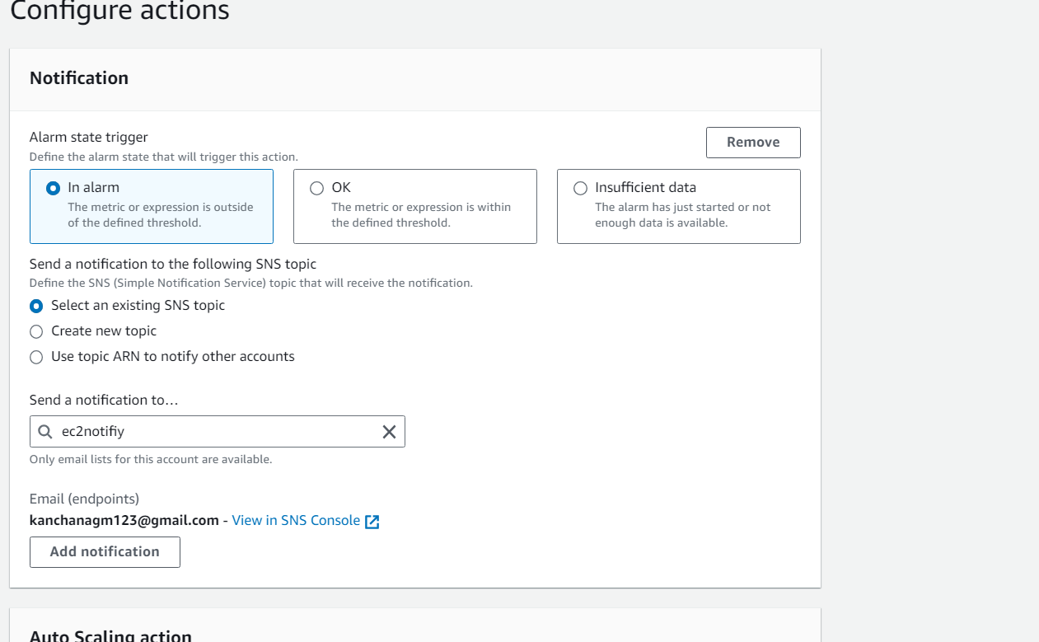

**Way 2:**

1. In the navigation pane, choose **Instances**.
2. Select the instance and choose **Actions**, **Monitor and troubleshoot**, **Manage CloudWatch alarms**.
3. On the **Manage CloudWatch alarms** detail page, under **Add or edit alarm**, select **Create an alarm**.
4. For **Alarm notification**, choose whether to turn the toggle on or off to configure Amazon Simple Notification Service (Amazon SNS) notifications. Enter an existing Amazon SNS topic or enter a name to create a new topic.
5. For **Alarm action**, choose whether to turn the toggle on or off to specify an action to take when the alarm is triggered. Select an action from the dropdown.
6. For **Alarm thresholds**, select the metric and criteria for the alarm. For example, you can leave the default settings for **Group samples by** (**Average**) and **Type of data to sample** (**CPU utilization**). For **Alarm when**, choose **>=** and enter **0.80**. For **Consecutive period**, enter **1**. For **Period**, select **5 minutes**.
7. (Optional) For **Sample metric data**, choose **Add to dashboard**.
8. Choose **Create**.

When the CPU threshold more or less (how we mention) we get email when it cross

