**Elastic load balancer/applications load balancer:**

* Elastic Load Balancing automatically distributes your incoming traffic across multiple targets, such as EC2 instances, containers, and IP addresses, in one or more Availability Zones.
* Elastic load balancing offers the ability to load balance across AWS and on-premises, resources using a single load balancer.

[] create **one VPC** and **3 subnets with 3 different regions**.

(After creating right click select edit subnet. select enable the auto-assign public IP and go to route table select route table and select subnet associations and add the created subnet)

[] launch 3 instances using three subnets

[] connect through putty

[] install nginx in all three servers

[] sudo su -

[] apt-get update

[] apt install nginx (check in chrome mentioning public ip)

[] cd /var/www/html

[] ls

[] vi index.html (paste some html code (w3school))

[] check it in chrome.

[] do same in 3 servers.

[] go to ec2 dashboard.

[] in load balancing select target groups.

[] create target group

[] in choose a target group

[] instances

[] target group name (whatever)

[] in protocol select TCP and in port 80

[] in VPC. select which we select in launching instance

[] health check protocol

[] TCP

[] in advanced health check setting

[] health check protocol

[] Traffic port

[] health threshold

[] 3

[] unhealth threshold

[]3

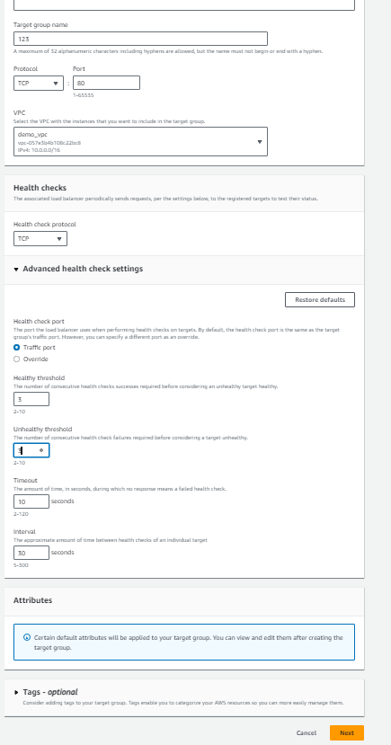

[] in Port for the selected instances

[] 80

[] select include as pending below

[] in review target

[] target

[] select our servers and create target group

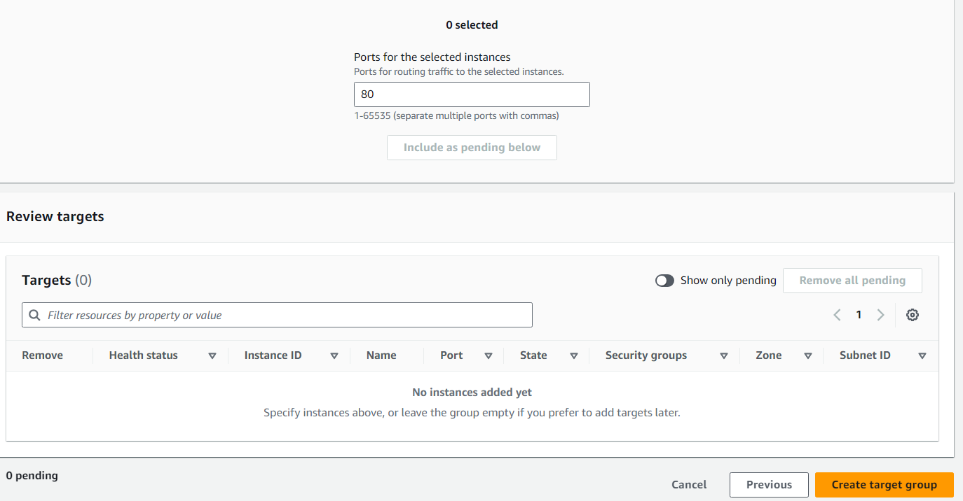

Load Balancers:

[] create load balancer

[] select network load balancer

[] create

[] load balancer name

[] scheme

[] internet-facing

[] IP address type

[] IPV4

[] VPC (select which we mention in launching instances)

[] Mapping (when we select VPC. It automatically lists attached sunets and select subnets)

[] security groups. Select which we created

[] in Listeners and routing, select created targetgroups

[]create load balancer

[] after creating, copy the DSN link of load balancer, wait till its shows active and paste it in chrome, we will get output, (server output means what we mention in html file)