**To get email notification when instance stop, start, terminate**

**SNS creation:**

### [] Go to AWS **SNS console,**

### [] Select **Create topic.**

[] select **Standard**. Then just enter the **name** and display **name** for your topic.

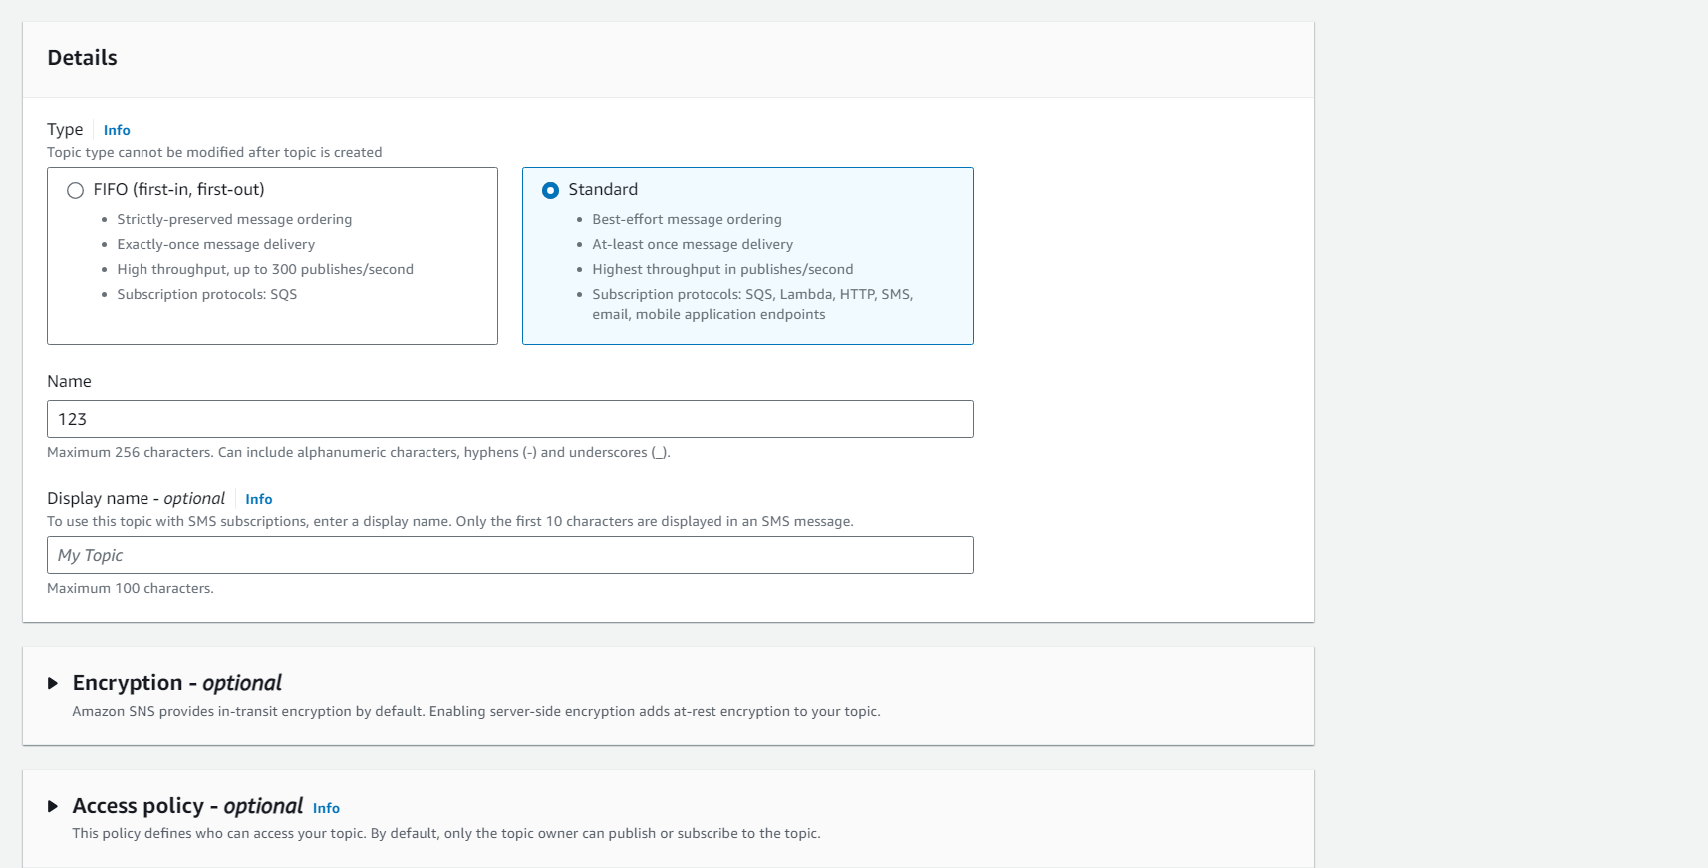

[] create topic.

[] On the **Subscriptions tab**, click **Create subscription**.

[] For Protocol, **select Email**.  
[]For Endpoint, **enter the email address** where you want to receive the notifications.

[] 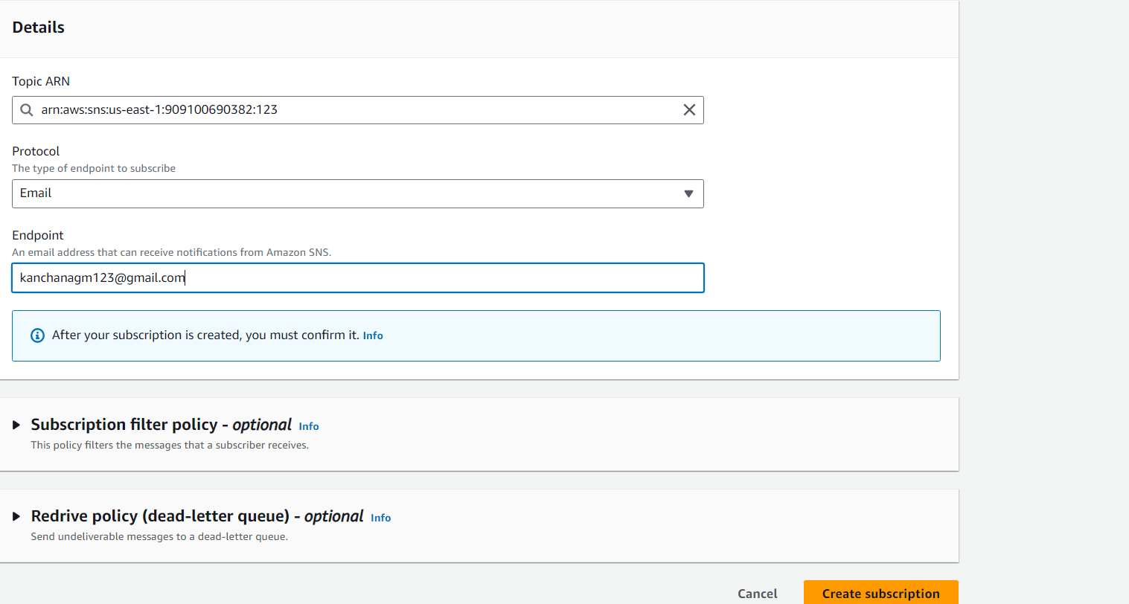

[] **create subscription**

### [] **Confirm email subscription sent to the email address you entered.**

[] 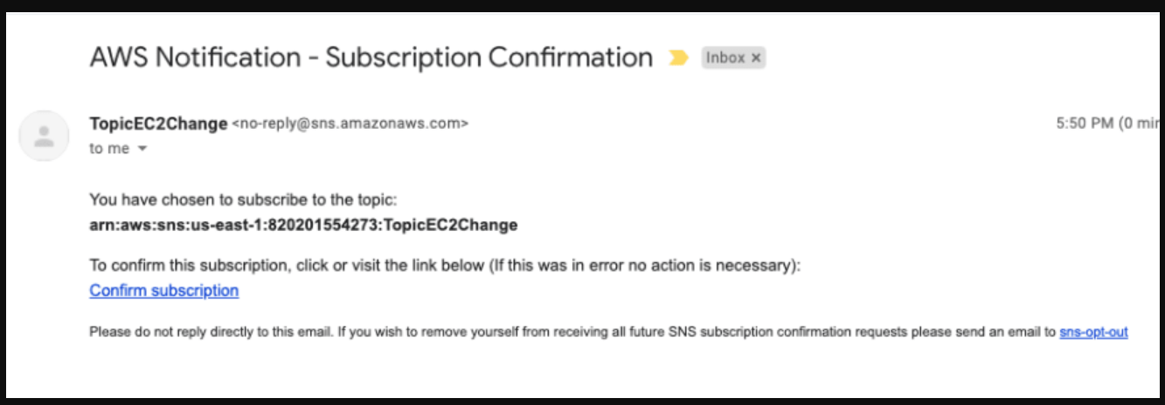

**[] Before event creation is there in aws cloud watch**

[] Go to **amazon EventBridge** console.

[] select **EventBridge Rule** and **create rule**

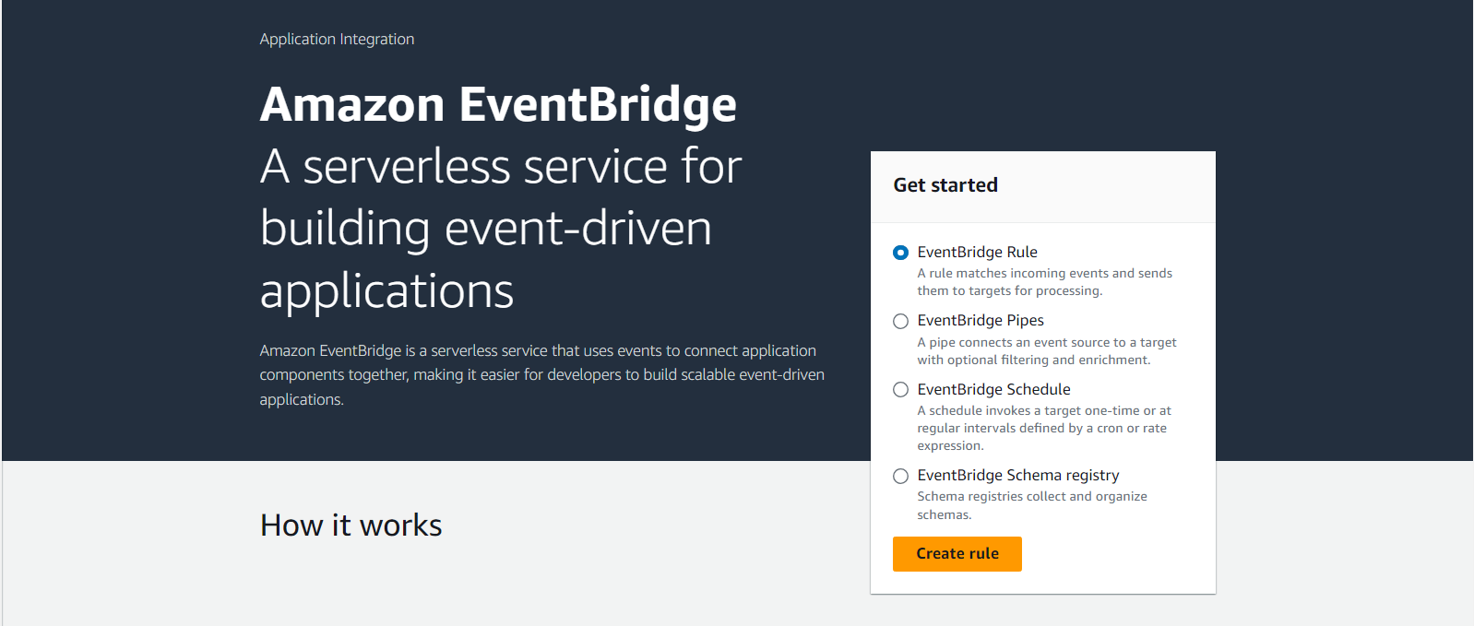

**[]** Enter a **Name** and **description for your rule**.  
On rule type, select **rule with an event pattern**

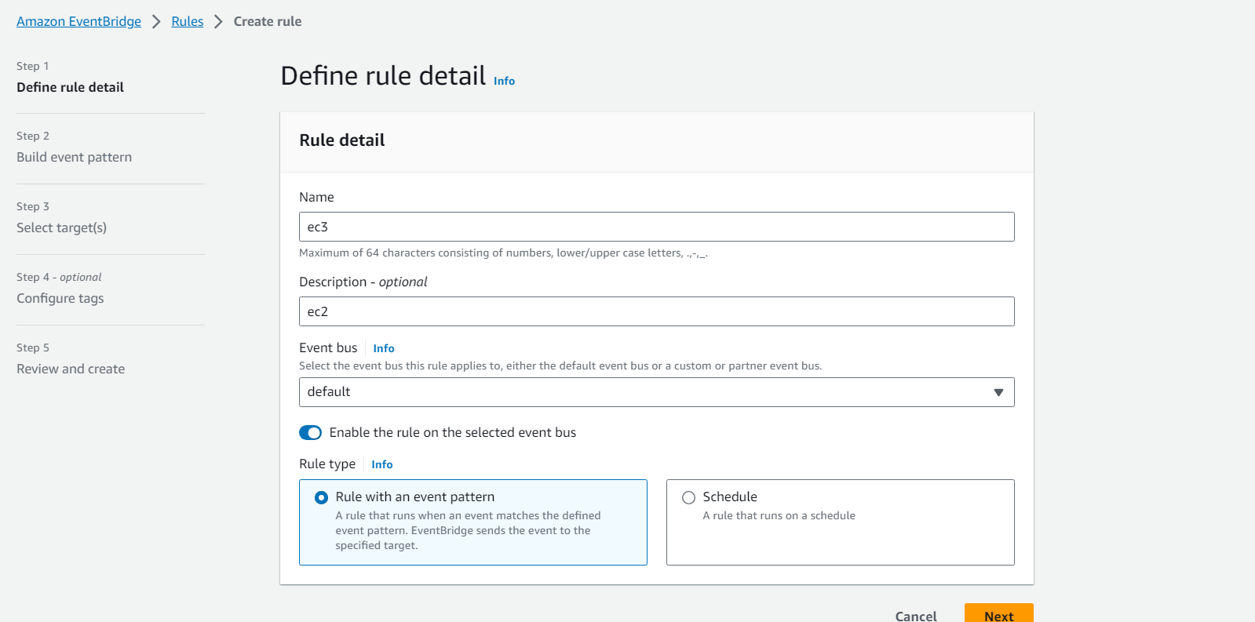

**[] next**

**[] select below which are slected**

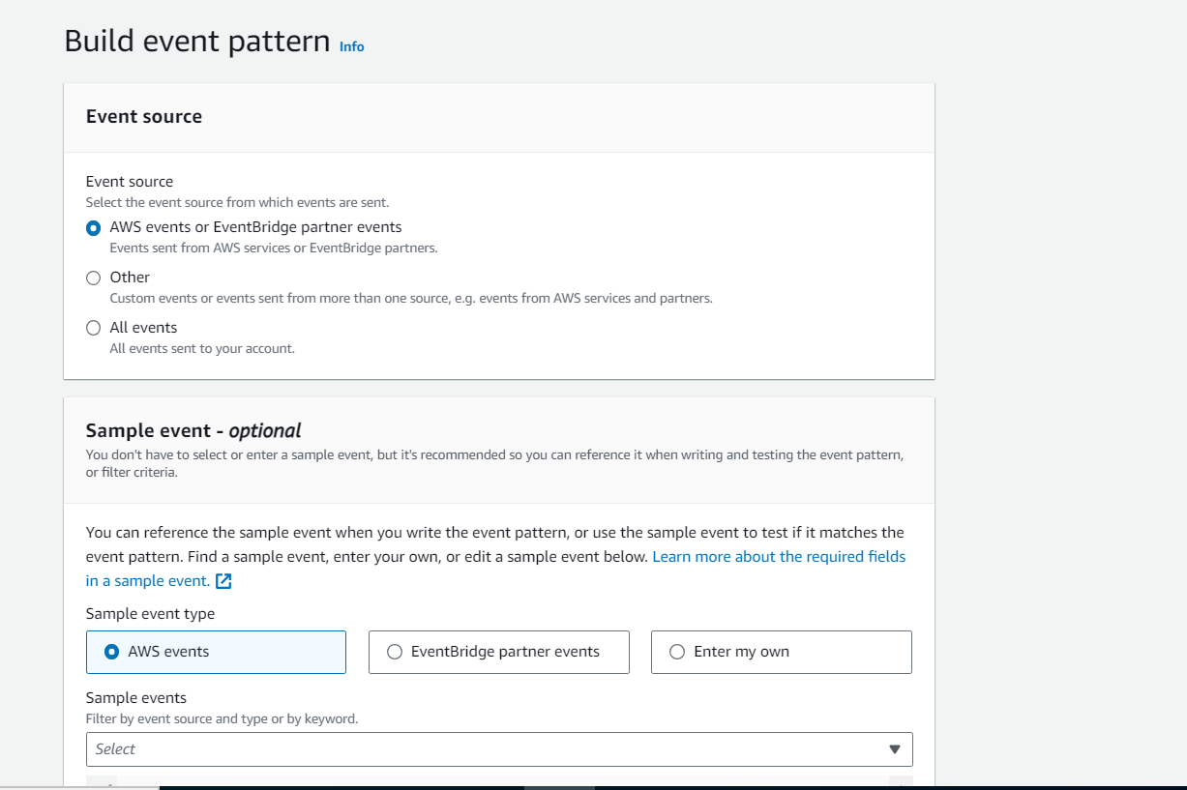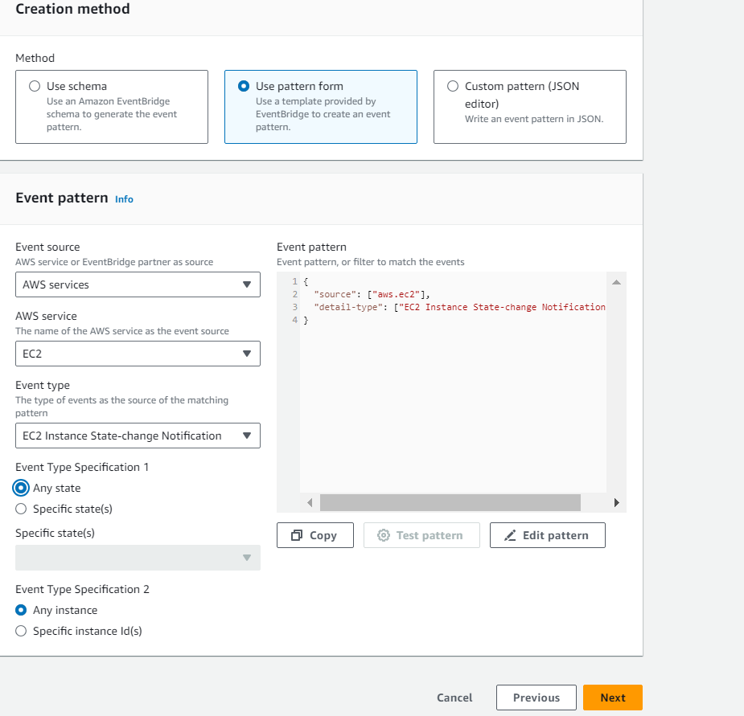

**[] next**

[] In Select **targets**, choose **SNS topic** For **Topic**, choose the topic name that you created earlier.

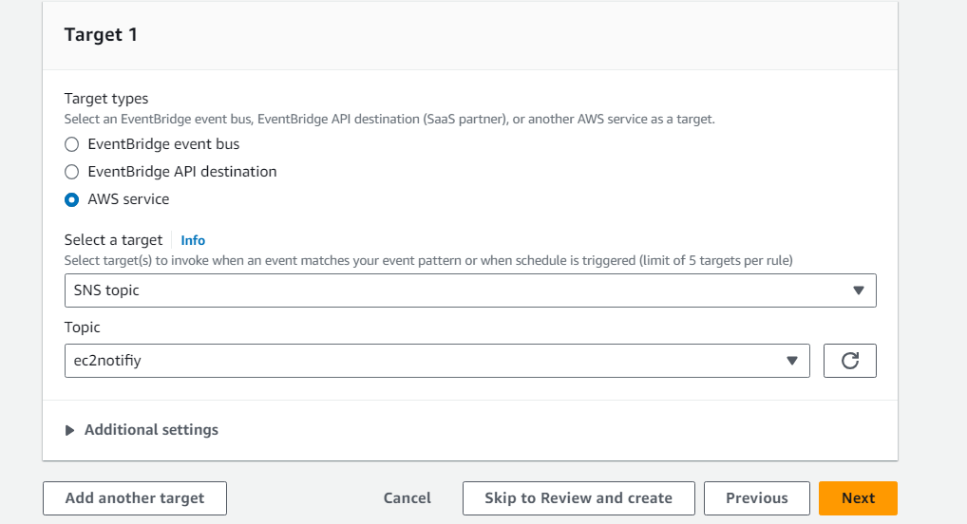

[] check to turn or/off we get mail