**Windows server launching:**

[] in ec2

[] [] In lift side select instances

[] select launch instance

[] in name and tags give whatever we want

[] Select **Windows** under QuickStart and Select **Microsoft Windows Server 2022 Base** AMI.

[] 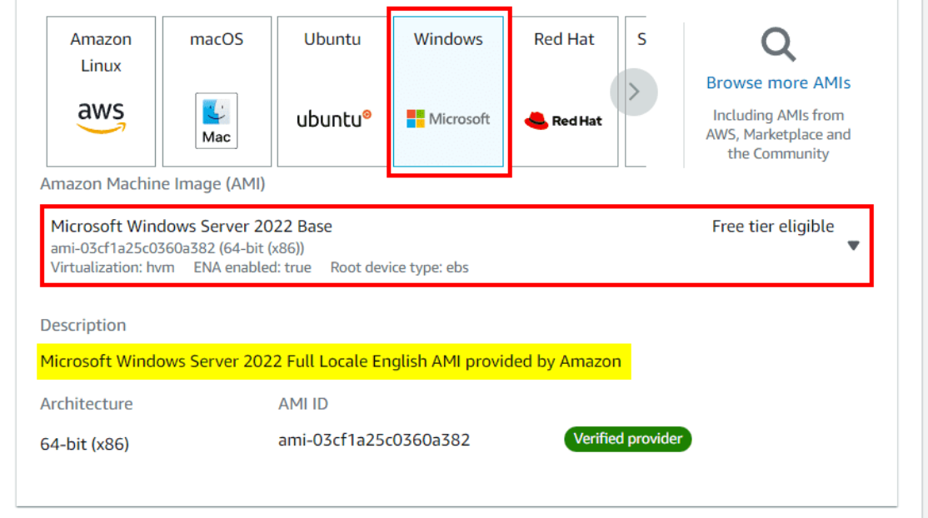

[] In **key pair**

[] we can select which we already created or else we can create

[] launch instance

[] Here, you shall see your instance is launching and the Status check is Initializing, wait for some time.

[] 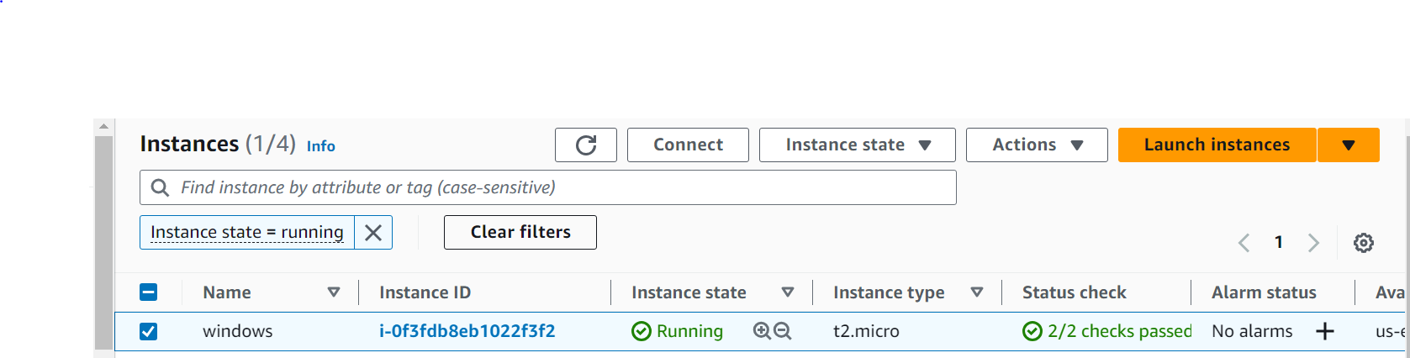

## **To Connect AWS Windows EC2 Instance**

[] Firstly we have to select the Windows instance **From the Running Instance** of the EC2 dashboard and click on **Connect.**



**[]** Here we have to select the **RDP (Remote desktop protocol) Client** and then **Download** the RDP File and save it somewhere safe then, we need a password to access the RDP file, so click on **Get Password.**

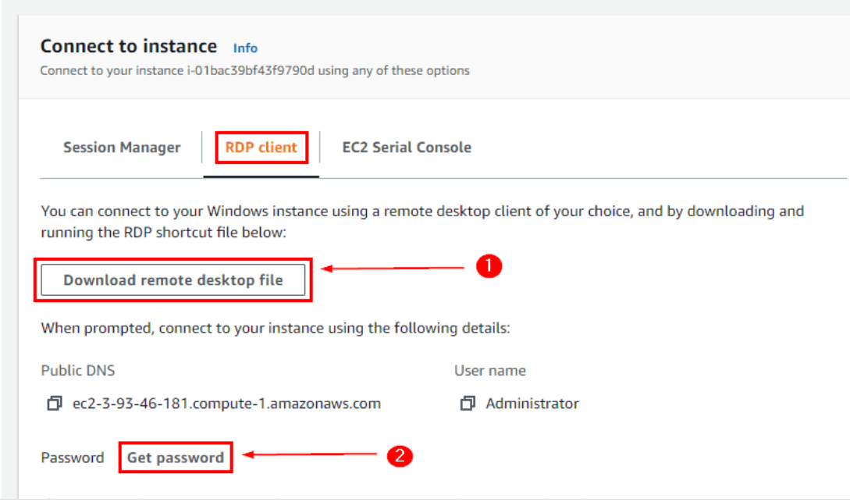

[]

[] **in upload private key file. Upload .pem what we already created**

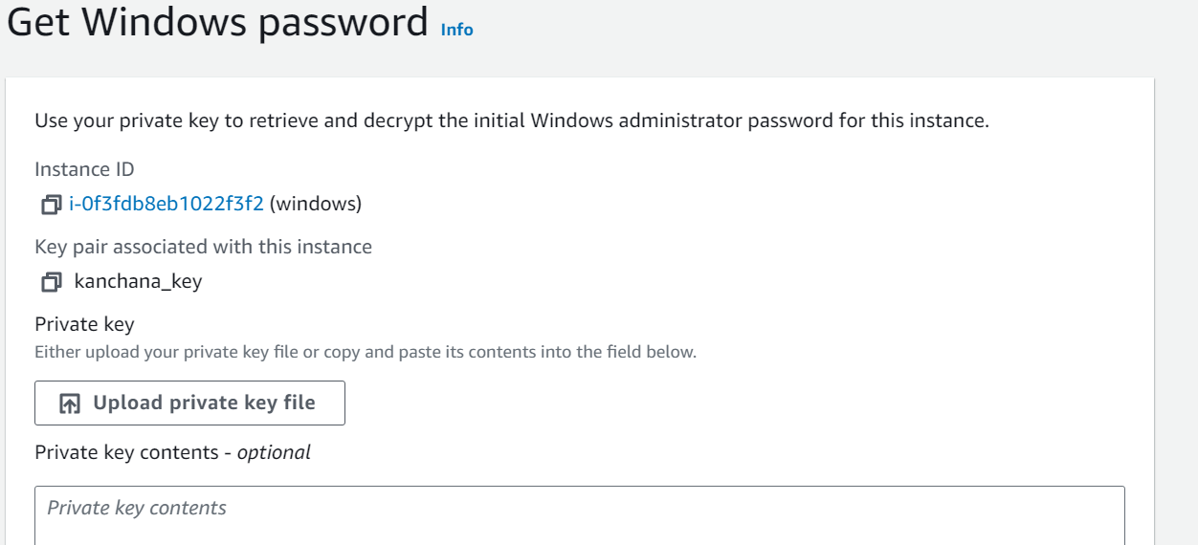

[] decrypt password

[] download remote desktop file

[] After submitting the Key-pair here the **Password is Generated**, copy and save it somewhere safe

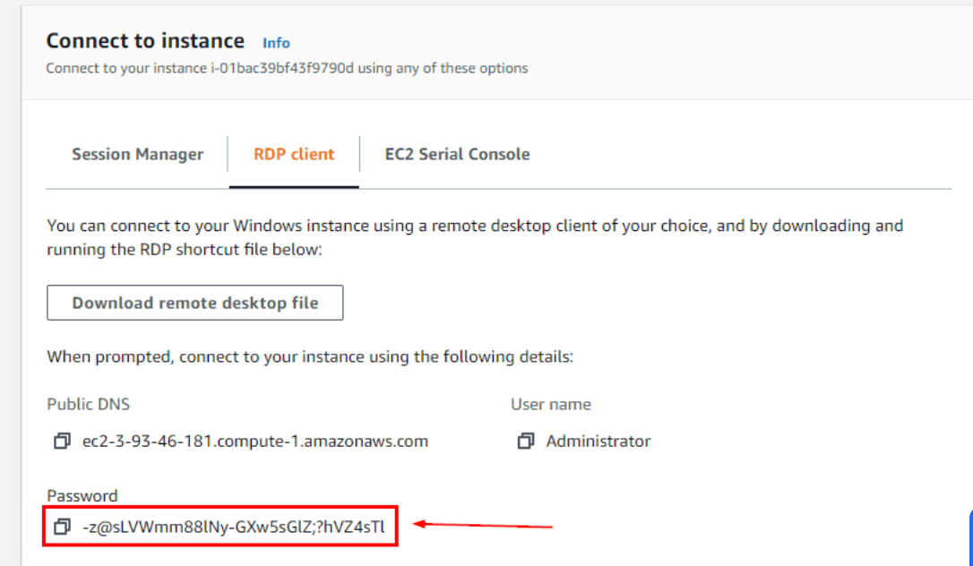

[] first time we need to open in where we download the download remote desktop file

[] Now open the **Remote Desktop File in your system ( in type here to search )**

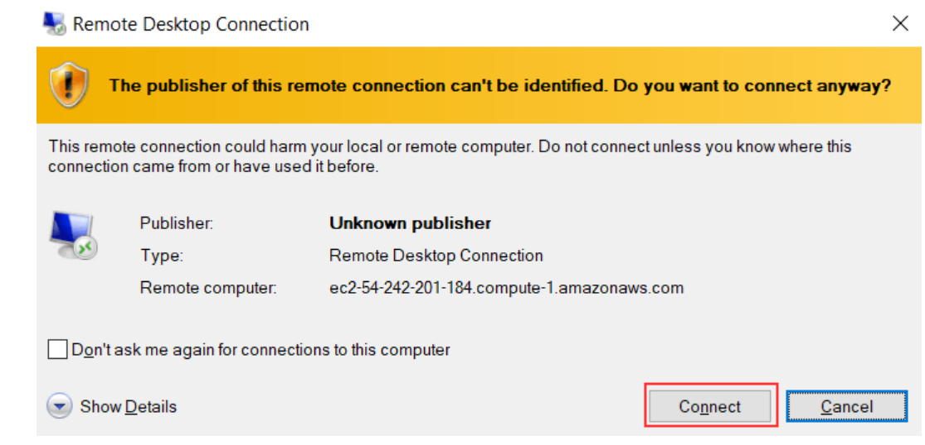

**[] password what we created**

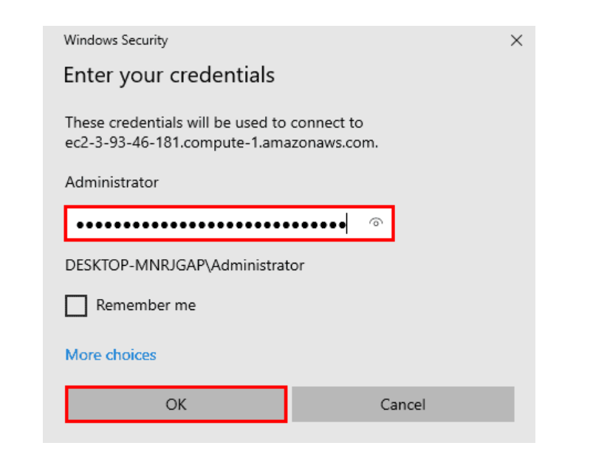

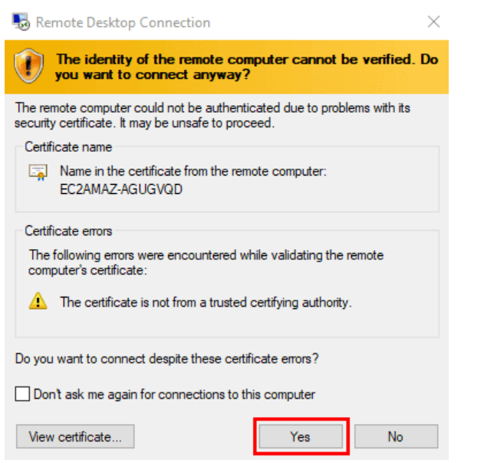

**Setup the window slave in jenkins using Launch agent by connecting it to controller**

**First we need to download java and git to windows server**

**And we need to set the path of java and git**

**To set path of git follow this https://phoenixnap.com/kb/how-to-install-git-windows**

**To set path of java https://phoenixnap.com/kb/how-to-install-git-windows**

**Windows Slaves adding:**

**[]** Open **jenkins dashboard** and select **manage jenkins** and in that select configure and select **manage nodes and add nodes**

**[] Name**: windows

**[] Description**: dfdferf rferfef

**[] No.of executors**: 1

**[] Remote Root directory**: C:\Jenkins (we will give this path after creating jenkins folder in windows server\remote server)

**[] Labels**: windowsslave (using this label we will select our node in pipeline and free style proj)

**[] Usage**: only build jobs with label expressions matching this node (select this button)

**[] Launch method**: Launch agent by connecting it to controller (select this button)

**[]** Select Use **websocket** yes in button of internal data dir.

**[]** Save

**[]** We will get **X** in nodes for the windows. Click on windows in nodes and we will get Commands.

**[]** open **jenkins dashboard** in windows server by copy the **jenkins url** and past that **url in windows chrome** we open the command and download the **agent.jar** and past that jar **folder in jenkins**

**OR**

**[]** after getting the commands past the command in windows server command prompt we well get the connection

**[]** we get the connections

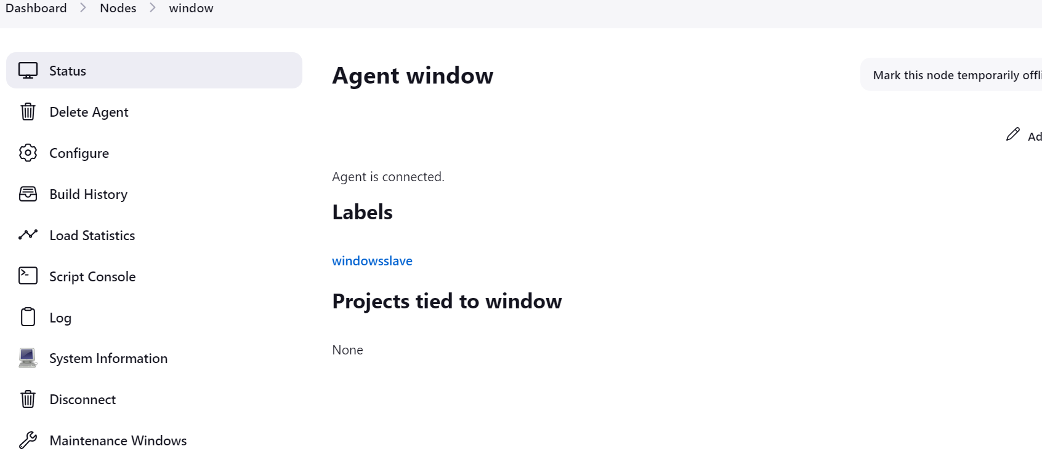

**Create Freestyle Project:**

**[]** Select **git** and give **git repo url** and **credentials**

**[]** save and build

**[]** Job build successfully to slave (windowsserver)

**[]** Check C:\jenkins\workspace

Successfully clone git to slave server

**Pipeline code :**

pipeline {

agent {label 'windowsslave'}

stages {

stage('Git checkout') {

steps {

git credentialsId: 'PATH', url: 'https://github.com/kanchana08/practice.git'

}

}

}

}

[] it clone the repo in windows C:\jenkins\worhspace

**Windows slave to custom workspace declarative pipeline:**

pipeline {

agent {

node {

label 'windowsslave'

customWorkspace 'C:/new11/new22'

}

}

stages {

stage('Git checkout') {

steps {

git credentialsId: 'PATH', url: 'https://github.com/kanchana08/practice.git'

}

}

**}**

**}**

[] it clone the repo in 'C:/new11/new22