KANCHANA.S

ICD

Human Resource General Information System (HRGIS) for Training

Specification Document

Table of Contents

Human Resource General Information System (HRGIS) for Training 0

Revision History 2

System Overview 3

User Interface List 4

Design and Specification 5

1. Training Master Control 5

2. Input Training Result 9

3. Change Course No. and Course Name 10

4. Input Training Result by Group 10

5. Register Trainee 10

6. Training Confirmation Sheet 10

7. ใบเซ็นชื่อ 11

8. Training Result Report 14

9. Current Manpower Report 15

10. Score of trainee 15

11. แบบประเมิน Course 15

12. แบบประเมิน Trainee ตามรายชื่อ 15

13. แบบประเมิน Trainer 15

14. Employee Data Report 15

15. Couse Detail and Number of Employee Report 15

16. Assy Skill Map 15

17. Education of Employee Report 15

18. Promotion Report 15

19. Target Group of Training 15

# Revision History

|  |  |  |  |
| --- | --- | --- | --- |
| Date | Author | Description | Approve by |
| 29-Nov-21 | KANCHANA.S | Initial create |  |
|  |  |  |  |
|  |  |  |  |
|  |  |  |  |

# System Overview

**USER**

**CPTSVS52T**

Api

**CPTSVS52T/SQLEXPRESS**

**HRGIS**

Database

**CPTSVS52T**

Web Interface

# User Interface List

|  |  |  |  |  |  |  |
| --- | --- | --- | --- | --- | --- | --- |
| **No.** | **Page and functions** | **Result** | **Notes** | **Confirm date** | **Confirm by** | **Dept** |
| **1** | **Training Master Control** |  |  |  |  |  |
| 1.1 | Program startup |  |  | 10-Nov-21 | Wanpen | MTP |
| 1.2 | Create course |  |  |  |  |  |
| 1.3 | Search course |  |  |  |  |  |
| 1.4 | Edit course |  |  |  |  |  |
| 1.5 | Delete course |  |  |  |  |  |
| **2** | **Input Training Result** |  |  |  |  |  |
| 2.1 | Input training result of trainee |  |  |  |  |  |
| 2.2 | Register trainee |  |  |  |  |  |
| **3** | **Change Course No. and Course Name** |  |  |  |  |  |
| 3.1 |  |  |  |  |  |  |
| **4** | **Input Training Result by Group** |  |  |  |  |  |
| 4.1 |  |  |  |  |  |  |
| **5** | **Register Trainee** |  |  |  |  |  |
| 5.1 |  |  |  |  |  |  |
| **6** | **Training Confirmation Sheet** |  |  |  |  |  |
| 6.1 |  |  |  |  |  |  |
| 6.2 |  |  |  |  |  |  |
| **7** | **ใบเซ็นชื่อ** |  |  |  |  |  |
| 7.1 | Program startup: Show input for filter by Course No. (exact match) |  |  |  |  |  |
| 7.2 | Create PDF report as image filter by Course No. |  |  |  |  |  |
| **8** | **Training Result Report** |  |  |  |  |  |
| 8.1 |  |  |  |  |  |  |
| 8.2 |  |  |  |  |  |  |

# 

# Design and Specification

## Training Master Control

### Objective

To manage master course

### Screen

Old

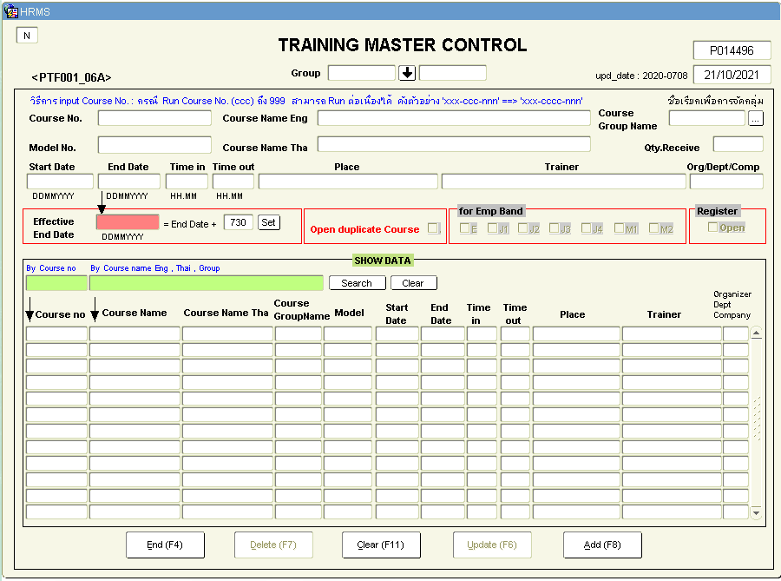

New

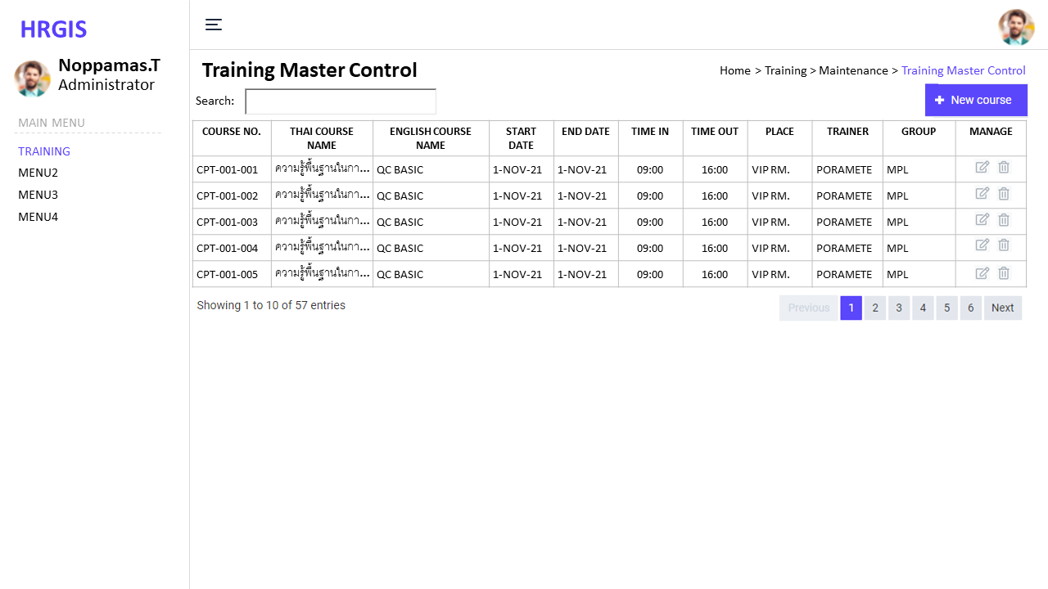<screen1>

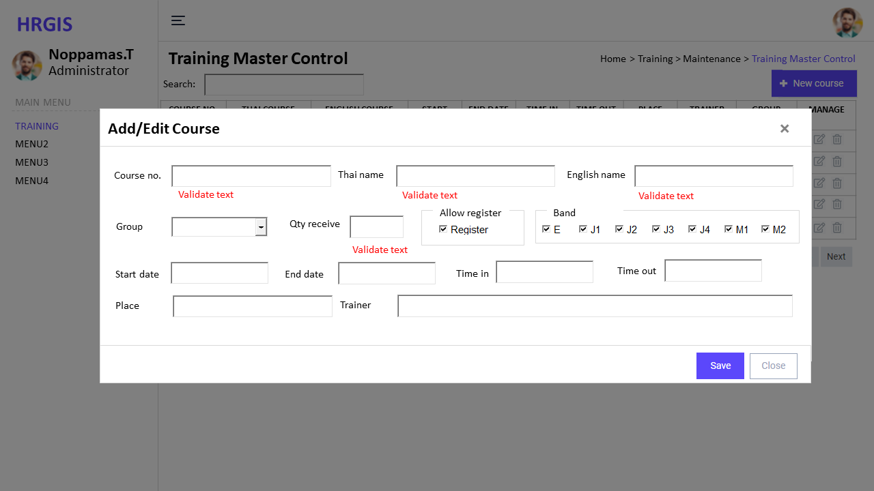<screen2>

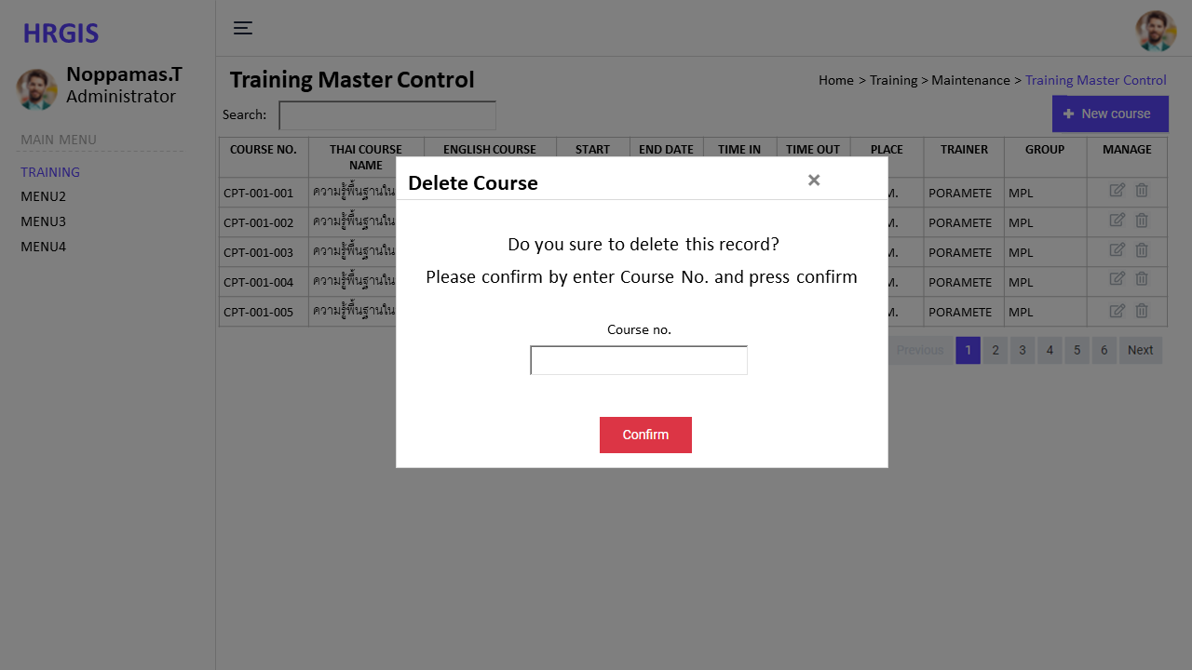<screen3>

### Database Item

|  |  |  |  |  |
| --- | --- | --- | --- | --- |
| **No.** | **Items** | **Table and field** | **Validate** | **Remark** |
| 1 | Course no. | tr_course.course_no | Required | PK |
| 2 | Thai course name | tr_course.course_name_th | Required |  |
| 3 | English course name | tr_course.course_name_en | Required |  |
| 4 | Group | tb_org.div_abbr, tb_org.dept_abbr | Required | FK, on delete no action, on update cascade |
| 5 | Qty receive | tr_course.qty | Integer |  |
| 6 | Allow register | tr_course.allow_register | Y, null |  |
| 7 | Start date | tr_course.start_date | Required, Date |  |
| 8 | End date | tr_course.end_date | Required, Date |  |
| 9 | Time in | tr_course.time_in | Required, Time |  |
| 10 | Time out | tr_course.time_out | Required, Time |  |
| 11 | Place | tr_course.place | Required |  |
| 12 | Trainer | tr_course.trainer | Required |  |
| 13 | Created at | tr_course.created_at | DateTime |  |
| 14 | Created by | tr_course.created_by | String |  |
| 15 | Updated at | tr_course.updated_at | Datetime |  |
| 16 | Updated by | tr_course.updated_by | String |  |
| 17 | Course no. | tr_course_band.course_no | Required | FK, on delete cascade, on update cascade |
| 18 | Band | tr_course_band.band | Required |  |

### Process

1. Create course: on click new course button
   * Input data and validate
   * Insert data to database
2. Search course and show data: on key up search field
   * Input data
   * Search when key up filter by input
   * Show data sort by date desc, sortable
3. Edit course: on click edit icon of each record
   * Input data and validate
   * Update data to database
4. Delete course: on click delete icon of each record
   * Show modal to confirm
   * Input Course no. to confirm
   * Delete from database

## Input Training Result

### Objective

To input trainee result and register more trainee

### Screen

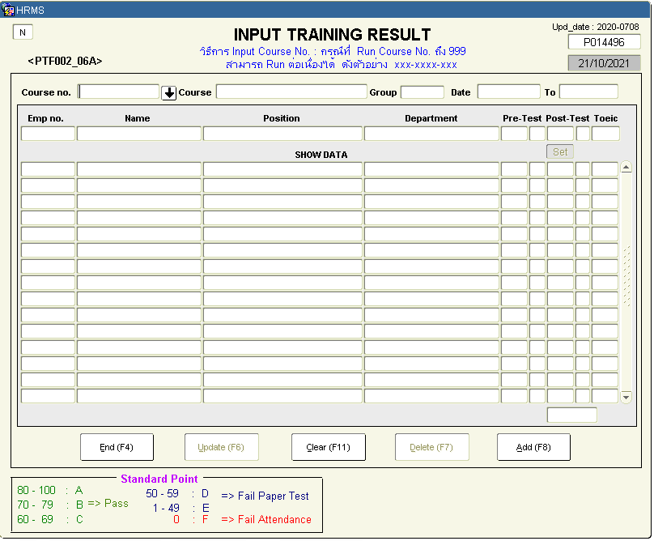Old

New

### Database Item

### Process

1. Input training result of trainee

* Select course
* Show course data
* Show approved trainee
* Input pre-test score
* Automatic calculate pre-test grade
* Input post-test score
* Automatic calculate post-test grade
* Create excel format to input score multiple trainee
* Import excel to update score
* Update score
* Refresh data after update

1. Register trainee

* Register approved trainee from paper
* Create textarea to paste multiple employee no. to register
* Register trainee

## Change Course No. and Course Name

### Objective

### Screen

### Database Item

### Process

## Input Training Result by Group

### Objective

### Screen

### Database Item

### Process

## Register Trainee

### Objective

### Screen

### Database Item

### Process

## Training Confirmation Sheet

### Objective

### Screen

### Database Item

### Process

## ใบเซ็นชื่อ

### Objective

To create report for request signature

### Screen

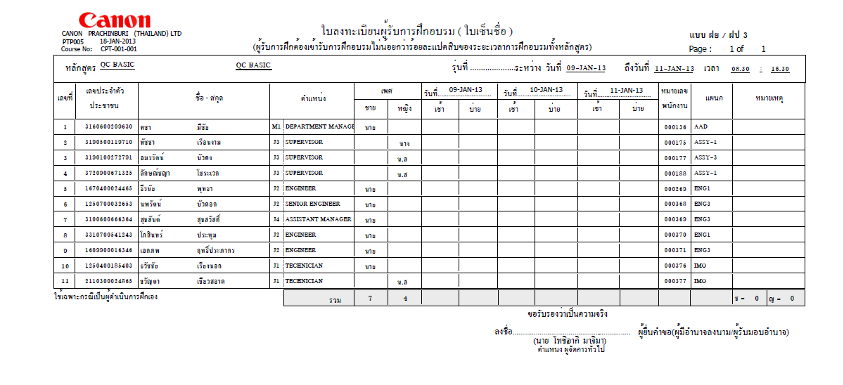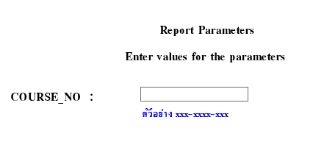Old

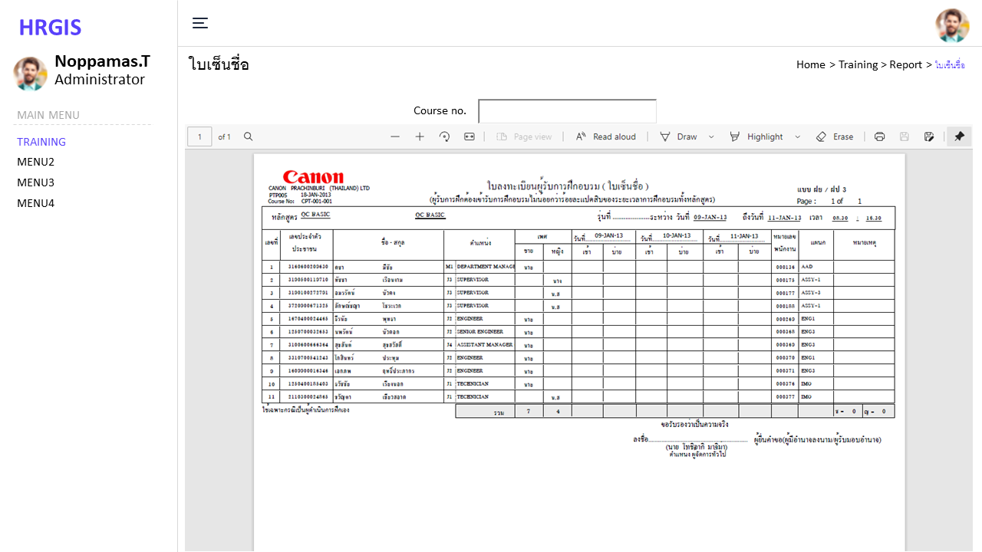New

### Database Item

|  |  |  |  |  |
| --- | --- | --- | --- | --- |
| **No.** | **Items** | **Table and field** | **Validate** | **Remark** |
| 1 | Course no. | tr_course.course_no |  |  |
| 2 | Thai course name | tr_course.course_name_th |  |  |
| 3 | English course name | tr_course.course_name_en |  |  |
| 4 | Start date | tr_course.start_date |  |  |
| 5 | End date | tr_course.end_date |  |  |
| 6 | Time in | tr_course.time_in |  |  |
| 7 | Time out | tr_course.time_out |  |  |
| 8 | Course no. | tr_course_trainee.course_no |  |  |
| 9 | เลขประจำตัวประชาชน | employee.ID_NO |  |  |
| 10 | ชื่อ สกุล | employee.FNAME_THA,  employee.GNAME_THA |  |  |
| 11 | Band | employee.BAND |  |  |
| 12 | ตำแหน่ง | employee.POSN_ENAME |  |  |
| 13 | เพศ | employee.SEX |  |  |
| 14 | หมายเลขพนักงาน | employee.EMP_NO |  |  |
| 15 | แผนก | employee.DEPT_ABB_NAME |  |  |

### Process

* + 1. Program startup: Show input for filter by Course No. (exact match)
    2. Create PDF report as image filter by Course No.
       1. ถ้าเกิน 3 วันให้ ออกแบบไม่ต้องใส่วันที่
       2. 25 คน/หน้า
       3. เปลี่ยนชื่อในใบเซ็นชื่อ

## Training Result Report

### Objective

### Screen

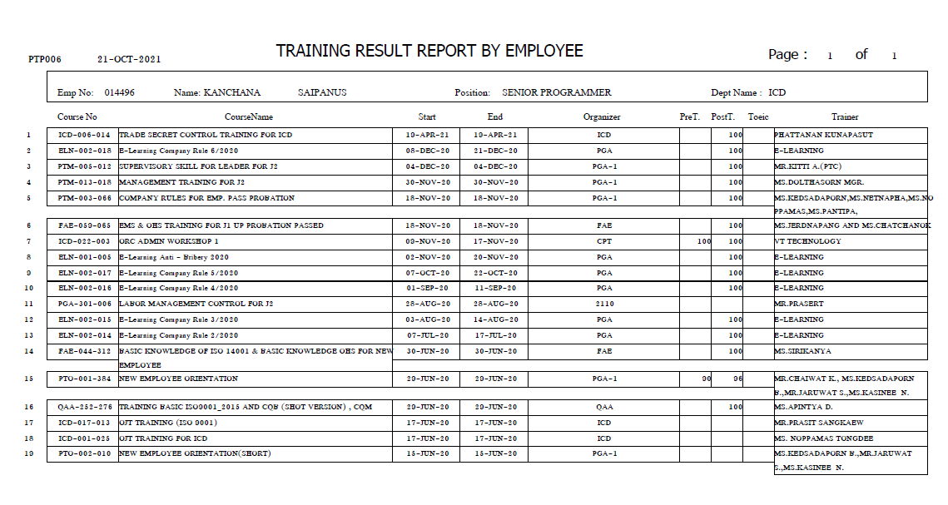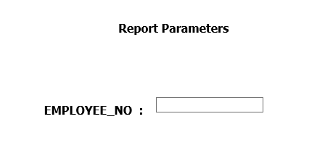Old

New

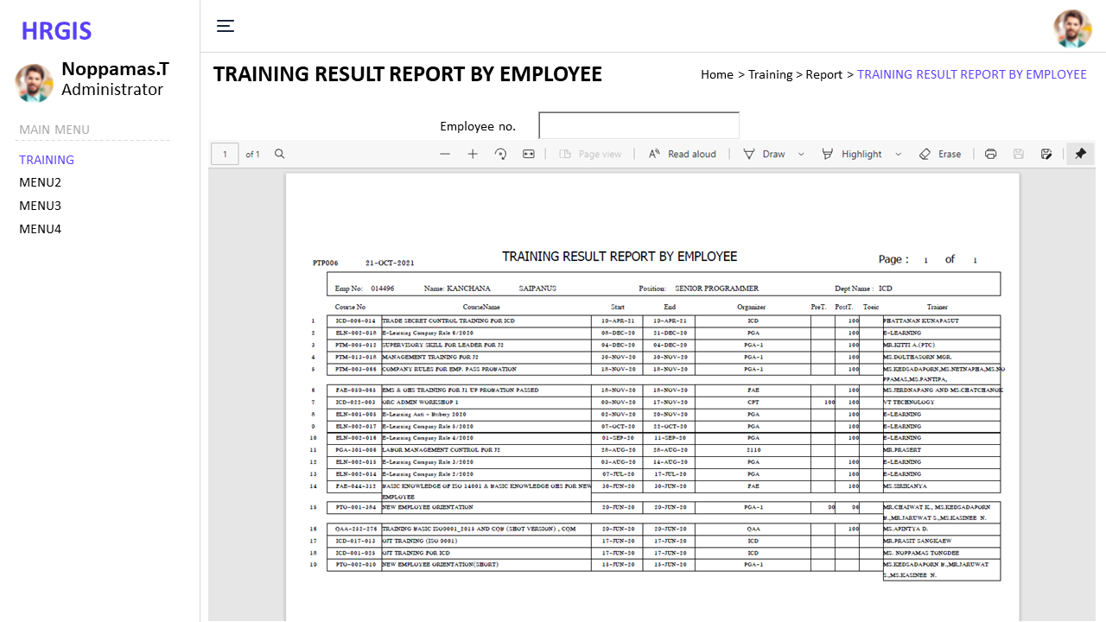

### Database Item

### Process

## Current Manpower Report

### Objective

### Screen

### Database Item

### Process

## Score of trainee

### Objective

### Screen

### Database Item

### Process

## แบบประเมิน Course

### Objective

### Screen

### Database Item

### Process

## แบบประเมิน Trainee ตามรายชื่อ

### Objective

### Screen

### Database Item

### Process

## แบบประเมิน Trainer

### Objective

### Screen

### Database Item

### Process

## Employee Data Report

### Objective

### Screen

### Database Item

### Process

## Couse Detail and Number of Employee Report

### Objective

### Screen

### Database Item

### Process

## Assy Skill Map

### Objective

### Screen

### Database Item

### Process

## Education of Employee Report

### Objective

### Screen

### Database Item

### Process

## Promotion Report

### Objective

### Screen

### Database Item

### Process

## Target Group of Training

### Objective

To show target group of course

### Screen

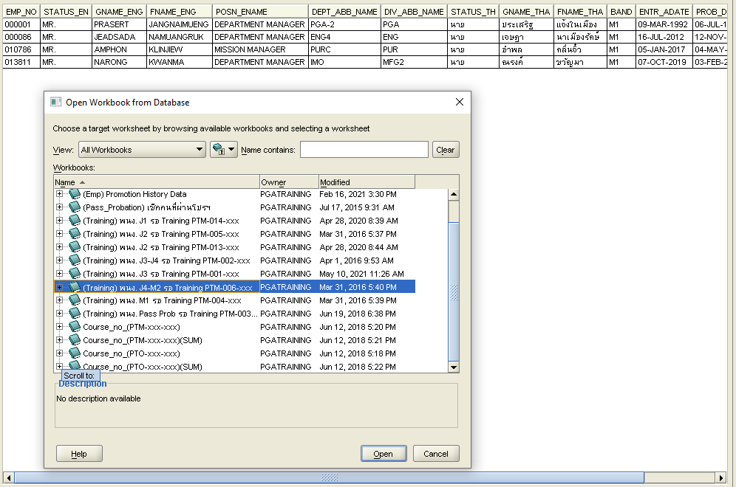Old

New

### Database Item

EMP_NO STATUS_EN GNAME_ENG FNAME_ENG POSN_ENAME DEPT_ABB_NAME DIV_ABB_NAME STATUS_TH GNAME_THA FNAME_THA BAND ENTR_ADATE PROB_DATE PROB_STATUS

### Process

1. Input course no.
2. Show employee data in target group pf course