KANCHANA.S

ICD

Human Resource General Information System (HRGIS) for Training

Specification Document

Table of Contents

[Human Resource General Information System (HRGIS) for Training 0](https://d.docs.live.net/6bf761fba7e921ad/HR/Example_Specification_Document.docx#_Toc87396255)

Revision History 2

System Overview 3

User Interface List 4

Design and Specification 5

1. Training Master Control 5

2. Input Training Result 9

3. Change Course No. and Course Name 11

4. Input Training Result by Group 11

5. Register Trainee 11

6. Training Confirmation Sheet 11

7. ใบเซ็นชื่อ 12

8. Training Result Report 15

9. Current Manpower Report 16

10. Score of trainee 16

11. แบบประเมิน Course 17

12. แบบประเมิน Trainee ตามรายชื่อ 17

13. แบบประเมิน Trainer 17

14. Employee Data Report 17

15. Couse Detail and Number of Employee Report 17

16. Assy Skill Map 17

17. Education of Employee Report 18

18. Promotion Report 18

19. Target Group of Training 19

# Revision History

|  |  |  |  |
| --- | --- | --- | --- |
| Date | Author | Description | Approve by |
| 29-Nov-21 | KANCHANA.S | Initial create |  |
|  |  |  |  |
|  |  |  |  |
|  |  |  |  |

# System Overview

**USER**

**CPTSVS52T**

Api

**CPTSVS52T/SQLEXPRESS**

**HRGIS**

Database

**CPTSVS52T**

Web Interface

# User Interface List

|  |  |  |  |  |  |  |
| --- | --- | --- | --- | --- | --- | --- |
| **No.** | **Page and functions** | **Result** | **Notes** | **Confirm date** | **Confirm by** | **Dept** |
| **1** | **Training Master Control** |  |  |  |  |  |
| 1.1 | Search course and show data |  |  | 10-Nov-21 | Wanpen | MTP |
| 1.2 | Create course |  |  |  |  |  |
| 1.3 | Edit course |  |  |  |  |  |
| 1.4 | Delete course |  |  |  |  |  |
| 1.5 | Add more filter |  |  |  |  |  |
| 1.7 | Make excel report |  |  |  |  |  |
| **2** | **Input Training Result** |  |  |  |  |  |
| 2.1 | Search + show course data by Course no. |  |  |  |  |  |
| 2.2 | Show trainee data by course |  |  |  |  |  |
| 2.3 | Register trainee |  |  |  |  |  |
| 2.4 | Edit pre-test, post-test score on Web |  |  |  |  |  |
| 2.5 | Import excel score |  |  |  |  |  |
| 2.6 | Delete trainee |  |  |  |  |  |
| **3** | **Input Training Result by Group** |  |  |  |  |  |
| 3.1 | Show form + Create course |  |  |  |  |  |
| 3.2 | Input employee no. start and end, pre-test, post-test to register and input score of trainee |  |  |  |  |  |
| 3.3 | Show result of register |  |  |  |  |  |
| **4** | **Register Trainee** |  |  |  |  |  |
| 4.1 | Search + show course data by Course no. |  |  |  |  |  |
| 4.2 |  |  |  |  |  |  |
| 4.3 |  |  |  |  |  |  |
| 4.4 |  |  |  |  |  |  |
| 4.5 |  |  |  |  |  |  |
| 4.6 |  |  |  |  |  |  |
| 4.7 |  |  |  |  |  |  |
| **No.** | **Page and functions** | **Result** | **Notes** | **Confirm date** | **Confirm by** | **Dept** |
| 4.8 |  |  |  |  |  |  |
| **5** | **Training Confirmation Sheet** |  |  |  |  |  |
| 5.1 |  |  |  |  |  |  |
| 5.2 |  |  |  |  |  |  |

# Design and Specification

## Training Master Control

### Objective

To manage master course

### Screen

Old

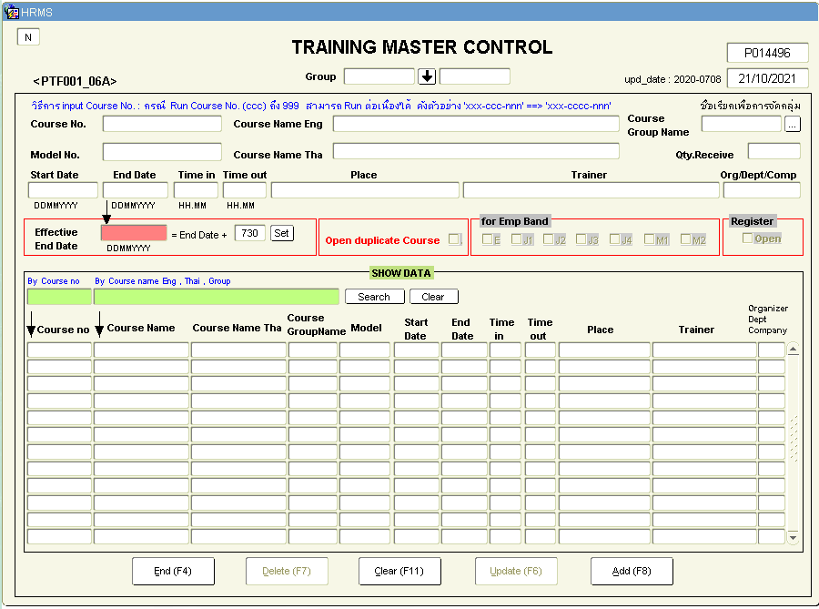

New

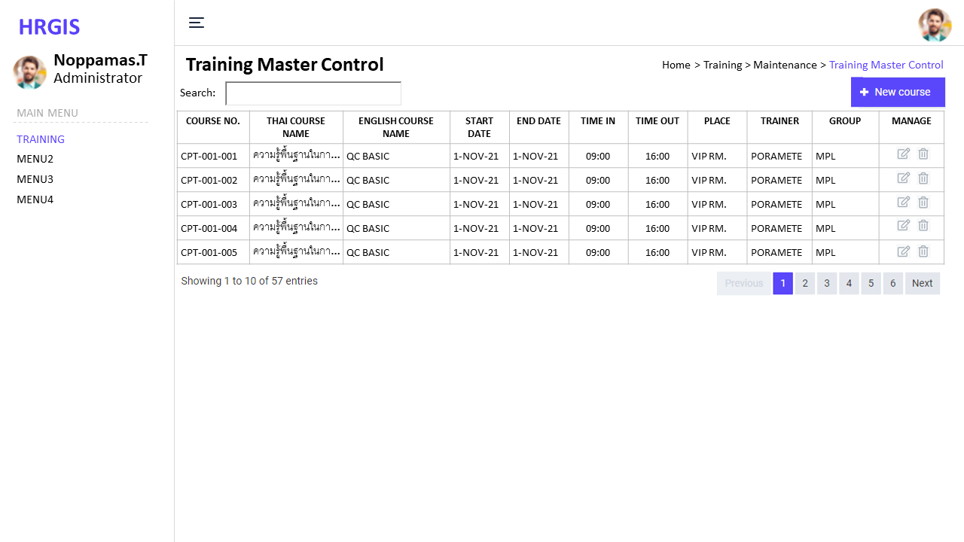<screen1>

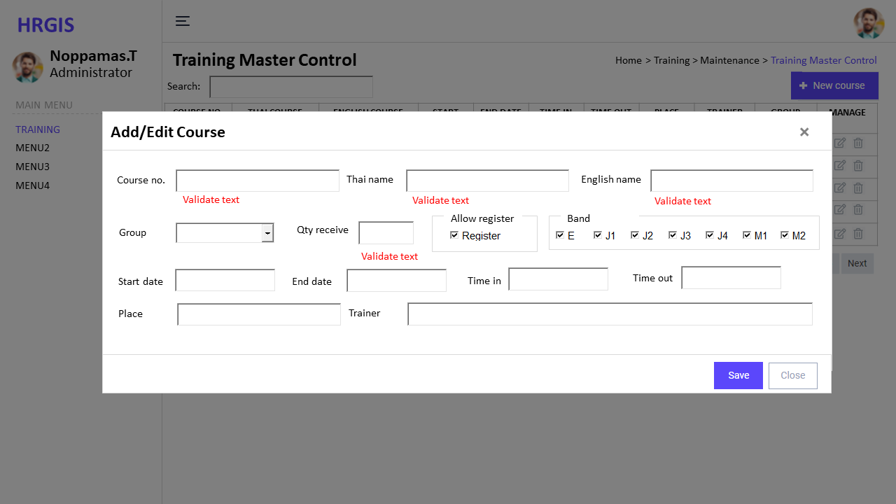<screen2>

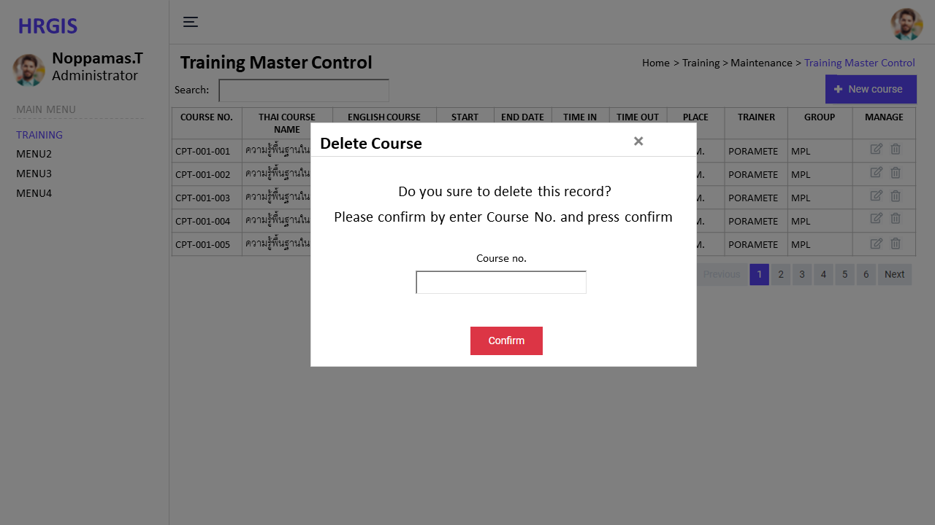<screen3>

### Database Item

|  |  |  |  |  |
| --- | --- | --- | --- | --- |
| **No.** | **Items** | **Table and field** | **Validate** | **Remark** |
| 1 | Course no. | tr_course.course_no | Required | PK |
| 2 | Thai course name | tr_course.course_name_th | Required |  |
| 3 | English course name | tr_course.course_name_en | Required |  |
| 4 | Group | tb_org.div_abbr, tb_org.dept_abbr | Required | FK, on delete no action, on update cascade |
| 5 | Qty receive | tr_course.qty | Integer |  |
| 6 | Allow register | tr_course.allow_register | Y, null |  |
| 7 | Start date | tr_course.start_date | Required, Date |  |
| 8 | End date | tr_course.end_date | Required, Date |  |
| 9 | Time in | tr_course.time_in | Required, Time |  |
| 10 | Time out | tr_course.time_out | Required, Time |  |
| 11 | Place | tr_course.place | Required |  |
| 12 | Trainer | tr_course.trainer | Required |  |
| 13 | Created at | tr_course.created_at | DateTime |  |
| 14 | Created by | tr_course.created_by | String |  |
| 15 | Updated at | tr_course.updated_at | Datetime |  |
| 16 | Updated by | tr_course.updated_by | String |  |
| 17 | Course no. | tr_course_band.course_no | Required | FK, on delete cascade, on update cascade |
| 18 | Band | tr_course_band.band | Required |  |

### Process

1. Search course and show data (on load and on key up search field)
   * Input data
   * Search when key up filter by input
   * Show data sort by date desc, sortable
2. Create course (on click new course button)
   * Input data and validate
   * Insert data to database
3. Edit course (on click edit icon of each record)
   * Input data and validate
   * Update data to database
4. Delete course (on click delete icon of each record)
   * Show modal to confirm
   * Input Course no. to confirm
   * Delete from database
5. Add more filter
6. Make excel report

## Input Training Result and Register

### Objective

To input trainee result and register more trainee

### Screen

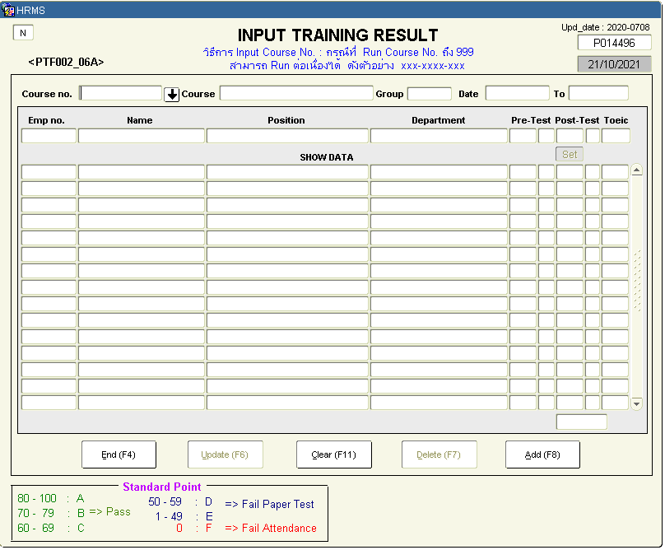Old

New

### Database Item

### Process

1. Search + show course data by Course no.
2. Show trainee data by course
3. Register trainee
4. Edit pre-test, post-test score on Web
5. Import excel score
6. Delete trainee

## Input Training Result by Group

### Objective

### Screen

### Database Item

### Process

* + 1. Show form + Create course
    2. Input employee no. start and end, pre-test, post-test to register and input score of trainee
    3. Show result of register

## Register Trainee

### Objective

### Screen

### Database Item

### Process

1. Search + show course data by Course no.
2. Input employee no. to register in course
3. Check count(trainee) > cap after enter employee no.
4. If success show employee data after enter employee no.
5. If not success show waiting list and sequence
6. Manager approve employee own dept
7. Center view data, program show data and count data
8. Center approve all CPT

## Training Confirmation Sheet

### Objective

### Screen

### Database Item

### Process

1. Search + show course data by Course no.
2. Show all trainee and data
3. Make excel
4. Make PDF report

## ใบเซ็นชื่อ

### Objective

To create report for request signature

### Screen

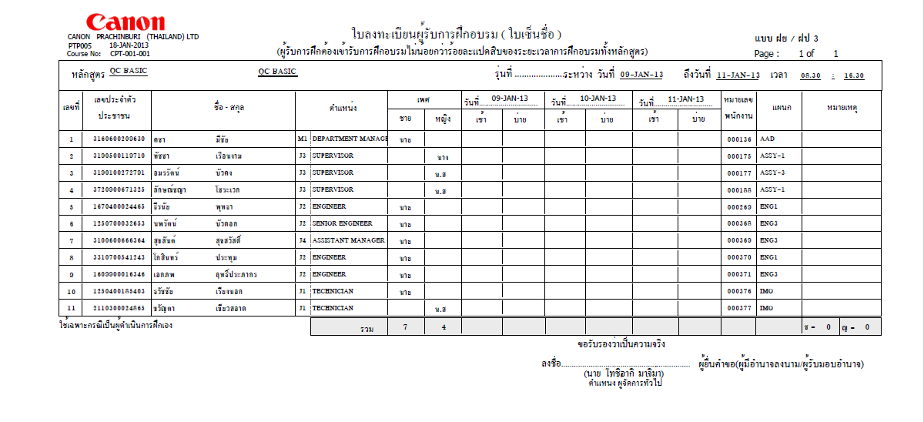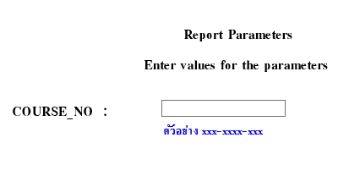Old

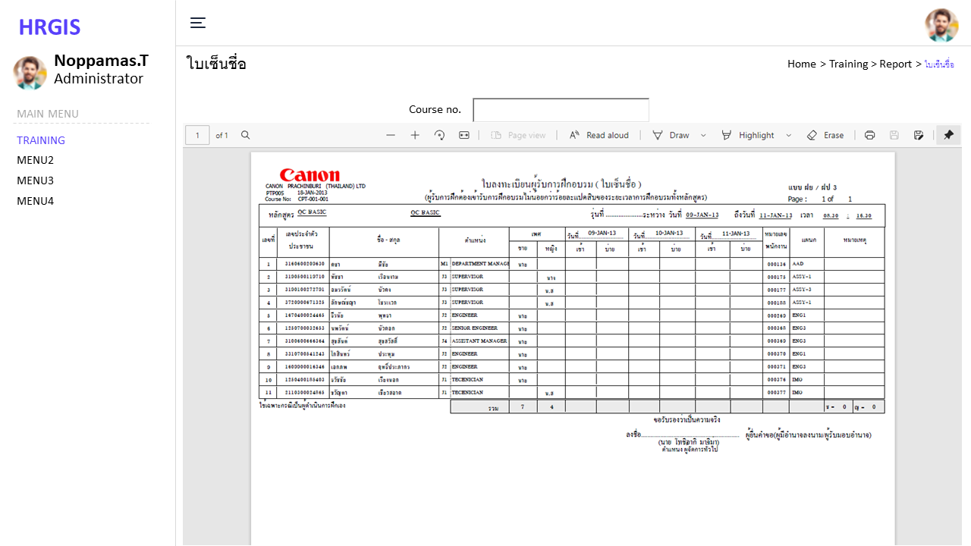New

### Database Item

|  |  |  |  |  |
| --- | --- | --- | --- | --- |
| **No.** | **Items** | **Table and field** | **Validate** | **Remark** |
| 1 | Course no. | tr_course.course_no |  |  |
| 2 | Thai course name | tr_course.course_name_th |  |  |
| 3 | English course name | tr_course.course_name_en |  |  |
| 4 | Start date | tr_course.start_date |  |  |
| 5 | End date | tr_course.end_date |  |  |
| 6 | Time in | tr_course.time_in |  |  |
| 7 | Time out | tr_course.time_out |  |  |
| 8 | Course no. | tr_course_trainee.course_no |  |  |
| 9 | เลขประจำตัวประชาชน | employee.ID_NO |  |  |
| 10 | ชื่อ สกุล | employee.FNAME_THA,  employee.GNAME_THA |  |  |
| 11 | Band | employee.BAND |  |  |
| 12 | ตำแหน่ง | employee.POSN_ENAME |  |  |
| 13 | เพศ | employee.SEX |  |  |
| 14 | หมายเลขพนักงาน | employee.EMP_NO |  |  |
| 15 | แผนก | employee.DEPT_ABB_NAME |  |  |

### Process

1. Program startup: Show input for filter by Course No. (exact match)
2. Create PDF report as image filter by Course No.

* ขนาด A4 แนวนอน
* ถ้าเกิน 3 วันให้ ออกแบบไม่ต้องใส่วันที่
* 25 คน/หน้า
* เปลี่ยนชื่อในใบเซ็นชื่อ

## Training Result Report

### Objective

### Screen

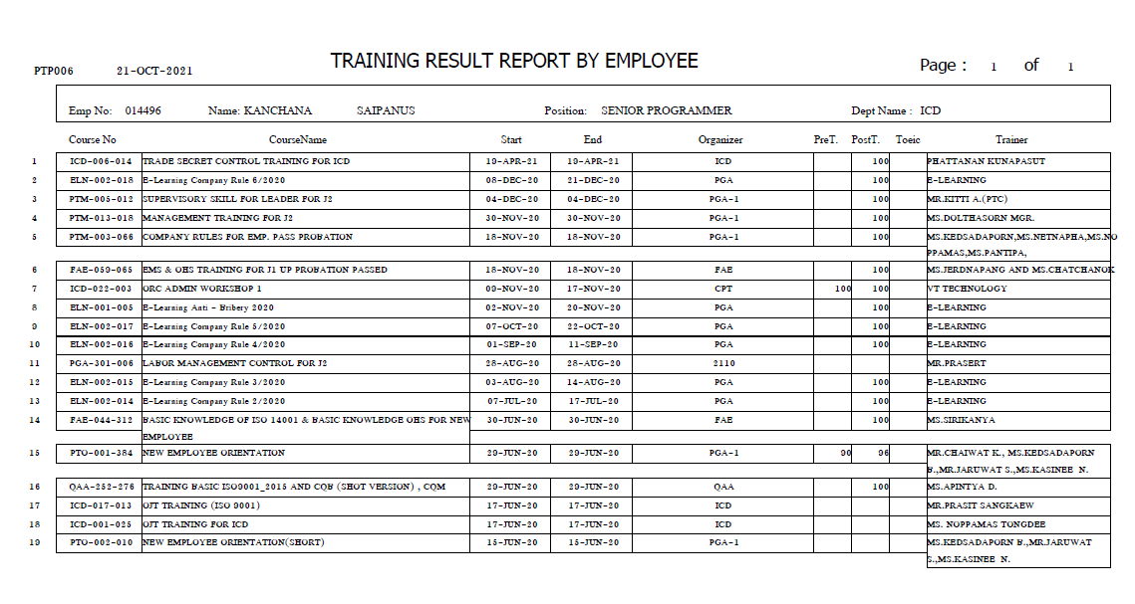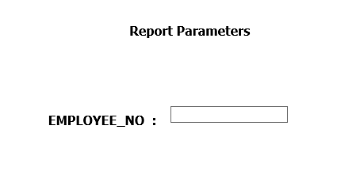Old

New

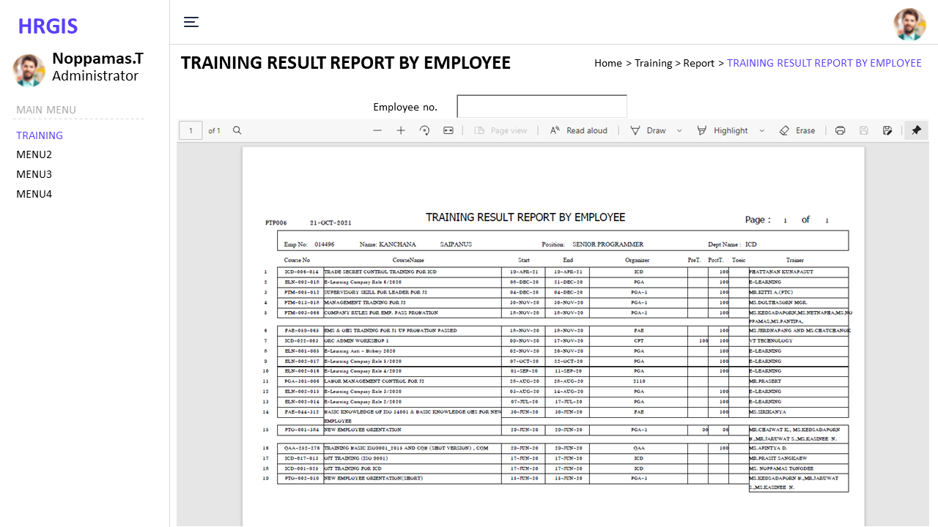

### Database Item

### Process

1. Parameter employee no.
2. Make PDF report
3. Export excel

## Current Manpower Report

### Objective

### Screen

### Database Item

### Process

1. Parameter date start and date end
2. Make PDF report

## Employee Data

### Objective

### Screen

### Database Item

### Process

1. Parameter course no.
2. Show employee data
3. Make Excel

## Employee Data Own Department

### Objective

### Screen

### Database Item

### Process

1. Parameter course no.
2. Show employee data
3. Make Excel

## Couse Detail and Number of Employee Report

### Objective

### Screen

### Database Item

### Process

1. Parameter course no.
2. Show count
3. Make Excel

## Assy Skill Map

### Objective

### Screen

### Database Item

### Process

1. Show table header is course no.: course English name
2. Export excel

## Education of Employee Report

### Objective

### Screen

### Database Item

### Process

1. Parameter employee data
2. Show employee data
3. Make Excel

## Promotion Report

### Objective

### Screen

### Database Item

### Process

1. Parameter employee data
2. Show employee data
3. Make Excel

## Target Group of Training

### Objective

To show target group of course

### Screen

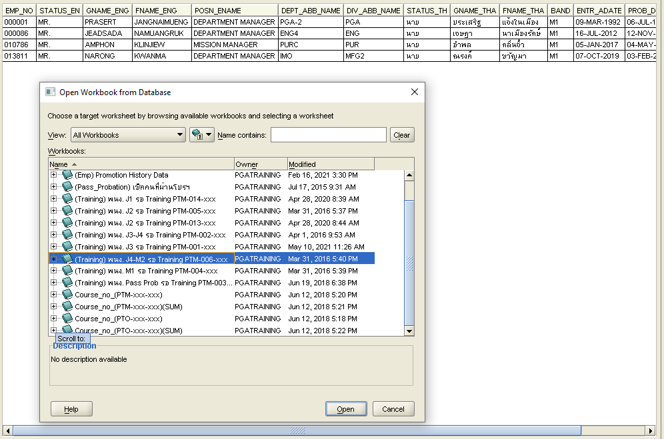Old

New

### Database Item

EMP_NO STATUS_EN GNAME_ENG FNAME_ENG POSN_ENAME DEPT_ABB_NAME DIV_ABB_NAME STATUS_TH GNAME_THA FNAME_THA BAND ENTR_ADATE PROB_DATE PROB_STATUS

### Process

1. Input course no.
2. Show employee data in target group pf course
3. Make Excel