 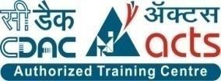

INSTITUTE FOR ADVANCED COMPUTING AND SOFTWARE DEVELOPMENT AKURDI, PUNE

**Documentation On**

**“ONLINE HOME SERVICES”**

PG-DAC MARCH 2022

**Submitted By**

Group No.24

**Names & Roll Numbers**

Ms. Barwade Kanchanmala R. 223033

Mr. Puri Kamaksha V. 223160

Mr. Prashant KarhaleMs. Megha Pawar

**Centre Coordinator Project Guide**

# Table of Contents

1. Introduction 1

Document Purpose 2

Problem Statement 2

Product Scope 2

Aim & Objectives 2

1. Overall Description 3

Product Perspective 3

Benefits of Society Management System 3

User and Characteristics 3

Operating Environment 3

Design and Implementation Constraints 3

1. Requirements Specification 4

External Interface Requirements 4

Non-Functional Requirements 12

1. System Diagram 11

Activity Diagram 11

Data Flow Diagram 13

Class Diagram 15

Use Case Diagram 16

ER Diagram 16

1. Table Structure 17

Flat owners 17

Notices 17

Complaints 17

Visitors 18

Bill 18

Workers 18

1. Conclusion 19

Future Scope 19

1. References 20

**List of Figures**

Figure 1 Admin Activity Diagram 11

Figure 2 Flat Owner Activity Diagram 12

Figure 3 Watchman Activity Diagram 12

Figure 4 Level 0 Data Flow Diagram 13

Figure 5 Level 1 Data Flow Diagram 13

Figure 6 Level 2 Data Flow Diagram for Admin 14

Figure 7 Level 2 Data Flow Diagram for Flat Owner 14

Figure 8 Level 2 Data Flow Diagram for Watchman 15

Figure 9 Class Diagram 15

Figure 10 Use Case Diagram 16

Figure 11 ER Diagram 16

# Introduction

Generally in houses we require so many different services like painting houses, housekeeping, gardening etc. For all above services previously we need to go to service provider and they will charge according to their own standard and in that business there is no transparency and no customer satisfaction. For this our Online Home Services is the best solution.

Online Home Services (OHS) is intended to provide solutions for customer using a single path named Internet. It will allow the admin to share the details that are required to customer and the customer can receive it from the same platform. An administrator plays an important role by making a service available for the customer and maintain the records.

## Document Purpose

It **guides to understand the project context & expectations**. Also, it helps to lay down a project plan to achieve deliverables. In fact, this document sets a direction for project manager and project team to sail through a project life cycle.

This document contains the complete software requirements for Online Home Services and describe the design decisions, architectural design needed to implement the system. It provides the visibility in design and provide information needed for software support. Its new, reliable and fast home services which helps for finding solution on daily need of home services.

Online Home Services:

Online Home Services to buy daily home services from website. There are two Users, Admin and Customer. Admin will perform add, update, delete operations for data with respect to services & employee, Customer will register and they will buy services from available services in their area.

## Problem Statement

Existing houses customer require so many different services like painting houses, housekeeping, gardening etc. For all above services previously physically customer need to go and search for best service provider and it was very hard to find, they will charge according to their own standard and in that business there is no transparency and no customer satisfaction. For this our Online Home Services is the best solution.

## Product Scope

Reach to maximum users and get them used to application as there are many ongoing problems with the home services.

As everything in the world is taking one step forward towards the technology there is need to make people get used to these services and make the application simple so that it would be useful for any person.

Make the project ready on platform for users as early as possible.

Once it reaches audience, services should be increased to solve minor to minor problems.

## Aims & Objectives

Specific goals are: -

* To produce a web-based system that allows the admin to add employee & services and provide functionalities.
* To ease customers by purchasing different services.

# Overall Description

## Product Perspective:

Existing system function:

Existing system for a service provider is based on our traditional way keeping records and details on paper and registers. Access of these details and papers are not granted to common member in absence of the authority. Existing houses customer require so many different services like painting houses, housekeeping, gardening etc. For all above services previously physically customer need to go and search for best service provider and it was very hard to find, they will charge according to their own standard and in that business there is no transparency and no customer satisfaction. For this our Online Home Services is the best solution.

PROPOSED SYSTEM

Product functionality:

Online Home Services provides the features for admin and customer. It includes several functionalities describes as below:

Service Management*:*

It provides facility to add, update, delete and view the services. Admin can view their details also update it if that particular services are pending or completed.

Employee Management:

The admin can add, update, delete and view the employee and there status.

Service Order:

Customer can place the service order on the basis of their requirement, view status of service order.

Benefits of Online Home Services

* This Online Home Services is fully functional and flexible.
* It is very easy to use.
* It saves a lot of time, money and labor.
* Eco-friendly: The monitoring of the Online Home Services and the overall business becomes easy and includes the least of paper work.
* The application acts as an office that is open 24/7.
* It increases the efficiency of the management at offering quality services to the customers.
* It provides custom features development and support with the application.

Users and Characteristics:

Admin:

* Admin can login to the system.
* View the list of all employees.
* View the list of all services.
* View the list of all orders.
* Add new Employee.
* Delete Employee.
* Update Employee.
* Add new Service.
* Update Service.
* Delete Service.
* Change the status of order.

Customer:

* + Customer can login to the system.
  + View his/her details.
  + Purchase service.
  + View his/her order.
  + Update their personal credentials.

## Operating Environment:

Server Side:

**Processor:** Intel® Xeon® processor 3500 series

**HDD:** Minimum 500GB Disk Space

**RAM:** Minimum 2GB **OS:** Windows 7 & above **Database:** MySQL 8.0

Client Side (minimum requirement):

**Processor:** Intel Dual Core

**HDD:** Minimum 80GB Disk Space

**RAM:** Minimum 1GB

**OS:** Windows 7 & above

## Design and Implementation Constraints:

* The application will use Ajax, JavaScript, jQuery and css as main web technologies.
* HTTP and FTP protocols are used as communication protocols. FTP is used to upload the web application in live domain and the client can access it via HTTP protocol.
* Several types of validations make this web application a secured one and SQL Injections can also be prevented.
* Since Online Home Services is a web-based application, internet connection must be established.
* The Online Home Services will be used on PCs and will function via internet or intranet in any web browser.

# Specific Requirement

## External Interface Requirements:

User Interfaces:

* + All the users will see the same page when they enter in this website. This page asks the users a username and a password.
  + After being authenticated by correct username and password, user will be redirect to home page where they can search for various services.
  + The user interface will be simple and consistence, using terminology commonly understood by intended users of the system. The system will have simple interface, consistence with standard interface, to eliminate need for user training of infrequent users.

Hardware Interfaces:

* + No extra hardware interfaces are needed.
  + The system will use the standard hardware and data communication resources.
  + This includes, but not limited to, general network connection at the server/hosting site, network server and network management tools.

Application Interfaces:

**OS:** Windows 7& above

**Web Browser:**

The system is a web-based application; clients need a modern web browser such as Mozilla Firebox, Internet Explorer, Opera, and Chrome. The computer must have an Internet connection in order to be able to access the system.

Communications Interfaces:

* + This system uses communication resources which includes but not limited to, HTTP protocol for communication with the web browser and web server and TCP/IP network protocol with HTTP protocol.
  + This application will communicate with the database that holds all the booking information. Users can contact with server side through HTTP protocol by means of a function that is called HTTP Service. This function allows the application to use the data retrieved by server to fulfill the request fired by the user.

# System Design

## Activity Diagram

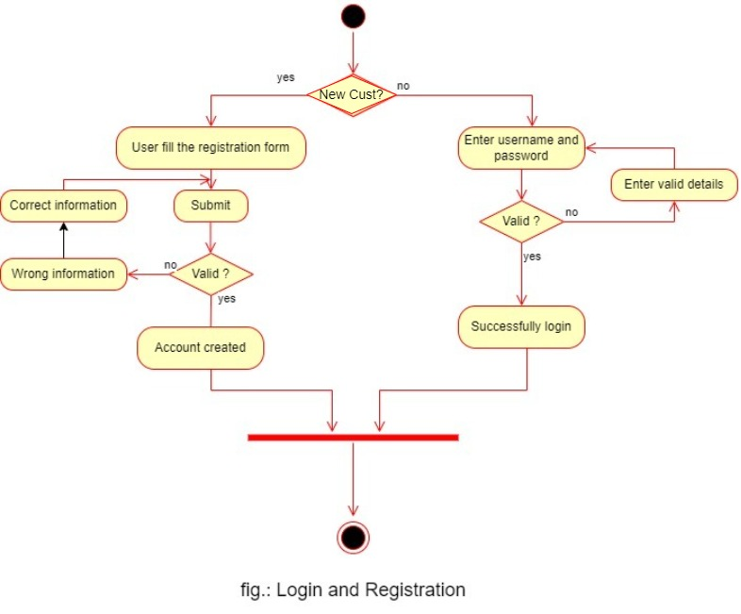

**Figure 1: Login and Registration**

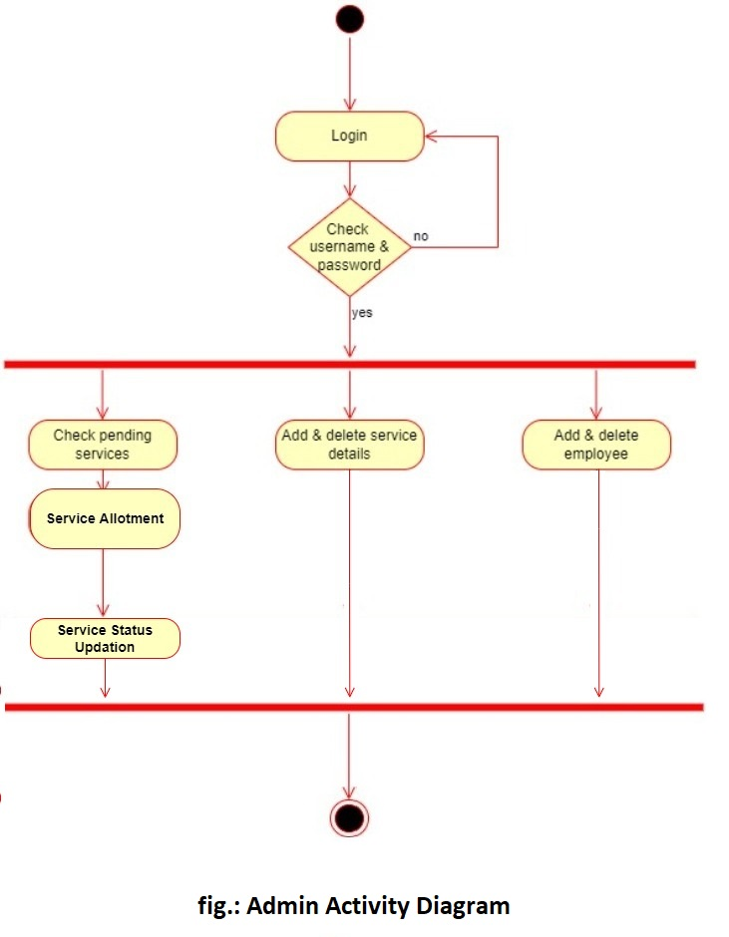

**Figure 2: Admin Activity Diagram**

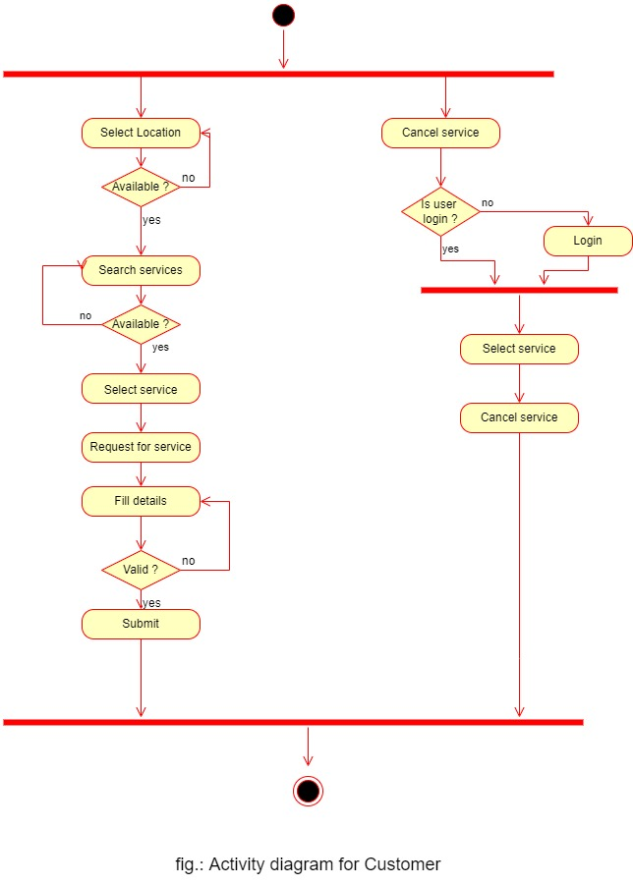

**Figure 3: Customer Activity Diagram**

## Data Flow Diagram

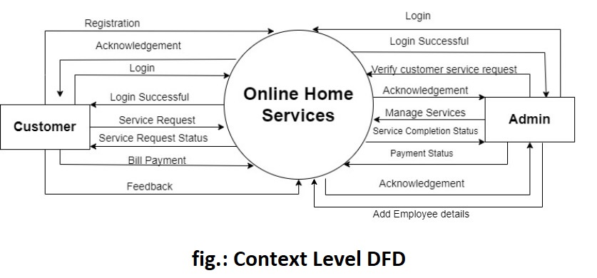

**Figure 4: Level 0 Data Flow Diagram**

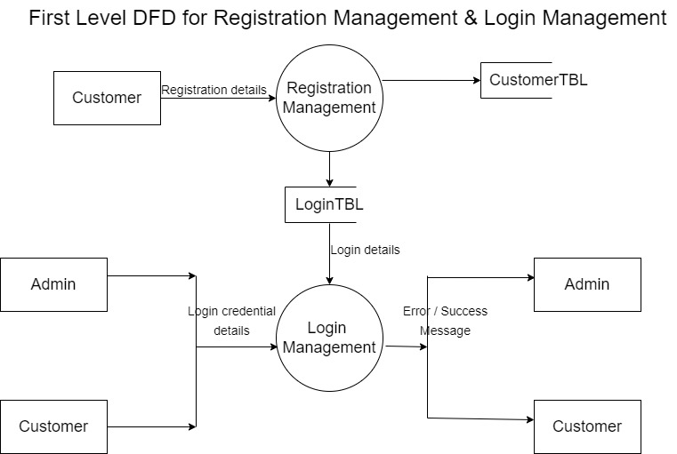

**Figure 5: Level 1 Data Flow Diagram**

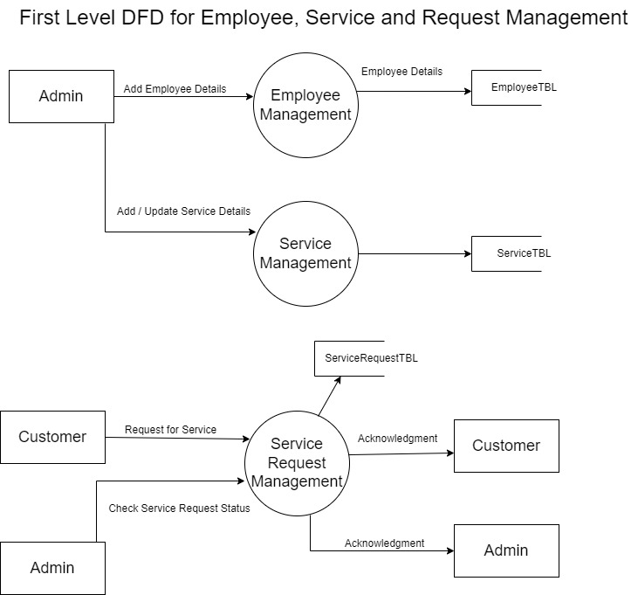

**Figure 6: Level 1 Data Flow Diagram for Admin**

## Class Diagram

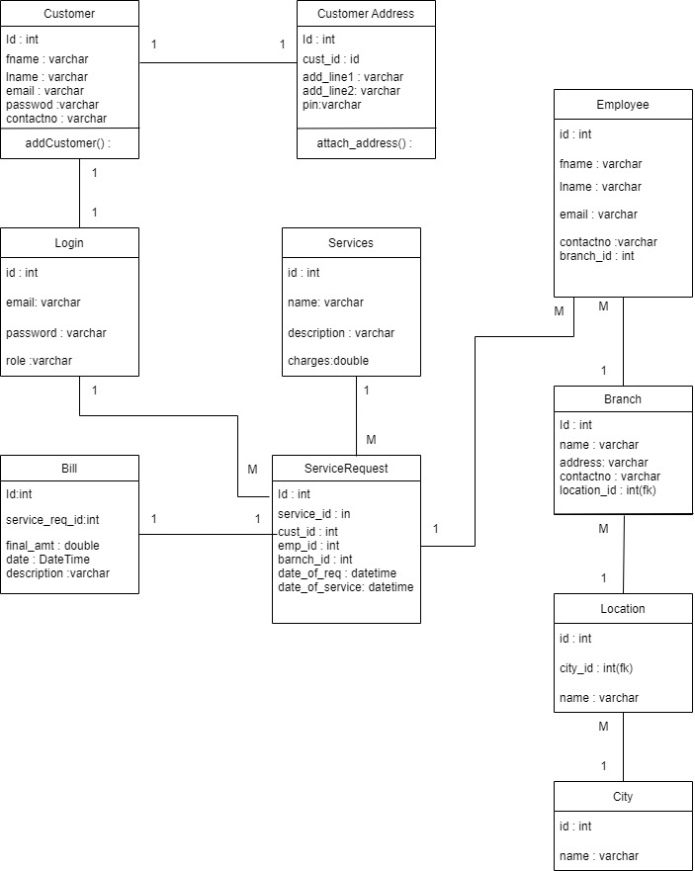

**Figure 9: Class Diagram**

## Use Case Diagram

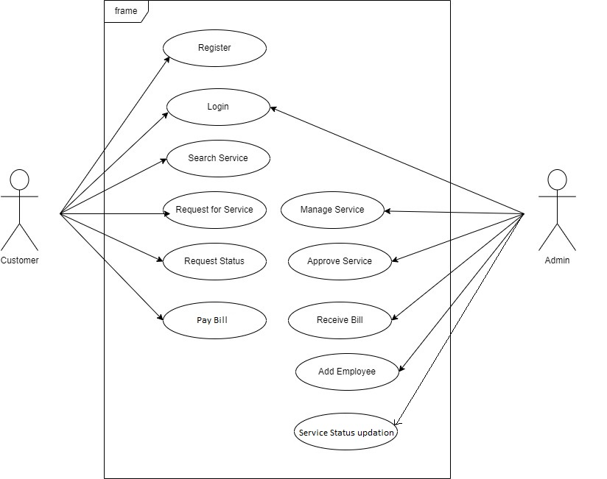

**Figure 10: Use Case Diagram**

## ER Diagram

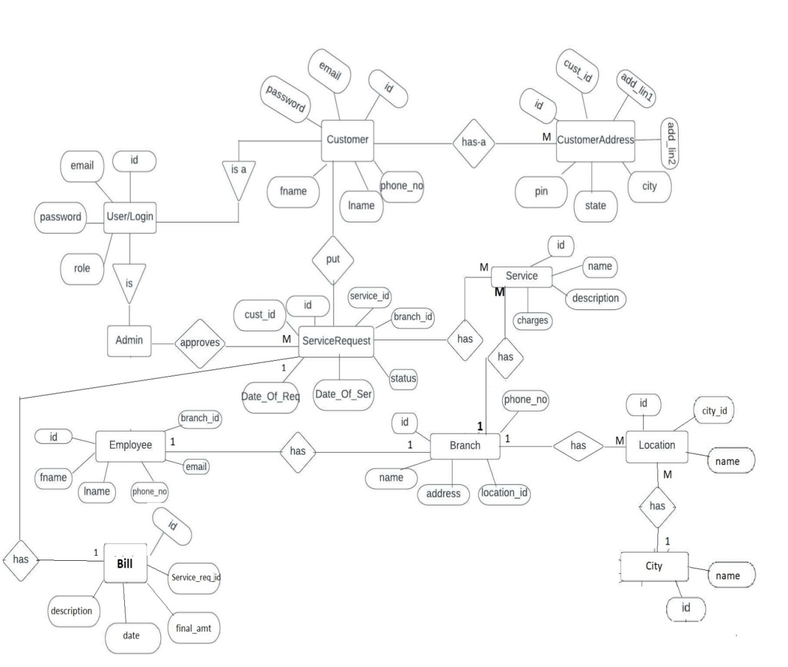

**Figure 11: ER Diagram**

# Table Structure

|  |  |  |  |  |  |
| --- | --- | --- | --- | --- | --- |
| Customer | |  |  |  |  |
|  |  |  |  |  |  |
|  | **Field** | **Datatype** | **Null** | **Key** | **Default** |
|  | id | INT | No | Primary | Auto-increment |
|  | fname | Varchar(40) | Yes |  | Null |
|  | lname | Varchar(40) | Yes |  | Null |
|  | Email | Varchar(40) | Yes | Unique | Null |
|  | password | Varchar(40) | Yes |  | Null |
|  | contactno | INT | Yes |  | Null |
|  | role | Varchar(40) | Yes |  | Default = customer |
|  |  |  |  |  |  |
|  |  |  |  |  |  |
| Employee | |  |  |  |  |
|  | **Field** | **Datatype** | **Null** | **Key** | **Default** |
|  | id | INT | No | Primary | Auto-increment |
|  | fname | Varchar(40) | Yes |  | Null |
|  | lname | Varchar(40) | Yes |  | Null |
|  | email | Varchar(40) | Yes | Unique | Null |
|  | contactno | INT | Yes |  | Null |
|  | branch_id | INT | Yes | Foreign | Null |
|  | role | Varchar(40) | Yes |  | Default = employee |
|  |  |  |  |  |  |
| Customer Address | |  |  |  |  |
|  | **Field** | **Datatype** | **Null** | **Key** | **Default** |
|  | id | INT | No | Primary | Auto-increment |
|  | cust_id |  | Yes | Foreign |  |
|  | addrline1 | Varchar(60) | Yes |  | Null |
|  | addrline2 | Varchar(60) | Yes |  | Null |
|  | city | Varchar(20) | Yes |  | Null |
|  | state | Varchar(20) | Yes |  | Null |
|  | pin | INT | Yes |  | Null |
|  |  |  |  |  |  |

|  |  |  |  |  |  |
| --- | --- | --- | --- | --- | --- |
| Services | |  |  |  |  |
|  |  |  |  |  |  |
|  | **Field** | **Datatype** | **Null** | **Key** | **Default** |
|  | id | INT | No | Primary | Auto-increment |
|  | name | Varchar(40) |  |  |  |
|  | description | Varchar(40) | Yes |  | Null |
|  | charges | Double | Yes |  | Null |
|  |  |  |  |  |  |
|  |  |  |  |  |  |
|  |  |  |  |  |  |
| Branch |  |  |  |  |  |
|  |  |  |  |  |  |
|  | **Field** | **Datatype** | **Null** | **Key** | **Default** |
|  | id | INT | No | Primary | Auto-increment |
|  | branchname | Varchar(40) | Yes |  | Null |
|  | branchaddress | Varchar(40) | Yes | Unique | Null |
|  | email | Varchar(40) | Yes | Unique | Null |
|  | contactno | INT | Yes | Unique | Null |
|  | adminID | INT | Yes | Foreign | Null |
|  |  |  |  |  |  |
|  |  |  |  |  |  |
|  |  |  |  |  |  |
|  |  |  |  |  |  |
| ServicesRequest | |  |  |  |  |
|  |  |  |  |  |  |
|  | **Field** | **Datatype** | **Null** | **Key** | **Default** |
|  | id | INT | No | Primary | Auto-increment |
|  | serviceId | INT |  | Foreign |  |
|  | custId | INT | Yes | Foreign | Null |
|  | empId | INT | Yes | Foreign | Null |
|  | dateOfReq | DateTime |  |  | Null |
|  | dateOfService | DateTime |  |  | Null |
|  | branchId | INT |  | Foreign | Null |
|  | status | Varchar(20) |  |  | Null |

# Conclusion

Online Home Services puts forth the actual working of a home services. Administration, management, employee management, customer management, etc. are the key features of our project. User can access services and functionalities from the online home service anywhere and anytime for their own comfort.

# Future Scope

This project can be enhanced further by adding online payment system, authentication by otp, for the user to reduce the extra work of the admin. The software is flexible enough to be modified and implemented as per future requirements. We have tried our best to present this free and user–friendly website to customers. Message alerts for various happenings in the application can be added to the system so that users do not miss the updates and happenings of the service request.

# 7.0 References

1. Maharashtra Co-operative Housing Societies Act; [MCS Act] 1960.
2. “Reserve Funds” means the funds constituted under the provisions of section 66(1) of the Act and “Bye law” No. 12 (i).
3. “Repairs and Maintenance Funds” means the fund constituted under the Bye Law No. 13(a).
4. ‟Sinking Funds” means the funds constituted under the Bye Law No. 13(c).

**ONLINE REFERENCE**

1. [www.housing-society-management-software.software.informer.com/1.0/](http://www.housing-society-management-software.software.informer.com/1.0/)