SMD
Unit 3
1) Draw an activity diagram for a Passport Management System To get a new passport, an applicant has to apply on-line, get the appointment. He has to submit the documents in passport office on the date of appontment. In case of insufficient or incorrect documents, the applicants have to reapply and get new appointment after submission of documents, applicants verification is done by the police. On successful verification, passport is issued to the applicant. If verification is unsuccessful, applicant has to reapply for passport. Construct the activity diagram of the given description using swim lanes.
Ans.
Activity Diagram for Passport Management System (Using Swim Lanes)

1) Definition / Introduction
- An Activity Diagram is a UML behavioral diagram that represents the flow of activities in a system from start to end.
- It shows control flow, decision points, parallel activities, and actors involved.
- Swim lanes are used to divide activities based on different actors or departments responsible for each task.

2) Main Explanation (Point-wise)
Actors (Swim Lanes Identified)
- Applicant
- Passport Office
- Police Department

Flow of Activities
- Start → Online Application
  - The process begins when the applicant fills and submits the online application form.
  - This step initiates the passport issuance process.
- Get Appointment
  - After applying, the applicant selects and confirms an appointment date.
  - This ensures a scheduled visit to the passport office.
- Submit Documents (Passport Office)
  - The applicant visits the office and submits required documents.
  - Documents are verified for correctness and completeness.
- Decision: Documents Valid?
  - A decision node checks whether documents are correct and sufficient.
  - If No, the process loops back to reapplication.
- Reapply for Appointment (if invalid)
  - Applicant must reapply online and get a new appointment.
  - This forms a loop (iteration) in the activity diagram.
- Police Verification
  - If documents are valid, details are sent to the police department.
  - Police perform background verification of the applicant.
- Decision: Verification Successful?
  - Another decision node checks verification status.
  - If unsuccessful, applicant must reapply.
- Reapply Process (if failed verification)
  - Applicant again goes through the application and appointment process.
  - This ensures only verified applicants proceed.
- Passport Issued
  - If verification is successful, the passport office issues the passport.
  - This marks successful completion.
- End State
- The process ends after passport issuance.

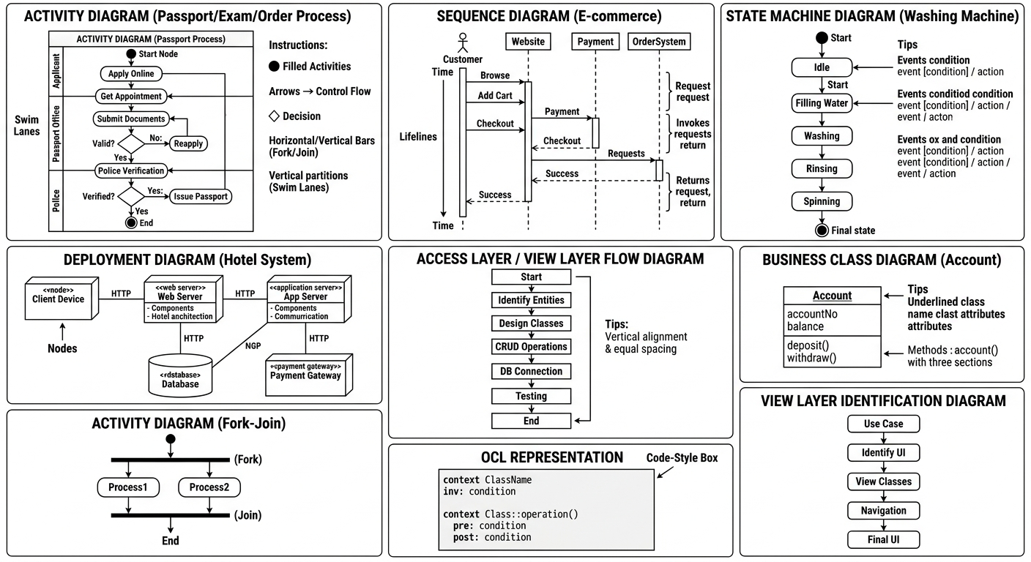

3) Activity Diagram (Swim Lane Representation)
---------------------------------------------------------------
| Applicant | Passport Office | Police Department |
---------------------------------------------------------------
| Start |
| ↓ |
| Apply Online |
| ↓ |
| Get Appointment |
| ↓ |
| Submit Documents →→→→→→→→→→→→→→→→→→→→→→→→→→→→→→→→→→→→→→→→→→ |
| Check Documents |
| ↓ |
| [Documents Valid?] |
| / \ |
| No Yes |
| ↓ ↓ |
| Reapply & Get Appointment →→→→→→→→→→→→→→→→→→→→→→→→→→→→→ |
| Police Verification |
| ↓ |
| [Verification OK?] |
| / \ |
| No Yes |
| ↓ ↓ |
| Reapply Process Issue Passport |
| ↓ |
| End |
---------------------------------------------------------------

4) Example (Real-life Understanding)
- Suppose a person applies for a passport but forgets to submit address proof.
- The system rejects the documents → the applicant must reapply and book a new appointment.
- After correct submission, police verify the address, and if valid, the passport is issued.

5) Conclusion
- The activity diagram clearly shows the step-by-step workflow of passport processing.
- Swim lanes help in identifying responsibilities of Applicant, Passport Office, and Police.
- It effectively represents decision points, loops, and process flow, making it easy to understand and analyze.

2) Explain the difference between sequence & collaboration diagram with examples.
Ans.
Difference Between Sequence Diagram and Collaboration Diagram

1) Definition / Introduction
- Both Sequence Diagram and Collaboration Diagram (also called Communication Diagram) are UML diagrams used for modeling interactions between objects in a system.
- They represent how objects communicate using messages, but differ in focus and representation style.

2) Main Differences (Point-wise)
1. Focus of Representation
- Sequence Diagram focuses on time sequence of messages, i.e., when messages are sent.
- Collaboration Diagram focuses on structural organization, i.e., how objects are connected.

2. Layout / Structure
- Sequence Diagram is arranged in a vertical format, where time flows top to bottom.
- Collaboration Diagram is arranged in a network format, showing objects and links like a graph.

3. Key Elements
- Sequence Diagram uses lifelines, activation bars, and messages to show interaction.
- Collaboration Diagram uses objects, links, and numbered messages to show communication.

4. Representation of Time
- Sequence Diagram clearly shows time order of messages using vertical flow.
- Collaboration Diagram does not explicitly show time, uses numbering (1, 2, 3…) to indicate sequence.

5. Complexity Handling
- Sequence Diagram is easier for understanding complex workflows step-by-step.
- Collaboration Diagram is better for understanding relationships between objects.

6. Visualization of Object Roles
- Sequence Diagram emphasizes interaction behavior more than structure.
- Collaboration Diagram emphasizes object roles and responsibilities in interaction.

7. Message Representation
- Sequence Diagram shows messages as horizontal arrows across lifelines.
- Collaboration Diagram shows messages as labeled arrows on links.

3) Diagram Representation
(A) Sequence Diagram (Example: Online Order System)
Customer → System: Place Order
System → Payment Gateway: Process Payment
Payment Gateway → System: Payment Success
System → Customer: Order Confirmation
👉 Shows step-by-step interaction over time

(B) Collaboration Diagram (Same Example)
[Customer] ----(1: Place Order)----> [System]
[System] ----(2: Process Payment)----> [Payment Gateway]
[Payment Gateway] ----(3: Success)----> [System]
[System] ----(4: Confirmation)----> [Customer]
👉 Shows object connections + numbered message flow


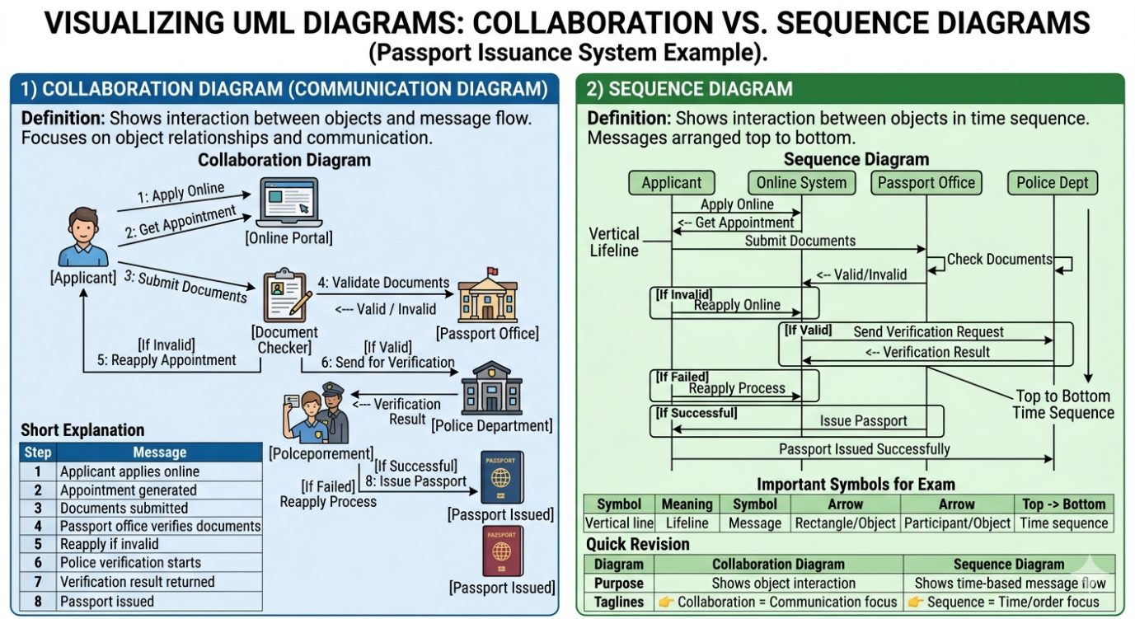

4) Example (Real-life Understanding)
- In an online shopping system:
  - Sequence Diagram helps to understand “what happens first, next, and last” when placing an order.
  - Collaboration Diagram helps to understand “which objects (Customer, System, Payment Gateway) interact and how they are connected”.

5) Conclusion
- Sequence Diagram is best for analyzing time-based interactions and flow of messages.
- Collaboration Diagram is best for understanding object relationships and communication structure.
- Both diagrams are complementary and used together for complete interaction modeling.
Basis | Sequence Diagram | Collaboration Diagram (Communication Diagram)
Focus | Emphasizes time sequence of messages (when interaction happens) | Emphasizes object relationships and structure (how objects are connected)
Layout / Structure | Vertical layout with time flowing from top to bottom | Network/graph layout showing objects connected via links
Representation of Time | Clearly shows time order using vertical flow | Time is shown using message numbering (1, 2, 3...)
Main Elements | Lifelines, activation bars, messages | Objects, links, numbered messages
Message Flow | Messages shown as horizontal arrows between lifelines | Messages shown as arrows on links with sequence numbers
Complexity Handling | Better for understanding step-by-step process flow | Better for understanding object relationships
Visualization | Focus on dynamic behavior (interaction over time) | Focus on static structure during interaction
Ease of Understanding | Easier for beginners to follow sequence of events | Slightly complex due to numbering and network structure
Use Case | Used when order of execution is important | Used when object collaboration and roles are important

3) Draw a state machine diagram for an automated Washing Machine. Make suitable assumptions and clearly state the assumptions made.
Ans.
State Machine Diagram for Automated Washing Machine

1) Definition / Introduction
- A State Machine Diagram (State Diagram) represents the different states of a system and how it transitions from one state to another based on events (triggers) and conditions.
- It is useful for modeling systems with clearly defined states and behavior, such as a washing machine.

2) Assumptions Made
- The washing machine operates in fully automatic mode.
- User selects a wash program and presses the start button.
- Water supply and power are available.
- The machine performs steps in sequence: Filling → Washing → Rinsing → Spinning → End.
- If any fault occurs (like door open), the system goes to a pause/error state.

3) Main States and Transitions (Point-wise)
1. Initial State
- Represented by a filled circle.
- The machine is in an idle condition, waiting for user input.

2. Idle State
- Machine waits for user to select program and press start.
- Transition occurs on Start Button Pressed.

3. Filling Water State
- Water is filled into the drum.
- Transition occurs when water level is reached.

4. Washing State
- Clothes are washed using detergent.
- Transition after washing time completes.

5. Rinsing State
- Clothes are rinsed with clean water.
- Transition after rinsing completes.

6. Spinning State
- Water is removed by spinning the drum.
- Transition after spin cycle completes.

7. Final State (End)
- Represented by a double circle.
- Washing process is completed and machine stops.

8. Error/Pause State (Optional)
- If door opens or fault occurs, machine pauses.
- Returns to previous state after issue is resolved.

4) State Machine Diagram
● → Idle
Idle → (Start Button Pressed) → Filling Water
Filling Water → (Water Level Reached) → Washing
Washing → (Wash Complete) → Rinsing
Rinsing → (Rinse Complete) → Spinning
Spinning → (Spin Complete) → ◎ End
Any State → (Door Open / Error) → Pause/Error State
Pause/Error State → (Issue Resolved) → Back to Previous State


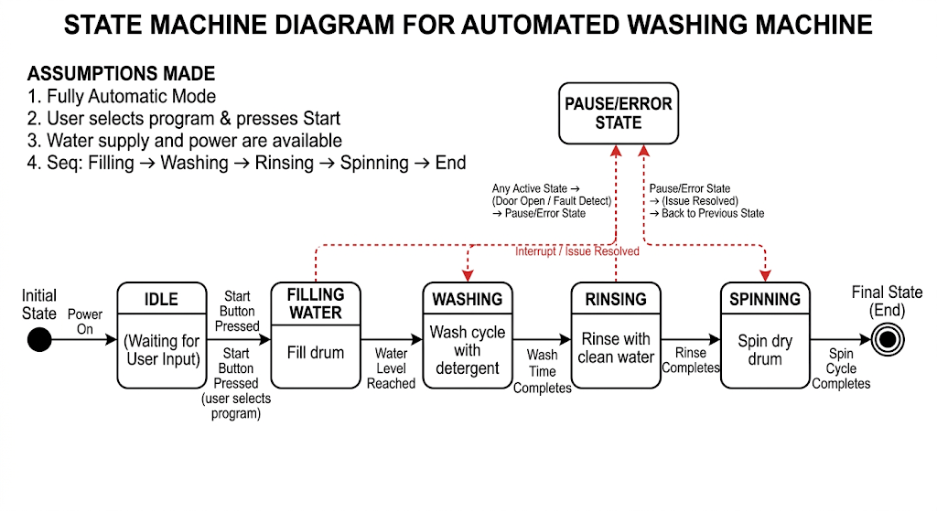

5) Example (Real-life Understanding)
- When you press Start, the machine begins filling water.
- After reaching the required level, it starts washing, then rinsing, and finally spinning.
- If you open the door in between, it pauses and resumes after closing.

6) Conclusion
- The state diagram clearly shows states, transitions, and conditions of a washing machine.
- It helps in understanding the behavior of the system step-by-step.
- Useful for designing and debugging real-time embedded systems like washing machines.

4) The project leader schedules a meeting of members of project group by using a meeting scheduler. These are some of the assumptions: The project leader interacts through a GUI form to schedule the meeting. A scheduler does the automated scheduling of meeting based on the free slots in the timetable. All the members involved in the meeting will get an invitation through SMS on their mobiles. The system depends on an external mobile gateway to forward SMS. Draw a sequence diagram that describes the above system.
Ans.
Sequence Diagram for Meeting Scheduler System

1) Definition / Introduction
- A Sequence Diagram is a UML interaction diagram that shows how objects communicate over time using messages.
- It represents lifelines, message flow, and order of execution from top to bottom.
- It is useful for modeling real-time interactions between system components.

2) Assumptions
- The Project Leader uses a GUI Form to schedule the meeting.
- The Scheduler System automatically checks free time slots.
- All Project Members receive meeting invitations via SMS.
- SMS is sent using an External Mobile Gateway.
- The system maintains a timetable/database for availability.

3) Main Objects (Lifelines)
- Project Leader
- GUI Form
- Scheduler
- Database/Timetable
- Mobile Gateway (External System)
- Project Members

4) Sequence of Interactions (Point-wise)
- Meeting Request Initiation
  - Project Leader enters meeting details in the GUI Form.
  - This includes date, time, and participants.
- Request Sent to Scheduler
  - GUI sends the schedule request to the Scheduler.
  - Scheduler starts processing the request.
- Check Availability
  - Scheduler queries the Database/Timetable for free slots.
  - Database returns available time slots.
- Schedule Confirmation
  - Scheduler selects a suitable slot and confirms the meeting.
  - Confirmation is sent back to the GUI.
- Send SMS Invitations
  - Scheduler sends meeting details to the Mobile Gateway.
  - Mobile Gateway acts as an external service.
- Forward SMS to Members
  - Mobile Gateway sends SMS notifications to all project members.
  - Members receive meeting invitation messages.
- End of Interaction
  - All members are notified and meeting is successfully scheduled.

5) Sequence Diagram
Project Leader → GUI Form: Enter Meeting Details
GUI Form → Scheduler: Send Scheduling Request
Scheduler → Database: Check Free Slots
Database → Scheduler: available Slots
Scheduler → GUI Form: Confirm Meeting Time
Scheduler → Mobile Gateway: Send SMS Details
Mobile Gateway → Project Members: Deliver SMS Invitation
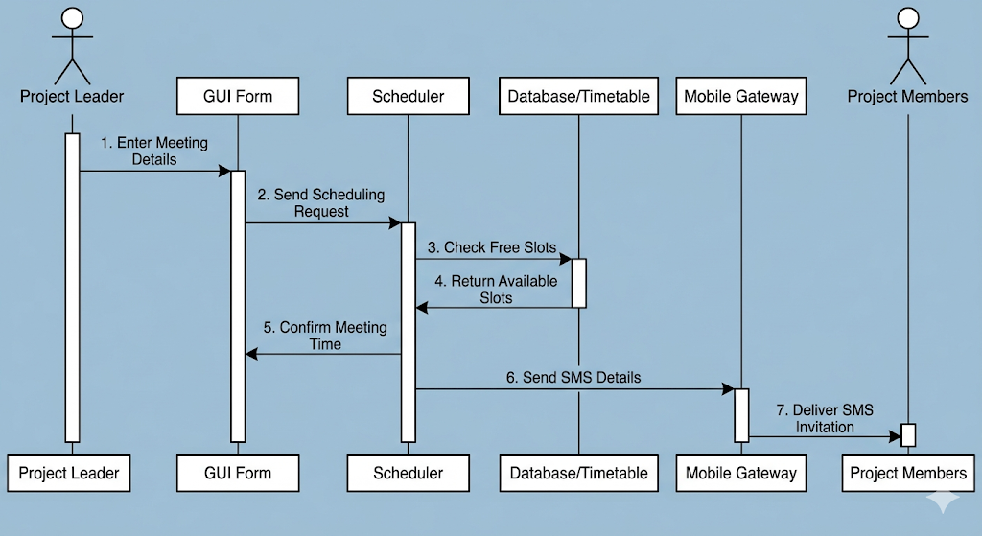

6) Example (Real-life Understanding)
- A team leader schedules a meeting using a web app.
- The system checks everyone's calendar and picks a free slot.
- All members instantly receive an SMS notification with meeting details.

7) Conclusion
- The sequence diagram clearly shows the interaction flow between components.
- It highlights time-ordered communication and external system dependency (mobile gateway).
- Useful for designing systems involving automation and notifications.

5) Explain the following by drawing a neat fragment on a state diagram
i) Entry and exit actions of a state.
ii) History states.
iii) Nested states.
iv) Activities.
Ans.
State Diagram Concepts (With Neat Fragments)

1) Definition / Introduction
- A State Diagram (State Machine Diagram) represents the dynamic behavior of a system by showing its states, transitions, and actions.
- It includes advanced concepts like entry/exit actions, history states, nested states, and activities for detailed modeling.

i) Entry and Exit Actions of a State
Explanation
- Entry Action
  - An entry action is executed immediately when a state is entered.
  - It is written as entry / action-name inside the state.
- Exit Action
  - An exit action is executed just before leaving the state.
  - It is written as exit / action-name.
- These actions help in defining initialization and cleanup operations of a state.
- They are useful in systems where certain tasks must be done every time a state is entered or exited.

Diagram Fragment
[Processing State]
-------------------------
entry / startTimer
do / processData
exit / stopTimer
-------------------------

Example
- In a Washing Machine:
  - Entry → Start motor
  - Exit → Stop motor

ii) History States
Explanation
- A History State is used to remember the last active sub-state.
- Represented by H (shallow history) or H (deep history)* inside a circle.
- When returning to a composite state, it resumes from last visited state instead of starting fresh.
- Improves efficiency by avoiding repetition of completed steps.

Diagram Fragment
[Composite State]
|
→ (H)
|
[State A] → [State B]

Example
- In a music player:
  - If paused, it resumes from the last played song, not from the beginning.

iii) Nested States (Composite States)
Explanation
- Nested states are states inside another state (also called composite states).
- They help in breaking complex systems into smaller manageable parts.
- Only one sub-state is active at a time within the composite state.
- Improves modularity and readability of diagrams.

Diagram Fragment
[Washing Process]
-------------------
| Wash |
| Rinse |
| Spin |
-------------------

Example
- In a Washing Machine, the "Washing Process" contains:
  - Washing → Rinsing → Spinning

iv) Activities
Explanation
- An Activity (do-activity) is an operation that executes continuously while in a state.
- Represented as do / activity-name inside the state.
- It continues until:
  - The state is exited, or
  - The activity is completed.
- Useful for modeling ongoing processes.

Diagram Fragment
[Downloading]
-------------------------
entry / connectServer
do / downloadFile
exit / disconnect
-------------------------

Example
- In a Download System:
  - Activity → Downloading file continuously until complete.

5) Conclusion
- These concepts (entry/exit actions, history states, nested states, and activities) enhance the expressiveness of state diagrams.
- They help in modeling complex, real-time system behavior more accurately.
- Using them improves clarity, modularity, and system design quality.
- Entry/Exit Actions: The diagram of the [Processing State] clearly shows that the entry / startTimer action triggers when entering the state, and the exit / stopTimer action triggers when leaving it.
- History States: A shallow history state, marked with the (H) icon, is shown in the [Main Workflow]. It ensures that if the system moves from Sub-State B to a [Power Saving] interrupt, it resumes directly from Sub-State B instead of starting over.
- Nested States: The [Washing Process] composite state contains nested sub-states: Wash, Rinse, and Spin, allowing you to break down a complex system into smaller, more manageable sub-processes.
- Activities: A do-activity, do / downloadFile, is shown as an action that runs continuously throughout the entire duration of the [Downloading] state.
The diagram below provides a visual breakdown of each of these concepts.
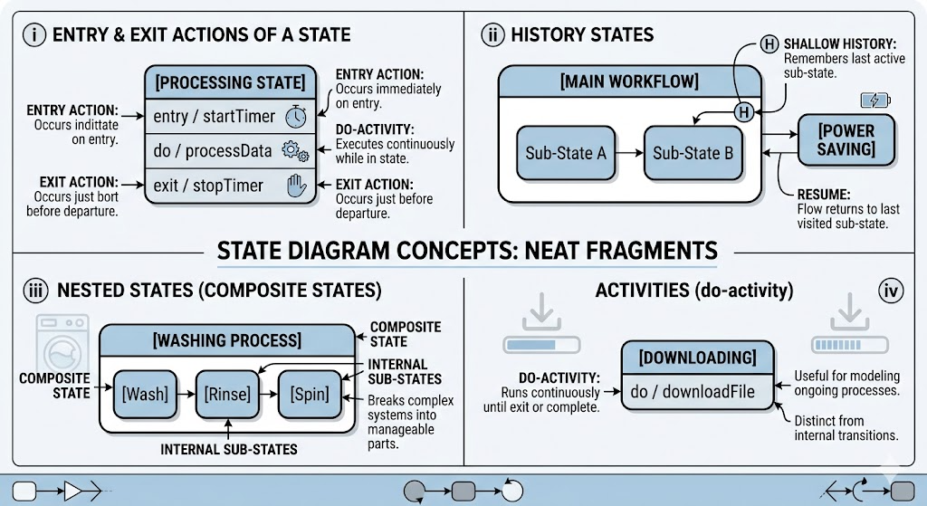
6) Draw the notations of synchronous asynchronous, return, Create object and destroy object messages in the context of sequence diagram
Ans.
Message Notations in Sequence Diagram

1) Definition / Introduction
- In a Sequence Diagram, messages represent communication between objects.
- Different types of messages are used to show how and when interactions occur.
- Important message types include: Synchronous, Asynchronous, Return, Create, and Destroy messages.

2) Message Notations (Point-wise with Diagram Fragments)

i) Synchronous Message
Explanation
- A Synchronous Message means the sender waits for the receiver to complete execution.
- It represents a blocking call (like a function call).
- Control is transferred to the receiver until execution is finished.
Notation
Object A ─────▶ Object B
(solid line with filled arrow)
Example
- A system calling a payment processing function and waiting for response.

ii) Asynchronous Message
Explanation
- An Asynchronous Message means the sender does not wait for the receiver.
- It is a non-blocking call, allowing parallel execution.
- Sender continues its work immediately.
Notation
Object A ─────▷ Object B
(solid line with open arrow)
Example
- Sending an email or SMS notification.

iii) Return Message
Explanation
- A Return Message shows the response/result from receiver to sender.
- It is usually optional in diagrams.
- Represents completion of a synchronous call.
Notation
Object B - - - - - - - -▶ Object A
(dashed line with arrow)
Example
- Returning payment success/failure to the system.

iv) Create Object Message
Explanation
- A Create Message is used to create a new object instance.
- The object’s lifeline starts at the point of creation.
- Represented using a message pointing to the object.
Notation
Object A ─────▶ Object B
| (Object B created here)
|
|
Example
- Creating a new user account object after registration.

v) Destroy Object Message
Explanation
- A Destroy Message indicates termination of an object.
- Represented by an ‘X’ at the end of the lifeline.
- The object cannot participate in further interactions.
Notation
Object A ─────▶ Object B
|
X (Object destroyed)
Example
- Deleting a temporary session object after logout.

3) Combined Diagram (All Notations Together)
A ───▶ B (Synchronous)
A ───▷ C (Asynchronous)
B - - - ▶ A (Return)
A ───▶ D (Create D)
D ───▶ X (Destroy D)

4) Conclusion
- Different message types in sequence diagrams help represent various interaction behaviors.
- They clearly distinguish between blocking, non-blocking, creation, and termination operations.
- Proper use of these notations improves clarity and accuracy of system interaction modeling.

7) Draw a state machine diagram for coffee vending machine which prepare the coffee by adding material of coffee. Assume suitable data.
Ans.
State Machine Diagram for Coffee Vending Machine

1) Definition / Introduction
- A State Machine Diagram represents the states of a system and the transitions between them based on events and conditions.
- It is useful for modeling systems like a coffee vending machine, where operations occur in a defined sequence.

2) Assumptions Made
- The machine is fully automatic.
- User selects coffee type (e.g., normal/strong).
- User must insert sufficient money before preparation.
- Ingredients available: water, milk, coffee powder, sugar.
- Machine checks availability of ingredients before preparing coffee.
- If ingredients or money are insufficient, the process is cancelled or restarted.

3) Main States and Transitions (Point-wise)
1. Initial State
- Represented by a filled circle.
- Machine is powered ON and ready.

2. Idle State
- Machine waits for user input (selection).
- Transition occurs when user selects coffee.

3. Accept Money State
- User inserts money.
- Transition based on sufficient/insufficient money.

4. Check Ingredients State
- Machine verifies availability of water, milk, coffee powder, sugar.
- Decision point determines next state.

5. Prepare Coffee State
- Machine performs mixing and heating operations.
- Includes internal activities like:
  - Boiling water
  - Adding coffee powder and sugar
  - Mixing milk

6. Dispense Coffee State
- Prepared coffee is delivered to the user.
- Transition to final state.

7. Final State
- Represented by double circle.
- Process completes successfully.

8. Error/Cancel State
- If money or ingredients are insufficient, process is cancelled.
- Machine returns to Idle state.

4) State Machine Diagram
● → Idle
Idle → (Select Coffee) → Accept Money
Accept Money → [Money Sufficient?]
├── No → Return Money → Idle
└── Yes → Check Ingredients
Check Ingredients → [Ingredients Available?]
├── No → Display "Out of Stock" → Idle
└── Yes → Prepare Coffee
Prepare Coffee → (Preparation Complete) → Dispense Coffee
Dispense Coffee → (Delivered) → ◎ End
Any State → (Cancel/Error) → Idle

5) Example (Real-life Understanding)
- A user selects coffee and inserts ₹20.
- If money and ingredients are sufficient, the machine prepares coffee and dispenses it.
- If milk is unavailable, it shows “Out of Stock” and returns to idle.

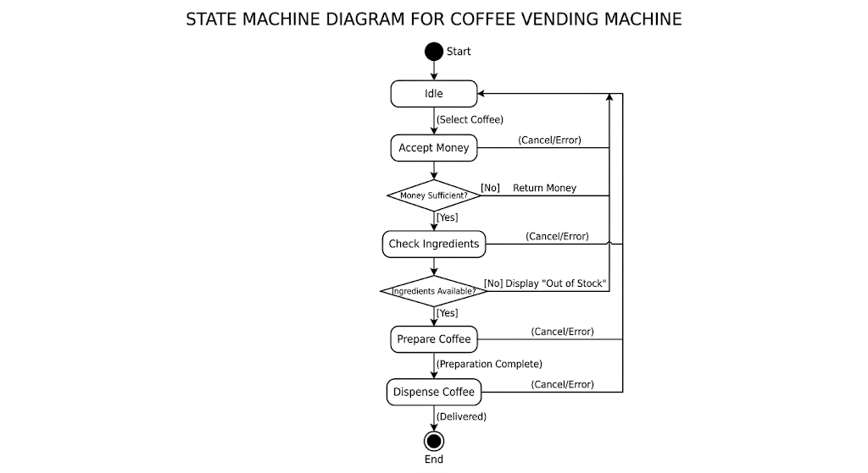

6) Conclusion
- The state diagram clearly shows states, decisions, and transitions in a coffee vending machine.
- It helps in understanding the complete workflow and error handling.
- Useful for designing embedded and real-time automated systems.

8) Explain in brief UML diagrams used for dynamic modelling.
Ans.
UML Diagrams Used for Dynamic Modelling

1) Definition / Introduction
- Dynamic Modelling in UML represents the behavior of a system over time.
- It focuses on interactions, state changes, and flow of control among system components.
- UML provides several diagrams to capture this dynamic behavior effectively.

2) UML Diagrams for Dynamic Modelling (Brief Explanation)

1. Activity Diagram
- An Activity Diagram shows the flow of activities from start to end in a process.
- It includes elements like actions, decision nodes, fork-join, and swim lanes.
- Used to model business workflows and algorithms.
- Helps in understanding sequential and parallel execution of tasks.
Example:
- Passport application process, online order processing.

2. Sequence Diagram
- A Sequence Diagram shows interaction between objects in time order.
- It uses lifelines, messages, and activation bars.
- Clearly represents which object communicates first, next, and last.
- Useful for modeling real-time system interactions.
Example:
- Online payment processing, meeting scheduler system.

3. Collaboration Diagram (Communication Diagram)
- A Collaboration Diagram shows interaction between objects along with their relationships.
- Uses objects, links, and numbered messages.
- Focuses on structural organization of objects rather than time.
- Helps in understanding how objects collaborate.
Example:
- Interaction between customer, system, and payment gateway.

4. State Machine Diagram (State Diagram)
- A State Diagram represents different states of an object and transitions between them.
- Includes states, events (triggers), transitions, and actions.
- Useful for systems with well-defined states and behavior.
- Helps in modeling reactive and event-driven systems.
Example:
- Washing machine, coffee vending machine.

5. Timing Diagram
- A Timing Diagram shows state changes of objects with respect to time.
- Focuses on timing constraints and duration of events.
- Useful in real-time and embedded systems.
- Represents how long a system stays in a particular state.
Example:
- Signal processing systems, communication protocols.

3) Simple Diagram Representation (Overview)
Activity → Flow of process
Sequence → Time-based interaction
Collaboration → Object relationships
State → State changes
Timing → Time constraints

4) Conclusion
- UML dynamic diagrams help in understanding how a system behaves and interacts over time.
- Each diagram focuses on a different aspect of behavior such as flow, interaction, or state changes.
- Together, they provide a complete behavioral view of the system, improving system design and analysis.

9) What are swim lines? What is its use? Illustrate.
Ans.
Swim Lanes in Activity Diagram

1) Definition / Introduction
- Swim Lanes are a feature of Activity Diagrams used to divide the diagram into different sections based on actors, roles, or departments.
- Each lane represents who is responsible for performing a particular activity.
- They improve clarity by showing responsibility distribution in a process.

2) What are Swim Lanes? (Explanation)
- Swim lanes are vertical or horizontal partitions in an activity diagram.
  - Each partition corresponds to an actor (user/system) or organizational unit.
- Activities are placed inside the lane of the responsible entity.
  - This helps in identifying ownership of tasks.
- The flow of control can cross lanes, showing interaction between different roles.
- They are especially useful in multi-user or multi-department systems.

3) Uses of Swim Lanes
- Clear Responsibility Identification
  - Shows which actor or department performs each activity.
  - Avoids confusion in system design.
- Improved Process Understanding
  - Makes complex workflows easy to read and analyze.
  - Helps in identifying bottlenecks.
- Better Communication
  - Useful for discussions between developers, analysts, and stakeholders.
  - Provides a visual separation of duties.
- Supports System Design
  - Helps in mapping activities to modules or components.
  - Useful for role-based system development.

4) Illustration (Example: Online Shopping System)
---------------------------------------------------------
| Customer | System | Payment Gateway |
---------------------------------------------------------
| Browse Items |
| ↓ |
| Place Order →→→→→→→→→→→→→→→→→→→→→→→→→→→→→→→→→→→→→→→→ |
| Process Order |
| ↓ |
| Request Payment →→→→→→→→→→→→→→→→→→→→→→ |
| Process Payment |
| ↓ |
| ←←←←←←←← Payment Success |
| Confirm Order |
---------------------------------------------------------



5) Example (Real-life Understanding)
- In a passport system:
  - Applicant → fills form
  - Passport Office → verifies documents
  - Police → verifies background
- Swim lanes clearly show who performs which task.

6) Conclusion
- Swim lanes are used to organize activities based on responsibility.
- They enhance clarity, readability, and communication in activity diagrams.
- Essential for modeling real-world systems involving multiple actors.

10) Construct sequence diagram for ATM banking system for invalid pin use case.
Ans.
Sequence Diagram for ATM Banking System (Invalid PIN Use Case)

1) Definition / Introduction
- A Sequence Diagram represents the interaction between objects over time using messages and lifelines.
- It shows how the system behaves step-by-step when a user performs an action.
- Here, we model the Invalid PIN scenario in an ATM system.

2) Assumptions
- The user inserts an ATM card into the machine.
- The system allows maximum 3 attempts for PIN entry.
- PIN verification is done by the Bank Server/Database.
- If PIN is incorrect, an error message is displayed.
- After 3 invalid attempts, the card is blocked or retained.

3) Main Objects (Lifelines)
- Customer (User)
- ATM Machine
- Bank Server / Database

4) Sequence of Interactions (Point-wise)
- Insert Card
  - Customer inserts ATM card into the machine.
  - ATM reads card details.
- Prompt for PIN
  - ATM requests the user to enter PIN.
  - Customer enters the PIN.
- Send PIN for Verification
  - ATM sends entered PIN to Bank Server for validation.
  - Server checks against stored data.
- Invalid PIN Response
  - Bank Server returns “Invalid PIN” message.
  - ATM receives failure response.
- Display Error Message
  - ATM displays “Incorrect PIN, Try Again”.
  - User is prompted to re-enter PIN.
- Repeat Attempts (Loop)
  - Steps repeat until maximum attempts (e.g., 3) are reached.
- Card Blocked / Retained
  - After exceeding attempts, ATM blocks or retains the card.
  - Transaction is terminated.

5) Sequence Diagram
Customer → ATM: Insert Card
ATM → Customer: Enter PIN
Customer → ATM: Enter PIN
ATM → Bank Server: Validate PIN
Bank Server → ATM: Invalid PIN
ATM → Customer: Display "Incorrect PIN"
(loop: Max 3 Attempts)
Customer → ATM: Re-enter PIN
ATM → Bank Server: Validate PIN
Bank Server → ATM: Invalid PIN
[After 3 Attempts]
ATM → Customer: Card Blocked / Retained
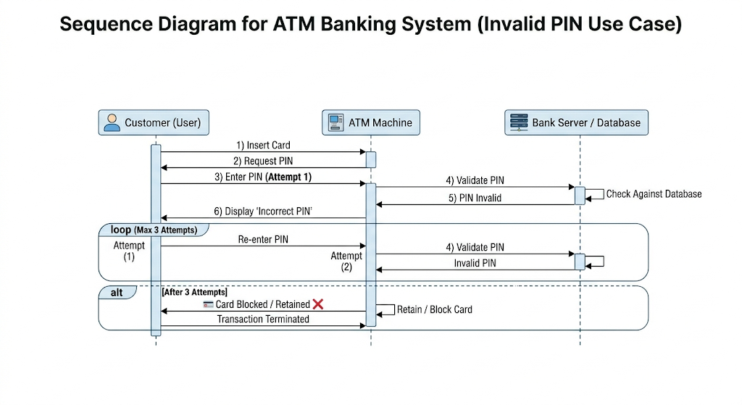

6) Example (Real-life Understanding)
- When a user enters the wrong PIN, the ATM shows an error.
- After 3 wrong attempts, the ATM may block or keep the card for security.

7) Conclusion
- The sequence diagram clearly shows the interaction between customer, ATM, and bank server.
- It highlights error handling and looping behavior.
- Useful for designing secure banking systems and validation processes.

11) Analyze the scenario for an end-semester examination form registration process and draw activity diagram using the concept of fork-join, constraints and swim-lanes.
Ans.
Activity Diagram for End-Semester Examination Form Registration

1) Definition / Introduction
- An Activity Diagram represents the flow of activities in a system.
- It shows decision points, parallel execution (fork-join), constraints, and responsibilities (swim lanes).
- Used here to model the exam form registration process.

2) Assumptions
- Student must be eligible (attendance & no dues) to register.
- Registration includes form filling and fee payment.
- Some activities (like document verification and payment processing) can occur in parallel.
- The system involves Student, Exam Portal, and Accounts Department.
- Registration is successful only after all conditions are satisfied.

3) Swim Lanes (Actors Identified)
- Student
- Exam Portal (System)
- Accounts Department

4) Flow of Activities (Point-wise)
1. Start & Login
- Student logs into the exam portal.
- System authenticates user credentials.

2. Fill Examination Form
- Student enters subjects and personal details.
- Form is submitted to the system.

3. Eligibility Check (Decision + Constraint)
- System checks constraints:
  - [Attendance ≥ Required %]
  - [No Pending Fees]
- If not satisfied → process stops.

4. Fork (Parallel Activities Begin)
- After eligibility, process splits into parallel tasks:
a) Fee Payment (Accounts Dept.)
  - Student pays exam fees.
  - Accounts verifies payment.
b) Form Verification (Exam Portal)
  - System verifies entered details.
  - Checks subject selection and correctness.

5. Join (Synchronization)
- Both payment confirmation and form verification must be completed.
- Only then the process moves forward.

6. Confirmation of Registration
- System generates confirmation receipt.
- Student is notified of successful registration.

7. End State
- Process ends after successful registration.

5) Activity Diagram (Swim Lanes + Fork-Join + Constraints)
------------------------------------------------------------------
| Student | Exam Portal | Accounts Department |
------------------------------------------------------------------
| Start |
| ↓ |
| Login →→→→→→→→→→→→→→→→→→→→→→→→→→→→→→→→→→→→→→→→→→→→→→→→ |
| Validate User |
| ↓ |
| Fill Exam Form →→→→→→→→→→→→→→→→→→→→→→→→→→→→→→→→→→→→→ |
| Check Eligibility |
| [Attendance ≥ % AND No Dues] |
| ↓ |
| ┌──────────── Fork ─────────────┐ |
| ↓ ↓ |
| Pay Fees →→→→→→→→→→→→→→→→→→→→→→→→→→→→→→→→→→→→→→→→ |
| Verify Payment Verify Form |
| ↓ ↓ |
| └──────────── Join ─────────────┘ |
| ↓ |
| Registration Confirmed |
| ↓ |
| End |
------------------------------------------------------------------
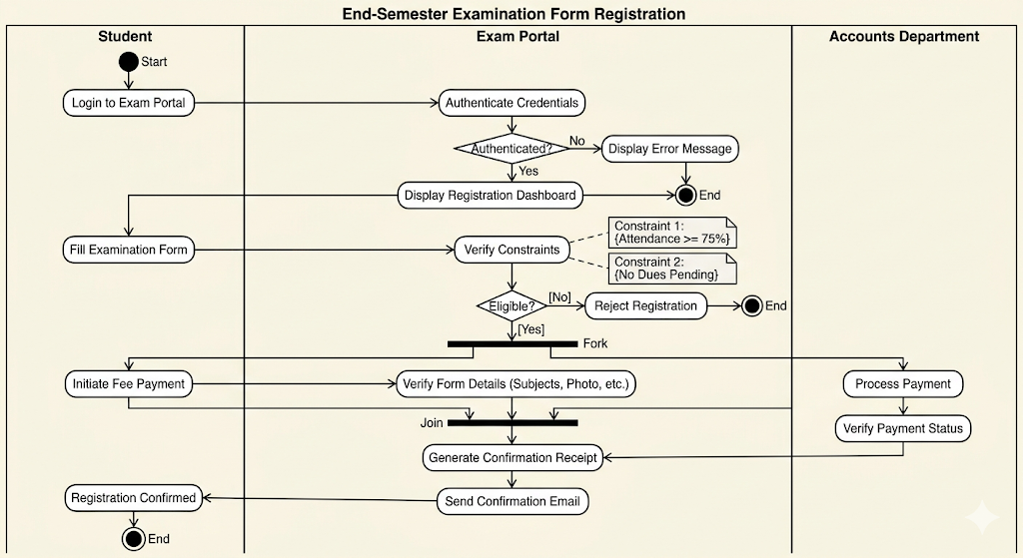

6) Example (Real-life Understanding)
- A student fills the exam form online.
- While the system checks form details, the student pays fees simultaneously.
- Only after both are completed, the system confirms registration.

7) Conclusion
- The activity diagram effectively shows workflow, parallel processing (fork-join), and constraints.
- Swim lanes clearly divide responsibilities among Student, System, and Accounts.
- Helps in designing efficient and real-world academic systems.

12) Draw the notations of synchronous asynchronous, return, create object and destroy object messages in the context of sequence diagram.
Ans.
Message Notations in Sequence Diagram

1) Definition / Introduction
- In a Sequence Diagram, messages represent communication between objects (lifelines).
- Different message types show how interaction happens (blocking, non-blocking, creation, termination, etc.).
- Important message types: Synchronous, Asynchronous, Return, Create, Destroy.

2) Notations with Diagram Fragments

i) Synchronous Message
Explanation
- A Synchronous message is a blocking call, where the sender waits for the receiver to finish.
- Control is transferred to the receiver until execution completes.
Notation
Object A | Object B |
| ─────────────▶ |
| |
👉 Solid line with filled arrowhead

ii) Asynchronous Message
Explanation
- An Asynchronous message is non-blocking, sender does not wait.
- Both sender and receiver can execute in parallel.
Notation
Object A | Object B |
| ─────────────▷ |
| |
👉 Solid line with open arrowhead

iii) Return Message
Explanation
- A Return message shows the response/result of an operation.
- It is optional and usually follows a synchronous call.
Notation
Object B | Object A |
| - - - - - - - - - - ▶ |
👉 Dashed line with arrow

iv) Create Object Message
Explanation
- A Create message is used to instantiate a new object.
- The object's lifeline starts from the point of creation.
Notation
Object A | Object B |
| ─────────────▶ | (created here)
|
|
👉 Lifeline of Object B starts at arrow point

v) Destroy Object Message
Explanation
- A Destroy message indicates termination of an object.
- Represented by an ‘X’ at the end of lifeline.
Notation
Object A | Object B |
| ─────────────▶ |
|
X
👉 Lifeline ends with X symbol

3) Combined View (Quick Revision)
A ───▶ B (Synchronous)
A ───▷ B (Asynchronous)
B - - ▶ A (Return)
A ───▶ C (Create C)
C ───▶ X (Destroy C)

4) Example (Real-life Understanding)
- ATM System:
  - Synchronous → Validate PIN
  - Return → PIN valid/invalid
  - Asynchronous → Send SMS alert
  - Create → Create transaction object
  - Destroy → End transaction session

5) Conclusion
- These message notations help represent different communication behaviors in sequence diagrams.
- They improve clarity by distinguishing types of interactions and object lifecycle events.
- Essential for accurate system interaction modeling.

13) Analyze the scenario for online purchase process from an e-commerce website and draw a sequence diagram using the concepts of object life line and message.
Ans.
Sequence Diagram for Online Purchase Process (E-commerce)

1) Definition / Introduction
- A Sequence Diagram represents interaction between objects over time using messages and lifelines.
- It shows object lifelines, message flow, and order of execution from top to bottom.
- Used here to model the online purchase process in an e-commerce system.

2) Assumptions
- User is registered and logged in.
- Products are available in inventory.
- Payment is done via an external payment gateway.
- Order is confirmed only after successful payment.
- System sends order confirmation to the user.

3) Main Objects (Lifelines)
- Customer
- E-commerce Website (System)
- Inventory System
- Payment Gateway
- Order Management System

4) Sequence of Interactions (Point-wise)
1. Product Selection
- Customer browses and selects product.
- Request is sent to the system.

2. Add to Cart
- Customer adds product to shopping cart.
- System updates cart details.

3. Checkout Process
- Customer initiates checkout.
- System prepares order details.

4. Check Availability
- System sends request to Inventory System.
- Inventory confirms product availability.

5. Payment Processing
- System sends payment request to Payment Gateway.
- Customer enters payment details.

6. Payment Confirmation
- Payment Gateway validates and returns success/failure message.
- If success → proceed further.

7. Order Creation
- System creates order in Order Management System.
- Order details are stored.

8. Confirmation to Customer
- System sends order confirmation to customer.
- Process ends successfully.

5) Sequence Diagram (with Lifelines & Messages)
Customer | Website | Inventory | Payment Gateway | Order System |
| | | | |
|──────────▶| Browse Product | |
| | | |
|──────────▶| Add to Cart | |
| | | |
|──────────▶| Checkout | |
| |──────────▶| Check Stock | |
| |◀──────────| Available | |
| |──────────▶| | Process Payment |
| |──────────▶| |──────────▶ |
| |◀──────────| | Payment Success |
| |──────────▶| | | Create Order
| |──────────▶| | |──────────▶
| |◀──────────| | | Order Confirmed
|◀──────────| Order Confirmation | |
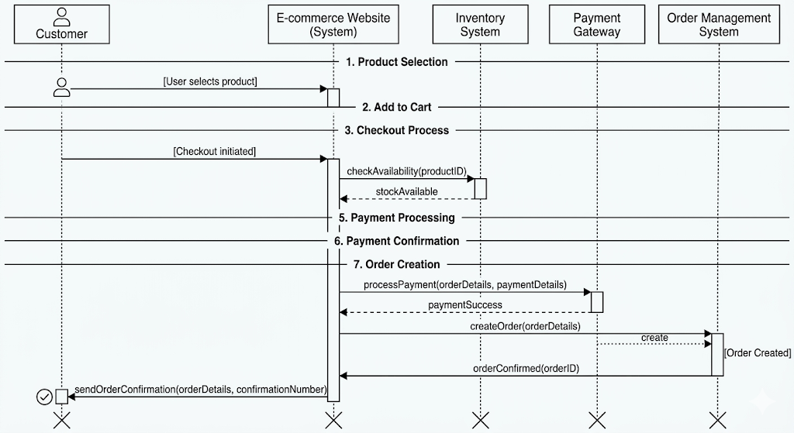

6) Example (Real-life Understanding)
- A user selects a mobile phone, adds it to cart, and proceeds to checkout.
- The system checks stock, processes payment via gateway, and confirms the order.
- User receives confirmation message/email.

7) Conclusion
- The sequence diagram clearly shows interaction between multiple system components.
- It highlights object lifelines and message flow in order.
- Useful for designing real-world e-commerce applications and understanding system behavior.

14) In the context of a state diagram, explain concurrent states, nested states, sub-machine states and composite states with suitable examples.
Ans.
State Diagram Concepts: Concurrent, Nested, Sub-machine & Composite States

1) Definition / Introduction
- A State Diagram (State Machine Diagram) models the dynamic behavior of a system through states and transitions.
- Advanced concepts like concurrent states, nested states, sub-machine states, and composite states help in representing complex real-world systems effectively.

2) Concurrent States
Explanation
- Concurrent states represent situations where multiple states are active simultaneously.
- The state is divided into regions, each executing independently in parallel.
- Used when a system performs multiple activities at the same time.
- Synchronization may occur using fork and join concepts.
Diagram Fragment
[System State]
┌───────────────┬───────────────┐
| Region 1 | Region 2 |
| Playing Music | Downloading |
└───────────────┴───────────────┘
Example
- In a smartphone:
  - Listening to music and downloading files simultaneously.

3) Nested States
Explanation
- Nested states are states placed inside another state.
- They break a complex state into smaller sub-states.
- Only one sub-state is active at a time within the parent state.
- Helps in hierarchical modeling and improves clarity.
Diagram Fragment
[Washing Process]
┌───────────────┐
| Wash |
| Rinse |
| Spin |
└───────────────┘
Example
- In a washing machine, “Washing Process” contains:
  - Washing → Rinsing → Spinning

4) Composite States
Explanation
- A Composite State is a state that contains other states (i.e., a parent state).
- It groups related states into a single higher-level state.
- May include nested or concurrent states inside it.
- Helps in reducing complexity by abstraction.
Diagram Fragment
[Order Processing]
┌─────────────────────┐
| Validate Order |
| Process Payment |
| Ship Order |
└─────────────────────┘
Example
- In an e-commerce system, “Order Processing” includes:
  - Validation → Payment → Shipping

5) Sub-machine States
Explanation
- A Sub-machine state refers to a state that invokes another state machine.
- It allows reuse of an existing state diagram within another diagram.
- Represented as a state with a reference to another state machine.
- Improves modularity and reusability.
Diagram Fragment
[Main Process]
↓
[Payment Process] (Sub-machine)
↓
[Next State]
Example
- In an ATM system:
  - “Transaction” state may include a sub-machine for:
    - PIN validation → Balance check → Withdrawal

6) Conclusion
- These concepts help in modeling complex system behavior effectively:
  - Concurrent states → Parallel execution
  - Nested states → Hierarchical breakdown
  - Composite states → Grouping of states
  - Sub-machine states → Reusability
- They improve clarity, modularity, and scalability of state diagrams in real-world applications.

15) Draw Activity Diagram using Swim lanes for given scenario. “A popular e-commerce website application serves customers to purchase items. Customer can select item by using ‘search item’ facility and add it in the cart. The cart total is calculated, and customer can pay bill by using various payment methods.”
Ans.
Activity Diagram using Swim Lanes for E-Commerce Website
1) Assumptions
- Customer searches and selects products.
- Selected products are added to the shopping cart.
- System calculates the total bill.
- Customer chooses a payment method.
- Payment is verified by the system.
- Order is confirmed after successful payment.

Activity Diagram (Swim Lane)
Swim Lane 1: Customer
Swim Lane 2: E-Commerce System
Swim Lane 3: Payment Gateway
+-------------------+------------------------+----------------------+
| Customer | E-Commerce System | Payment Gateway |
+-------------------+------------------------+----------------------+
Start
|
|
Search Item
|
v
Display Items
|
v
Select Item
|
v
Add Item to Cart
|
v
Calculate Total
|
v
Display Total Bill
|
v
Choose Payment Method
|
v
Send Payment Request
---------------------------------------------->
Process Payment
|
v
Payment Success?
/ \
No Yes
| |
v v
Payment Failed Payment Approved
| |
<-------------------------------------------- |
Display Failure Message |
|
<---------------------------------------------------------
Confirm Order
|
v
Display Confirmation
|
v
End

Easy Exam Drawing Format
--------------------------------------------------------------------
| Customer | E-Commerce System | Payment Gateway |
--------------------------------------------------------------------
| Start | | |
| | | | |
| Search Item | | |
| |--------------->| Display Items | |
| Select Item | | |
| |--------------->| Add Item to Cart | |
| | Calculate Total | |
| | Display Total | |
| Choose Payment | | |
| |--------------->| Send Payment Request | |
| |------------------------>| Process Payment |
| | | Payment Success? |
| |<------------------------| Approved/Failed |
| | Confirm Order | |
|<-------------------| Display Confirmation | |
| End | | |
--------------------------------------------------------------------

Important Symbols to Draw
Initial Node
●
Activity
+-------------+
| Search Item |
+-------------+
Decision Node
◇
Payment
Success?
Final Node
◎
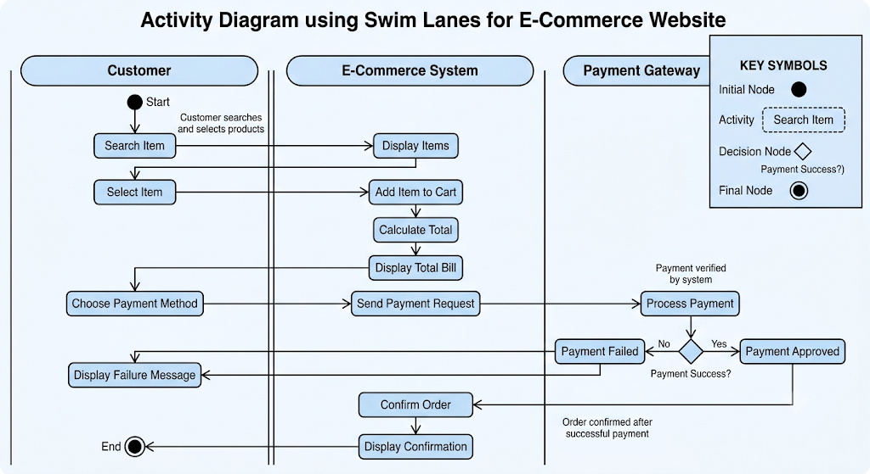

Conclusion
The activity diagram shows how the Customer, E-Commerce System, and Payment Gateway interact using swim lanes. It clearly represents responsibilities, control flow, payment processing, and order confirmation, making it suitable for an 8–10 mark UML activity diagram question.

16) Explain state diagram? Draw and discuss notations used for State Machine, Triggers and Ports, Transitions and conditions, Initial and Final State
Ans.
State Diagram (State Machine Diagram)

1) Definition / Introduction
- A State Diagram (State Machine Diagram) is a UML behavioral diagram used to represent the different states of an object and the transitions between those states during its lifetime.
- It shows how an object reacts to events (triggers) and changes its state.
- State diagrams are useful for modeling dynamic behavior of systems.
Examples:
- ATM Machine
- Washing Machine
- Traffic Light System
- Coffee Vending Machine

2) Need of State Diagram
- Represents Dynamic Behavior
  - Shows how an object behaves over time.
- Tracks State Changes
  - Describes movement from one state to another.
- Models Event-Driven Systems
  - Useful where behavior depends on events.
- Improves System Understanding
  - Clearly visualizes object lifecycle.

3) Notations Used in State Diagram

A) State Machine (State)
Definition
- A State represents a condition or situation during the life of an object.
- It indicates what the object is doing at a particular time.
Notation
+----------------+
| State |
+----------------+
Example
+----------------+
| Idle |
+----------------+
Explanation
- "Idle" indicates the system is waiting for an action.
- State names are written inside a rounded rectangle.

B) Triggers and Ports
Trigger
Definition
- A Trigger is an event that causes a state transition.
- It activates a change from one state to another.
Notation
Trigger Event
-------------
buttonPressed
coinInserted
startPressed
Example
+---------+ start
| Idle | -------->
+---------+
Here, start is the trigger.

Port
Definition
- A Port is an interaction point through which a state machine communicates with external entities.
- It receives or sends events.
Notation
+-------------+
| Machine |
| [Port] |
+-------------+
Example
+-------------+
| Coffee |
| Machine |
| [Input] |
+-------------+

C) Transitions and Conditions

Transition
Definition
- A Transition is the movement from one state to another.
- It occurs when a trigger event happens.
Notation
+------+ --------> +------+
|State1| |State2|
+------+ +------+
Example
+------+ Insert Coin +----------+
| Idle | ------------> | Select |
+------+ +----------+

Guard Condition
Definition
- A Guard Condition is a Boolean condition that must be true for the transition to occur.
Notation
trigger [condition]
Example
InsertCoin [balance > 0]
Diagram:
+------+ InsertCoin [balance>0] +--------+
| Idle | -----------------------> | Select |
+------+ +--------+
Explanation
- Transition occurs only if balance > 0.

D) Initial State
Definition
- Initial State indicates where the state machine begins.
- Every state diagram starts with one initial state.
Notation
●
Example
●
|
v
+------+
| Idle |
+------+

E) Final State
Definition
- Final State indicates termination of the state machine.
- No transitions occur after reaching this state.
Notation
◎
Example
+---------+
| Finished|
+---------+
|
v
◎

4) Combined State Diagram Example
Coffee Vending Machine
●
|
v

+--------------+
| Idle |
+--------------+
|
Insert Coin
|
v

+--------------+
| Select Item |
+--------------+
|
[Coffee Selected]
|
v

+--------------+
| Prepare |
| Coffee |
+--------------+
|
Coffee Ready
|
v

+--------------+
| Deliver |
+--------------+
|
v
◎

5) Summary Table
Notation | Symbol | Purpose
State | Rounded Rectangle | Represents condition of object
Trigger | Event Name | Causes transition
Port | Small Square on Boundary | Interaction point
Transition | Arrow → | Moves between states
Guard Condition | [Condition] | Controls transition
Initial State | ● | Starting point
Final State | ◎ | Ending point

6) Conclusion
- A State Diagram models the lifecycle and behavior of an object through different states.
- Important notations include State Machine, Trigger, Port, Transition, Guard Condition, Initial State, and Final State.
- It is widely used for modeling event-driven systems such as ATMs, vending machines, washing machines, and traffic control systems.

17) Consider typical scenarios of College’s Library Management System, Identify events performed by different users for the system, and Draw Sequence Diagram.
Ans.
Sequence Diagram for College Library Management System

1) Introduction
A Sequence Diagram is a UML interaction diagram that shows how objects interact with each other in a particular scenario in time sequence order. It represents the flow of messages exchanged between actors and system objects.

2) Typical Library Management System Scenario
Users Involved
- Student/Faculty Member
- Librarian
- Library Management System
- Database
Events Performed
Student/User
- Login to system
- Search book
- Request book issue
- Return book
Librarian
- Verify member
- Issue book
- Accept returned book
- Update records
Library System
- Validate user
- Check book availability
- Generate issue record
- Calculate fine
Database
- Store and retrieve book/member information

3) Sequence Diagram
Scenario: Book Issue Proces
4) Easy UML Exam Diagram
+---------+ +-----------+ +----------------+ +----------+
| Student | | Librarian | | Library System | | Database |
+---------+ +-----------+ +----------------+ +----------+
| | | |
|-------------->| | |
| Login() | | |
| |--------------->| |
| | Validate User | |
| | |--------------->|
| | | Check User |
| | |<---------------|
| |<---------------| |
| | User Valid | |
| Search Book | | |
|-------------->| | |
| |--------------->| |
| | Check Book | |
| | |--------------->|
| | | Search Record |
| | |<---------------|
| |<---------------| |
| Request Book | | |
|-------------->| | |
| |--------------->| |
| | Issue Book | |
| | |--------------->|
| | | Update Record |
| | |<---------------|
|<--------------| Book Issued | |

5) Notations Used in Sequence Diagram
Notation | Symbol | Purpose
Actor | 👤 | External user interacting with system
Object | Rectangle | Represents participant/object
Lifeline | Vertical dashed line | Existence of object over time
Activation Bar | Thin rectangle | Object performing an action
Message | Solid arrow → | Request sent from one object to another
Return Message | Dashed arrow --> | Response returned
Create Object | Arrow to object head | Creates new object
Destroy Object | X | Terminates object
Self Message | Curved arrow | Object calling its own method

6) Sequence Diagram Notation Fragment
Student System
| |
|----Login()------>|
| |
|<--Success()------|
| |
Meaning
- Solid Arrow (→) : Message Call
- Dashed Arrow (-->) : Return Message
- Vertical Dashed Line : Lifeline
- Rectangle on Lifeline : Activation

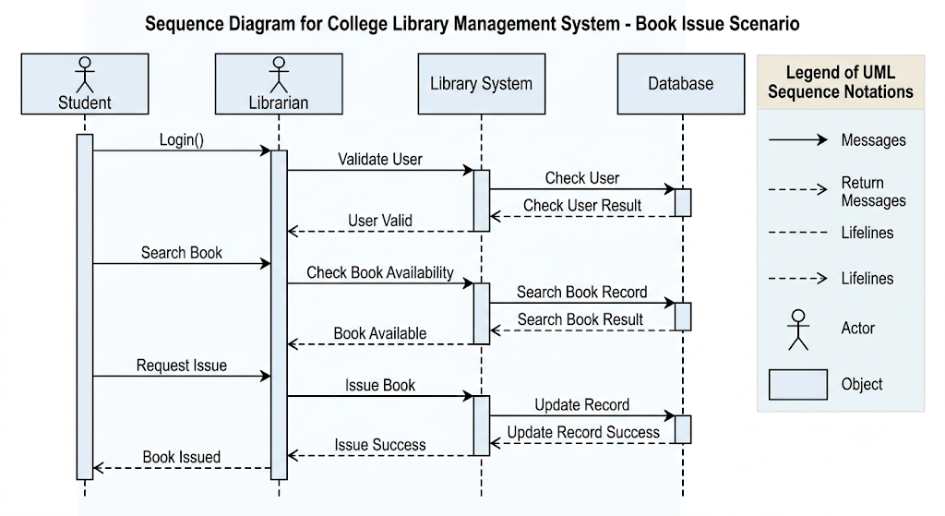

7) Conclusion
The sequence diagram models the Book Issue Process in a College Library Management System by showing interactions among Student, Librarian, Library System, and Database. It clearly illustrates the order of messages exchanged and is a commonly asked 8–10 mark UML Sequence Diagram question in examinations.

18) What is interaction and behavior modeling? list different diagram used for this modeling? Draw components used in 2 diagrams.
Ans.
Interaction and Behavior Modeling

1) Definition / Introduction
Interaction Modeling
- Interaction Modeling describes how different objects or components of a system communicate and exchange messages to perform a task.
- It focuses on the flow of messages and collaboration among objects.
Behavior Modeling
- Behavior Modeling describes the dynamic behavior of a system over time.
- It shows how a system reacts to events, changes states, and performs activities.
👉 Together, interaction and behavior modeling help understand how a system works dynamically.

2) Need of Interaction and Behavior Modeling
- Represents Dynamic Aspects
  - Shows system behavior during execution.
- Improves Understanding
  - Helps developers understand object interactions.
- Supports System Design
  - Assists in designing complex systems.
- Identifies Events and Responses
  - Shows how the system reacts to user actions.

3) Diagrams Used for Interaction and Behavior Modeling
A) Interaction Diagrams
- Sequence Diagram
- Communication (Collaboration) Diagram
- Timing Diagram
- Interaction Overview Diagram

B) Behavior Diagrams
- Activity Diagram
- State Machine (State Chart) Diagram
- Use Case Diagram (behavior-oriented UML diagram)

4) Draw Components Used in Two Diagrams

A) Sequence Diagram Components
1. Actor
👤
Student
Represents an external user interacting with the system.

2. Object
+-----------+
| System |
+-----------+
Represents a participating object.

3. Lifeline
+--------+
| Object |
+--------+
|
|
|
Shows existence of an object over time.

4. Message
Object1 ---------> Object2
Login()
Represents communication between objects.

5. Return Message
Object1 <-------- Object2
Success()
Represents response from receiver.

Combined Sequence Diagram Fragment
Student Library System
| |
|----Login()------>|
| |
|<---Success()-----|
| |

B) Activity Diagram Components
1. Initial State
●
Starting point of activity.

2. Activity
+-------------+
| Search Book |
+-------------+
Represents an action performed.

3. Decision Node
◇
Book?
Used for conditional branching.

4. Control Flow
+------+ -----> +------+
| A | | B |
+------+ +------+
Shows flow between activities.

5. Final State
◎
Indicates end of activity.

Combined Activity Diagram Fragment
●
|
v
+---------------+
| Search Book |
+---------------+
|
v
◇
Available?
/ \
Yes No
| |
v v
+---------+ +-----------+
| Issue | | Display |
| Book | | Not Found |
+---------+ +-----------+
|
v
◎

5) Summary Table
Modeling Type | Diagrams Used
Interaction Modeling | Sequence Diagram, Communication Diagram, Timing Diagram, Interaction Overview Diagram
Behavior Modeling | Activity Diagram, State Machine Diagram, Use Case Diagram

6) Conclusion
- Interaction Modeling focuses on communication among objects.
- Behavior Modeling focuses on system actions, activities, and state changes.
- Common UML diagrams used are Sequence, Communication, Activity, and State Machine Diagrams.
- These diagrams help in understanding and designing the dynamic aspects of software systems.

Unit 4
1) Explain object-relation mapping and capabilities to be defined.
Ans.
Object-Relational Mapping (ORM) and its Capabilities

1) Definition / Introduction
- Object-Relational Mapping (ORM) is a technique used to convert data between object-oriented models and relational databases.
- It helps in mapping classes → tables, objects → rows, and attributes → columns.
- ORM allows developers to work with objects instead of SQL queries, improving productivity.

2) Object-Relational Mapping (Explanation)
- Class to Table Mapping
  - Each class in an object-oriented system is mapped to a table in the database.
  - Example: Student class → Student table.
- Object to Row Mapping
  - Each object (instance) of a class represents a row (record) in the table.
  - Example: One student object → one row in Student table.
- Attributes to Columns Mapping
  - Class attributes are mapped to columns in the table.
  - Example: name, age → columns in database.
- Relationships Mapping
  - Associations like one-to-one, one-to-many, many-to-many are mapped using foreign keys.
  - Example: One customer → many orders.
- Primary Key Handling
  - Each object has a unique identifier (ID) mapped to a primary key in the table.

3) Capabilities to be Defined in ORM

1. Persistence Capability
- ORM should allow objects to be stored (saved) in the database automatically.
- Supports operations like insert, update, delete (CRUD).

2. Retrieval Capability
- Provides methods to fetch objects from the database without writing SQL.
- Supports querying using object-oriented syntax.

3. Relationship Handling
- ORM must manage associations between objects.
- Automatically handles joins and foreign key relationships.

4. Transaction Management
- Ensures data consistency and integrity using transactions.
- Supports commit and rollback operations.

5. Lazy and Eager Loading
- Controls how related objects are loaded:
  - Lazy Loading → load when needed
  - Eager Loading → load immediately

6. Caching Mechanism
- ORM provides caching to improve performance.
- Frequently accessed data is stored temporarily to reduce database calls.

7. Data Validation
- Ensures that data follows constraints and rules before storing.
- Example: checking null values, data types.

8. Schema Generation
- Automatically creates or updates database schema based on class structure.
- Reduces manual database design effort.

4) Diagram (Basic Mapping Representation)
Class: Student
---------------------
| id | name | age |
---------------------
↓ Mapping
Table: Student
---------------------
| id | name | age |
---------------------

5) Example (Real-life Understanding)
- In an E-commerce system:
  - Product class → Product table
  - Order class → Order table
  - ORM automatically saves and retrieves product/order data without SQL.

6) Conclusion
- ORM simplifies interaction between object-oriented applications and relational databases.
- It improves developer productivity, maintainability, and scalability.
- Proper ORM capabilities ensure efficient data handling and system performance.

2) What are the activities involved in access layer design process? Explain in brief.
Ans.
Activities Involved in Access Layer Design Process

1) Definition / Introduction
- The Access Layer (also called Data Access Layer) is responsible for interacting with the database and retrieving/storing data.
- It acts as a bridge between business logic and data storage, ensuring data abstraction and security.
- Designing this layer involves several activities to ensure efficient and reliable data access.

2) Activities in Access Layer Design (Point-wise)

1. Identify Data Sources
- Determine the type of data sources such as relational databases, files, or external systems.
- Understand the structure and format of data to be accessed.
- Helps in choosing appropriate data access techniques.

2. Define Data Access Requirements
- Identify what data is needed and how frequently it is accessed.
- Analyze operations like read, write, update, delete (CRUD).
- Ensures that the access layer meets application requirements.

3. Design Data Access Classes
- Create classes or modules responsible for interacting with the database.
- These classes encapsulate database operations and hide implementation details.
- Improves modularity and maintainability.

4. Implement Object-Relational Mapping (ORM)
- Map objects to database tables using ORM techniques.
- Reduces the need for writing complex SQL queries manually.
- Ensures smooth data conversion between objects and tables.

5. Handle Database Connections
- Design mechanisms for efficient connection management.
- Use techniques like connection pooling to improve performance.
- Prevents issues like connection leaks.

6. Manage Transactions
- Ensure data consistency and integrity during operations.
- Implement commit and rollback mechanisms.
- Important for operations involving multiple steps.

7. Implement Error and Exception Handling
- Handle database errors such as connection failure or query errors.
- Provide meaningful error messages for debugging.
- Improves system reliability.

8. Apply Security Measures
- Protect data using authentication and authorization.
- Prevent attacks like SQL injection.
- Ensures safe data access.

9. Optimize Performance
- Use techniques like caching and indexing.
- Reduce unnecessary database calls.
- Improves overall system efficiency.

10. Testing and Validation
- Test all data access operations for correctness and performance.
- Validate data consistency and error handling.
- Ensures robust and reliable access layer.

3) Diagram (Basic Access Layer Structure)
User Interface
↓
Business Logic Layer
↓
Access Layer (DAO / ORM)
↓
Database

4) Example (Real-life Understanding)
- In an Online Shopping System:
  - Access layer retrieves product details, stores orders, and updates inventory.
  - Business logic interacts with database only through this layer.

5) Conclusion
- The access layer design process ensures efficient, secure, and organized data handling.
- Proper design improves performance, scalability, and maintainability.
- It plays a crucial role in multi-tier architecture systems.

3) List and explain the steps in view layer macro process?
Ans.
Steps in View Layer Macro Process

1) Definition / Introduction
- The View Layer (Presentation Layer) is responsible for user interaction and display of information.
- It defines how data is presented to users through UI elements like forms, pages, and screens.
- The View Layer Macro Process involves steps to design an effective, user-friendly interface.

2) Steps in View Layer Macro Process (Point-wise)

1. Identify User Requirements
- Understand the needs and expectations of users.
- Analyze what information users want to view and interact with.
- Helps in designing a user-centered interface.

2. Define User Interface Structure
- Decide the overall layout of the interface (pages, screens, navigation).
- Identify components like menus, forms, buttons, and panels.
- Ensures proper organization of UI elements.

3. Design View Components
- Create individual UI components such as text fields, tables, images, and forms.
- Ensure components are consistent and reusable.
- Improves maintainability and usability.

4. Map Data to Views
- Determine how data from the system is displayed on the interface.
- Bind UI components with data sources (model/business layer).
- Ensures accurate and dynamic data presentation.

5. Define Navigation Flow
- Design how users move between different screens/pages.
- Include navigation elements like links, menus, and buttons.
- Ensures smooth and intuitive user experience.

6. Handle User Input
- Define how the system accepts and processes user input.
- Include form handling, validation, and error messages.
- Ensures correct and reliable data entry.

7. Apply UI Design Principles
- Follow principles like simplicity, consistency, and responsiveness.
- Use proper colors, fonts, and layouts.
- Enhances user experience (UX).

8. Integrate with Business Logic
- Connect the view layer with the business logic layer.
- Ensure data flows correctly between UI and backend.
- Maintains proper separation of concerns.

9. Test and Evaluate UI
- Test the interface for usability, performance, and correctness.
- Identify issues and improve design.
- Ensures a user-friendly and error-free interface.

3) Diagram (View Layer Interaction)
User
↓
View Layer (UI)
↓
Business Logic Layer
↓
Database

4) Example (Real-life Understanding)
- In an E-commerce website:
  - View layer shows product pages, cart, and checkout forms.
  - User interacts with UI, and data is processed by backend systems.

5) Conclusion
- The view layer macro process ensures effective design of user interfaces.
- It improves usability, interaction, and overall user experience.
- A well-designed view layer leads to better system acceptance and efficiency.

4) State and explain in detail main activities involved in design process?
Ans.
Main Activities Involved in Design Process

1) Definition / Introduction
- The Design Process in software engineering transforms requirements (analysis models) into a structured solution (design models).
- It focuses on defining architecture, components, interfaces, and data structures.
- The goal is to create a system that is efficient, scalable, and easy to implement.

2) Main Activities in Design Process (Point-wise)

1. Architectural Design
- Defines the overall structure of the system and how components are organized.
- Identifies subsystems, layers (UI, business, data), and their interactions.
- Helps in achieving scalability, performance, and maintainability.

2. Data Design
- Focuses on designing data structures, databases, and data relationships.
- Defines tables, attributes, keys, and constraints.
- Ensures efficient storage, retrieval, and integrity of data.

3. Interface Design
- Defines interaction between system components and with external systems.
- Includes user interfaces (UI) and system interfaces (APIs).
- Ensures smooth communication and usability.

4. Component-Level Design
- Breaks the system into smaller modules or components.
- Defines internal logic, algorithms, and responsibilities of each component.
- Improves modularity and reusability.

5. Deployment Design
- Specifies how software is distributed across hardware environments.
- Defines nodes, servers, and network configuration.
- Ensures efficient execution and resource utilization.

6. Database Design
- Designs the database schema and relationships.
- Includes normalization, indexing, and constraints.
- Ensures data consistency and performance.

7. Security Design
- Defines measures for authentication, authorization, and data protection.
- Prevents threats like unauthorized access and data breaches.
- Ensures system reliability and trustworthiness.

8. Error Handling Design
- Specifies how the system handles errors and exceptions.
- Includes error messages, logging, and recovery mechanisms.
- Improves system robustness.

9. Performance Optimization
- Focuses on improving speed, response time, and efficiency.
- Uses techniques like caching, load balancing, and efficient algorithms.
- Ensures the system meets performance requirements.

10. Design Validation and Review
- Evaluates the design for correctness, completeness, and feasibility.
- Conducts reviews and walkthroughs.
- Ensures the design meets user requirements and quality standards.

3) Diagram (Design Process Overview)
Requirements
↓
Architectural Design
↓
Detailed Design (Data, Interface, Components)
↓
Deployment & Optimization
↓
Implementation

4) Example (Real-life Understanding)
- In an E-commerce system:
  - Architectural design → 3-tier structure
  - Data design → product & order database
  - Interface design → web UI & payment API
  - Component design → cart, payment, order modules

5) Conclusion
- The design process involves multiple activities that transform requirements into a working system structure.
- Proper design ensures quality, scalability, and maintainability.
- It is a crucial phase for successful software development.

5) Define OCL? What do you mean by expressions? Give the syntax for some common expressions.
Ans.
Object Constraint Language (OCL)

1) Definition / Introduction
- OCL (Object Constraint Language) is a formal language used in UML to specify constraints and rules on models.
- It is used to define conditions that cannot be expressed using diagrams alone.
- OCL is declarative (no side effects) and is mainly used for validation and specification.

2) What do you mean by Expressions?
- An OCL Expression is a statement that evaluates to a value (Boolean, number, string, etc.).
- It is used to define conditions, constraints, and queries on UML models.
- Expressions are written in a precise and unambiguous way.
- They are commonly used in:
  - Invariants (conditions always true)
  - Preconditions (before operation)
  - Postconditions (after operation)

3) Common OCL Expressions with Syntax

1. Invariant Expression
- Used to define a condition that must always be true for a class.
Syntax:
context ClassName
inv: condition
Example:
context Student
inv: self.age > 0

2. Precondition Expression
- Specifies a condition that must be true before an operation is executed.
Syntax:
context ClassName::operation()
pre: condition
Example:
context Account::withdraw(amount: Real)
pre: amount > 0

3. Postcondition Expression
- Specifies a condition that must be true after an operation execution.
Syntax:
context ClassName::operation()
post: condition
Example:
context Account::withdraw(amount: Real)
post: self.balance = self.balance@pre - amount

4. Selection (Filtering) Expression
- Used to select elements from a collection based on a condition.
Syntax:
collection->select(condition)
Example:
students->select(age > 18)

5. Collection Size Expression
- Used to find the number of elements in a collection.
Syntax:
collection->size()
Example:
students->size()

6. ForAll Expression
- Checks if a condition is true for all elements in a collection.
Syntax:
collection->forAll(condition)
Example:
students->forAll(age > 18)

7. Exists Expression
- Checks if at least one element satisfies a condition.
Syntax:
collection->exists(condition)
Example:
students->exists(age < 18)

8. Let Expression
- Used to define a temporary variable in expressions.
Syntax:
let variable : Type = value in expression
Example:
let x : Integer = 10 in x * 2

4) Example (Real-life Understanding)
- In a Bank System:
  - Invariant → balance ≥ 0
  - Precondition → withdrawal amount > 0
  - Postcondition → updated balance after transaction

5) Conclusion
- OCL is used to define precise constraints in UML models.
- Expressions help in specifying rules, validations, and conditions clearly.
- It improves accuracy and correctness of system design.

6) Explain the design process of access layer classes with flow charts assuming suitable application.
Ans.
Design Process of Access Layer Classes (with Flowchart)

1) Definition / Introduction
- The Access Layer (Data Access Layer) is responsible for interacting with the database and performing CRUD operations.
- It isolates database logic from business logic, improving modularity and maintainability.
- Designing access layer classes involves defining how data is accessed, processed, and managed.

2) Assumed Application
👉 Online Shopping System
- Entities: Product, Customer, Order
- Access layer classes:
  - ProductDAO
  - CustomerDAO
  - OrderDAO

3) Design Process (Point-wise)

1. Identify Data Entities
- Determine main business objects like Product, Customer, Order.
- Each entity corresponds to a database table.
- Helps in defining separate access classes.

2. Define Access Layer Classes (DAO)
- Create Data Access Objects (DAO) for each entity.
- Each DAO handles database operations for one entity.
- Example: ProductDAO manages product data.

3. Define CRUD Operations
- Implement standard operations:
  - Create (Insert)
  - Read (Select)
  - Update
  - Delete
- Ensures complete data manipulation capability.

4. Establish Database Connection
- Design method to connect with database.
- Use connection pooling for performance.
- Ensures efficient and reusable connections.

5. Implement ORM / Mapping
- Map classes to tables and objects to rows.
- Convert database records into objects and vice versa.
- Reduces manual SQL coding.

6. Handle Transactions
- Ensure data consistency using transactions.
- Use commit and rollback for safe operations.
- Important for multi-step operations (e.g., order processing).

7. Error and Exception Handling
- Handle issues like connection failure, query errors.
- Provide meaningful error messages/logging.
- Improves system reliability.

8. Optimize Performance
- Use caching, indexing, and efficient queries.
- Minimize unnecessary database calls.
- Enhances system performance.

9. Testing and Validation
- Test all methods for correct data access.
- Validate edge cases and error scenarios.
- Ensures robustness of access layer.

4) Flowchart of Access Layer Design Process
Start
↓
Identify Entities (Product, Customer, Order)
↓
Design DAO Classes
↓
Define CRUD Operations
↓
Establish DB Connection
↓
Apply ORM Mapping
↓
Handle Transactions
↓
Implement Error Handling
↓
Optimize Performance
↓
Test & Validate
↓
End



5) Example (Real-life Understanding)
- When a user places an order:
  - OrderDAO saves order details
  - ProductDAO updates stock
  - CustomerDAO retrieves user info
- All operations are handled through access layer classes, not directly from UI.

6) Conclusion
- The design of access layer classes ensures organized, secure, and efficient data handling.
- It improves separation of concerns and system maintainability.
- Proper design leads to scalable and high-performance applications.

7) Draw and explain deployment diagram for a Railway Reservation System.
Ans.
Deployment Diagram for Railway Reservation System

1) Definition / Introduction
- A Deployment Diagram is a UML structural diagram that shows the physical arrangement of hardware (nodes) and software components deployed on them.
- It represents how the system is installed, configured, and executed in a real environment.
- Used to model client-server architecture and network connections.

2) Main Nodes in Railway Reservation System
- Client Node (User Device) – Computer/mobile used by passengers.
- Web Server – Handles user requests and UI.
- Application Server – Processes business logic (booking, cancellation).
- Database Server – Stores train, ticket, and user data.
- Payment Gateway (External System) – Handles online payments.

3) Deployment Diagram
+-------------------+ +-------------------+ +---------------------+
| Client Device | | Web Server | | Application Server |
| (Browser/Mobile) | | (UI Components) | | (Booking System) |
+-------------------+ +-------------------+ +---------------------+
| | |
| HTTP Request | |
|--------------------------->| |
| | Process Request |
| |--------------------------->|
| | | Business Logic
| | |
| | |------------------+
| | | |
| | v v
| | +----------------+ +------------------+
| | | Database Server| | Payment Gateway |
| | | (Train Data) | | (External System)|
| | +----------------+ +------------------+
| | |
|<---------------------------|<---------------------------|
| Response (Ticket Info) |
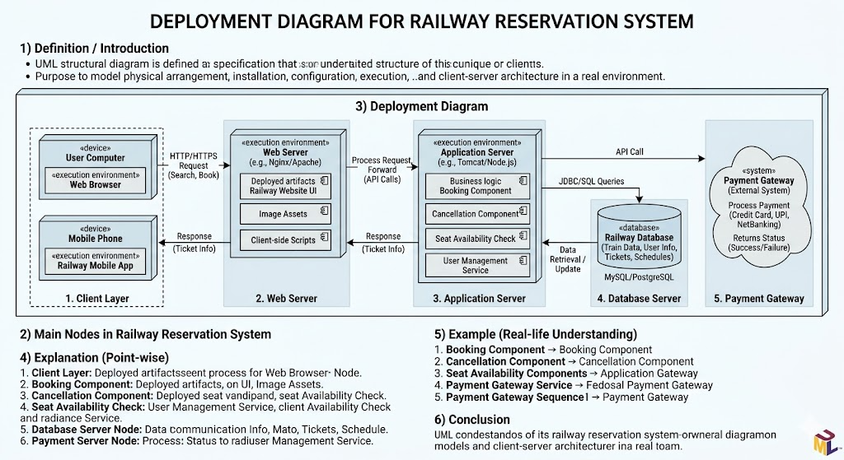

4) Explanation (Point-wise)

1. Client Layer
- User accesses the system via web browser or mobile app.
- Sends requests like search train, book ticket.

2. Web Server
- Handles HTTP requests and responses.
- Displays UI pages and forwards requests to application server.

3. Application Server
- Contains business logic such as:
  - Seat availability check
  - Ticket booking and cancellation
- Communicates with database and payment systems.

4. Database Server
- Stores train schedules, user details, ticket information.
- Ensures data consistency and retrieval.

5. Payment Gateway
- External system used for processing online payments.
- Returns payment success/failure status.

6. Communication Links
- Nodes communicate using network protocols (HTTP, JDBC, APIs).
- Shows interaction between distributed components.

5) Example (Real-life Understanding)
- A passenger books a ticket online:
  - Client sends request → Web server → Application server
  - Application checks database and processes payment
  - Ticket confirmation is sent back to the user

6) Conclusion
- The deployment diagram shows the physical architecture of the railway reservation system.
- It helps in understanding system distribution, communication, and scalability.
- Essential for designing real-world distributed applications.

8) What is OCL? Explain syntaxes for pre and post conditions with suitable examples
Ans.
Object Constraint Language (OCL)

1) Definition / Introduction
- OCL (Object Constraint Language) is a formal specification language used in UML to define constraints, rules, and conditions on models.
- It is used when diagrams alone are not sufficient to express detailed logic.
- OCL is declarative and side-effect free, meaning it only describes conditions and does not change system state.

2) Pre and Post Conditions in OCL
- Preconditions and Postconditions are used to define conditions before and after an operation execution.
- They help in ensuring correct behavior of operations.

3) Precondition
Explanation
- A Precondition specifies a condition that must be true before an operation is executed.
- If the condition is not satisfied, the operation should not be performed.
- It ensures that the system is in a valid state before execution.

Syntax
context ClassName::operation(parameters)
pre: condition

Example
context Account::withdraw(amount: Real)
pre: amount > 0 and amount <= self.balance
- Meaning:
  - Withdrawal amount must be positive.
  - Amount must be less than or equal to available balance.

4) Postcondition
Explanation
- A Postcondition specifies a condition that must be true after the operation execution.
- It describes the result or effect of the operation.
- It ensures that the system reaches a valid state after execution.

Syntax
context ClassName::operation(parameters)
post: condition

Example
context Account::withdraw(amount: Real)
post: self.balance = self.balance@pre - amount
- Meaning:
  - After withdrawal, the new balance is reduced by the withdrawn amount.
  - @pre refers to the value before execution.

5) Combined Example
context Account::withdraw(amount: Real)
pre: amount > 0 and amount <= self.balance
post: self.balance = self.balance@pre - amount

6) Example (Real-life Understanding)
- In an ATM System:
  - Precondition → User must have sufficient balance.
  - Postcondition → Balance is updated after withdrawal.

7) Conclusion
- OCL helps in defining precise constraints in UML models.
- Preconditions ensure valid input before execution, while postconditions ensure correct output after execution.
- Together, they improve accuracy, reliability, and correctness of system design.

9) Explain the Macro-level process of identification of view layer classes by analyzing use cases by using suitable example.
Ans.
Macro-Level Process of Identifying View Layer Classes (Using Use Cases)

1) Definition / Introduction
- The View Layer (Presentation Layer) contains classes responsible for user interaction and display of information.
- The macro-level process focuses on identifying these classes by analyzing use cases.
- It ensures that all user-visible functionalities are properly represented in the UI.

2) Steps in Macro-Level Identification (Point-wise)

1. Analyze Use Cases
- Study each use case to understand user goals and interactions.
- Identify inputs, outputs, and user actions.
- Helps in determining what screens or interfaces are required.

2. Identify User Interface Boundaries
- Determine where user interacts with the system.
- These boundaries represent view layer components.
- Each interaction point may correspond to a UI class or screen.

3. Identify View Layer Classes
- For each use case, define classes that handle display and input.
- Examples: forms, pages, dialogs, dashboards.
- These classes are responsible for presenting data and capturing input.

4. Define Responsibilities of Each Class
- Assign responsibilities like:
  - Display data
  - Accept user input
  - Validate input
- Ensures clear separation of concerns.

5. Map Use Case Steps to UI Components
- Convert each step in the use case into UI elements.
- Example: “Enter login details” → Login Form class.
- Ensures all use case steps are covered in UI design.

6. Identify Navigation Flow
- Determine how users move between screens.
- Define transitions like next, back, submit.
- Ensures smooth user experience.

7. Refine and Optimize View Classes
- Combine or split classes for better usability and efficiency.
- Ensure consistency and reusability of UI components.

3) Example (Online Shopping System – “Place Order” Use Case)
Use Case Steps
- User logs in
- Browses products
- Adds item to cart
- Proceeds to checkout
- Makes payment

Identified View Layer Classes
- Login Page Class
  - Accepts username/password
  - Validates user input
- Product Display Page
  - Shows list of products
  - Allows selection
- Cart Page
  - Displays selected items
  - Allows modification
- Checkout Page
  - Shows order summary
  - Collects delivery details
- Payment Page
  - Accepts payment information
  - Displays confirmation

4) Diagram (View Layer Identification Flow)
Use Case Analysis
↓
Identify UI Boundaries
↓
Identify View Classes
↓
Assign Responsibilities
↓
Map Use Case Steps
↓
Define Navigation
↓
Refine UI Design

5) Real-life Understanding
- When using an e-commerce website, each step (login, browse, cart, payment) corresponds to a separate screen/page.
- These screens are view layer classes identified from use cases.

6) Conclusion
- The macro-level process ensures systematic identification of view layer classes from use cases.
- It improves user interface design and usability.
- Helps in building structured, user-friendly, and maintainable systems.

10) Explain steps in designing business classes.
Ans.
Steps in Designing Business Classes

1) Definition / Introduction
- Business Classes represent the core business logic and entities of a system.
- They model real-world concepts such as Customer, Order, Account, etc.
- Designing business classes ensures proper handling of data, rules, and operations in the system.

2) Steps in Designing Business Classes (Point-wise)

1. Identify Business Entities
- Analyze requirements and use cases to identify key domain objects.
- These objects represent real-world entities.
- Example: In banking → Account, Customer, Transaction.

2. Define Class Attributes
- Identify properties (data members) for each class.
- Attributes represent characteristics of the entity.
- Example: Account → accountNo, balance, type.

3. Define Class Operations (Methods)
- Determine functions/behaviors each class performs.
- Operations implement business logic.
- Example: Account → deposit(), withdraw().

4. Establish Relationships
- Define relationships such as:
  - Association (Customer–Account)
  - Aggregation/Composition
  - Inheritance
- Helps in modeling interactions between classes.

5. Apply Business Rules
- Incorporate constraints and rules into class design.
- Example: balance should not be negative.
- Ensures valid and consistent behavior.

6. Design Class Interfaces
- Define public methods accessible to other classes.
- Hide internal implementation using encapsulation.
- Improves security and modularity.

7. Refine Class Design
- Remove redundancy and improve cohesion.
- Ensure each class has a single responsibility.
- Apply design principles like low coupling.

8. Validate with Use Cases
- Check whether classes support all use case scenarios.
- Ensure no functionality is missing.
- Improves accuracy of design.

9. Optimize for Reusability
- Design classes to be reusable in different modules.
- Avoid duplication of logic.
- Enhances maintainability.

3) Diagram (Basic Business Class Design)
Class: Account
-------------------------
Attributes:
- accountNo
- balance
Methods:
- deposit()
- withdraw()
-------------------------

4) Example (Real-life Understanding)
- In an E-commerce system:
  - Customer Class → stores user details
  - Order Class → handles order processing
  - Product Class → manages product data

5) Conclusion
- Designing business classes is essential for implementing core system functionality.
- Proper design ensures clarity, reusability, and maintainability.
- It forms the backbone of object-oriented system development.

11) Justify the use of activity diagram in design of business class.
Ans.
Use of Activity Diagram in Design of Business Class

1) Definition / Introduction
- An Activity Diagram represents the flow of activities and control logic in a system.
- It helps in understanding how business processes are executed step-by-step.
- In business class design, it is used to model workflows and identify operations (methods).

2) Justification / Importance (Point-wise)

1. Helps in Understanding Business Workflow
- Activity diagrams clearly show the sequence of activities in a process.
- This helps designers understand how business operations are performed.
- Example: Order processing flow (select → pay → confirm).

2. Identifies Business Operations (Methods)
- Each activity can be mapped to a method in a business class.
- Helps in defining class responsibilities and functions.
- Example: “Process Payment” → processPayment() method.

3. Supports Identification of Classes
- Activities involving different entities help identify business classes.
- Example: Customer, Order, Payment classes derived from workflow.

4. Shows Decision Logic
- Decision nodes represent conditions and business rules.
- These conditions are implemented as logic inside class methods.
- Example: Payment success/failure condition.

5. Represents Parallel Processing
- Fork-join elements show parallel activities.
- Helps in designing classes that support concurrent operations.
- Example: Payment processing and order validation simultaneously.

6. Improves Clarity and Communication
- Provides a visual representation of system behavior.
- Easy for developers and stakeholders to understand and discuss.
- Reduces ambiguity in design.

7. Ensures Complete Coverage of Use Cases
- Activity diagrams ensure all steps in a use case are covered.
- Helps in designing complete and accurate business classes.

3) Diagram (Example: Order Processing)
Start
↓
Select Product
↓
Add to Cart
↓
[Payment Successful?]
├── No → Cancel Order
└── Yes → Process Order
↓
Confirm Order
↓
End

4) Example (Real-life Understanding)
- In an E-commerce system:
  - Activity diagram shows steps of placing an order.
  - These steps help define business class methods like:
    - addToCart()
    - makePayment()
    - confirmOrder()

5) Conclusion
- Activity diagrams play a crucial role in designing business classes.
- They help in identifying methods, classes, and workflows.
- Ensure clear, complete, and efficient system design.

12) What are the benefits of the Access Layer Class? List the access layer tasks.
Ans.
Access Layer Class – Benefits and Tasks

1) Definition / Introduction
- The Access Layer Class (Data Access Layer - DAL) is responsible for handling all interactions with the database.
- It acts as a bridge between business logic and data storage, hiding database details.
- It ensures clean separation of concerns in software design.

2) Benefits of Access Layer Class (Point-wise)

1. Separation of Concerns
- Separates business logic from data access logic.
- Makes the system modular and well-organized.
- Changes in database do not affect business layer directly.

2. Improved Maintainability
- Centralizes all database operations in one layer.
- Easier to modify or update database code.
- Reduces duplication of code.

3. Reusability
- Access layer classes can be reused across multiple modules.
- Avoids rewriting database logic.
- Saves development time and effort.

4. Data Abstraction
- Hides complex SQL queries and database details.
- Provides simple methods like getData(), saveData().
- Makes system easier to understand.

5. Enhanced Security
- Prevents direct access to the database.
- Helps in avoiding SQL injection and unauthorized access.
- Ensures controlled data operations.

6. Better Performance
- Supports techniques like caching and connection pooling.
- Reduces unnecessary database calls.
- Improves system efficiency.

7. Easier Testing
- Enables independent testing of data access logic.
- Supports use of mock databases.
- Improves system reliability.

3) Access Layer Tasks (Point-wise)

1. Database Connection Management
- Establish and manage connections to the database.
- Use connection pooling for efficiency.

2. Data Retrieval
- Fetch data from database using queries.
- Convert database records into objects.

3. Data Insertion
- Insert new records into database.
- Ensure data validity before storing.

4. Data Update
- Modify existing records based on requirements.
- Maintain data consistency.

5. Data Deletion
- Remove records from database when required.
- Ensure safe deletion using constraints.

6. Transaction Management
- Handle commit and rollback operations.
- Maintain data integrity during multiple operations.

7. Error and Exception Handling
- Handle database-related errors like connection failure.
- Provide proper logging and messages.

8. Data Mapping (ORM)
- Map objects to database tables and vice versa.
- Simplifies interaction with database.

9. Security Handling
- Implement authentication and authorization checks.
- Prevent malicious database access.

10. Performance Optimization
- Use indexing, caching, and optimized queries.
- Improve speed and efficiency of data operations.

4) Diagram (Access Layer Role)
User Interface
↓
Business Logic Layer
↓
Access Layer Class
↓
Database

5) Example (Real-life Understanding)
- In an Online Shopping System:
  - Access layer retrieves product data, stores orders, updates inventory.
  - Business logic interacts with database only through this layer.

6) Conclusion
- Access layer classes provide organized, secure, and efficient data handling.
- They improve maintainability, reusability, and performance.
- Essential for designing scalable and robust applications.

13) What is OCL? Explain its various mechanisms and its applications.
Ans.
Object Constraint Language (OCL)

1) Definition / Introduction
- OCL (Object Constraint Language) is a formal, declarative language used with UML to specify constraints, rules, and queries on models.
- It is used when diagrams alone cannot express detailed conditions and logic.
- OCL is side-effect free, meaning it only describes conditions and does not modify system state.

2) Various Mechanisms of OCL (Point-wise)

1. Invariants
- Invariants are conditions that must be always true for a class.
- Used to maintain data integrity and consistency.
Syntax:
context ClassName
inv: condition
Example:
context Account
inv: self.balance >= 0

2. Preconditions
- Define conditions that must be true before an operation executes.
- Ensure valid input or system state.
Syntax:
context ClassName::operation()
pre: condition
Example:
context Account::withdraw(amount: Real)
pre: amount > 0 and amount <= self.balance

3. Postconditions
- Define conditions that must be true after an operation execution.
- Describe the result or effect of an operation.
Syntax:
context ClassName::operation()
post: condition
Example:
context Account::withdraw(amount: Real)
post: self.balance = self.balance@pre - amount

4. Derivation Rules
- Used to define derived attributes whose values are computed.
- Avoids storing redundant data.
Syntax:
context ClassName::attribute: Type
derive: expression
Example:
context Person::age: Integer
derive: currentYear - self.birthYear

5. Query Expressions
- Used to retrieve or filter data without modifying it.
- Works on collections.
Example:
students->select(age > 18)
students->size()

6. Constraints on Associations
- Define rules on relationships between classes.
- Ensures valid links between objects.
Example:
context Customer
inv: self.orders->size() >= 1

3) Applications of OCL (Point-wise)

1. Model Validation
- Ensures UML models follow correct rules and constraints.
- Helps detect design errors early.

2. Business Rule Specification
- Used to define business logic and policies.
- Example: minimum balance in bank account.

3. Database Constraint Definition
- Maps to database constraints like NOT NULL, CHECK, UNIQUE.
- Ensures data consistency.

4. Software Design Documentation
- Provides precise and unambiguous documentation.
- Improves clarity of system behavior.

5. Test Case Generation
- Helps in generating test cases based on constraints.
- Ensures system correctness.

6. Code Generation Support
- Used in tools to generate validated code from UML models.
- Ensures correctness in implementation.

4) Diagram (OCL in UML Context)
UML Diagram
↓
OCL Constraints (Rules)
↓
Validated System Model

5) Example (Real-life Understanding)
- In a Bank System:
  - Invariant → balance ≥ 0
  - Precondition → withdrawal amount ≤ balance
  - Postcondition → balance updated correctly

6) Conclusion
- OCL enhances UML by adding precise constraints and rules.
- Its mechanisms (invariants, pre/post conditions, queries) ensure correct and reliable system design.
- Widely used for validation, documentation, and improving software quality.

14) Describe the steps involved in the process of designing view layer.
Ans.
Steps Involved in Designing View Layer

1) Definition / Introduction
- The View Layer (Presentation Layer) is responsible for displaying information and interacting with users.
- It includes elements like forms, web pages, UI screens, and controls.
- Designing the view layer ensures a user-friendly, efficient, and interactive interface.

2) Steps in Designing View Layer (Point-wise)

1. Analyze User Requirements
- Study user needs, goals, and use cases.
- Identify what information users want to view and input.
- Helps in designing a user-centered interface.

2. Identify View Layer Classes
- Determine UI-related classes such as forms, pages, dialogs, dashboards.
- Each class represents a specific user interaction screen.
- Example: LoginPage, ProductPage.

3. Design UI Structure
- Define the overall layout and structure of the interface.
- Organize components like menus, buttons, forms, panels.
- Ensures logical arrangement and easy navigation.

4. Design View Components
- Create individual UI elements such as:
  - Text fields
  - Tables
  - Images
  - Buttons
- Ensure components are consistent and reusable.

5. Map Data to UI
- Link UI elements with data from business layer.
- Ensure correct data binding and display.
- Supports dynamic content updates.

6. Define Navigation Flow
- Design how users move between screens/pages.
- Include navigation elements like links, menus, buttons.
- Ensures smooth and intuitive experience.

7. Handle User Input and Validation
- Define how system accepts and processes input.
- Apply validation rules (e.g., required fields).
- Display appropriate error messages.

8. Apply UI Design Principles
- Follow principles like:
  - Consistency
  - Simplicity
  - Responsiveness
- Improves overall user experience (UX).

9. Integrate with Business Logic
- Connect view layer with business layer for data processing.
- Ensure proper communication between layers.
- Maintains separation of concerns.

10. Test and Refine UI
- Test interface for usability, performance, and correctness.
- Collect feedback and improve design.
- Ensures a high-quality user interface.

3) Diagram (View Layer Design Flow)
User Requirements
↓
Identify View Classes
↓
Design UI Structure
↓
Design Components
↓
Map Data
↓
Navigation & Input Handling
↓
Testing & Refinement

4) Example (Real-life Understanding)
- In an E-commerce system:
  - Login Page → Product Page → Cart → Checkout
- Each step corresponds to a view layer component designed using this process.

5) Conclusion
- Designing the view layer ensures effective interaction between user and system.
- Following structured steps improves usability, consistency, and performance.
- A well-designed view layer leads to better user satisfaction and system success.

15) Draw a detailed Deployment diagram for Hotel management system scenario.
Ans.
Deployment Diagram for Hotel Management System

1) Definition / Introduction
- A Deployment Diagram represents the physical architecture of a system, showing hardware nodes and software components deployed on them.
- It illustrates how different parts of the system are distributed and communicate over a network.
- In a Hotel Management System, it helps visualize client devices, servers, database, and external services.

2) Assumptions
- System follows a 3-tier architecture (Client–Server model).
- Users include Receptionist, Admin, and Customers.
- The system supports online booking and payment.
- Payment is handled via an external payment gateway.
- Central database stores room, booking, and customer details.

3) Main Nodes Identified
- Client Devices (PC/Mobile – Receptionist/Admin/Customer)
- Web Server (UI handling)
- Application Server (Business logic)
- Database Server (Data storage)
- Payment Gateway (External System)

4) Deployment Diagram
+------------------------+ +------------------------+ +------------------------+
| Client Devices | | Web Server | | Application Server |
| (Receptionist/Admin/ | | (UI & Request Handler) | | (Business Logic Layer) |
| Customer Browser/App) | +------------------------+ +------------------------+
+------------------------+ | |
| | |
| HTTP/HTTPS Request | |
|-------------------------------->| |
| | Process Request |
| |-------------------------------->|
| | |
| | | Execute Logic
| | |
| | |--------------------+
| | | |
| | v v
| | +------------------+ +----------------------+
| | | Database Server | | Payment Gateway |
| | | (Hotel DB) | | (External Service) |
| | +------------------+ +----------------------+
| | |
|<--------------------------------|<--------------------------------|
| Response (Booking Info, Confirmation, etc.) |


5) Explanation (Point-wise)

1. Client Layer
- Includes Receptionist, Admin, and Customer devices.
- Users perform actions like room booking, check-in, billing.
- Sends requests via web browser or mobile app.

2. Web Server
- Handles HTTP/HTTPS requests from clients.
- Displays web pages and UI components.
- Forwards requests to the application server.

3. Application Server
- Contains business logic such as:
  - Room availability check
  - Booking and cancellation
  - Billing and report generation
- Acts as the core processing unit.

4. Database Server
- Stores all system data:
  - Customer details
  - Room information
  - Booking records
- Ensures data consistency and retrieval.

5. Payment Gateway
- External system used for online payments.
- Handles secure transactions and returns status.

6. Communication Links
- Nodes communicate via network protocols (HTTP, APIs, DB connections).
- Shows distributed nature of the system.

6) Example (Real-life Understanding)
- A customer books a hotel room online:
  - Client → Web Server → Application Server
  - Application checks database and processes payment
  - Confirmation is sent back to the user

7) Conclusion
- The deployment diagram shows the physical structure and interaction of components.
- Helps in understanding system scalability, distribution, and performance.
- Essential for designing real-world client-server applications like hotel management systems.

16) Discuss what is object relational system ? How it is used in designing table class mapping
Ans.
Object Relational System (Object-Relational Mapping - ORM) and Table Class Mapping

1) Definition / Introduction
- An Object Relational System (ORS) or Object Relational Mapping (ORM) is a technique used to map object-oriented classes to relational database tables.
- It acts as a bridge between the object-oriented model and the relational database model.
- ORM allows developers to work with database records as objects instead of writing complex SQL queries.
Examples:
- Hibernate (Java)
- Entity Framework (.NET)
- Django ORM (Python)

2) Need of Object Relational System
- Bridges Object and Relational Models
  - Converts classes and objects into database tables and records.
- Reduces SQL Coding
  - Developers can manipulate data using objects.
- Improves Maintainability
  - Database changes can be managed through class definitions.
- Supports Reusability
  - Business objects can be reused across applications.

3) How Object Relational System Works
Object-Oriented Side
Student
--------
rollNo
name
address
Relational Database Side
STUDENT
--------
roll_no
name
address
Mapping
Class Attribute → Table Column

rollNo → roll_no
name → name
address → address

4) Class-to-Table Mapping Rules

A) Class → Table
Rule
- Each class is mapped to one database table.
Example
Class : Student

↓

Table : STUDENT

B) Object → Row (Tuple)
Rule
- Each object instance becomes a row in the table.
Example
Student s1

↓

One record in STUDENT table

C) Attribute → Column
Rule
- Class attributes become table columns.
Example
Student
-------
rollNo
name
address

↓

STUDENT
-------
roll_no
name
address

D) Object Identifier → Primary Key
Rule
- Unique object identifier is mapped to Primary Key.
Example
rollNo

↓

roll_no (PK)

E) Association → Foreign Key
Rule
- Relationship between classes is represented using Foreign Keys.
Example
Student ---- Department

↓

STUDENT
department_id (FK)

5) Example of Table-Class Mapping

Class Diagram
+-------------+
| Student |
+-------------+
| rollNo |
| name |
+-------------+
|
| belongs to
|
v

+-------------+
| Department |
+-------------+
| deptId |
| deptName |
+-------------+

Relational Tables
STUDENT
STUDENT
----------------
roll_no (PK)
name
dept_id (FK)
DEPARTMENT
DEPARTMENT
----------------
dept_id (PK)
dept_name

Schema Diagram
DEPARTMENT
------------------
dept_id (PK)
dept_name
|
|
|
v

STUDENT
------------------
roll_no (PK)
name
dept_id (FK)

6) Benefits of Object Relational Mapping
- Automatic Mapping
  - Converts objects to database records automatically.
- Database Independence
  - Application code remains largely unchanged if database changes.
- Reduced Development Time
  - Less manual SQL coding required.
- Better Maintainability
  - Easy to manage large applications.
- Improved Productivity
  - Developers work with familiar object concepts.

7) Diagram Showing ORM Concept
+------------------+
| Business Classes |
+------------------+
|
| ORM Mapping
|
v
+------------------+
| Database Tables |
+------------------+
Example:
Student Class
|
| ORM
v
STUDENT Table

8) Conclusion
- An Object Relational System (ORM) is a mechanism that maps object-oriented classes to relational database tables.
- It simplifies database access by converting:
  - Class → Table
  - Object → Row
  - Attribute → Column
  - Association → Foreign Key
- ORM improves maintainability, productivity, and database integration, making it an important concept in table-class mapping and software design.

17) Bank offers credit card and debit card to the account holders. Consider different activities to be performed by card holder and draw Class diagram with association. Map Class to tables. Draw schema diagrm
Ans.
Class Diagram for Bank Credit Card and Debit Card System

1) Assumptions
A bank provides Credit Cards and Debit Cards to account holders.
Activities performed by Card Holder:
- Open Account
- Apply for Debit Card
- Apply for Credit Card
- Withdraw Cash
- Make Payment/Purchase
- Check Balance
- View Transaction History
- Pay Credit Card Bill

2) Identify Classes
Main Classes
- AccountHolder
- BankAccount
- DebitCard
- CreditCard
- Transaction
- Bank

3) Class Diagram with Association
+-------------------+
| AccountHolder |
+-------------------+
| holderId |
| name |
| address |
| mobileNo |
+-------------------+
| applyCard() |
| checkBalance() |
+-------------------+
|
| 1
|
| owns
|
| *
+-------------------+
| BankAccount |
+-------------------+
| accountNo |
| balance |
| accountType |
+-------------------+
| deposit() |
| withdraw() |
+-------------------+
/ \
/ \
/ \
/ \

+---------------+ +---------------+
| DebitCard | | CreditCard |
+---------------+ +---------------+
| cardNo | | cardNo |
| expiryDate | | creditLimit |
+---------------+ +---------------+
| withdraw() | | payBill() |
| purchase() | | purchase() |
+---------------+ +---------------+

|
| performs
|
*
+-------------------+
| Transaction |
+-------------------+
| transactionId |
| amount |
| date |
| type |
+-------------------+
| generateReceipt() |
+-------------------+

^
|
|
+-------------------+
| Bank |
+-------------------+
| bankId |
| branchName |
+-------------------+
| issueCard() |
| approveCard() |
+-------------------+

4) Association Explanation
Association | Meaning
AccountHolder → BankAccount | Account holder owns account
BankAccount → DebitCard | Account linked with debit card
BankAccount → CreditCard | Bank may issue credit card
Card → Transaction | Card performs transactions
Bank → Cards | Bank issues cards

5) Mapping Classes to Tables (Class → Relation Mapping)

ACCOUNT_HOLDER
ACCOUNT_HOLDER
--------------
holder_id (PK)
name
address
mobile_no

BANK_ACCOUNT
BANK_ACCOUNT
------------
account_no (PK)
holder_id (FK)
balance
account_type

DEBIT_CARD
DEBIT_CARD
----------
debit_card_no (PK)
account_no (FK)
expiry_date

CREDIT_CARD
CREDIT_CARD
-----------
credit_card_no (PK)
account_no (FK)
credit_limit
expiry_date

TRANSACTION
TRANSACTION
-----------
transaction_id (PK)
card_no
amount
transaction_date
transaction_type

BANK
BANK
----
bank_id (PK)
branch_name

6) Schema Diagram (Relational Schema)
ACCOUNT_HOLDER
--------------------
holder_id (PK)
name
address
mobile_no
|
|
| FK
v

BANK_ACCOUNT
--------------------
account_no (PK)
holder_id (FK)
balance
account_type
|
|
----------------
| |
| |
v v

DEBIT_CARD CREDIT_CARD
------------ ------------
debit_card_no credit_card_no
account_no FK account_no FK
expiry_date credit_limit
expiry_date

|
|
v

TRANSACTION
--------------------
transaction_id (PK)
card_no
amount
date
type

7) Notations Used
Class Notation
+----------------+
| Class Name |
+----------------+
| Attributes |
+----------------+
| Operations() |
+----------------+

Association
Class A -------- Class B
Represents relationship between classes.

Multiplicity
1 -------- *
- One-to-Many relationship
Example:
- One AccountHolder can have many Accounts.

Generalization (Inheritance)
Parent
▲
/ \
/ \
Child1 Child2
Example:
Card
▲
/ \
/ \
Debit Credit
Card Card

Primary Key (PK)
account_no (PK)
Unique identifier.

Foreign Key (FK)
holder_id (FK)
Reference to another table.
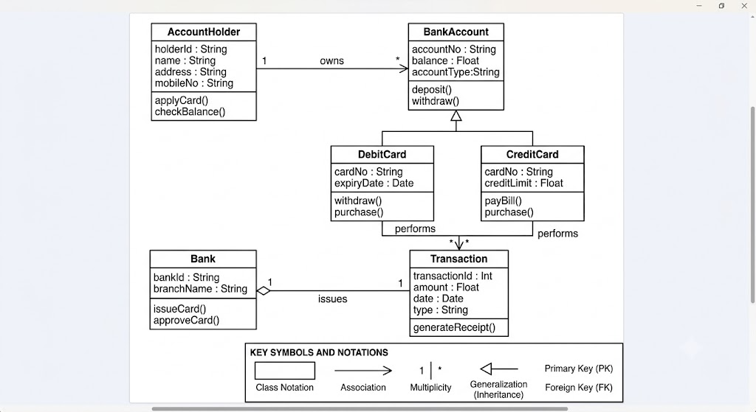
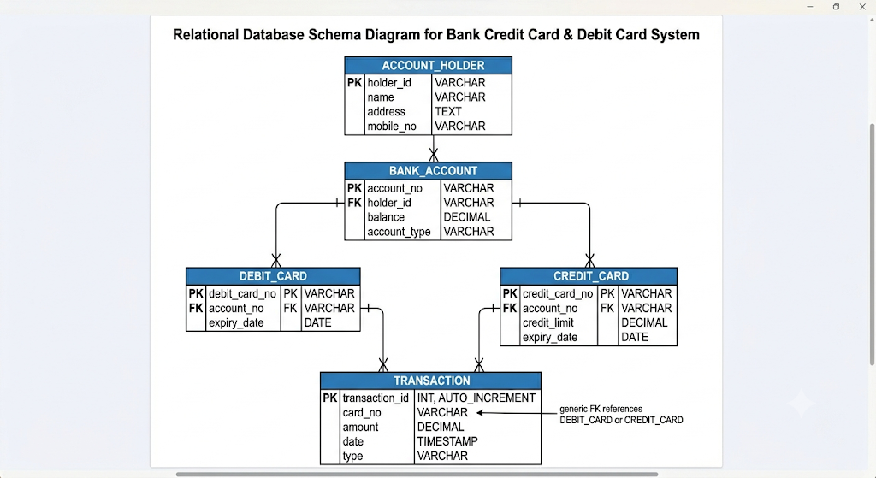

8) Conclusion
The Class Diagram models the relationship between AccountHolder, BankAccount, DebitCard, CreditCard, Transaction, and Bank. After mapping classes to relational tables, the Schema Diagram represents the database structure using Primary Keys (PK) and Foreign Keys (FK). This is a complete exam-oriented answer covering Class Diagram, Associations, Class-to-Table Mapping, Schema Diagram, and UML Notations.

18) Draw Component and Deployment Diagram for Car rental system.
Ans.
Component and Deployment Diagram for Car Rental System

1) Component Diagram for Car Rental System
Definition
- A Component Diagram represents the software components of a system and their dependencies.
- It shows how different modules interact to provide system functionality.

Main Components in Car Rental System
- Customer Interface
- Car Rental Management
- Booking Module
- Payment Module
- Authentication Module
- Database

Component Diagram
+----------------------+
| Customer Interface |
+----------------------+
|
v

+----------------------+
| Authentication Module|
+----------------------+
|
v

+----------------------+
| Car Rental Management|
+----------------------+
/ | \
/ | \
v v v

+-------------+ +------------+ +-------------+
| Booking | | Car Mgmt | | Customer |
| Module | | Module | | Module |
+-------------+ +------------+ +-------------+
|
v

+------------------+
| Payment Module |
+------------------+
|
v

+------------------+
| Rental Database |
+------------------+

Explanation
Customer Interface
- Allows customers to search, book, and rent cars.
Authentication Module
- Validates customer login credentials.
Car Rental Management
- Controls overall rental operations.
Booking Module
- Handles vehicle reservation requests.
Car Management Module
- Maintains car availability and details.
Customer Module
- Stores customer information.
Payment Module
- Processes rental payments.
Rental Database
- Stores booking, vehicle, and customer data.

UML Component Notation
Component Symbol
+------------------+
| Component |
| [ ] |
+------------------+
In exam, draw a small component symbol:
_____________
| Component |
| [ ] |
|_____________|

2) Deployment Diagram for Car Rental System
Definition
- A Deployment Diagram shows the physical arrangement of hardware nodes and software components.
- It illustrates where software components are deployed.

Nodes Used
- Customer Device
- Web Server
- Application Server
- Payment Gateway Server
- Database Server

Deployment Diagram
+---------------------+
| Customer Device |
| (Browser/Mobile) |
+---------------------+
|
| HTTP
v

+---------------------+
| Web Server |
| Car Rental Website |
+---------------------+
|
|
v

+---------------------+
| Application Server |
| Business Logic |
| Booking Module |
| Car Management |
+---------------------+
/ \
/ \
v v

+------------------+ +------------------+
| Database Server | | Payment Gateway |
| Rental Database | | External System |
+------------------+ +------------------+

Explanation
Customer Device
- Used by customer to access rental services.
Web Server
- Hosts website and receives requests.
Application Server
- Executes booking and rental logic.
Database Server
- Stores:
  - Customer details
  - Car details
  - Booking records
  - Payment information
Payment Gateway
- Processes online payments securely.

Deployment Diagram Notations
Node
+---------------+
| Node |
+---------------+
Represents hardware or execution environment.

Communication Path
Node A -------- Node B
Represents network communication.

Artifact
<<artifact>>
RentalSystem.jar
Represents deployed software component.

Combined Exam-Oriented Diagram
Customer Device
|
v
Web Server
|
v
Application Server
/ \
/ \
v v
Database Payment Gateway
Server
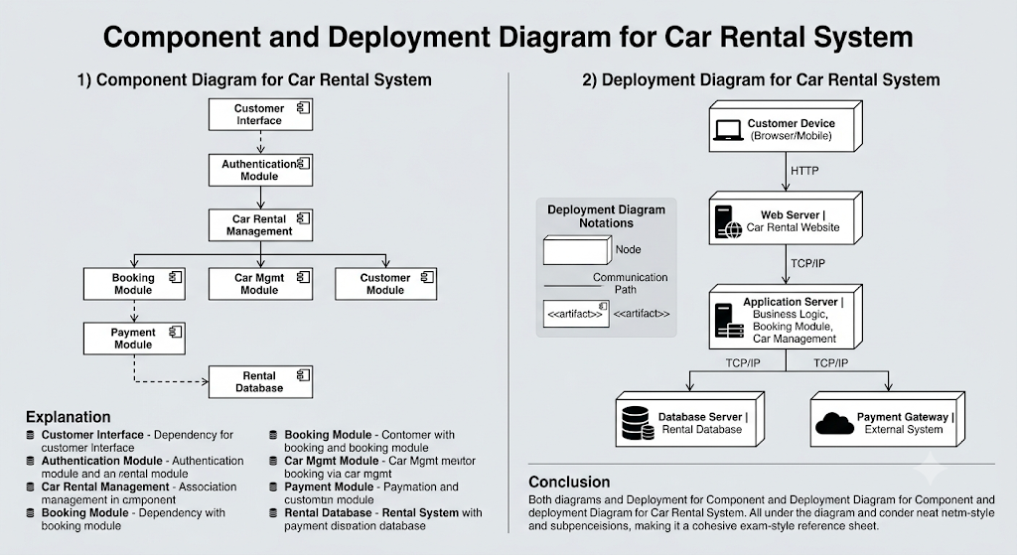

Conclusion
- Component Diagram shows the logical organization of software modules such as Booking, Payment, Customer Management, and Database.
- Deployment Diagram shows the physical deployment of the Car Rental System on Customer Device, Web Server, Application Server, Database Server, and Payment Gateway.
- Together, these diagrams provide a complete view of the software architecture and physical deployment of the Car Rental System.

Unit 5
1) Explain following design patterns with suitable application design requirements : [18]
a) Factory design pattern
b) State design pattern
c) Adapter design pattern
Ans.
Design Patterns: Factory, State, and Adapter

a) Factory Design Pattern

1) Definition / Introduction
- The Factory Design Pattern is a creational pattern used to create objects without specifying the exact class.
- It provides a factory method that returns objects based on input conditions.
- Promotes loose coupling and flexibility in object creation.

2) Explanation (Point-wise)
- Encapsulation of Object Creation
  - Object creation logic is hidden inside a factory class.
  - Client does not use new keyword directly.
- Use of Common Interface
  - All objects created share a common interface or superclass.
  - Ensures uniform behavior.
- Dynamic Object Selection
  - Factory decides which object to create at runtime.
  - Based on input parameters or conditions.
- Loose Coupling
  - Client depends only on interface, not concrete classes.
  - Easier to modify or extend system.

3) Diagram
Product (Interface)
/ \
ConcreteA ConcreteB
\ /
Factory Class
|
Client

4) Example (Application Requirement)
- Online Payment System:
  - Requirement: Support multiple payment modes (Credit Card, UPI, Net Banking).
  - Factory creates appropriate Payment object based on user choice.
  - Example: PaymentFactory.getPayment("UPI").

5) Conclusion
- Factory pattern simplifies object creation and improves scalability.
- Useful when system requires multiple object types with similar behavior.

b) State Design Pattern

1) Definition / Introduction
- The State Design Pattern is a behavioral pattern that allows an object to change its behavior when its internal state changes.
- The object appears to change its class dynamically.

2) Explanation (Point-wise)
- State-Based Behavior
  - Object behavior varies depending on its current state.
  - Each state is represented by a separate class.
- Encapsulation of State Logic
  - State-specific behavior is encapsulated in state classes.
  - Avoids large conditional statements.
- Context Class
  - Main class maintains a reference to the current state.
  - Delegates behavior to state object.
- Easy State Transition
  - State objects control transition from one state to another.

3) Diagram
Context
|
State Interface
/ \
StateA StateB

4) Example (Application Requirement)
- ATM Machine System:
  - States: Idle, Card Inserted, Transaction, Out of Service.
  - Behavior changes based on state:
    - Idle → wait for card
    - Card Inserted → validate PIN
    - Transaction → process request

5) Conclusion
- State pattern improves maintainability and flexibility.
- Ideal for systems with multiple states and dynamic behavior changes.

c) Adapter Design Pattern

1) Definition / Introduction
- The Adapter Design Pattern is a structural pattern used to connect incompatible interfaces.
- It acts as a bridge between two different systems.

2) Explanation (Point-wise)
- Interface Conversion
  - Converts one interface into another expected by the client.
  - Enables compatibility between different systems.
- Wrapper Class (Adapter)
  - Adapter class wraps the existing incompatible class.
  - Translates requests into suitable format.
- Reusability of Existing Code
  - Allows use of existing classes without modification.
  - Avoids rewriting code.
- Improves Integration
  - Useful when integrating third-party or legacy systems.

3) Diagram
Client → Target Interface
↑
Adapter
↓
Adaptee (Existing Class)

4) Example (Application Requirement)
- Mobile Charger Example:
  - Requirement: Use different plug types with same socket.
  - Adapter converts different plug formats to match socket.
- Software Example:
  - Integrating a third-party payment gateway API with different interface.
  - Adapter converts system calls to API format.

5) Conclusion
- Adapter pattern enables integration of incompatible systems.
- Enhances flexibility and reusability in software design.

Final Conclusion
- Factory Pattern → Object creation flexibility
- State Pattern → Behavior changes based on state
- Adapter Pattern → Interface compatibility

2) List GOF patterns. Explain any three patterns in detail
Ans.
Gang of Four (GoF) Design Patterns

1) Definition / Introduction
- GoF (Gang of Four) Design Patterns are 23 standard design patterns introduced by Erich Gamma, Richard Helm, Ralph Johnson, and John Vlissides.
- They provide reusable solutions to common software design problems.
- Patterns are classified into three categories: Creational, Structural, and Behavioral.

2) List of GoF Design Patterns

A) Creational Patterns (Object Creation)
- Singleton
- Factory Method
- Abstract Factory
- Builder
- Prototype

B) Structural Patterns (Class/Object Structure)
- Adapter
- Bridge
- Composite
- Decorator
- Facade
- Flyweight
- Proxy

C) Behavioral Patterns (Object Interaction)
- Chain of Responsibility
- Command
- Interpreter
- Iterator
- Mediator
- Memento
- Observer
- State
- Strategy
- Template Method
- Visitor

3) Explanation of Any Three Patterns

a) Singleton Pattern

Definition
- Ensures that a class has only one instance and provides a global access point to it.

Explanation (Point-wise)
- Single Instance Control
  - Only one object of the class is created.
  - Controlled using a private constructor.
- Global Access Point
  - Instance is accessed through a static method.
- Lazy Initialization (Optional)
  - Object is created only when needed.
- Thread Safety (Advanced)
  - Ensures safe access in multi-threaded environments.

Diagram
+------------------+
| Singleton |
|------------------|
| - instance |
|------------------|
| + getInstance() |
+------------------+

Example
- Database Connection Manager
  - Only one connection object is maintained throughout the system.

Conclusion
- Prevents multiple object creation and ensures efficient resource usage.

b) Strategy Pattern

Definition
- Defines a family of algorithms and allows them to be interchanged at runtime.

Explanation (Point-wise)
- Encapsulation of Algorithms
  - Each algorithm is implemented in a separate class.
- Common Interface
  - All strategies follow a common interface.
- Runtime Flexibility
  - Algorithm can be changed dynamically.
- Avoids Conditional Statements
  - Eliminates large if-else or switch blocks.

Diagram
Context
|
Strategy Interface
/ \
StrategyA StrategyB

Example
- Payment System
  - Different strategies: Credit Card, UPI, Net Banking.
  - User selects strategy at runtime.

Conclusion
- Improves flexibility and supports open/closed principle.

c) Adapter Pattern

Definition
- Converts the interface of a class into another interface expected by the client.

Explanation (Point-wise)
- Interface Compatibility
  - Allows incompatible classes to work together.
- Wrapper Class
  - Adapter acts as a bridge between client and existing class.
- Code Reusability
  - Existing code can be reused without modification.
- System Integration
  - Useful for integrating third-party or legacy systems.

Diagram
Client → Target Interface
↑
Adapter
↓
Adaptee

Example
- Media Player Application
  - Adapter allows playing different file formats (MP3, MP4, VLC).

Conclusion
- Adapter pattern enables smooth integration and interoperability.

4) Final Conclusion
- GoF patterns provide proven solutions for software design problems.
- Patterns like Singleton, Strategy, and Adapter improve:
  - Reusability
  - Flexibility
  - Maintainability
- They are essential for building robust and scalable systems.

3) Elaborate on General Responsibility Assignment Software Patterns
Ans.
General Responsibility Assignment Software Patterns (GRASP)

1) Definition / Introduction
- GRASP (General Responsibility Assignment Software Patterns) is a set of guidelines/principles used to assign responsibilities to classes and objects in object-oriented design.
- Introduced by Craig Larman, GRASP helps in achieving low coupling, high cohesion, and better system design.
- It provides best practices for deciding which class should do what.

2) GRASP Patterns (Point-wise Explanation)

1. Information Expert
- Responsibility should be assigned to the class that has the necessary information (data).
- Promotes encapsulation and logical design.
- Example: Order class calculates total because it contains item details.

2. Creator
- A class should create objects of another class if it:
  - Contains or uses those objects
  - Has necessary initialization data
- Example: Order creates OrderItem.

3. Controller
- Assign responsibility of handling system events to a controller class.
- Acts as a bridge between UI and business logic.
- Example: OrderController handles order requests.

4. Low Coupling
- Classes should have minimum dependencies on other classes.
- Reduces impact of changes and improves maintainability.
- Example: Avoid direct dependency between UI and database.

5. High Cohesion
- A class should have closely related responsibilities.
- Improves clarity, maintainability, and reusability.
- Example: Payment class handles only payment-related tasks.

6. Polymorphism
- Different classes should respond to the same message in different ways.
- Use inheritance and overriding to achieve flexibility.
- Example: Different payment methods implement pay() differently.

7. Pure Fabrication
- Create a non-domain class to handle responsibilities that do not fit naturally.
- Helps maintain low coupling and high cohesion.
- Example: DatabaseHelper class for database operations.

8. Indirection
- Introduce an intermediate class to reduce direct dependency between classes.
- Improves flexibility and decoupling.
- Example: Service layer between UI and database.

9. Protected Variations
- Protect elements from the impact of changes by encapsulating variations.
- Use interfaces or abstract classes.
- Example: Payment interface protects system from changes in payment methods.

3) Diagram (GRASP Overview)
User Interface
↓
Controller
↓
Business Classes (Expert, Creator)
↓
Helper Classes (Pure Fabrication)

4) Example (E-commerce System)
- Controller → OrderController handles requests
- Information Expert → Order calculates total
- Creator → Order creates OrderItem
- Low Coupling → UI does not access DB directly
- Polymorphism → Different payment methods

5) Conclusion
- GRASP patterns provide a systematic approach to assigning responsibilities.
- They improve:
  - Maintainability
  - Scalability
  - Flexibility
- Essential for designing well-structured object-oriented systems.

4) Explain Strategy and State patterns with suitable examples.
Ans.
Strategy and State Design Patterns

1) Strategy Design Pattern

1) Definition / Introduction
- The Strategy Pattern is a behavioral design pattern that defines a family of algorithms and makes them interchangeable at runtime.
- It allows selecting an algorithm dynamically without modifying the client code.
- Promotes flexibility and reusability.

2) Explanation (Point-wise)
- Encapsulation of Algorithms
  - Each algorithm is implemented in a separate class (strategy class).
  - Keeps logic modular and organized.
- Common Interface
  - All strategies implement a common interface.
  - Ensures uniform method execution.
- Context Class
  - Maintains a reference to a strategy object.
  - Delegates execution to the selected strategy.
- Runtime Flexibility
  - Strategy can be changed dynamically during execution.
  - Avoids large conditional statements.

3) Diagram
Context
|
Strategy Interface
/ \
StrategyA StrategyB

4) Example (Application Requirement)
- Online Payment System
  - Requirement: Support multiple payment methods.
  - Strategies: CreditCardPayment, UPI, NetBanking.
  - User selects preferred method at runtime.
👉 Methods:
- pay() implemented differently in each class.

5) Conclusion
- Strategy pattern improves flexibility and maintainability.
- Ideal when multiple algorithms exist for same task.

2) State Design Pattern

1) Definition / Introduction
- The State Pattern is a behavioral pattern where an object changes its behavior when its internal state changes.
- The object appears to change its class dynamically.

2) Explanation (Point-wise)
- State-Based Behavior
  - Behavior depends on the current state of the object.
  - Each state is represented by a separate class.
- Encapsulation of States
  - State-specific behavior is encapsulated in individual state classes.
  - Avoids complex conditional logic.
- Context Class
  - Maintains reference to the current state.
  - Delegates operations to the current state.
- State Transitions
  - State objects define transitions between states.

3) Diagram
Context
|
State Interface
/ \
StateA StateB

4) Example (Application Requirement)
- ATM Machine System
  - States:
    - Idle
    - Card Inserted
    - Transaction
    - Out of Service
👉 Behavior:
- Idle → Wait for card
- Card Inserted → Validate PIN
- Transaction → Process request

5) Conclusion
- State pattern improves clarity and maintainability.
- Suitable for systems with multiple states and dynamic behavior changes.

3) Key Difference (Quick Revision)
Feature | Strategy Pattern | State Pattern
Purpose | Change algorithm | Change state-based behavior
Focus | Different ways to perform a task | Different states of an object
Control | Client chooses strategy | State changes automatically
Example | Payment methods | ATM states

Final Conclusion
- Strategy Pattern → Used when multiple algorithms are available.
- State Pattern → Used when behavior depends on object state.
- Both improve flexibility, modularity, and clean design.

5) Describe Introduction and Information Expert pattern with suitable examples.
Ans.
GRASP: Introduction and Information Expert Pattern

1) Definition / Introduction (GRASP)
- GRASP (General Responsibility Assignment Software Patterns) are guidelines for assigning responsibilities to classes in object-oriented design.
- They help in achieving low coupling, high cohesion, and maintainable design.
- GRASP answers the key question: “Which class should do what?”
- It improves clarity, scalability, and reusability of software systems.

2) Need / Importance of GRASP
- Better Responsibility Assignment
  - Helps assign responsibilities to the right classes.
  - Avoids confusion and poor design decisions.
- Improves Maintainability
  - Leads to organized and modular structure.
  - Easy to update or modify system.
- Enhances Reusability
  - Classes are designed with specific responsibilities.
  - Can be reused in other systems.
- Supports Good Design Principles
  - Promotes low coupling and high cohesion.
  - Results in clean and efficient code.

3) Information Expert Pattern

1) Definition
- The Information Expert Pattern states:
👉 Assign responsibility to the class that has the required information (data) to fulfill it.
- It ensures that behavior is placed where the necessary data already exists.

2) Explanation (Point-wise)
- Responsibility Based on Data Ownership
  - The class that contains the data should perform related operations.
  - Avoids unnecessary data transfer between classes.
- Promotes Encapsulation
  - Data and behavior are kept together in the same class.
  - Improves data security and organization.
- Reduces Coupling
  - Minimizes dependencies between classes.
  - Each class handles its own responsibilities.
- Improves Cohesion
  - Class focuses on closely related tasks.
  - Leads to better maintainability.

3) Diagram
Class: Order
-------------------------
Attributes:
- items
- prices
Method:
- calculateTotal()
-------------------------
👉 Order class is the Information Expert because it has all item details.

4) Example (Real-life Understanding)
- E-commerce System:
  - Order class contains:
    - List of items
    - Price of each item
  - Responsibility: calculate total cost
👉 Instead of another class calculating total, Order itself does it.

5) Another Example
- Student System:
  - Student class has marks
  - Responsibility: calculate average marks
👉 Student is the Information Expert.

6) Conclusion
- GRASP provides a foundation for good object-oriented design.
- The Information Expert Pattern ensures:
  - Responsibilities are assigned logically
  - Better encapsulation, cohesion, and low coupling
👉 It leads to efficient and maintainable software systems.

6) Elaborate on Pure Fabrication pattern and Protected variation pattern with suitable. examples.
Ans.
GRASP Patterns: Pure Fabrication and Protected Variations

1) Definition / Introduction
- GRASP patterns guide how to assign responsibilities to achieve low coupling and high cohesion.
- Pure Fabrication and Protected Variations are used when direct assignment to domain classes leads to poor design.
- They improve flexibility, maintainability, and scalability of systems.

2) Pure Fabrication Pattern

1) Definition
- Pure Fabrication is a pattern where a new artificial (non-domain) class is created to handle responsibilities that do not naturally belong to any existing class.
- It is used to achieve low coupling and high cohesion.

2) Explanation (Point-wise)
- Artificial Class Creation
  - Create a class that does not represent a real-world entity.
  - Used purely for design improvement.
- Improves Low Coupling
  - Moves responsibilities away from tightly coupled classes.
  - Reduces dependency between domain objects.
- Enhances High Cohesion
  - Keeps related responsibilities in one place.
  - Avoids overloading domain classes.
- Supports Reusability
  - Fabricated class can be reused in multiple parts of the system.

3) Diagram
Customer -----> Order
\ |
\ |
---> DatabaseHelper (Pure Fabrication)

4) Example
- Database Handling in E-commerce System:
  - Instead of Customer or Order directly handling database operations,
  - A separate class DatabaseHelper or OrderDAO is created.
👉 This class is not a real-world entity but improves design.

5) Conclusion
- Pure Fabrication helps maintain clean design by separating responsibilities.
- Useful when domain classes become too complex or tightly coupled.

3) Protected Variations Pattern

1) Definition
- Protected Variations is a pattern that protects elements from the impact of changes (variations) by encapsulating them behind stable interfaces.
- It minimizes the effect of changes in one part of the system on others.

2) Explanation (Point-wise)
- Encapsulation of Changes
  - Identify parts of the system that may change frequently.
  - Encapsulate them using interfaces or abstract classes.
- Stable Interfaces
  - Clients depend on stable interfaces, not changing implementations.
  - Ensures minimal impact of changes.
- Reduces Ripple Effect
  - Changes in one module do not affect other modules.
  - Improves system robustness.
- Supports Flexibility and Extensibility
  - New variations can be added without modifying existing code.

3) Diagram
Payment Interface
/ \
CreditCard UPI Payment
↑
Client

4) Example
- Payment System:
  - Different payment methods: Credit Card, UPI, Net Banking.
  - Use a Payment interface.
👉 If a new method (e.g., Wallet) is added:
- No change required in client code → only new class added.

5) Conclusion
- Protected Variations ensures system is resistant to change impact.
- It improves flexibility, scalability, and maintainability.

4) Final Conclusion
- Pure Fabrication → Introduces artificial classes to improve design.
- Protected Variations → Protects system from future changes.
👉 Both patterns are essential for building robust and adaptable software systems.

7) Write a note on usage of following patterns
i) Singleton pattern
ii) Adapter pattern
iii) Facade pattern
Ans.
Usage of Design Patterns: Singleton, Adapter, Facade

1) Definition / Introduction
- Design Patterns are reusable solutions to common software design problems.
- They improve code structure, flexibility, and maintainability.
- Here we discuss the usage (where and why used) of three important patterns.

i) Singleton Pattern

1) Definition
- Ensures that a class has only one instance and provides a global access point to it.

2) Usage (Point-wise)
- Centralized Resource Management
  - Used when only one object is required to manage a resource.
  - Example: Database connection manager.
- Configuration Management
  - Stores application-wide settings in a single shared instance.
  - Ensures consistency across system.
- Logging System
  - Single logger object handles all logging activities.
  - Avoids multiple log file instances.
- Caching Mechanism
  - Maintains shared cache data accessible to all components.
  - Improves performance.

3) Example
- Printer Spooler System
  - Only one spooler manages all print jobs.

4) Conclusion
- Singleton is used when controlled access to a single instance is required.

ii) Adapter Pattern

1) Definition
- Converts the interface of a class into another interface expected by the client.

2) Usage (Point-wise)
- Integration of Third-Party Systems
  - Used when external APIs have different interfaces.
  - Adapter makes them compatible.
- Legacy System Integration
  - Allows old systems to work with new applications.
  - Avoids rewriting existing code.
- Interface Conversion
  - Converts data or method calls from one format to another.
- Reusability of Existing Classes
  - Enables reuse of classes without modifying their code.

3) Example
- Mobile Charger Adapter
  - Converts different plug types to fit into a socket.
- Software Example
  - Adapter used to integrate payment gateway API with application.

4) Conclusion
- Adapter is used for compatibility between incompatible systems.

iii) Facade Pattern

1) Definition
- Provides a simplified interface to a complex subsystem.

2) Usage (Point-wise)
- Simplifies Complex Systems
  - Hides internal complexity behind a simple interface.
  - Makes system easier to use.
- Reduces Dependency
  - Clients interact only with facade, not with multiple classes.
  - Reduces coupling.
- Improves Readability and Maintenance
  - Clean and easy-to-understand interface.
  - Easier to maintain code.
- Layered Architecture Support
  - Acts as an entry point for subsystems.
  - Common in multi-layered applications.

3) Example
- Home Theater System
  - Facade provides a single method like watchMovie()
  - Internally controls TV, speakers, lights, etc.
- Software Example
  - A single API call handles multiple backend operations (login, validation, DB access).

4) Conclusion
- Facade pattern is used to simplify interaction with complex systems.

5) Final Conclusion
- Singleton → Used for single shared instance
- Adapter → Used for interface compatibility
- Facade → Used for simplifying complex systems
👉 These patterns improve efficiency, maintainability, and system design quality.

8) What is a behavioural design pattern? How iterator pattern solves the problem of traversal of any type of list?
Ans.
Behavioral Design Pattern and Iterator Pattern

1) Behavioral Design Pattern
Definition / Introduction
- Behavioral Design Patterns focus on interaction and communication between objects.
- They define how objects collaborate and distribute responsibilities.
- These patterns improve flexibility and maintainability by separating behavior.

Explanation (Point-wise)
- Focus on Object Interaction
  - Describes how objects communicate with each other.
  - Defines clear responsibilities.
- Encapsulation of Behavior
  - Behavior is separated into independent classes or methods.
  - Makes code easier to modify.
- Improves Flexibility
  - Behavior can be changed without affecting other parts.
  - Supports dynamic changes.
- Examples of Behavioral Patterns
  - Strategy, State, Iterator, Observer, Command

Conclusion
- Behavioral patterns help in designing systems with efficient communication and dynamic behavior.

2) Iterator Pattern

1) Definition / Introduction
- The Iterator Pattern is a behavioral pattern that provides a way to access elements of a collection sequentially without exposing its internal structure.
- It separates traversal logic from the collection.

2) Problem in Traversal
- Different collections (Array, List, Tree) have different internal structures.
- Without iterator:
  - Client must know internal representation.
  - Leads to complex and tightly coupled code.

3) How Iterator Solves the Problem (Point-wise)

1. Provides Uniform Traversal Interface
- Offers common methods like:
  - hasNext()
  - next()
- Works for any collection type.

2. Hides Internal Structure
- Client does not need to know how data is stored.
- Traversal logic is handled by the iterator.

3. Supports Multiple Data Structures
- Same iterator interface works for:
  - Arrays
  - Lists
  - Trees

4. Allows Multiple Traversals
- Multiple iterators can traverse the same collection independently.

5. Reduces Coupling
- Client interacts only with iterator, not with collection internals.
- Improves maintainability.

4) Diagram
Collection Interface
|
Concrete Collection
|
Iterator Interface
/ \
Concrete Iterator Client

5) Example (Real-life Understanding)
- Playlist System:
  - Songs stored in different formats (array/list).
  - Iterator allows user to:
    - Play next song
    - Check if more songs exist
👉 User does not need to know storage structure.

6) Conclusion
- Iterator pattern provides a standard way to traverse any collection.
- It improves:
  - Abstraction
  - Flexibility
  - Code reusability

Final Summary
- Behavioral Pattern → Focus on object interaction
- Iterator Pattern → Solves traversal problem by providing uniform and abstract access mechanism
👉 Essential for designing clean and scalable systems.

9) Explain the solution of facade pattern using UML diagram.
Ans.
Facade Design Pattern – Solution using UML Diagram

1) Definition / Introduction
- The Facade Pattern is a structural design pattern that provides a simplified interface to a complex subsystem.
- It hides the internal complexity and exposes only the necessary functionality to the client.
- Helps in reducing coupling and improving usability.

2) Problem (Why Facade is Needed)
- In complex systems, a client may need to interact with multiple classes.
- This leads to:
  - Tight coupling
  - Complex code
  - Difficult maintenance
👉 Example: Home theater system (TV, DVD, speakers, lights).

3) Solution using Facade Pattern (Point-wise)

1. Introduce Facade Class
- Create a Facade class that acts as a single entry point.
- It provides simple methods to access complex subsystem functionality.

2. Encapsulate Subsystem Complexity
- The facade internally interacts with multiple subsystem classes.
- Client does not need to know about these classes.

3. Simplify Client Interaction
- Client communicates only with Facade, not with subsystem classes.
- Reduces dependency and complexity.

4. Maintain Flexibility
- Subsystem classes can still be accessed directly if needed.
- Changes in subsystem do not affect client.

4) UML Diagram
Client
|
v
+---------+
| Facade |
+---------+
| +operation() |
+---------+
/ | \
v v v
+--------+ +--------+ +--------+
|System A| |System B| |System C|
+--------+ +--------+ +--------+

5) Explanation of Diagram
- Client
  - Interacts only with the Facade class.
- Facade
  - Provides simplified methods like operation().
  - Internally calls subsystem methods.
- Subsystem Classes (A, B, C)
  - Perform actual complex operations.
  - Hidden from client.

6) Example (Real-life Understanding)
- Home Theater System:
  - Subsystems: TV, DVD Player, Speakers, Lights
  - Facade method: watchMovie()
    - Turns on TV
    - Starts DVD
    - Adjusts sound and lights
👉 User calls one method instead of multiple operations.

7) Conclusion
- Facade pattern provides a simple interface to complex systems.
- It improves:
  - Ease of use
  - Low coupling
  - Maintainability
👉 Essential for designing user-friendly and scalable systems.

10) Give the solution for structural design pattern.
Ans.
Structural Design Pattern – Solution

1) Definition / Introduction
- Structural Design Patterns deal with the composition of classes and objects to form larger structures.
- They help in organizing relationships to ensure flexibility and efficiency.
- These patterns simplify system design by managing complex class relationships.

2) Problem (Why Structural Patterns are Needed)
- Systems often contain multiple classes with complex relationships.
- Direct interaction between classes may lead to:
  - Tight coupling
  - Difficult maintenance
  - Poor scalability
👉 Need a structured way to connect classes and reuse existing code.

3) General Solution of Structural Design Patterns (Point-wise)

1. Composition over Inheritance
- Use object composition instead of inheritance.
- Combine objects dynamically to achieve flexibility.

2. Introduce Intermediate Structures
- Use wrapper or adapter classes to connect incompatible components.
- Reduces direct dependency between classes.

3. Simplify Complex Systems
- Provide high-level interfaces to hide subsystem complexity.
- Makes system easier to use.

4. Reuse Existing Components
- Existing classes are reused without modification.
- Improves development speed and efficiency.

5. Improve Flexibility
- Structure allows easy addition or modification of components.
- System becomes scalable.

6. Reduce Coupling
- Classes interact through interfaces or abstractions.
- Minimizes dependency.

4) UML Representation (General Structure)
Client
|
v
Interface/Facade
|
v
Adapter / Wrapper
|
v
Existing Classes (Subsystem)

5) Examples of Structural Pattern Solutions

1. Adapter Pattern
- Converts incompatible interfaces.
- Example: Payment API integration.

2. Facade Pattern
- Provides simplified interface to complex system.
- Example: Home theater system.

3. Decorator Pattern
- Adds new functionality dynamically.
- Example: Adding features to UI components.

4. Proxy Pattern
- Controls access to an object.
- Example: Secure access to database.

6) Real-life Example
- E-commerce System:
  - Facade → handles order processing
  - Adapter → integrates payment gateway
  - Decorator → adds discount features

7) Conclusion
- Structural patterns provide solutions for organizing and connecting classes efficiently.
- They improve:
  - Reusability
  - Flexibility
  - Maintainability
👉 Essential for designing scalable and well-structured software systems.

11) What is an iterator pattern, what is its use and how is it modelled using UML.
Ans.
Iterator Design Pattern

1) Definition / Introduction
- The Iterator Pattern is a behavioral design pattern that provides a way to access elements of a collection sequentially without exposing its internal structure.
- It separates traversal logic from the collection object.
- Enables uniform access to different data structures.

2) Use of Iterator Pattern (Point-wise)

1. Uniform Traversal Mechanism
- Provides common methods like hasNext() and next().
- Allows traversal of different collections using the same interface.

2. Hides Internal Representation
- Client does not need to know whether data is stored as array, list, or tree.
- Improves abstraction and simplicity.

3. Supports Multiple Traversals
- Multiple iterators can be used to traverse the same collection independently.

4. Reduces Coupling
- Client interacts with iterator instead of collection internals.
- Improves maintainability and flexibility.

5. Enhances Reusability
- Same iterator logic can be reused for different collections.

3) UML Modeling of Iterator Pattern

1. Main Components
- Iterator Interface
  - Declares traversal methods (next(), hasNext()).
- Concrete Iterator
  - Implements iterator interface.
  - Maintains current position in collection.
- Aggregate (Collection) Interface
  - Declares method to create iterator.
- Concrete Aggregate
  - Implements collection and returns iterator.
- Client
  - Uses iterator to access elements.

2) UML Diagram
+------------------+
| Iterator |
|------------------|
| +next() |
| +hasNext() |
+------------------+
▲
|
+----------------------+
| Concrete Iterator |
|----------------------|
| - currentPosition |
| +next() |
| +hasNext() |
+----------------------+
+------------------+
| Aggregate |
|------------------|
| +createIterator()|
+------------------+
▲
|
+----------------------+
| Concrete Aggregate |
|----------------------|
| +createIterator() |
+----------------------+
Client
|
v
Uses Iterator

4) Example (Real-life Understanding)
- Music Playlist System:
  - Songs stored in array/list.
  - Iterator allows:
    - Play next song
    - Check if more songs exist
👉 User does not know how songs are stored.

5) Conclusion
- Iterator pattern provides a standard and abstract way to traverse collections.
- It improves:
  - Encapsulation
  - Flexibility
  - Code reusability
👉 Essential for handling different data structures with a common interface.

12) What is a design pattern? How do you categorize design pattern? Give an example for each category.
Ans.
Design Pattern

1) Definition / Introduction
- A Design Pattern is a reusable solution to commonly occurring problems in software design.
- It provides a standard approach or template for solving design issues.
- Patterns are not code, but guidelines to structure classes and objects effectively.

2) Categorization of Design Patterns
- Design patterns are mainly classified into three categories based on their purpose:
  - Creational Patterns
  - Structural Patterns
  - Behavioral Patterns

A) Creational Design Patterns

Definition
- Deal with object creation mechanisms.
- Aim to create objects in a flexible and reusable way.

Explanation (Point-wise)
- Encapsulate Object Creation
  - Hide the logic of object creation from the client.
- Improve Flexibility
  - Allow system to decide which objects to create.
- Reduce Dependency
  - Client depends on abstraction, not concrete classes.

Example: Factory Pattern
- Creates objects based on input without specifying exact class.
- Example: Payment system creating different payment objects.

B) Structural Design Patterns

Definition
- Deal with composition of classes and objects.
- Help in forming larger structures efficiently.

Explanation (Point-wise)
- Organize Relationships
  - Define how classes are connected.
- Simplify System Structure
  - Reduce complexity using proper design.
- Promote Reusability
  - Reuse existing classes effectively.

Example: Adapter Pattern
- Converts one interface into another compatible interface.
- Example: Integrating third-party API.

C) Behavioral Design Patterns

Definition
- Focus on communication and interaction between objects.
- Define how responsibilities are distributed.

Explanation (Point-wise)
- Manage Object Interaction
  - Define communication between objects.
- Encapsulate Behavior
  - Separate behavior into independent units.
- Increase Flexibility
  - Behavior can change dynamically.

Example: Strategy Pattern
- Defines multiple algorithms and selects one at runtime.
- Example: Different payment methods.

3) Diagram (Categorization Overview)
Design Patterns
|
-----------------------------------------
| | |
Creational Structural Behavioral

4) Conclusion
- Design patterns provide proven solutions for software design problems.
- Categorization helps in selecting the right pattern for the right problem.
- They improve:
  - Reusability
  - Maintainability
  - Scalability
👉 Essential for building robust and well-structured software systems.

13) How pure fabrication can solve issues related to high cohesion and low coupling? Explain with the help of Sales man as the scenario
Ans.
Pure Fabrication Pattern to Achieve High Cohesion and Low Coupling (Salesman Scenario)

1) Definition / Introduction
- Pure Fabrication is a GRASP (General Responsibility Assignment Software Pattern).
- It suggests creating an artificial class that does not represent any real-world object when assigning responsibilities to existing classes would reduce cohesion or increase coupling.
- The fabricated class is created solely to improve software design.
Keywords:
Pure Fabrication, High Cohesion, Low Coupling, Reusability, Maintainability

2) Problem in Salesman Scenario
Consider a Salesman Management System.
Classes:
Salesman
---------
salesmanId
name
salary
commission
Suppose the Salesman class performs:
- Calculate commission
- Store salesman details in database
- Update records
- Generate reports
- Search records
Issue
If all responsibilities are assigned to the Salesman class:
Salesman
---------
calculateCommission()
saveToDatabase()
updateRecord()
generateReport()
searchSalesman()
Problems
- Low Cohesion
  - One class performs many unrelated tasks.
  - Database operations and report generation are not part of salesman data.
- High Coupling
  - Salesman class becomes dependent on database and reporting modules.
- Difficult Maintenance
  - Any database change requires modification in Salesman class.

3) Solution Using Pure Fabrication
Create a separate fabricated class:
SalesmanDAO
(DAO = Data Access Object)
Responsibilities of SalesmanDAO
- saveSalesman()
- updateSalesman()
- deleteSalesman()
- searchSalesman()
Now Salesman contains only business data and business logic.

4) UML Diagram
+------------------+
| Salesman |
+------------------+
| salesmanId |
| name |
| salary |
| commission |
+------------------+
| calculateComm() |
+------------------+
|
|
v
+----------------------+
| SalesmanDAO |
+----------------------+
| saveSalesman() |
| updateSalesman() |
| deleteSalesman() |
| searchSalesman() |
+----------------------+
|
v
Database

5) How Pure Fabrication Achieves High Cohesion
Before
Salesman
├─ Business Logic
├─ Database Logic
├─ Report Logic
└─ Search Logic
- Multiple unrelated responsibilities.
- Cohesion is low.
After
Salesman
└─ Business Logic Only

SalesmanDAO
└─ Database Operations Only
- Each class has a single well-defined responsibility.
- High Cohesion is achieved.

6) How Pure Fabrication Achieves Low Coupling
Before
Salesman
|
+---- Database
|
+---- Reports
|
+---- Search Module
- Many dependencies.
- High coupling.
After
Salesman
|
v
SalesmanDAO
|
v
Database
- Salesman no longer depends directly on database.
- Coupling is reduced.

7) Advantages of Pure Fabrication
- Achieves High Cohesion
  - Each class performs related tasks only.
- Reduces Coupling
  - Classes have fewer dependencies.
- Improves Reusability
  - DAO class can be reused in different modules.
- Simplifies Maintenance
  - Changes in database affect only DAO class.
- Improves Flexibility
  - Easy to modify and extend the system.

8) Real-Life Example
E-Commerce System
Instead of:
Order
├─ Calculate Total
├─ Save Order
├─ Generate Invoice
└─ Update Database
Create:
Order
└─ Business Logic

OrderDAO
└─ Database Operations
This is another example of Pure Fabrication.

9) Conclusion
- Pure Fabrication introduces an artificial class to handle responsibilities that do not naturally belong to domain classes.
- In the Salesman scenario, creating a SalesmanDAO class moves database operations away from the Salesman class.
- This results in:
  - High Cohesion (each class has a focused responsibility)
  - Low Coupling (reduced dependencies between classes)
  - Better maintainability, flexibility, and reusability of the system.

14) Explain Façade Behavioral Patterns. Write in detail any 2 Façade Behavioral Patterns
Ans.
Façade and Behavioral Design Patterns

1) Introduction
Design patterns are reusable solutions to common software design problems. They are broadly classified into:
- Creational Patterns – Object creation.
- Structural Patterns – Class/object composition.
- Behavioral Patterns – Interaction and communication among objects.
Façade Pattern belongs to the Structural Design Pattern category, while Strategy and State are examples of Behavioral Patterns.

A) Façade Pattern (Structural Pattern)
Definition
- The Façade Pattern provides a simple and unified interface to a complex subsystem.
- It hides the complexity of multiple classes and provides a single point of access to the client.

UML Diagram
Client
|
v
+-----------+
| Facade |
+-----------+
/ | \
/ | \
v v v
SystemA SystemB SystemC

Example
Home Theater System
Subsystems:
- TV
- DVD Player
- Speaker System
- Lights
Instead of controlling each device separately:
TV.on()
DVD.play()
Speaker.start()
Lights.dim()
The user simply calls:
watchMovie()
through the HomeTheaterFacade class.

B) Behavioral Design Patterns
Definition
- Behavioral patterns focus on communication and responsibility among objects.
- They define how objects interact and exchange information.
Examples:
- Strategy Pattern
- State Pattern
- Iterator Pattern
- Observer Pattern

2) Strategy Pattern (Behavioral Pattern)
Definition
- The Strategy Pattern defines a family of algorithms and makes them interchangeable at runtime.
- The client can choose the required algorithm without modifying code.

Example: Online Payment System
Requirement
A shopping website supports:
- Credit Card
- Debit Card
- UPI
Strategies
PaymentStrategy
|
--------------------
| | |
Credit Debit UPI
Card Card
Working
Customer selects payment mode.
pay()
is executed according to selected strategy.

Advantages
- Eliminates large if-else statements.
- Easy to add new algorithms.
- Improves flexibility.
- Promotes code reuse.

Real-Life Example
Google Maps:
- Fastest Route
- Shortest Route
- Toll-Free Route
Each route calculation acts as a different strategy.

3) State Pattern (Behavioral Pattern)
Definition
- The State Pattern allows an object to change its behavior when its internal state changes.
- Different states are represented by separate classes.

UML Diagram
Example: ATM Machine
States
- Idle State
- Card Inserted State
- Transaction State
- Out of Service State
s
Advantages
- Removes complex conditional statements.
- Improves maintainability.
- Makes state transitions explicit.
- Easy to add new states.

Real-Life Example
Traffic Signal System
Red → Yellow → Green → Red
Each color represents a different state with different behavior.

Comparison of Strategy and State Pattern
Feature | Strategy Pattern | State Pattern
Purpose | Change algorithm | Change behavior based on state
Focus | Different ways to perform a task | Different states of an object
Selection | Chosen by client | Changes automatically
Example | Payment methods | ATM states

Conclusion
- Façade Pattern simplifies interaction with complex subsystems by providing a single interface.
- Behavioral Patterns define how objects communicate and behave.
- Two important behavioral patterns are:
  - Strategy Pattern – selects algorithms dynamically.
  - State Pattern – changes behavior according to object state.
- These patterns improve flexibility, maintainability, and scalability of software systems.

15) Apply strategy design pattern to the following and draw the class diagram. A company has many employees. Each employee has a name and a performance index in the range of 1 to 5. When the index is 2 the increment is 10 percent of the previous year salary, 3 the increment is 15 percent of the previous year salary, 4 the increment is 20 percent of the previous year salary. Indicate roll of each class in the class diagram.
Ans.
Strategy Design Pattern for Employee Salary Increment System

1) Introduction
- The Strategy Pattern is a Behavioral Design Pattern.
- It defines a family of algorithms, encapsulates each algorithm in a separate class, and makes them interchangeable.
- The client can select the appropriate algorithm at runtime.
In Given Scenario
The increment percentage depends on the Performance Index:
Performance Index | Increment
2 | 10% of salary
3 | 15% of salary
4 | 20% of salary
Different increment calculations can be implemented as different strategies.

2) Identify Classes and Their Roles
1. Employee (Context Class)
- Stores employee details.
- Maintains reference to Increment Strategy.
- Uses strategy to calculate increment.

2. IncrementStrategy (Strategy Interface)
- Defines common method:
calculateIncrement()

3. Increment10 (Concrete Strategy)
- Calculates 10% increment.
- Used when Performance Index = 2.

4. Increment15 (Concrete Strategy)
- Calculates 15% increment.
- Used when Performance Index = 3.

5. Increment20 (Concrete Strategy)
- Calculates 20% increment.
- Used when Performance Index = 4.

3) UML Class Diagram
+----------------------+
| IncrementStrategy |
+----------------------+
| +calculateIncrement()|
+----------------------+
▲
__________________|__________________
| | |
| | |
| | |

+----------------+ +----------------+ +----------------+
| Increment10 | | Increment15 | | Increment20 |
+----------------+ +----------------+ +----------------+
| +calculateInc()| | +calculateInc()| | +calculateInc()|
+----------------+ +----------------+ +----------------+

▲
|
|
uses Strategy
|
|

+------------------+
| Employee |
+------------------+
| empId |
| name |
| salary |
| performanceIndex |
+------------------+
| setStrategy() |
| getIncrement() |
+------------------+

4) Working of Strategy Pattern
Employee with Performance Index = 2
Employee
|
v
Increment10 Strategy
|
v
10% Increment

Employee with Performance Index = 3
Employee
|
v
Increment15 Strategy
|
v
15% Increment

Employee with Performance Index = 4
Employee
|
v
Increment20 Strategy
|
v
20% Increment

5) Example
Assume Salary = ₹50,000
Index = 2
Increment = 10%

= 50000 × 10/100
= ₹5,000
New Salary = ₹55,000

Index = 3
Increment = 15%

= 50000 × 15/100
= ₹7,500
New Salary = ₹57,500

Index = 4
Increment = 20%

= 50000 × 20/100
= ₹10,000
New Salary = ₹60,000
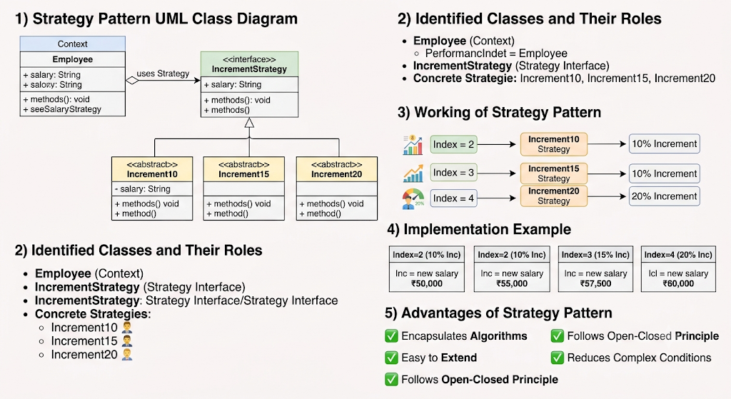

6) Advantages of Using Strategy Pattern
- Encapsulates Increment Algorithms
  - Each increment rule is placed in a separate class.
- Easy to Extend
  - New increment percentages can be added without changing existing code.
- Follows Open-Closed Principle
  - System is open for extension but closed for modification.
- Reduces Complex Conditions
  - Eliminates large if-else or switch statements.
- Improves Maintainability
  - Increment logic is easy to manage and test.

7) Conclusion
The Strategy Pattern is suitable for the Employee Increment System because different salary increment calculations (10%, 15%, and 20%) are implemented as separate strategies. The Employee class acts as the Context, IncrementStrategy acts as the Strategy Interface, and Increment10, Increment15, and Increment20 are Concrete Strategy classes. This design provides flexibility, reusability, and easy maintenance.

16) Explain GOF design patterns
Ans.
GOF (Gang of Four) Design Patterns

1) Definition / Introduction
- GOF (Gang of Four) Design Patterns are reusable solutions to commonly occurring software design problems.
- They were introduced by four authors:
  - Erich Gamma
  - Richard Helm
  - Ralph Johnson
  - John Vlissides
- Their famous book is Design Patterns: Elements of Reusable Object-Oriented Software.
- GOF patterns provide proven design solutions that improve reusability, maintainability, flexibility, and scalability.

2) Need for GOF Design Patterns
1. Reuse Proven Solutions
- Avoids solving the same design problem repeatedly.
- Uses tested and reliable approaches.
2. Improves Maintainability
- Makes software easier to modify and extend.
3. Reduces Complexity
- Provides standard design structures.
4. Enhances Communication
- Developers can discuss designs using common pattern names.

3) Categories of GOF Design Patterns
GOF patterns are divided into three categories:
GOF Design Patterns
|
--------------------------------
| | |
Creational Structural Behavioral
Patterns Patterns Patterns

A) Creational Patterns
Definition
- Concerned with object creation mechanisms.
- Hide the complexities of object creation.
GOF Creational Patterns
- Singleton
- Factory Method
- Abstract Factory
- Builder
- Prototype

Example: Singleton Pattern
+------------------+
| Singleton |
+------------------+
| -instance |
+------------------+
| +getInstance() |
+------------------+
Use: Database Connection Manager, Configuration Manager.

B) Structural Patterns
Definition
- Deal with composition of classes and objects.
- Help form larger structures while keeping systems flexible.
GOF Structural Patterns
- Adapter
- Bridge
- Composite
- Decorator
- Facade
- Flyweight
- Proxy

Example: Adapter Pattern
Client
|
v
Adapter
|
v
Adaptee
Use: Connecting incompatible interfaces.

C) Behavioral Patterns
Definition
- Focus on interaction and communication between objects.
- Define responsibilities among objects.
GOF Behavioral Patterns
- Strategy
- State
- Iterator
- Observer
- Command
- Mediator
- Memento
- Template Method
- Visitor
- Chain of Responsibility
- Interpreter

Example: Strategy Pattern
Context
|
Strategy Interface
/ \
A B
Use: Multiple payment methods, route selection.

4) GOF Patterns Commonly Covered in Syllabus
Category | Pattern | Purpose
Creational | Singleton | Only one object instance
Creational | Factory | Creates objects dynamically
Structural | Adapter | Converts one interface to another
Structural | Facade | Provides simplified interface
Behavioral | Strategy | Selects algorithm at runtime
Behavioral | State | Changes behavior based on state

5) Detailed Explanation of Important GOF Patterns
1. Singleton Pattern
- Ensures only one instance of a class exists.
- Example: Printer Spooler, Database Connection.
2. Factory Pattern
- Creates objects without specifying exact class.
- Example: Vehicle Factory creating Car or Bike.
3. Adapter Pattern
- Makes incompatible interfaces work together.
- Example: Mobile charger adapter.
4. Facade Pattern
- Provides one simplified interface to a complex subsystem.
- Example: Home Theater Controller.
5. Strategy Pattern
- Encapsulates multiple algorithms.
- Example: Credit Card, Debit Card, UPI Payment.
6. State Pattern
- Object changes behavior according to current state.
- Example: ATM Machine, Traffic Signal.

6) Advantages of GOF Design Patterns
1. Reusability
- Patterns can be applied across different projects.
2. Flexibility
- Easy to extend functionality.
3. Maintainability
- Simplifies modifications and debugging.
4. Scalability
- Supports growth of large systems.
5. Better Design Quality
- Encourages best software engineering practices.

7) Summary Table
Category | Number of GOF Patterns | Example
Creational | 5 | Singleton, Factory
Structural | 7 | Adapter, Facade
Behavioral | 11 | Strategy, State
Total GOF Patterns = 23

8) Conclusion
- GOF Design Patterns are standardized, reusable solutions to common software design problems.
- They are classified into:
  - Creational Patterns (object creation)
  - Structural Patterns (class/object composition)
  - Behavioral Patterns (object interaction)
- Patterns such as Singleton, Factory, Adapter, Facade, Strategy, and State are widely used in software development to create flexible, reusable, and maintainable systems.

Unit 6
1) Explain the need for software architectural styles. List out some of the common architectural styles in use and give examples for each style.
Ans.
Need for Software Architectural Styles
Definition / Introduction
Software architectural styles define a standard way of organizing system structure by describing how components and connectors are arranged. They provide a reusable blueprint for designing software systems.

Need for Software Architectural Styles (Point-wise Explanation)
1. Provides Standard Structure
Architectural styles give a fixed and proven structure for designing software systems.
This reduces confusion in system design and ensures consistency across modules.

2. Improves Reusability
They allow developers to reuse proven design solutions instead of designing from scratch.
This increases development speed and reduces cost.

3. Enhances Communication
Architectural styles act as a common language between developers, designers, and stakeholders.
This improves understanding of system design easily.

4. Supports Maintainability
A well-defined architecture makes the system easy to modify, debug, and extend.
Changes in one part do not heavily impact other parts.

5. Ensures Quality Attributes
Styles help in achieving quality attributes like performance, scalability, security, and reliability.
Different styles focus on different system needs.

6. Reduces Complexity
By dividing the system into components and layers, architectural styles reduce overall system complexity.
This makes large systems easier to manage.

Common Software Architectural Styles
1. Layered Architecture Style
- System is divided into layers, each with specific responsibility.
- Each layer interacts only with adjacent layers.
Example:
- Operating System (User Interface → Kernel → Hardware layers)
- Web applications (Presentation → Business → Data layer)

2. Client–Server Architecture Style
- System is divided into client and server.
- Client requests services, server provides responses.
Example:
- Web browsing (Browser = client, Web server = server)
- Online banking systems

3. Object-Oriented Architecture Style
- System is designed using objects that interact with each other.
- Focuses on encapsulation, inheritance, and polymorphism.
Example:
- Java-based applications
- Banking system with Account, Customer objects

4. Component-Based Architecture Style
- System is built using independent reusable components.
- Each component performs a specific function.
Example:
- E-commerce systems (Payment module, Cart module)
- Plug-in based software like browsers

5. Service-Oriented Architecture (SOA)
- System consists of independent services communicating over a network.
- Services are loosely coupled and reusable.
Example:
- Online travel booking system (flight, hotel, payment services)
- Cloud-based applications

6. Event-Driven Architecture Style
- System reacts to events or user actions.
- Components communicate by event messages
Example:
- GUI applications (button click events)
- Stock market trading systems

7. Pipe and Filter Architecture Style
- Data flows through filters connected by pipes.
- Each filter performs a transformation.
Example:
- Compiler design (Lexical → Syntax → Code generation)
- Image processing systems

Diagram (Client–Server Example)
Client 1 Client 2
\ /
\ /
---- Server ----
(Data/Services)

Conclusion
Software architectural styles are important because they provide structured design approaches for building complex systems. They improve maintainability, scalability, reusability, and communication, and different styles are chosen based on system requirements.

2) Describe the process of messaging with SOAP and Atomic transaction.
Ans.
Messaging with SOAP and Atomic Transaction

Definition / Introduction
SOAP (Simple Object Access Protocol) is a XML-based messaging protocol used to exchange structured information between applications over a network (mostly in web services).
An Atomic Transaction ensures that a group of operations either completely succeed or completely fail, maintaining data consistency in distributed systems.

1. SOAP Messaging Process (Point-wise Explanation)
1. Message Creation
- The client application creates a SOAP message in XML format.
- It contains:
  - Envelope (root element)
  - Header (optional metadata like authentication)
  - Body (actual request or response data)

2. Message Wrapping in Envelope
- SOAP message is wrapped inside a SOAP Envelope.
- Envelope defines the start and end of the message.
- Ensures proper interpretation by receiver.

3. Transmission over Protocol
- SOAP messages are sent using HTTP/HTTPS, SMTP, or TCP.
- HTTP is most commonly used for web services communication.

4. Message Processing at Server
- Server receives SOAP message and parses XML structure.
- Extracts request from SOAP Body and processes it.

5. Response Generation
- Server generates a SOAP response message.
- Response follows same structure (Envelope → Header → Body).
- Sent back to client.

SOAP Message Structure Diagram
SOAP Message
┌──────────────┐
│ Envelope │
│ ┌──────────┐ │
│ │ Header │ │ (Optional)
│ └──────────┘ │
│ ┌──────────┐ │
│ │ Body │ │ (Request/Response data)
│ └──────────┘ │
└──────────────┘

2. Atomic Transaction in SOAP (WS-AtomicTransaction)
Definition
An Atomic Transaction ensures that a set of distributed operations are treated as a single unit of work, following ACID properties (especially atomicity and consistency).

3. Process of Atomic Transaction (Point-wise Explanation)
1. Transaction Initiation
- A client or coordinator starts a transaction.
- Multiple web services are involved in execution.

2. Execution of Operations
- Each service performs its part of the operation.
- Services send SOAP messages during execution.

3. Prepare Phase
- All participating services check if they can successfully complete the operation.
- Each service replies YES (ready) or NO (abort).

4. Commit / Rollback Decision
- If all services agree → Commit transaction
- If any service fails → Rollback entire transaction

5. Completion
- Final state is either:
  - All operations succeed (commit)
  - No changes applied (rollback)

Atomic Transaction Flow Diagram
Client/Coordinator
|
Start Transaction
|
---------------------
| | |
Service A Service B Service C
| | |
Prepare Prepare Prepare
\ | /
------ Decision ------
| |
Commit Rollback

Example
- Online flight booking system
  - Flight booking
  - Payment processing
  - Seat reservation
👉 If payment fails → entire booking is cancelled (rollback)
👉 If all succeed → booking is confirmed (commit)

Conclusion
SOAP provides a standard XML-based messaging mechanism for web services communication, while Atomic Transactions ensure reliability and consistency in distributed systems. Together, they enable secure, consistent, and reliable service-based applications.

3) Write note on component base software architecture.
Ans.
Component-Based Software Architecture (CBSA)

Definition / Introduction
Component-Based Software Architecture (CBSA) is a software design approach in which the system is built using independent, reusable, and replaceable software components.
Each component performs a specific function and interacts with other components through well-defined interfaces.

1. Key Concepts of CBSA (Point-wise Explanation)
1. Component
- A self-contained unit of software that performs a specific task.
- It has internal logic hidden (encapsulation) and exposes only interfaces.

2. Interface
- Defines how components communicate with each other.
- Ensures loose coupling between components.

3. Reusability
- Components can be reused in multiple systems or applications.
- Reduces development time and cost.

4. Replaceability
- A component can be replaced without affecting the entire system.
- Improves system flexibility and maintainability.

2. Architecture Structure
Explanation
- System is divided into multiple independent components.
- Components interact through a middleware or communication layer.
- Each component performs a specific functionality.

Diagram
┌──────────────┐
│ Component A │
└──────┬───────┘
│
┌──────▼───────┐
│ Middleware │
└──────┬───────┘
│
┌───────────┼───────────┐
│ │ │
┌───────┐ ┌───────┐ ┌───────┐
│Comp B │ │Comp C │ │Comp D │
└───────┘ └───────┘ └───────┘

3. Characteristics of CBSA
1. Modularity
- System is divided into independent modules (components).
- Each module handles a specific function.

2. Loose Coupling
- Components are independent of each other.
- Changes in one component do not heavily affect others.

3. High Reusability
- Components can be reused in different applications.
- Example: login module used in multiple systems.

4. Interoperability
- Components can work across different platforms and technologies.
- Communication is done via standard interfaces.

4. Advantages of CBSA
- ✔ Reduces development time due to reuse
- ✔ Easy maintenance and updates
- ✔ Improved system scalability
- ✔ Better reliability and flexibility
- ✔ Parallel development of components

5. Disadvantages of CBSA
- ❌ Integration complexity between components
- ❌ Dependency on third-party components
- ❌ Performance overhead due to communication layers
- ❌ Difficult debugging in distributed components

6. Example
E-commerce System
- User Component → handles login and profile
- Product Component → manages product catalog
- Cart Component → handles shopping cart
- Payment Component → processes transactions
👉 Each component works independently but together forms a complete system.

Conclusion
Component-Based Software Architecture focuses on building systems using independent and reusable components, improving modularity, flexibility, and maintainability. It is widely used in modern software systems like web applications, enterprise systems, and cloud-based platforms.

4) What is software architecture and Explain software design levels.
Ans.
Software Architecture and Software Design Levels

1. Software Architecture
Definition / Introduction
Software Architecture is the high-level structure of a software system that defines its components, their relationships, and the principles governing their design and evolution.
It acts as a blueprint of the entire system.

Explanation (Point-wise)
1. System Structure Definition
- Defines the overall organization of the system.
- Includes components, modules, and their interactions.

2. Component Interaction
- Describes how different components communicate with each other.
- Uses connectors like APIs, protocols, or data flow.

3. Architectural Decisions
- Includes major design decisions such as:
  - Technology selection
  - Data flow design
  - System distribution

4. Focus on Quality Attributes
- Ensures performance, scalability, security, and reliability.
- Helps in meeting system requirements.

Diagram (Software Architecture Overview)
User Interface
│
Application Layer
│
Business Logic Layer
│
Database Layer

2. Software Design Levels
Definition
Software Design Levels describe how a software system is designed in a step-by-step hierarchy, from high-level structure to detailed implementation.

3. Types of Software Design Levels (Point-wise Explanation)

1. Architectural Design (High-Level Design)
- Defines the overall system structure.
- Identifies major components and their interactions.
- Focuses on system architecture and style.
Example:
- Client-server architecture in a banking system.

2. High-Level Design (HLD)
- Breaks system into subsystems or modules.
- Describes data flow and module interaction.
- Provides a detailed system blueprint.
Example:
- Banking system modules: Login, Account, Transaction, Loan.

3. Low-Level Design (LLD)
- Focuses on internal design of modules/classes.
- Defines methods, data structures, and logic.
- Very close to implementation level.
Example:
- Class design for Account: deposit(), withdraw() methods.

Diagram (Design Levels Hierarchy)
Software Architecture
↓
High-Level Design (HLD)
↓
Low-Level Design (LLD)
↓
Implementation (Code)

4. Comparison of Design Levels
Level | Focus | Detail Level
Architecture | Overall system structure | Very high-level
HLD | Modules & interactions | Medium detail
LLD | Classes & methods | Very detailed

5. Example (Banking System)
- Architecture: Client-server system
- HLD: Login module, Transaction module, Account module
- LLD: Class design for Account, methods like deposit(), withdraw()

Conclusion
Software architecture defines the overall structure and blueprint of the system, while software design levels (HLD and LLD) provide a step-by-step refinement from system view to detailed implementation. Together, they ensure proper planning, scalability, and maintainability of software systems.

5) Examine the following
i) Data Abstraction and Object-Oriented Organization
ii) Pipes and Filters.
Ans.
i) Data Abstraction and Object-Oriented Organization
Definition / Introduction
Object-Oriented Organization (OO Architecture) is a software architectural style in which the system is structured as a collection of interacting objects that represent real-world entities.
It is based on data abstraction, where internal details are hidden and only essential features are exposed.

Explanation (Point-wise)
1. Data Abstraction
- Data abstraction means hiding internal implementation details and showing only essential information.
- Achieved using classes and objects with controlled access through methods.

2. Objects as Building Blocks
- System is divided into objects representing real-world entities.
- Each object contains:
  - Data (attributes)
  - Behavior (methods)

3. Encapsulation
- Data and methods are bundled together inside a class.
- Prevents direct access to internal data, improving security and modularity.

4. Reusability through Inheritance
- New classes can be created from existing ones using inheritance.
- Reduces redundancy and improves code reuse.

5. Communication between Objects
- Objects interact by sending messages (method calls).
- Promotes loose coupling and flexibility.

Diagram
Class A (Object) ---> Class B (Object)
| |
Data + Methods Data + Methods

Example
- Banking System
  - Objects: Account, Customer, Transaction
  - Each object handles its own data like balance, customer details, etc.

Conclusion
Data abstraction and object-oriented organization help in building systems that are modular, reusable, secure, and easy to maintain by modeling software as real-world objects.

ii) Pipes and Filters Architecture
Definition / Introduction
Pipes and Filters is an architectural style in which a system is divided into a series of processing components (filters) connected by data channels (pipes).
Each filter processes input data and passes output to the next filter.

Explanation (Point-wise)
1. Filters
- Filters are independent processing units.
- Each filter performs a specific transformation on data.

2. Pipes
- Pipes act as communication channels between filters.
- They transfer data from one filter to another.

3. Sequential Processing
- Data flows in a sequential manner from one filter to the next.
- Each stage refines or transforms the data.

4. Independence
- Filters are independent and reusable.
- Changes in one filter do not affect others.

5. Flexibility
- Filters can be added, removed, or rearranged easily.
- Useful for modular system design.

Diagram
Input → [Filter 1] → [Filter 2] → [Filter 3] → Output
(Pipe) (Pipe) (Pipe)

Example
- Compiler Design
  - Lexical Analysis → Syntax Analysis → Semantic Analysis → Code Generation
- Each stage acts as a filter, passing output to the next stage.

Conclusion
Pipes and Filters architecture is useful for systems involving data transformation pipelines, offering modularity, reusability, and easy maintenance.

6) Write short notes on a) Software product line architecture b) Real time software architecture c) Component based software architecture.
Ans.
a) Software Product Line Architecture (SPLA)
Definition / Introduction
Software Product Line Architecture (SPLA) is an architectural approach in which a family of related software products is developed using a common core architecture with reusable components.
It focuses on reuse of core assets to produce multiple similar systems efficiently.

Explanation (Point-wise)
1. Core Asset Base
- SPLA uses a shared set of reusable components, code, and design.
- These assets form the core platform for all products.

2. Product Variability
- Different products are created by adding or modifying features.
- Supports customization without changing the core system.

3. High Reusability
- Maximum reuse of architecture, modules, and components.
- Reduces development time and cost.

4. Domain-Oriented Design
- Focuses on a specific application domain (e.g., banking, telecom).
- All products are variations within the same domain.

Example
- Mobile operating systems
  - Android versions for different devices
- Microsoft Office suite
  - Word, Excel, PowerPoint share common components

Conclusion
Software Product Line Architecture improves efficiency, consistency, and scalability by enabling development of multiple related products using a common reusable architecture.

b) Real-Time Software Architecture
Definition / Introduction
Real-Time Software Architecture is designed for systems where correctness depends not only on logical results but also on time constraints.
It ensures that operations are completed within strict time limits (deadlines).

Explanation (Point-wise)
1. Time Constraints
- System must respond within a fixed time limit.
- Missing deadlines can cause system failure.

2. Deterministic Behavior
- System behavior must be predictable and consistent.
- Important for critical applications.

3. Task Scheduling
- Uses priority-based scheduling algorithms.
- Ensures high-priority tasks execute first.

4. Event-Driven Processing
- System responds to external or internal events immediately.
- Common in embedded systems.

Example
- Air traffic control systems
- Medical monitoring systems (heart rate monitor)
- Automotive braking systems (ABS)

Conclusion
Real-time software architecture is essential for systems requiring timely and predictable responses, especially in critical embedded and control systems.

c) Component-Based Software Architecture (CBSA)
Definition / Introduction
Component-Based Software Architecture (CBSA) is an approach where a system is built using independent, reusable, and replaceable components that interact through well-defined interfaces.

Explanation (Point-wise)
1. Independent Components
- System is divided into self-contained components.
- Each component performs a specific function.

2. Reusability
- Components can be reused in different applications.
- Reduces development effort.

3. Loose Coupling
- Components interact through interfaces, not internal logic.
- Changes in one component do not affect others.

4. Easy Maintenance
- Components can be updated or replaced easily.
- Improves system flexibility.

Example
- E-commerce system
  - Payment component
  - Cart component
  - User management component

Conclusion
Component-Based Software Architecture improves modularity, reusability, and maintainability, making it widely used in modern software systems.

7) Discuss in detail design of Client/ Server software architecture
Ans.
Design of Client/Server Software Architecture

Definition / Introduction
Client/Server Software Architecture is a distributed architecture in which the system is divided into two main parts:
- Client → Requests services
- Server → Provides services
The design focuses on how clients and servers interact, share data, and manage communication over a network.

1. Basic Design of Client/Server Architecture
1. Client Component
- Client is a front-end system used by users.
- It handles user interface and request generation.
- Sends requests to server and waits for response.

2. Server Component
- Server is a back-end system that provides services.
- It manages data processing, storage, and business logic.
- Responds to client requests.

3. Communication Layer
- Communication happens through network protocols (HTTP, TCP/IP, etc.).
- Ensures request-response mechanism between client and server.

Diagram of Client/Server Architecture
Client 1 Client 2 Client 3
\ | /
\ | /
------ Network Layer ------
|
Server System
(Database + Application Logic)

2. Design Considerations
1. Separation of Concerns
- Client handles UI and interaction.
- Server handles processing and data management.
- Improves modularity and maintainability.

2. Scalability
- System must handle increasing number of clients.
- Achieved using load balancing and multiple servers.

3. Security
- Server ensures authentication and authorization.
- Protects sensitive data using encryption and firewalls.

4. Performance
- Efficient communication between client and server is essential.
- Uses optimized queries and caching techniques.

5. Reliability
- Server must ensure continuous availability.
- Fault tolerance mechanisms are used.

3. Types of Client/Server Architecture

1. 2-Tier Architecture
- Client directly communicates with server.
- Server handles database and logic together.
Example:
- Desktop applications connected to database server.

2. 3-Tier Architecture
- System is divided into:
  - Presentation layer (Client)
  - Application layer (Server logic)
  - Database layer
Example:
- Web applications like online banking systems.

3. N-Tier Architecture
- Extension of 3-tier with multiple layers.
- Each layer has specific responsibility.
Example:
- Large enterprise systems like e-commerce platforms.

4. Working of Client/Server System
Step-wise Process
1. Request Generation
- Client sends a request for service or data.

2. Request Processing
- Server receives request and processes it.
- May involve database queries or business logic.

3. Response Generation
- Server prepares result and sends response back.

4. Display to User
- Client receives response and displays it to user.

5. Advantages
- ✔ Centralized data management
- ✔ Easy maintenance and updates
- ✔ Better security control
- ✔ Scalable system design
- ✔ Efficient resource sharing

6. Disadvantages
- ❌ Server can become a bottleneck
- ❌ Network dependency (failure affects system)
- ❌ High initial setup cost
- ❌ Performance depends on server capacity

7. Example
- Online banking system
  - Client: Mobile app or browser
  - Server: Banking database and transaction system
- Client requests balance → server processes → response returned.

Conclusion
Client/Server architecture is a widely used design approach where clients request services and servers provide them through a structured communication system. It ensures scalability, security, and centralized control, making it suitable for modern distributed applications like web systems, banking, and cloud services.

8) What is object oriented software architecture. Discuss key features of the same.
Ans.
Object-Oriented Software Architecture (OOSA)

Definition / Introduction
Object-Oriented Software Architecture is a software design approach in which a system is organized as a collection of interacting objects that represent real-world entities.
Each object contains both data (attributes) and behavior (methods) and communicates with other objects to perform system functions.

Key Features of Object-Oriented Software Architecture

1. Abstraction
- Definition: Abstraction means hiding internal implementation details and showing only essential features.
- It focuses on what an object does, not how it does it.
- Helps in reducing system complexity.
Example:
- A user operates an ATM without knowing internal banking processes.

2. Encapsulation
- Definition: Encapsulation means bundling data and methods together in a single unit called a class.
- It restricts direct access to internal data using access modifiers.
- Ensures data security and integrity.
Example:
- Bank account balance is accessed only through deposit/withdraw methods.

3. Inheritance
- Definition: Inheritance allows a new class to acquire properties and behavior of an existing class.
- Promotes code reuse and hierarchy structure.
- Reduces redundancy in system design.
Example:
- Class SavingsAccount inherits from Account.

4. Polymorphism
- Definition: Polymorphism means one function behaves in different ways based on context.
- Improves system flexibility and scalability.
Example:
- draw() function behaves differently for circle, rectangle, and triangle.

5. Modularity
- System is divided into independent objects or modules.
- Each object handles a specific responsibility.
- Makes system easy to maintain and understand.

6. Reusability
- Objects and classes can be reused in multiple applications.
- Reduces development time and effort.
- Encourages efficient software development.

7. Message Passing
- Objects communicate with each other using messages (method calls).
- Supports loose coupling between components.
- Improves system flexibility.

8. Dynamic Binding
- The method to be executed is decided at runtime, not compile time.
- Enhances system flexibility and extensibility.

Diagram of Object-Oriented Architecture
Object A Object B Object C
(Data + Methods) (Data + Methods) (Data + Methods)
\ | /
\---- Message Passing -----/

Example
Banking System
- Objects: Customer, Account, Transaction
- Each object has:
  - Data → balance, name
  - Methods → deposit(), withdraw()

Advantages
- ✔ Easy maintenance and modification
- ✔ High reusability of code
- ✔ Better security through encapsulation
- ✔ Real-world modeling becomes easier
- ✔ Scalable and flexible system design

Disadvantages
- ❌ More complex design in initial phase
- ❌ Slightly slower execution due to object interaction
- ❌ Requires skilled developers
- ❌ Memory overhead due to objects

Conclusion
Object-Oriented Software Architecture is a powerful design approach that organizes software as a set of interacting objects, providing key benefits like reusability, modularity, security, and scalability, making it widely used in modern software development.

9) Explain the entities involved in documenting a software architectural pattern.
Ans.
Entities Involved in Documenting a Software Architectural Pattern

Definition / Introduction
A software architectural pattern provides a reusable solution template for recurring design problems in software architecture.
When documenting such patterns, we describe a set of standard entities (building blocks) that explain how the pattern works, its structure, and usage.

Entities Involved in Architectural Pattern Documentation

1. Pattern Name
- The unique identifier of the architectural pattern.
- Helps in quickly recognizing the pattern type.
- Should be meaningful and standard.
Example:
- Client–Server Pattern
- Layered Pattern
- Pipe and Filter Pattern

2. Intent (Purpose)
- Describes the main goal of the pattern.
- Explains what problem it solves and why it is used.
- Helps developers decide whether the pattern fits the requirement.
Example:
- Client–Server → To separate service provider and service requester.

3. Context
- Defines the situation or environment where the pattern is applicable.
- Specifies system conditions where the pattern works best.
Example:
- Used in distributed systems like web applications.

4. Problem Description
- Explains the design problem the pattern addresses.
- Includes constraints, challenges, and system requirements.
Example:
- How to handle multiple clients accessing shared resources efficiently?

5. Solution
- Describes the core structure and working of the pattern.
- Includes components, relationships, and interactions.
- Often represented using UML or architecture diagrams.

6. Structure
- Shows the static arrangement of components.
- Defines how entities are organized and connected.
Example:
- Layers in Layered Architecture
- Pipes and Filters sequence

7. Participants (Components/Elements)
- Lists all major entities involved in the pattern.
- Describes their roles and responsibilities.
Example (Client–Server):
- Client → Requests services
- Server → Provides services

8. Collaboration
- Explains how components interact with each other.
- Describes communication flow and control relationships.
Example:
- Client sends request → Server processes → Response returned.

9. Consequences
- Describes advantages and disadvantages of the pattern.
- Helps evaluate trade-offs before using it.
Example:
- Advantage → Scalability
- Disadvantage → Server bottleneck

10. Implementation Guidelines
- Provides best practices for implementing the pattern.
- Includes tools, frameworks, or technologies used.
Example:
- Use REST APIs for client-server communication.

11. Known Uses
- Lists real-world systems where the pattern is used.
- Helps validate practicality of the pattern.
Example:
- Web browsers (Client–Server)
- Compilers (Pipe and Filter)

12. Related Patterns
- Shows similar or alternative patterns.
- Helps in choosing the best design option.
Example:
- Client–Server is related to Peer-to-Peer architecture.

Diagram (General Pattern Structure)
Pattern
├── Intent
├── Context
├── Problem
├── Solution
├── Structure
├── Participants
├── Collaboration
├── Consequences
├── Implementation
├── Known Uses
└── Related Patterns

Conclusion
Documenting a software architectural pattern involves describing key entities like intent, structure, participants, and consequences, which together provide a complete understanding of how the pattern solves a recurring design problem effectively.

10) What is service oriented architecture? Explain its applications.
Ans.
Service-Oriented Architecture (SOA)

Definition / Introduction
Service-Oriented Architecture (SOA) is a software architectural style in which applications are built as a collection of independent, loosely coupled services that communicate over a network using standard protocols.
Each service provides a specific business functionality and can be reused across different applications.

Explanation of SOA (Point-wise)

1. Services as Building Blocks
- System is divided into small independent services.
- Each service performs a specific business function.
- Services can be developed, deployed, and maintained independently.

2. Loose Coupling
- Services are independent of each other.
- They interact only through well-defined interfaces (APIs).
- Changes in one service do not affect others.

3. Standard Communication
- Services communicate using standard protocols like HTTP, SOAP, REST, XML, JSON.
- Ensures platform independence and interoperability.

4. Reusability
- A single service can be used by multiple applications.
- Reduces development time and effort.

5. Discoverability
- Services can be published and discovered dynamically.
- Service registry helps in finding available services.

6. Interoperability
- Different systems written in different technologies can work together.
- Example: Java service interacting with .NET service.

SOA Architecture Diagram
Client Applications
|
v
-------------------------
| Service Bus (ESB) |
-------------------------
| | |
Service A Service B Service C

Applications of Service-Oriented Architecture (SOA)

1. E-Commerce Systems
- Different services like:
  - Product catalog service
  - Payment service
  - Order management service
- Each service works independently but together completes shopping process.

2. Banking Systems
- Services include:
  - Account management
  - Fund transfer
  - Loan processing
- Ensures secure and modular financial operations.

3. Healthcare Systems
- Services like:
  - Patient management
  - Appointment booking
  - Lab report generation
- Allows hospitals and labs to integrate easily.

4. Travel and Booking Systems
- Services include:
  - Flight booking
  - Hotel reservation
  - Payment processing
- Example: Online travel portals.

5. Government Services (E-Governance)
- Services such as:
  - Tax filing
  - Passport application
  - License services
- Enables integration across departments.

6. Cloud Computing Systems
- Cloud platforms provide services like:
  - Storage (Google Drive)
  - Compute services (AWS EC2)
- Users consume services on demand.

7. Enterprise Systems
- Large organizations use SOA for:
  - HR systems
  - Payroll systems
  - Inventory management
- Helps integrate different departments.

Advantages of SOA
- ✔ Reusable services
- ✔ Easy integration between systems
- ✔ Scalability and flexibility
- ✔ Platform independence
- ✔ Faster development

Disadvantages of SOA
- ❌ Complex system design
- ❌ High initial setup cost
- ❌ Performance overhead due to network communication
- ❌ Service management complexity

Conclusion
Service-Oriented Architecture is a powerful design approach where applications are built using independent, reusable services that communicate over a network. It is widely used in e-commerce, banking, healthcare, cloud computing, and enterprise systems due to its flexibility, scalability, and interoperability.

11) List and explain multiple views of a software architecture.
Ans.
Multiple Views of a Software Architecture

Definition / Introduction
A software architecture view represents the system from a specific perspective to understand its structure and behavior.
Since a complex system cannot be understood in a single view, multiple architectural views are used to describe different aspects clearly.
This approach is also known as the “4+1 View Model” of software architecture.

1. Logical View
Definition
The Logical View describes the functional requirements of the system using objects, classes, and relationships.

Explanation (Point-wise)
- Focuses on what the system does.
- Represents system using UML class diagrams or object diagrams.
- Shows static structure of the system.
- Useful for designers and developers.

Example
- Banking system:
  - Classes: Account, Customer, Transaction

Key Point
👉 Focus on functional decomposition of the system

2. Process View
Definition
The Process View describes the system’s dynamic behavior and runtime processes.

Explanation (Point-wise)
- Focuses on how system behaves during execution.
- Deals with processes, threads, and communication.
- Important for performance and concurrency.

Example
- ATM system:
  - Separate processes for withdrawal, balance inquiry, deposit

Key Point
👉 Focus on runtime behavior and interaction

3. Development View (Implementation View)
Definition
The Development View describes the system from a programming and implementation perspective.

Explanation (Point-wise)
- Shows software modules, packages, and libraries.
- Helps developers organize code structure.
- Focuses on software management and maintainability.

Example
- E-commerce system:
  - Modules: User module, Product module, Payment module

Key Point
👉 Focus on code organization and development structure

4. Physical View (Deployment View)
Definition
The Physical View shows how software is deployed on hardware systems.

Explanation (Point-wise)
- Describes hardware nodes, servers, and network setup.
- Maps software components to physical machines.
- Important for scalability and distribution.

Example
- Web application:
  - Client browser → Web server → Database server

Key Point
👉 Focus on system deployment on hardware

5. Scenarios (Use Case View)
Definition
The Scenario View describes system behavior using use cases and real-world scenarios.

Explanation (Point-wise)
- Acts as a validation view for all other views.
- Describes user interactions with the system.
- Helps in understanding system requirements clearly.

Example
- Online banking:
  - Use case: “Transfer money”
  - Steps: login → select account → transfer funds

Key Point
👉 Focus on end-user interactions and system validation

4+1 View Model Diagram
+------------------+
| Scenarios |
+------------------+
/ | \
/ | \
Logical Process Development Physical
View View View View

Conclusion
The multiple views of software architecture help in understanding a system from different perspectives such as structure, behavior, implementation, deployment, and user interaction. The 4+1 view model ensures better clarity, communication, and system design quality in complex software systems.

12) Write a short note on: product line software architectures.
Ans.
Product Line Software Architectures (Short Note)

Definition / Introduction
A Product Line Software Architecture (PLSA) is a software engineering approach in which a family of related software products is developed using a common architecture and shared core assets, while allowing controlled variations among products.

Explanation (Point-wise)
1. Core Asset Base
- A common architecture, code, and components are developed once.
- These shared assets are reused across all products in the product line.

2. Product Variability
- Different products are created by adding, removing, or modifying features.
- Supports customization without changing the core system.

3. Systematic Reuse
- Promotes maximum reuse of design, components, and architecture.
- Reduces development cost and time significantly.

4. Domain-Specific Approach
- Focuses on a specific application domain (e.g., banking, mobile apps, e-commerce).
- All products belong to the same domain but have variations.

5. Managed Evolution
- Changes in core architecture automatically benefit all products.
- Ensures easy maintenance and upgrades.

Example
- Microsoft Office Suite
  - Word, Excel, PowerPoint share a common architecture but different features.
- Mobile phone software
  - Same OS base with different versions for different devices.

Advantages
- ✔ High reusability of components
- ✔ Reduced development time and cost
- ✔ Improved product consistency
- ✔ Easy maintenance and upgrades
- ✔ Faster time-to-market

Disadvantages
- ❌ High initial design complexity
- ❌ Requires strong domain analysis
- ❌ Difficult to manage feature variability
- ❌ Costly upfront investment

Conclusion
Product Line Software Architecture enables efficient development of multiple related software products using a shared core architecture, improving reuse, consistency, and productivity in large-scale software systems.

13) What is real time software architecture? Explain the important characteristics of real time software architecture
Ans
4) Basic Real-Time Software Architecture
+------------------+
| Sensors/Input |
+------------------+
|
v
+------------------+
| Event Handler |
+------------------+
|
v
+------------------+
| Real-Time Kernel |
+------------------+
|
v
+------------------+
| Application Task |
+------------------+
|
v
+------------------+
| Actuator/Output |
+------------------+

5) Types of Real-Time Systems
A) Hard Real-Time System
- Missing a deadline is unacceptable.
- May result in severe damage or failure.
Example: Air Traffic Control, Airbag System

B) Soft Real-Time System
- Missing a deadline reduces performance but does not cause complete failure.
Example: Video Streaming, Online Gaming

6) Summary Table
Characteristic | Description
Determinism | Predictable response time
Timeliness | Meets deadlines
Concurrency | Executes multiple tasks simultaneously
Reliability | Continuous correct operation
Fault Tolerance | Handles failures gracefully
Responsiveness | Quick reaction to events
Scalability | Supports future expansion
Resource Management | Efficient use of resources
Modularity | Independent components
Maintainability | Easy modification and updates

7) Conclusion
- Real-Time Software Architecture is designed for systems that must produce correct results within specified time constraints.
- Key characteristics include determinism, timeliness, concurrency, reliability, fault tolerance, responsiveness, scalability, and maintainability.
- These characteristics ensure that real-time systems operate safely, efficiently, and predictably in critical applications such as healthcare, transportation, and industrial automation.

14) What is component based architecture? State different ways of representing component.
Ans.
Component-Based Architecture

1) Definition / Introduction
- Component-Based Architecture (CBA) is a software architecture in which a system is built by combining independent and reusable software components.
- A component is a self-contained unit that provides specific functionality through well-defined interfaces.
- Components can be developed, tested, deployed, and maintained independently.
Examples
- Payment Module
- Login Module
- Report Generation Module
- Inventory Management Module

2) Need for Component-Based Architecture
- Reusability
  - Components can be reused in multiple applications.
- Maintainability
  - Changes in one component have minimal impact on others.
- Scalability
  - New components can be added easily.
- Reduced Development Time
  - Existing components can be reused instead of developing from scratch.

3) Characteristics of Component-Based Architecture
1. Encapsulation
- Internal implementation is hidden from users.
2. Reusability
- Same component can be used in different systems.
3. Replaceability
- One component can be replaced with another implementing the same interface.
4. Independence
- Components operate independently.
5. Interoperability
- Components communicate through interfaces.

4) Basic Component-Based Architecture
+-------------+
| User UI |
+-------------+
|
v

+-------------+
| Login Comp. |
+-------------+
|
v

+-------------+
| Business |
| Component |
+-------------+
|
v

+-------------+
| Database |
| Component |
+-------------+

5) Different Ways of Representing a Component in UML
A component is represented using a rectangle with the UML component icon.
7) Summary Table
Representation | Symbol | Purpose
Component | Rectangle with [ ] | Represents software component
Provided Interface | ○ (Lollipop) | Service offered by component
Required Interface | ◖ (Socket) | Service needed by component
Dependency | → | Relationship between components
Port | □ | Interaction point

8) Conclusion
- Component-Based Architecture builds software using independent, reusable components.
- It improves reusability, maintainability, scalability, and flexibility.
- Components can be represented in UML using:
  - Standard Component Notation
  - Provided Interface (Lollipop)
  - Required Interface (Socket)
  - Dependencies
  - Ports
- Component-based design is widely used in modern enterprise and distributed applications.

15) Describe Quality attributes in architecture design.
Ans.
Quality Attributes in Architecture Design

1) Definition / Introduction
- Quality Attributes are non-functional requirements that define how well a software system performs.
- They help architects evaluate the effectiveness of a software architecture.
- While functional requirements specify what the system does, quality attributes specify how well the system performs those functions.
Examples
- Performance
- Reliability
- Security
- Scalability
- Maintainability

2) Importance of Quality Attributes
- Improve overall system quality.
- Help in selecting appropriate architecture.
- Increase user satisfaction.
- Ensure system reliability and security.
- Support future growth and maintenance.

3) Major Quality Attributes in Architecture Design

1. Performance
Definition
- Measures how quickly the system responds to user requests.
Characteristics
- Fast response time.
- High throughput.
- Efficient resource utilization.
Example
- An ATM should display account information within a few seconds.

2. Reliability
Definition
- Ability of the system to perform correctly without failure for a specified period.
Characteristics
- Continuous operation.
- Accurate results.
- Low failure rate.
Example
- Online banking systems should operate reliably 24×7.

3. Availability
Definition
- Measures the percentage of time the system remains operational and accessible.
Characteristics
- Minimal downtime.
- Continuous service availability.
Example
- E-commerce websites should be available throughout the day.

4. Scalability
Definition
- Ability of the system to handle increased workload without performance degradation.
Characteristics
- Supports more users.
- Handles increased transactions.
Example
- Online shopping websites during festival sales.

5. Maintainability
Definition
- Ease with which software can be modified, corrected, or enhanced.
Characteristics
- Easy debugging.
- Easy updates.
- Modular design.
Example
- Adding new features to a Library Management System.

6. Security
Definition
- Protects system data and resources from unauthorized access.
Characteristics
- Authentication.
- Authorization.
- Data confidentiality.
Example
- Internet banking requiring username, password, and OTP.

7. Usability
Definition
- Ease with which users can learn and use the system.
Characteristics
- User-friendly interface.
- Easy navigation.
- Clear instructions.
Example
- Mobile banking applications.

8. Modifiability
Definition
- Ability to make changes without affecting other system components.
Characteristics
- Flexible architecture.
- Easy enhancement.
Example
- Adding a new payment gateway to an existing shopping application.

9. Portability
Definition
- Ability of software to run on different platforms with minimal changes.
Characteristics
- Platform independence.
- Easy migration.
Example
- Java applications running on Windows, Linux, and MacOS.

10. Interoperability
Definition
- Ability of different systems or components to communicate and work together.
Characteristics
- Data exchange.
- System integration.
Example
- Payment Gateway integrated with E-commerce Website.

5) Summary Table
Quality Attribute | Description | Example
Performance | Fast response and processing | ATM System
Reliability | Correct operation without failure | Banking System
Availability | System accessible when needed | E-commerce Site
Scalability | Handles increasing workload | Online Shopping
Maintainability | Easy modification and updates | Library System
Security | Protection from unauthorized access | Internet Banking
Usability | Easy to use interface | Mobile App
Modifiability | Easy enhancement | ERP System
Portability | Works on multiple platforms | Java Application
Interoperability | Communicates with other systems | Payment Gateway

6) Conclusion
- Quality Attributes are important non-functional requirements that determine the success of software architecture.
- Key attributes include Performance, Reliability, Availability, Scalability, Maintainability, Security, Usability, Portability, Modifiability, and Interoperability.
- A good software architecture balances these attributes to produce a robust, secure, efficient, and user-friendly system.

16) Explain dynamic view of software architecture with the help of example
Ans.
Dynamic View of Software Architecture

1) Definition / Introduction
- The Dynamic View of Software Architecture describes the behavior of a system during execution.
- It shows how different components, objects, and processes interact over time to perform a task.
- Unlike the Static View, which shows system structure, the dynamic view focuses on runtime behavior.
Keywords
Runtime Behavior, Interaction, Communication, Message Flow, Process Execution

2) Purpose of Dynamic View
- Shows how system components interact.
- Describes flow of control and data.
- Helps understand system behavior during execution.
- Identifies synchronization and communication among components.
- Useful for performance and real-time system analysis.

3) Characteristics of Dynamic View
1. Runtime Representation
- Represents what happens when the system is running.
- Focuses on execution behavior.
2. Interaction-Oriented
- Shows communication between objects and components.
3. Event-Driven
- System behavior changes according to events and messages.
4. Time-Dependent
- Sequence and timing of operations are important.

4) UML Diagrams Used for Dynamic View
- Sequence Diagram
- Activity Diagram
- State Machine Diagram
- Communication (Collaboration) Diagram
- Timing Diagram

5) Example: ATM Banking System
Scenario
A customer wants to withdraw money from an ATM.
Steps
- Insert ATM card.
- Enter PIN.
- Validate PIN.
- Select withdrawal option.
- Enter amount.
- Check account balance.
- Dispense cash.
- Print receipt.

Explanation
- Customer interacts with ATM.
- ATM communicates with Bank Server.
- Messages are exchanged to complete the transaction.
- This interaction represents the dynamic behavior of the system.

6) Dynamic View Using Activity Diagram
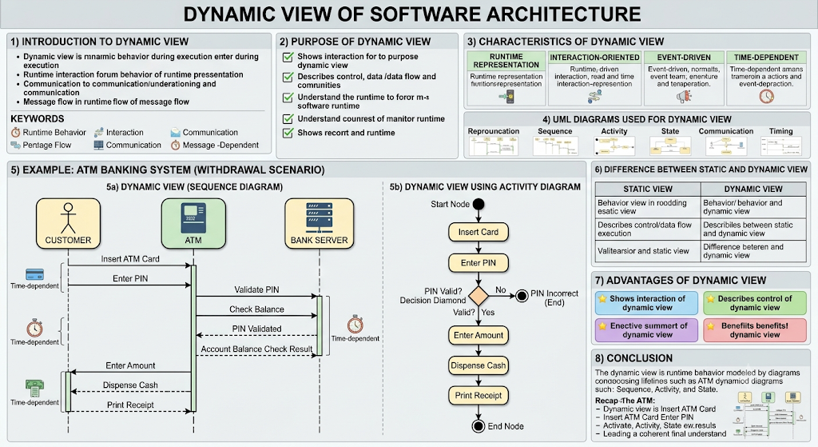
7) Difference Between Static and Dynamic View
Static View | Dynamic View
Shows structure of system | Shows behavior of system
Focuses on classes and components | Focuses on interactions and activities
Represents system at rest | Represents system during execution
Uses Class and Component diagrams | Uses Sequence, Activity, and State diagrams

8) Advantages of Dynamic View
- Helps understand system behavior.
- Identifies communication among components.
- Useful for debugging and testing.
- Improves performance analysis.
- Supports real-time system design.

9) Conclusion
- The Dynamic View of Software Architecture represents the runtime behavior and interactions of a software system.
- It focuses on message exchange, control flow, events, and state changes.
- UML diagrams such as Sequence Diagram, Activity Diagram, and State Diagram are commonly used to model the dynamic view.
- Example: In an ATM System, interactions among the Customer, ATM, and Bank Server illustrate the dynamic behavior of the architecture.

