***Project Report***

**On**

**“HealthCare Recommendation System”**

**By**

**Kanchan D. Ghuse**

Under the Guidance of

Miss. Sharayu mam

(**Research & Training Head,Sr. Developer)**

Soham CONSULTANTS

Technology is power. Technology is future.   
ISO 9001:2015 | Microsoft Partner Company

**TABLE OF CONTENTS**

**1.Introduction and Database schema 4**

**1.1 Objective 5**

**1.2 Introduction 5**

**1.3 Database Schema 5**

**2.Dataflow Diagrams and workflow 13**

**2.1 DFD 14**

**2.2 Project flow 16**

**2.3 Project flow explanation 17**

**3.Modules Description and Technologies 18**

**3.1Modules 19**

**3.2 Technologies 19**

**5.Screenshots 21**

**6.conclusion 29**

CHAP 1:

INTRODUCTION

AND

DATABASE SCHEMA

**1.1Objective:**

* Build a consumer-focused integrated primary health care system;
* Improve access and reduce inequity;
* Increase the focus on health promotion and prevention, screening and early intervention; and
* Improve quality, safety, performance and accountability.

**1.2 Introduction**

Healthcare Recommendation System is an application developed in the windows platform for the users which have health problems or which have queries related to diseases.

I develop a system which is an online application that can be accessible to all users with proper login provided. The users can search any of the disease and information related to it. The system will recommend the users choice according to past history. This system contains the expert doctors who always ready to solve the users queries. This system is maintaining all the data related to diseases, with its systems and description. So there is flexibility for users to search any thing about the disease they want.

So, this project provides a facility of maintaining the details of iseases and provide the information to user at any time without any cost.

**1.3. Database Schema**

**Tables:**

**Table User:**

|  |  |  |  |  |  |  |
| --- | --- | --- | --- | --- | --- | --- |
| Userid | Usename | Password | Type | Status | Seque | ans |
| kan12 | Kanchan | ka | admin | Active | Birthplace? | pune |
| Shy963 | Shyam | shy | user | Active | Colour? | pink |
| Di94 | D721 | DimpleShrma | Doctor | Active | Birthplace? | pune |

**Table Doctor:**

|  |  |  |  |  |  |  |
| --- | --- | --- | --- | --- | --- | --- |
| Docid | Docname | Password | Degree | Mobileno | Seque | ans |
| Di94 | DimpleShrma | D721 | mbbs | 8788977518 | Birthplace? | pink |
| Pr89 | Priyamodak | p721 | BDS | 7219760472 | Colour | red |

**Table feedback:**

|  |  |  |  |  |  |
| --- | --- | --- | --- | --- | --- |
| que | userid | ans | Docid | typename | disname |
| what are the risk factors related to typhoid? | Shym963 | Poor appetite  Headaches.  Generalized aches and pains.Fever | Di94 | Fever | typhoid |
| Which strain of typhoid could become virtually untreatable? | Shy963 | **TYPHOID** affects some 21m people each year, and about 1% of cases are fatal. | Di94 | Infectious | typhoid |

**Table pasthis:**

|  |  |  |  |  |
| --- | --- | --- | --- | --- |
| disname | typename | Symtoms | description | userid |
| Maleria | fever | Moderate to severe shaking chills | Malaria is a mosquito-borne infectious disease that affects humans and other animals. | Shy963 |
| typhoid | fever | Poor appetite  Headaches  Generalized aches and pains | Typhoid is an infection caused by the bacterium Salmonella typhimurium (S. typhi).The bacterium lives in the intestines | Shy963 |

**Table disease:**

|  |  |  |  |  |
| --- | --- | --- | --- | --- |
| Disname | typename | symptoms | Description | docid |
| typhoid | fever | Poor appetite  Headaches  Generalized aches and pains  Fever as high as 104 degrees Farenheit | Typhoid is an infection caused by the bacterium Salmonella typhimurium (S. typhi).The bacterium lives in the intestines and bloodstream of humans. | Di94 |
| Tuberculosis | Infectious | Eventually, the cough increases, the patient may have chest pain from pleurisy, and there may be blood in the sputum, an alarming symptom. | Tuberculosis (TB), infectious disease that is caused by the tubercle bacillus.In most forms of the disease, the bacillus spreads slowly and widely in the lungs. | Di94 |

**Procedures:**

**1.insto :** create procedure insto(dnm varchar(40),type varchar(30),sys varchar(6000),des varchar(6000),que varchar(300),ans varchar(3000),did varchar(20))

begin

insert into pasthis values(dnm,type,sys,des,que,ans,did);

end//

**2.reguse**

delimiter //

create procedure reguse(userid varchar(50),username varchar(50), password varchar(20), seque varchar(50), answer varchar(20))

begin

insert into register values(userid,username,password,default,seque,answer,default);

end//

delimiter ;

**3.addtouse:**

create procedure addtouse(userid varchar(50),username varchar(50), password varchar(20),type varchar(20))

begin

insert into user values(userid,username,password,type,default,default,default);

end//

**4.regdoctor:**

create procedure regdoctor(docid varchar(50),name varchar(100), password varchar(20), degree varchar(100),mobileno varchar(50))

begin

insert into doctor values(docid,name,password,degree,mobileno,default,default);

end//

**5.getdoc:**

mysql> delimiter //

mysql> create procedure getdoc()

-> begin

-> select * from doctor;

-> end //

**6.recom**

mysql> delimiter //

mysql> create procedure recom(did varchar(20))

begin

select disname,typename,symptoms,description,que,ans from pasthis where userid=did;

end //

**7.editpro:**

mysql> delimiter //

mysql> create procedure editpro(did varchar(30))

-> begin

-> select * from doctor

-> where docid=did;

-> end//

Query OK, 0 rows affected (0.09 sec)

**7.updoc**

create procedure updoc(name varchar(30),password varchar(40),degree varchar(40), contactno varchar(30),seque varchar(20),ans varchar(20),docid varchar(20))

begin

update doctor set name=name,password=password,degree=degree,contactno=contactno,seque=seque,ans=ans where docid=docid;

end//

CHAP 2:

DATA FLOW DIAGRAM

and Project flow

**2.1 Data flow diagrams**

**1.Home page**

DATABASE

ADMIN

UID AND PSW

USER

DOCTOR

**Fig:DFD of home page**

**2.User Module**

USER

feedback

Any query

Show answers

logout

**fig**

disease

user

feedback

search

Change Password

**Fig:DFD of user page**

**3.Admin Module**

Admin

Add doctors

insert select select insert select

user

disease

user

doctor

doctor

Show users

Show disease

Change Password

Show Doctors

**fig:dfd of admin page**

**4.Doctor module**

Doctor

Edit profile

insert insert insert select

user

feedback

disease

doctors

logout

Reply queries

Change Password

Add disease

**2.2.Project flow diagram & explanation**

Healthcare Recommendation system

Online Sports Event Registration

Database

Display error message

Check UID PSW

Database

Check userid and password

Display error message

User Module

Doctor Module

Admin Module

Institute Module

Interzonal Module

Zonal Module

**Fig:workflow of project**

**2.3 Project workflow explanation**

In this project , the users can search any disease with its description, symptoms etc and can also ask the queries to doctors.

Firstly the user have to register using sign in option. The sign page has form in which information is fill by user.Afer filling information the user can login the using userid and password.

After login the user can search disease or symptoms or anything that he/she want. If users have some queries then they can ask using ask queries link. The ask query link contain the doctors with different specialization. The user has opportunity to ask queries to the related doctor of disease.

This query is directly submitted to doctor. The users can see their quries reply through show answers link. The user has also facility to change the password.

When user login next time then he can find the similar search result that he searched previously. So it is easy for user to search.

Next part of project is admin part. The admin of a program will control all activities of the project. It can see the users. The doctors are added by admin, and he wil provide id and password to doctor for login. The admin can see disease that are added by doctors.

Next part includes doctors login. After successful login the doctor enters to his page. The doctors page contain edit profile option so that the doctor can change his/her details if they want. The edit profile option is specilly given to dotors page because doctors are added by admin.

Then the doctors add disease with all the information. The doctors has to reply quries that are asked by users.

CHAP 3:

MODULES DESCRIPTION

AND tECHNOLOGIES

**3.1 Modules description**

There are 3 modules in the project-

1.user module

2.admin module

3.doctor module

**1.user module**

This module contain the information for users.

* The user can ask queries.
* They can search any information they want
* They can change password

**2.Admin module**

This module has control over the overall project.

* The admin can see users,doctors and disease information
* The admin has add doctors.

**3.Doctor Module**

This module designed for doctors

* The doctors add disease informations
* They have to reply users queries.
* They can edit their profile

**3.2 Technologies details:**

**Java:** Java programming language was originally developed by Sun Microsystems which was initiated by James Gosling and released in 1995 as core component of Sun Microsystems' Java platform (Java 1.0 [J2SE]).

The latest release of the Java Standard Edition is Java SE 8. With the advancement of Java and its widespread popularity, multiple configurations were built to suit various types of platforms. For example: J2EE for Enterprise Applications, J2ME for Mobile Applications.

The new J2 versions were renamed as Java SE, Java EE, and Java ME respectively. Java is guaranteed to be **Write Once, Run Anywhere.**

**Eclipse IDE:**

Eclipse is an integrated development environment used in computer programming, and in 2014 was the most widely used Java IDE in one website's poll. It contains a base workspace and an extensible plug-in system for customizing the environment. Eclipse is written mostly in Java and its primary use is for developing Java applications, but it may also be used to develop applications in other programming languages via plug-ins, including Ada, ABAP, C, C++, C#, Clojure, COBOL, D, Erlang, Fortran, Groovy, Haskell, JavaScript, Julia, Lasso, Lua, NATURAL, Perl, PHP, Prolog, Python, R, Ruby, Rust, Scala, and Scheme. It can also be used to develop documents with LaTeX and packages for the software Mathematica. Development environments include the Eclipse Java development tools for Java and Scala, Eclipse CDT for C/C++, and Eclipse PDT for PHP, among others.

**MYSQL :**

MySQL Enterprise Edition includes the most comprehensive set of advanced features, management tools and technical support to achieve the highest levels of MySQL scalability, security, reliability, and uptime. It reduces the risk, cost, and complexity in developing, deploying, and managing business-critical MySQL applications.

CHAP 4:

Screenshots

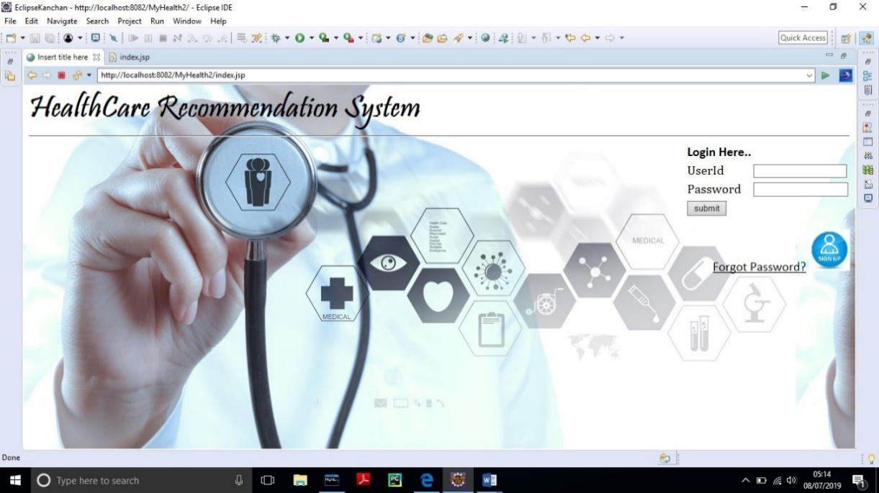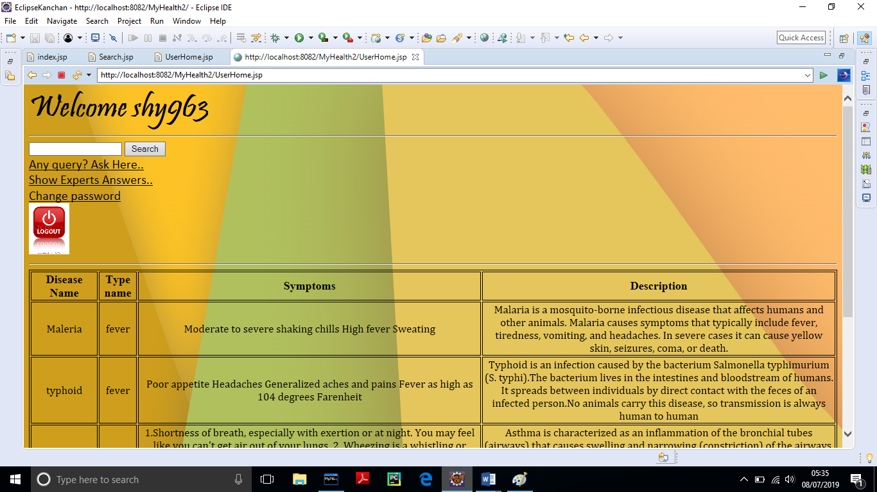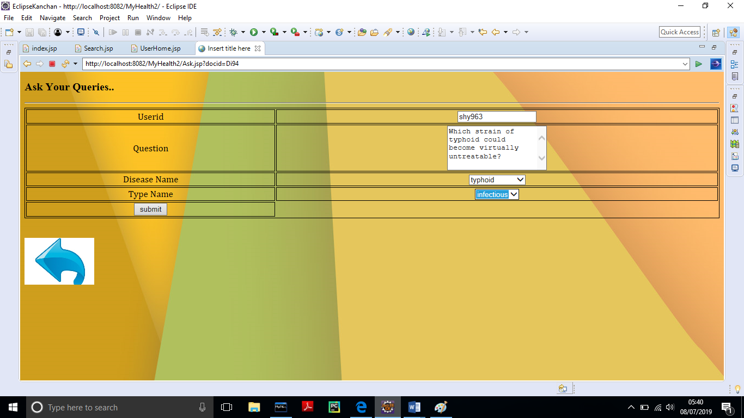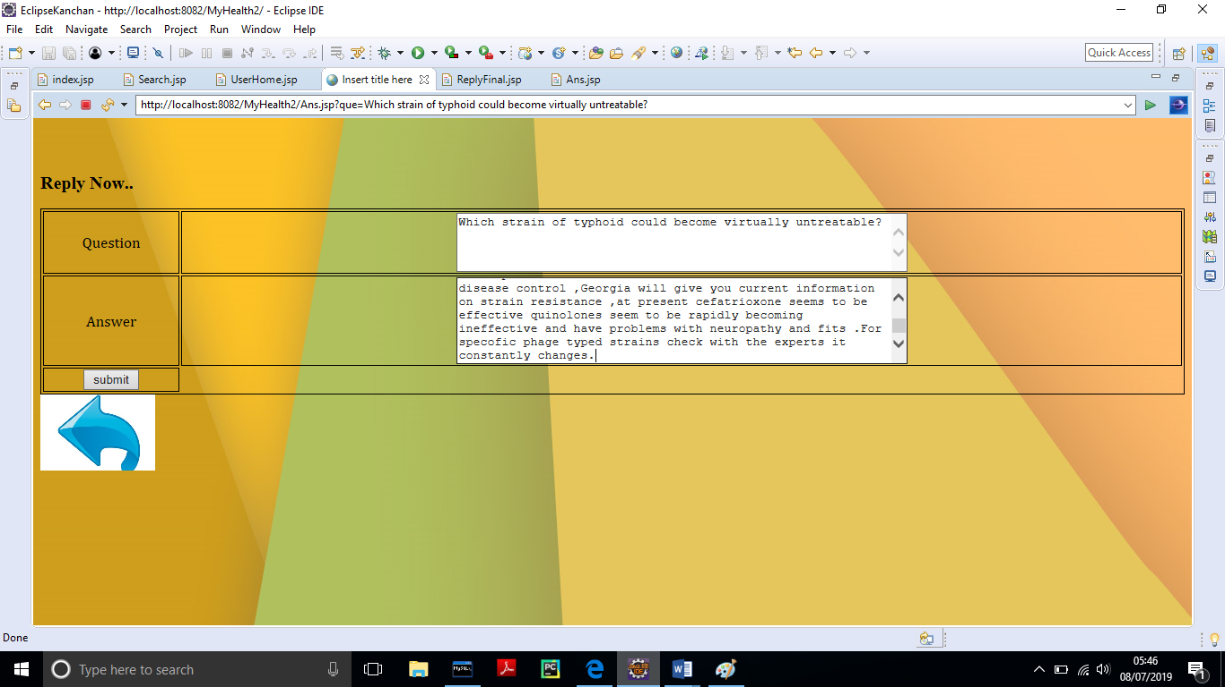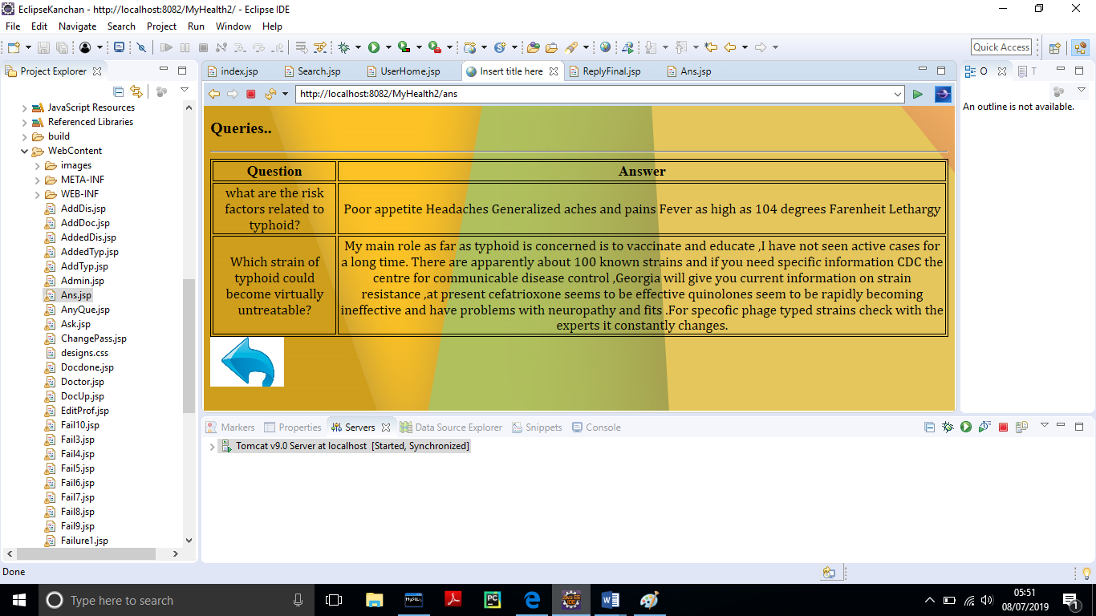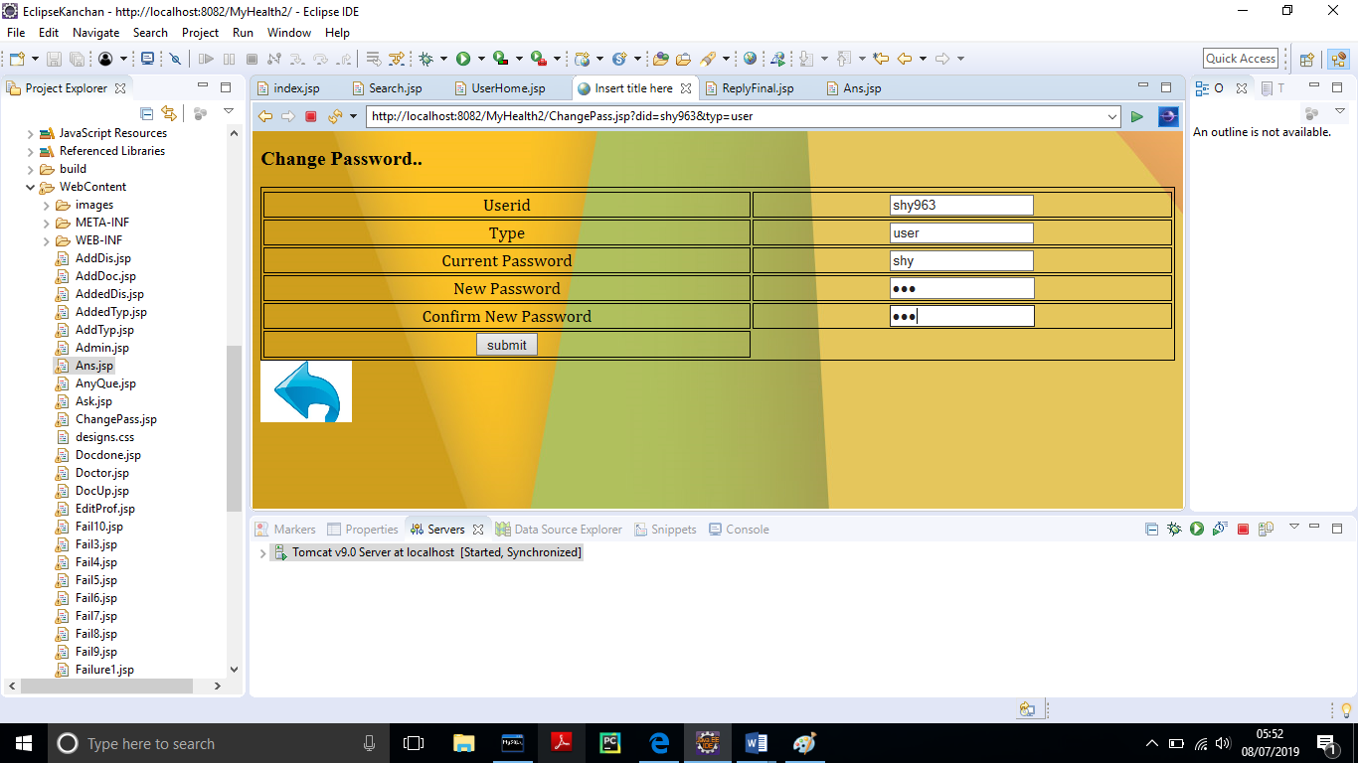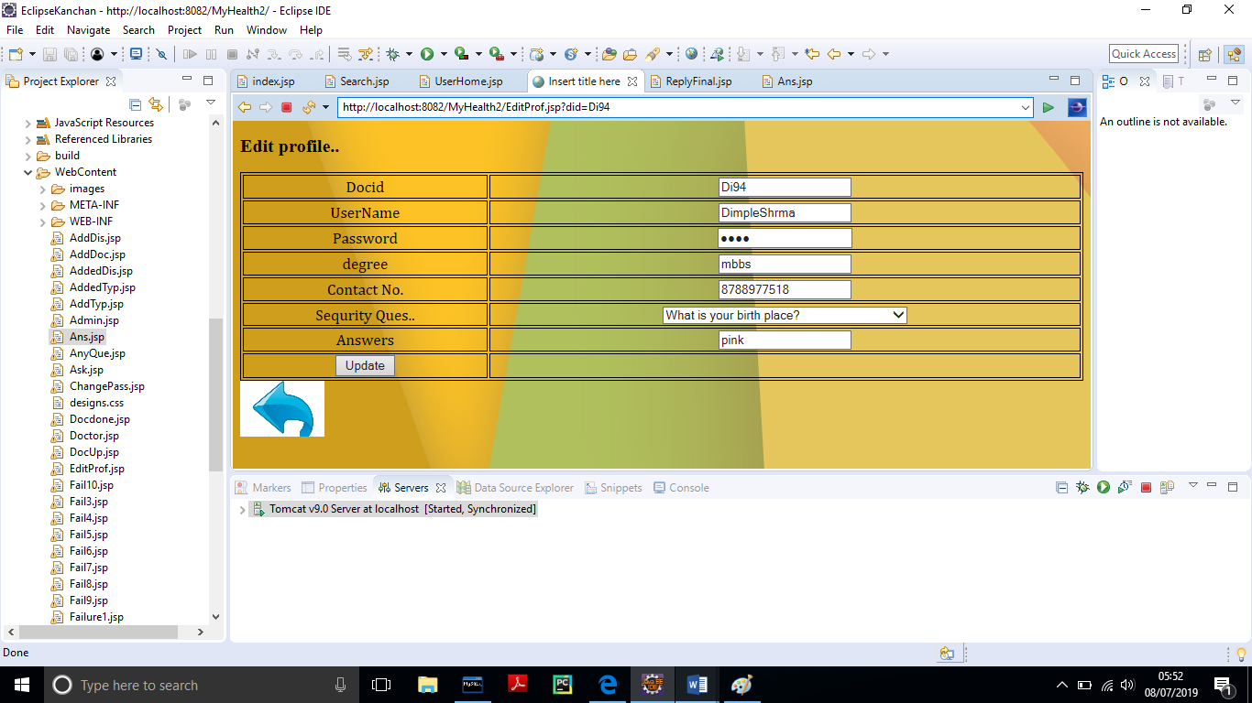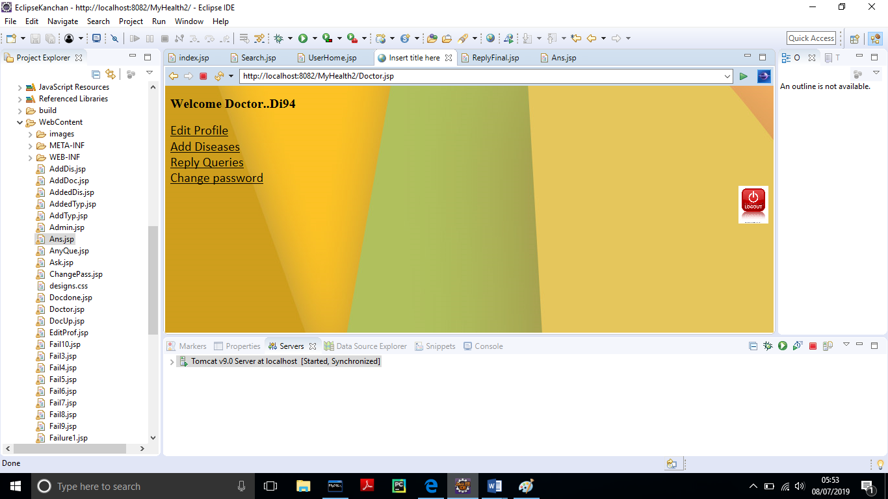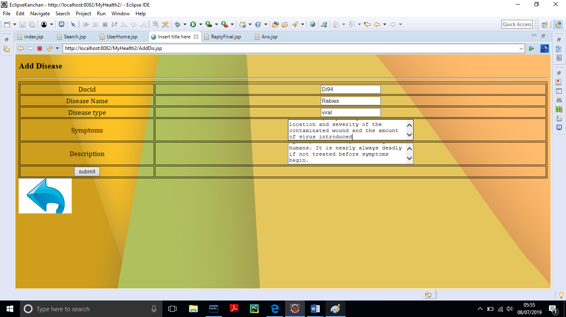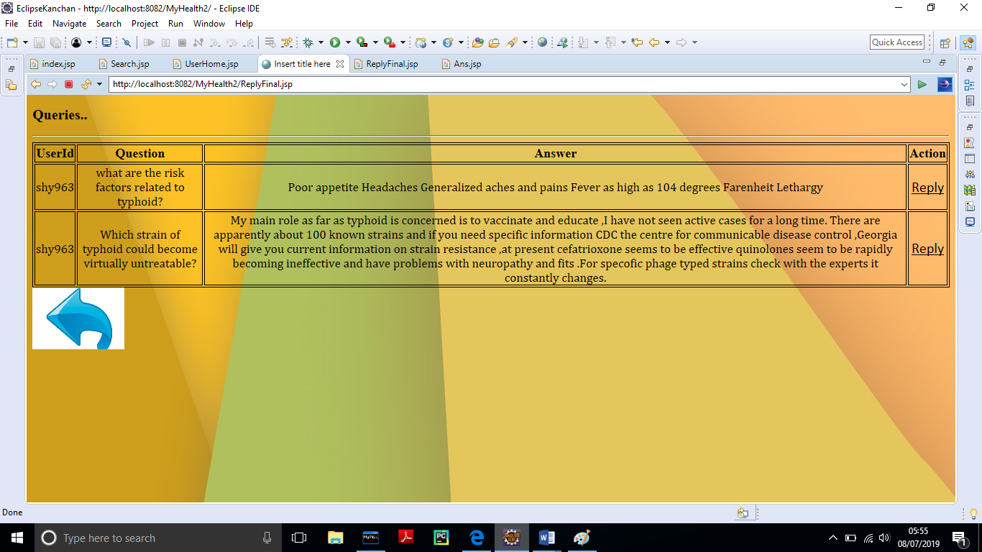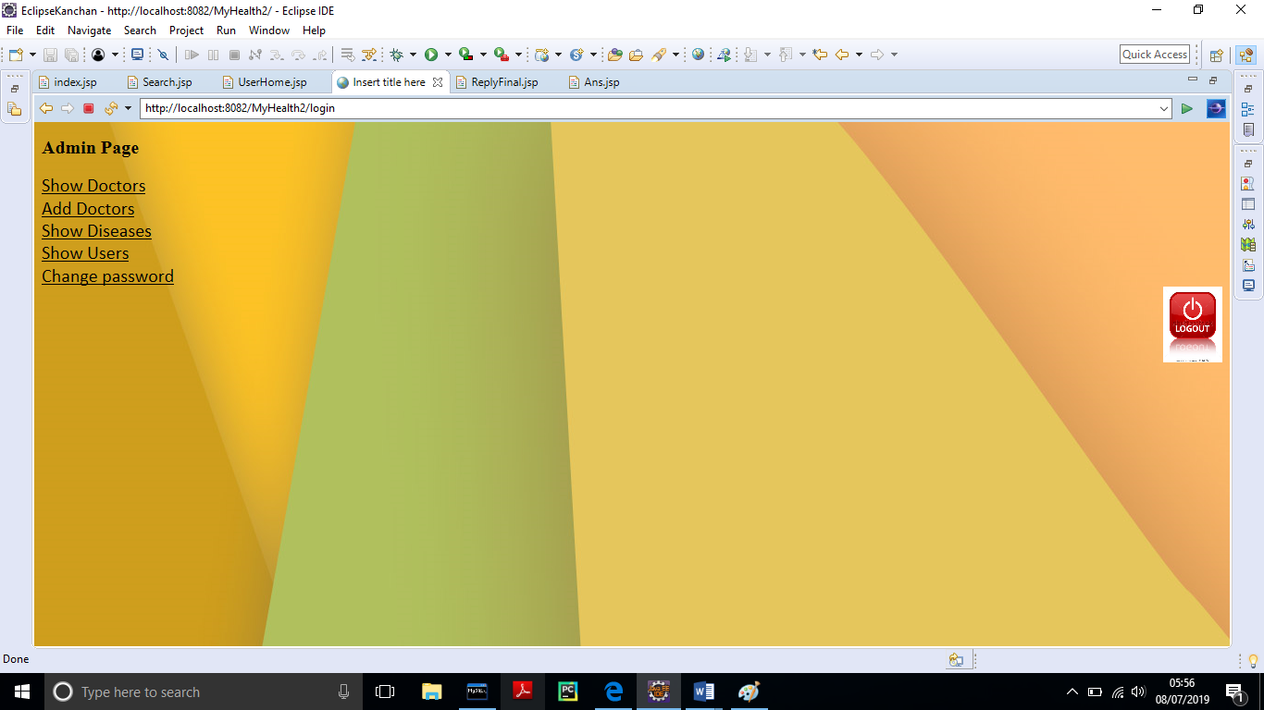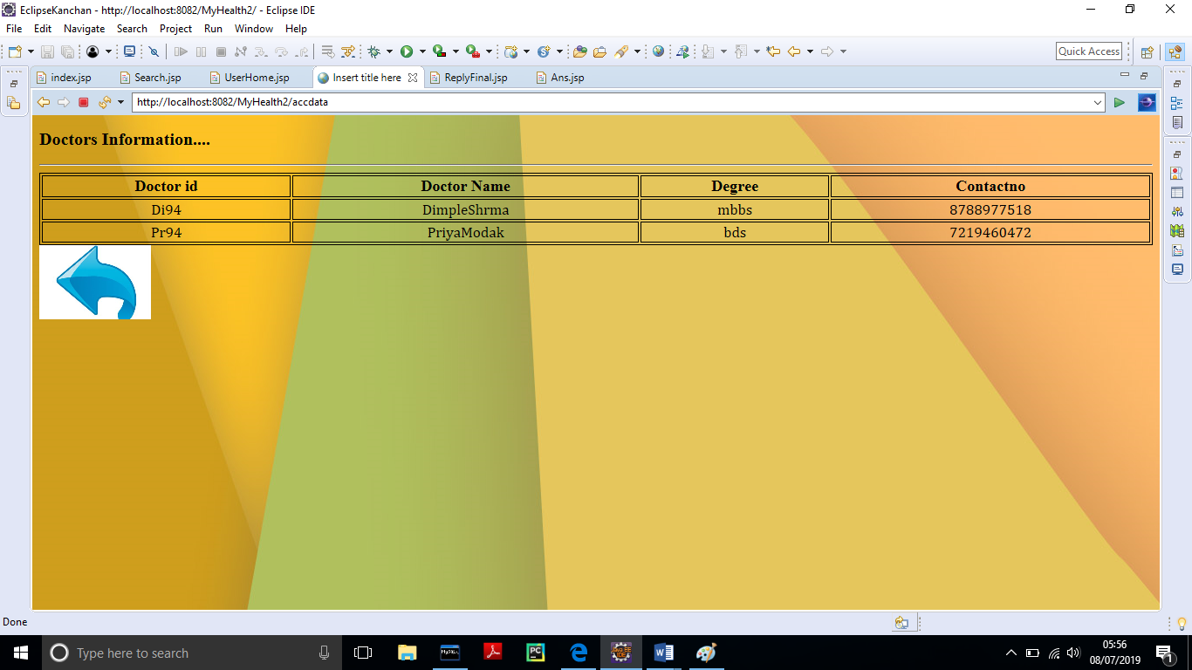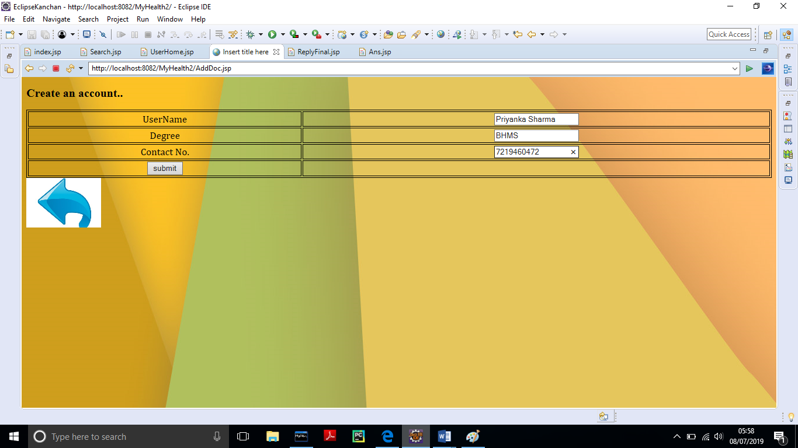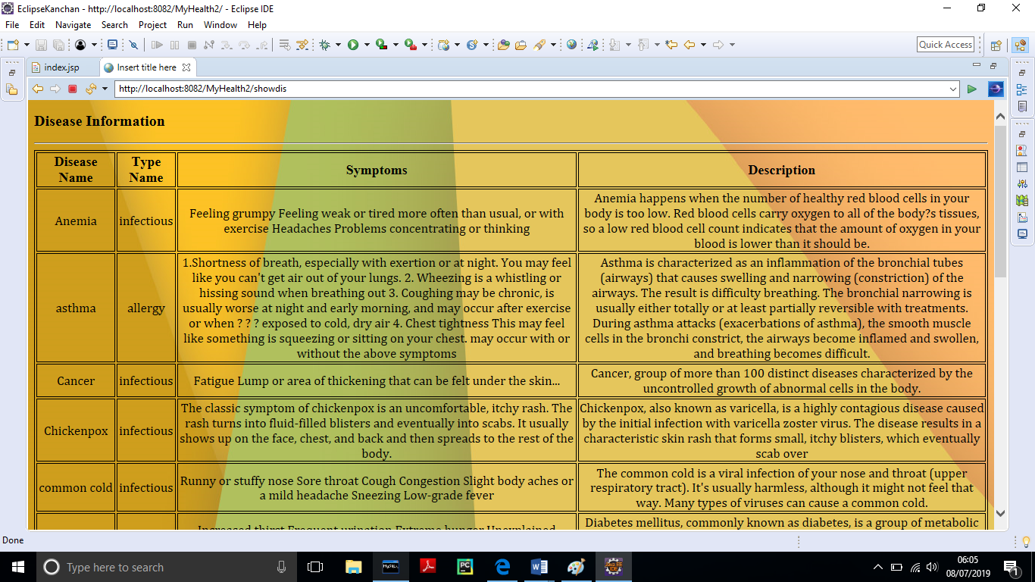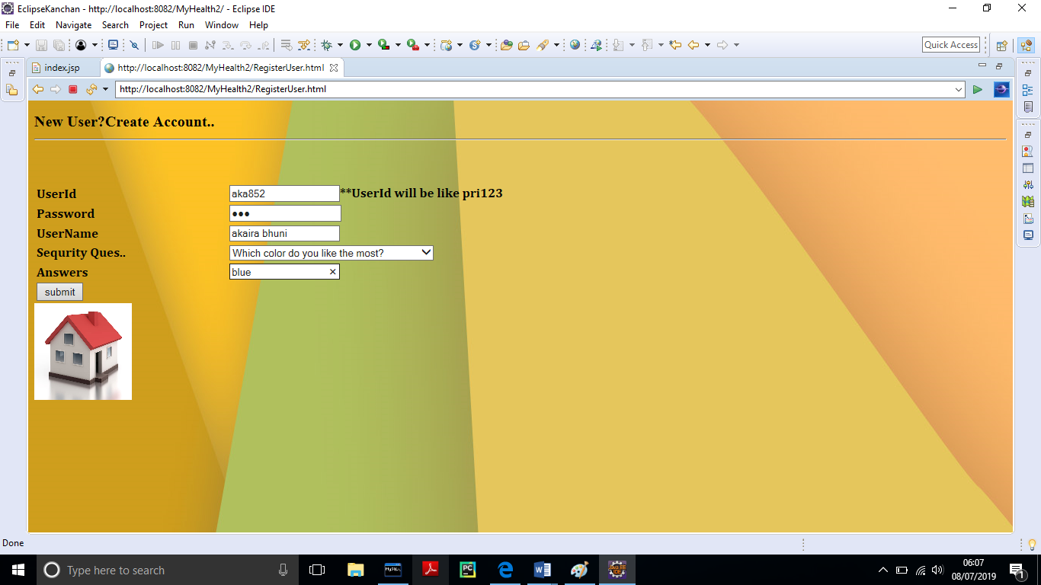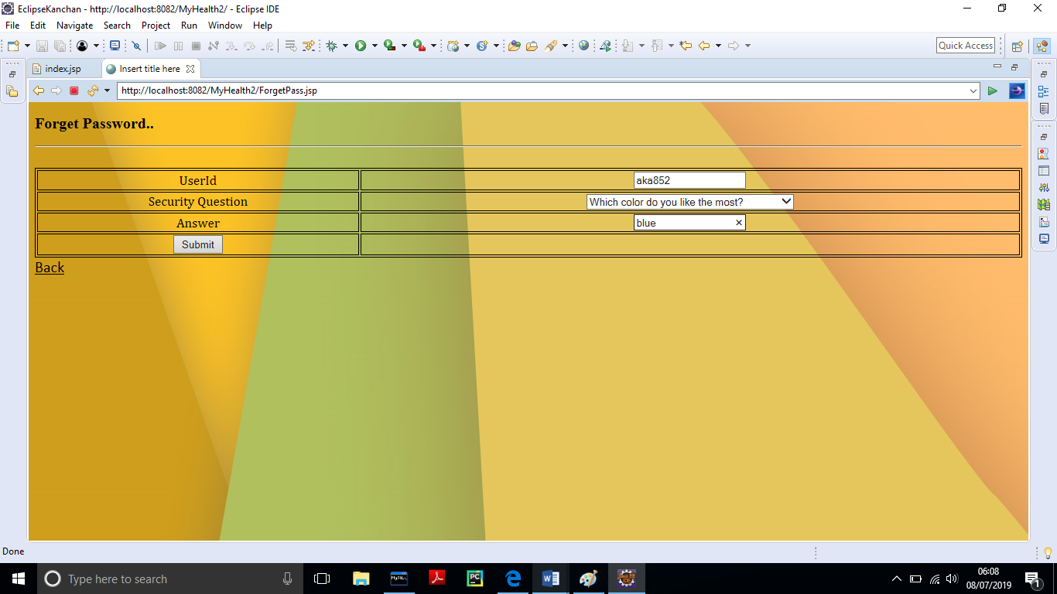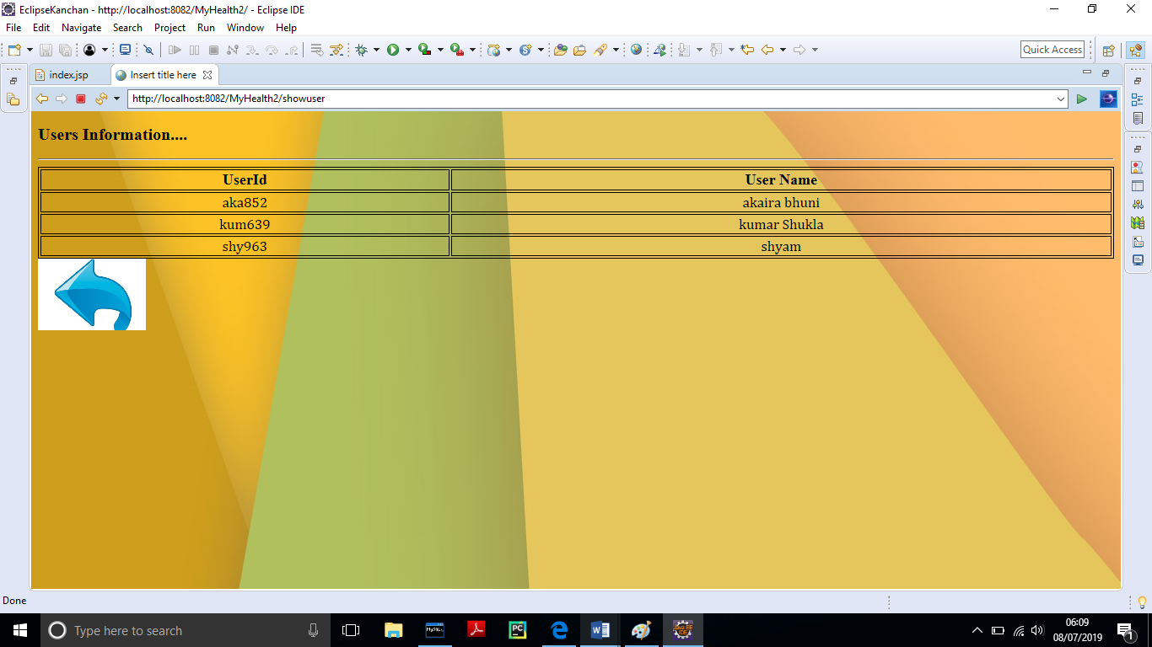

Fig. ask queries window

Fig. user window

Fig.home window

Fig: Reply window

Fig: Answers of queries window

Fig: change password window

Fig: edit profile window

Fig: doctor home window

Fig: add disease window

Fig: reply by doctor window

Fig: admin home window

Fig: doctors information window

Fig: create doctor account window

Fig: disease information window

Fig: create user account window

Fig: forgot password window

Fig: show users window

CHAP 5:

CONCLUSION

**5.1 Conclusion**

Thus in this way we develop the project under the guidance of Mrs. Sharayu mam. Through this project we can manage the activities related to health.

Health care is moving into the home increasingly often and involving a mixture of people, a variety of tasks, and a broad diversity of devices and technologies; it is also occurring in a range of residential environments. The factors driving this migration include the rising costs of providing health care; the growing numbers of older adults; the increasing prevalence of chronic disease; improved survival rates of various diseases, injuries, and other conditions large numbers of veterans returning from war with serious injuries; and a wide range of technological innovations. The health care that results varies considerably in its safety, effectiveness, and efficiency, as well as its quality and cost.