Objective
To demonstrate:
• Inter-service communication using RestTemplate
• Service Discovery using Eureka Server
• API Gateway routing
• Load Balancing using Spring Cloud LoadBalancer
• Fault tolerance using Resilience4j Circuit Breaker
Request Flow
Browser API-GATEWAY (8083) USER-MS (8081)RestTemplateCONTACTS-MS
Eureka acts as service registry to find USER-MS.
- Eureka server shows API-GATEWAY, USER-MS and CONTACTS-MS are up & running.
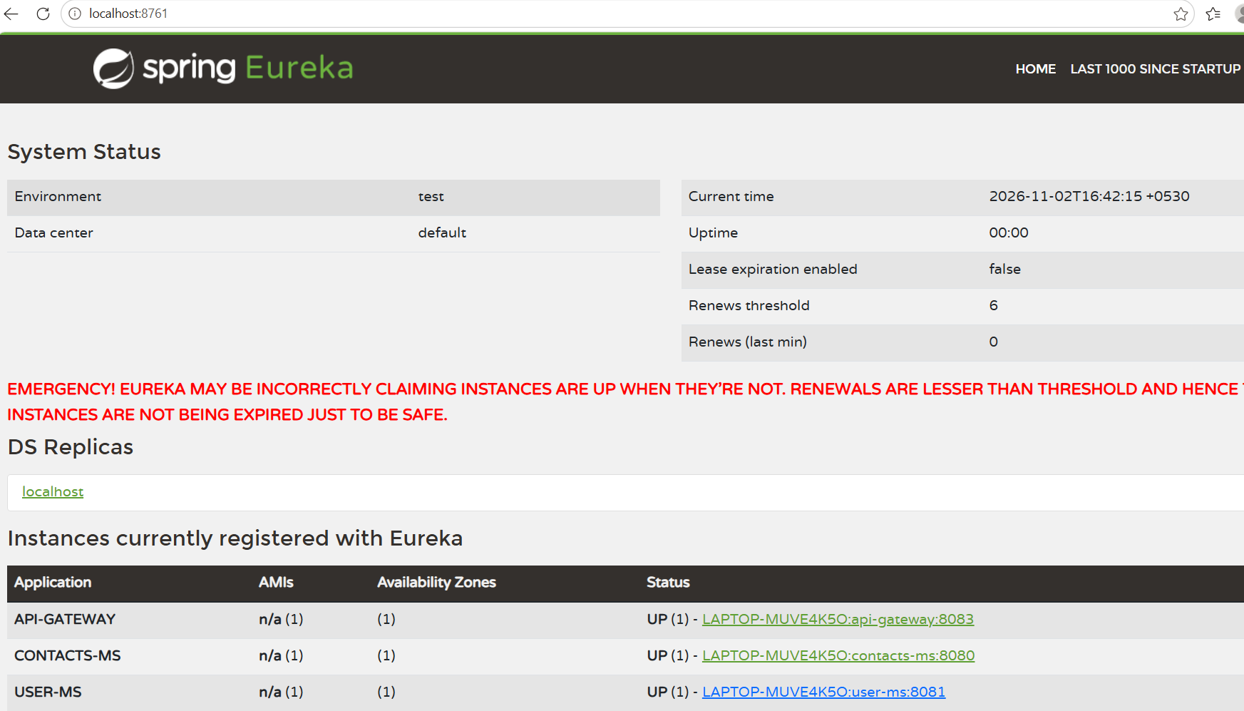
Tested for direct call to USER-MS for contacts data. It is working as expected and contacts data is displayed.
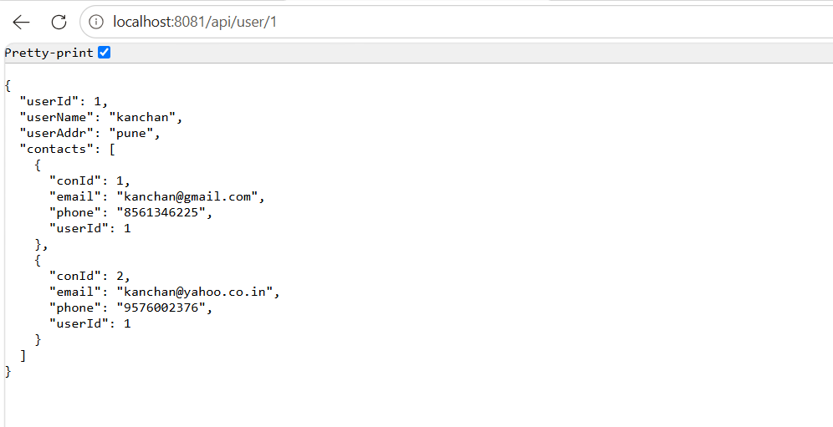

Now accessed USER-MS through API-GATEWAY. It is working as expected with contacts data. (API-GATEWAY USER-MS RestTemplate CONTACTS-MS)
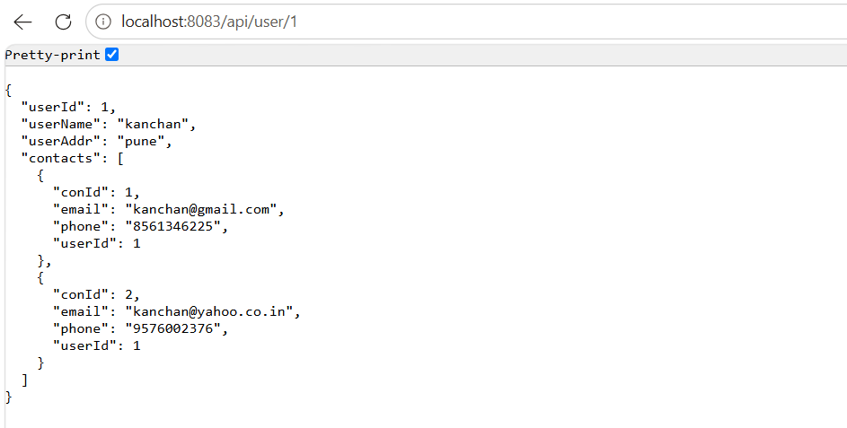
- Load Balancing
Browser API-GATEWAY (8083)USER-MS (8081)RestTemplateSpring Cloud LoadBalancerEureka Discovery (8761)Selects one instance CONTACTS-MS (8080 OR 8084 OR 8086)
Configured 3 instances of CONTACTS-MS at different ports as 8080, 8084,8086
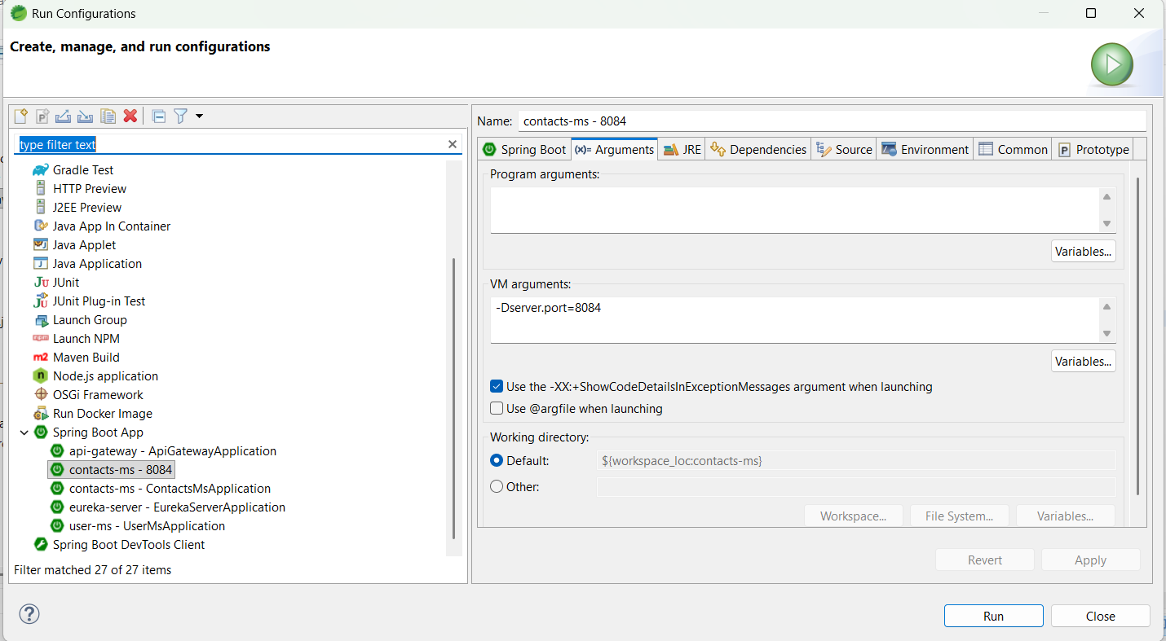

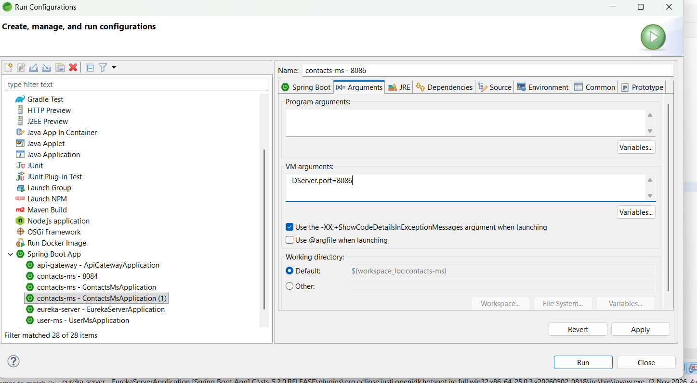
Verified on Eureka server for 3 instances. They are up and running.
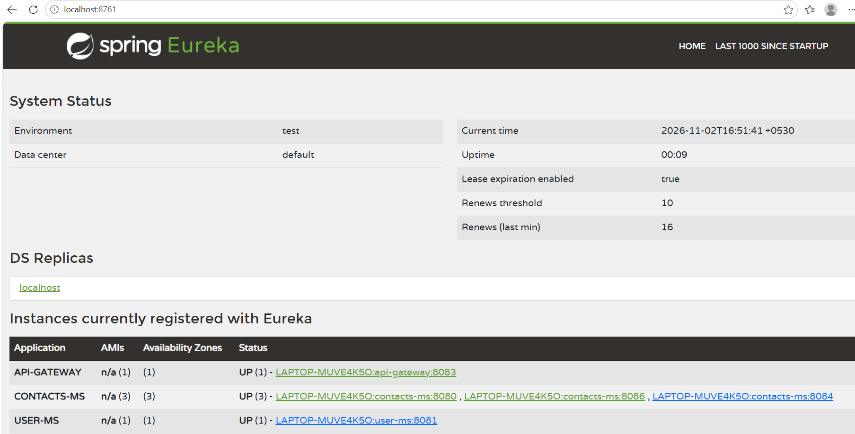
Request made 3 times to API-GATEWAY (to access USER-MS)
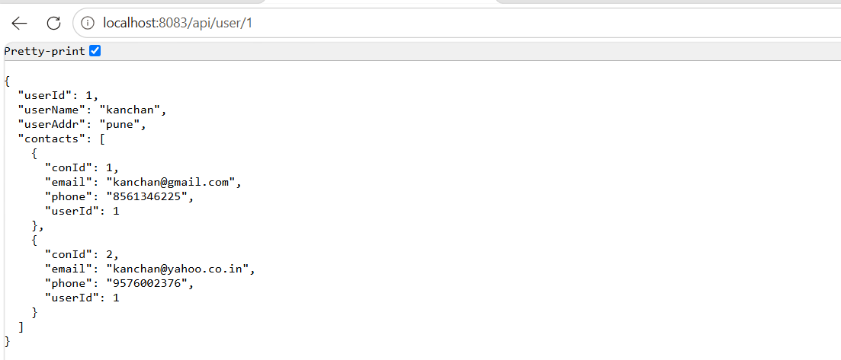
Spring Cloud LoadBalancer asks Eureka for all available instances and distributes requests among 3 instances. Below logs confirm requests are reaching different instances.
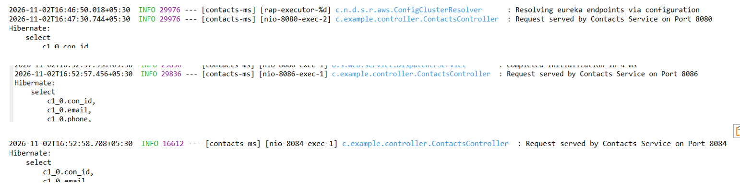
- Circuit breaker
  - When one/all CONTACTS-SERVICE instance/s are up and running then it works
as expected, (verified in load balancing as well)
  - Stopped all CONTACTS-MS instances
Eureka server does NOT show CONTACTS-MS instance.
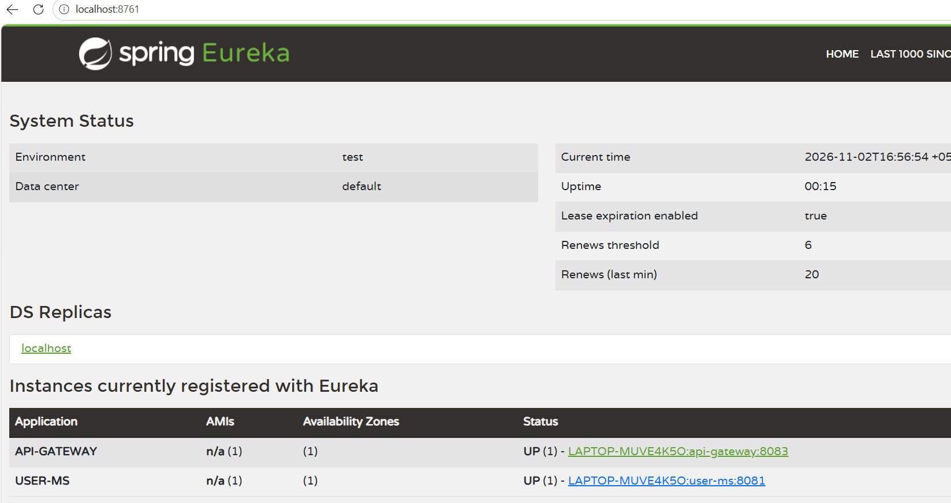
Request is made but as Contacts service is not available it displays the message as ‘Fallback user’ and ‘Contacts service not available’ in console.
Browser output:
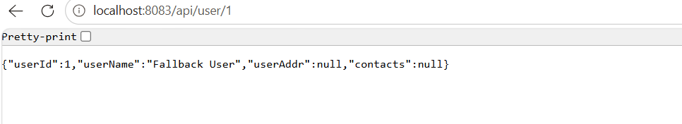
Console output:

Again, request is made
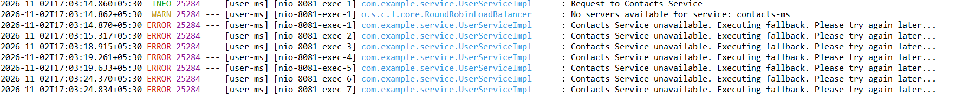
Now CONTACTS-MS service started. Verified on Eureka server.
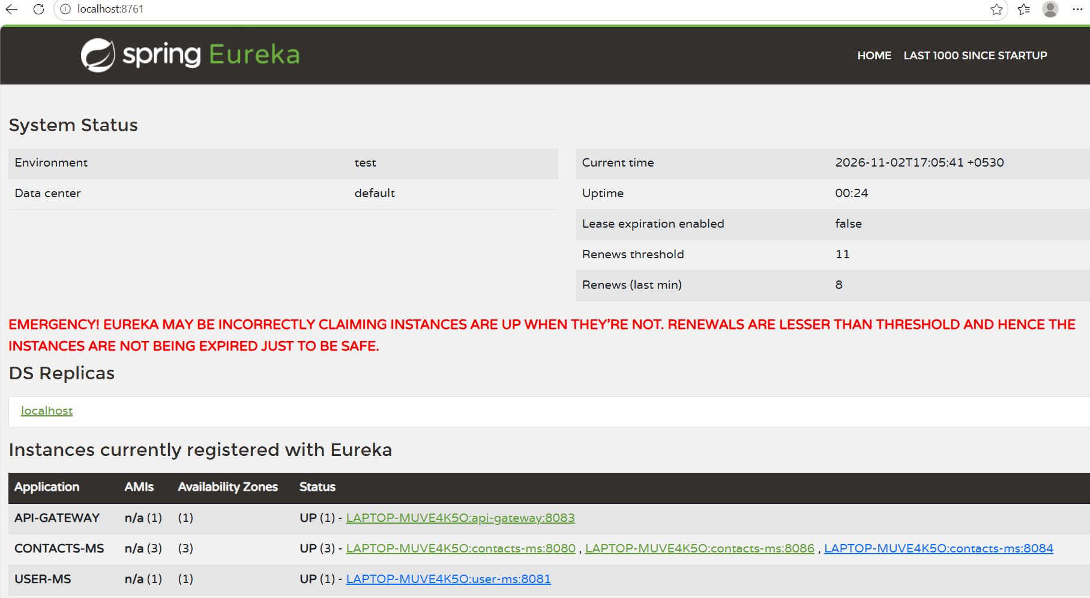
Request made to access USER-MS again. Now service is available hence response is returned.
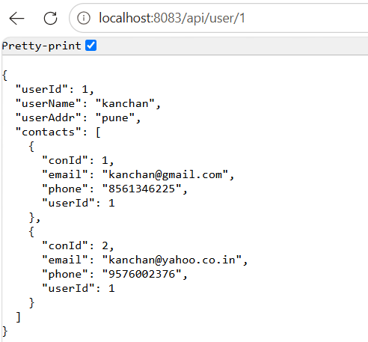

Request is served by CONTACTS-MS-8086 instance and sent response back.
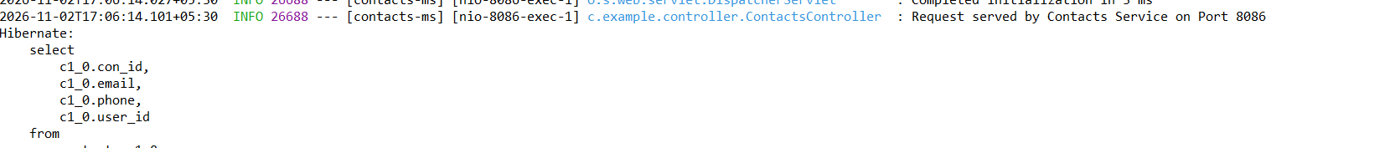

Execution of circuit breaker:
1.Circuit Breaker moved to OPEN state after service failures.
2.During the next 20 seconds (which is configured in application.yml), requests were not forwarded to Contacts Service. Fallback method was executed immediately.
3.After 20 seconds, Circuit Breaker transitioned to HALF_OPEN state.
4.When Contacts Service became available again, requests succeeded and Circuit Breaker returned to CLOSED state.
Conclusion
The prototype successfully demonstrates service discovery, request routing, client-side load balancing, fault tolerance and inter-service communication using Spring Boot, Spring Cloud Gateway, Eureka, Resilience4j, and RestTemplate.

