Objective
To demonstrate:
• Inter-Service Communication using Spring WebFlux WebClient (Reactive HTTP Client)
• Service Discovery using Eureka Server
• API Gateway routing
• Load Balancing using Spring Cloud LoadBalancer
• Fault tolerance using Resilience4j Circuit Breaker
- Request Flow
Browser API-GATEWAY (8083) USER-MS (8081)WebClient Eureka DiscoveryCONTACTS-MS
Eureka server acts as service registry and maintains information about all registered microservice instances.
- Eureka server shows API-GATEWAY, USER-MS and CONTACTS-MS are up & running.
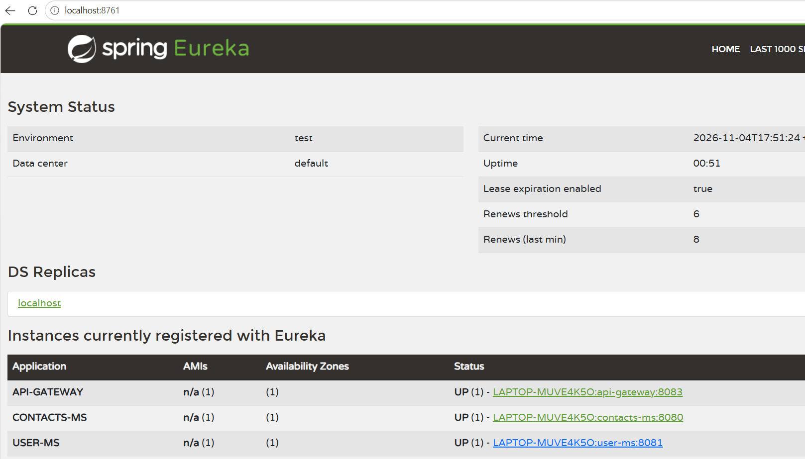
Accessed USER-MS through API-GATEWAY. USER-MS successfully invoked CONTACTS-MS using WebClient and returned the aggregated response. (API-GATEWAY USER-MS WebClient CONTACTS-MS)
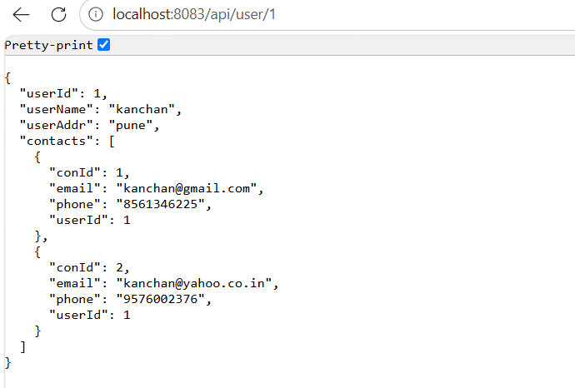
- Load Balancing
Browser API-GATEWAY (8083)USER-MS (8081)WebClient Spring Cloud LoadBalancerEureka Discovery (8761)Selects one instance CONTACTS-MS (8080 OR 8084 OR 8086)
Configured 3 instances of CONTACTS-MS at different ports as 8080, 8084,8086
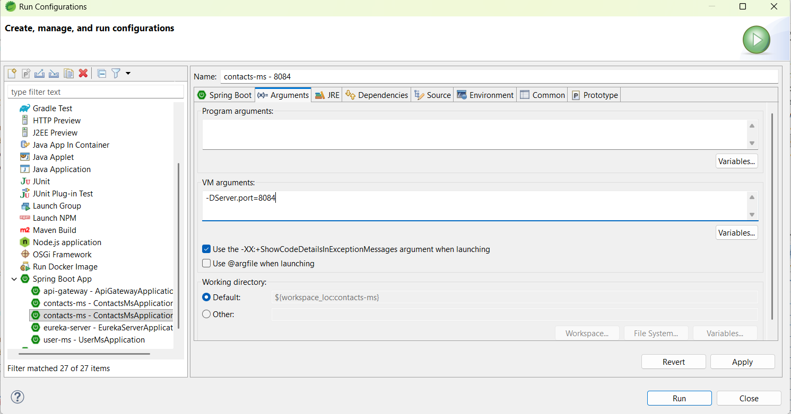

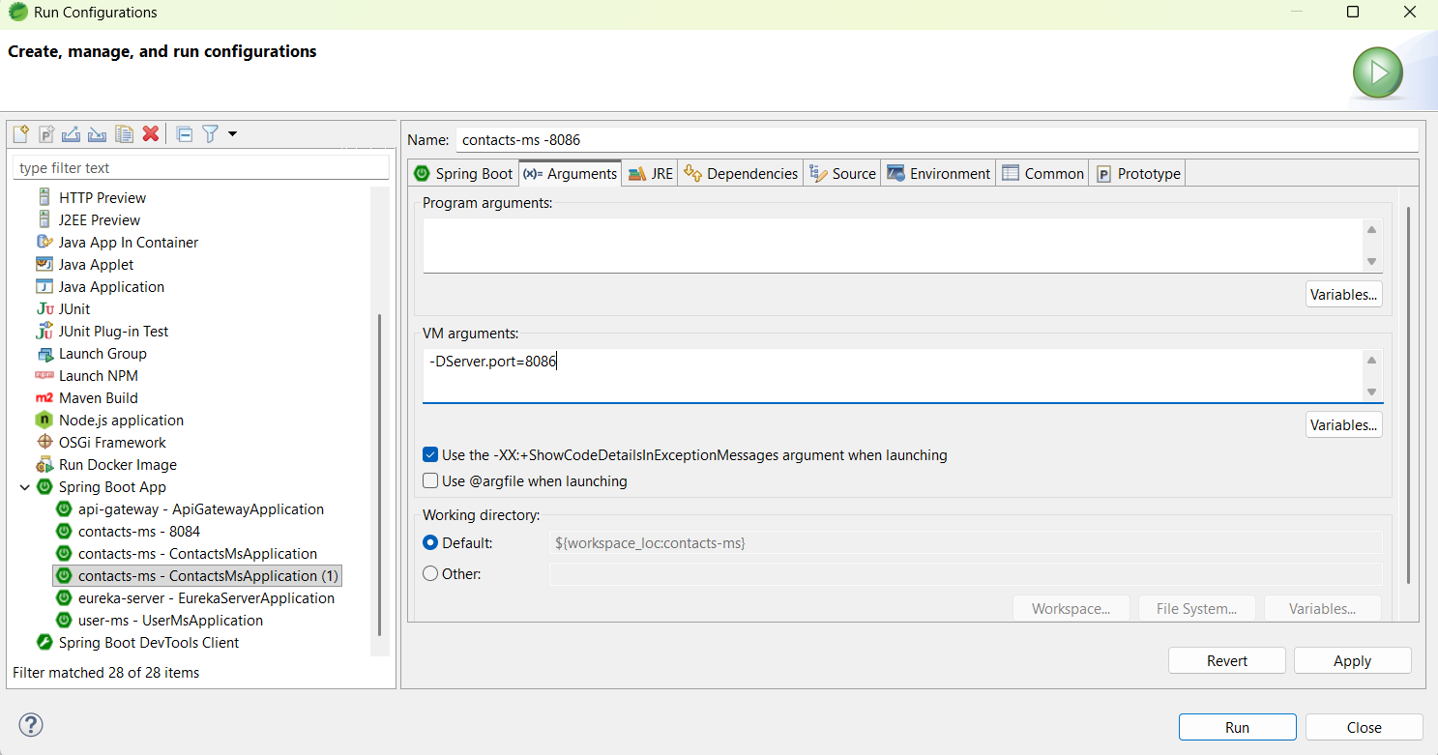

Verified on Eureka server for 3 instances. They are up and running.
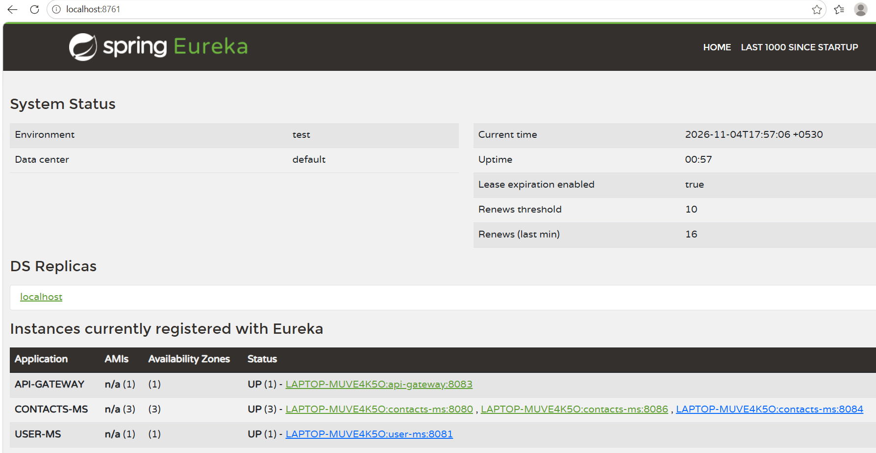
Request made 3 times to API-GATEWAY (to access USER-MS)
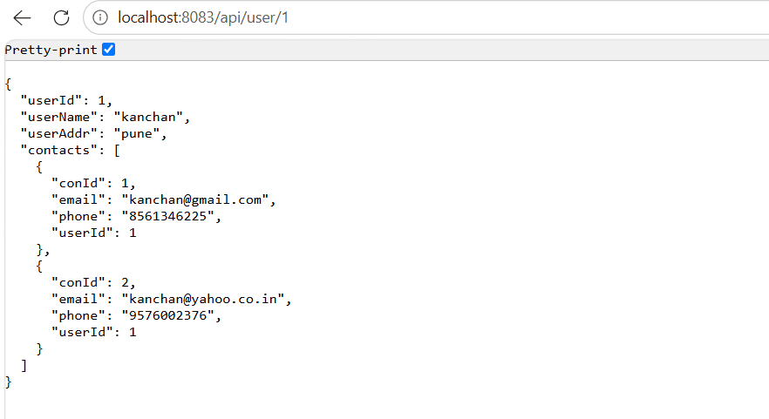
Spring Cloud LoadBalancer retrieves available CONTACTS-MS instances from Eureka Server and distributes requests among them. Below logs confirm that requests are routed to different instances.
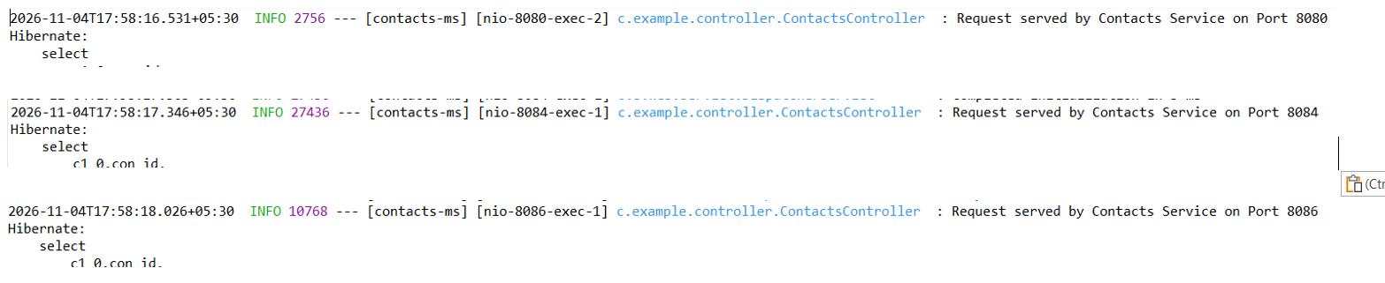

- Circuit breaker
  - When one/all CONTACTS-SERVICE instance/s are up and running then it works
as expected, (verified in load balancing as well)
  - Stopped all CONTACTS-MS instances
Eureka server does NOT show CONTACTS-MS instance.
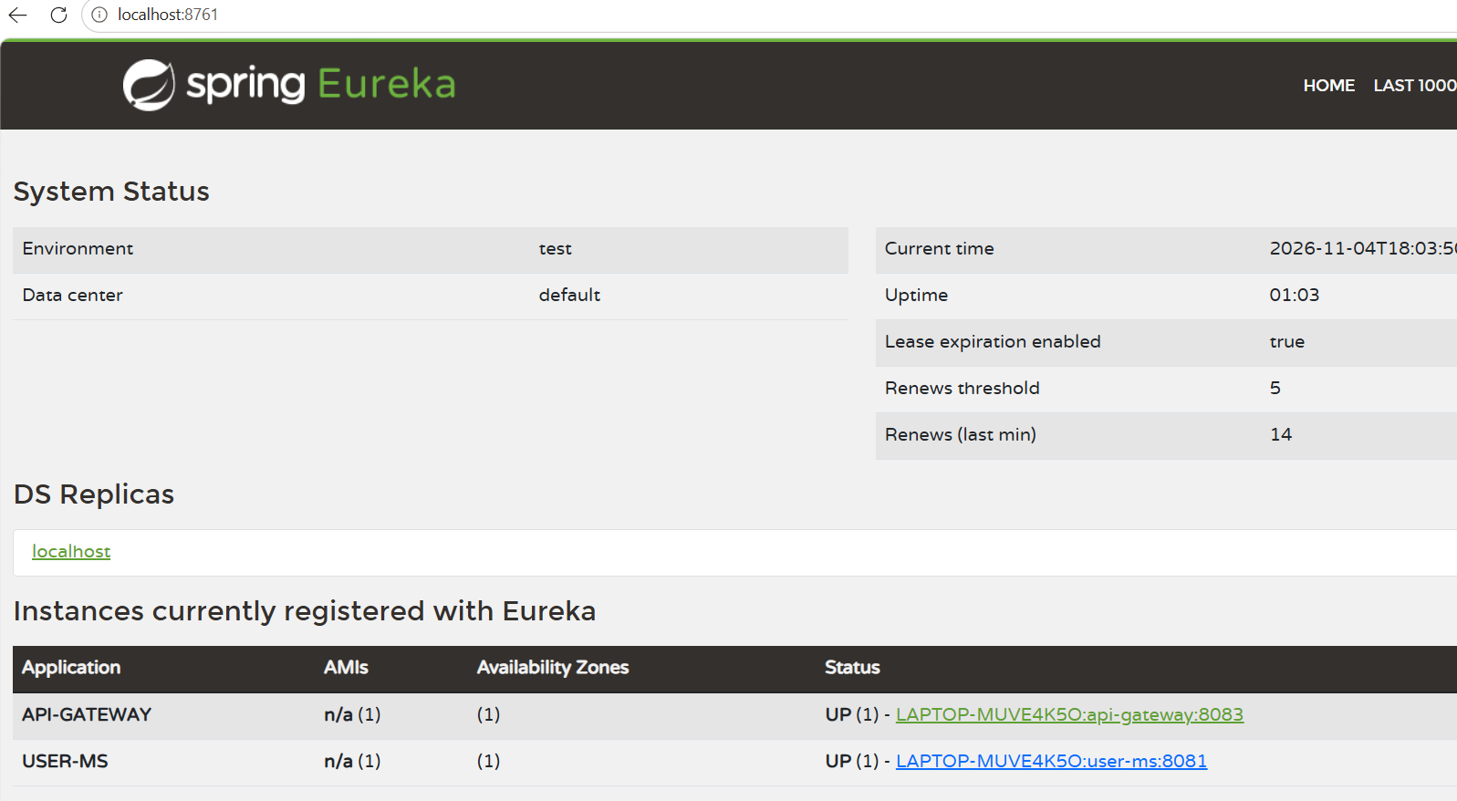
Request was made while CONTACTS-MS was unavailable. USER-MS executed the configured fallback method and returned a fallback response instead of propagating the error.
Browser output:
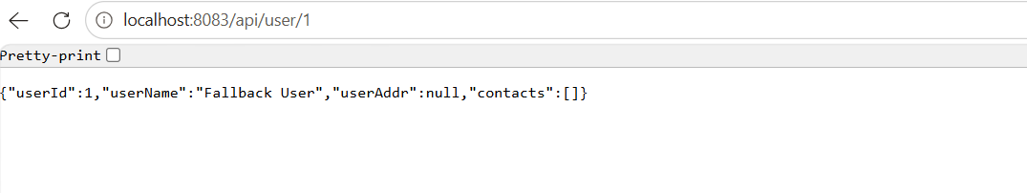
Console output:
A subsequent request was made while the Circuit Breaker remained in OPEN state. The request was not forwarded to CONTACTS-MS and the fallback response was returned immediately.
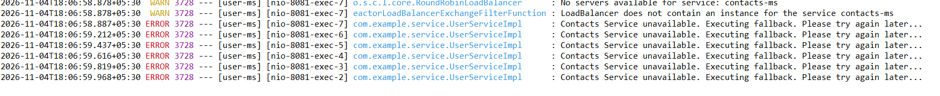
Now CONTACTS-MS service started. Verified on Eureka server.
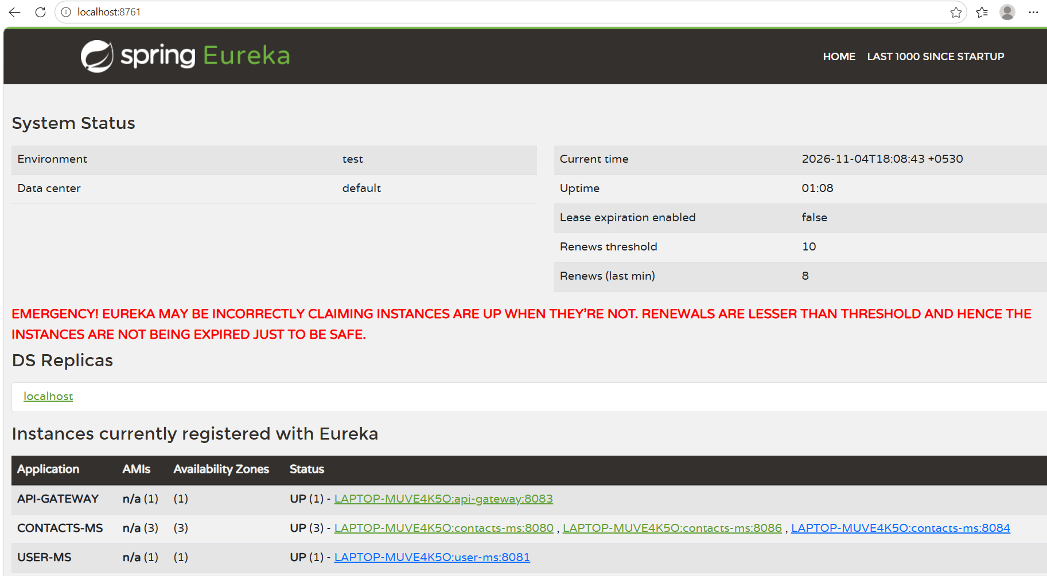
After CONTACTS-MS became available, a new request was made. The service call succeeded and normal response processing resumed.
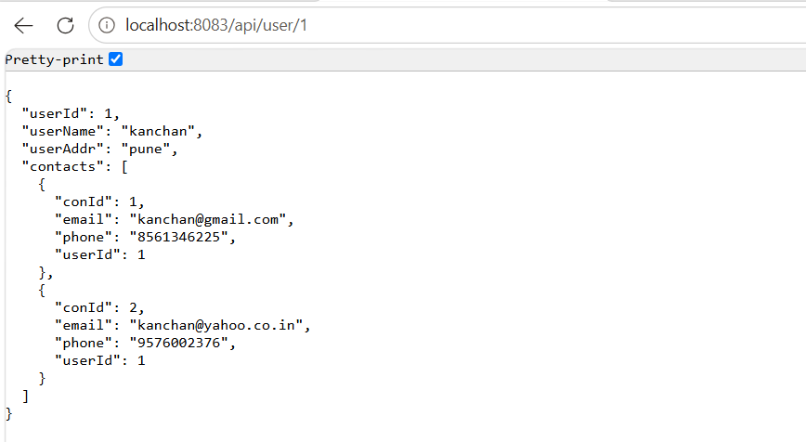

Request is served by CONTACTS-MS-8080 instance and sent response back.

Execution of circuit breaker:
1. Circuit Breaker transitioned to OPEN state after repeated service failures.
2. During the configured wait duration of 20 seconds, requests were not forwarded to CONTACTS-MS. Fallback responses were returned immediately.
3. After 20 seconds, the Circuit Breaker transitioned to HALF_OPEN state and allowed limited test requests.
4. When CONTACTS-MS became available and the test requests succeeded, the Circuit Breaker returned to CLOSED state.

Conclusion
The prototype successfully demonstrates service discovery, request routing, client-side load balancing, fault tolerance and inter-service communication using Spring Boot, Spring Cloud Gateway, Eureka, Resilience4j, and WebClient.

