Objective
To demonstrate:
• Inter-service communication using FeignClient
• Service Discovery using Eureka Server
• API Gateway routing
• Load Balancing using Spring Cloud OpenFeign integrated with Eureka Discovery and Spring Cloud LoadBalancer.
• Fault tolerance using Resilience4j Circuit Breaker
- Request Flow
Browser API-GATEWAY (8083) USER-MS (8081)FeignClient CONTACTS -MS
Eureka acts as service registry to find USER-MS.
- Eureka server shows API-GATEWAY, USER-MS and CONTACTS-MS are up & running.
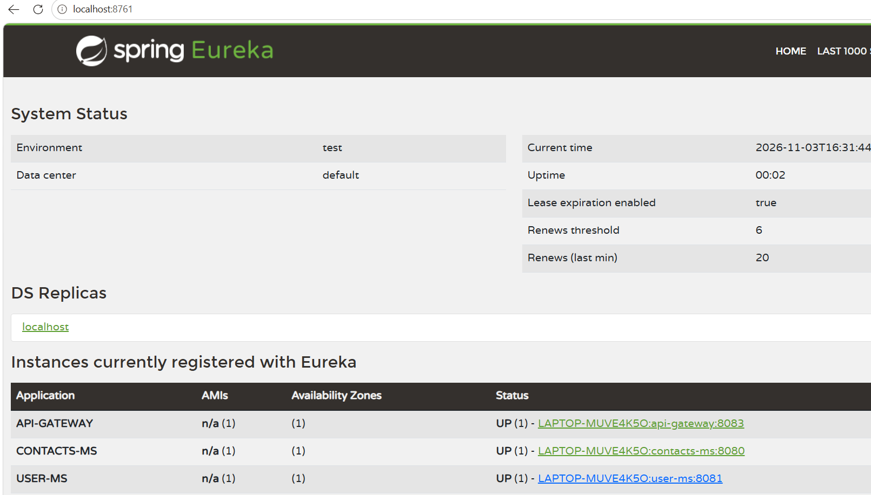
Tested for USER-MS through API-GATEWAY. It is working as expected with contacts data. (API-GATEWAY USER-MS FeignClient CONTACTS -MS)
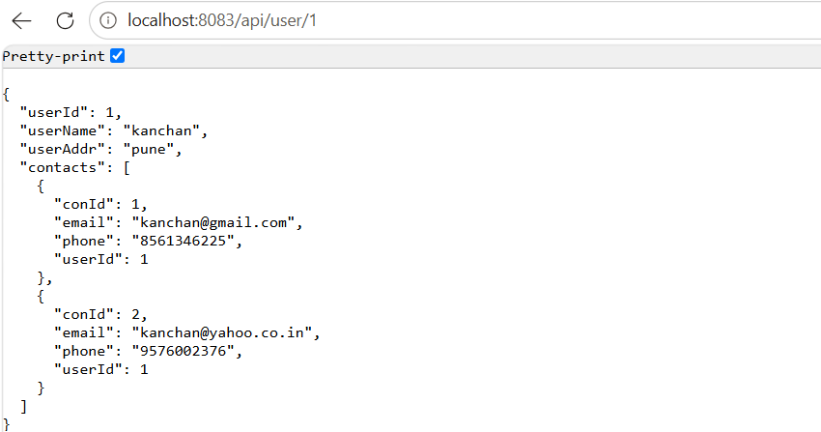

- Load Balancing
Browser API-GATEWAY (8083)USER-MS (8081)FeignClient Spring Cloud LoadBalancerEureka Discovery (8761)Selects one instance CONTACTS -MS (8080 OR 8084 OR 8086)
Configured 3 instances of CONTACTS-MS at different ports as 8080, 8084,8086
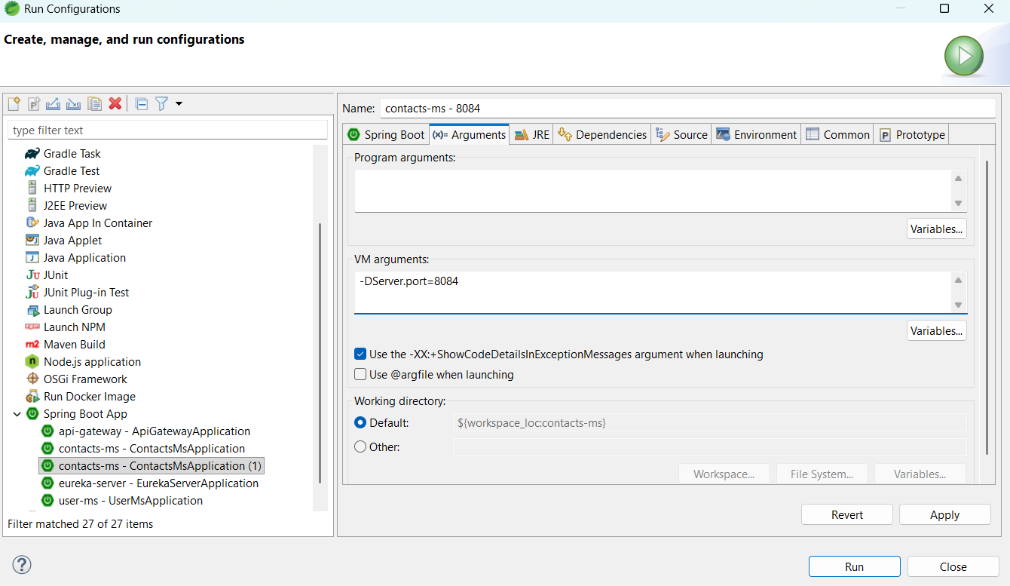
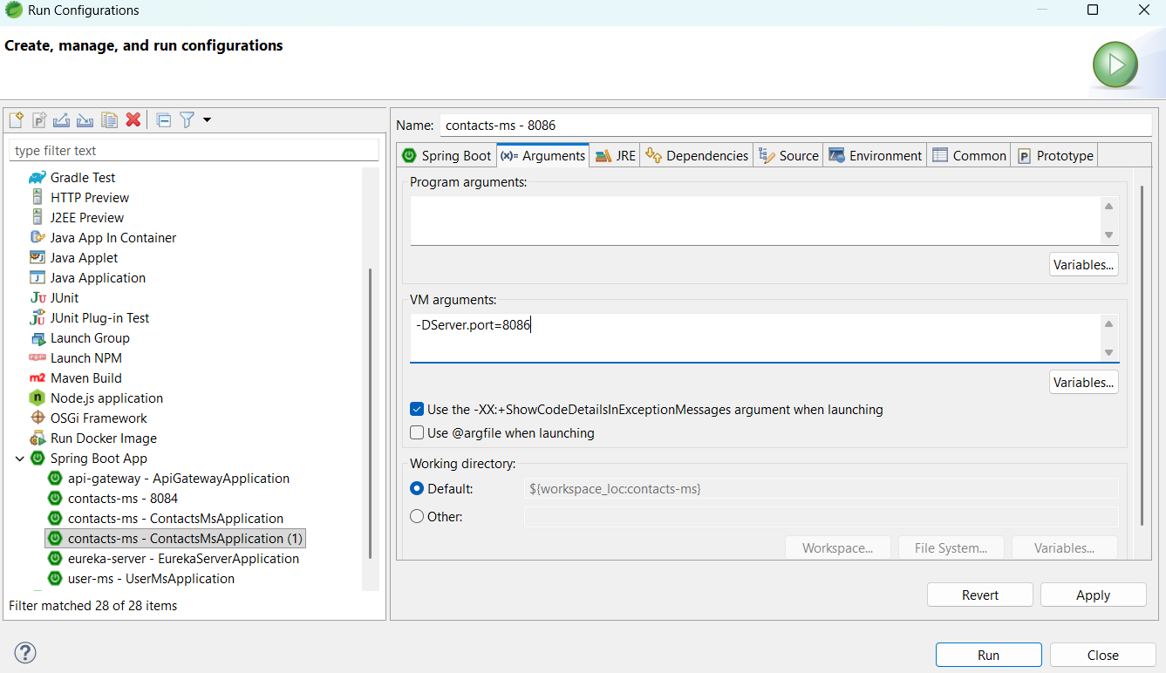

Verified on Eureka server for 3 instances. They are up and running.
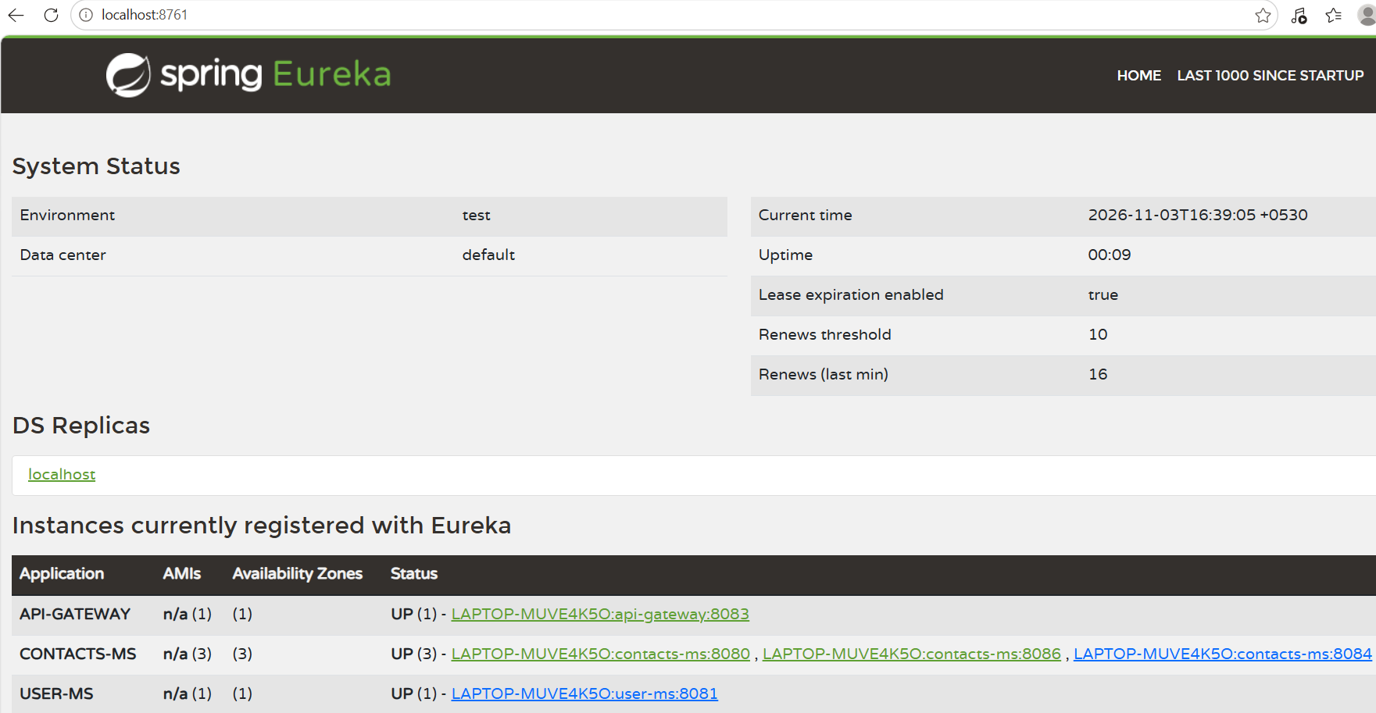
Request made 3 times to API-GATEWAY (to access USER-MS)
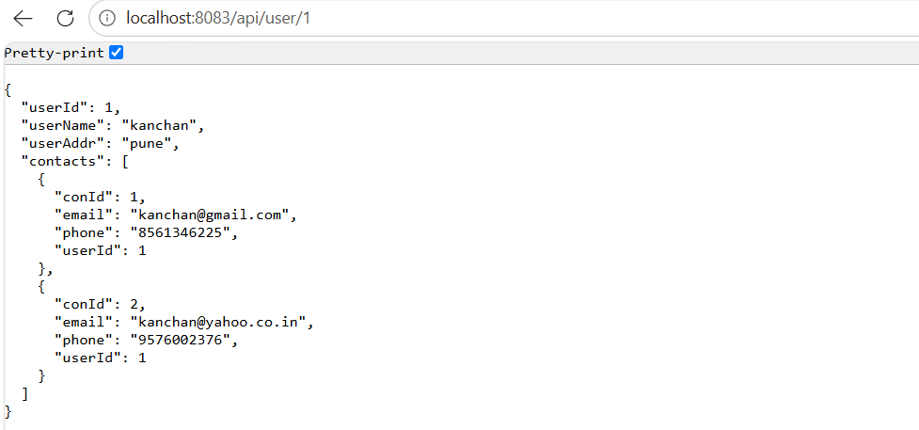
Spring Cloud LoadBalancer asks Eureka for all available instances and distributes requests among 3 instances. Below logs confirm requests are reaching different instances.
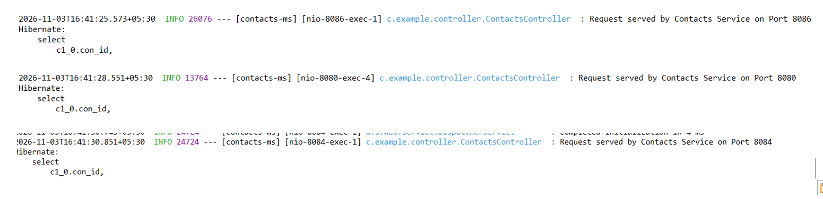

- Circuit breaker
  - When one/all CONTACTS-MS instance/s are up and running then it works
as expected, (verified in load balancing as well)
  - Stopped all CONTACTS-MS instances
Eureka server does NOT show any CONTACTS-MS instance.
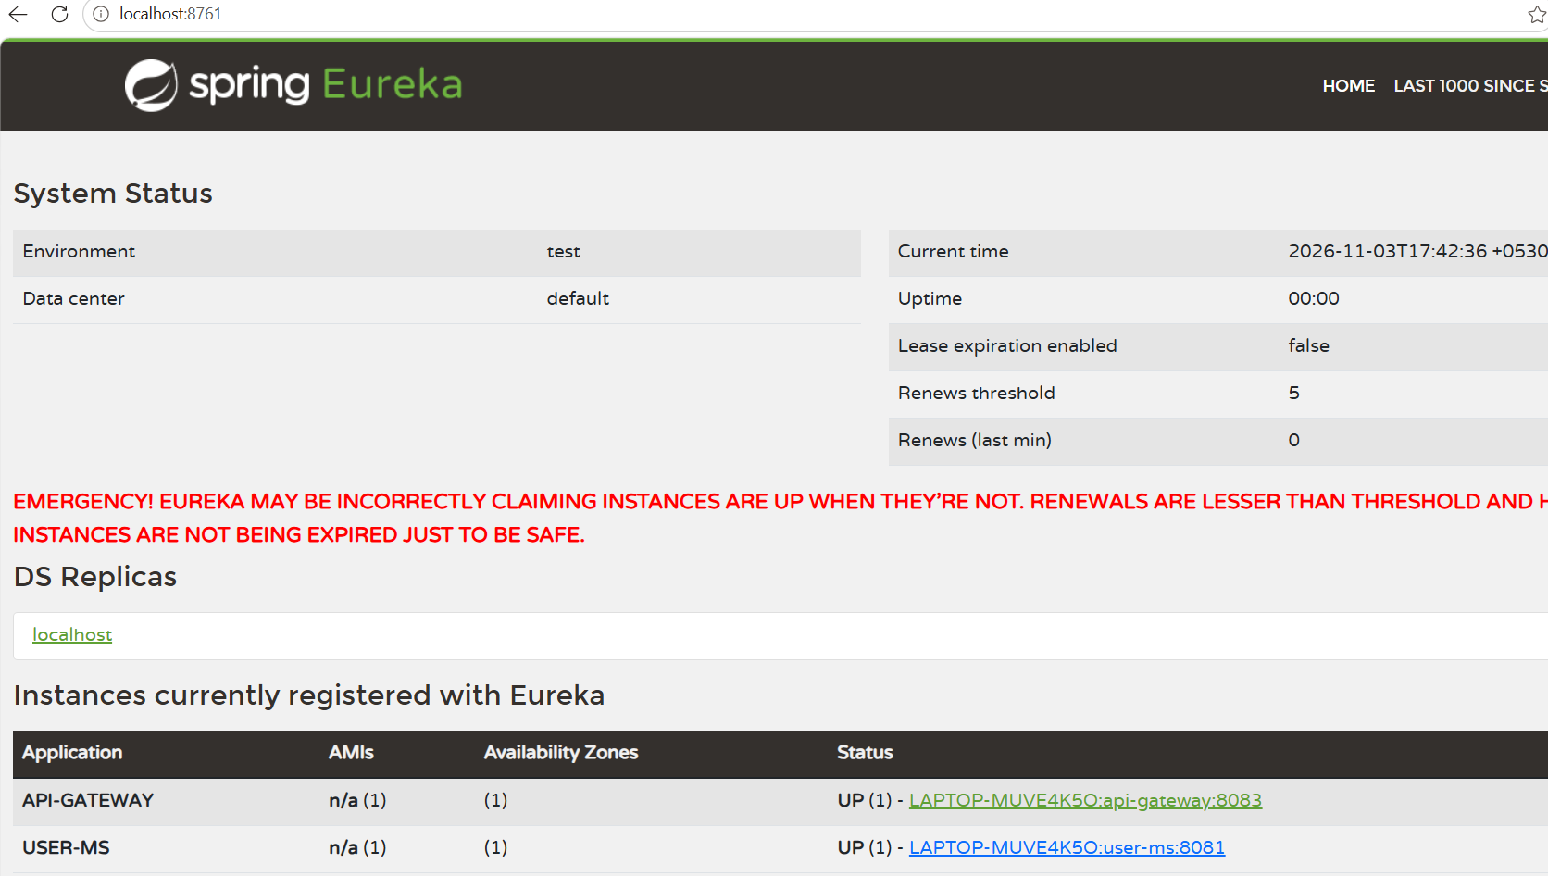
Request is made but as Contacts service is not available it displays empty contacts list on browser and ‘Contacts service unavailable’ in console.
Browser output:
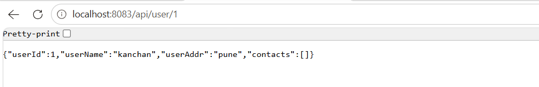
Console output:
After 5 consecutive failed requests (minimumNumberOfCalls: 5), the failure rate exceeded the configured threshold of 50% (failureRateThreshold: 50). As a result, the Circuit Breaker transitioned from CLOSED to OPEN state and fallback responses were returned.
After waiting 20 seconds (waitDurationInOpenState: 20s), the Circuit Breaker automatically transitioned to HALF-OPEN state. Three trial requests were allowed (permittedNumberOfCallsInHalfOpenState: 3) to verify whether CONTACTS-MS had recovered. Since CONTACTS-MS was still unavailable, all trial requests failed and the Circuit Breaker transitioned back to OPEN state. The fallback messages displayed in the console confirm this behaviour.
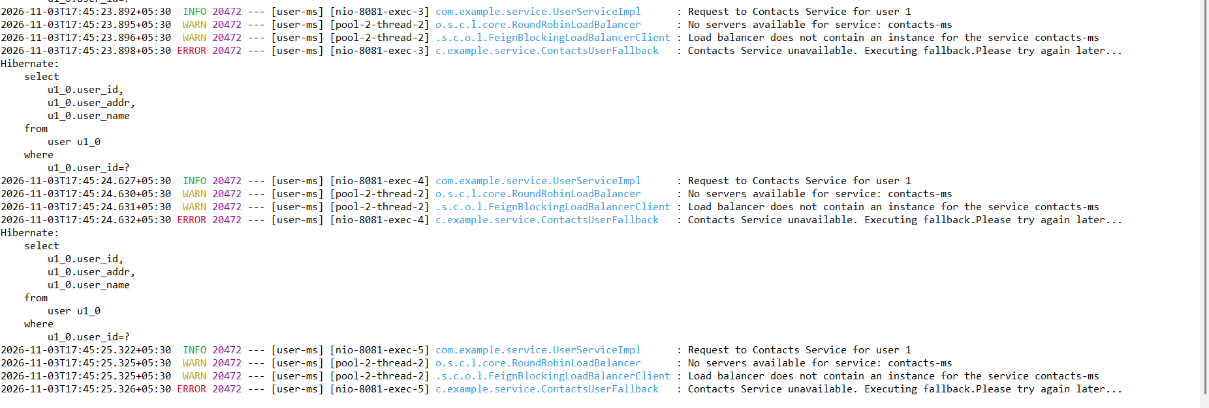
Now CONTACTS-MS service started. Verified on Eureka server.
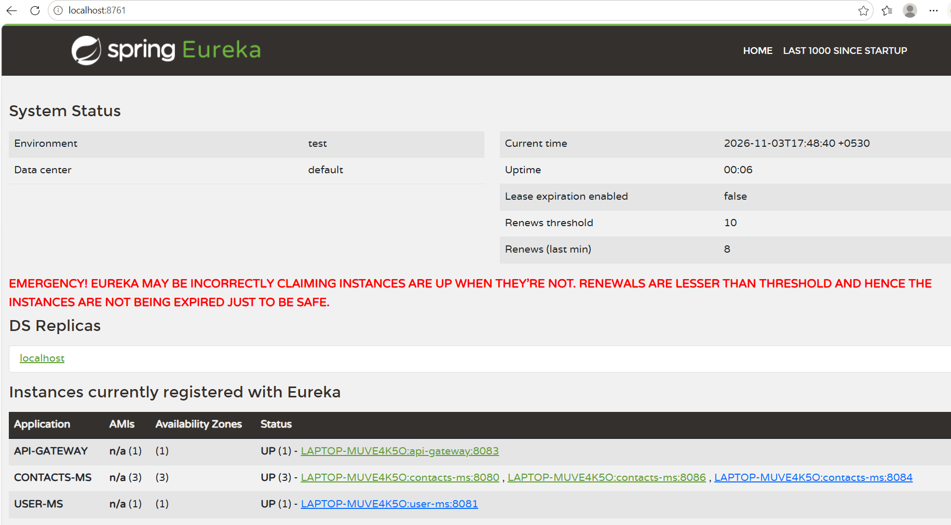
Request made to access USER-MS again. Now service is available and response is returned that indicates it again came back to CLOSED state.
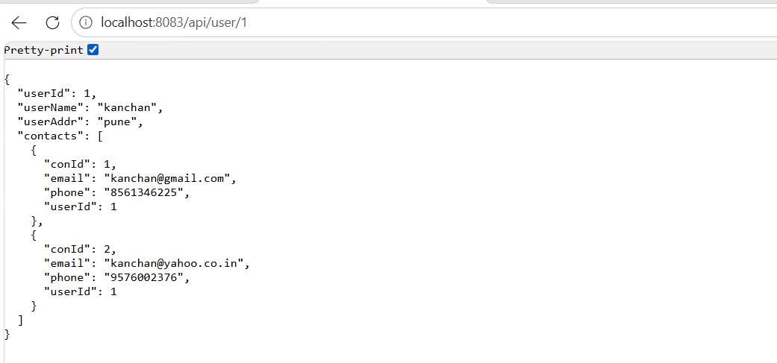
Request is served by CONTACTS -MS-8086 instance and sent response back.
Circuit breaker life cycle observed as
CLOSED → OPEN → HALF-OPEN → CLOSED
Conclusion
This prototype successfully demonstrated following
- Feign Client successfully performed service-to-service communication.
- Eureka Server successfully performed service discovery.
- Requests were distributed across multiple CONTACTS-MS instances proving load balancing.
- Resilience4j Circuit Breaker prevented repeated calls to unavailable services.
- Fallback response was returned during service outage.
- Circuit Breaker successfully recovered after CONTACTS-MS became available again.

