**PLANS**

These are two plans, that can be purchased.

This includes domain name “aakasadesign.com” for 3 years, hosting space for 48months, SSL certificate, Customised Email.

Difference:

|  |  |
| --- | --- |
| Plan 1 | Plan 2 |
| Lower Bandwidth | Higher Bandwidth (used for faster loading of website) |
| SSL certificate just for a year | SSL certificate for lifetime (most important part of website hosting, gives security to website) |
| Only 1 Email Address can be created with website domain name  (eg. [contact@aakasadesign.com](mailto:contact@aakasadesign.com) ) | Multiple(Unlimited) Email Address can be created  (eg. [contact@aakasadesign.com](mailto:contact@aakasadesign.com),  [test@aakasadesign.com](mailto:test@aakasadesign.com) ,etc) |
| No backups | Weekly backups |
| No free domain for first year | Free domain for first year |

Note: These are the important differences, for more difference please refer first image (difference) attached. In that Single web hosting (plan 1) and Premium web hosting (plan 2) is selected.

**Difference**

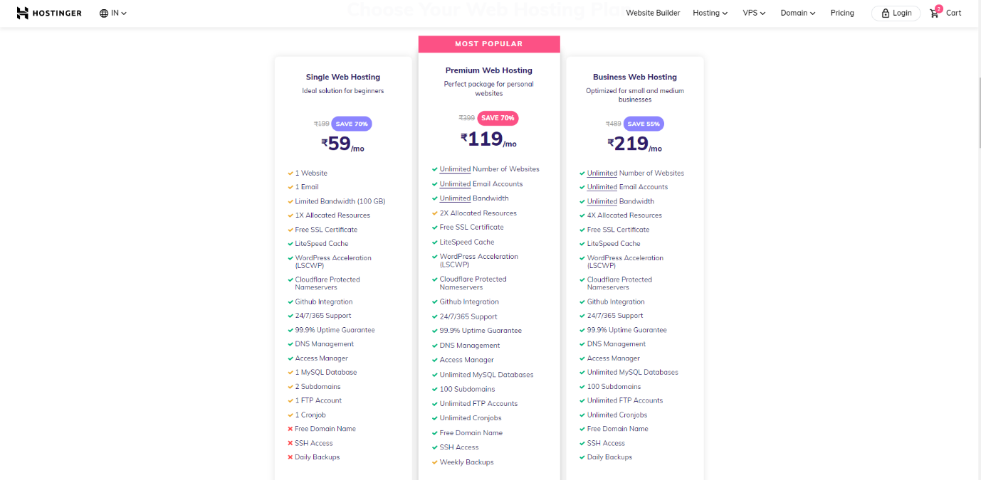

**Plan 1**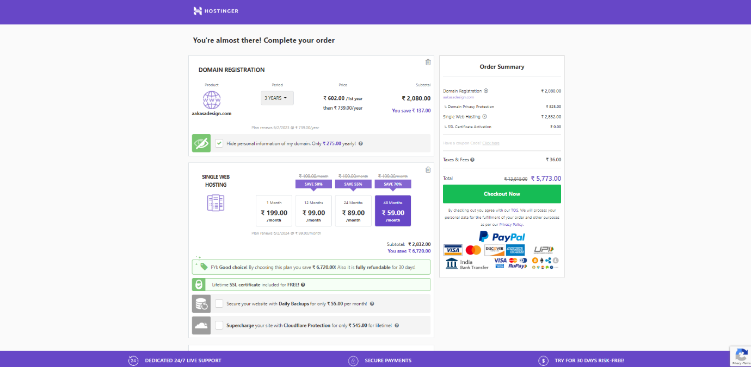

**Plan 2**