PARAMETRIC ANALYSIS AND OPTIMIZATION OF AN ETHANOL-FUELLED SI ENGINE
Using ANSYS Chemkin-Pro 2025 R2
Technical Report
ME60111 — Internal Combustion Engine
Department of Mechanical Engineering
Indian Institute of Technology Kharagpur
Group 11
Group Members
Group 11 members and primary contributions.
Roll Number | Student Name | Primary Contribution
23ME10066 | Raksha Gupta | Baseline simulation
23ME10038 | Kanchan Potdar | 150-case parameter study
23ME10074 | Saloni | Performance optimization and Otto comparison
23ME10053 | Nagineni Lakshmipravallika | Python data analysis and visualization
23ME10060 | Pranjali Khatua | Technical report and presentation

Table of Contents
1 Introduction 3
1.1 Background 3
1.2 Objectives and Scope 3
2 Chemkin SI-Engine Model and Operating Conditions 3
3 Reaction Mechanism and Combustion Model 5
3.1 Ethanol-Air Chemistry 5
3.2 Combustion Representation 5
4 Performance Parameters and Theoretical Relations 5
5 Numerical Methodology and Parameter Study 6
6 Results and Discussion 7
6.1 Effect of Engine Speed 7
6.2 Effect of Combustion Start Angle 8
6.3 Effect of Burn Duration 9
7 Parameter Interactions and Optimization 10
7.1 Interaction of Combustion Start and Burn Duration 10
7.2 Optimal Operating Conditions 13
8 Comparison with the Ideal Otto Cycle 14
8.1 Ideal Otto-Cycle Efficiency 14
8.2 Physical Interpretation of the Difference 15
9 Discussion 15
9.1 Major Findings 15
9.2 Model Limitations 15
10 Conclusions 16
11 Group Member Contributions 16
References 17
Nomenclature 18
Appendix A. Supplementary Parameter-Study Results 18

1 Introduction

1.1 Background
Spark-ignition engine output depends on when heat is released relative to top dead centre (TDC). Combustion start and burn duration affect the pressure history and therefore the indicated work over the compression and expansion strokes. Engine speed changes the rate at which cyclic work is delivered. A discrete parameter study allows these effects and their interactions to be compared within one defined model. In a four-stroke SI cycle, the piston compresses the unburned charge as it approaches top dead centre, the position of minimum cylinder volume. Crank angle measures piston and crank position relative to this reference; negative angles here occur before TDC. After TDC the piston descends and expanding gas can deliver positive work. A finite prescribed combustion interval distributes heat release over a range of crank angles rather than at one mathematical instant. Combustion start angle determines where this imposed event begins relative to TDC, while burn duration determines its angular extent. Torque is associated with work delivered per revolution, power with the rate of work, efficiency with the fraction of fuel energy converted to indicated work, and ISFC with fuel consumed per unit indicated energy output.

1.2 Objectives and Scope
The Group 11 assignment requires evaluation of engine speed, combustion start angle and burn duration; identification of conditions giving maximum indicated torque and power and minimum indicated specific fuel consumption (ISFC); comparison with ideal Otto-cycle efficiency; and explanation of isolated and interacting parameter effects. The present results are Chemkin simulation outputs and post-processing of 150 sampled cases. No experimental validation was performed. These objectives are evaluated using the same three-input grid so that a change in one input can be interpreted at fixed values of the other two, while the complete set reveals whether their effects depend on one another. The word “optimal” throughout this report means best among those sampled combinations.

2 Chemkin SI-Engine Model and Operating Conditions
The ANSYS Chemkin-Pro SI Engine Zonal Simulator represents the cylinder charge with burned and unburned reacting zones. The packaged project input records the baseline configuration in Table 1. Figure 1 documents the actual engine-geometry panel. The baseline mixture fractions are ethanol 0.0335363, O₂ 0.2029574 and N₂ 0.7635063 by mole; the oxidizer portion corresponds to 21% O₂ and 79% N₂. The unburned zone retains the charge ahead of the propagating burn, while the burned zone contains gas that has passed through the prescribed combustion event. This reduced-order zonal description follows the changing cylinder volume and reacting composition without resolving a three-dimensional flame. The model input specifies compression ratio, geometry and crank-angle limits; these determine the volume history used in the thermodynamic calculation. Figure 1 is the direct Chemkin configuration evidence for the engine geometry and baseline operation.
Table 1. Engine configuration and baseline model settings
Setting | Verified configuration
Fuel / oxidizer | Ethanol / air (21% O₂, 79% N₂ by mole)
Compression ratio | 12
Bore / stroke | 8.5 cm / 10.82 cm
Connecting rod / crank radius ratio | 3.3
Baseline speed | 600 RPM
End simulation crank angle | 139.8° ATDC
Combustion zones / profile | Two active chemistry zones / Wiebe profile
Combustion specification | Prescribed start angle and burn duration
Wall heat transfer | Zero wall heat transfer
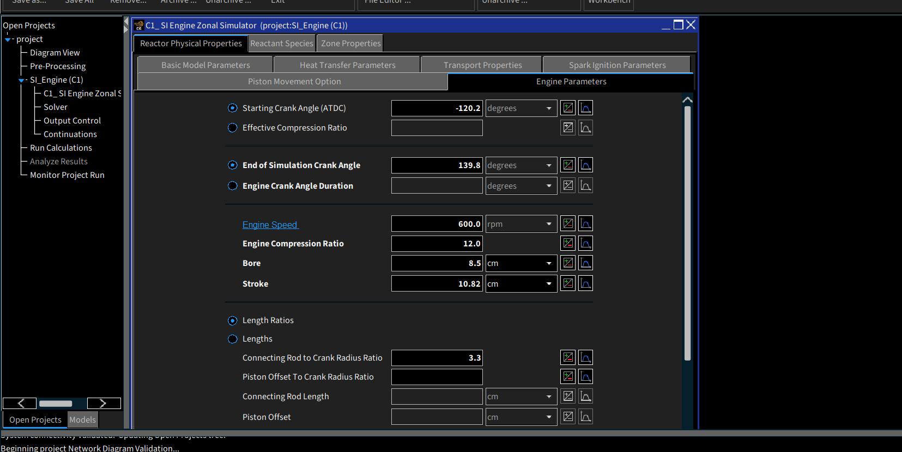
Figure 1. Chemkin-Pro engine geometry and baseline operating configuration.
The configuration is a modelling basis, not an experimental engine characterization. Table 2 states the principal assumptions and their implications. The source project files specify the reactant composition and imported chemistry files; the supplied screenshot set does not contain legible dedicated panels for these settings. The zero-wall-transfer setting means the simulated charge does not lose heat to the piston, head or liner. It is useful for isolating combustion-phasing trends, but it differs from a physical engine. Prescribed combustion imposes a burn trajectory instead of predicting the ignition and flame-development process independently.
Table 2. Principal modelling assumptions
Assumption | Modelling implication
Two-zone SI-engine model | Burned and unburned regions are treated separately.
Prescribed combustion / Wiebe profile | Start and duration are imposed through a burn profile.
Detailed chemistry | Species evolution uses the supplied kinetic and thermodynamic data.
Zero wall heat transfer | Cylinder-wall thermal losses are excluded.

3 Reaction Mechanism and Combustion Model

3.1 Ethanol-Air Chemistry
A chemical kinetic mechanism describes the reacting species and the rates at which they change. The supplied ethanol-air mechanism contains 80 species and 349 reactions. The packaged Chemkin configuration points to mech.dat for reactions, therm.dat for thermodynamic data, and trans.dat for transport data. Intermediate species and radicals permit the model to describe the evolving mixture beyond a single net reaction. The overall stoichiometric reaction is given in Equation (1).
$C_{2}H_{5}OH + 3O_{2} → 2CO_{2} + 3H_{2}O$ | (1)
Equation (1) represents the overall stoichiometric balance. Chemkin uses the detailed reaction mechanism, including intermediate species and radicals, together with kinetic and thermodynamic information to calculate the evolving reacting-gas state [2]. It fixes the net atom balance for complete stoichiometric oxidation but does not describe the path or speed of combustion. The detailed set is needed because reaction rates, intermediate populations and gas properties vary through the cycle. The report does not infer a particular elementary pathway from the net equation.

3.2 Combustion Representation
The input selects two active chemistry zones, a start–duration specification and a Wiebe burn profile. Unburned and burned regions evolve during the prescribed combustion event. Start angle determines its timing relative to TDC, while burn duration determines the crank-angle interval over which the imposed burn progresses. Detailed chemistry governs the reacting composition within this framework. These settings are verified from the packaged input rather than inferred from a screenshot. The Wiebe form prescribes a smooth cumulative burned-fraction history; its start and duration parameters therefore control the timing and spread of energy release. Advancing the start moves that history toward the compression stroke, whereas increasing duration distributes it farther across expansion. Detailed chemistry still affects evolving species and properties within the imposed phasing framework. This distinction matters when interpreting the parameter-study results: changing burn duration is a controlled model input, not a measured flame speed.

4 Performance Parameters and Theoretical Relations
The exported indicated quantities refer to the Chemkin intake valve closing (IVC)–exhaust valve opening (EVO) calculation window. The principal performance quantities in this study are indicated torque, indicated power, indicated thermal efficiency and ISFC. The following relations interpret the exported Chemkin results and verify their physical meaning and units. These are simulation-derived indicated quantities, not measured brake-shaft performance.
$P_{i} = \frac{2πN T_{i}}{60}$ | (2)
Here Pᵢ is indicated power (W), N is engine speed (rev/min), and Tᵢ is indicated torque (N·m). The factor 2πN/60 converts revolutions per minute into radians per second. At a fixed torque, each revolution contributes comparable work but more revolutions occur each second as N rises; this is why power may rise without a comparable torque increase.
$η_{th,i} = \frac{P_{i}}{{\dot{m}}_{f} LHV}$ | (3)
Here ηₜₕ,ᵢ is indicated thermal efficiency, ṁf is fuel mass-flow rate (kg/s), and LHV is lower heating value (J/kg). The denominator is the rate of chemical energy supplied by fuel. Efficiency is therefore a dimensionless energy-conversion measure, not a direct measure of output magnitude: two operating points can deliver different powers while having similar efficiencies.
$ISFC = \frac{{\dot{m}}_{f}}{P_{i}} × 3.6 × {10}^{9}$ | (4)
ISFC is in g/kWh when ṁf is in kg/s and Pᵢ is in W. The reported ISFC and efficiency values are exported Chemkin results; these expressions explain their physical meaning and units. This normalization makes fuel demand comparable across different power levels. A lower ISFC signifies that less fuel mass is needed to produce one kilowatt-hour of indicated work. The numerical conversion follows from 1000 g per kilogram and 3.6 × 10⁶ joules per kilowatt-hour.

5 Numerical Methodology and Parameter Study
A full-factorial discrete study varied three inputs while retaining the stated model configuration. Table 3 gives the sampled levels. The exported Run #2 through Run #151 results provide one row for each unique combination; Run #1 is an excluded baseline. The workflow comprised Chemkin setup, parameter variations, result export, Python cleaning and plotting, and objective-wise selection from the sampled grid. Full factorial means that each of the six speed values is paired with every one of the five start angles and every one of the five burn durations. Thus each speed contains 25 timing combinations, and the complete study contains 6 × 25 = 150 cases. This structure allows one-variable slices to be extracted at fixed companion settings and permits interaction curves to be compared over the common duration levels.
Table 3. Parameter ranges used in the full-factorial Chemkin study
Parameter | Values / range | Levels
Engine speed | 500–3000 RPM in 500 RPM increments | 6
Combustion start | −15, −12.5, −10, −7.5, −5°CA | 5
Burn duration | 10, 20, 30, 40, 50°CA | 5
6 × 5 × 5 = 150 simulations
Figure 2 shows the populated Chemkin parameter-study table. It supports the configured variation; the 150-case CSV is the numerical basis for the analysis. The available run-status screenshot does not independently establish convergence of every case. The screenshot is configuration evidence, whereas the exported case table is the source for values, rankings and plotted trends. The case count and unique combinations were checked against the CSV. The presence of output rows alone is not an independent proof that every solver trajectory converged.
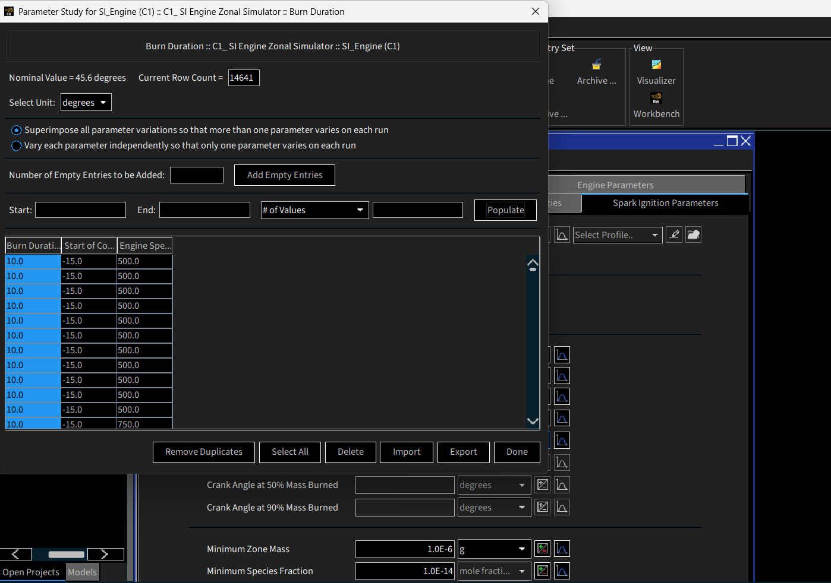
Figure 2. Populated Chemkin-Pro parameter-study table for the engine parameter variations.

6 Results and Discussion

6.1 Effect of Engine Speed
At −10°CA combustion start and 30°CA burn duration, Figure 3 shows that indicated torque changes only slightly from 500 to 3000 RPM, whereas indicated power rises strongly. Equation (2) explains this pattern: with nearly constant Tᵢ, Pᵢ increases approximately in proportion to N. Within this model and fixed slice, higher speed delivers more indicated work per unit time. The torque plot is comparatively flat, while the power plot spans a much larger relative change. In this fixed slice the speed change leaves the simulated work-producing torque broadly similar, so rotational frequency dominates the power response. This is a statement about the selected operating slice and model; it does not imply torque is speed-independent for every SI engine or for every combination in the grid.
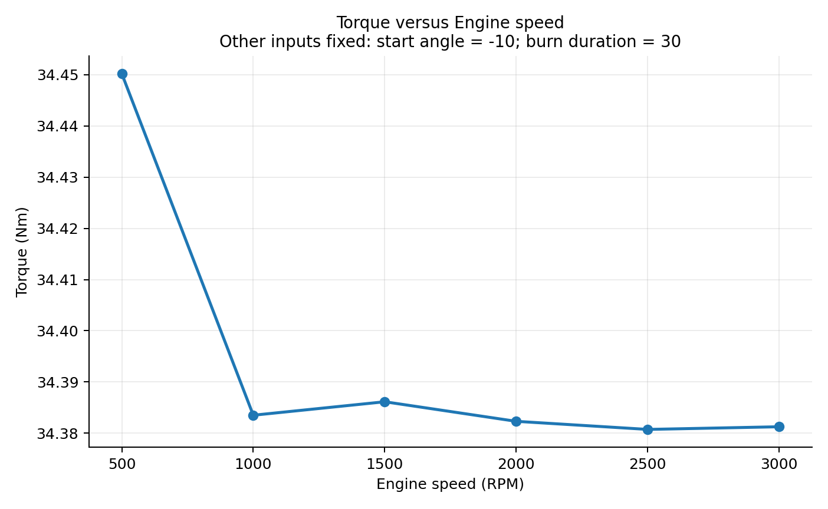
Figure 3. Effect of engine speed on indicated torque at −10°CA start and 30°CA duration.
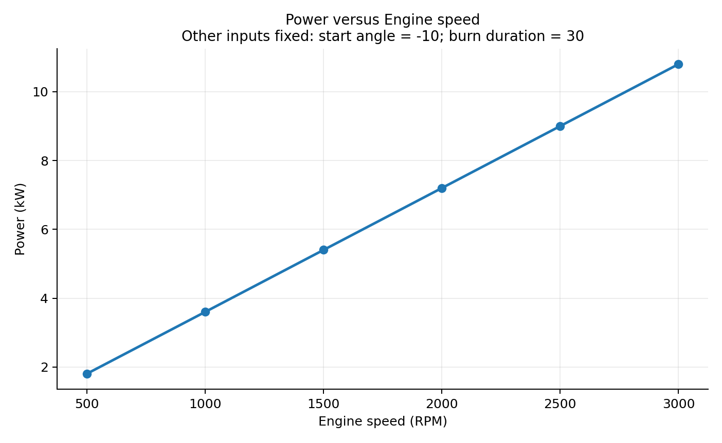
Figure 4. Effect of engine speed on indicated power at −10°CA start and 30°CA duration.

6.2 Effect of Combustion Start Angle
At 1500 RPM and 30°CA burn duration, Figures 5 and 6 show improvement in torque and indicated efficiency as combustion is advanced from −5°CA toward −15°CA. Earlier heat release in this fixed slice can increase pressure during the useful expansion interval. This isolated trend does not imply that −15°CA is the best setting over the complete grid: the preferred start angle changes when burn duration changes. Advancing the prescribed event places more of the imposed release before or near TDC. For the relatively long 30°CA burn considered here, the resulting pressure phasing is consistent with the higher indicated work shown in the plots. An earlier start can also raise pressure during compression, however, so the direction of this local trend should not be extrapolated to a short burn. The complete interaction study tests precisely that dependence. The apparent difference from the −5°CA full-grid best point arises because the preferred start angle changes with burn duration.
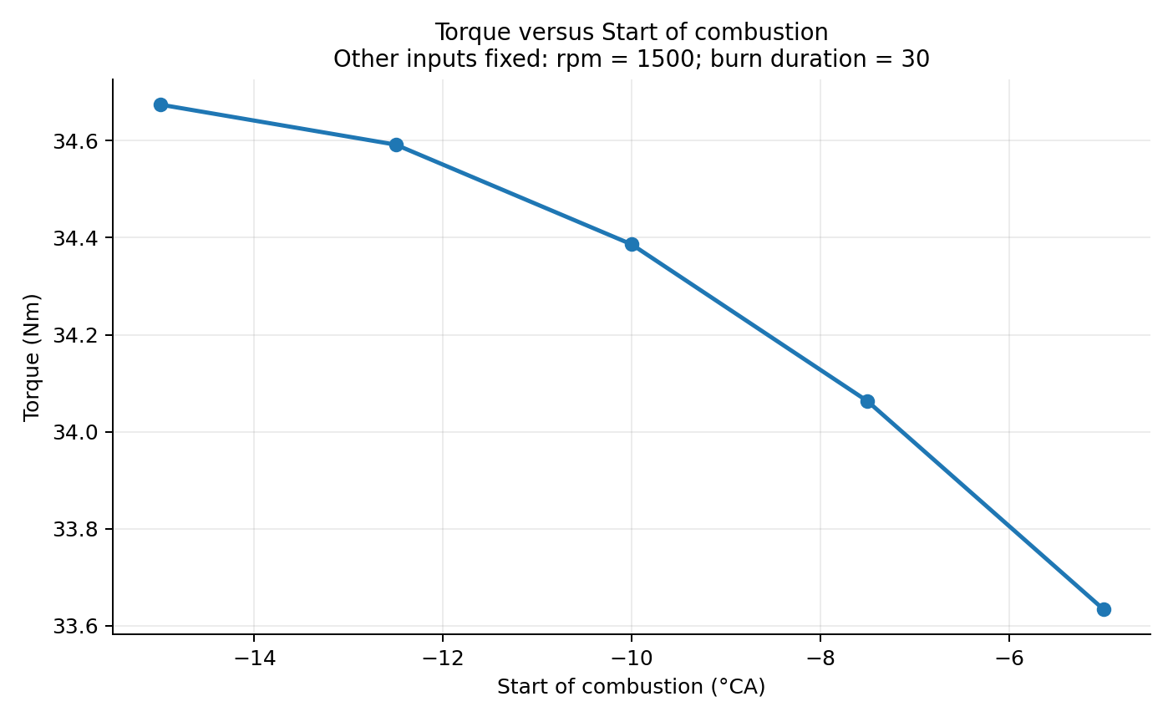
Figure 5. Effect of combustion start angle on indicated torque at 1500 RPM and 30°CA duration.
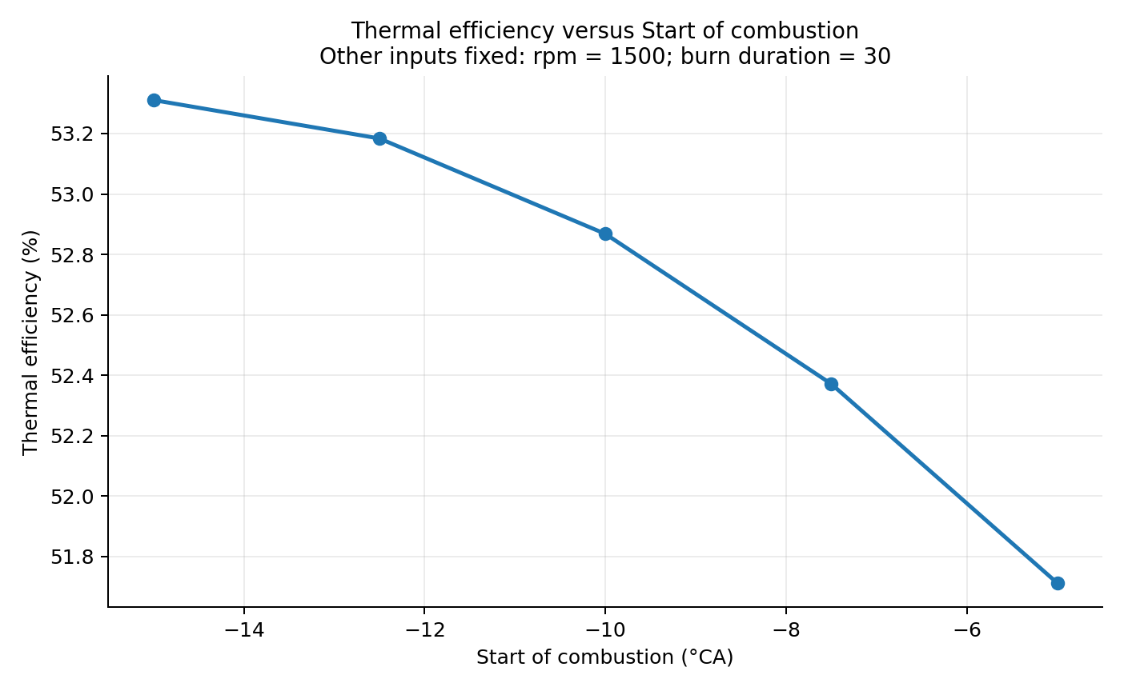
Figure 6. Effect of combustion start angle on indicated efficiency at 1500 RPM and 30°CA duration.

6.3 Effect of Burn Duration
At 1500 RPM and −10°CA start, Figure 7 gives the highest torque near 20°CA duration in this fixed slice; Figure 8 shows the corresponding local ISFC response. Extending combustion releases a greater share of energy after cylinder expansion has progressed, when additional pressure contributes less useful work. Beyond the local best duration, torque falls and ISFC rises. This fixed-slice result is distinct from the full-grid best condition. Burn duration is the angular span over which the prescribed event proceeds. A very short or very long interval can move the pressure rise away from the most useful portion of expansion for a particular start angle. The plotted torque maximum around 20°CA and ISFC response are therefore local to this 1500 RPM, −10°CA slice. At other starts the duration ranking differs, as the interaction curves show. This is local fixed-slice behaviour, not the complete-grid optimum.
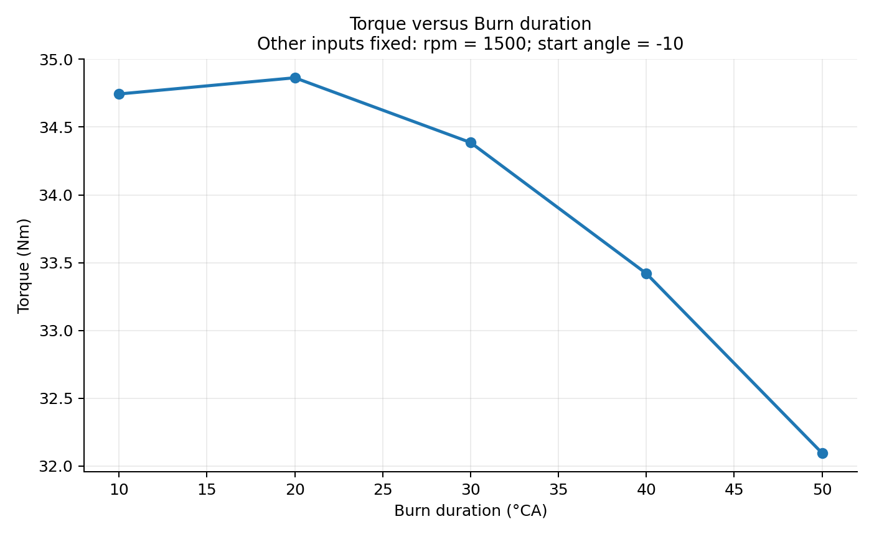
Figure 7. Effect of burn duration on indicated torque at 1500 RPM and −10°CA start.
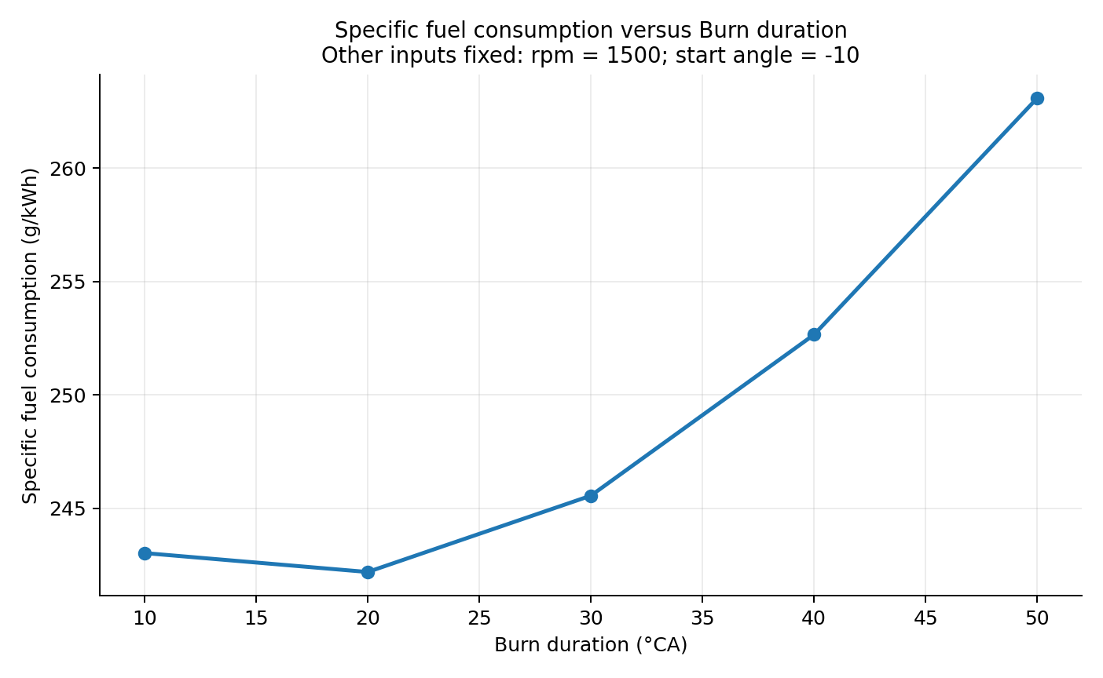
Figure 8. Effect of burn duration on indicated ISFC at 1500 RPM and −10°CA start.

7 Parameter Interactions and Optimization

7.1 Interaction of Combustion Start and Burn Duration
Figures 9–11 use the complete start-angle and burn-duration combinations at selected speeds. The crossing and changing separation of the plotted series show that the start-angle effect depends on burn duration. These interactions explain why isolated one-variable slices cannot identify the best condition for the full grid. On each plot the horizontal axis is burn duration in crank-angle degrees. Each coloured curve holds a distinct combustion start angle fixed, and its points are the five sampled durations at the stated speed. Parallel curves with similar spacing would suggest a more uniform start-angle effect; changes in their separation and ordering indicate that the effect of start timing depends on burn duration. The plotted lines connect discrete simulations and do not establish behaviour between sampled points.
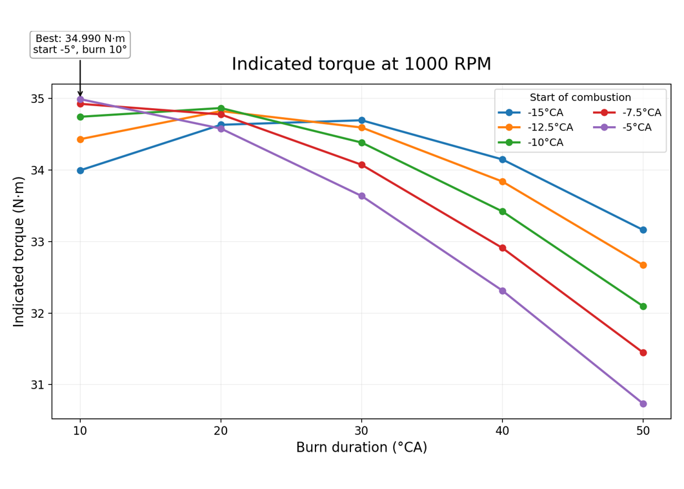
Figure 9. Combustion start–burn duration interaction for indicated torque at 1000 RPM.
The largest sampled torque is 34.990 N·m at 1000 RPM, −5°CA start and 10°CA duration. At longer durations, the ordering of start angles changes: the short burn event favours a later start, while a long event can benefit from earlier initiation. This is consistent with the need to place the main heat release near the beginning of expansion. At the shortest duration the −5°CA curve reaches the highest point, but the advantage of that later start disappears as the duration is lengthened. The changed curve ordering means the best start angle in one duration slice cannot simply be carried to another. The physical interpretation is a shift in the timing of the main pressure rise relative to TDC; the plot itself reports torque, not a decomposed pressure-work contribution.
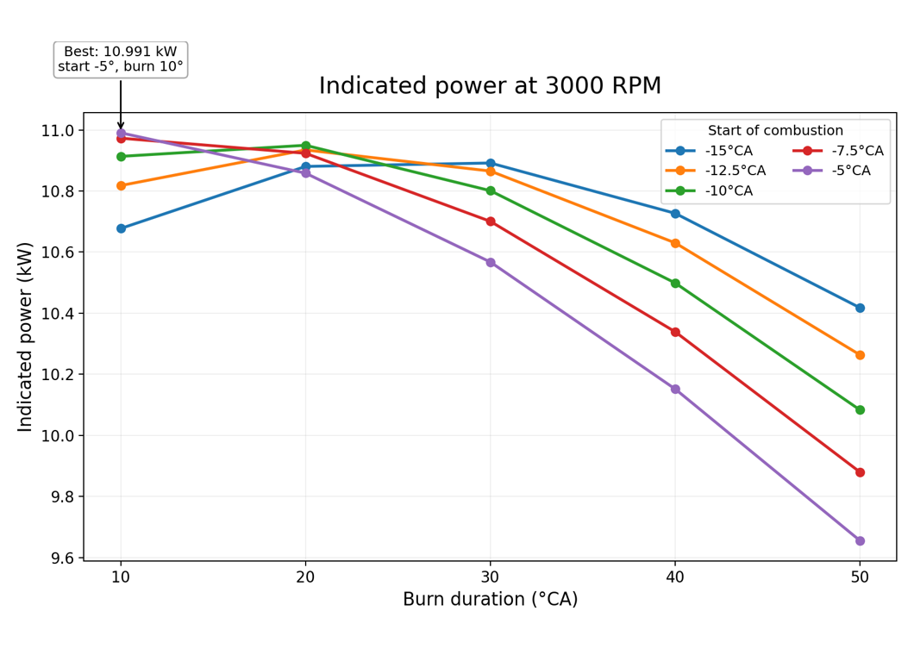
Figure 10. Combustion start–burn duration interaction for indicated power at 3000 RPM.
The maximum sampled power is 10.991 kW at 3000 RPM with the same −5°CA start and 10°CA duration. This phasing maintains high indicated torque; the higher rotational speed converts cyclic work into the largest rate of work, as expressed by Equation (2). As in the torque plot, the start-angle curves do not preserve a single fixed ranking across all burn durations. In particular, the short-duration later-start combination retains high torque at the highest tested speed. Since power is torque multiplied by angular speed, this speed-specific plot and Equation (2) together explain why the power maximum occurs at a different RPM from the torque maximum.
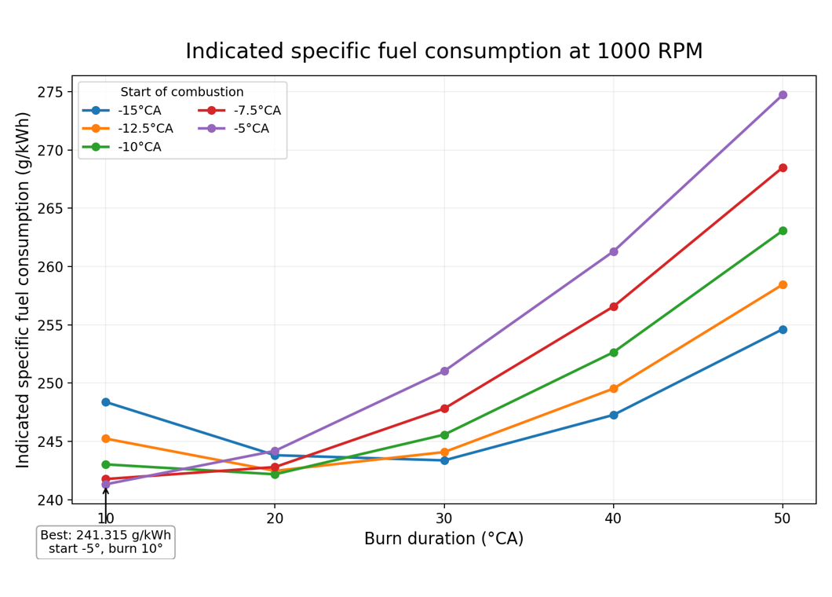
Figure 11. Combustion start–burn duration interaction for indicated ISFC at 1000 RPM.
The minimum sampled ISFC is 241.315 g/kWh at 1000 RPM, −5°CA start and 10°CA duration. Lower ISFC means more useful indicated work per unit fuel. The curves show that long duration penalizes the later starts most strongly. The −15°CA trend at 30°CA duration in Section 6.2 and the −5°CA plus 10°CA full-grid result are therefore consistent: combustion start and burn duration cannot be interpreted independently. The ordinate is grams of fuel per kilowatt-hour of indicated output, so lower points are favourable. As duration increases, the later-start curve rises especially strongly, showing that its fuel-use advantage at 10°CA is conditional on a short burn. This pattern is consistent with a declining share of fuel energy being converted into indicated work when heat release is moved too far into expansion. The supplementary sampled-grid heatmaps in Appendix A show the same boundary region without replacing the interaction-line interpretation.

7.2 Optimal Operating Conditions
Table 4 selects each objective directly from the 150-case CSV. The best points lie on the sampled start-angle and duration boundaries; no continuous optimum is implied. The table separates four distinct objectives, rather than treating torque, power, efficiency and fuel consumption as interchangeable. The common −5°CA, 10°CA timing combination is a feature of this sampled model grid. Speed still distinguishes the power maximum from the other three selected results.
Table 4. Best sampled operating conditions for the evaluated objectives
Objective | Best result | Speed | Start | Duration
Maximum indicated torque | 34.990 N·m | 1000 RPM | −5°CA | 10°CA
Maximum indicated power | 10.991 kW | 3000 RPM | −5°CA | 10°CA
Minimum indicated ISFC | 241.315 g/kWh | 1000 RPM | −5°CA | 10°CA
Maximum indicated efficiency | 53.797% | 1000 RPM | −5°CA | 10°CA
Boundary optimum: The best sampled timing combination, −5°CA start and 10°CA burn duration, lies on both tested timing boundaries. The continuous optimum may lie outside the evaluated range; the present study establishes only the best condition within the sampled grid.
A 10°CA combustion duration concentrates heat release near TDC, when cylinder volume is small. Within the present prescribed-combustion model, this is consistent with a favourable pressure contribution during early expansion and greater indicated work. Starting such a short event substantially earlier can shift heat release into the compression stroke and is expected to increase compression-side work. A late or prolonged event releases more energy after significant expansion. Within the evaluated grid, −5°CA start and 10°CA duration provide the best sampled balance. Torque varies relatively little with speed, so maximum power occurs at 3000 RPM while torque and efficiency peak at 1000 RPM. This interpretation follows from the imposed phasing and standard pressure-volume reasoning; the study did not compute a separate compression-side work loss for each case. Earlier pressure rise before TDC can oppose the upward-moving piston. Conversely, when release persists after substantial volume growth, the same energy can produce a smaller pressure contribution to expansion work. The 30°CA fixed slice favours earlier initiation because that longer burn requires more lead time, whereas the 10°CA event can be initiated closer to TDC.
The reported optima are the best sampled points from the 150-case discrete grid and do not establish continuous global optimality.

8 Comparison with the Ideal Otto Cycle

8.1 Ideal Otto-Cycle Efficiency
The ideal Otto cycle is an air-standard thermodynamic benchmark comprising isentropic compression, instantaneous constant-volume heat addition, isentropic expansion and constant-volume heat rejection. Under constant ideal-air properties, its efficiency depends on compression ratio r and specific-heat ratio γ = Cₚ/Cᵥ. For the verified model compression ratio r = 12 and the stated ideal-air assumption γ = 1.4, Equation (5) gives the ideal air-standard Otto-cycle benchmark of 62.99% [3].
$η_{Otto} = 1 − \frac{1}{r^{γ − 1}}$ | (5)
$η_{Otto} = 1 − \frac{1}{{12}^{1.4 − 1}} = 0.6299 ≈ 62.99\%$
Here ηOtto is ideal-cycle thermal efficiency, r is compression ratio, and γ is the assumed ideal-air specific-heat ratio. The substitution yields 62.99%, compared with the maximum simulated indicated efficiency of 53.80% in Table 5. Their difference is 9.19 percentage points, a benchmark gap rather than an isolated physical loss. The γ = 1.4 assumption is used only for this ideal calculation, not for the reacting-gas Chemkin results.
Table 5. Ideal Otto and maximum simulated indicated efficiencies
Quantity | Value
Compression ratio | 12
Assumed ideal-air γ | 1.4
Ideal Otto efficiency | 62.99%
Maximum Chemkin indicated efficiency | 53.80%
Difference | 9.19 percentage points

8.2 Physical Interpretation of the Difference
The Otto value assumes instantaneous constant-volume heat addition, constant specific heats and idealized compression and expansion. The Chemkin calculation instead uses finite-duration prescribed ethanol combustion, detailed reacting chemistry and temperature- and composition-dependent gas properties. These different assumptions together explain why the simulated indicated efficiency is lower than the ideal benchmark. The 9.19 percentage-point difference is a benchmark gap, not a measured loss assigned to one mechanism. In particular, wall heat transfer cannot explain this difference within the baseline model because zero wall heat transfer was imposed.

9 Discussion

9.1 Major Findings
Combustion-phasing interaction: The preferred start angle shifts with burn duration; the interaction plots resolve the apparent conflict between isolated slices and the grid result.
Torque and power: Nearly speed-independent indicated torque makes power rise with RPM, leading to different speed settings for their maxima.
Efficiency and ISFC: The lowest ISFC and highest indicated efficiency occur at the same sampled condition, consistent with greater useful work per unit fuel.

9.2 Model Limitations
Finite and boundary-limited parameter grid: 150 discrete combinations were tested. The best start angle and burn duration occur at the tested boundaries. Future optimisation should first extend the feasible timing range beyond the present boundaries, where physically and model-wise appropriate, and then perform a finer local sweep around the resulting promising region.
Zero wall heat loss: Real cylinders exchange heat through the piston, liner and head; future models should include calibrated heat transfer. This assumption can affect absolute temperature, pressure and efficiency predictions. It also prevents the Otto comparison gap from being attributed to heat transfer in the present calculation.
Prescribed combustion: Actual flame development depends on turbulence, mixture preparation, ignition and geometry; a more predictive combustion treatment could test sensitivity. The simulated timing study probes the consequences of imposed profiles, not the engine hardware needed to realize them. Predictions may shift if ignition and flame propagation are computed from flow and geometry.
Limited variables: Only speed, start and duration varied; further studies could vary load, mixture and geometry. The reported best point is conditional on the fixed values of all other settings. Varying mixture, load or geometry could change the ranking.
No experimental validation: No same-engine measurements were compared; future work should validate pressure traces and performance before applying the results to hardware. Numerical consistency checks support processing of the export but cannot establish predictive accuracy for a physical engine. Any design recommendation needs measurements from a comparable engine.
Solver evidence: The supplied materials do not include a complete per-run convergence log set; future archival should retain each case status and solver log.

10 Conclusions
The 150-case full-factorial Chemkin study evaluated engine speed, combustion start angle and burn duration for a two-zone, prescribed-combustion ethanol SI-engine model. The post-processed indicated results identify the strongest points within the sampled grid, not a continuous global optimum. The workflow links the project input and mechanism to the parameter-study export and then to the Python analysis. Actual configuration screenshots document the geometry and populated study table, while the CSV supports the objective rankings and plots. The best sampled timing combination occurs at the tested start-angle and duration boundaries; extension of the feasible range is needed before claiming a broader optimum.
Maximum indicated torque was 34.990 N·m at 1000 RPM, and maximum indicated power was 10.991 kW at 3000 RPM. Both used −5°CA start and 10°CA burn duration. At 1000 RPM with the same phasing, minimum ISFC was 241.315 g/kWh and maximum indicated efficiency was 53.797%.
Combustion timing and duration interact: rapid heat release appropriately phased near TDC provides the strongest sampled performance. Isolated trends at fixed duration do not transfer unchanged to other durations. Nearly constant torque over the tested speed range explains the rise in power with RPM.
The ideal Otto efficiency of 62.99% is a theoretical benchmark above the maximum simulated indicated efficiency. The difference reflects combined modelling and thermodynamic distinctions and is not attributable to wall heat loss in this zero-wall-transfer baseline. Future work should refine the grid, include more realistic physical effects and compare predictions with experiments.

11 Group Member Contributions
Table 6 records the assigned primary contributions.
Table 6. Group 11 member contributions
Roll Number | Student Name | Primary Contribution
23ME10066 | Raksha Gupta | Baseline simulation
23ME10038 | Kanchan Potdar | 150-case parameter study
23ME10074 | Saloni | Performance optimization and Otto comparison
23ME10053 | Nagineni Lakshmipravallika | Python data analysis and visualization
23ME10060 | Pranjali Khatua | Technical report and presentation

References
[1] ANSYS Chemkin-Pro 2025 R2, Group 11 packaged SI-engine project and input files, supplied project archive, 2026.
[2] Group 11 supplied ethanol-air mechanism files, mech.dat, therm.dat and trans.dat, packaged with the Chemkin project, 2026.
[3] ME60111 Internal Combustion Engine, Group 11 problem statement and course assignment, Indian Institute of Technology Kharagpur, supplied PDF, 2026.
[4] Group 11, 150-case Chemkin endpoint performance export and Python analysis outputs, supplied project files, 2026.

Nomenclature
Table 7. Symbols used in this report
Symbol | Meaning | Unit
N | Engine speed | RPM
Tᵢ | Indicated torque | N·m
Pᵢ | Indicated power | W or kW
ṁf | Fuel mass-flow rate | kg/s
LHV | Lower heating value | J/kg
ηₜₕ,ᵢ | Indicated thermal efficiency | – or %
ISFC | Indicated specific fuel consumption | g/kWh
r | Compression ratio | –
γ | Ideal Otto specific-heat ratio | –
CA | Crank angle | degrees

Appendix A. Supplementary Parameter-Study Results
The following existing Python heatmaps display discrete cells from the same 150-case export. Colour varies across tested combinations only; the images do not establish a continuous surface between or beyond the sampled settings. The interaction line plots in Figures 9–11 remain the primary basis for interpreting timing–duration interaction.
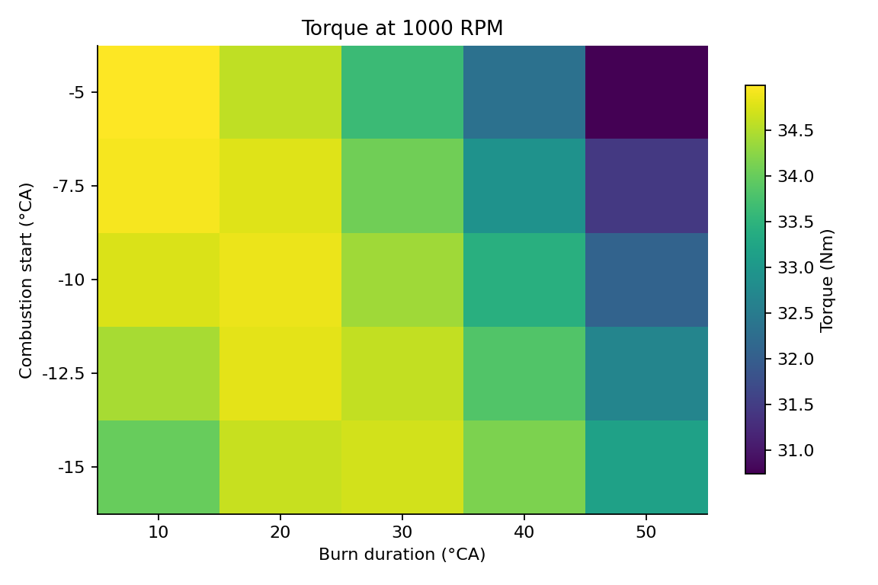
Figure 12. Sampled indicated-torque grid over combustion start and burn duration at 1000 RPM.
Figure 12 maps the 25 tested timing combinations at 1000 RPM. The highest torque cell is at −5°CA and 10°CA, on the latest-start and shortest-duration boundaries. The varying colour pattern across rows is consistent with the interaction already shown by Figure 9; it does not show a turn-over beyond either tested boundary.
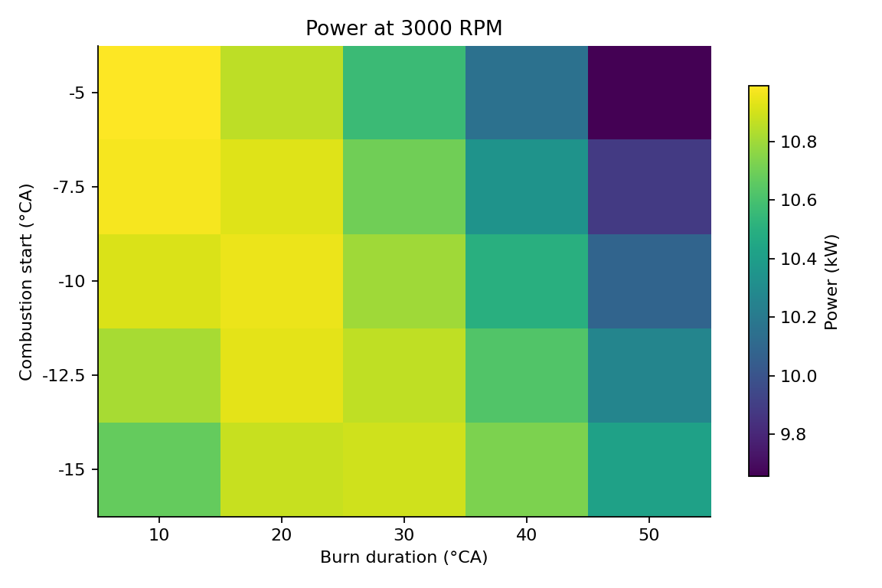
Figure 13. Sampled indicated-power grid over combustion start and burn duration at 3000 RPM.
Figure 13 shows the 3000 RPM power ranking over the same discrete timing grid. The strongest sampled cell again occurs at −5°CA and 10°CA. The result complements Figure 10 by displaying every sampled start–duration pair as a cell, while the line plot more clearly shows changes in curve ordering.
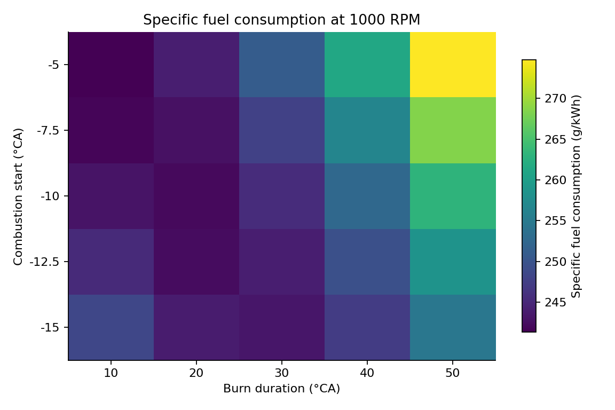
Figure 14. Sampled indicated-ISFC grid over combustion start and burn duration at 1000 RPM.
Figure 14 maps sampled ISFC at 1000 RPM; lower values are favourable. Its minimum lies at −5°CA start and 10°CA duration, on both timing-grid boundaries, consistent with Figure 11.

