

Week 5 - Project Report
By : Kanchan Rai

Topic : FlightBookingSystem w/ WebFlux

The following document contains the description and explanation of the project FlightBookingSystem made with WebFlux. This project has all the required validations for all end points, exception handling, unit test coverage of 90%. Load testing carried out as well for all endpoints. The database used is MongoDB. And Reactive Programming has been carried out as well.

INDEX

1. Sonar Cube Report 3
1.1 Before Fixing 3
1.2 After Fixing 4
2. JCoco Coverage Report 6
3. MongoDB Aggregations 6
4. JMeter Load Testing 9
4.1 With 20 Threads 9
4.1 With 50 Threads 12
4.1 With 100 Threads 13
5. All API Endpoints Testing & Results 15

1. Sonar Cube Report

1.1 Before Fixing

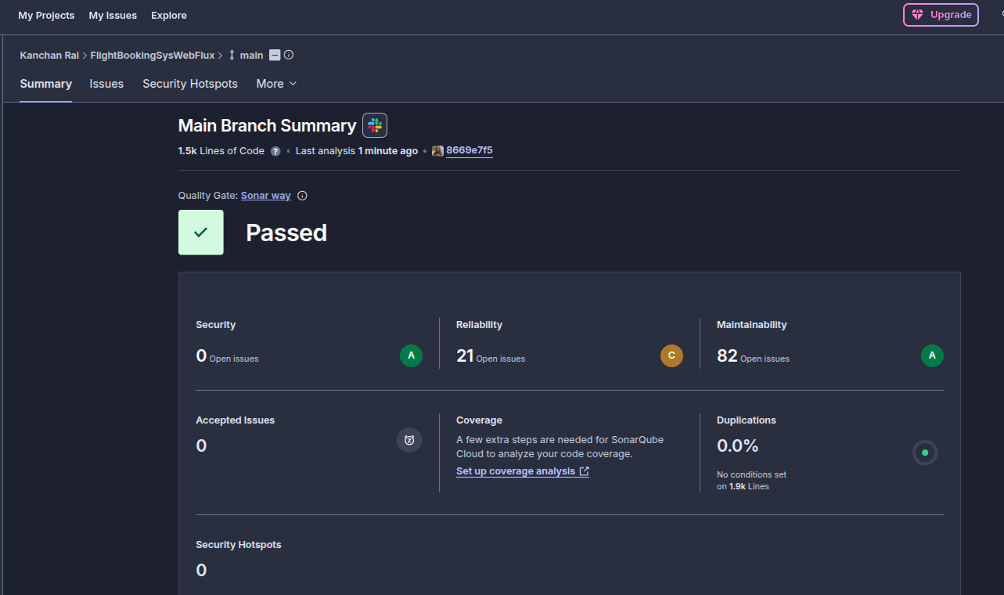
21 - Reliability Issues, 82 - Maintainability Issues, 0 - Security Issues, 0.0 % Duplications, 0 Accepted Issues.
I fixed the issues in reliability and maintainability as suggested by Sonar Qube and reduced them from 87 to 14 issues. These 16 issues are related to changing the @Autowired annotation to constructor injection which I have not changed as of now.

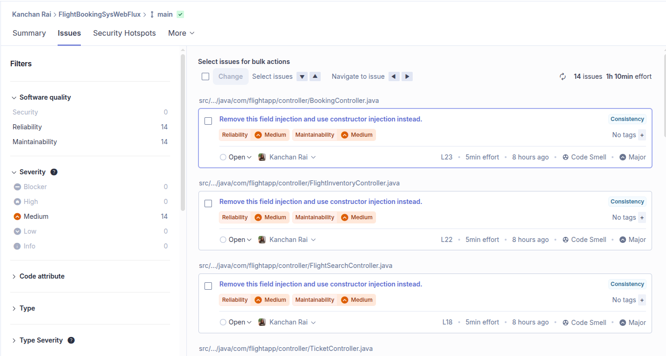
These issues present as follows -

1.2 After Fixing
0.0% Duplications, 14 Issues, 0 Security Issues, 0 Reliability Issues

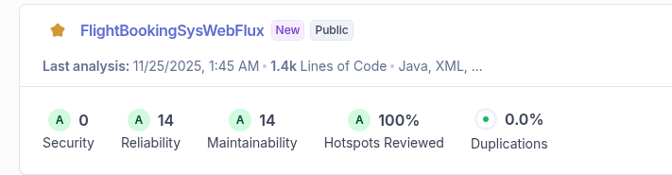

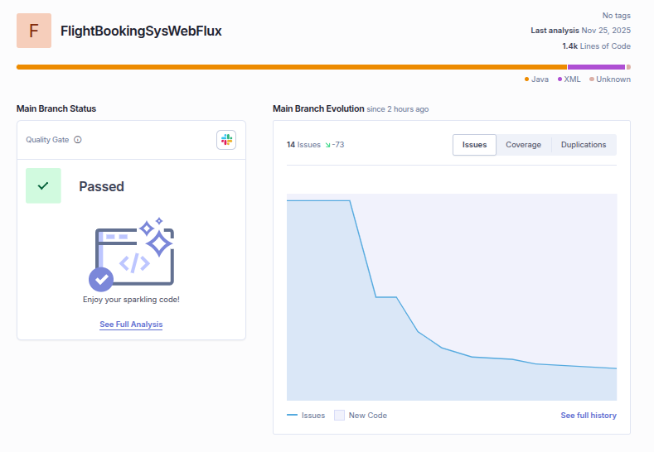

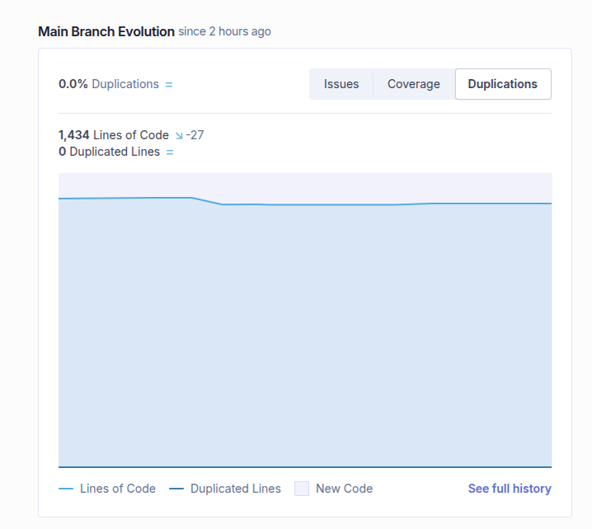
0.0% Duplications & 90 % Coverage

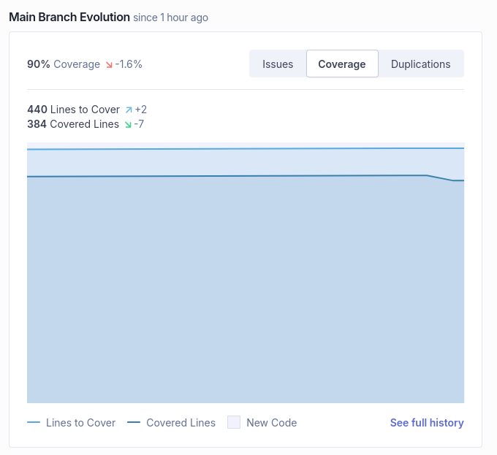

2. JCoco Coverage Report -

90 % Test Coverage

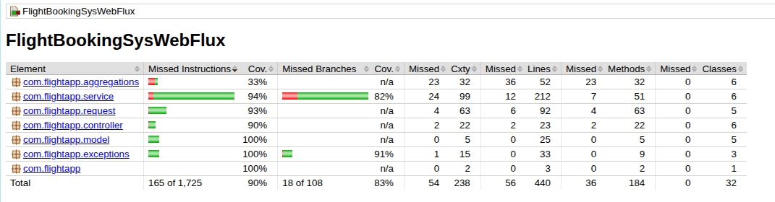

3. MongoDB Aggregations

I have also added the MongoDB Aggregations Pipeline and created GET routes for the same

These aggregations have a separate package called com.flightapp.aggregations. Then a controller for the same has been made in the com.flightapp.controller package. The FlightInventoryRepository has these aggregations, like this -

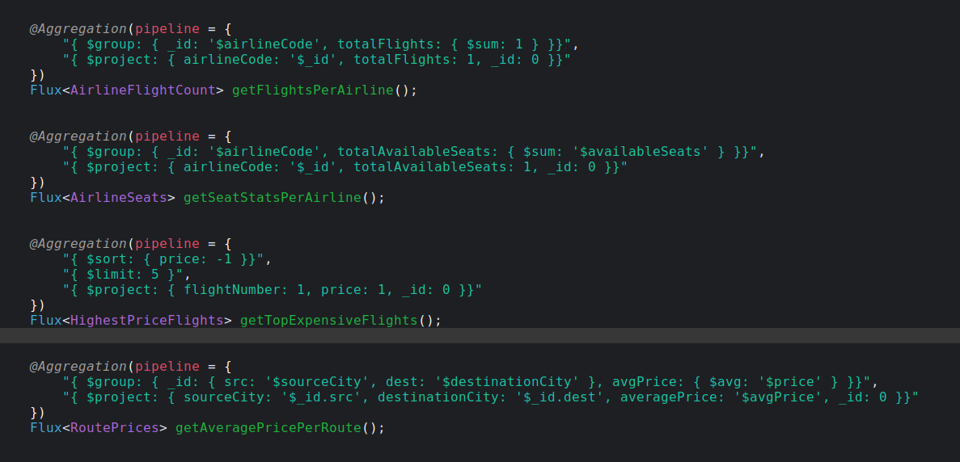

Each aggregation result is as follows -

- GET flights per air line

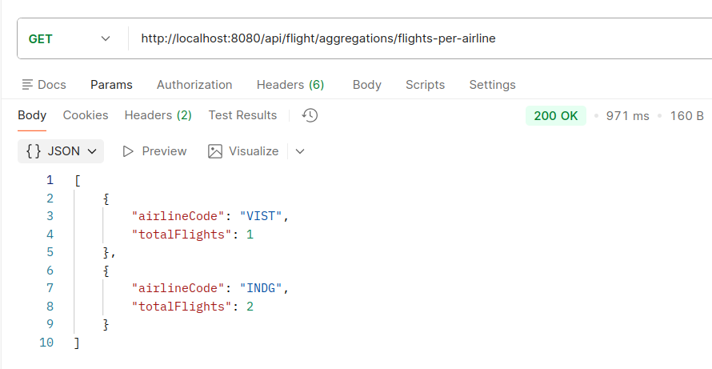

- GET Average price per route

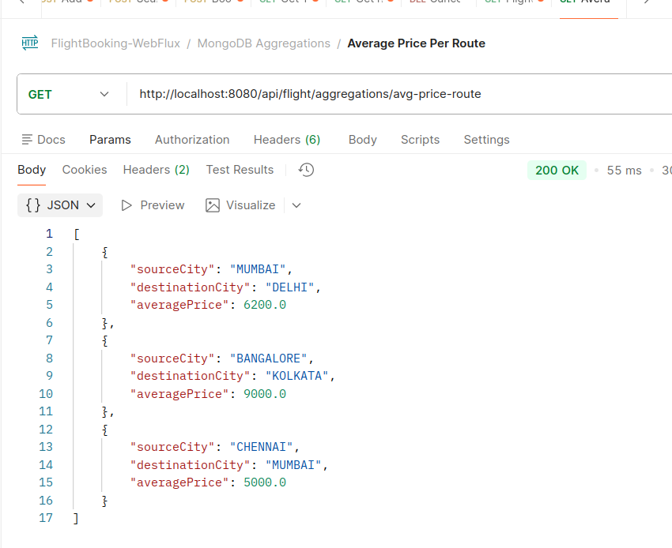

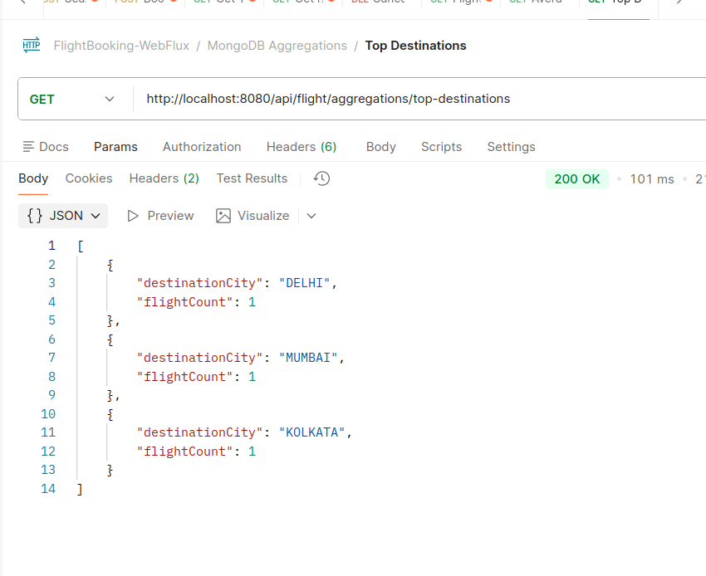
GET top destinations

- GET Seats per airline
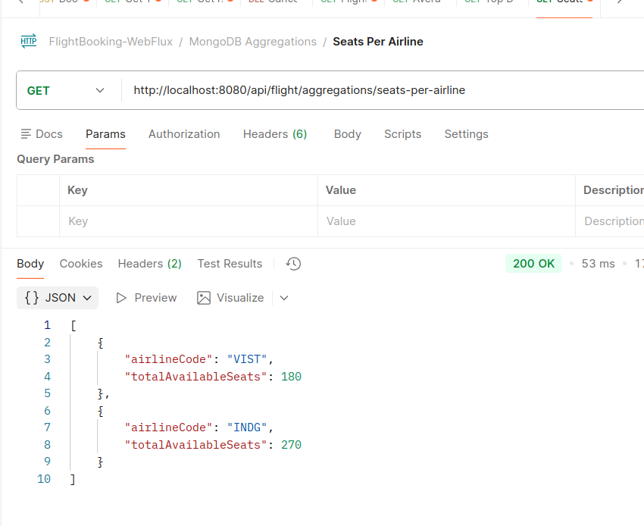

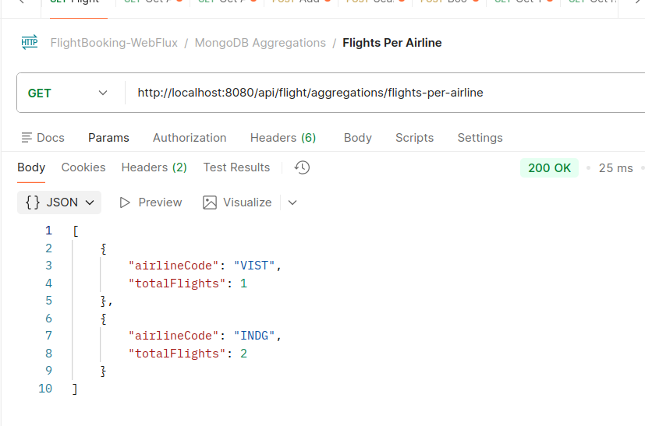
GET Flights per air line

4. JMeter Load Testing

4.1 With 20 Threads
The load testing has been carried out for all endpoints. Each one of GET,POST,DELETE has been shown below.

GET - Search a flight

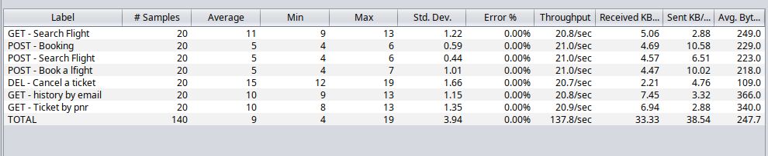

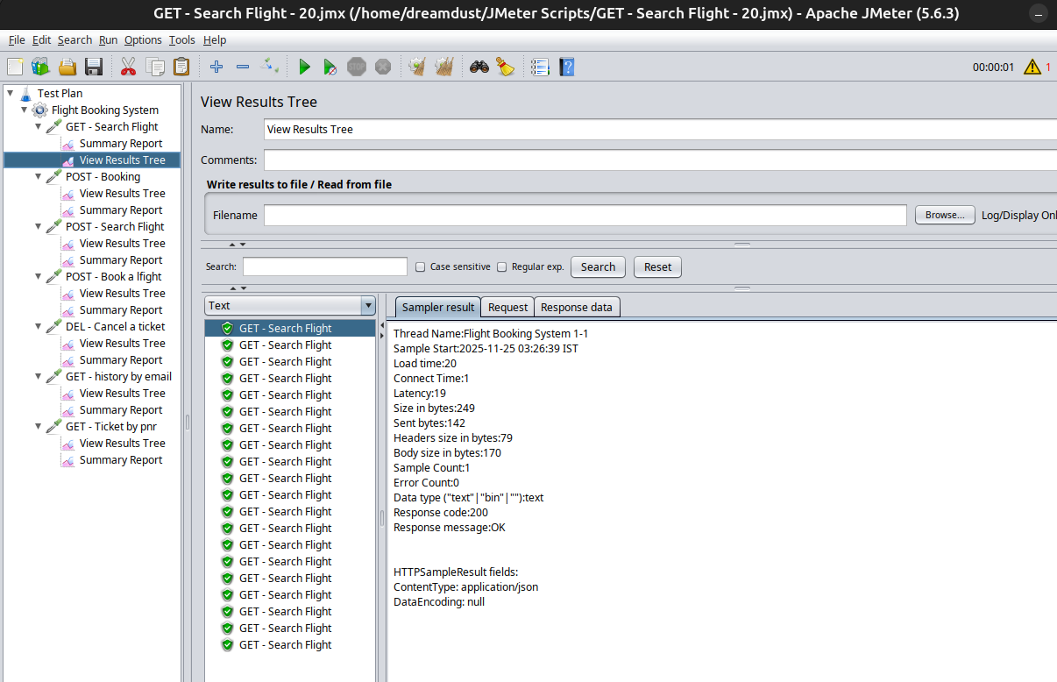

POST - Book a flight
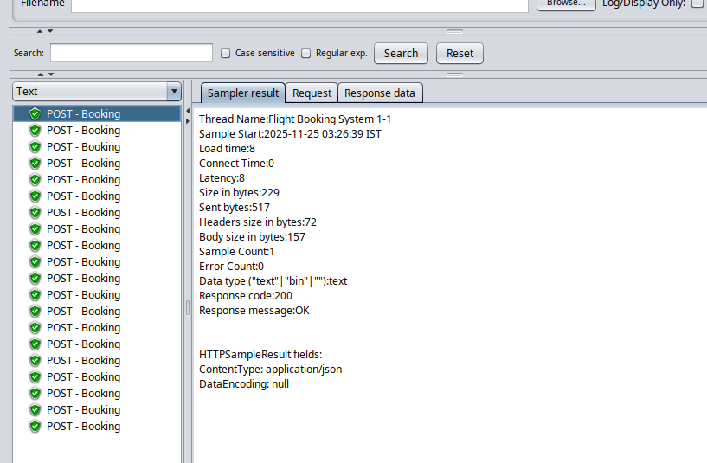

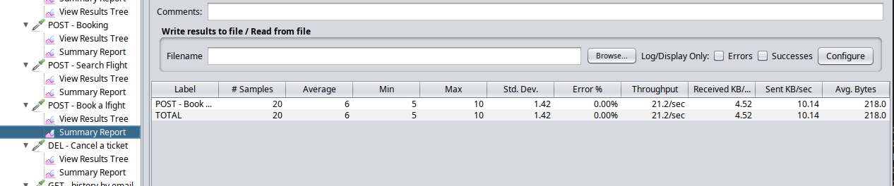

DELETE - Cancel a Booking

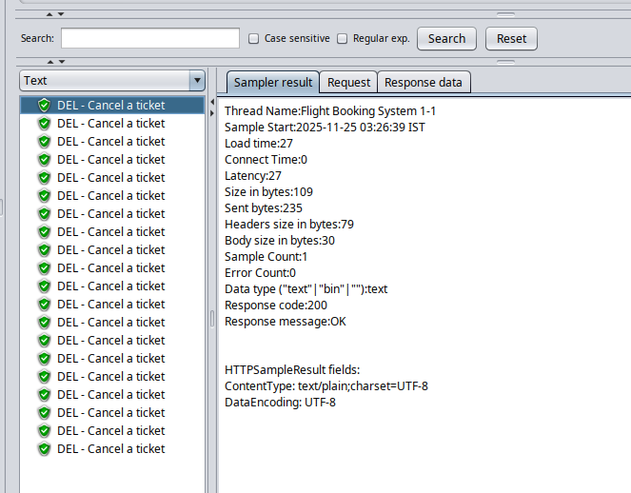

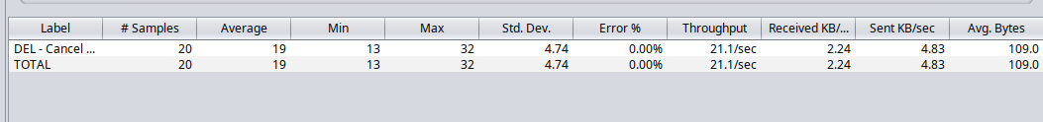

4.2 With 50 Threads
GET - Search a flight

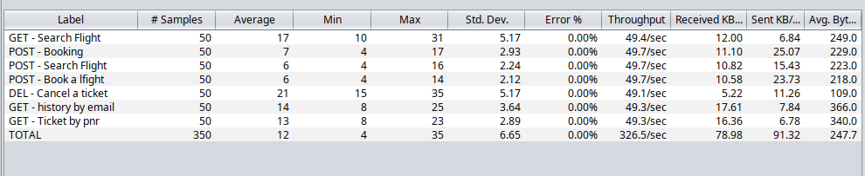

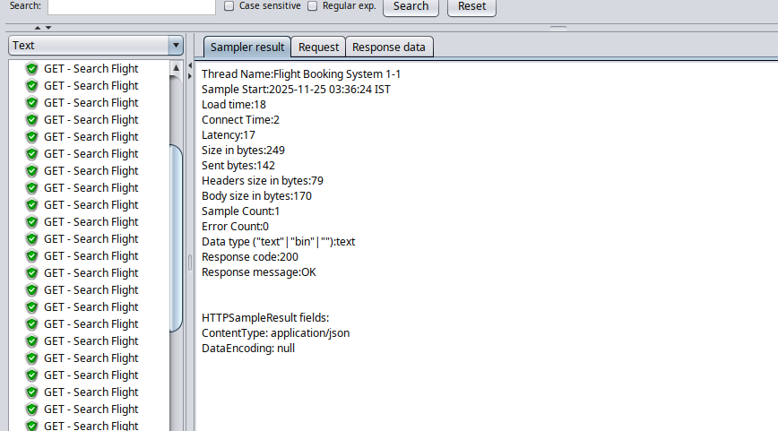

POST - Book a flight
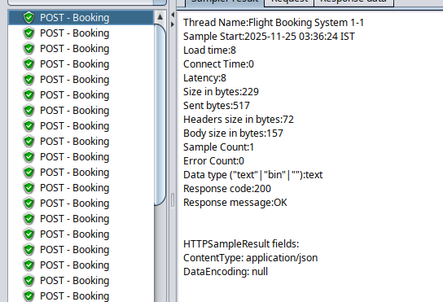
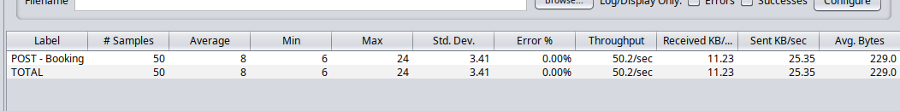

4.1 With 100 Threads

DELETE - Cancel a booking

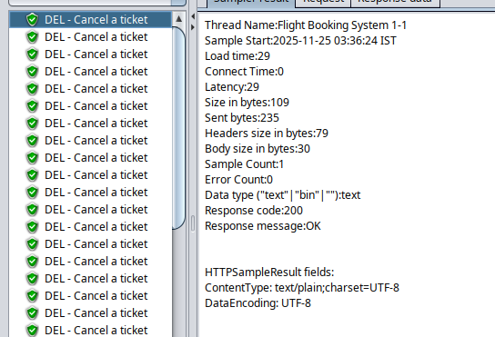

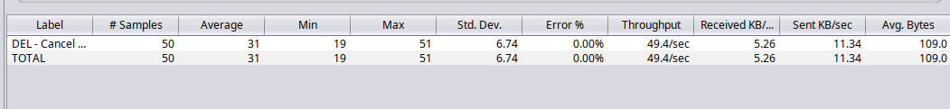

4.3 With 100 Threads
GET - Search a flight
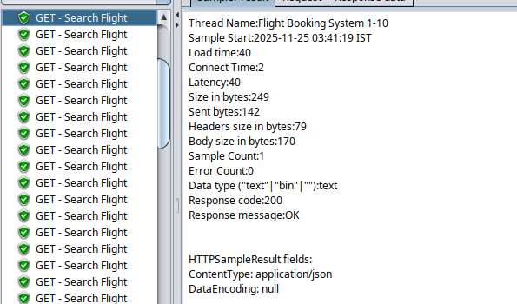
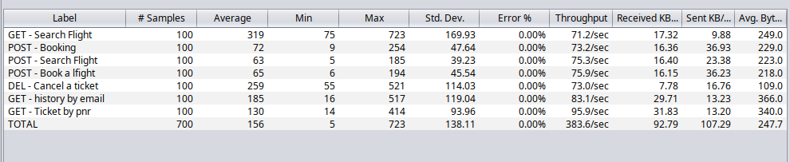

POST - Book a flight
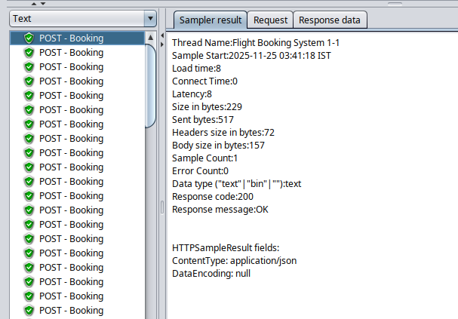

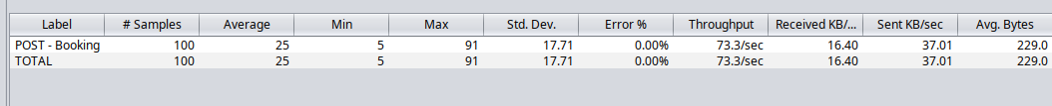

DELETE - Cancel a Booking
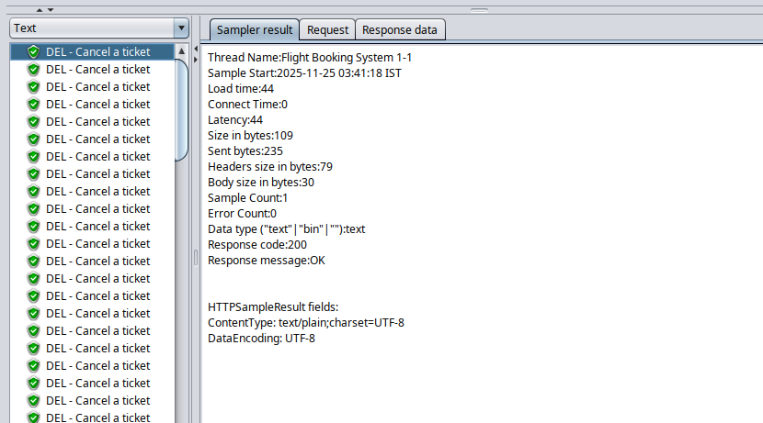

5. All API Endpoints Testing & Results

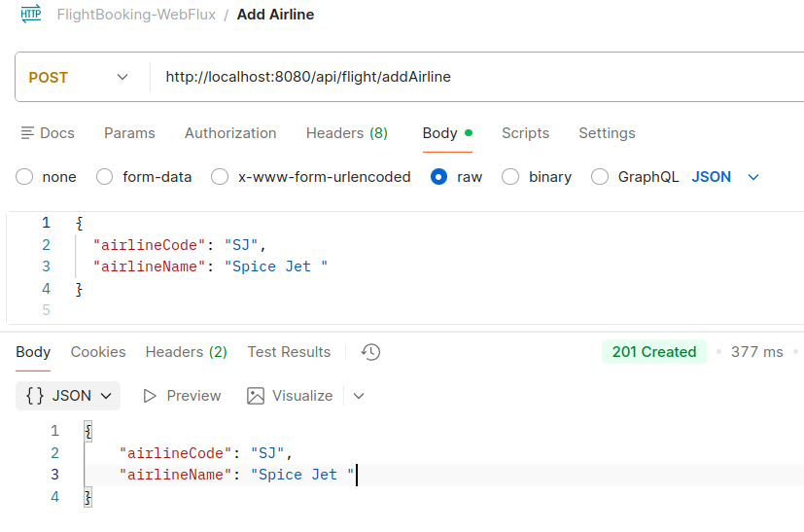
POST http://localhost:8080/api/flight/addAirline - Add Airline

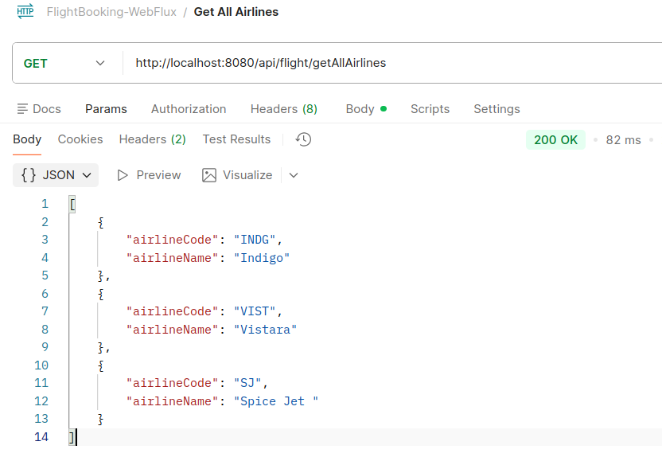
- GET http://localhost:8080/api/flight/getAllAirlines - Get All Airlines

- POST http://localhost:8080/api/flight/airline/inventory/add - Add Flight
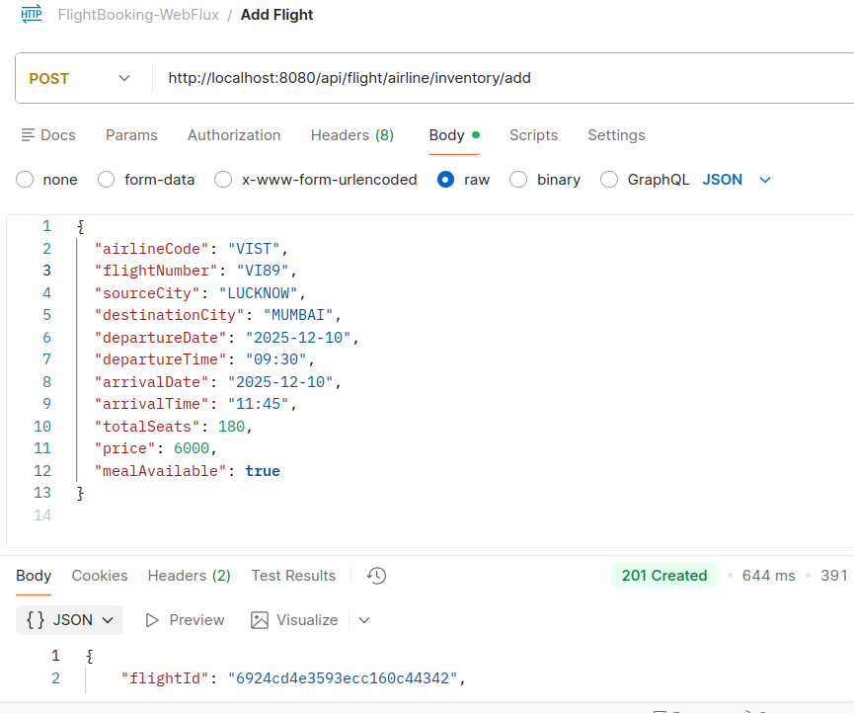

- POST http://localhost:8080/api/flight/search - Search Flight
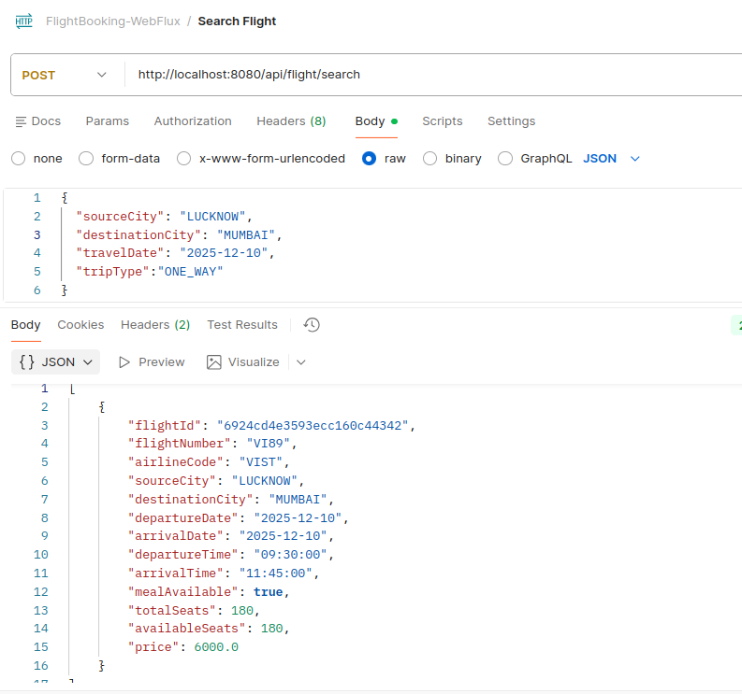

- POST http://localhost:8080/api/flight/booking/6924cd4e3593ecc160c44342 - Book a flight
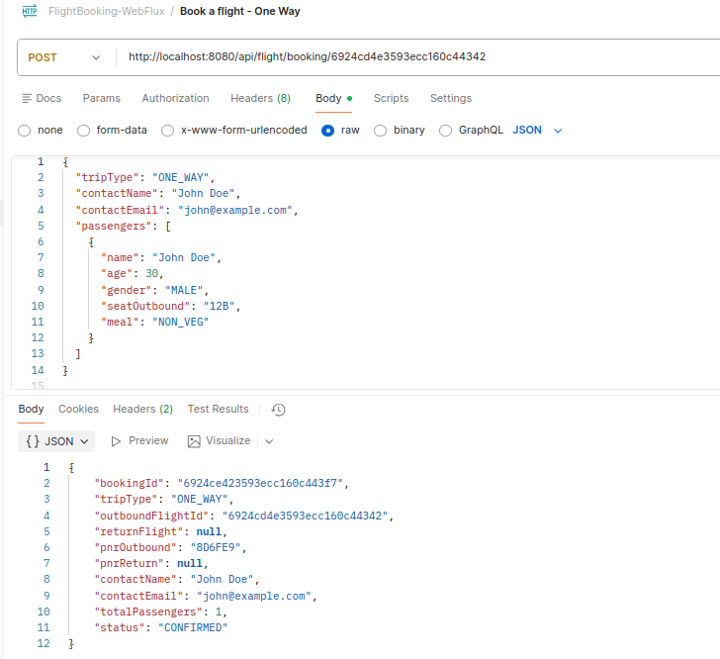

- GET http://localhost:8080/api/flight/ticket/1a919a - Get Ticket by pnr
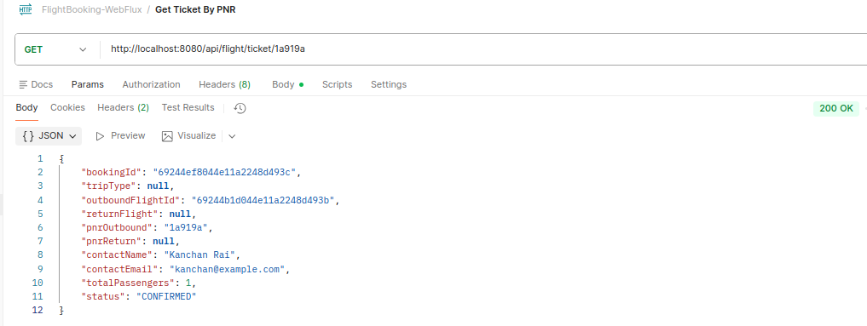

- GET - History by email
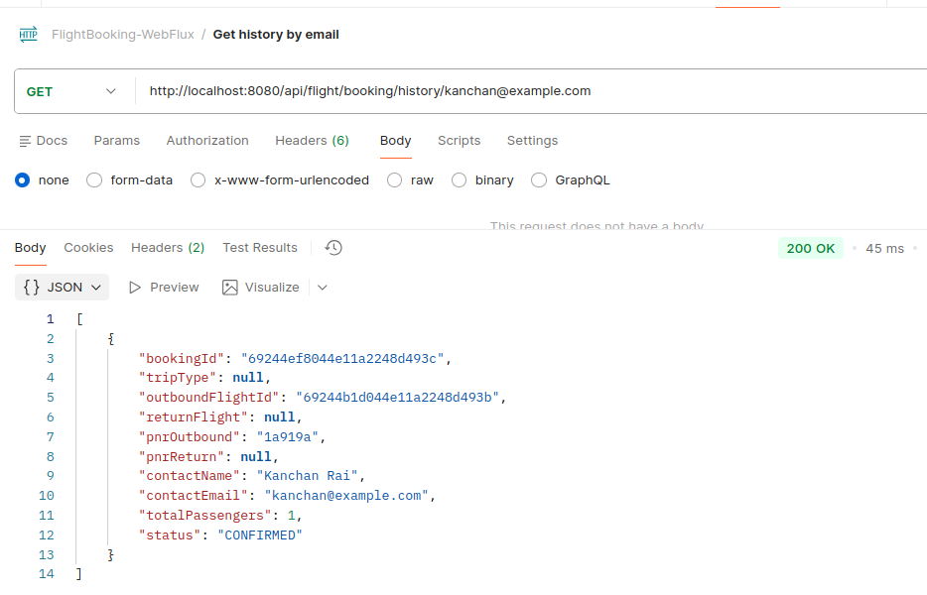

- DELETE - Cancel a ticket

