REPORT(ABS)

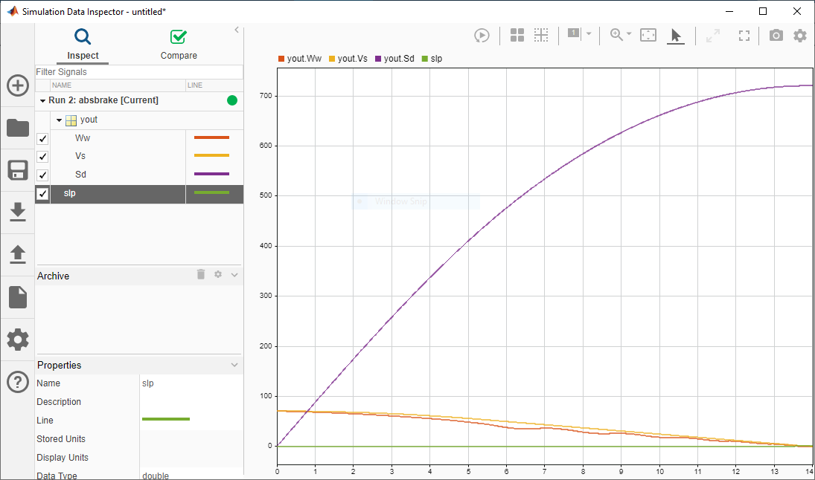

Data inspector

Solver selection:Ode45