Customer Support Ticket Classification and Priority Prediction
Machine Learning Internship Project Report
Submitted By: Kancharla Pavani Kalyani
Internship: Future Interns – Machine Learning Internship
Task2: Customer Support Ticket Classification and Priority Prediction
Repository: FUTURE_ML_02
Date: June 2026

Abstract
This project uses Natural Language Processing (NLP) and Machine Learning to automatically classify customer support tickets and assign priority levels.

Introduction
Customer support teams receive many tickets daily. Automating classification helps improve response time and efficiency.

Objective
To classify tickets into categories and assign High, Medium, or Low priority levels.

Tools Used
Python, Pandas, NLTK, Scikit-learn, Jupyter Notebook.

Dataset Description
The dataset contains ticket descriptions, categories, and priority labels.
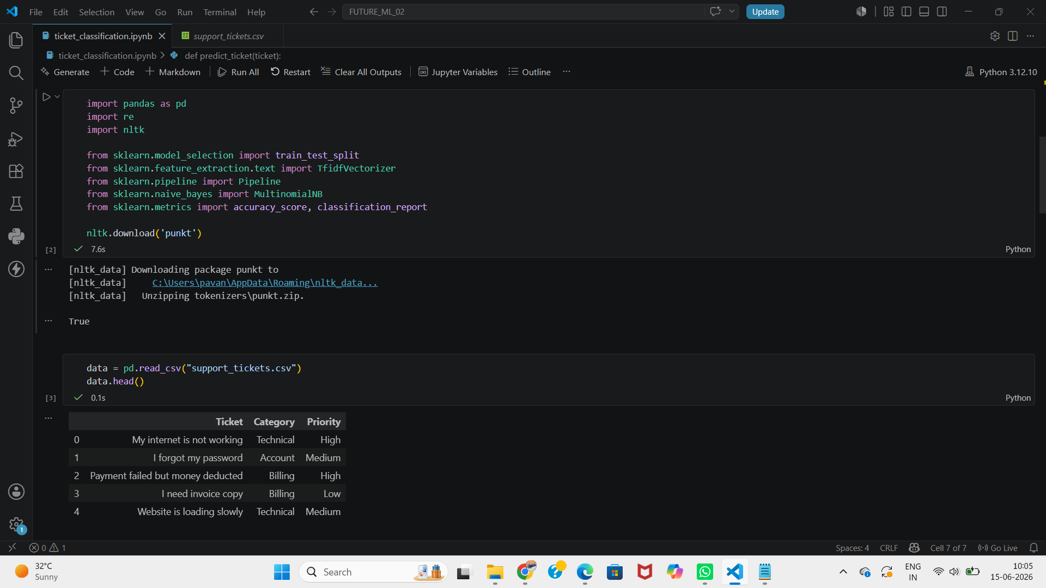
Figure 1: Dataset Loading Output

Methodology
Data collection, text cleaning, preprocessing, TF-IDF vectorization, model training, prediction, and evaluation.

Text Preprocessing
Lowercasing, removing special characters, and preparing text for machine learning.
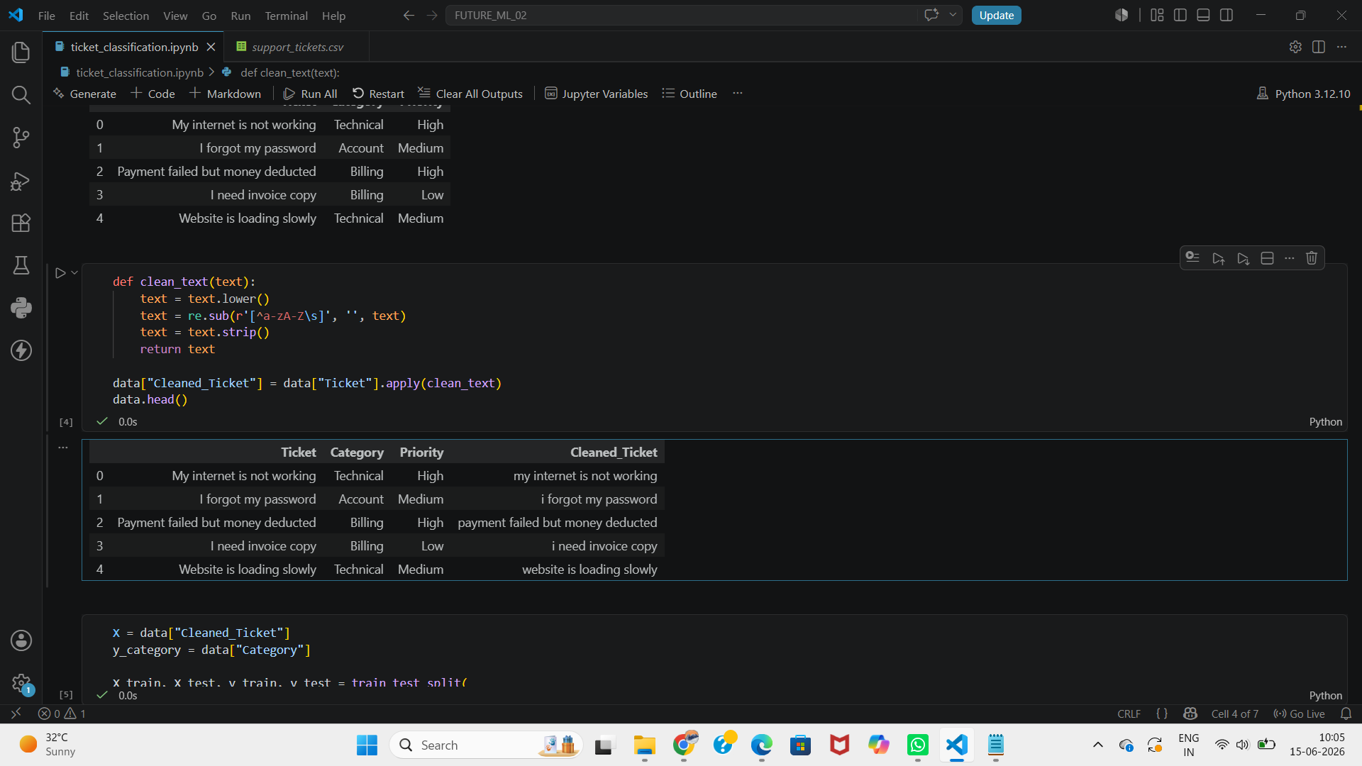
Figure 2: Text Preprocessing Output

Model Building
Multinomial Naive Bayes with TF-IDF features was used for category and priority prediction.
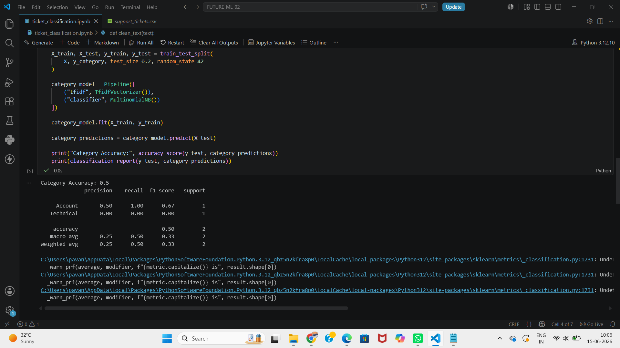
Figure 3: Category Classification Results

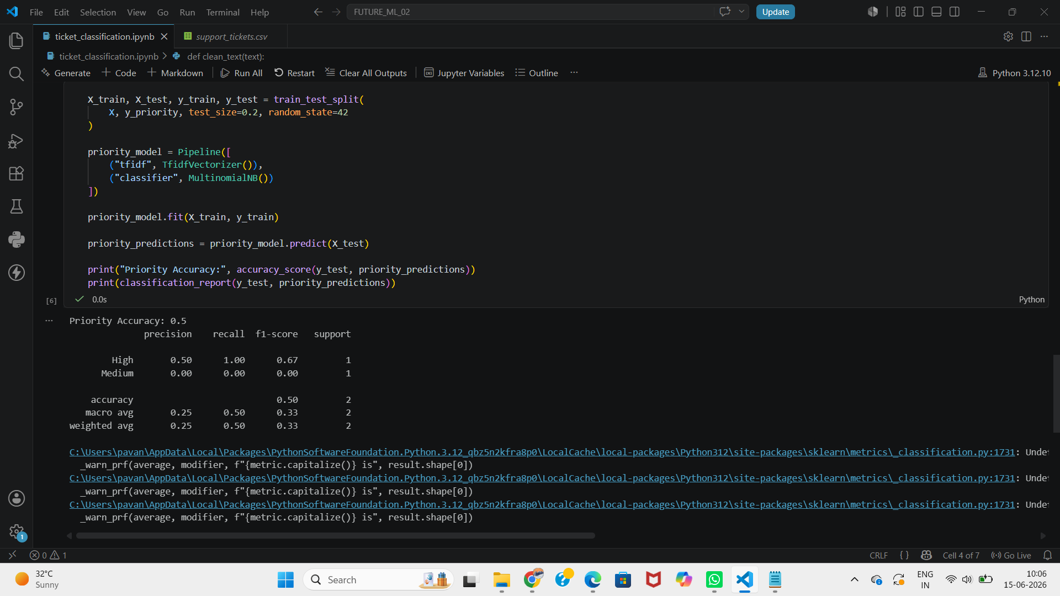
Figure 4: Priority Prediction Results

Results
The system successfully predicts ticket categories and priority levels for new support requests.
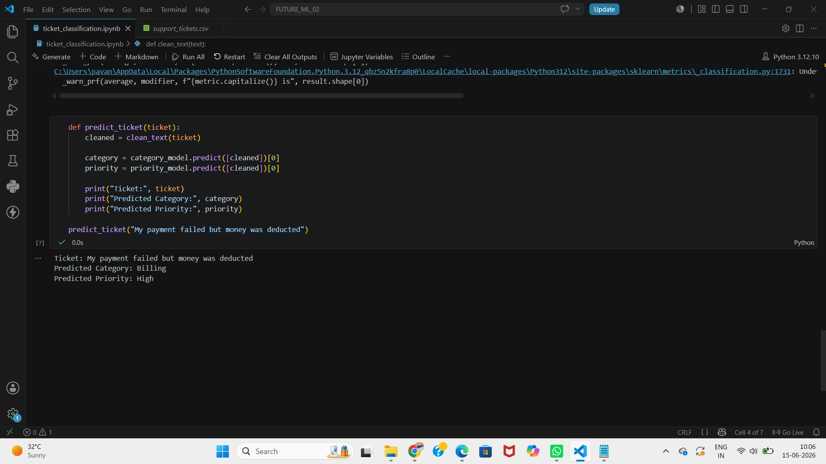
Figure 5: Final Ticket Prediction Output

The developed system successfully classifies customer support tickets into predefined categories such as Technical, Billing, and Account. It also predicts the priority level of tickets as High, Medium, or Low. The model demonstrated effective performance on the sample dataset and can assist support teams in handling customer requests efficiently.
The category classification model and priority prediction model were evaluated using accuracy and classification reports. The results indicate that the system can effectively classify support tickets and assign priority levels based on textual information.

Conclusion
The project demonstrates how NLP can help support teams respond faster and smarter.

